**Accounting and Finance**

Straightforward yet ground-breaking, the BUSINESSBOXERP Accounting module can be best depicted in these two words. You can process your exchanges rapidly utilizing BUSINESSBOXERP Accounting. BUSINESS IN A BOX's accounting module comes integrated with all different applications of BUSINESSBOXERP like Sale, Purchase, Inventory and Human Resources. This makes working with BUSINESSBOXERP progressively straightforward and brisk.

Numerous things make BUSINESSBOXERP a one-of-a-kind product than any other ERP Accounting module. When we contrast BUSINESSBOXERP Accounting and other ERP suites like Microsoft Dynamics and NetSuite, one can see numerous highlights which BUSINESSBOXERP alone have. For instance, Quick reconciliation, Automatic Sync, Batch Send, Third Party Follow up, Payment Automation, Alerts, and Expenses. In any case, neither NetSuite nor Dynamics bolster these highlights yet just some of them. Since all bookkeeping exchanges are related to clients or providers, you get reports to perform investigation per client/provider, for example, the client statements, revenues per customer, matured receivable/payable and so on. Another exemplary accessible in BUSINESSBOXERP is its business intelligence motor which will enable you to explore through organization information in an increasingly sorted out way. The charts and outlines plotted by the BI engine is for sure a helpful device in basic leadership. BUSINESSBOXERP is versatile as well. You can utilize it to check your records in a hurry.

Following is the way BUSINESSBOXERP manages regular records and exchanges.

**Double-entry bookkeeping**

BUSINESSBOXERP automatically creates journal entries for every accounting transaction and utilizes a double-entry bookkeeping system.

**Accrual and Cash Basis Methods**

BUSINESSBOXERP support both accrual and cash basis detailing. This enables the end-user to report income/cost at the time when transaction exchanges happen.

**Multi-companies**

BUSINESSBOXERP permits dealing with several organizations within the same database. Each organization has its very own chart of accounts and guideline rules. One can get consolidation reports following your solidification rules.

**Multi-currencies**

Each exchange is recorded in the default currency of the organization. For transactions happening in another currency, BUSINESSBOXERP stores both the value in the money of the organization and the value in the cash of the exchange. BUSINESSBOXERP can produce currency gains and misfortunes after the reconciliation of journal items.

**International Standards**

BUSINESSBOXERP accounting support over fifty nations. The BUSINESSBOXERP executes accounting standards that are regular to all nations. Customized applications are accessible to oblige the specificities of an individual nation, like a chart of accounts, taxes, or bank interfaces.

**Accounts Receivable & Payable**

By default, BUSINESSBOXERP utilizes a solitary record for all record receivable sections.

In BUSINESS IN A BOX, you can create budgetary reports continuously. BUSINESS IN A BOX's reports include:

* Performance reports, (for example, Profit and Loss, Budget Variances)
* Position reports, (for example, Balance Sheet, Aged Payables, Aged Receivables)
* Cash reports, (for example, Bank Summary)
* Detail reports, (for example, Trial Balance and General Ledger)
* Management reports, (for example, Budgets, Executive Summary)

**Import bank feeds automatically**

BUSINESSBOXERP makes money reconciliation simple by frequently bringing in bank statements lines from your bank directly into your BUSINESSBOXERP account.

**Inventory Valuation**

BUSINESSBOXERP underpins both periodic (manual) and perpetual (automated) inventory valuations.

**Easily retained earnings**

BUSINESSBOXERP automatically ascertains your present year earnings in real-time; with the goal that no year-end journal or rollover is required. This is determined via consequently reporting the profit and loss balance to your balance sheet report.

**Accounting Dashboard**

As soon as you open your accounting dashboard, you can view the journals created. One can also find the shortcuts to create a new invoice/bill, option to upload invoices/bills, configure bank reconciliations and more.

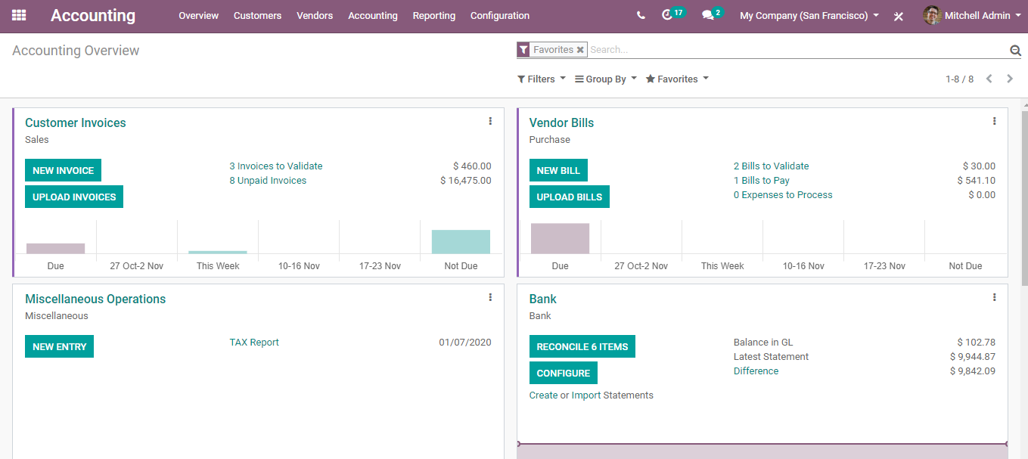

However, upon clicking the **SELECTION** button you get to other options as well.

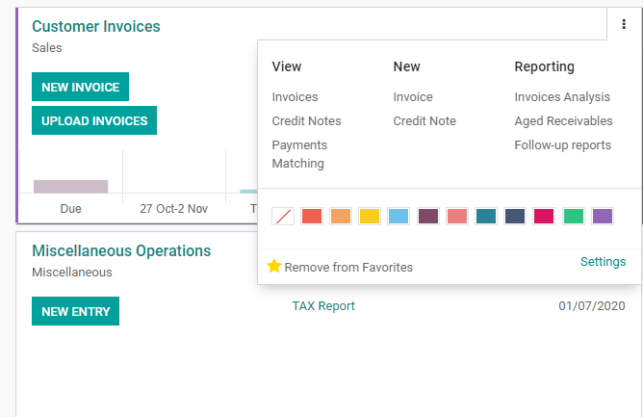

For instance, under the journal **Customer Invoices,** one can view the Invoices and credit notes, also create new invoices and credit notes.

The user can instantly create invoices and send them in a few clicks.

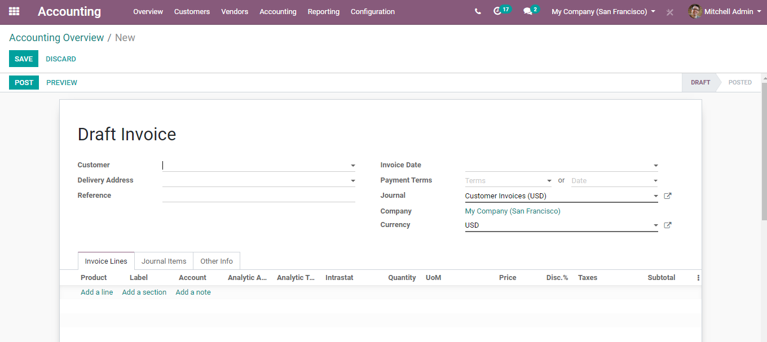

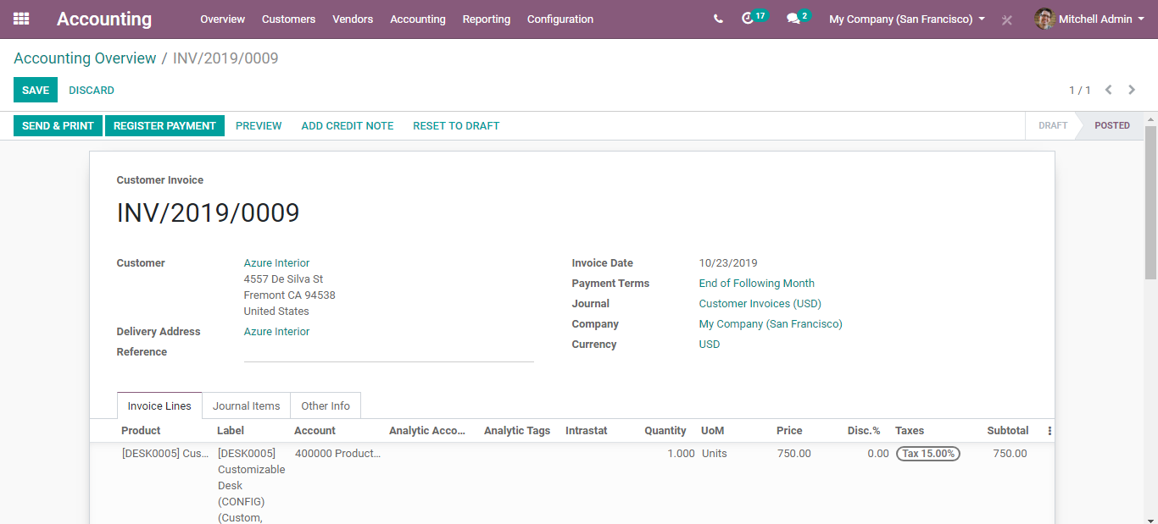

Via going under Reporting,

You get various reports such as Follow-up reports, invoice analysis, aged receivables and so on.

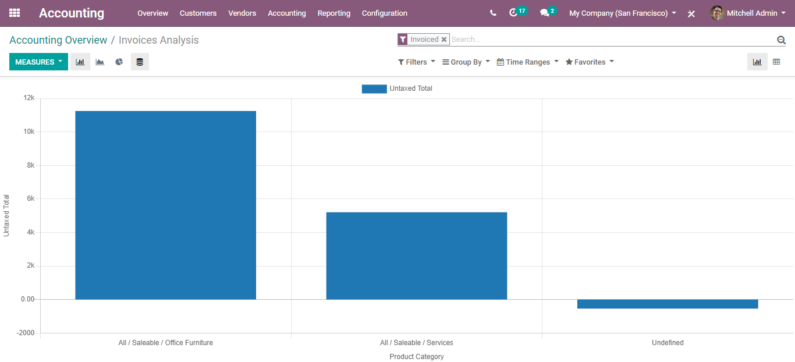

You also automatically get the filter favourites options to configure the dashboard view.

odoo-accounting

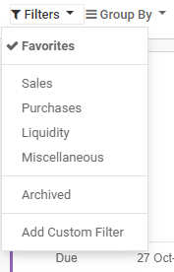

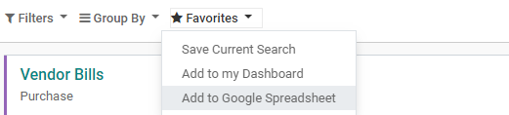

Basic Configurations

CONFIGURING A NEW BANK ACCOUNT

Utilizing BUSINESS IN A BOX, one can manage multiple bank accounts. The user can easily add, update, or delete their bank account following a few simple steps.

**Configuration**

Go to**Accounting> Configuration> Payments> Bank Account**

You can see a rundown of several bank accounts created by BUSINESS IN A BOX. However, one can edit it before filling in the relevant bank information.

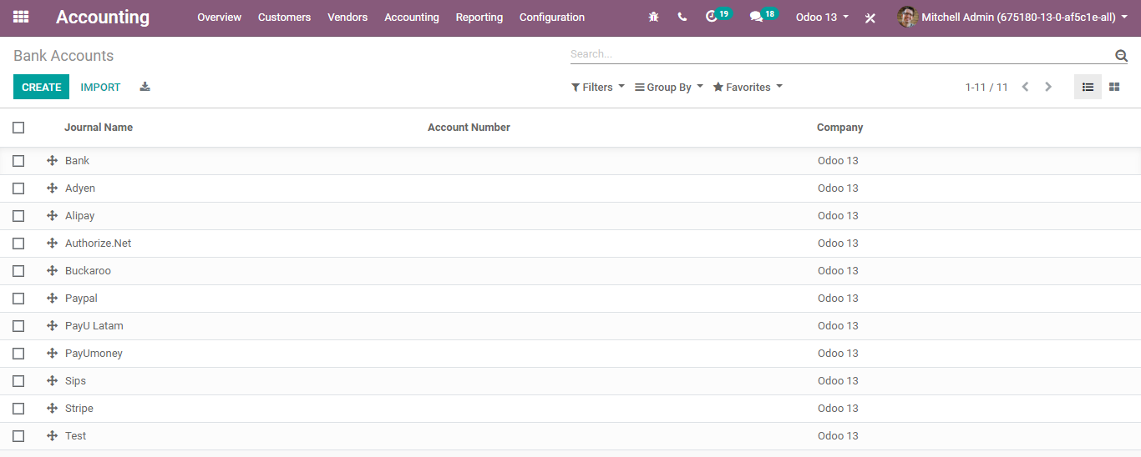

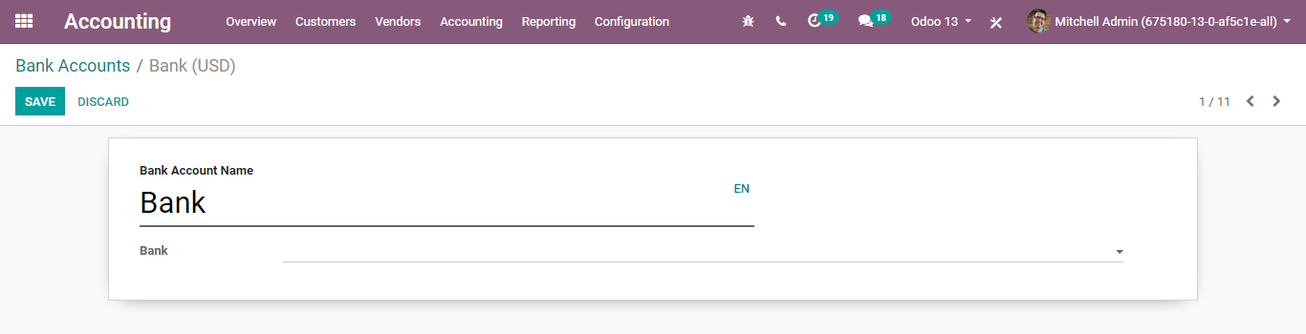

**CONFIGURING CHART OF ACCOUNTS**

A chart of accounts is a rundown of the names of the accounts that an organization has recognized and made accessible for the recording transactions in its general ledger. An organization has the adaptability to tailor its chart of accounts to best suit its needs. This is determined via consequently reporting the profit and loss balance in your balance sheet report.

BUSINESSBOXERP provisions the end client to utilize the predefined charts of accounts, encompassing all basic configurations like tax codes and fiscal localization packages. However, one can also create a chart of accounts in BUSINESS IN A BOX.

For that go to **accounting-> Configuration-> Accounting ->Chart of Accounts.**

One can see the rundown of different account names. Upon clicking any, one can make sufficient edits to the existing. Click the Save button to mark changes.

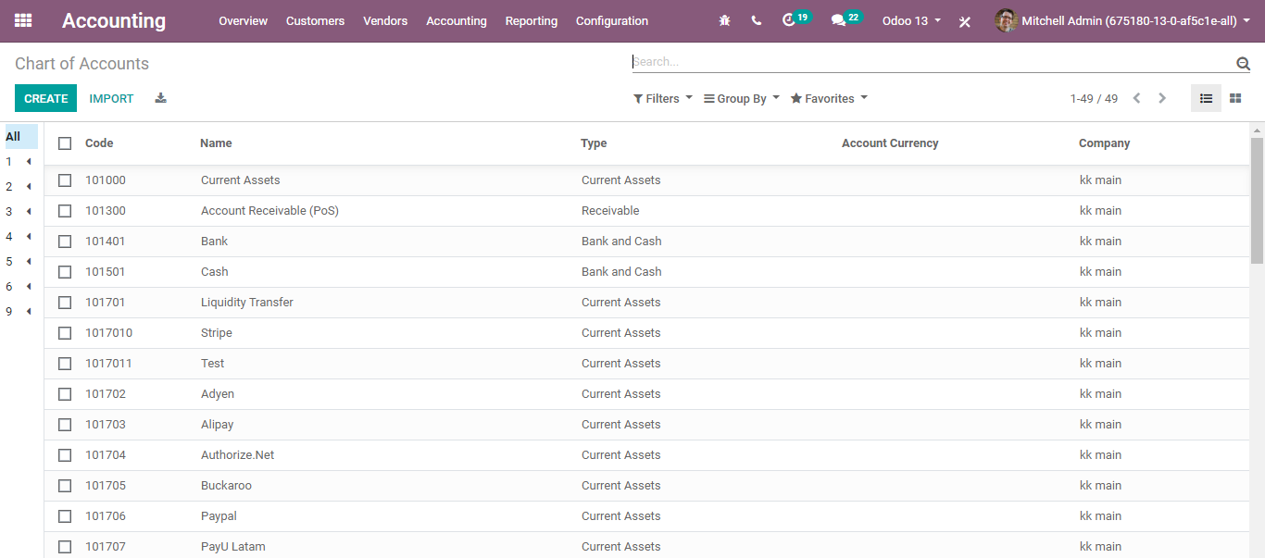

Upon clicking CREATE button, you will be navigated to a new window like below:

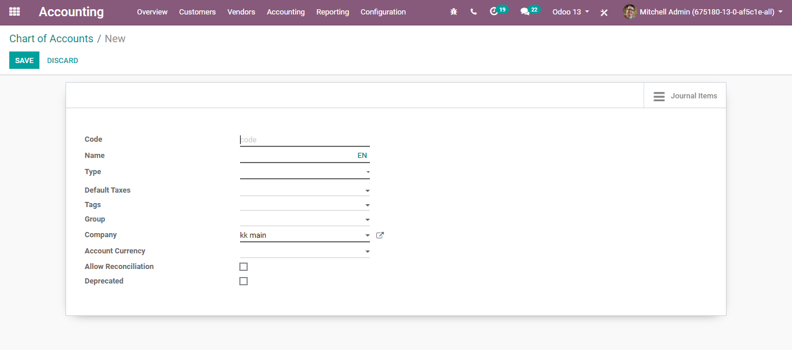

One can include the details like Tax code, Account Name, Account Type (Account type is used for information purposes, to generate country-specific legal reports, and set the rules to close a fiscal year and generate opening entries), Default taxes, Tags for Custom Reporting, Group, Company, and Account Currency (Forces all moves for this account to have this account currency).

**CONFIGURING TAXES**

BUSINESS IN A BOX's tax engine is very adaptable, and it comes supportive to a wide range of tax types like value-added taxes (VAT), eco-taxes, federal/states/city taxes, retention, withholding taxes and so on. For most nations, the system is pre-designed or configured with the right taxes.

**Configuration**

To define new taxes for various use cases.

Go to **Accounting> Configuration-> Invoicing > Taxes**

From this menu, you get all the taxes you can utilize say sales tax or purchase taxes.

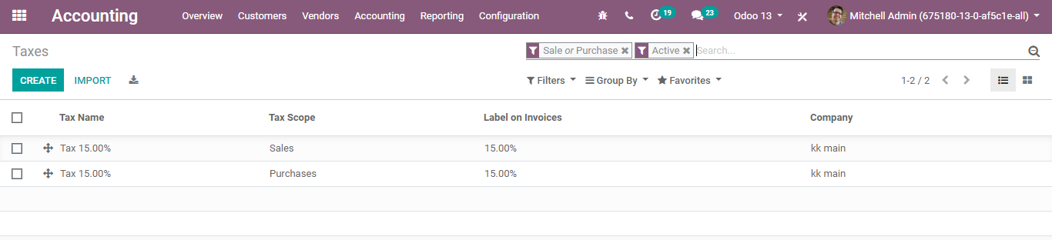

Upon clicking the desired, you will be navigated to a new window just like below:

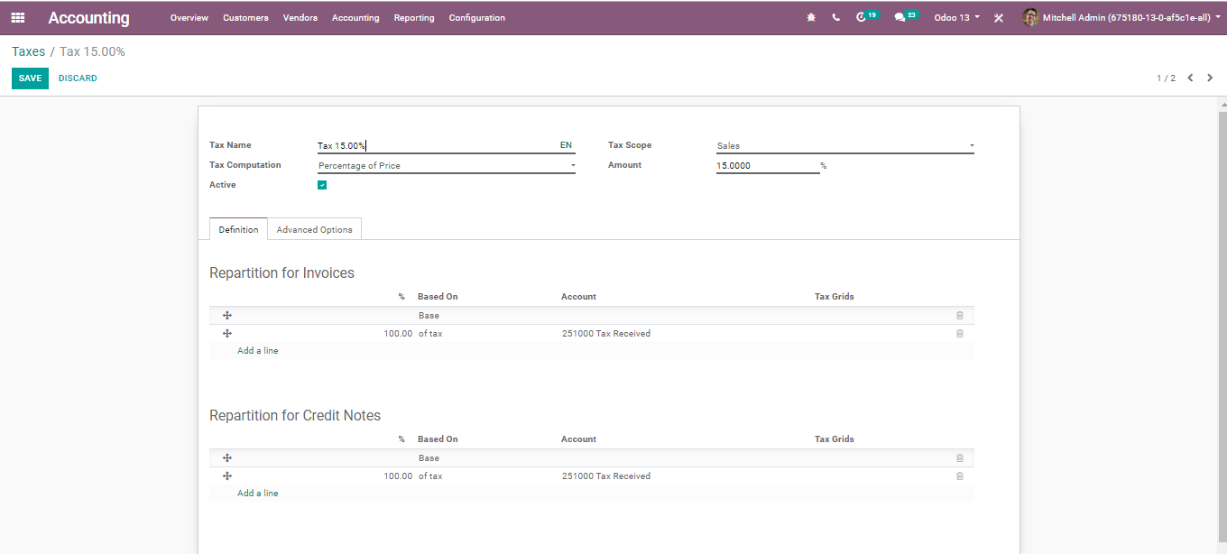

The creation form will have the following attributes:

* **Tax Name:**Name of the tax
* **Tax Scope:** The field defines where to use this tax. If you select ‘None,’ you can only use this tax with another taxed group. BUSINESSBOXERP provides Sales, Purchase, none (for example belittled or deprecated expense) and Adjustment.

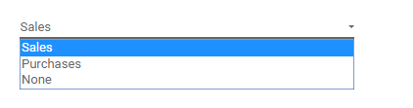

**Tax computation:** BUSINESSBOXERP have four different types of tax computation-

* Group of taxes
* Fixed
* Percentage of price
* Percentage of price tax included

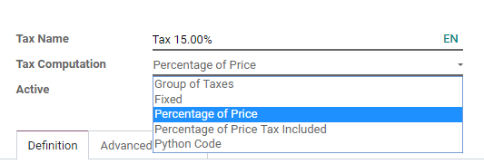

**Under Advanced Options Tab,**

* **The label on Invoices:** This can be used on the invoice report to represent this tax. One can add custom tags to create custom reports.
* **Included in analytic cost:** If we set this option, then the amount computed by this tax will assign to the same analytic account mentioned in the invoice line.
* **Included in price:** Set this option if this tax is included in the unit price of the product/service.
* **Affect base of subsequent taxes:** If you set this option, the Base amount of subsequent taxes will be the sum of the current base amount and tax amount of this tax.
* **Tax Due**
  + **Based on Invoice:** The tax is due as soon as the invoice is validated.
  + **Based on Payment:** The tax is due as soon as the payment of the invoice is received.

**CONFIGURING FISCAL POSITIONS**

BUSINESSBOXERP can handle multi-Company and multi-currency concepts. This feature is for helping the business organizations who are dealing with outstation clients, be it the Customers or the Suppliers. Both teams may be operating from another country or state. Therefore, the laws and regulations concerning taxes will be different from each other. A fiscal position comes in handy for such business circumstances. Using BUSINESS IN A BOX’s fiscal position one can seamlessly map taxes and accounts specific to that country.

**Configuration:**

**Go to Accounting > Configuration > Invoicing > Fiscal Position**

One can either create a new fiscal position corresponding to the nation of your supplier/customer or edit/use the existing fiscal positions in BUSINESS IN A BOX.

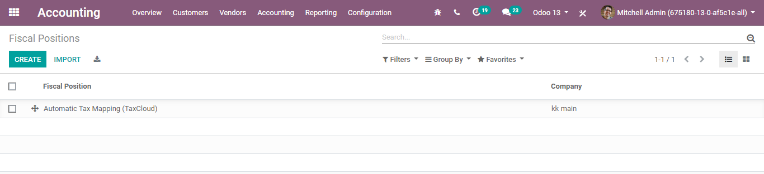

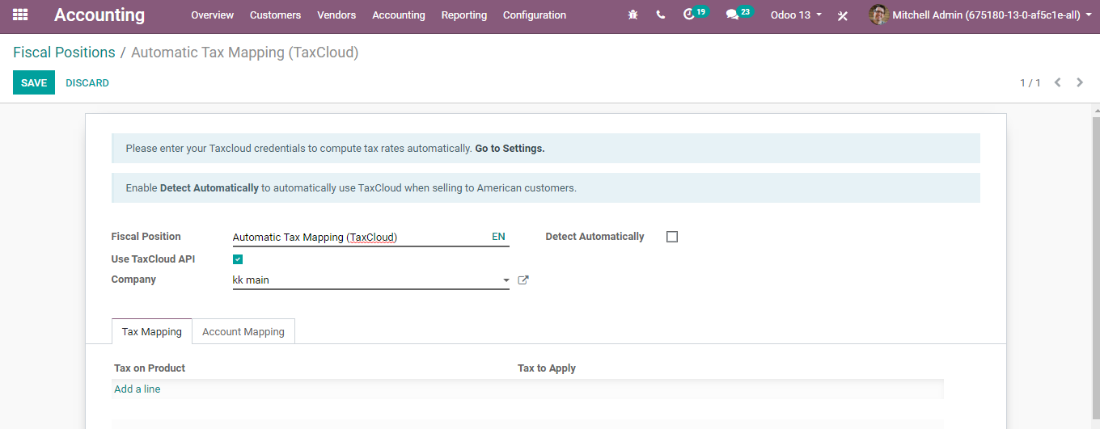

**Tax Mapping:** Tax mapping is another useful option to configure taxes. For example, imagine a product with have 10% tax rate in one state and a 15 % tax rate in another state. Using Tax Mapping and Accounts Mapping one can easily manage them under BUSINESSBOXERP fiscal positions.

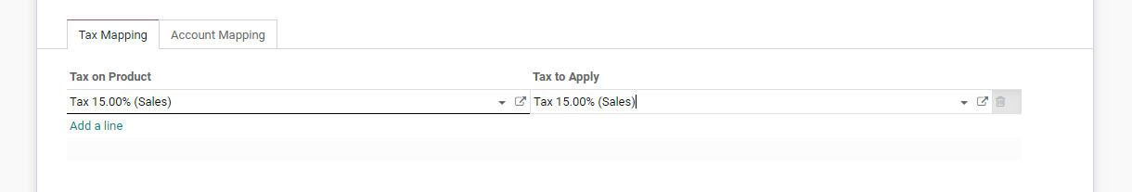

**CONFIGURING JOURNALS**

All your bookkeeping sections or accounting entries need to show up in an accounting journal. An accounting journal is a record of transaction exchanges requested by a date. So, you ought to make a Sales Journal for customer invoices, a Sales Refund Journal for customer credit takes notes, a Purchase Journal for supplier invoices, a Purchase Refund journal for supplier credit notes and a Bank Journal for bank exchanges. However, one can also add different journals in BUSINESS IN A BOX.

**Configuration**

Go to **Accounting > Configuration > Invoicing > Journals.**

Upon clicking Journals, you will be navigated to a new window, where BUSINESSBOXERP enlists with different Journal Types like Customer Invoices, Vendor Bills, and more.

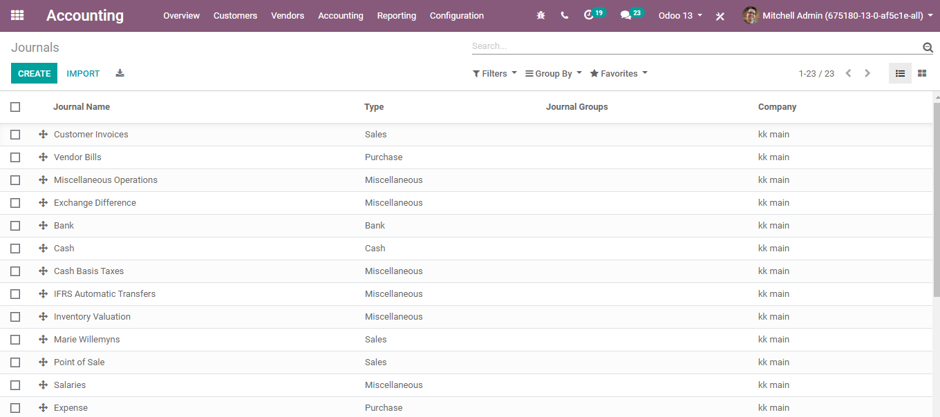

Upon clicking the create button, you can add a new accounting journal in BUSINESS IN A BOX.

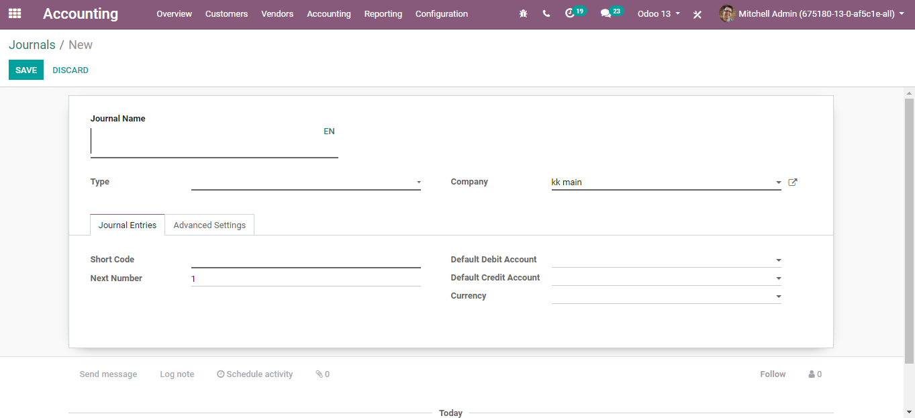

The creation form includes:

* **Journal Name:**The field defines the name of the accounting journal.
* **Type:** There are five types of journals in BUSINESS IN A BOX.
* **Company:** The company related to this journal.
* **Short Code:** The journal entries of this journal will be named using this prefix.
* **Next Number:** The next sequence number will be used for the next invoice.
* **Default Debit Account:**It is the default account for the debit amounts.
* **Default Credit Account:** It is the default account for the credit amount.
* **Currency:** The currency used to enter the statement.

**Under the Advanced Settings option**

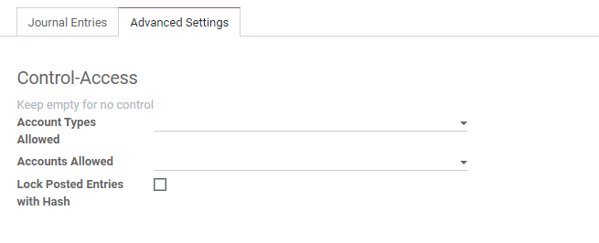

**Lock Posted Entries with Hash:**If ticked, the accounting entry or invoice receives a hash as soon as it is posted and cannot be modified anymore.

**CONFIGURING INTERCOMS**

Incoterms is the abbreviation for International commercial terms. Fifteen terms of sale are accepted worldwide in a task of expenses and responsibilities among purchaser and merchant. Essentially, Incoterms are exchange/trade terms distributed by the international chamber of commerce (ICC), and it is widely used in both global(international) and local (domestic)exchange contracts. In other words, Incoterms divide the transaction costs and responsibilities between the buyer and seller and reflect the state of art transportation practices.

**Configuration**

Go to **Accounting > Configuration >Invoicing > Incoterms**

Upon clicking the Incoterms, you will be navigated to a new window just like the below image:

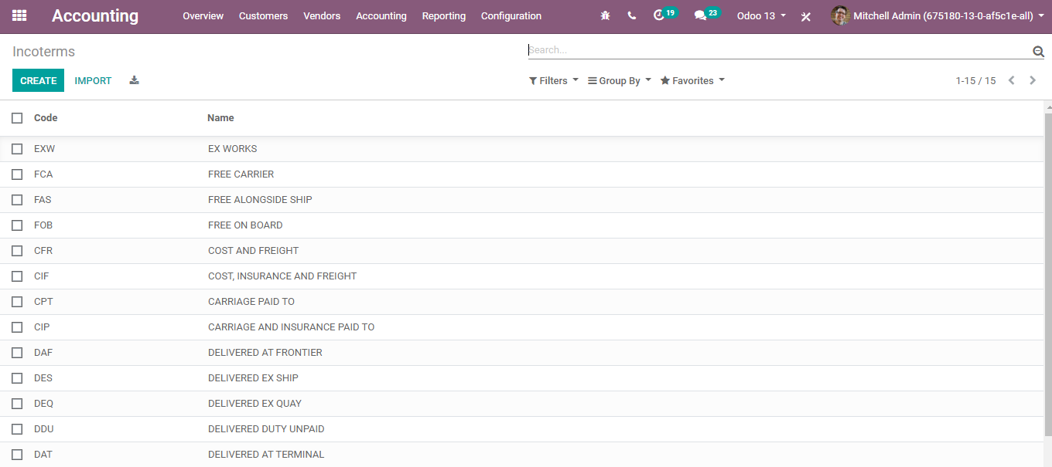

BUSINESSBOXERP rundown a list of Incoterm for your business, however, one can create a new Incoterm via clicking the CREATE button.

Upon clicking the create button, you can enter the Name: Incoterm Name and Code: Incoterm Standard Code for the intercom.

Click SAVE to mark changes.

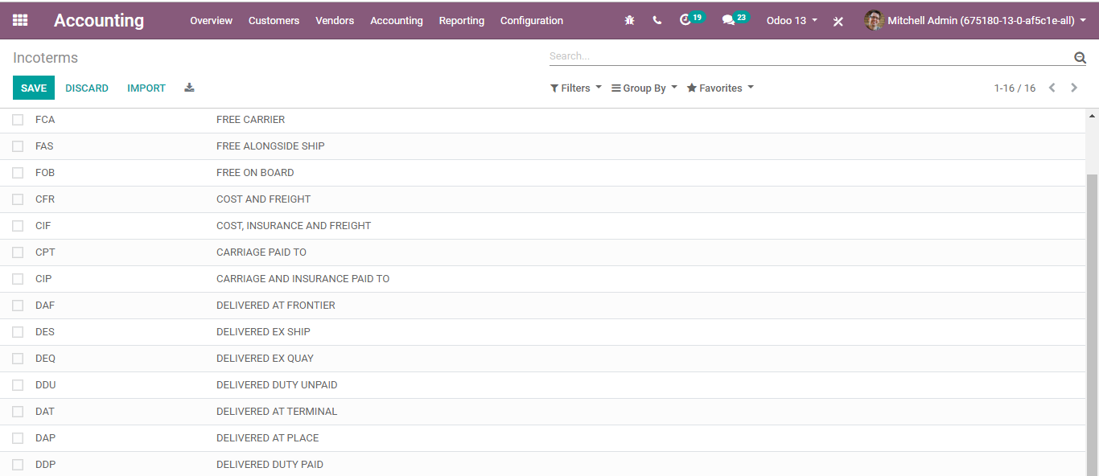

**CONFIGURING PAYMENT TERMS**

Business organizations often indulge in different payment collection and different payment making methods. In many cases, the payments to suppliers or the payments from customers come as instalments. To help the business with that case of payments, BUSINESSBOXERP offers a certain set of features envisioning different configurations and different payment methods. Under BUSINESS IN A BOX, it is titled as Payment terms. One can set different payment terms in BUSINESSBOXERP and utilize them for both customer bills and vendor bills.

**Configuration:**

Go to **Accounting>Configuration> Invoicing>Payment Terms**

Upon clicking the payment terms option, you will be navigated to a new window just like below,

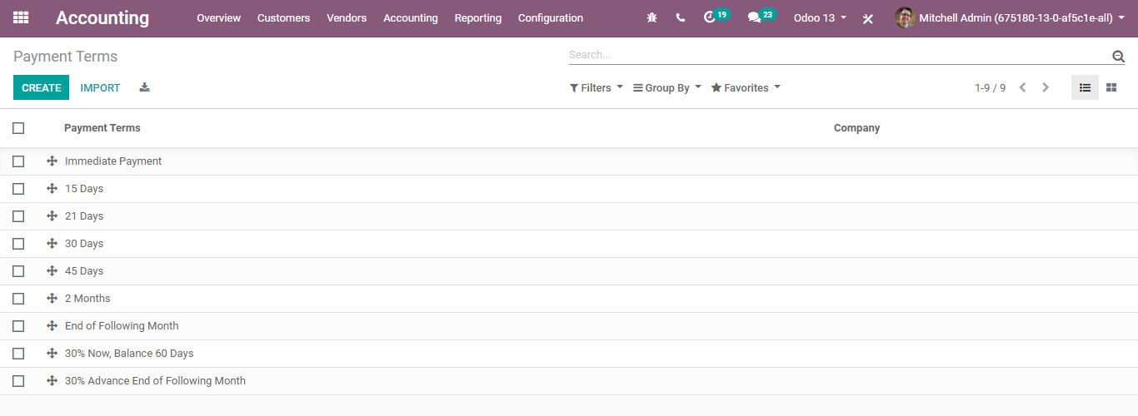

One can use different payment terms like immediate payment, 15 days, 21 days, 30% advance and balance after one month, etc. depending on different situations.

Via clicking on CREATE button, under BUSINESSBOXERP one can create a new payment term depending on the business operation.

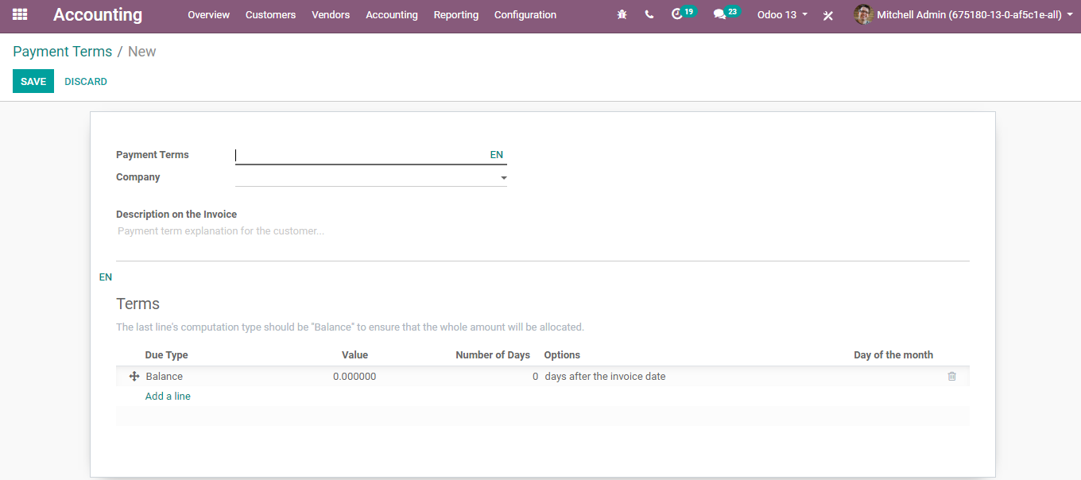

Here one can create a new payment term, say “20 % advance within 3 days and balance in 10 days”.

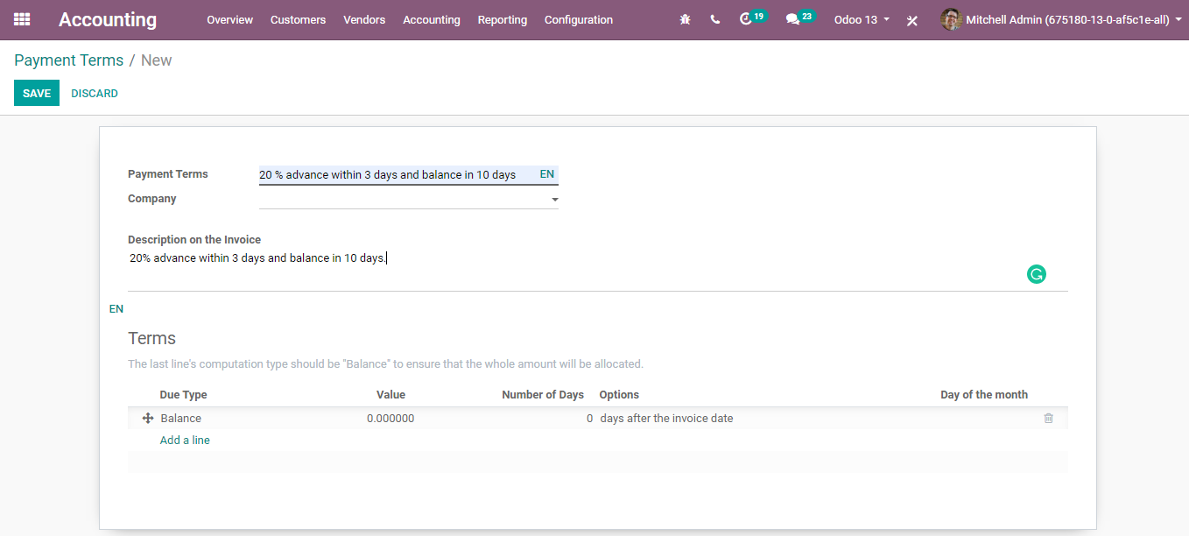

Later give a payment term description detailing the payment term in the provided space. The end-user can see that this description will be displayed in the invoice or the sale order.

Later add the terms, click on 'Add Item,’ and add the details of the term. Please note that the last line of terms always should be the 'Balance', otherwise a warning message will be displayed while attempting to save the payment term and we cannot save it.

When we add a new line, we will get redirected to the following wizard.

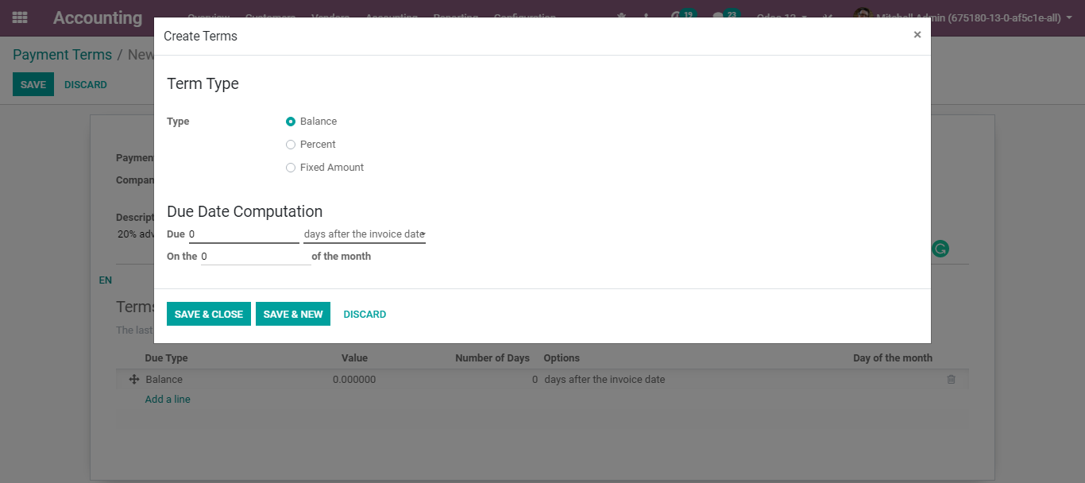

From the wizard, one can choose the Term Type and the Due Date computation method.

**Under BUSINESS IN A BOX, there are three kinds of Term Type,**

* Balance
* Percent
* Fixed Amount

One can select the term type according to the business need.

Just below the Term Type, there is the option for selecting the Due Date computation method for that Type. The options are explained below.

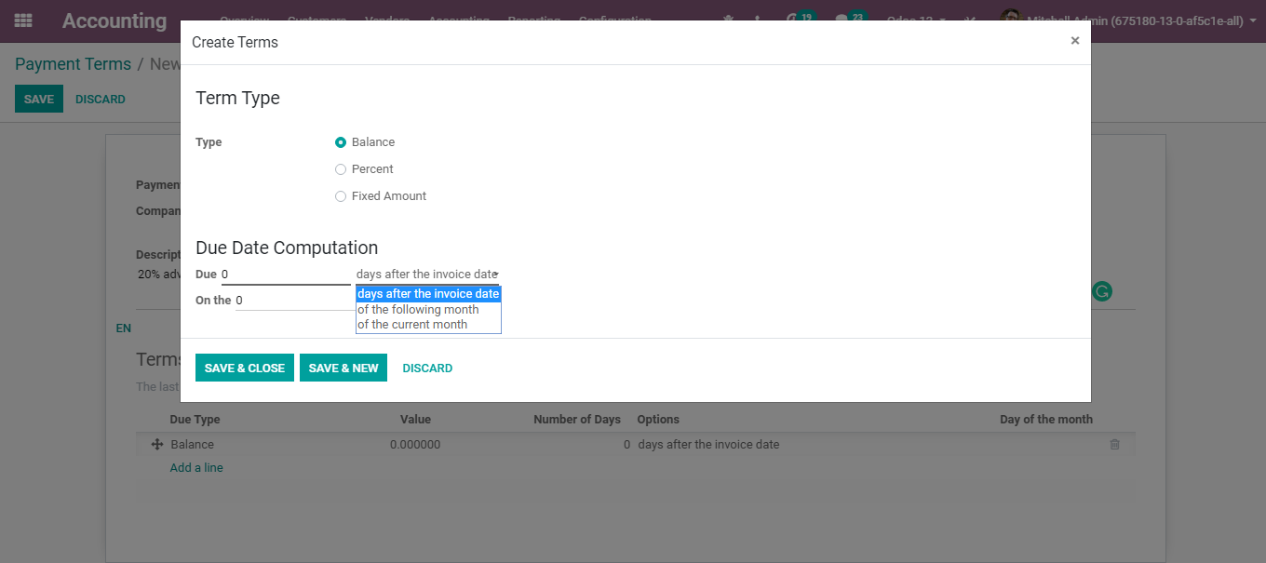

**Day(s) after the invoice date:** The amount should be paid within the specified days after the invoice date.

**Last day of the following month**: The amount should be paid within the last day of the following month

**Last day of the current month:** The amount should be paid within the last day of the current month

Upon setting the terms, click the SAVE button for saving the payment terms. After this, one can seamlessly set the payment term in Partner master or Sale Order or Invoice.

One can set the payment terms in:

* Sale Order or Quotation
* Invoice
* Partner Master. Upon selecting a partner, the payment terms will be automatically added to the invoice or sale order.

**CONFIGURING FOLLOW-UP LEVELS**

It is fundamental for your business to gather instalments or collect the payments when they are past due. BUSINESSBOXERP will enable the end-user to recognize payments that are late and will enable the end-user to send appropriate reminders.

**Configuration**

Got to **Accounting>Configuration> Invoicing >Follow-up** levels

By default, a follow-up plan is made accessible in BUSINESS IN A BOX, however, one can tweak it anyway you need. Depending upon the number of past-due days, plan to send an email, a letter or to attempt a manual activity, one can customize their follow-up level in BUSINESS IN A BOX. You can likewise alter the format utilized for the announcement as indicated by the phase of the procedure.

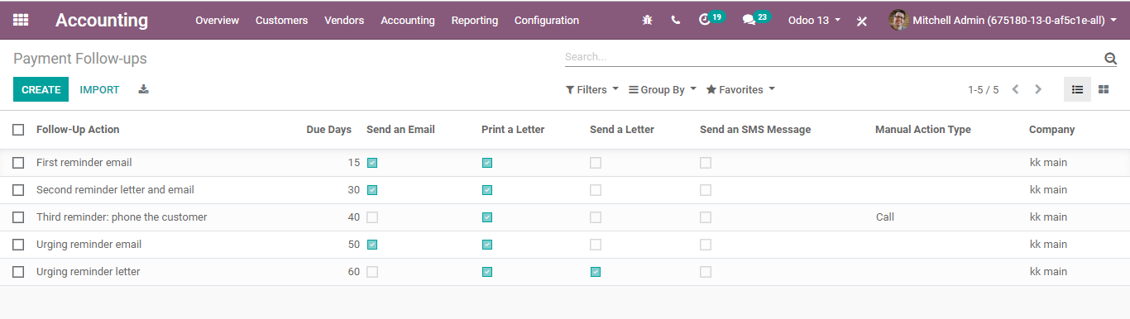

Upon clicking CREATE button, you will be navigated to a new window like below:

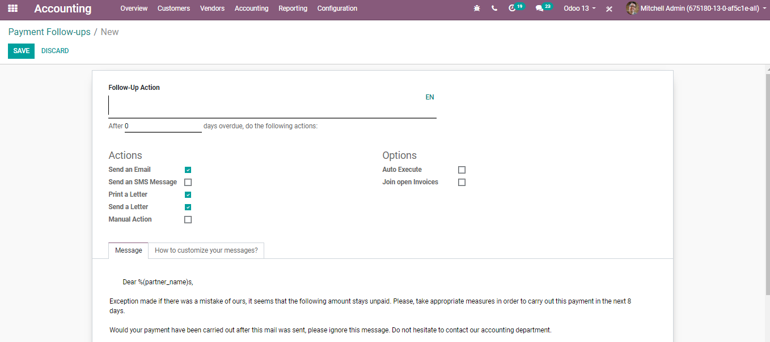

**CONFIGURING FISCAL YEARS**

A fiscal year (FY) is a period that an organization or government utilizes for bookkeeping purposes and preparing budget summaries. The fiscal year changes among nations and is utilized for financial reporting by businesses and different associations. A fiscal year may not be the same as a scheduled calendar year, however, for tax purposes, the Internal Revenue Service (IRS) enables organizations to be either calendar-year taxpayers or fiscal-year taxpayers.

One can configure fiscal year via clicking the button CONFIGURE under the FISCAL YEAR segment.

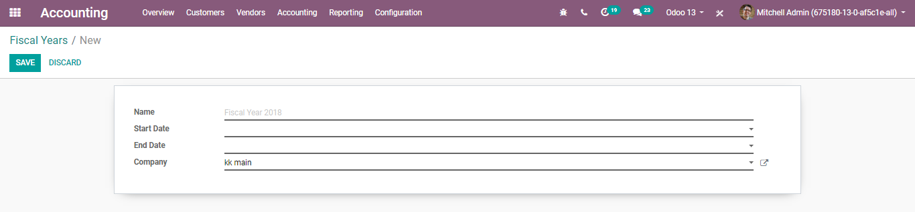

Here, the user can add relevant details like Name, Start Date, End Date and Company and create a new fiscal year about company policy.

By default, the fiscal year starts on the 1st of January and ends on the 31st of December, as those are the most common opening and closing dates. However, one can change the dates depending on your company.

One can also configure the fiscal year, via going to Accounts-> Configuration-> Settings.

Tick the option Fiscal years under Fiscal Periods option.

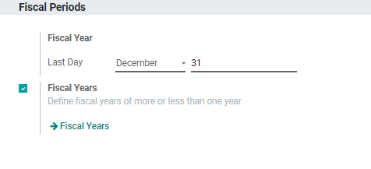

Much of the time, the fiscal year lasts for 12 months. If it is your case, you simply need to define what is the last day of your fiscal year in the bookkeeping settings. By default, it is determined to be 31st December.

However, as we said forth, there may be a few special cases. For instance, if your business organization’s fiscal year, lasts pretty much than a year. In this case, you would need some extra arrangements.

**Configuration**

**Accounting -> Configurations->Accounting-> Fiscal years**

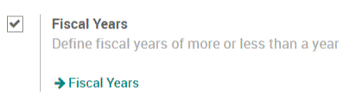

You would be able to configure your fiscal year here via clicking on the link Fiscal Year.

**CONFIGURING BUDGETARY POSITIONS**

Overseeing budgets is seen as a fundamental element for sustaining a business. It enables the individuals to quantify the real financial performance against the arranged one. BUSINESSBOXERP deals its budget utilizing both General and Analytic Accounts.

**Budgetary Positions**

Budgetary positions are the general accounts for which you need to keep spending plans (regularly cost or salary accounts). They should be characterized so that BUSINESSBOXERP can know, which accounts he needs to get the budget data. Some may be already introduced with your chart of accounts.

**Configurations**

To define the budgetary positions, go to **accounting>Configurations>Accounting> Budgetary Positions.**

The end-user can define here in the field, which accounts relates to the project's expenses. One can take a position and add a line to select accounts.

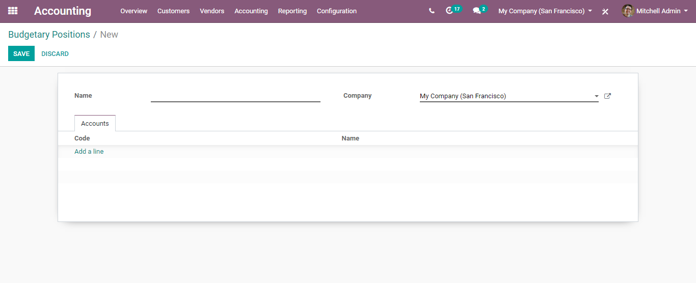

Upon clicking Add a line button, you will be navigated to a new wizard, from where you can choose the specific number of accounts used.

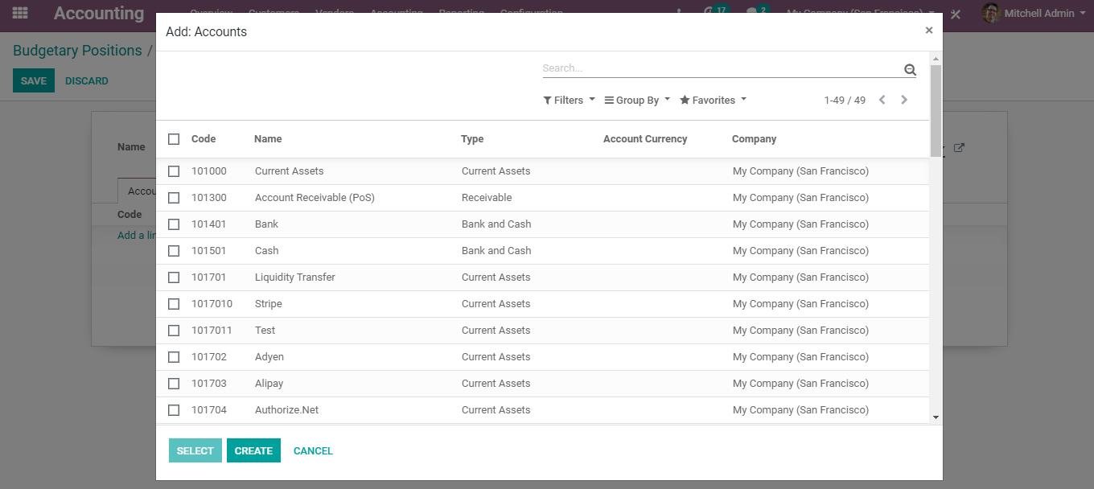

Click on Select and Save the changes to conform Budgetary Positions in BUSINESS IN A BOX.

Repeat the very same steps for creating a revenue budgetary position. However here, one can only select the relevant income accounts.

**Deferred Revenue Management**

Deferred Revenue is an advance payment recorded on the beneficiary's balance sheet as a liability account until either the administrations/services have been rendered or the products have been conveyed. In other words, deferred revenue is an advance payment received by a company. However, it is not yet revenue so cannot be reported on the income statement. Deferred revenue thus acts as a liability account since it alludes to income that has not yet been earned. However, as products and services are conveyed over time, the income is recognized and posted on the income statement.

**Configuration**

To configure the deferred revenues, firstly configure deferred revenue models.

For that go to the Settings menu under the module Accounting,

**Accounting > Configuration > Accounting > Deferred Revenues models**

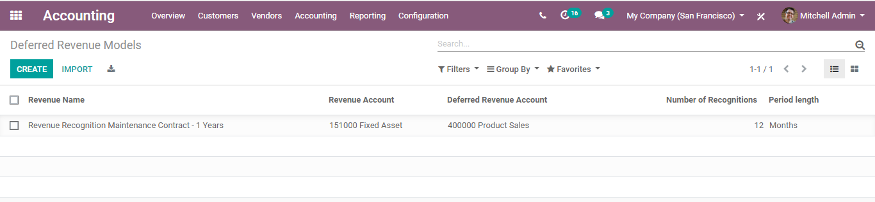

Upon clicking the CREATE button, you can create a new Deferred Revenue Model.

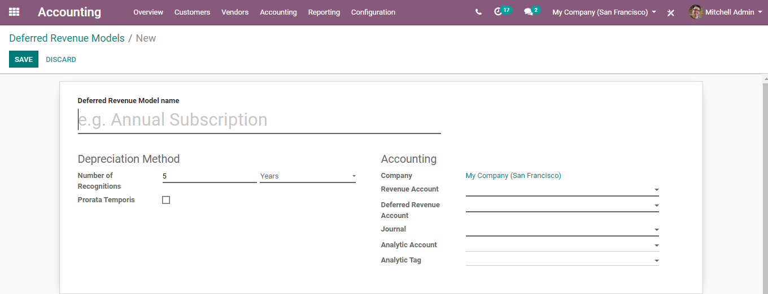

You have the following attributes for the deferred revenue model

Here one can define the Deferred Revenue Model Name. Secondly, the Depreciation method for instance the number of depreciations needs to depreciate your asset.

**Prorate Temporis:** If ticked, indicates that the first depreciation entry for this asset must be done from the asset date (purchase date) instead of the first January/Start date of the fiscal year.

**Revenue Account:** Account used to recognize this revenue.

**Deferred Revenue Account:** Account used to record the deferred income.

Also, one can specify Journal, Analytic Account and Analytic Tag.

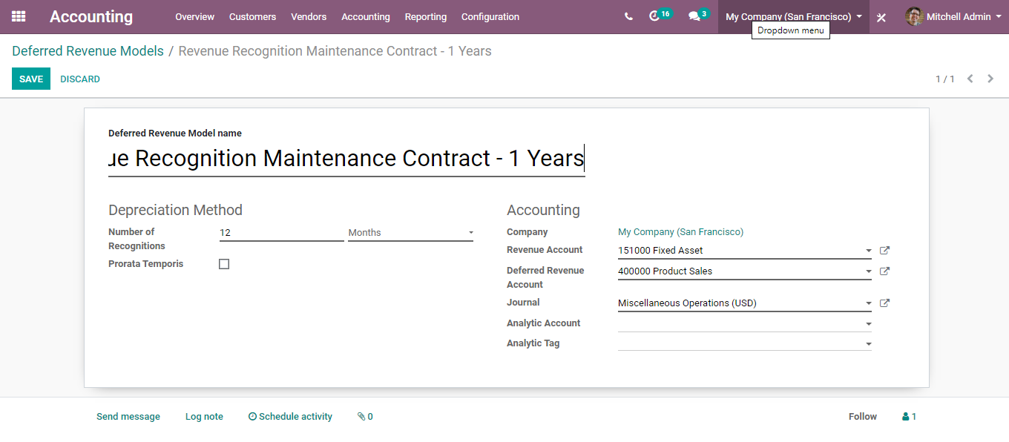

Next, go to **accounting>Accounting>Deferred Revenues**

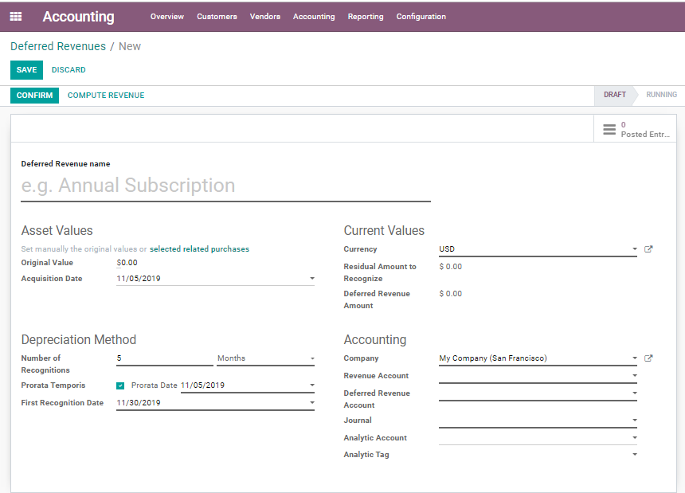

Here one can manually set the original values or select related purchases. Also, set Depreciation

Method and accounts related to the expense.

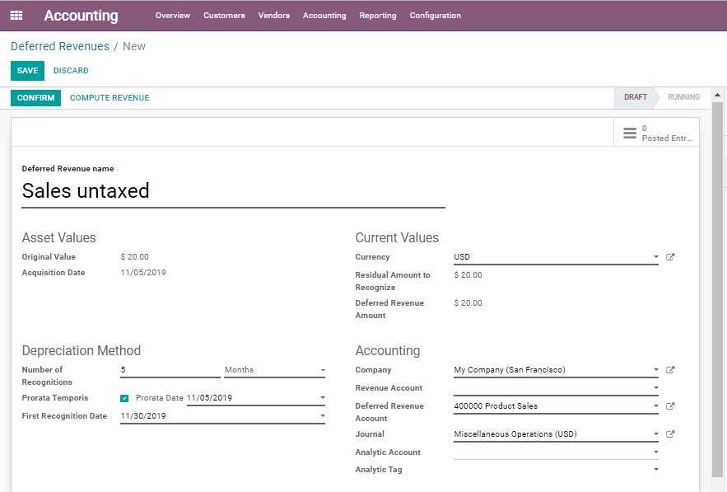

Via specifying every parameter in the form, one can compute the revenue. This can be done via clicking the **COMPUTE REVENUE** button.

One can see the revenue computed under the **Revenue Board.**

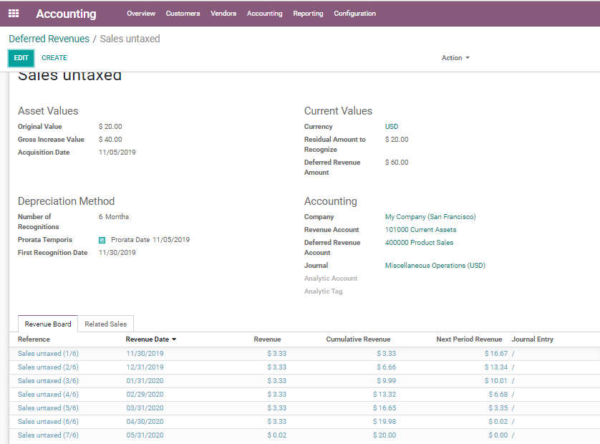

Via clicking the **POSTED ENTRIES** on top, you get navigated to a new window like below. Here you can see the journal entries in draft state for the created Deferred Revenue.

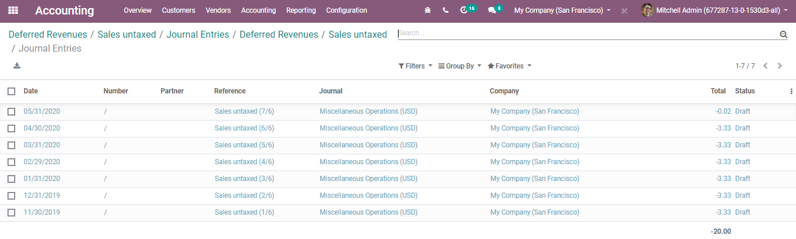

However, after confirming it, you like to modify the revenue, simply click the **MODIFY REVENUE**button.

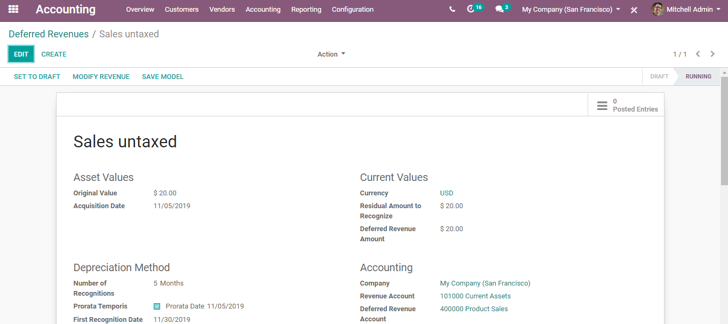

One can give away the reason behind the modification and new values for the depreciation.

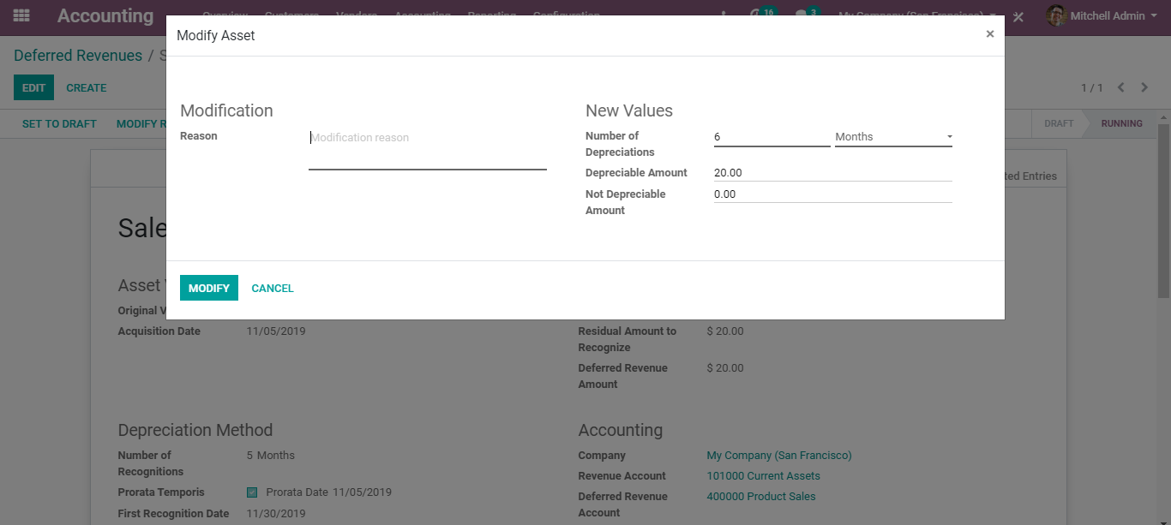

**Asset Management**

Asset management is the systematic process of initiating the operation, maintenance, upgrading, and disposing of asset costs effectively. BUSINESSBOXERP supports Asset Management. It helps to keep track of the fixed assets such as Land, Machinery and so forth. One can compute its depreciation entries automatically.

To configure assets in BUSINESS IN A BOX,

Go to **Accounting> Configuration>Accounting >Asset Models**

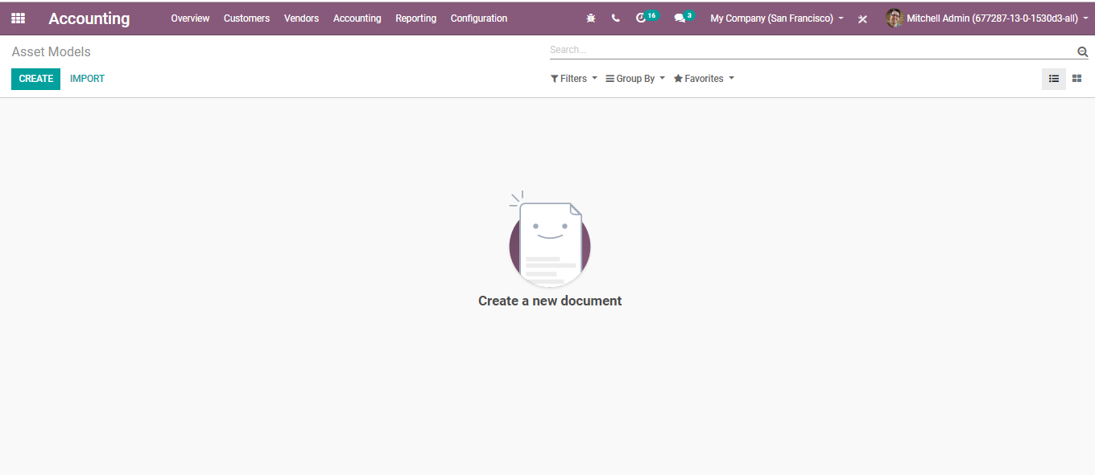

Click **CREATE** button to create a new Asset Model.

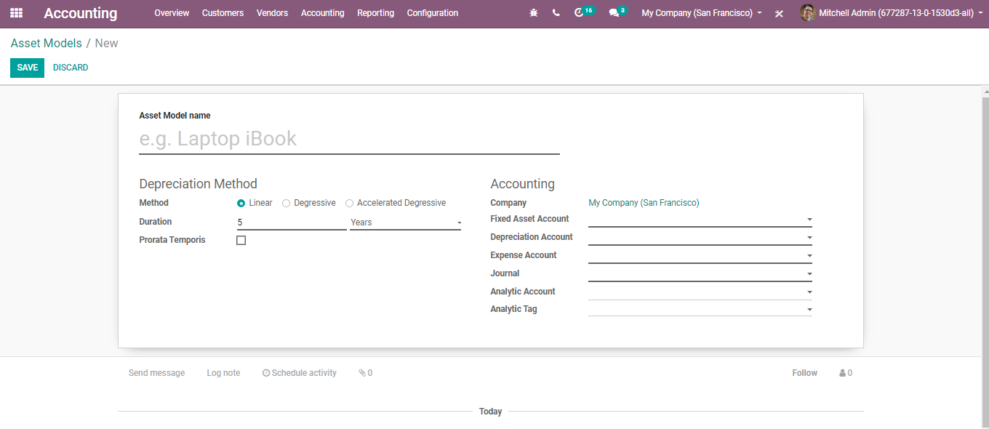

Under the creation form, you can specify the name of asset model, company name, journal, Asset account (account used to record the purchase of this asset at its original price), Depreciation Account (account used in the depreciation entries to decrease the asset value), Expense Account (account used in the periodical entries, to record the part of the asset as an expense), Analytic account and Analytic tag.

Under depreciation method computation methods, you have three options.

* **Linear:** Calculated based on Gross Value/Number of Depreciations.
* **Degressive:** Calculated based on Residue Value*Degressive Factor.
* **Accelerated Degressive:** Like Degressive but with a minimum depreciation value equal to linear value.

**Duration:** Under Depreciation Duration, you can provide several depreciations needed to depreciate your assets per year/month.

**Prorate Temporis:** If ticked, indicates that the first depreciation entry for this asset must be done from the asset date (purchase date) instead of the first January/Start date of the fiscal year.

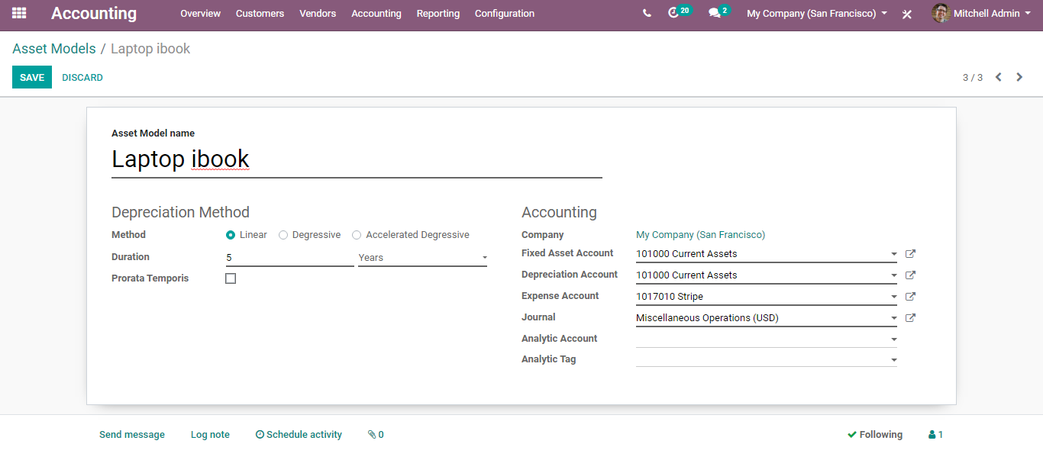

After entering all the details, click SAVE to mark the changes.

Now via going to **Accounting>Accounting>Assets**, you can create new assets.

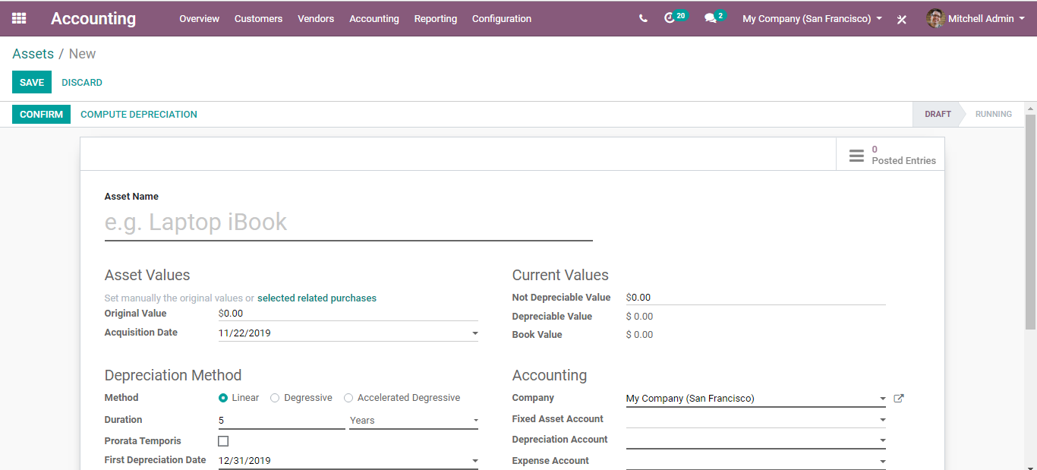

Now if you select the fixed asset account from the drop-down menu, you can see the category of the asset (asset model on top).

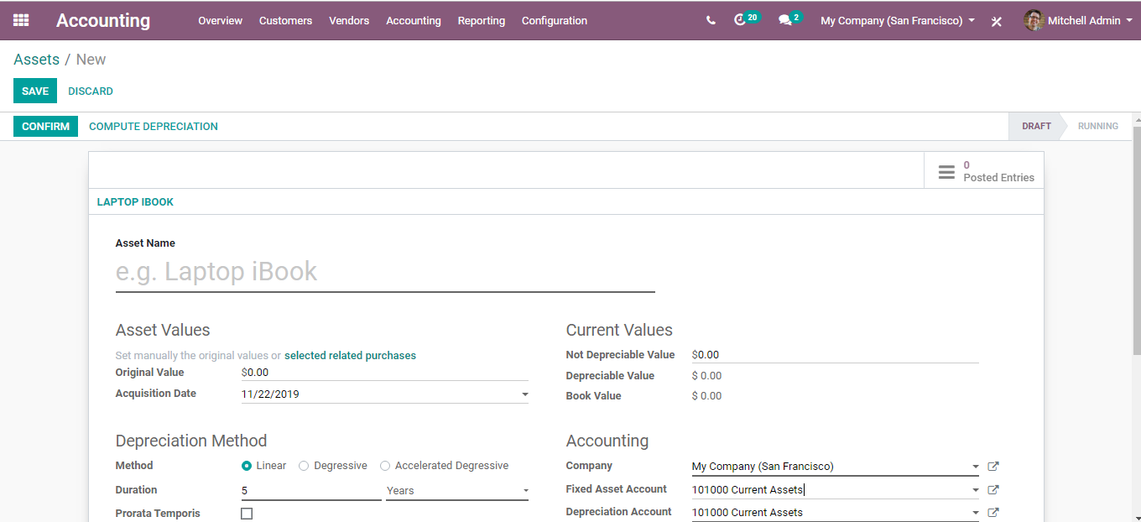

After adding all the parameters in the asset creation form, click **COMPUTE DEPRECIATION** button.

One can see the depreciation computed under the depreciation board.

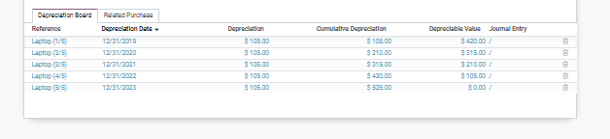

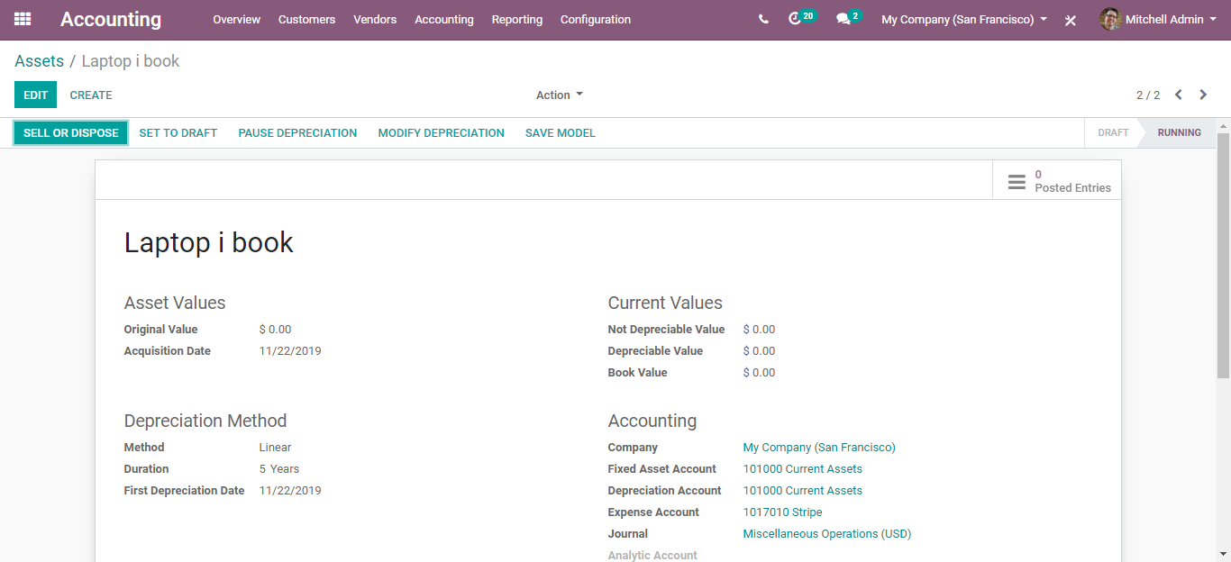

Via clicking the **POSTED ENTRIES,** you get navigated to a new window, where you can see the journal entries created for the asset.

Via confirming the asset, one can SELL**/DISPOSE** of the asset.

**Analytical Accounting in BUSINESS IN A BOX**

Tracking expenses and revenues are one of the standout internal procedures a business association can use. In analytical accounting, it depends on financial information to make conclusions about how, when, and why a business spends and gets cash. BUSINESSBOXERP comes supportive of analytic accounting. With BUSINESSBOXERP analytic accounting, one can create analytic accounts, analytic tags without having to create more accounts in charts of accounts.

BUSINESS IN A BOX’s analytic accounting can be utilized for many purposes like analysing the cost of the company, re-invoicing the time to a customer, or even analysing the performance of a service or a project. BUSINESS IN A BOX’s analytic accounting allows the end-user to generate reports that give the insights end-user need and look at the transactions from a different perspective. One can analyse how profitable that a custom creation is, and how much we spend across different departments.

**Configuration**

Go to **Accounting->Configuration->Settings->Analytics**. Activate both Analytic Accounting and Analytic Tags.

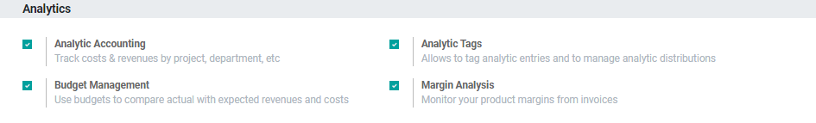

Firstly, create a new analytic account. For that go to **Configurations->Analytic Accounts** under the Analytic Accounting section.

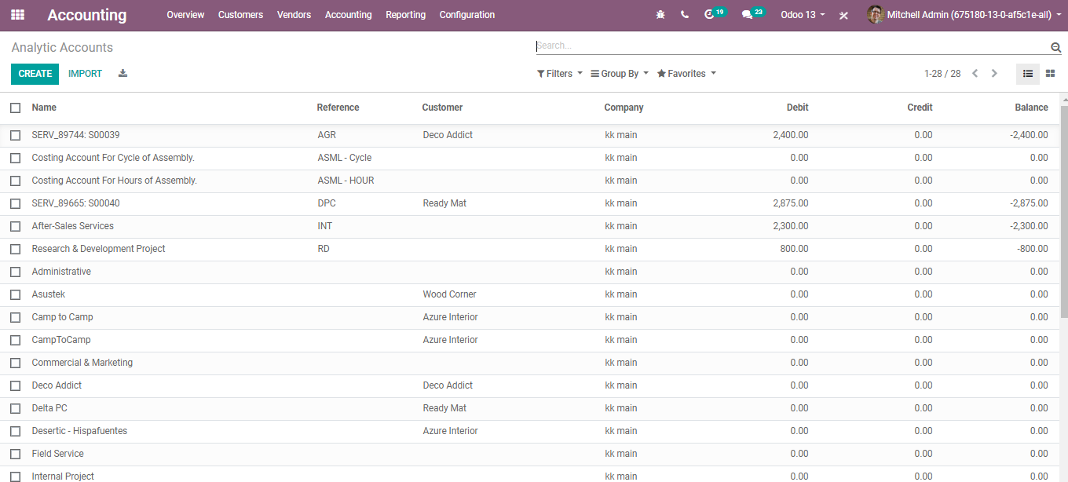

Click on CREATE button to create a new analytic account.

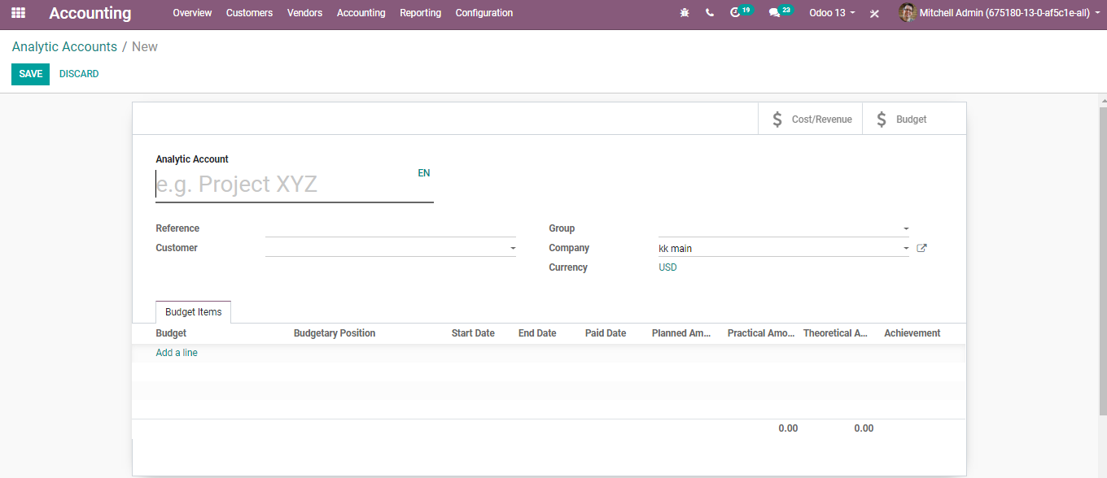

**Here we have the following attributes:**

* Name the account: Filed to provide analytic account name.
* Reference: is for easy filtering.
* Customer: we can set a customer; by this, we can group the accounts.
* Company: setting the company here.
* Group: this will be a group where one can add multiple analytic accounts and get the results for all these accounts.

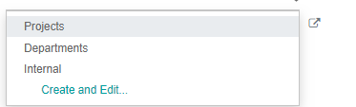

Upon clicking the option **CREATE AND EDIT**, one can create a new group in the analytic account.

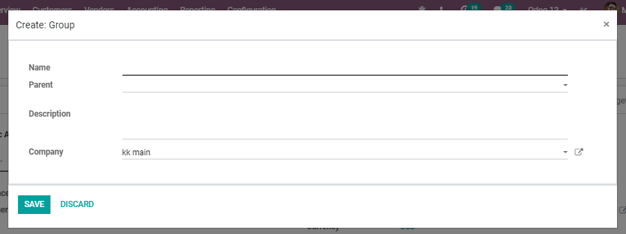

Here one can name the company, add the parent group and discussion and the select company.

CLICK on the SAVE button to mark changes.

**ANALYTIC TAGS**

Analytic Distribution is utilized for margining the business costs/income among different analytic accounts created in BUSINESS IN A BOX. One can easily configure this division need in BUSINESSBOXERP using Analytic Tags

Configuration

Go to **Accounting->Configuration->Settings->Analytics**. Activate both Analytic Accounting and Analytic Tags.

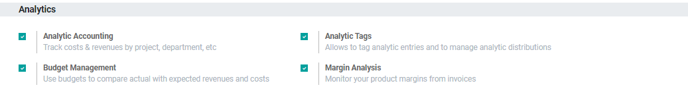

Now if you go to accounting>Configuration> Analytic Accounting>Analytic Tags, you will be navigated to a new window like below:

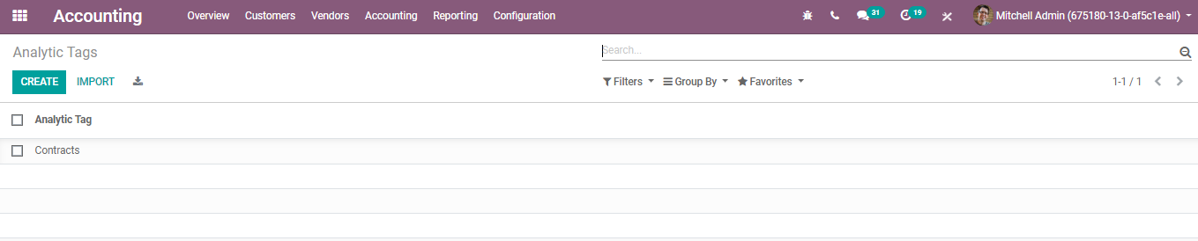

Upon clicking the CREATE button,

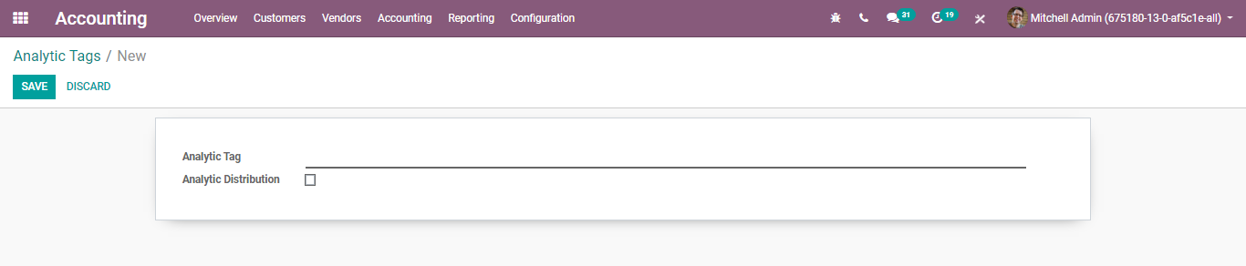

Next, go to the invoice. For that **Accounting>Customers>Invoice**

Create a new one by clicking on create button. One can add the analytic account and analytic tag for the product under the invoice.

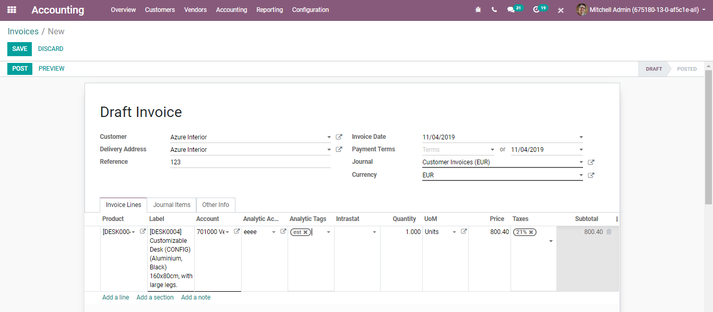

Further, **VALIDATE**.

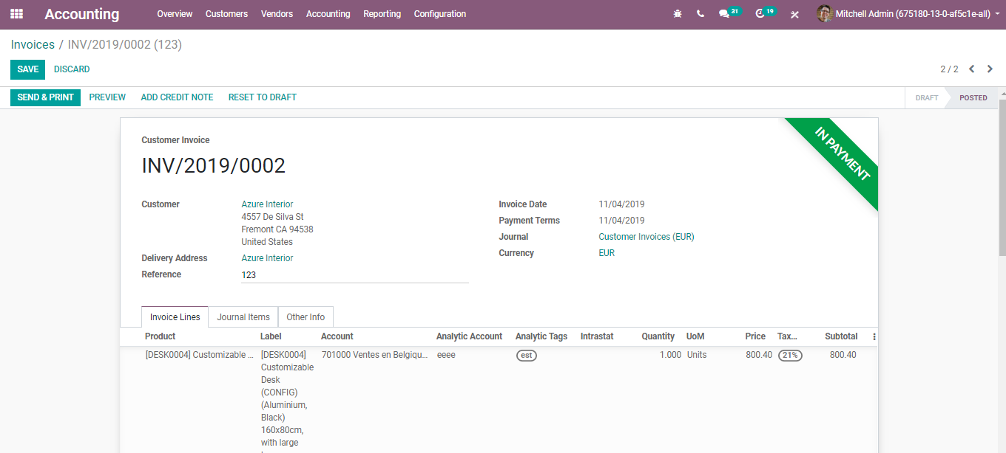

Once you validate this, one can go to the **Accounting> Accounting**> Analytic Items.

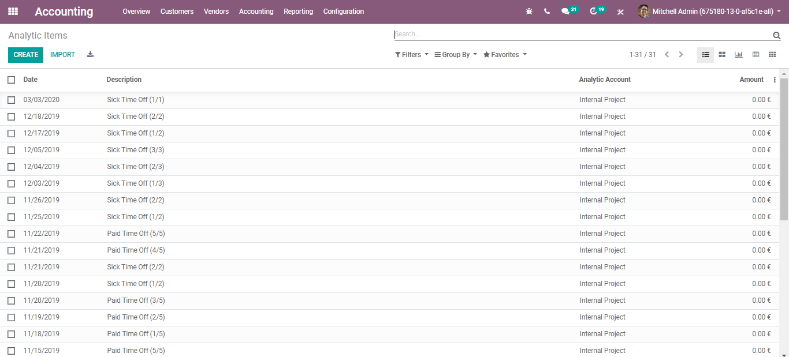

The analytic items are like journal items, but for analytic accounting. So, let us group by Analytic account.

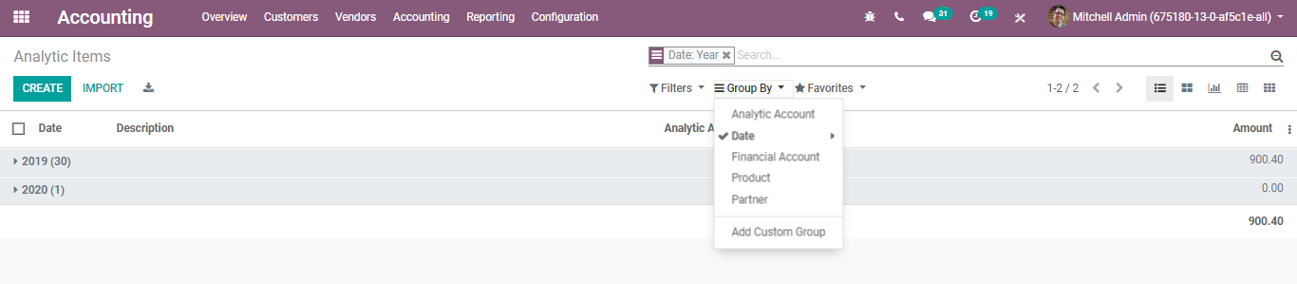

Upon filtering you get, the analytic items are nicely organized, making you see everything this way like the below image:

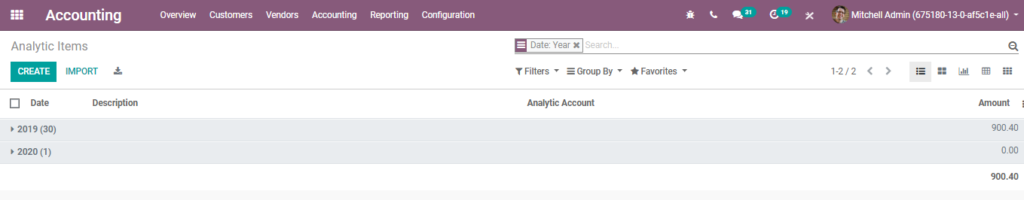

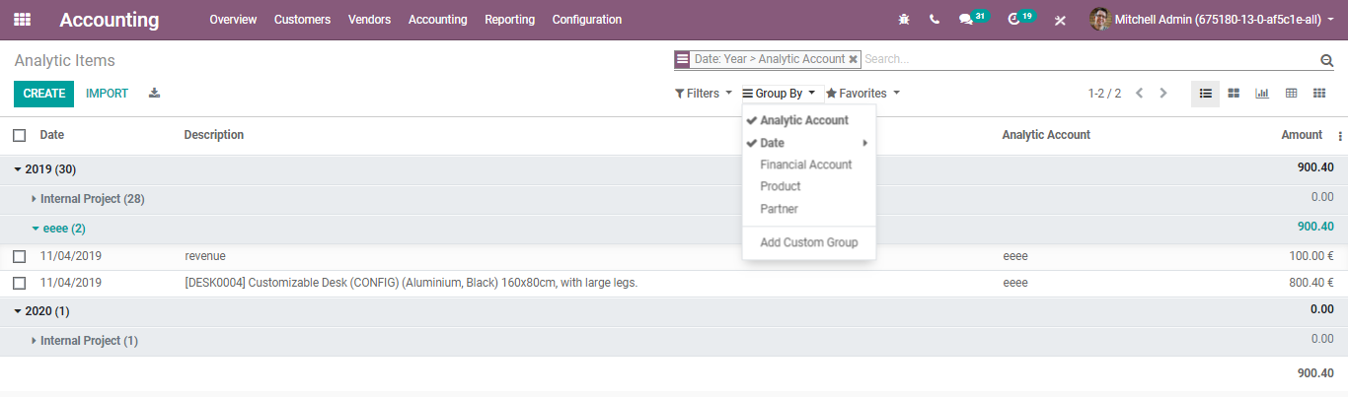

And if we go to our analytic account, we created, we see all entries that are linked to analytic accounts are displayed here. Upon clicking the item, you have all the information, just like below

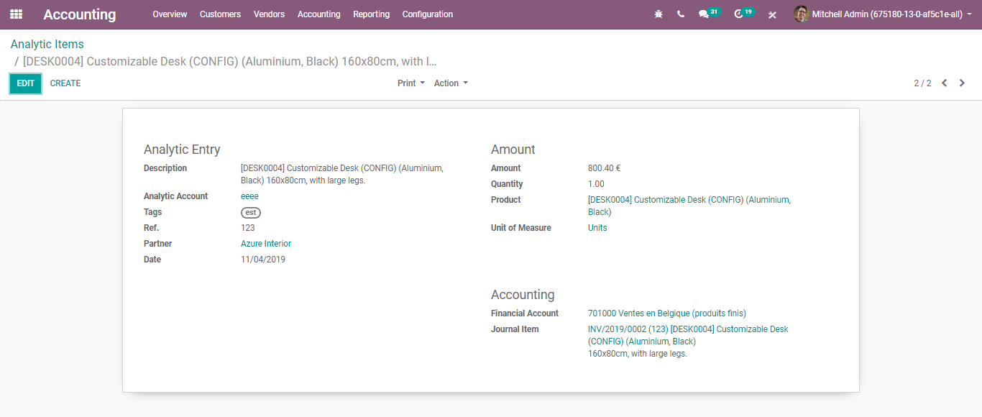

**ANALYTIC REPORTS**

BUSINESSBOXERP provisions to see all the balances for all the analytic accounts for a specific period.

**Configuration**

**Accounting->Reporting->Analytic Reporting**

Here the end-user will be able to see all the analytic accounts on the left side and their balances on the right.

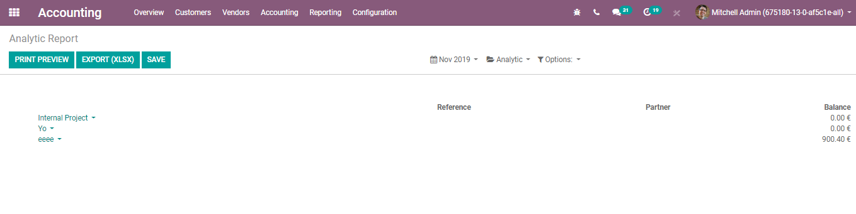

BUSINESSBOXERP also provisions to filter the analytic reports via clicking the date icon

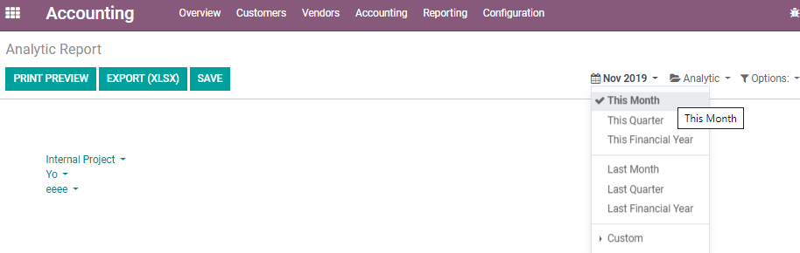

One can filter the reports for a month, for a quarter, for a financial year, last month, last quarter, last financial. One can also customize the period by setting the start date and end date.

To view the balance of the group under analytic accounts, choose the option Hierarchy and Subtotals

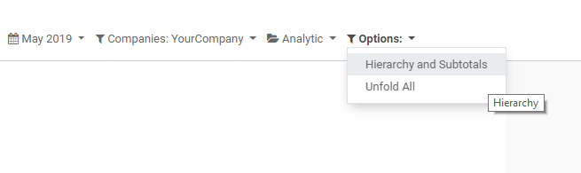

Via clicking tapping it, one will be able to see the balance for all the groups created under analytic accounts.

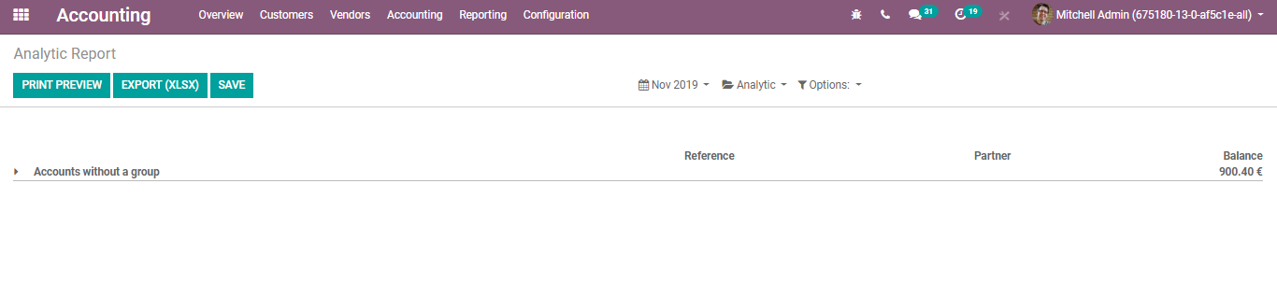

Upon selecting the group, one can view the analytic accounts that are marked and the individual balances for these accounts.

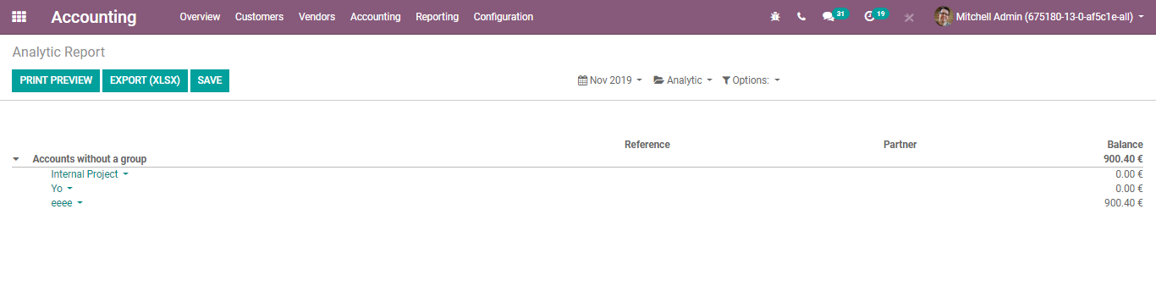

Via clicking on the **PRINT PREVIEW** button, the end-user can avail the pdf copy of the analytic report.

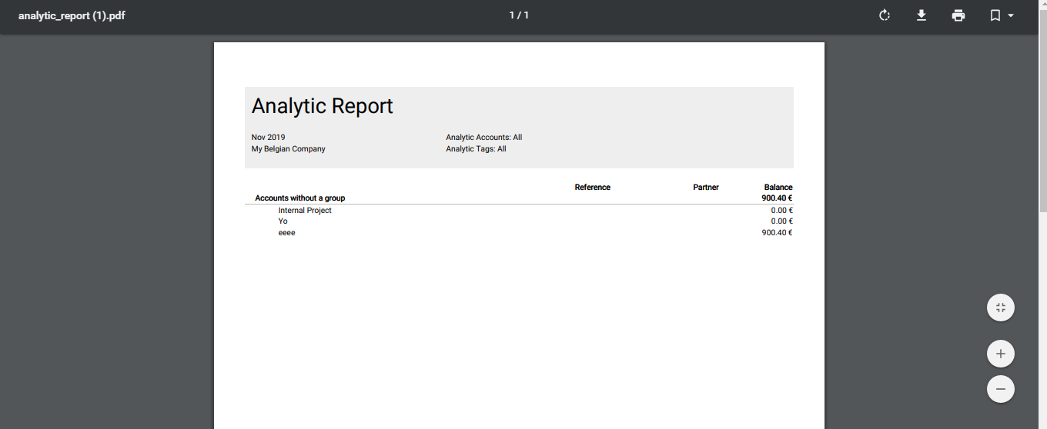

Upon clicking the EXPORT (XLSX), you get to the excel sheet of the report.

**PROFIT AND LOSS REPORT OF ANALYTIC ACCOUNT**

To avail of the profit and loss report of the analytic account, go to **Reporting->Profit and Loss**

Upon clicking the PROFIT AND LOSS, you get navigated to a new window, where you see the basic Profit and Loss Report.

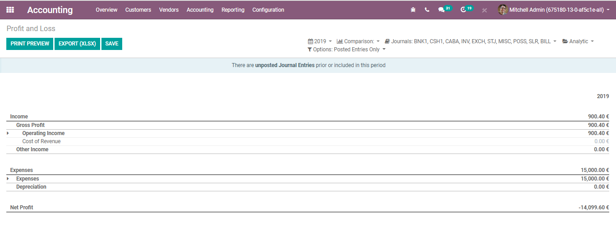

However, one can easily acquire the profit and loss report of the analytic account via giving entries in the analytics icon on top, as cited in the below image.

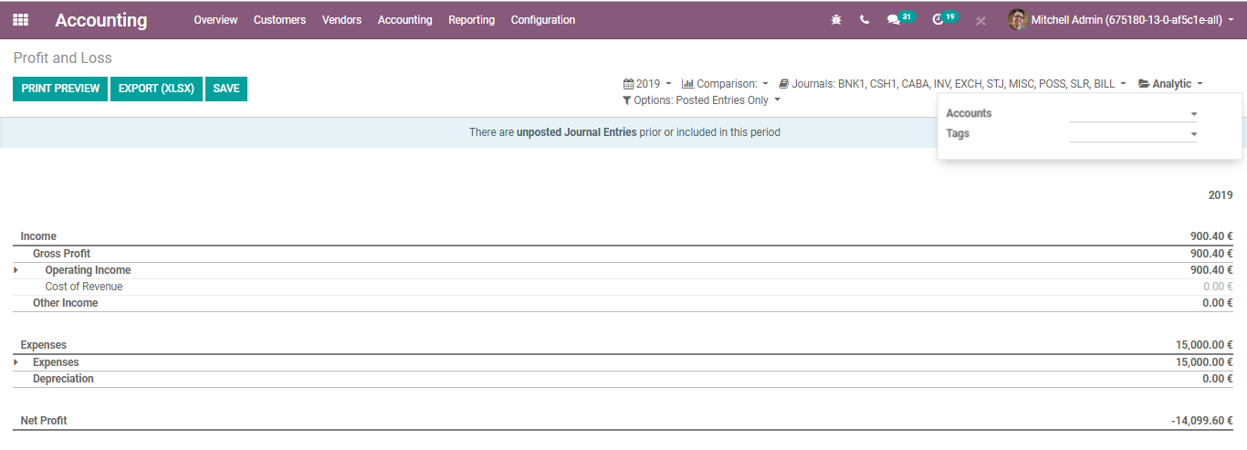

You can select the analytic account you created under the account column and view the profit and loss report for the same without any complexity.

**Budget management**

Budget management plays a vital role in marking business success. Utilizing BUSINESSBOXERP accounting budget management, one can efficiently track and monitor the financial status with its planned details. BUSINESSBOXERP utilizes general and analytic accounting in its budget management.

One need to configure three things to work with BUSINESSBOXERP budget management

* Budgetary Positions
* Analytic Accounts
* Budget

Budgetary positions are moreover a mapping the general accounts with budgets. To create a budgetary position, one can go to

**Accounting>Configuration>Accounting >Budgetary Position**

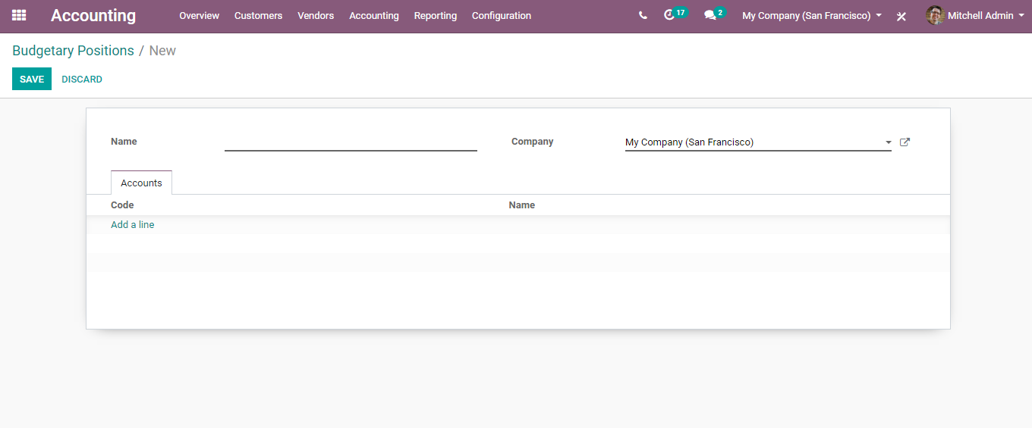

Here, one can define accounts linked to the budget.

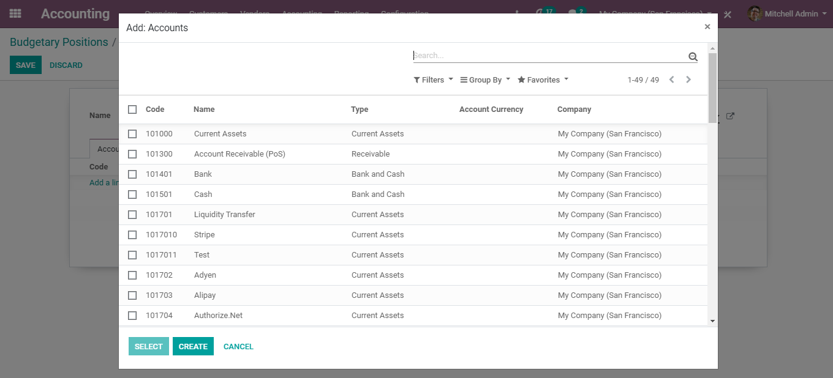

Click on Select.

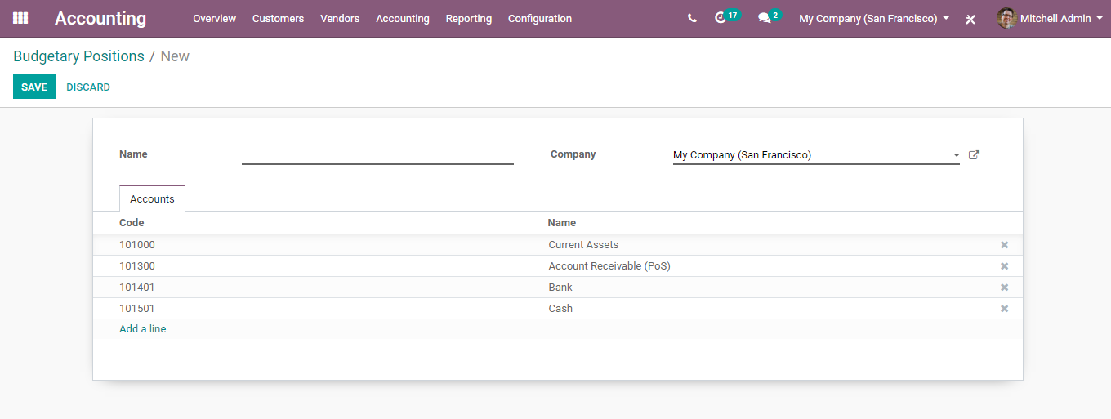

Save the changes to confirm your Budgetary position.

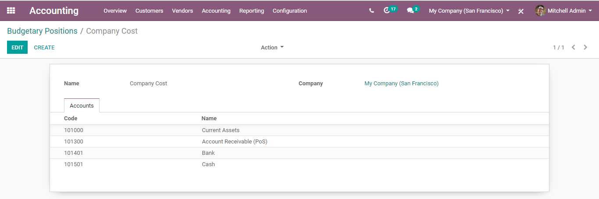

One can follow the very same steps for making a revenue budgetary position. The only thing one needs to remember is, in that case, select the relevant income accounts.

**Analytical Account**

BUSINESSBOXERP must realize which expenses or costs apply to a predefined budget. To do so we must link the invoices and costs to a defined analytical account. One can create the analytical account by entering the accounting module and clicking

**Accounting>Configurations> Analytic Accounting >Analytic Accounts**.

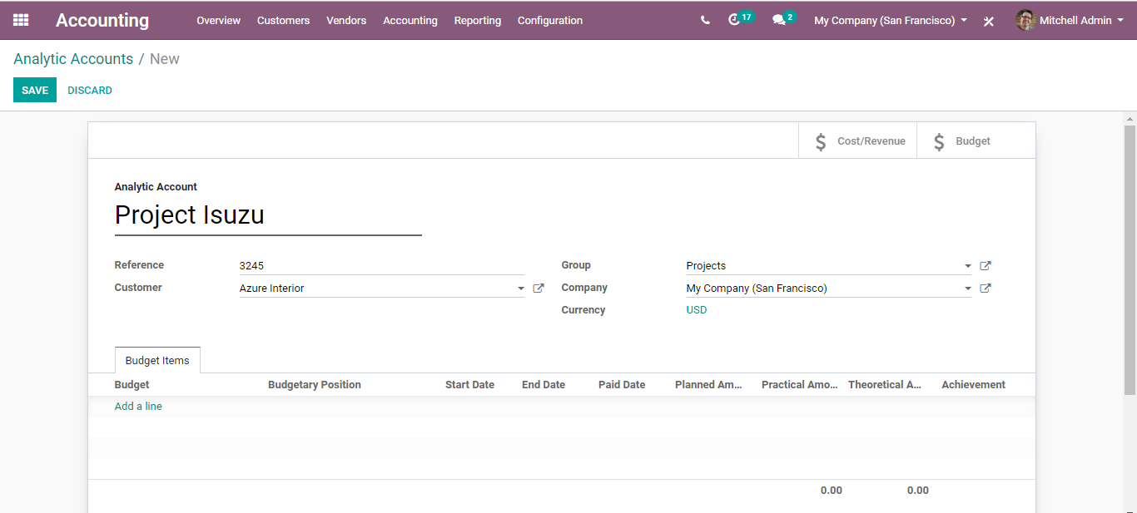

The next step is setting a budget.

To set budget targets, go to the accounting app, select Accounting ->Management->Budgets and create a new Budget.

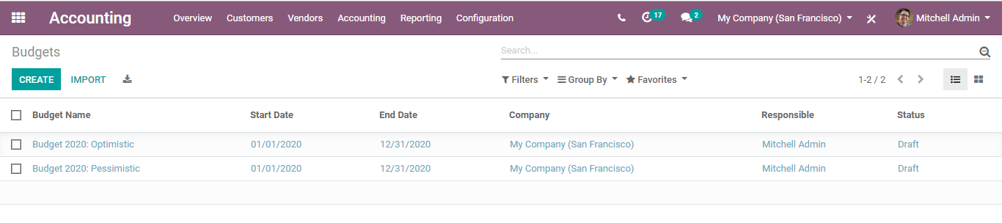

Upon Clicking CREATE button, you can create a new budget.

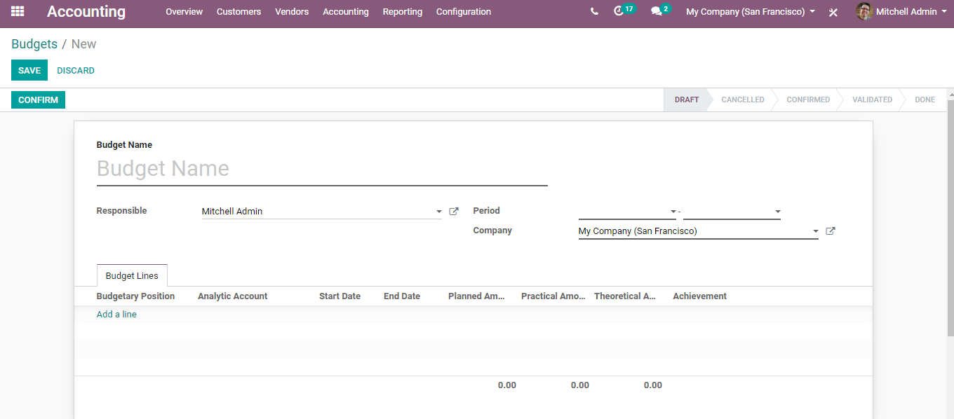

Note:

In the Budget line, the field Analytical account is set as not mandatory by BUSINESS IN A BOX. But for the proper working of Budget 'Analytic account' is mandatory. So, do not forget to put the Analytical account in the Budget lines.

You can create a new analytic account or select an existing analytical account from the budget lines. Later confirm the budget.

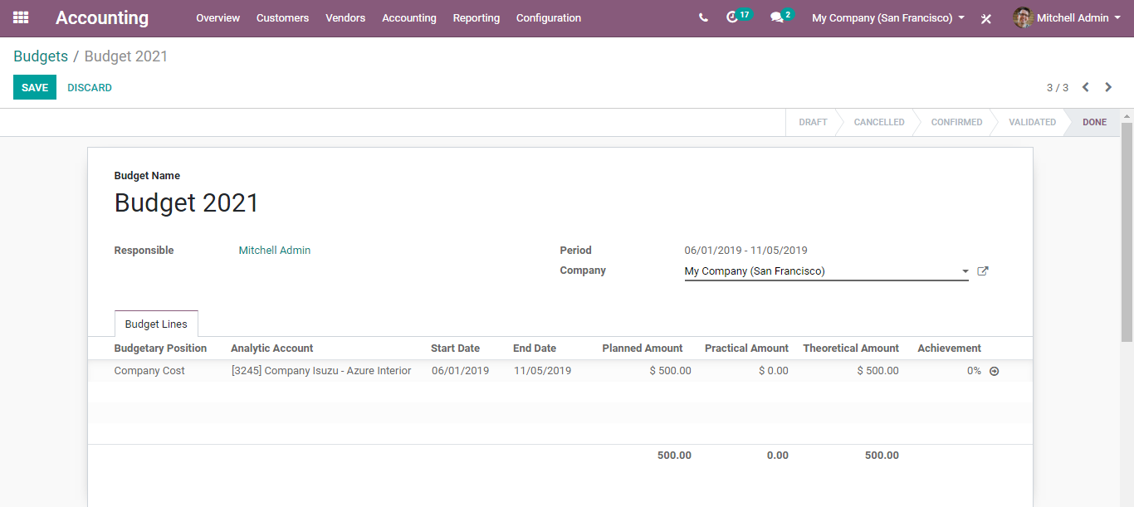

**Customer Invoice to Payments**

Depending upon your business and the application you use, there are various approaches to automate customer invoice creation in BUSINESS IN A BOX. In the usual scenario, draft invoices are made by the framework (with data originating from different reports like sales orders or contracts) and accountants simply must approve/validate the draft invoices and send the solicitations in batch (by customary mail or email).

One can either create a customer invoice directly from the dashboard via clicking on the **NEW INVOICE** button or via going to the **CUSTOMERS** section in the accounting tab and selecting the **INVOICE** option

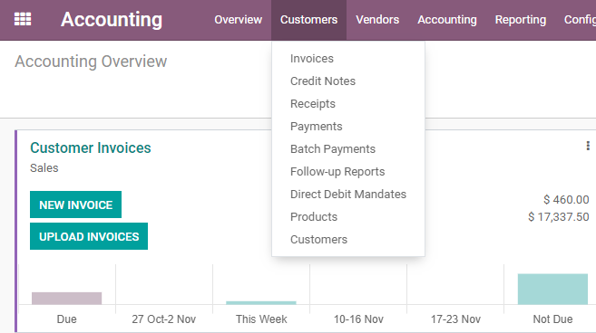

Upon, clicking the **NEW INVOICE** button, you will be navigated to a new window with a creation form like below.

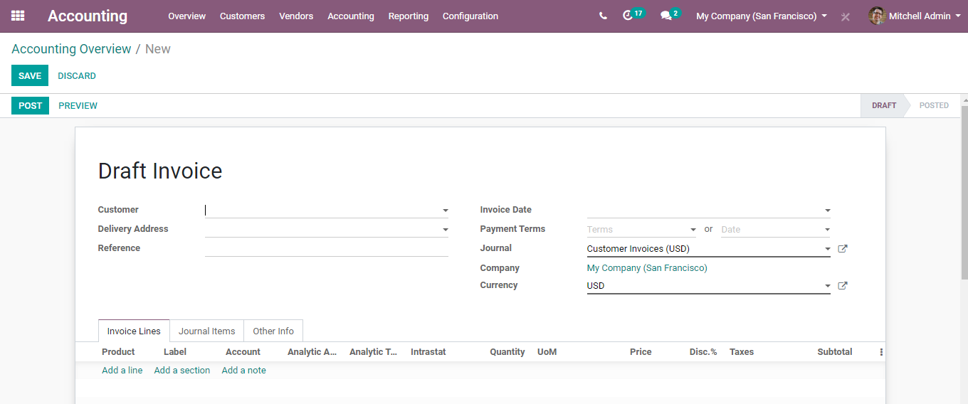

The field includes the following attributes:

**Customer:** You can find a contact by its name, TIN, Email, or Internal Reference.

**Delivery Address**: Delivery Address for Current Invoice.

**Payment Terms:** If you use payment terms, the due date will be automatically computed at the generation of accounting entries. If you keep the payment terms and the due date empty, it means direct payment. The payment terms may compute several due dates, for example, 50% now, fifty% in one month.

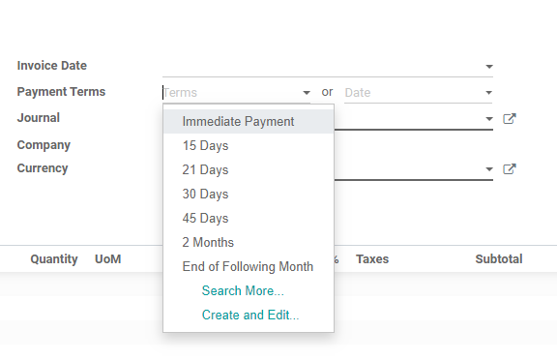

Or else one can also set the Payment terms via defining a date.

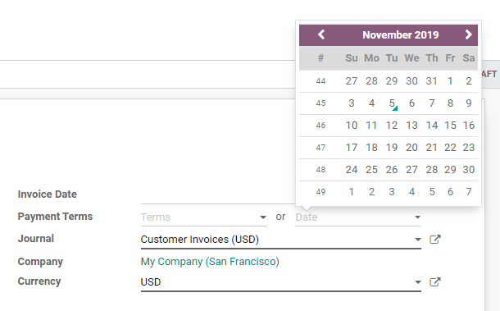

**Invoice date**: Keep it empty to use the current date.

**Salesperson:** Under the field, one can assign the salesperson authorized for the deal.

**Journal:** Defines the Journal authorized for the deal.

**Company:** Company related to this Journal.

**Currency:** Currency used for the transaction.

Under the Invoice Lines Tab, one can add the products the customer desires to buy, description if any under the label section, the account you configured for the deal, and more.

After entering all the details,

You can register send the invoice and later register the payment.

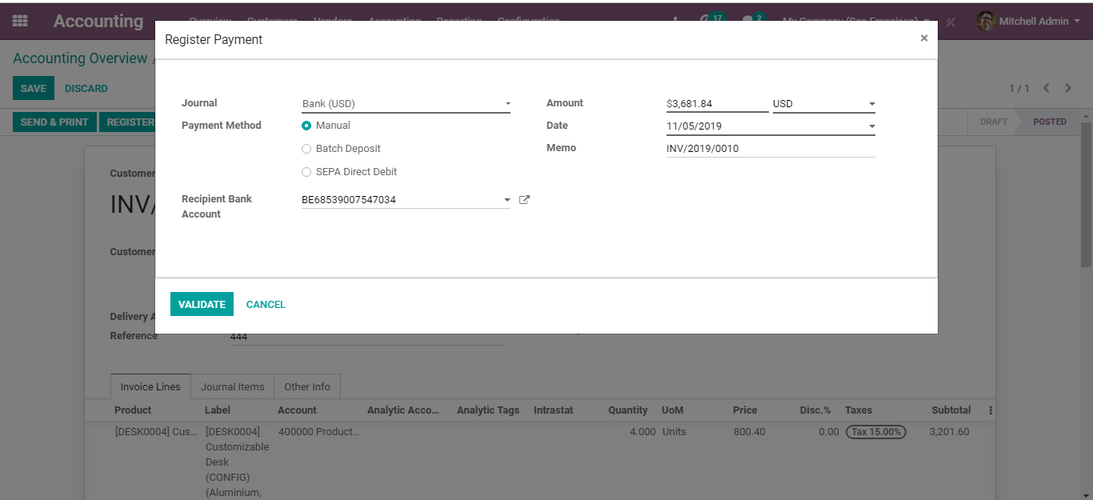

click **VALIDATE**, you can see that the invoice has been paid for.

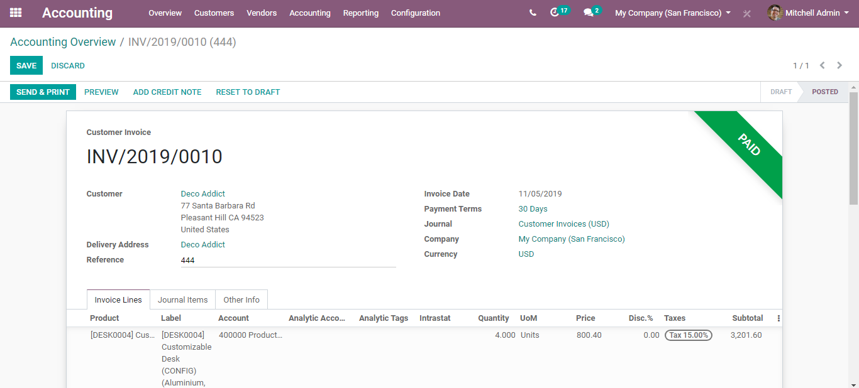

And upon clicking the little green icon, you get acquainted with more information about the payment. One can see that this payment invoice has been reconciled together. And, in case if one needs to un reconcile, all they must do is click UNRECONCILE.

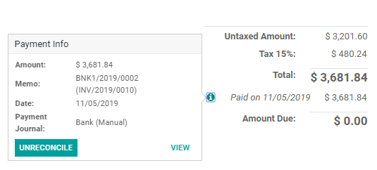

In case, the invoice payment is partial, you get the payment information citing the amount due.

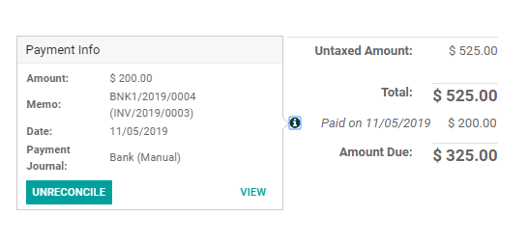

Via clicking the PREVIEW button on the top, you get to see the website view of the invoice.

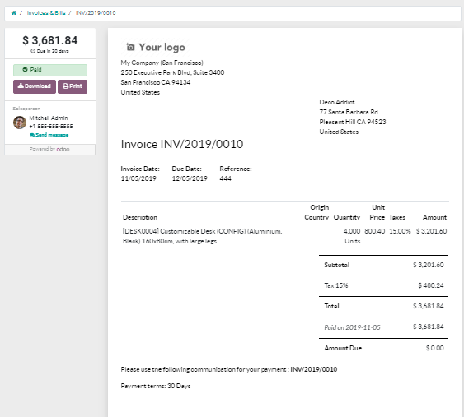

Now if you go to **Accounting> Journals> Sales**, you can see the journal entry that was automatically created for the invoice.

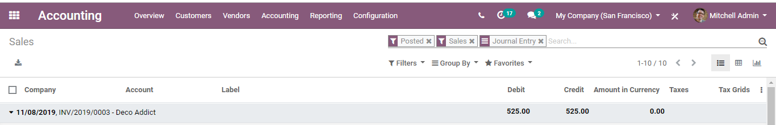

Upon clicking them, you have a journal entry with debit and credit balanced.

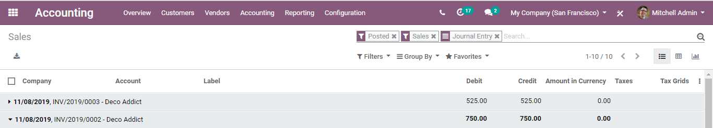

Now if you go to **Customers-> Payments**

You can see the Invoice Payment details such as date, invoice name, journal, payment method, customer, amount, status, and the company.

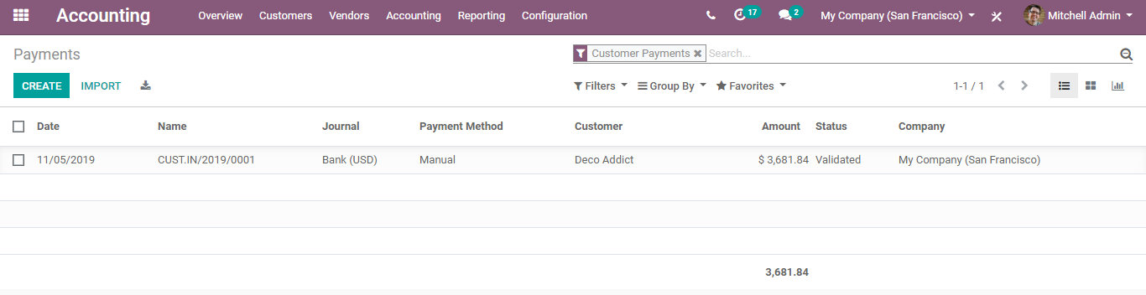

From here, you can access the corresponding journal items and the invoices.

Upon clicking the Journal Items, you can see that the client paid a certain amount, and that amount is debited in the bank account, and it is credited in the account receivable.

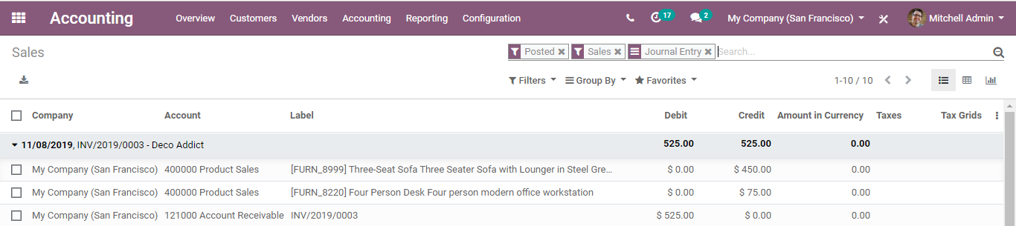

And there is a balance between CREDIT and DEBIT.

**Reporting**

**Aged Receivable Balance**

To get a rundown of invoices, one can go for the **Aged Receivable report**, under-reporting menu.

**Configuration**

**Reporting > Partner Reports > Aged receivable.**

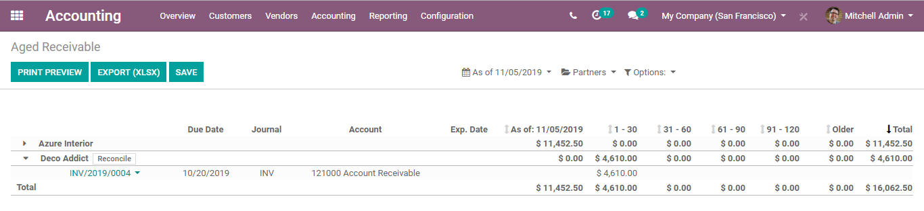

Anytime while you are glancing through the report, you can print straightforwardly to Excel or PDF and get precisely what you see on the screen.

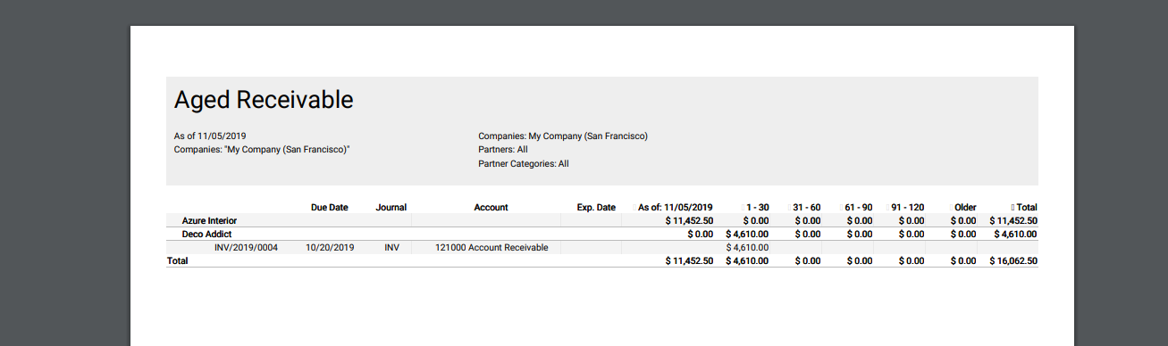

To view all Journal Entries,

Configuration

Got to **Accounting-> Accounting->Journal Entries**

This is where you can create the journal entries manually.

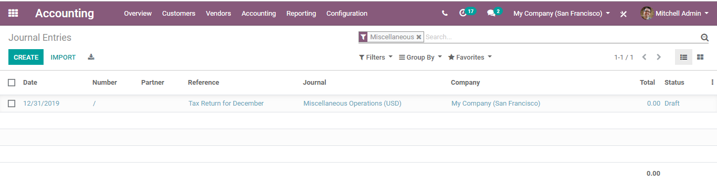

As you see in the above image, by default the filters would be **MISCELLANEOUS OPERATIONS**.

To create a new journal entry, click the button CREATE.

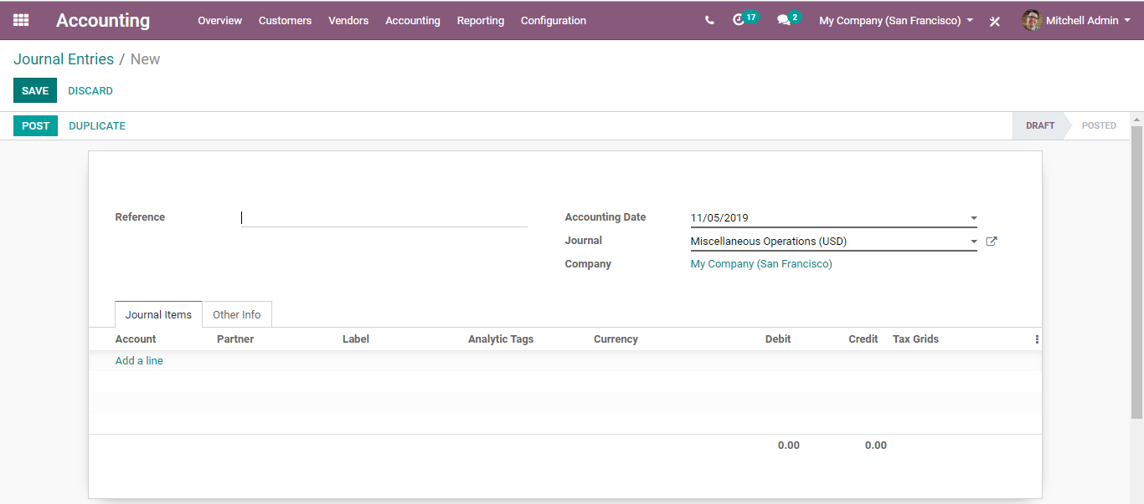

**Vendor bills to payment in BUSINESS IN A BOX**

When the vendor bills are registered or enlisted in BUSINESS IN A BOX, one can without much of a stretch pay vendors the correct amount at the right time (not too late, not very early; contingent upon the vendor policy). BUSINESSBOXERP likewise offers reports to follow your aged payable balances.

If you need to control vendor bills received from your vendors, you can utilize the BUSINESSBOXERP Purchase application that enables you to control and pre-complete them consequently dependent on past buying/purchase orders.

**Configuration**

It can be done in two ways. Either the user can straight click the option New Bill from Accounting Dashboard under Vendor Bill section or via going to **Accounting>Vendors>Bills**.

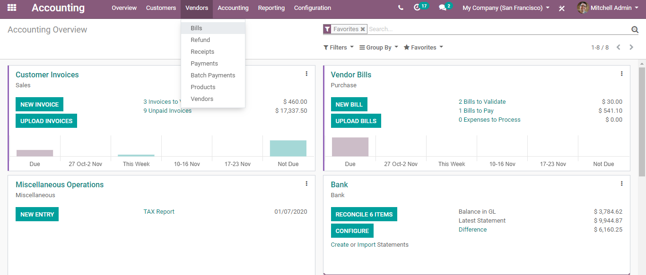

Upon clicking the NEW BILL Button/Bills under the vendor option, you will be navigated to a new window like the below image.

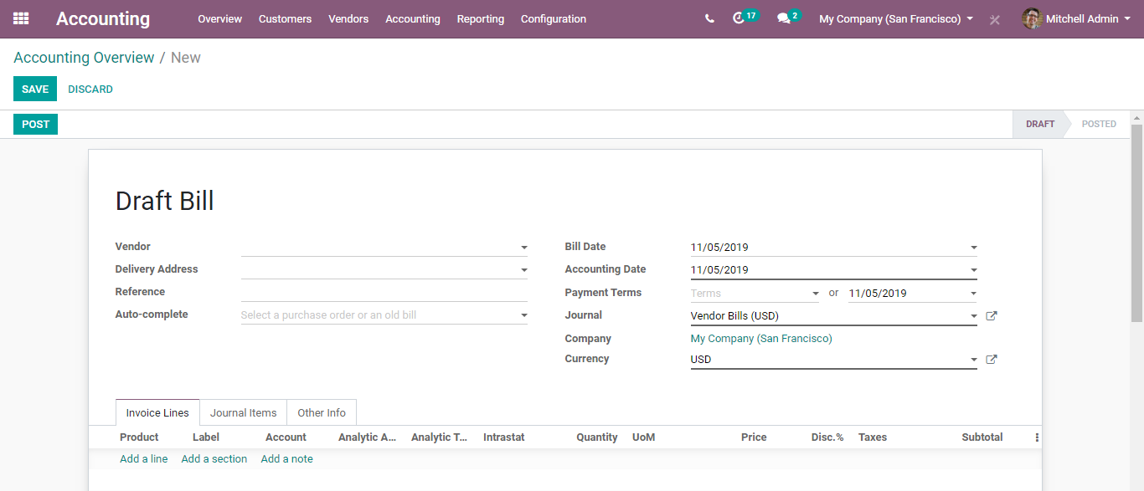

Here, you can register the new vendor bill by choosing the vendor and contributing their invoice as the Vendor Reference. Later add and confirm the product lines, making sure of correct product quantities, taxes/expenses, and prices.

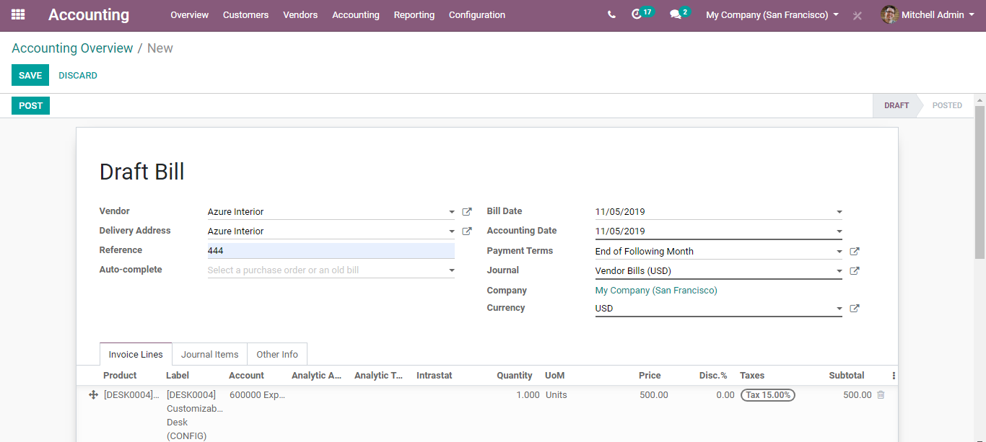

One can however configure the account to which the product is linked via clicking the Account section,

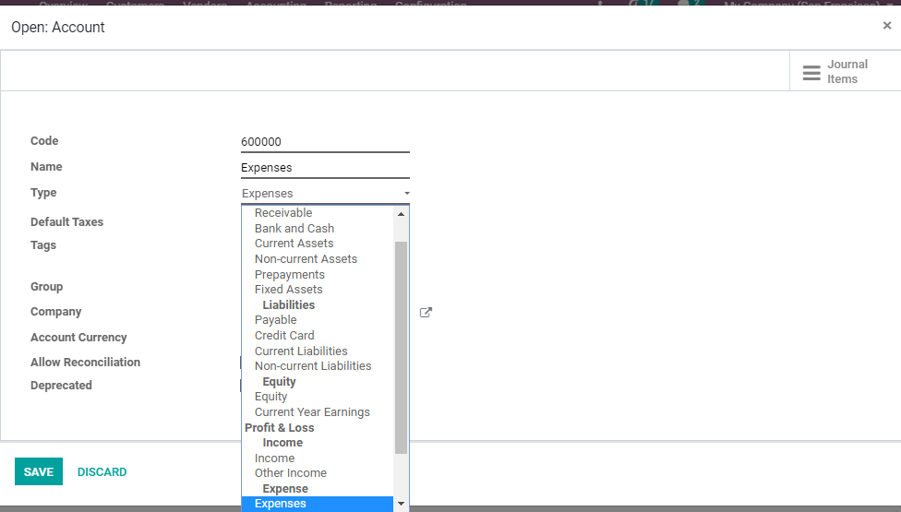

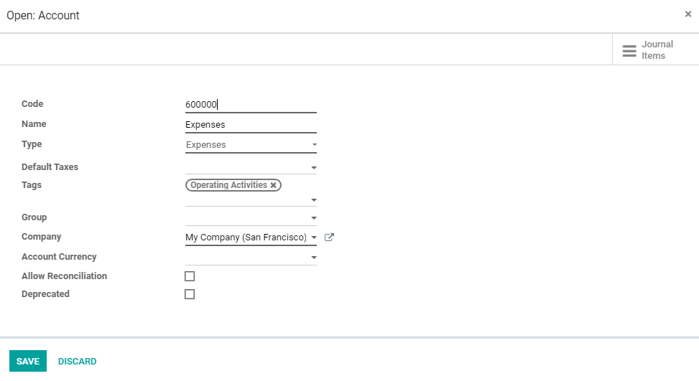

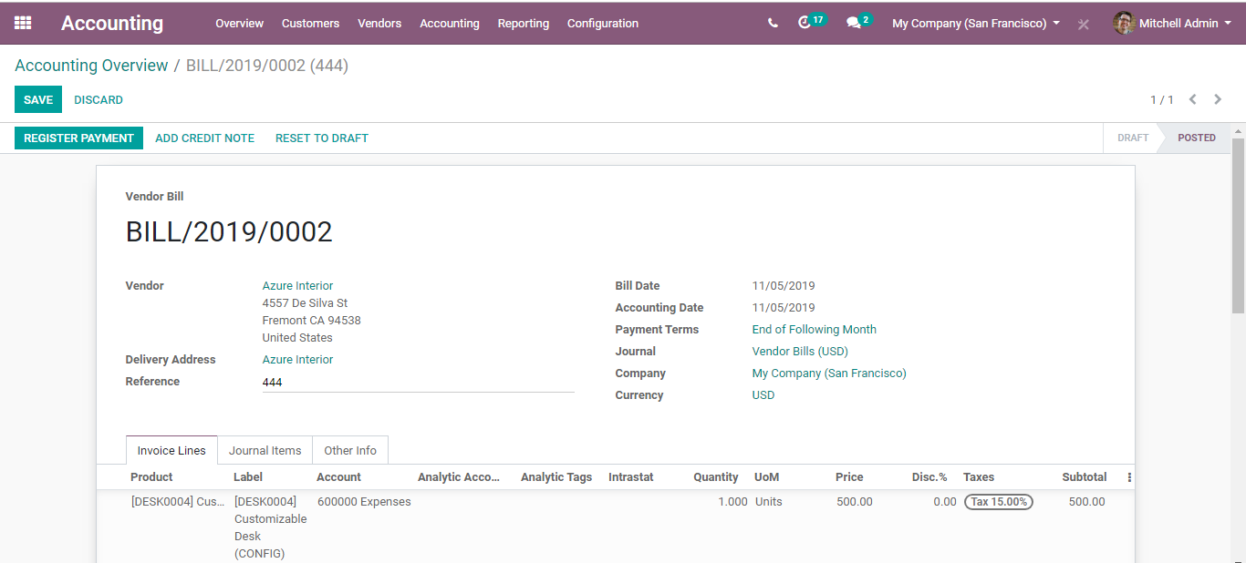

Validate the Vendor Bill via clicking on validate button.

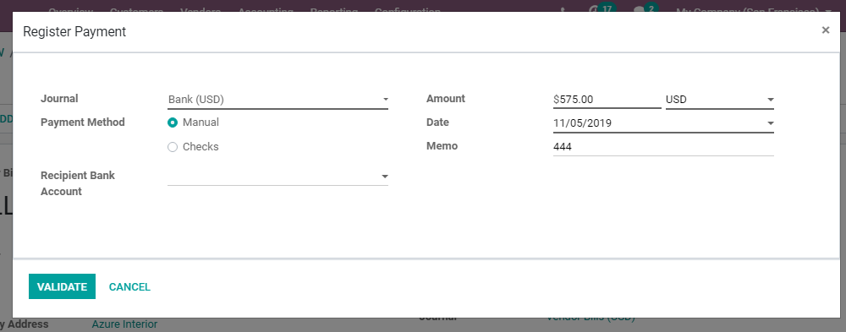

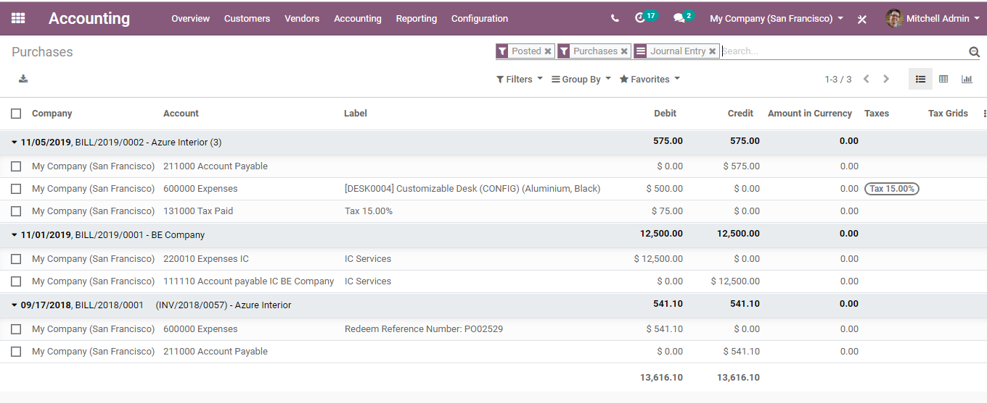

Correspondingly, a journal entry will be crafted dependent on the invoice. You can see them via going to **Accounting> Journals>Purchase**.



This journal entry may vary contingent upon the accounting package you choose to use.

For most European nations, the journal entry will utilize the accompanying records:

**Accounts Payable:** characterized on the vendor form

**Taxes:** characterized on the items and per line

**Expenses:** characterized online items utilized

For Anglo-Saxon (US) bookkeeping, the journal entry will utilize the accompanying records:

**Accounts Payable:** characterized on the vendor form

**Taxes:** characterized on the items and per line

**Merchandise Received:** characterized on the product form.

One can check the Profit & Loss, or the Balance Sheet reports after validating a few vendor bills.

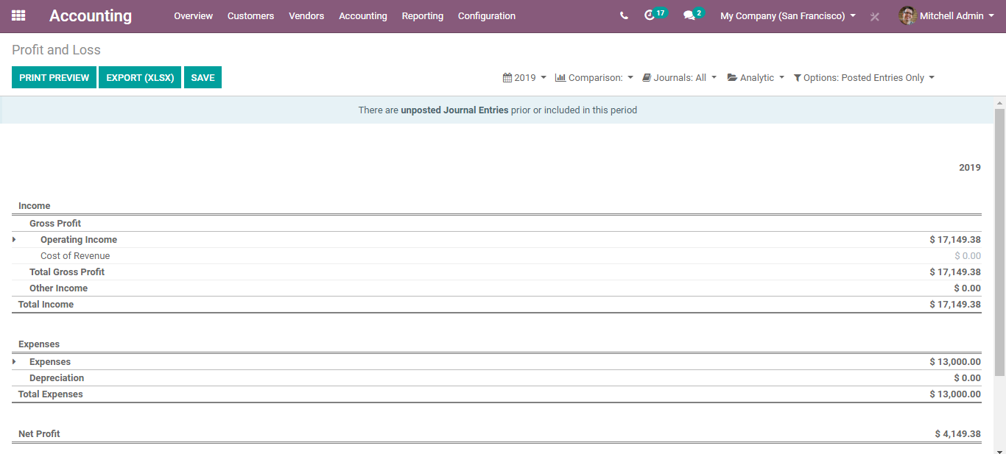

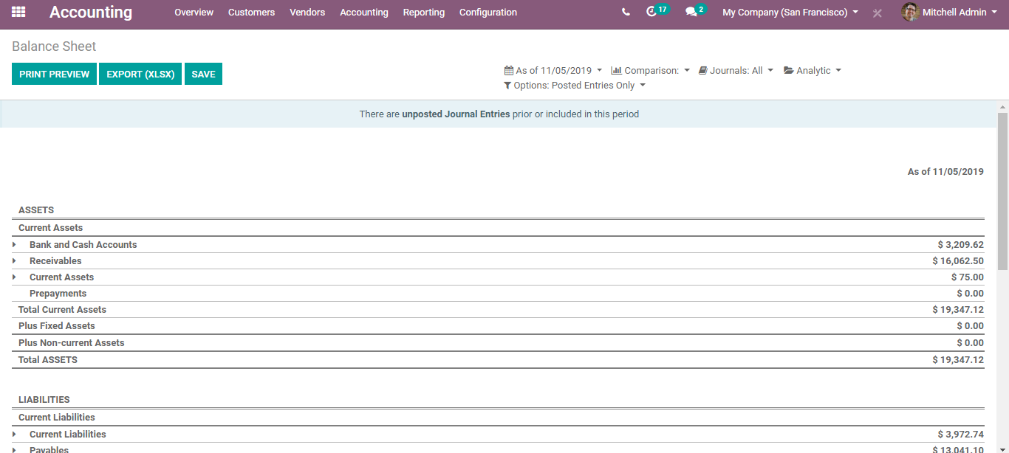

**Reporting**

**Aged payable balance**

To get a rundown of open vendor bills and their related due dates, one can go for the **Aged Payable report,** under-reporting menu.

**Configuration**

**Reporting > Partner Reports > Aged payable.**

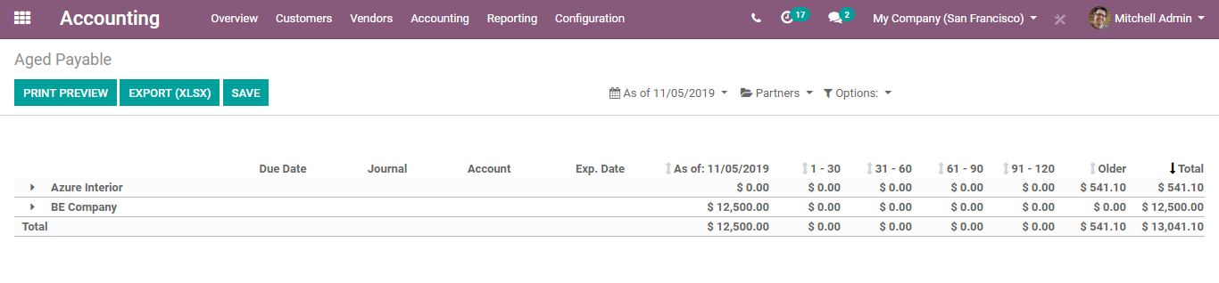

From here, one can directly click the merchant's name to open the details of every outstanding bill and the sums due, or you can comment on any line for managements information.

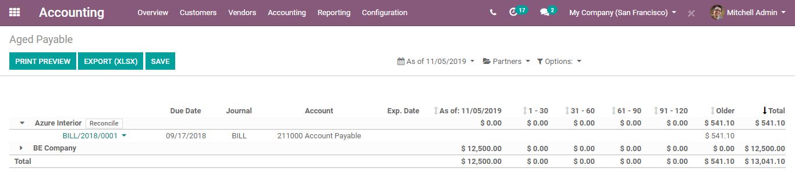

Anytime while you are glancing through the report, you can print straightforwardly to Excel or PDF and get precisely what you see on the screen.

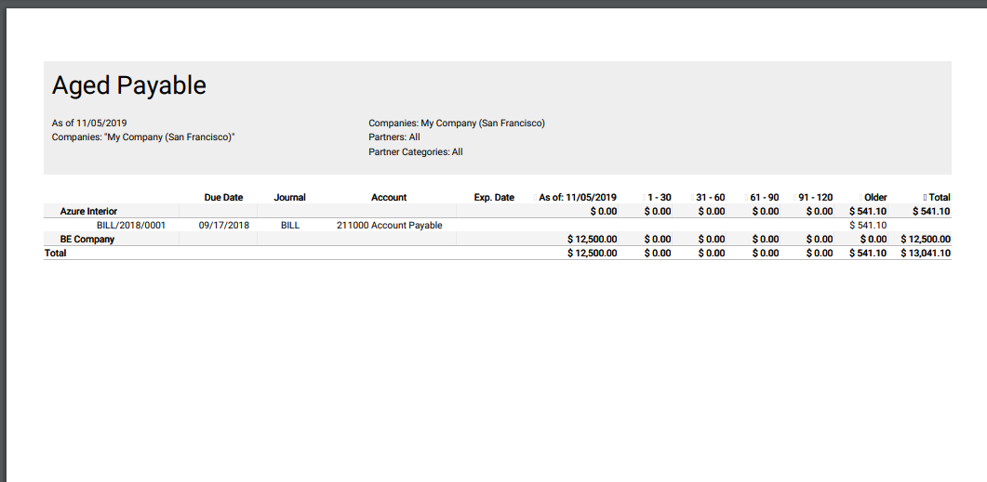

**Cash Rounding Methods**

Cash Rounding is conducted when the base unit of an account is smaller than the most reduced denomination category of the currency. The payable sum for money exchange is adjusted to the closest various of cash unit accessible, through exchanges paid in different ways (e.g.: cheques, credit cards) are not adjusted.

In any business, cash rounding is an important feature. This feature enables the vendor to round off the cost of any request while an instalment is made. Cash rounding is supported in BUSINESS IN A BOX, it is used to round the total amount of a bill to the nearest five cents. This helps the vendor in creating a bill with a rounded total amount.

To enable the rounding function**, Go to Accounting module > Configuration > Settings > Taxes > Rounding Method**

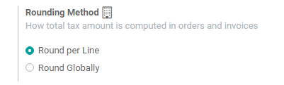

**Round per Line:** Rounding per line is advised if your prices are tax-included. That way the sum of line subtotals equals the total with taxes.

**Round Globally:**

One can either select it from here or can go to **accounting module -> Configuration -> Management -> Cash Rounding.**

Upon clicking create button, one can create a new cash rounding method in BUSINESS IN A BOX.

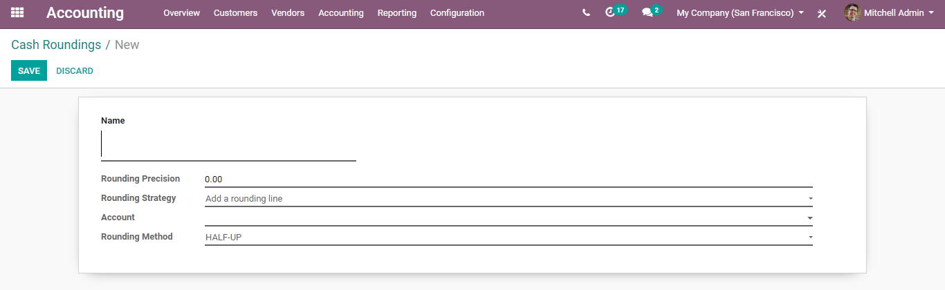

The creation form has the following parameters:

**Name** Name of rounding.

**Rounding Precision:** The precision of a numeric value describes the number of digits that are used to express that value, including digits to both the left and right of any decimal point. The rounding precision will affect the rounding of the computed value.

**Rounding Strategy:** You can do cash rounding by using two strategies.

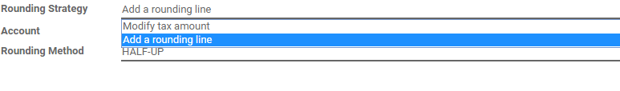

* **Modify tax amount:** Add the rounding to the highest amount of tax.
* **Add a rounding line:** Add the rounding in a new line.

Account: It defines an account, where the rounding will go.

Rounding Method: You can do three types of rounding methods in BUSINESS IN A BOX.

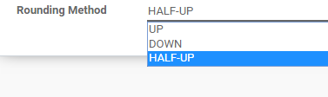

* **UP:** Value round towards plus infinity based on the rounding precision.
* **DOWN:** Value round towards minus infinity based on the rounding precision.
* **HALF-UP:** When the fraction part of a value is greater than or equal to 0.5, then round half

towards plus infinity otherwise round half towards minus infinity.

**Bank Statement and Reconciliation**

Bank reconciliation is the process by which a person’s accounting records concerning a cash account is matched with the information of his bank statement. The main aim of the process is to find out the difference between these two records to keep the accounting records as appropriate as possible. The bank information encompasses the record of all transactions carried under a person's account for a month. The reconciliation process should be carried out at regular intervals to ensure that a company’s cash records are correct, immune to fraudulent activities and mitigation of problems concerning bounced checks and overdraft fees.

BUSINESSBOXERP enables easy linking of your invoices and all other payment details with the bank statements without hardship. The reconciliation methods in BUSINESSBOXERP are carried in two formats.

* Direct registering of payment with invoices.
* Open invoices reconciled with bank statements.

Step 1: Make Money Payment

First, create an Invoice for the customer.

For that go to **accounting->Customers->Invoices**

Create an Invoice.

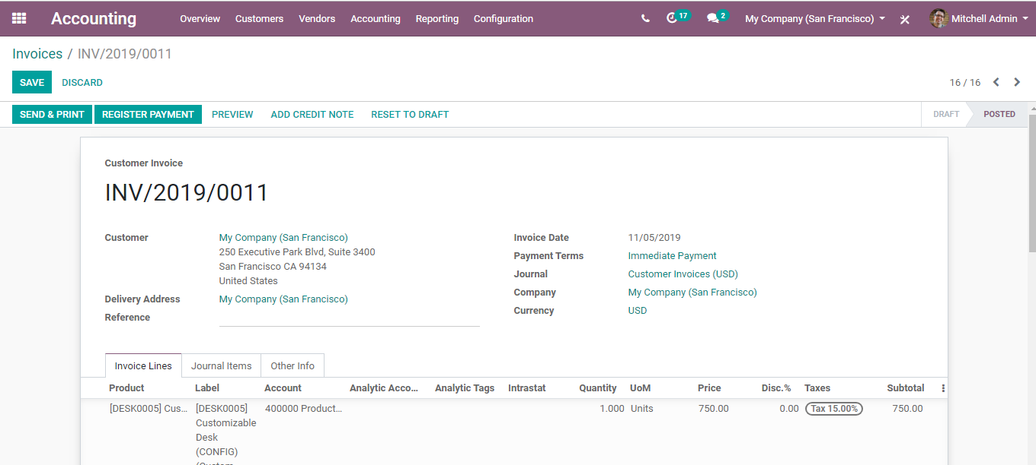

When the customer makes the payment, click **REGISTER PAYMENT**.

A company accountant handles the bank statements only on weekends, correspondingly the invoice will be marked as paid. It is done to remember that the service with our customer can be started. Payment confirmation is sent from the customer side, so payment registration can be done, and the invoice can be marked as paid. If clicking the REGISTER PAYMENT option, it is marked in BUSINESSBOXERP software that the invoice is paid. The payment method, payment amount and payment date must be specified here.

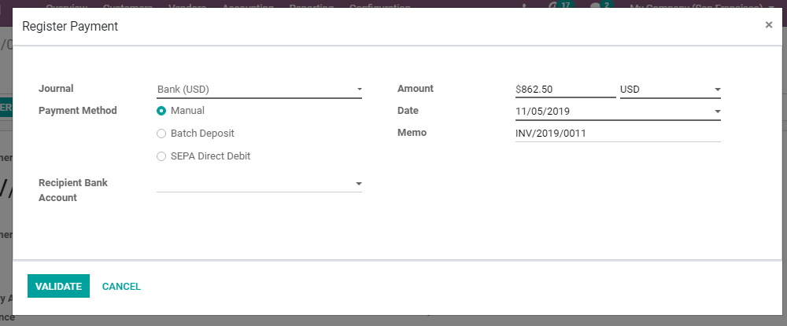

To find the payment back from the invoice, click the little green icon. You will get the payment information. You can see the reconciliation process automatically done.

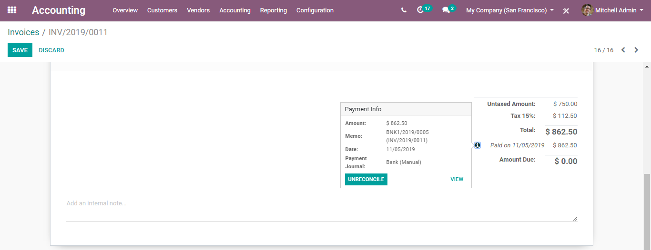

**Bank statement reconciliation case**

Import or create bank statements. From the banks feed section, the documents must be referred.

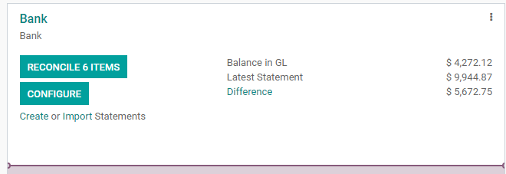

There will be an option in the dashboard to reconcile X number of items (X denotes the number of items we want to reconcile), click on that.

If the mentioned name of the partner, the amount entered etc. are correct, BUSINESSBOXERP software automatically executes the reconciliation process.

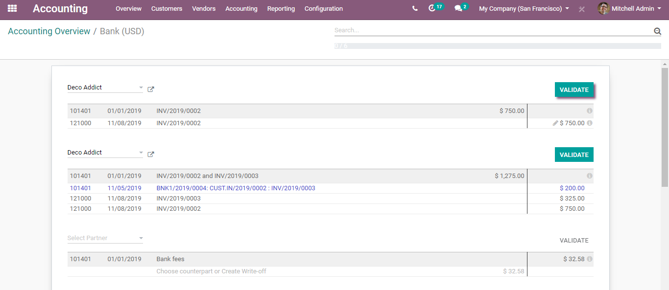

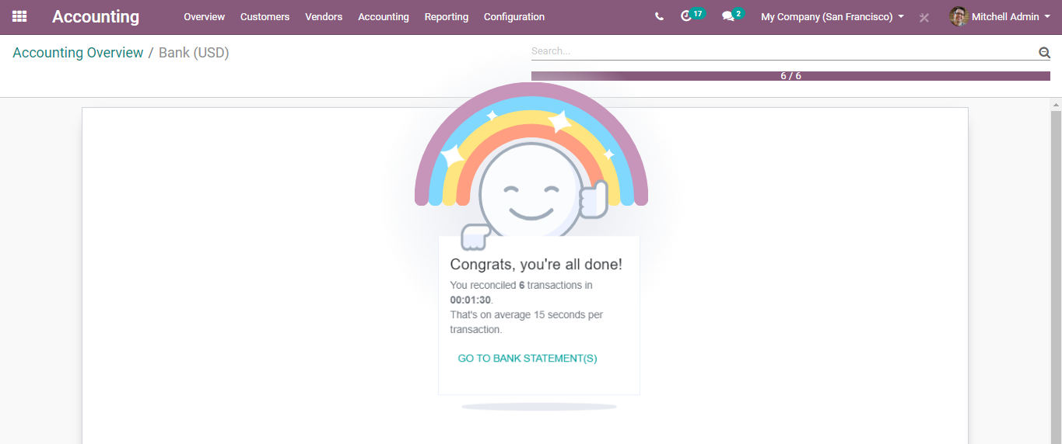

The above image shows the successful execution of all reconciliation processes.

Now, suppose if some issues happen during the process, like the partner’s name missing out, amount getting mismatched, in that case, one must make use of manual actions.

Suppose if the partner’s name is not there in the bank statement, there you must manually enter it.

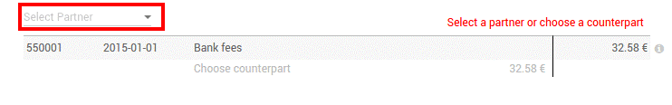

If a down payment method is adapted, one must check if it is right and then payments should be validated accordingly.

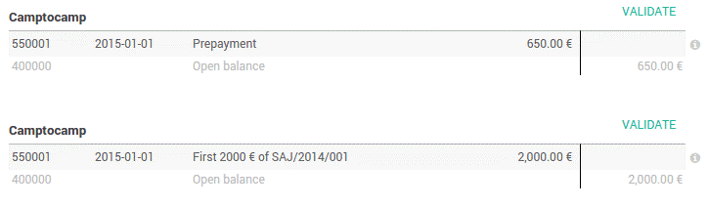

There is an option to reconcile balanced items in the sheet. For that press CTRL-enter.

**RECONCILIATION MODELS**

One can pre-fill in BUSINESSBOXERP certain accounting entries to easily reconcile them. Seamlessly reconcile recurrent entries such as bank fees.

**Creating Reconciliation Models**

Go to **Accounting>Configuration>Accounting>Reconciliation Models**.

Or else one can go to the Bank journal under the accounting application dashboard and click on More ‣ Reconciliation Models.

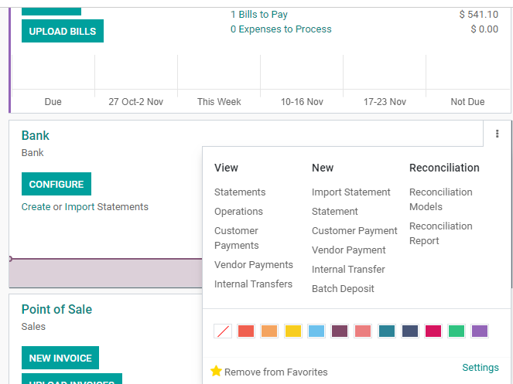

Click **RECONCILIATION MODELS**.

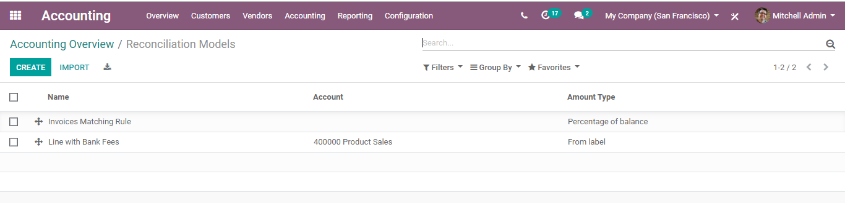

Click the **CREATE** button for creating a new model.

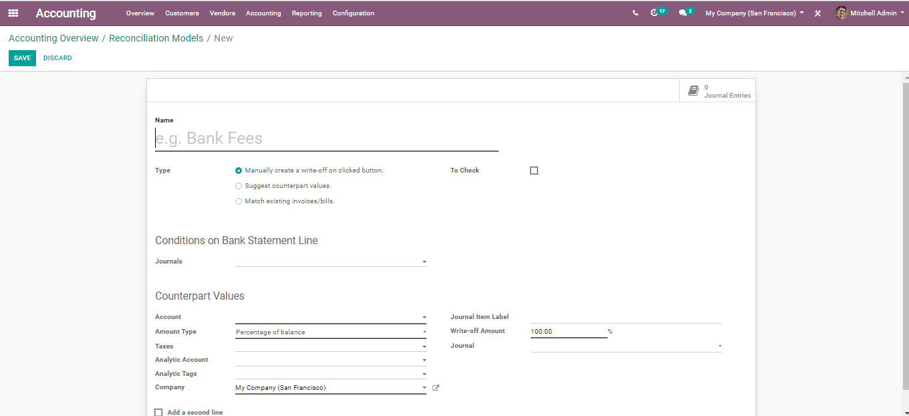

Let us take a use case. Every month a company receives a bank fee cost based on its current balance. Hence, the fee is variable.

Let us keep the model’s name as Bank fees, select the correct account to book those fees. Also, specify the amount type. Based on the provided parameters, BUSINESSBOXERP takes the fee into the account.

Click the **SAVE** button, to mark the changes.

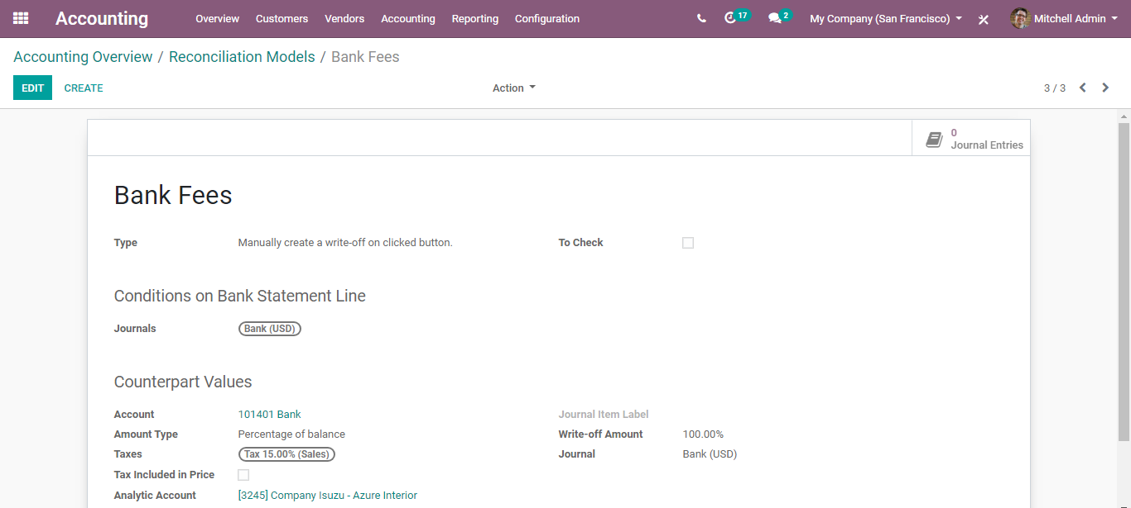

**Registering payments based on reconciliation model**

Register your payment via importing your bank statements.

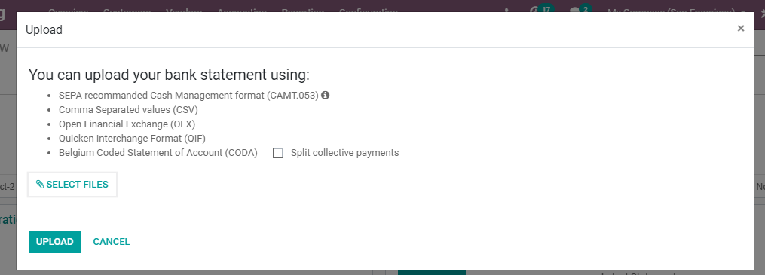

During the reconciliation process, select open balance. Then click on the reconciliation model, here it is the bank fees. After doing this, one will instantly get the relevant data. To finish the process, click on reconcile.

**Multi-currencies in BUSINESS IN A BOX**

Utilizing the option, multi-currency in BUSINESSBOXERP will enable the end-user to send sales invoices, quotes, and purchase orders, also receive bills and instalments in monetary standards other than your own. With multi-currency, you can likewise set up financial balances in different currency forms and run reports on foreign currency exercises.

**Configuration**

Go to **Accounting->Configuration->Setting->Currencies->multi-currencies**

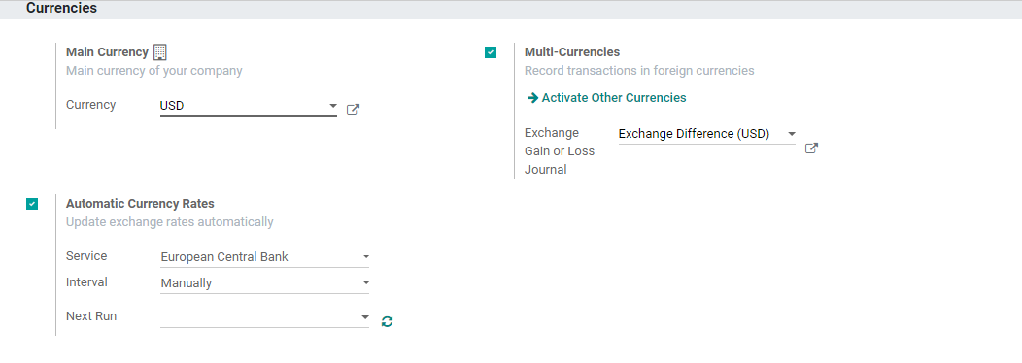

Turn on the option multi-currencies under the currencies tab. Click the **SAVE** button to mark the changes.

To see a few more currencies, click Activate Other Currencies option. One can click on the new currencies and activate them in case of need.

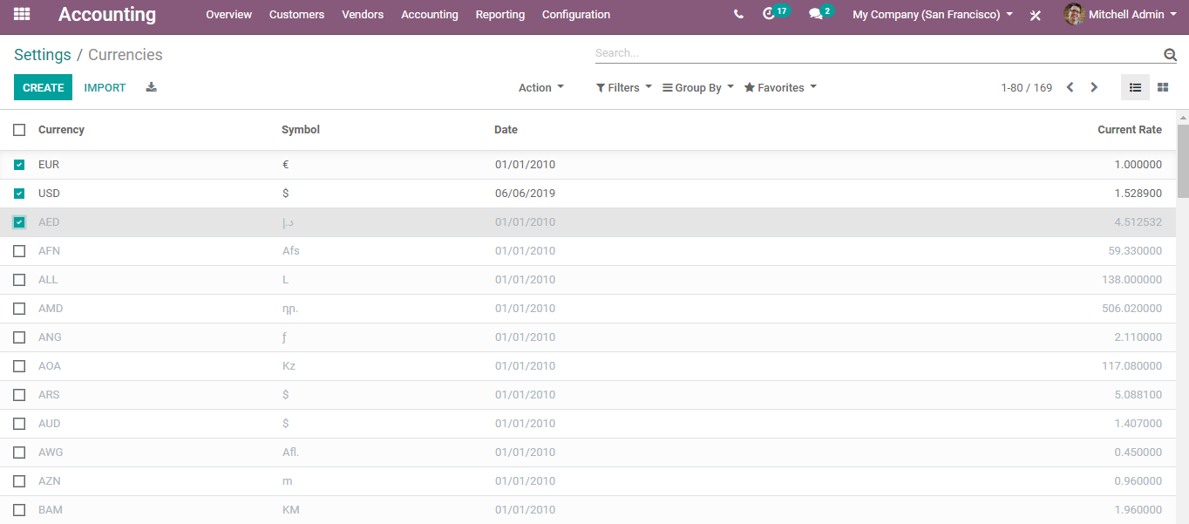

**EXCHANGE GAIN OR LOSS JOURNAL**

The option records the contrasts between the payment registration and the expected amount. For instance, if an instalment is paid one month after the receipt was issued, the conversion/exchange scale would have changed. The fluctuation infers some misfortune or benefit that are recorded by BUSINESS IN A BOX.

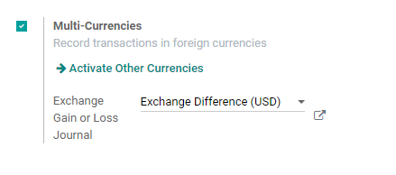

BUSINESSBOXERP provides different options like Miscellaneous Operation, Exchange Difference, Cash Basis Tax Journal, Stock Journal. One can also CREATE AND EDIT a new one.

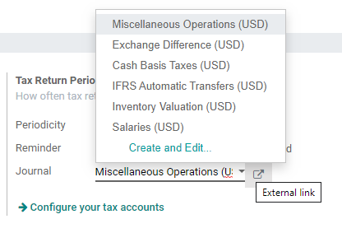

**Automatic Currency Rates in BUSINESS IN A BOX**

By default, the currencies must be changed manually. However, under BUSINESS IN A BOX, one can synchronize it with different exchange services like Yahoo, Europe Central Bank and more.

One can also set the interval for conversion like Manually, Daily, Weekly or Monthly.

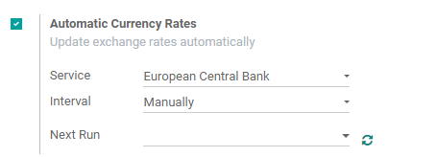

Click **SAVE** to mark the changes.