**Contacts**

For any business organization managing the contacts is very essential. Contacts running from leads to customers, partners to suppliers are very crucial for smooth and uninterrupted business flow. With the help of the BUSINESSBOXERP contacts module, one can easily keep track of every transaction carried between the business contacts. Being integrated with our modules of BUSINESS IN A BOX, it comes easy to quick-fix things.

Firstly, install the Contacts Module from BUSINESSBOXERP apps.

As soon as you enter the dashboard, you see the already created contacts.

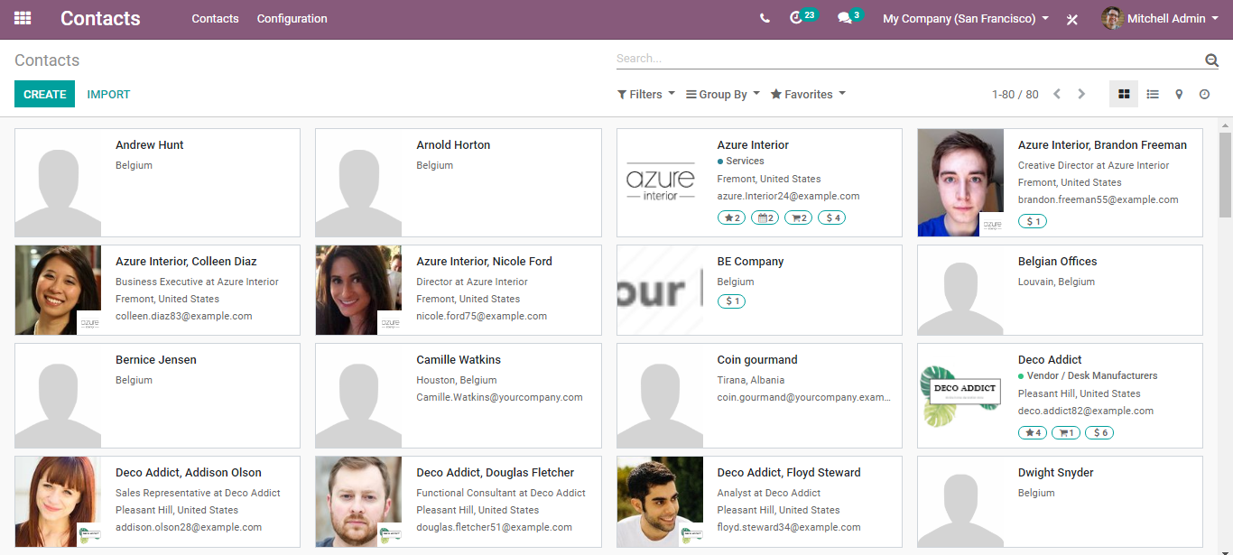

To create a new contact, click the create button provided on top.

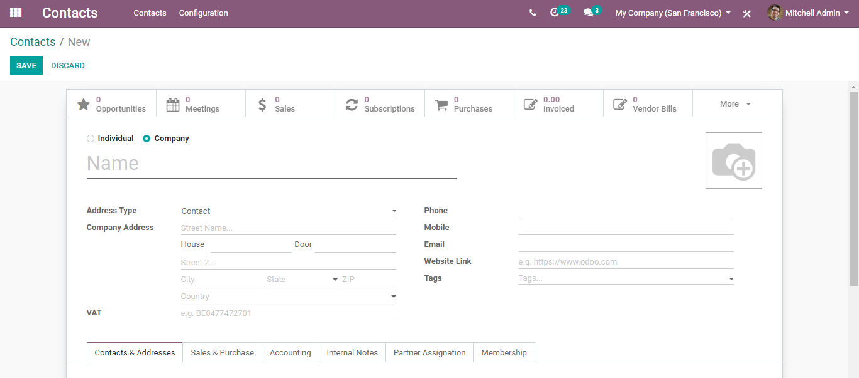

Under the create form, one can add all the basic information about the contact- image, name, address, contact number, email, tags, if he is a salesperson/purchaser, accounting details, and so on.

Let’s go one by one.

Under BUSINESSBOXERP you have two types of contacts:

* Individual
* Company

Under Contact and Address Tab

Here you have the option to completely configure a new customer of yours via adding his name, address, phone, mobile, email id, notes etc.

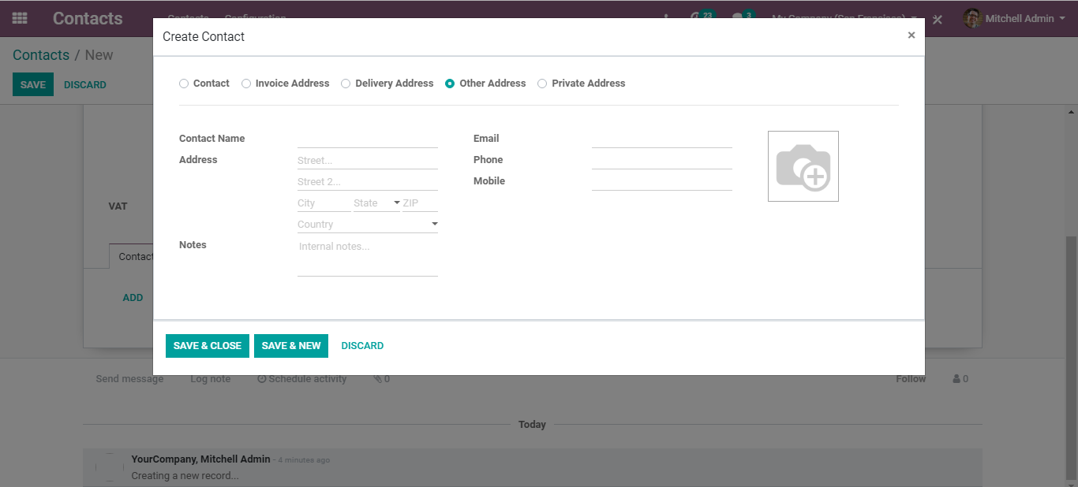

Under Sales and Purchase Tab

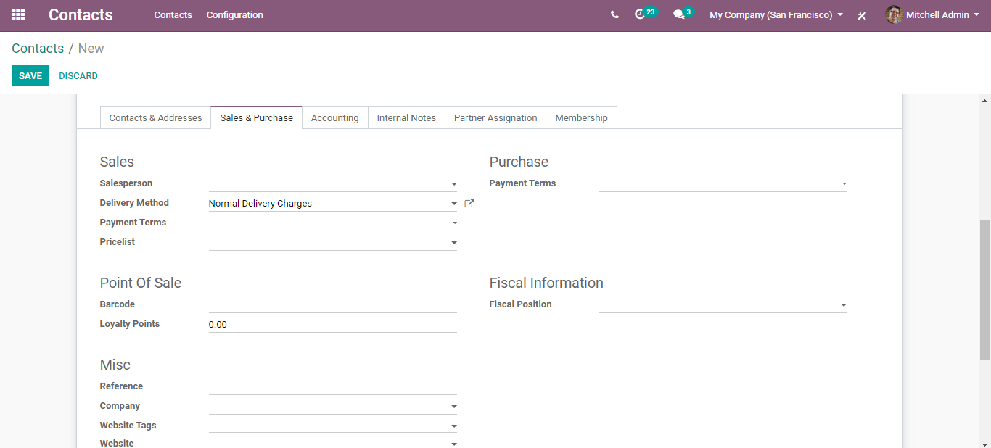

The fields include:

* Salesperson: The internal user in charge of this contract.
* Delivery Method: Default Delivery method used in sales order.
* Payment Terms: This payment term will be used instead of the default one for the sales order and customer invoice.
* Pricelist: This price list will be used instead of the default one, for sales to the current partner.
* Barcode: Use a barcode to identify this product from POS.
* Fiscal Position: Fiscal position determines the taxes/accounts used for this contract.

**Under Accounting Tab**

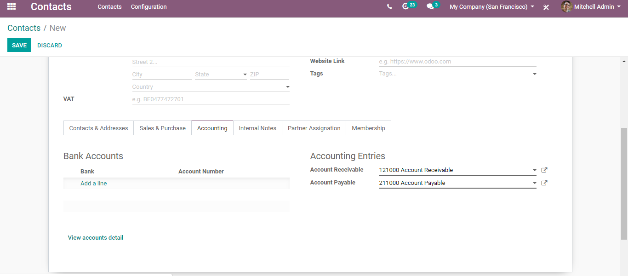

* Bank: The name of the bank, where the customer holds the account.
* Account number: The customer’s registered account number.
* Account Receivable: This account will be used instead of the default one as the receivable account for the current partner.
* Account Payable: The account will be used instead of the default one as the payable account for the current partner.

**Internal Note Tab**

The internal note is a functional feature that you put comments without disturbing followers. If you want to notify a particular seller, rather than disturbing all others, you can insert an internal note in the contact form.

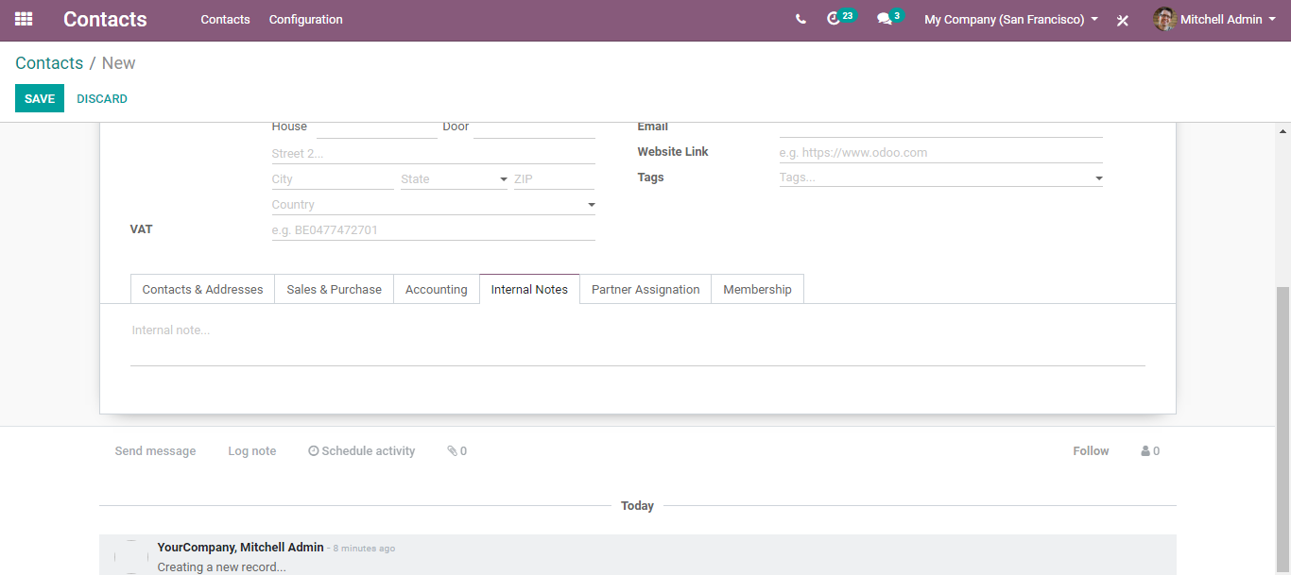

**Under Partner Assignation Tab,**

You can give away the Geolocation, partner-level details, partner review and so on.

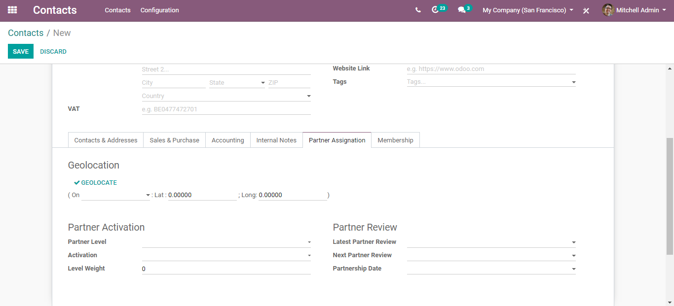

**Under Membership tab**

You can tick whether the contact is a free member, current membership status, and in case he is new to the company, from there itself one can add the membership details.

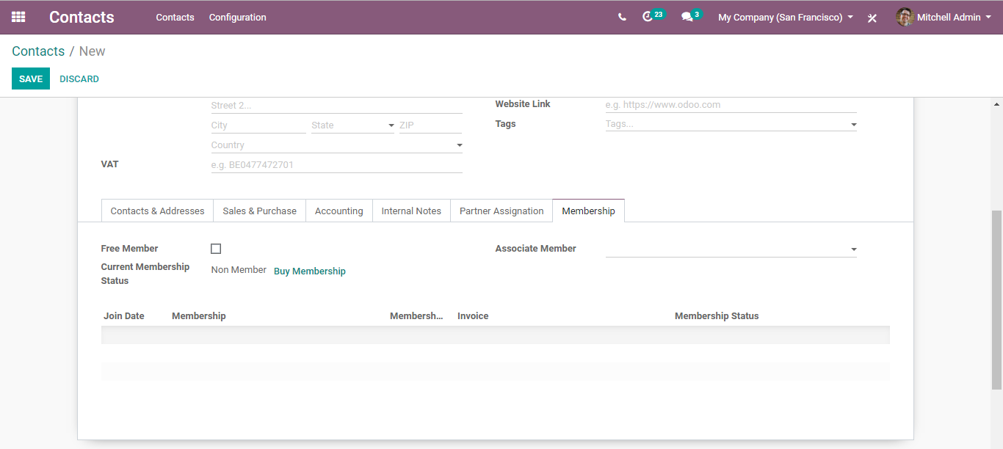

After entering all the valid info, click save to mark the changes.

**Overview of all meetings immediately**

From the contact form, one can easily review the meetings scheduled with a contact.

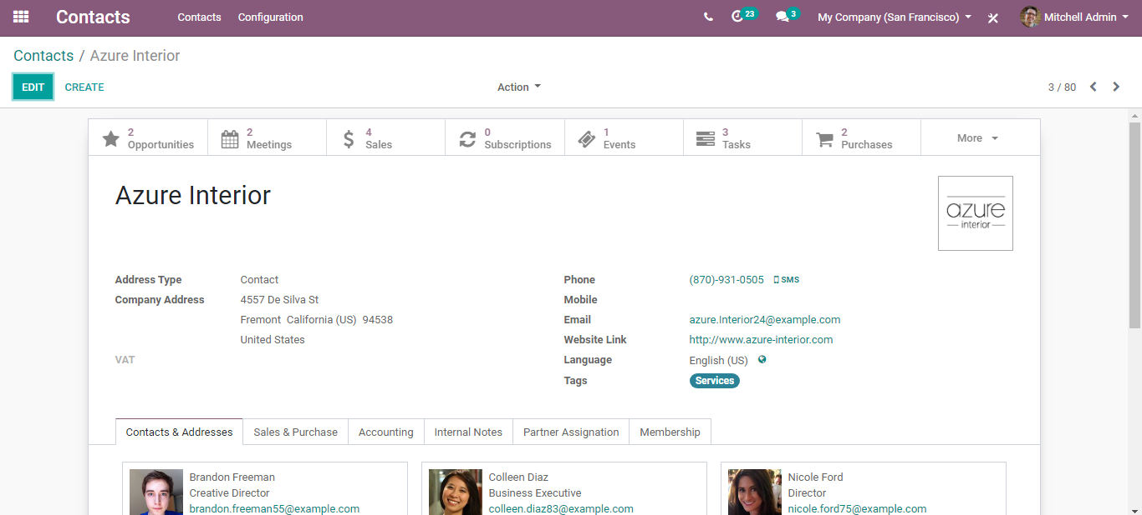

Via clicking the calendar icon on top, it straight away goes to the meetings tab, where one can send invitations and add useful information. Also, from there one can synchronize everything with Google Calendar.

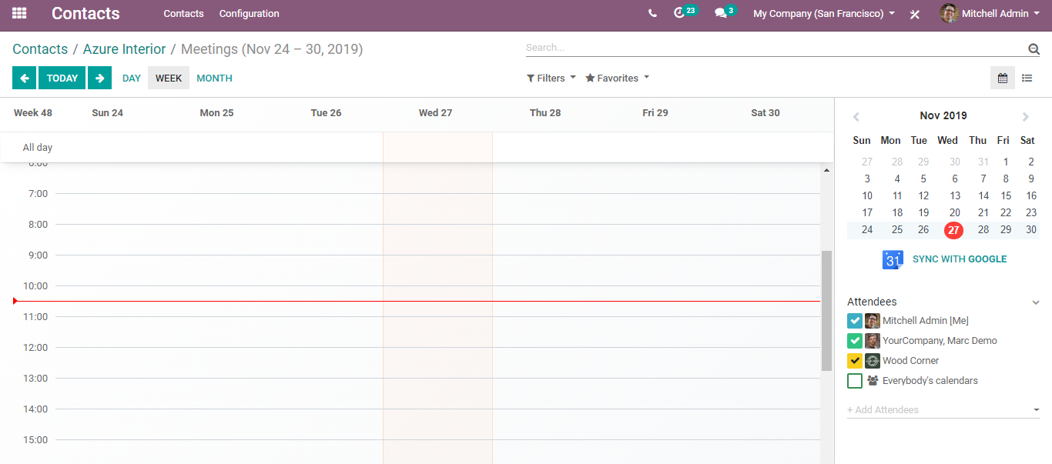

**Filtering of Data**

Coming back to the dashboard, you can see the filters and groups by options. Make use of the powerful filters given on top to quickly sort the data you need.

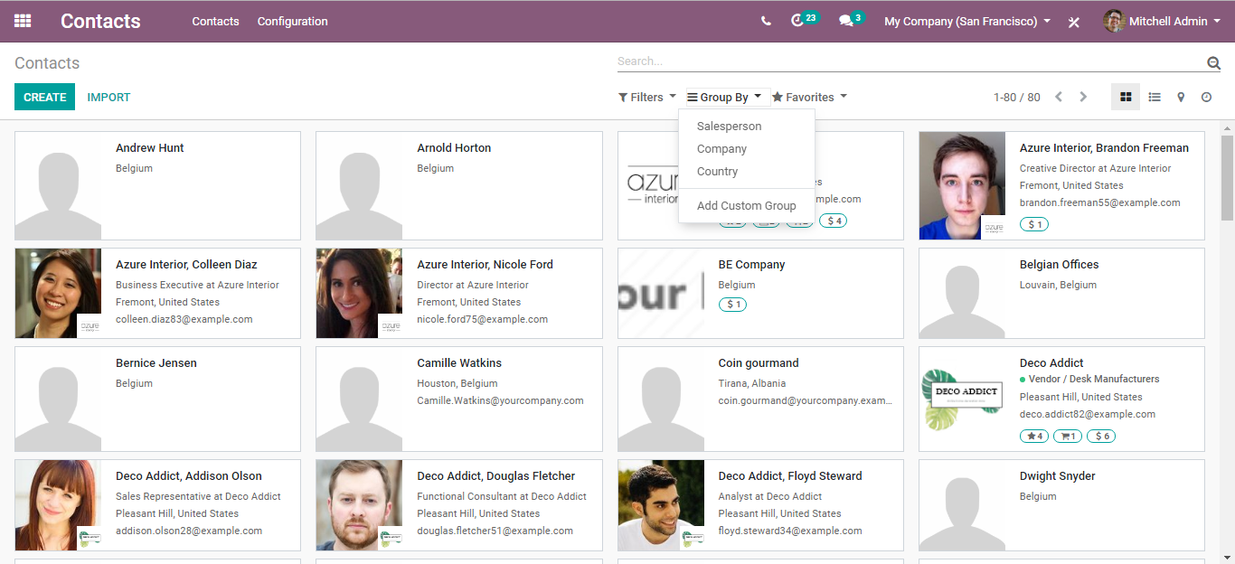

Using group by option, one can easily group the contacts based on their country, the activity of the company or the salesperson. Via clicking on add custom group you can insert new parameters for filtering the data.

**Quick overview of business interaction**

From the contacts form, one can easily get access to the RFQs, sales orders and purchase orders. Even it is possible to view the complete history of each customer, including their total invoiced and overdue amounts.

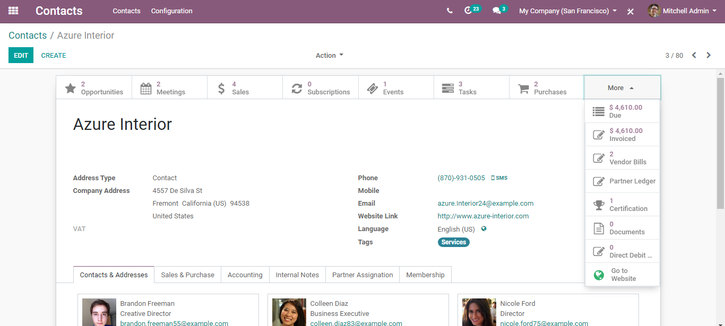

Via clicking any, you get into its details.

