**BUSINESSBOXERP Discuss**

BUSINESSBOXERP Discuss is BUSINESSBOXERP’s internal communication feature which allows you to have private conversations, as well as group chats. It enhances business communications and reduces business emails.

BUSINESSBOXERP Discuss is a simple to utilize the messaging application for groups that bring all your association's correspondence into one spot. It allows you to send and receive messages from any place in BUSINESSBOXERP, also deal with your messages and warnings effectively from the application. With Discuss module one can make channels for group talks, discussions about undertakings, meeting coordination, and more in one basic and accessible interface. With BUSINESSBOXERP Discuss you can choose which conversations you would like to follow. And you need not worry about other people seeing your communication. Moreover, BUSINESSBOXERP Discuss comes integrated with all other BUSINESSBOXERP apps.

To start with, firstly install the discuss module.

As soon as you enter the module, the first thing we see is the main inbox. In the left panel, we see the inbox, starred conversations, history of communication, different other categories. This includes channels created for discussions, private channels, direct messages etc.

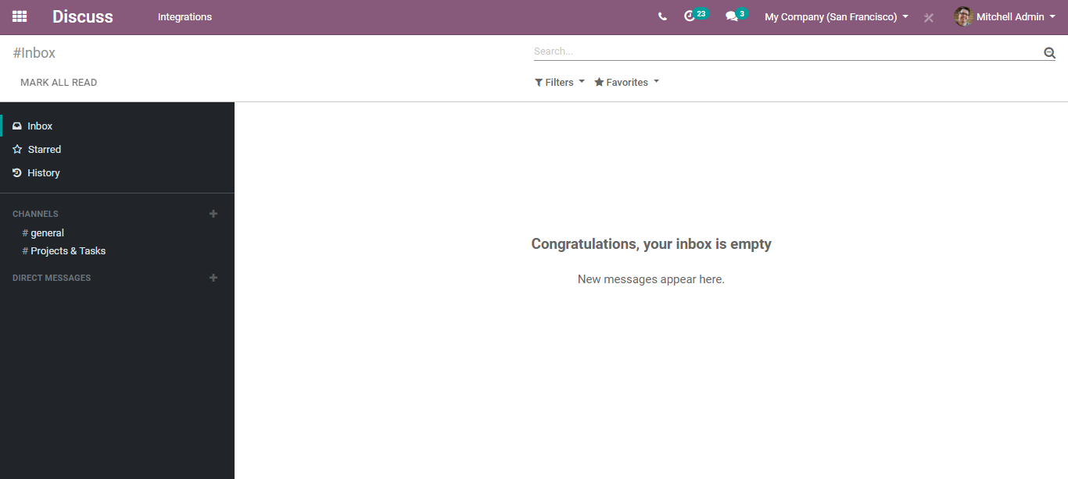

**Creating Channels**

Creating channels helps you to build a conversation with multiple individuals and you can categorize this conversation type the way you want, say the location, project, team, etc. There are many options under BUSINESSBOXERP Discuss.

To create a new channel, click the + icon on the left side.

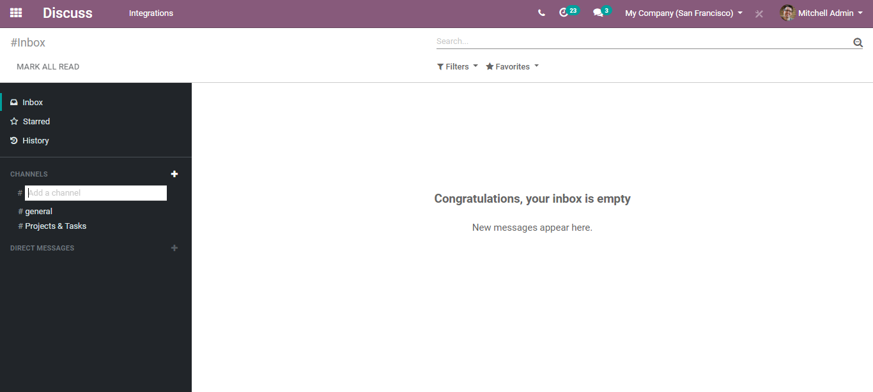

Then add the name of the channel. From right here you can choose whether the channel is a private one or the public one.

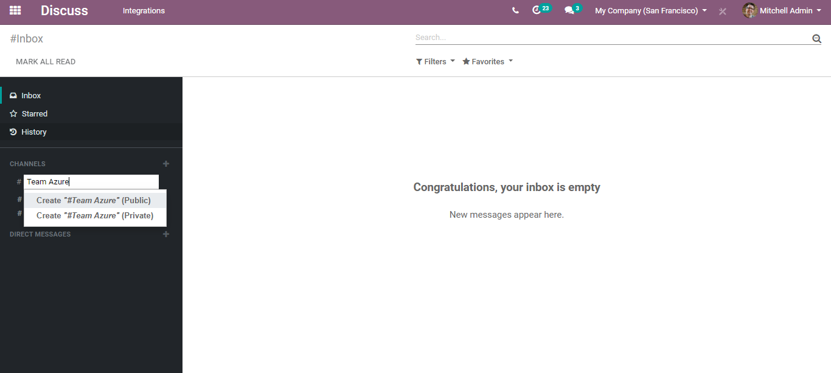

Now via clicking on the configuration setting icon of the channel, you can make changes to your created channel.

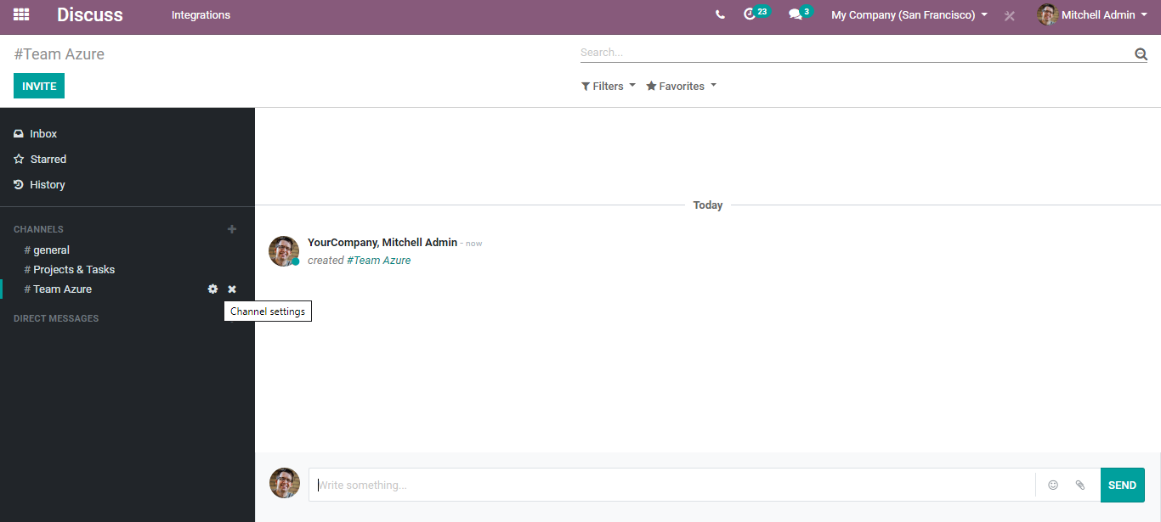

Via clicking the icon, you will be navigated to a new window like below.

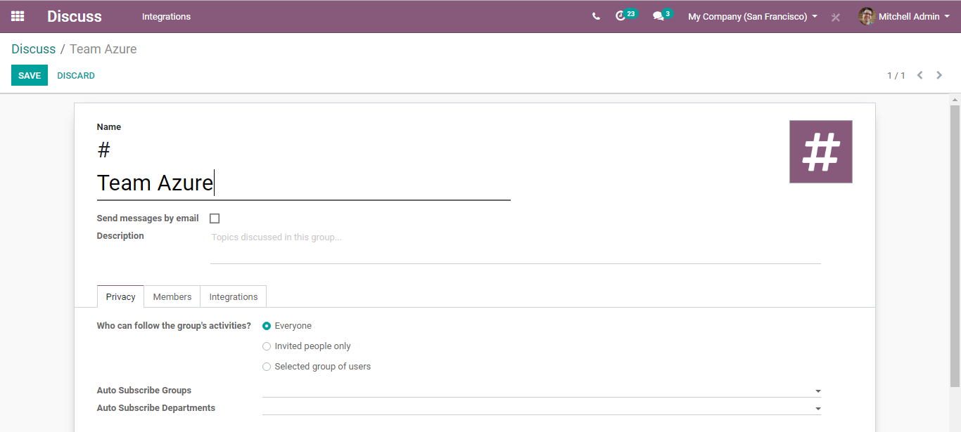

You can find # created channel name on top, followed by an option to send messages of this channel by email, field to insert the descriptions.

Under the Privacy tab,

You can set the privacy for your group activities. You can choose from three options, who can follow the group activities.

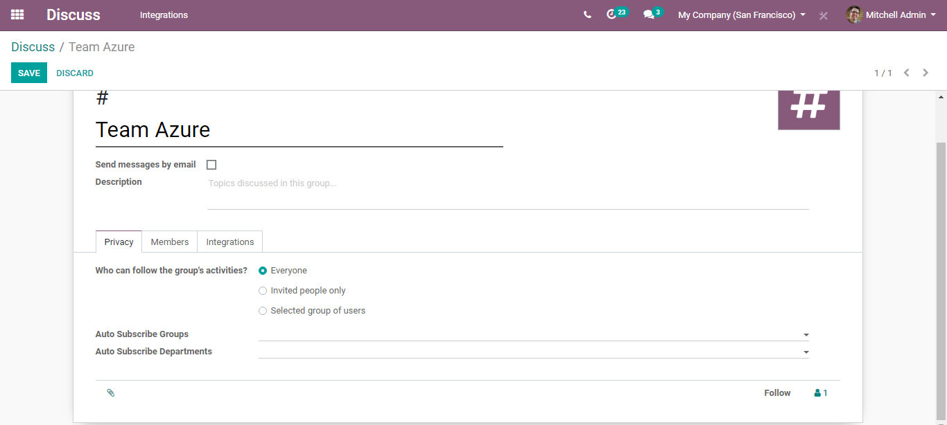

You can also see other fields in the tab:

* Auto Subscribe Groups: Members of those groups will automatically be added as followers. Note that they will be able to manage their subscription manually if necessary.
* Auto Subscribe Departments: Automatically subscribe members of those departments to this channel.

**Under Members Tab,**

Via clicking add a line you can add recipients and their email. Also, attachments if any.

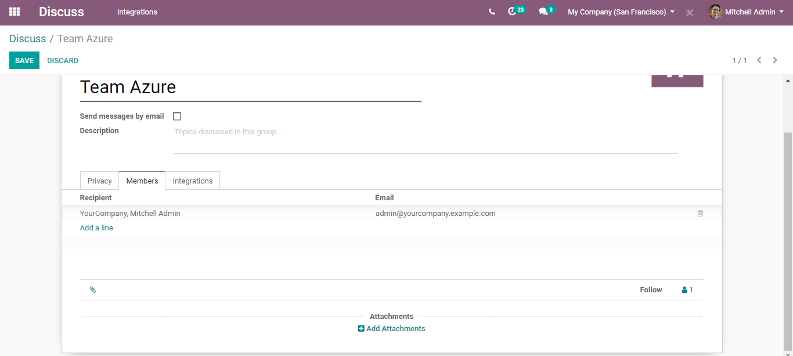

**Integration’s tab**

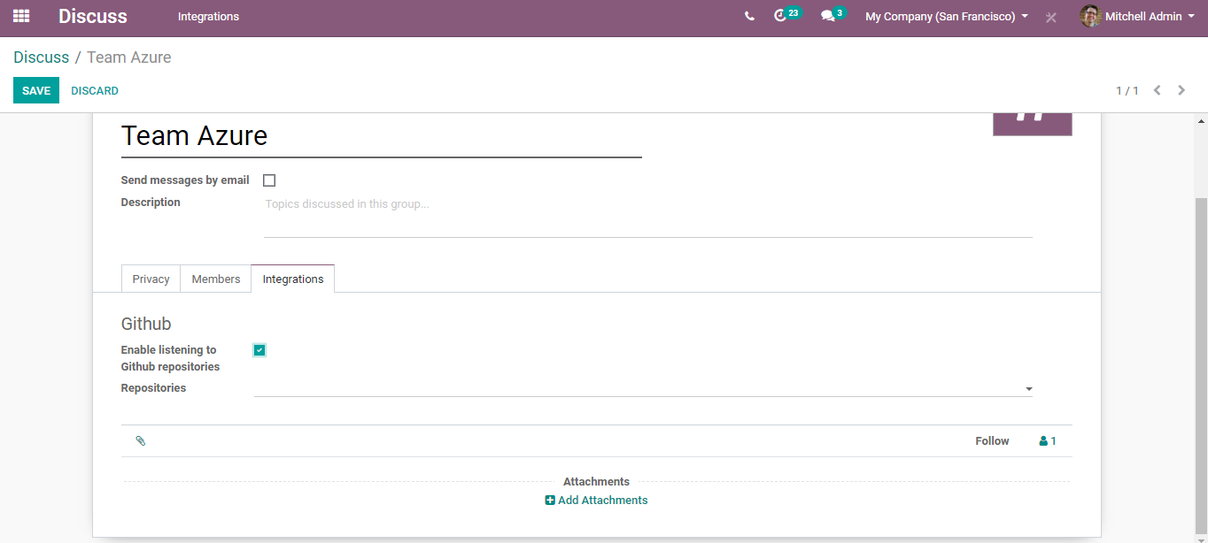

Via tapping the option, you can enable listening to GitHub repositories.

Later click save to mark the changes.

**Direct Messages**

Same as with channels via clicking the + icon, one can proceed with direct messages.

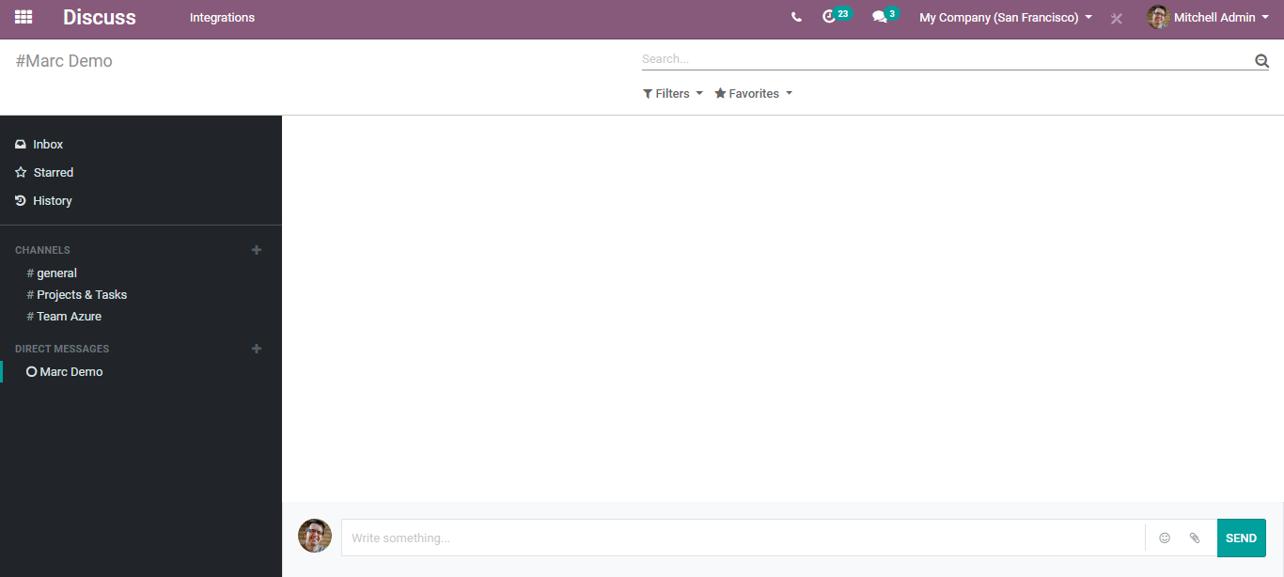

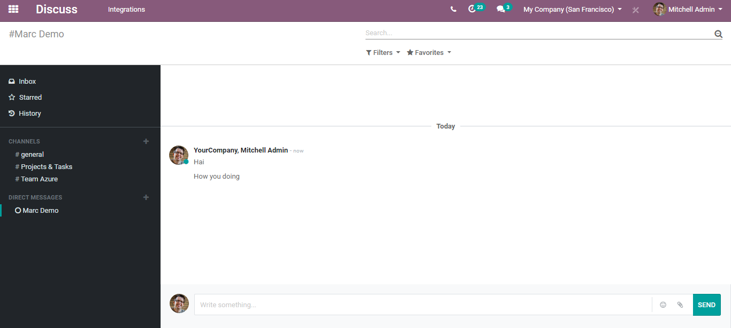

The replies can be seen right here. However, in case the user isn’t in the Discuss application, he can see them via going to the conversation tab on top of the app store.

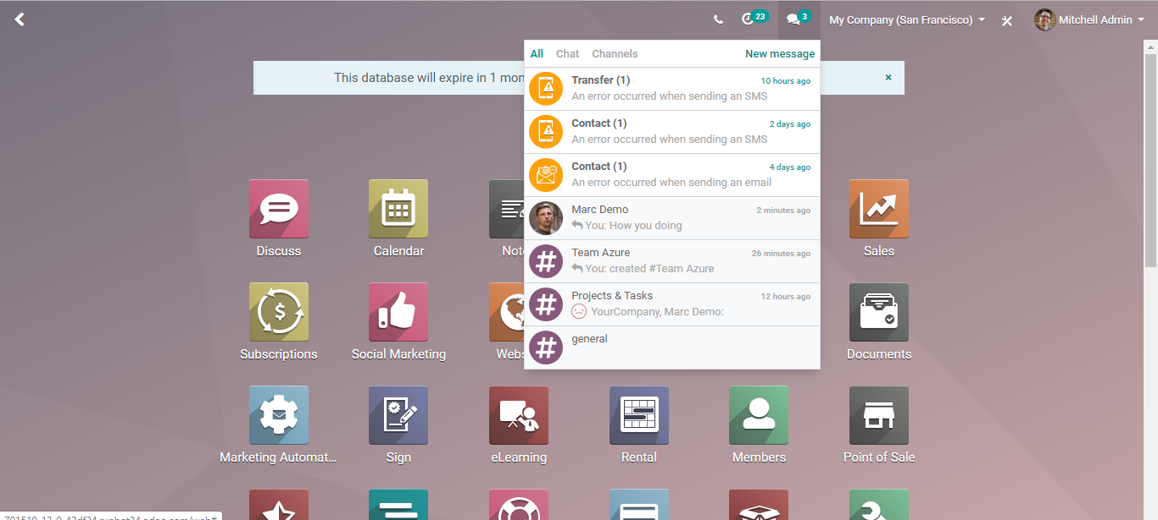

In case, you receive any message, you can simply click that from here and communicate back. You need not go back to the discuss module for initiating the communication.

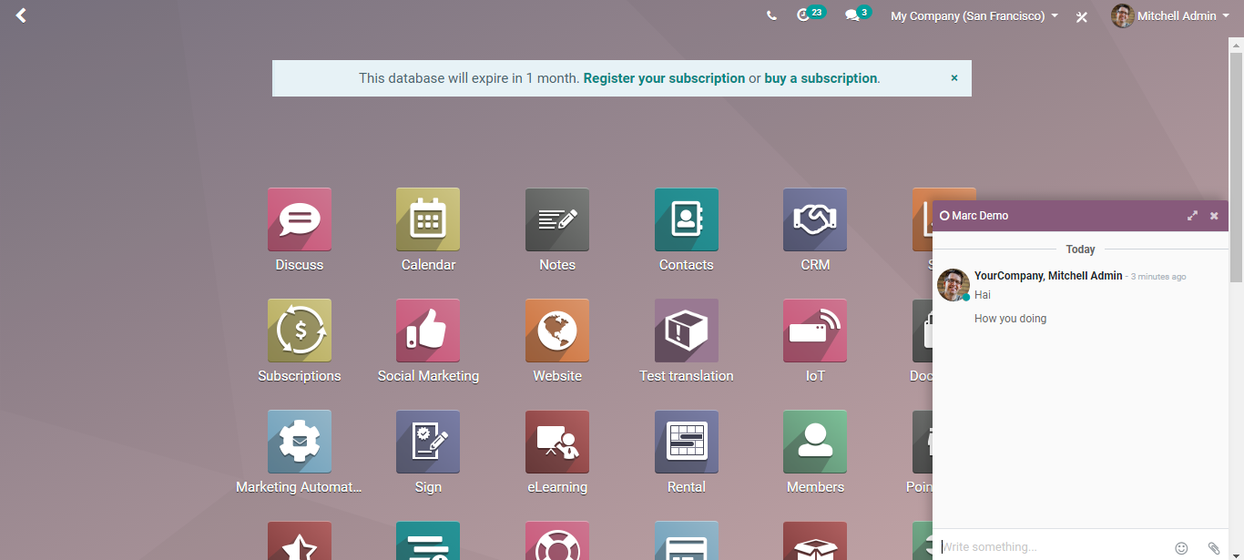

**How to follow a discussion thread?**

You can keep track of virtually any business be it an opportunity, quotation, task, in BUSINESSBOXERP.

For that go to application say sales or purchase. And on the bottom of the sales order or the purchase order, you can see the conversation thread.

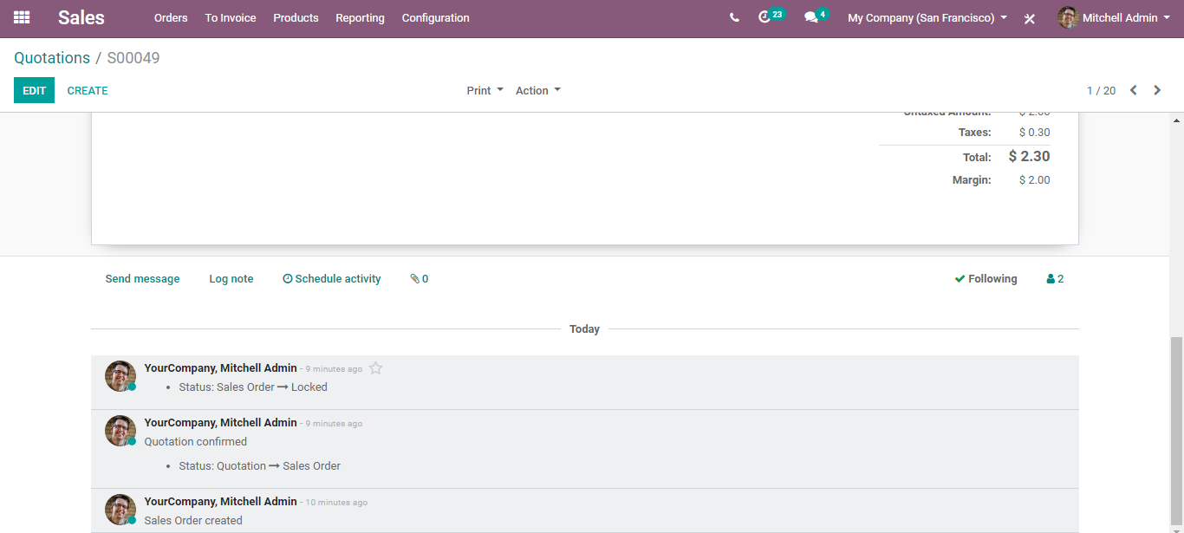

From here, you send direct messages to someone via clicking log notes, also schedule the activity if any.

**Notifications and Responses**

Under the Discuss module, it is quite easy to monitor updates and progress in BUSINESSBOXERP. Notifications and messages appear next to your inbox.



Checkmarks indicate the message as reading and remove it from your inbox. In case you need the conversation to be saved for later references you can start it.

All the starred conversations appear under the Starred box. In BUSINESSBOXERP, users can star any message or notification in Discuss.

