**BUSINESSBOXERP Document**

With BUSINESSBOXERP Documents, the end-users can easily share, transfer, filter or archive the scanned business documents. Using BUSINESSBOXERP documents one can easily establish a paperless company on their end. BUSINESSBOXERP Documents immensely saves your time spent on producing record bills, scanning varied contracts, and getting them approved by officials. BUSINESSBOXERP documents manage mainly four types of documents

* Word/Pdf
* URL
* Videos
* Pictures

Install the BUSINESSBOXERP Documents from BUSINESSBOXERP Apps

The document management system of BUSINESSBOXERP works on two concepts: Workspaces and Tags. One can see them on the left side of the dashboard.

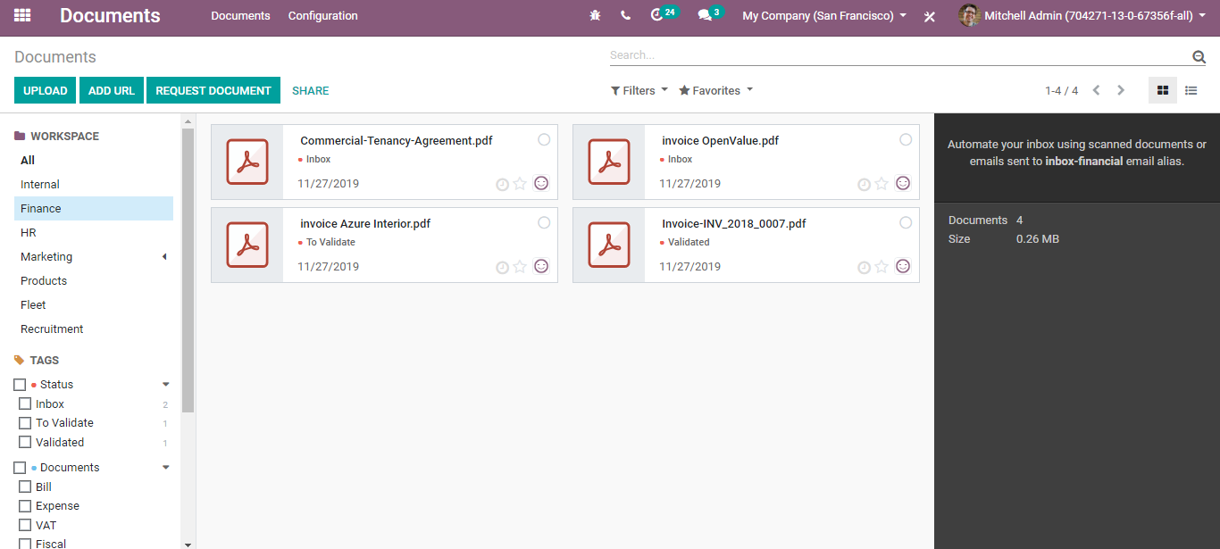

Workspaces are your different business departments. Each manager of these departments holds different kinds of documents, for example, the finance workspace will contain vendor agreements, contract bills etc whereas the HR workspace will have documents like employee contracts or leave documents. And with each workspace documents, you have these tags. You can see the tag categories- say STATUS, in which you have inbox, to validate, Validated. This is a great way to organize your workspace by adding little differentiation between your documents. Also, it helps to quickly look at the documents that you want to look at - say inbox.

Upon clicking it, the documents under the inbox will only be seen on the screen.

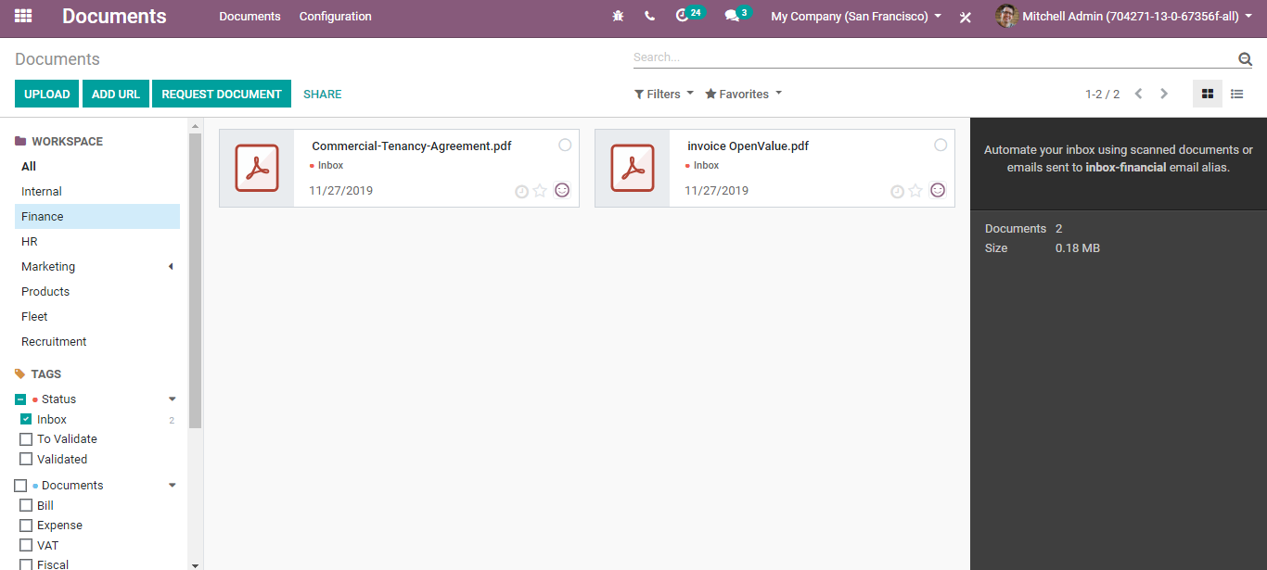

**Create Tags and Workspaces**

**To create tags,**

**Go to Documents>Configuration >Tags**

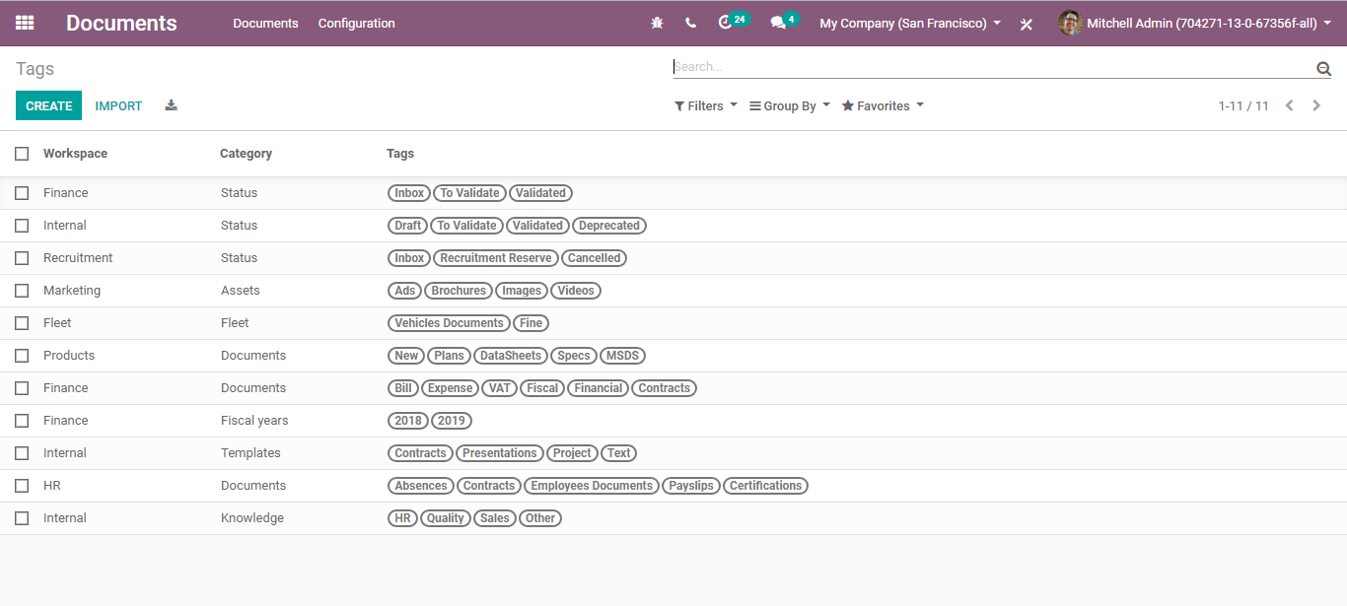

Upon clicking CREATE button, you can create new tags in the document.

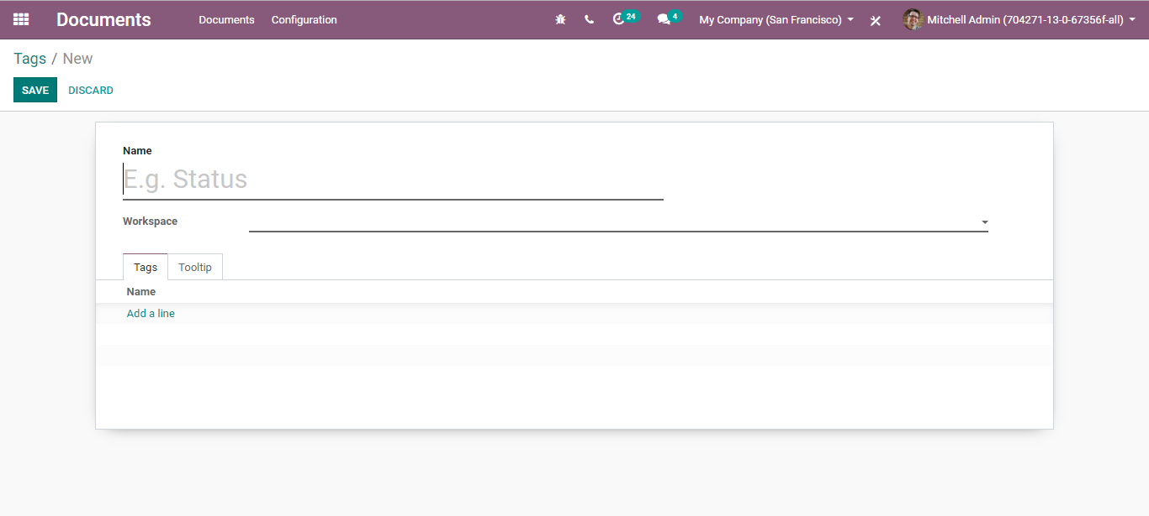

Here you can define the name for your tag, add the workspace from the drop-down menu.

**To create workspace,**

**Again, go to Documents> Configuration> Workspace**

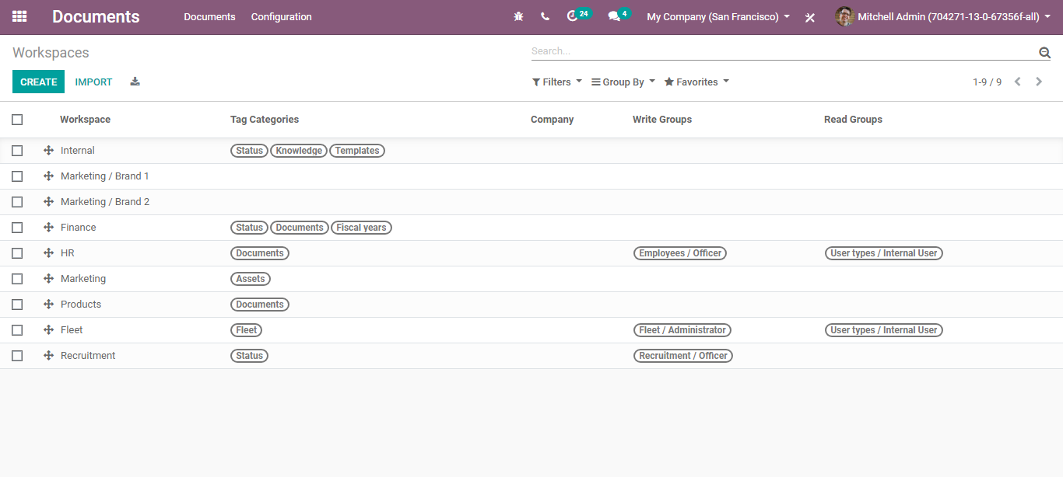

Click CREATE to configure the new workspace.

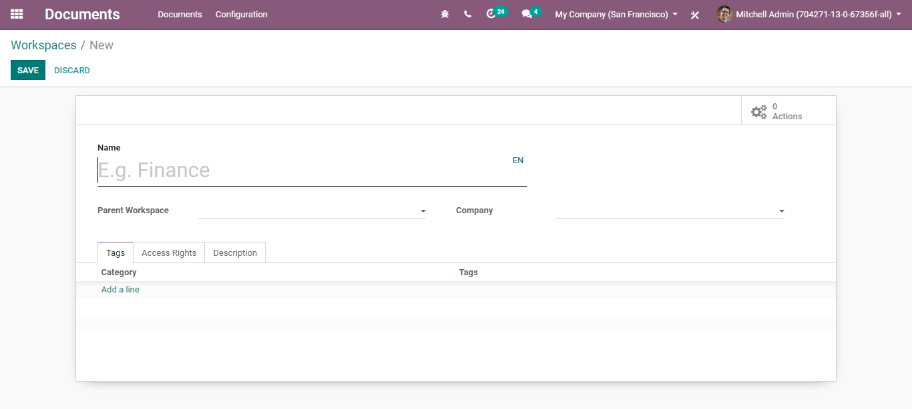

Here, one can add the name of the workspace, parent workspace (A workspace will inherit the tags of its parent workspace), company (this workspace will be available only to the selected company), tags, access rights to the workspace,

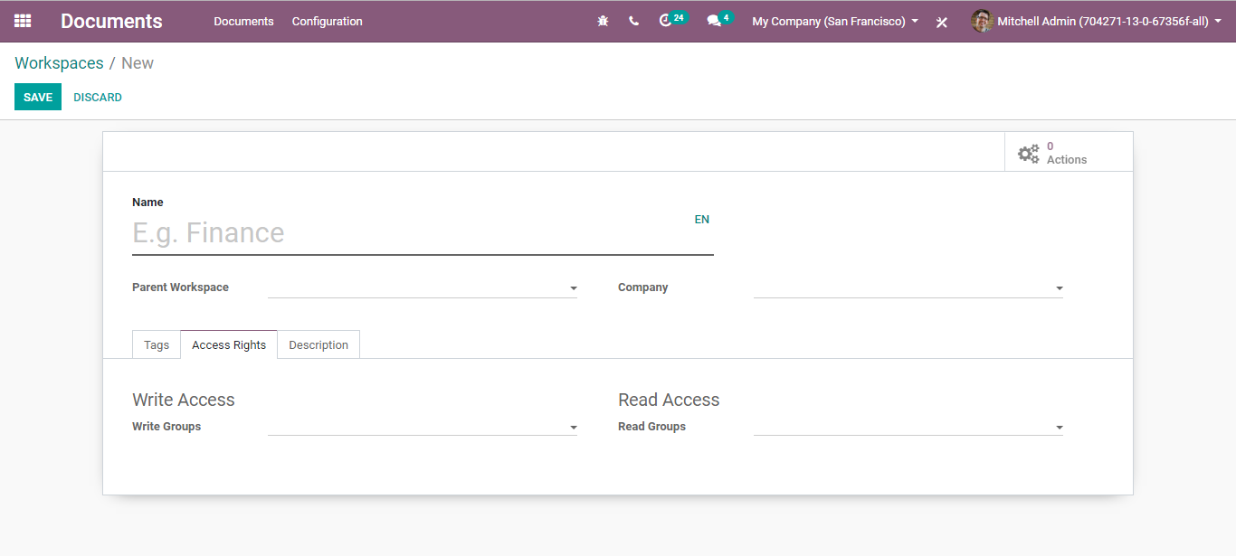

Write Groups: Groups can see the workspace and read/create/edit its document.

Read Groups: Groups can see the workspace and can read its documents without creating/editing rights.

One can also add action rules to the workspace to channel your communication, the right way.

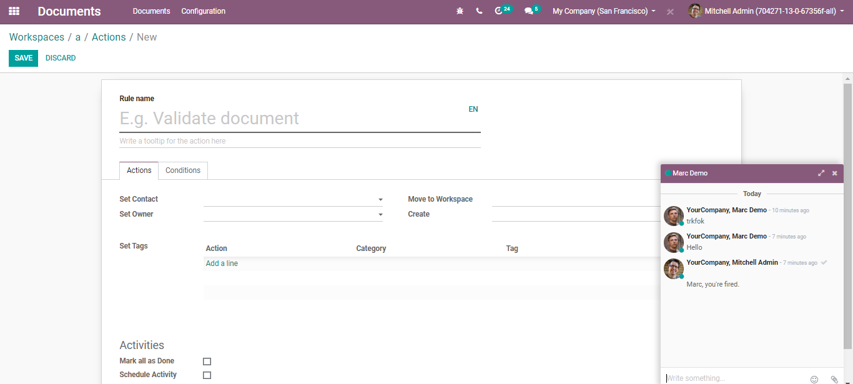

**Preview and modify documents**

To preview any documents, simply click on the icon of the document on left. It gives you a new pop-up window where you can preview the document. Once you are done, simply exit.

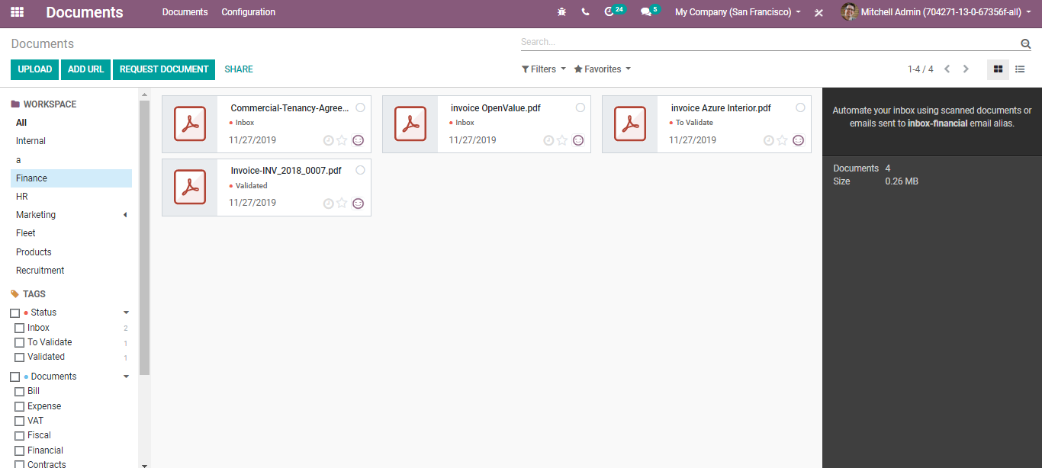

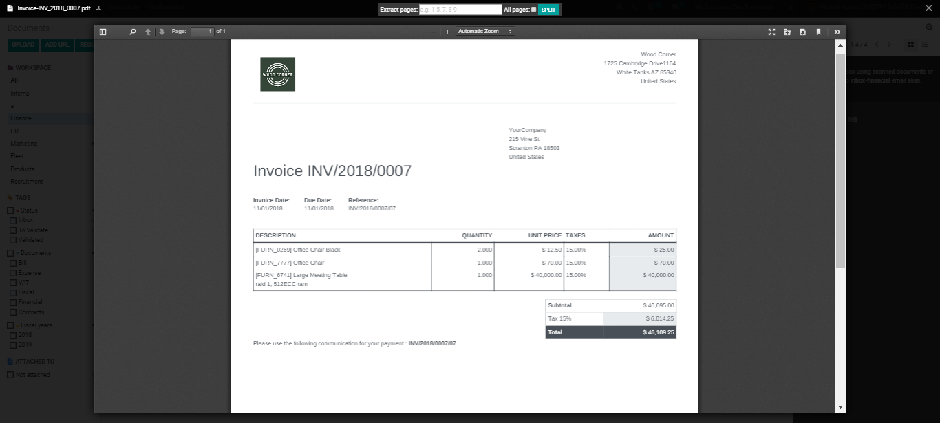

This works the very same for videos as well.

To preview the video, simply click on the icon on left and you are moved to a new screen- a pop-up window to play the video.

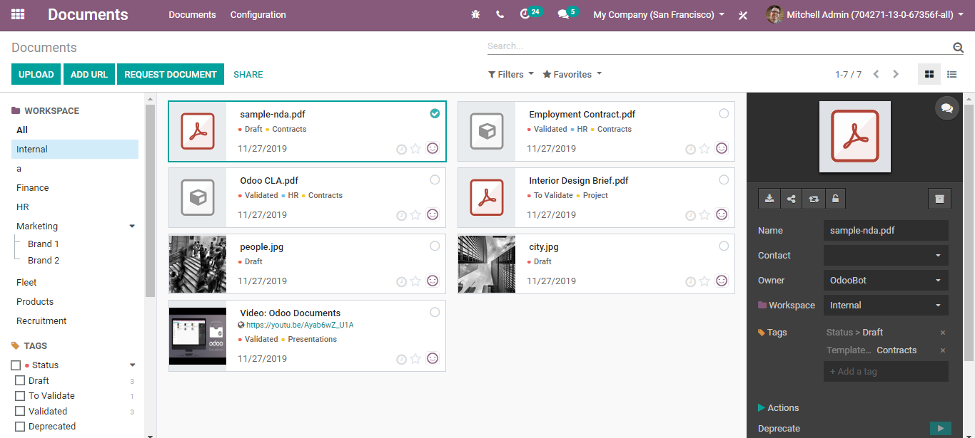

Exit after watching it and you are redirected to your workspace.

Let’s see now how to modify a document.

To do so click on the document on the page,

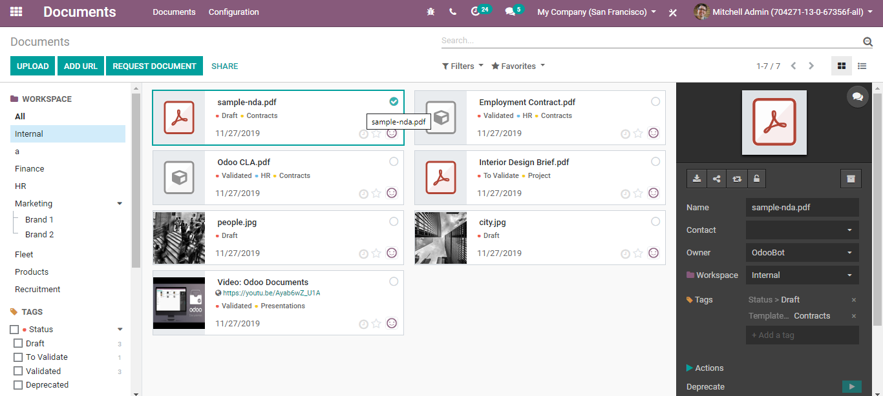

You can see a black coloured edit space on the left. There you can make the modification to your documents say to change the name of your document, add a contact, change the document owner, change the workspace etc. All these changes will be reflected in the document immediately.

One can also find certain additional actions like the following:

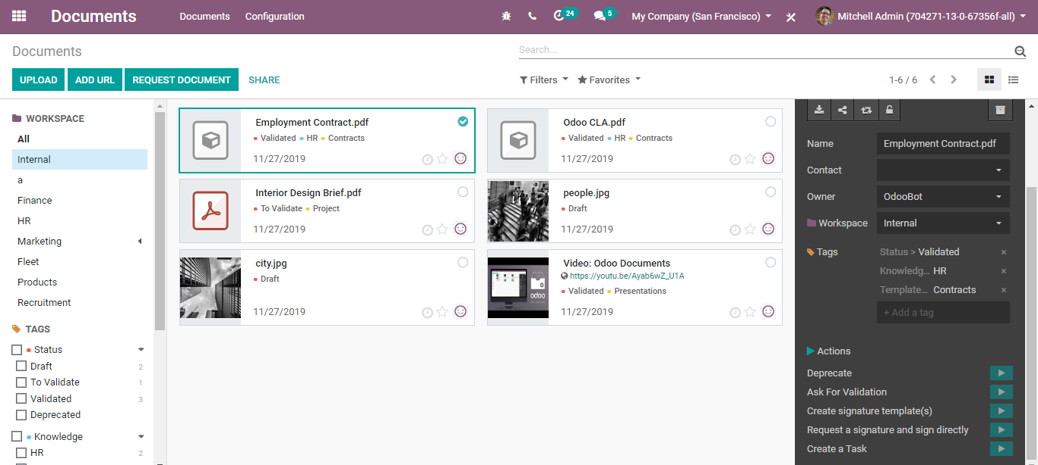

* Deprecate Documents- Disapproving of documents if it’s found irrelevant or incorrect.
* Validate Documents- Easily validation of documents that are sent.
* Create signature templates.
* Request a signature and sign directly.
* Create a Task.

**Linking one workspace to another**

**For that go to Documents >Configuration,**

Create a new workspace.

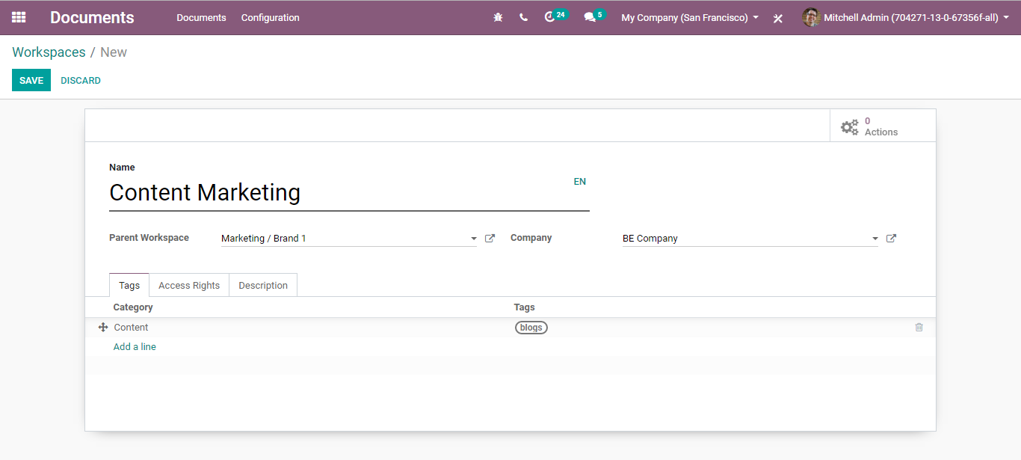

Via giving the parent category for the workspace one can link the workspace to another as the workspace will inherit the tags of its parent category.

**Sharing the documents**

To share the documents and click the share button.

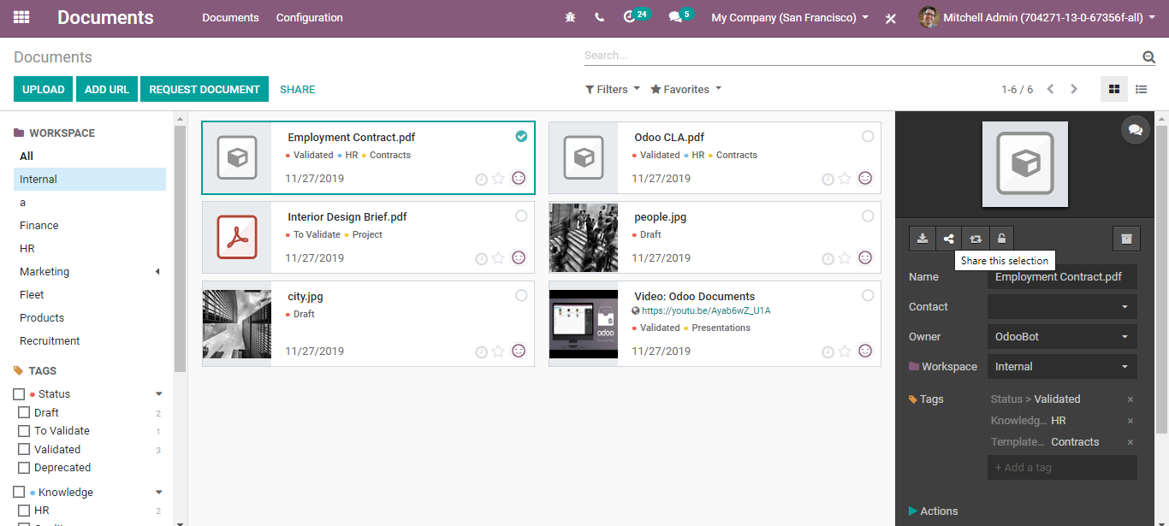

Upon clicking the share button, you will be navigated to a new window like below.

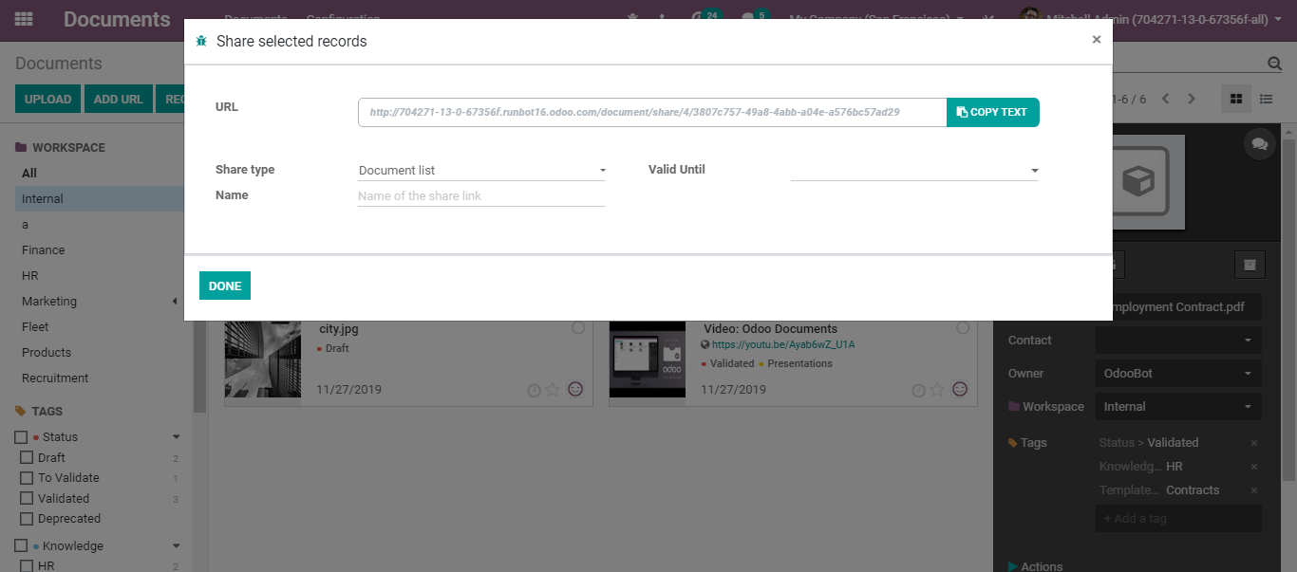

Here you can copy the text, name the share link, set the validity of the link say the link shall be valid only up to this date,

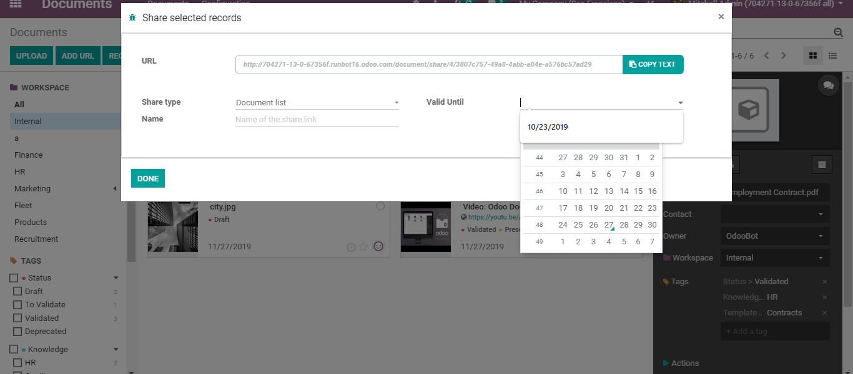

Click DONE to share the individual document.

One can also share the workspace via clicking the SHARE button on top,

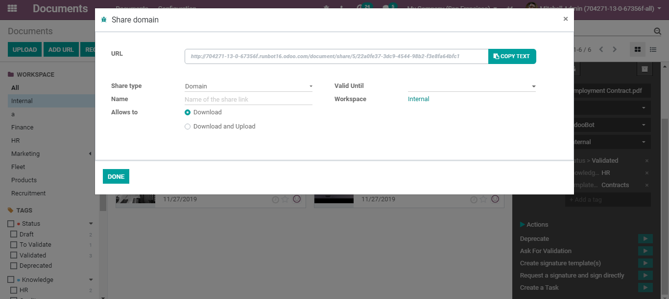

As you see in the above image, you have a couple of options here say

Allow to download or allow to download and upload documents to the workspace.

**Enhanced Communication**

Every internal and external communication can be managed under BUSINESSBOXERP documents. As said before, one can easily upload, Add URLs and Request Documents if you need additional documents to carry out your tasks.

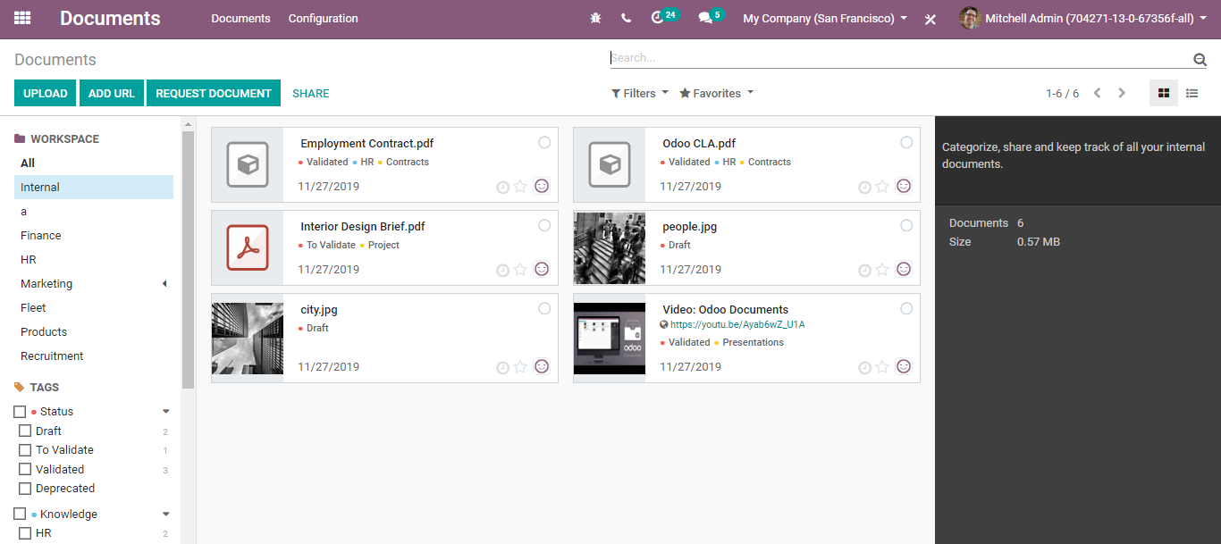

These options help the business at large with its internal communication.

Via clicking the Request Document button, you are redirected to a new window like below.

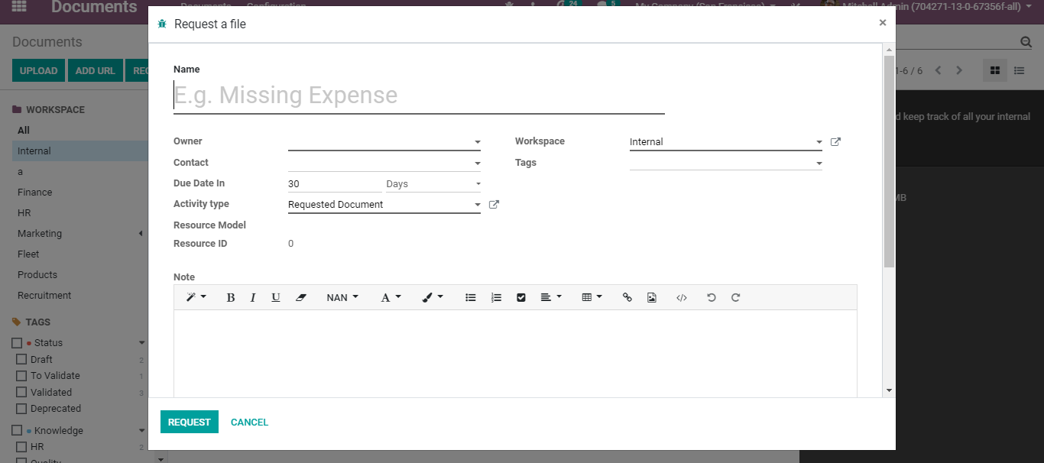

Under the template, the end-user has the option to define the document name, Owner name, Workspace, Due Date, Activity types, Tags etc. There is also a field to add an internal note if any.

Click the Request button to proceed.