**Email Marketing**

Email Marketing is the demonstration of sending notices or any kind of business message over a gathering of individuals, either the potential or current client via email. It assists with an incredible route in convincing the new customers alongside holding current customers to share a third-party ad or generally quickly make any buy move.

BusinessBoxERP Email Marketing improve the business and take them to the next level. It is viewed as a powerful device for developing the business in an all the quicker and successful way.

To start with, firstly install the Module Email marketing from BusinessBoxERP App list.

You can see the interface as soon as you enter the application. You can see the already created mailings in the dashboard.

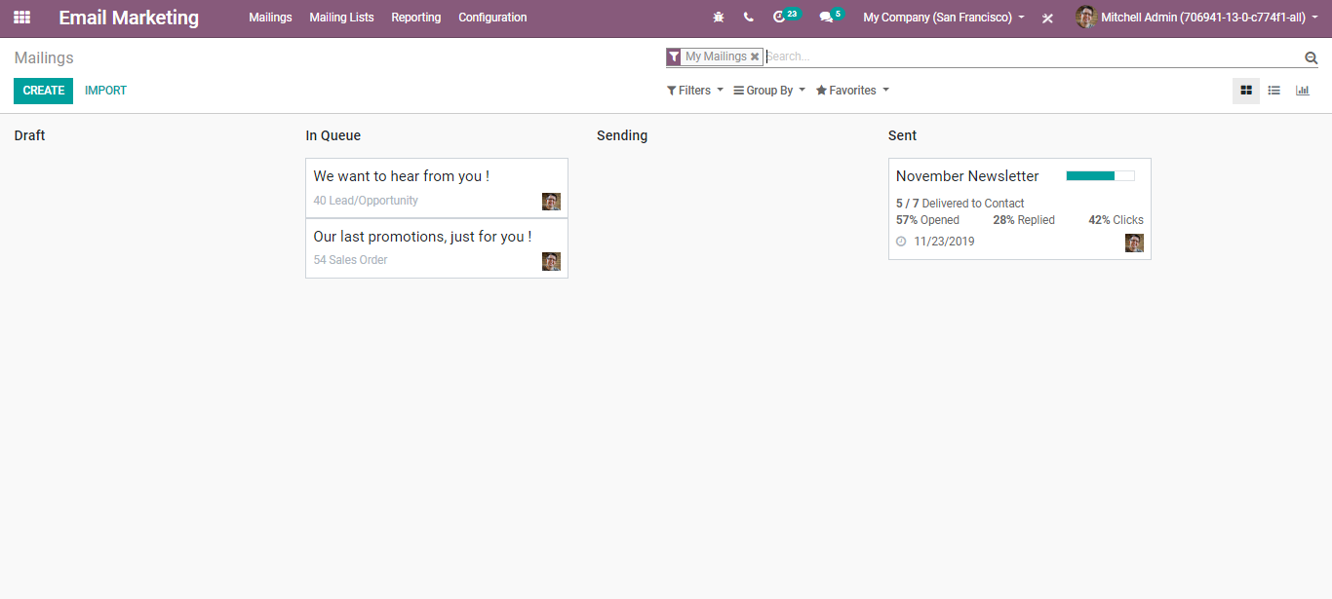

**Mailings**

To create mailings, go to Email Marketing> Mailings > Create

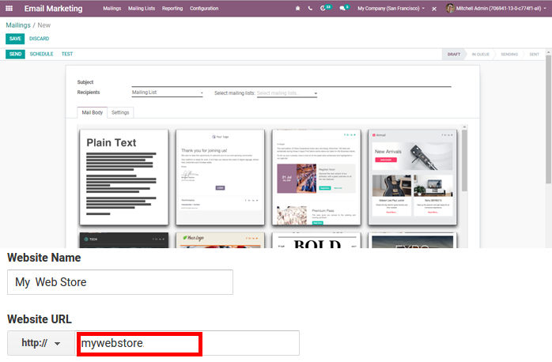

Under the create form:

One can add the subject: Name of the mailing

Recipients: You can choose the recipient models from the drop-down menu say applicants, contact etc.

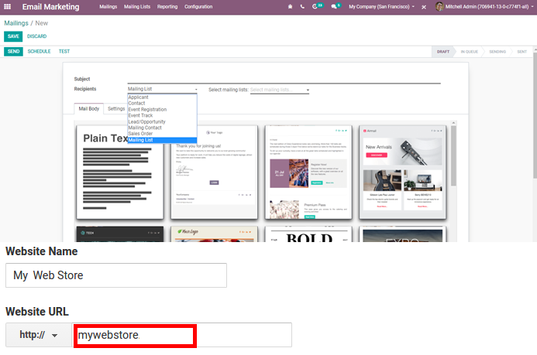

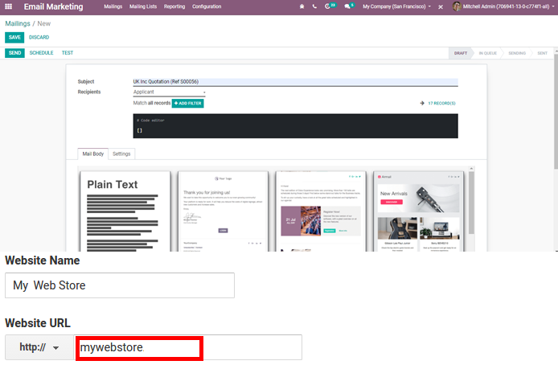

Upon selecting the recipients, we can select the related records. If it is a quotation, we can select the customer etc. depending upon our selection of the recipient. We can add filters for our records.

Mail Body: Depending on your choice, one can choose the template from the roll-down menu.

Settings:

Here you have several other options like Name, Responsible, Reply to, attachments and many more.

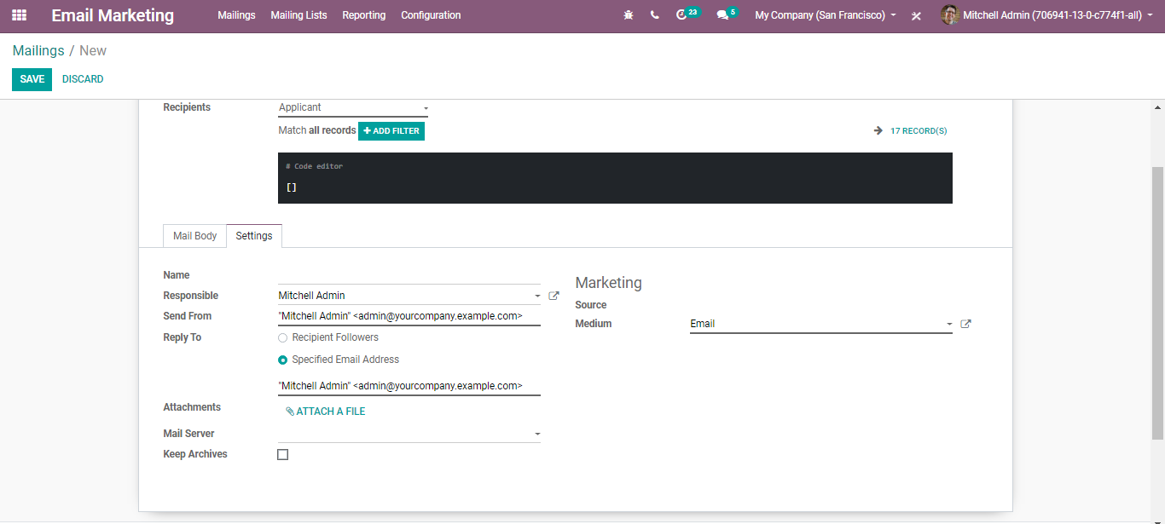

After saving the necessary details, one can send the emails or can schedule for a later date if you want. Click the SCHEDULE button to execute the action.

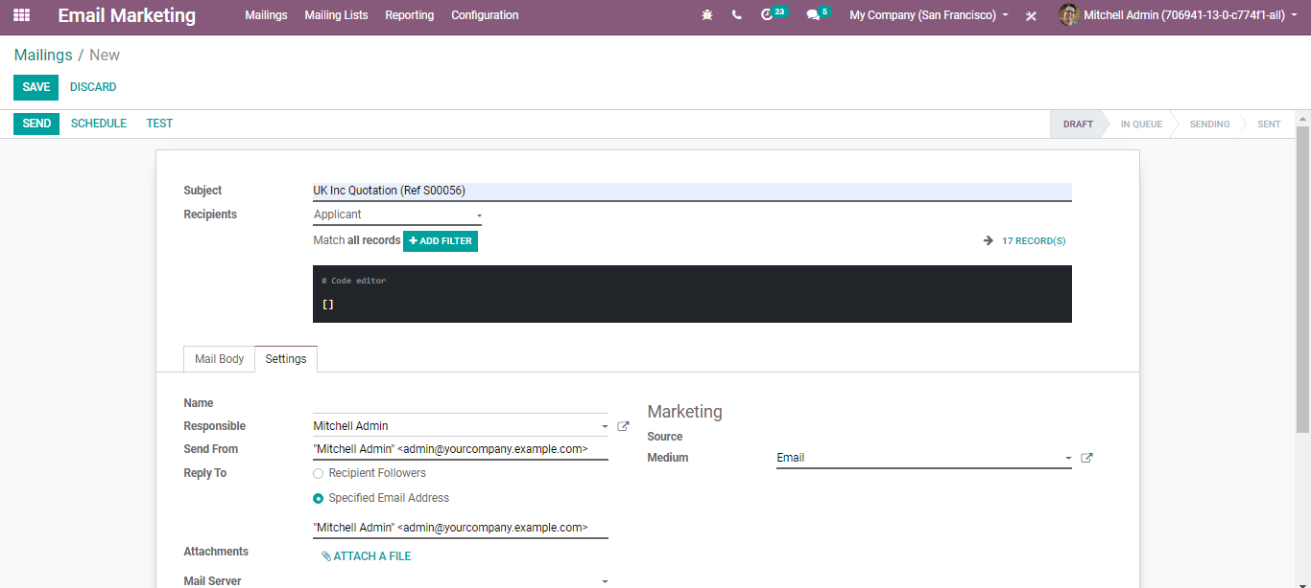

Via clicking the mailing, one can directly review the status of their mail such as count of emails sent, leads, invoices, how many emails opened or how many reviewed or replied etc.

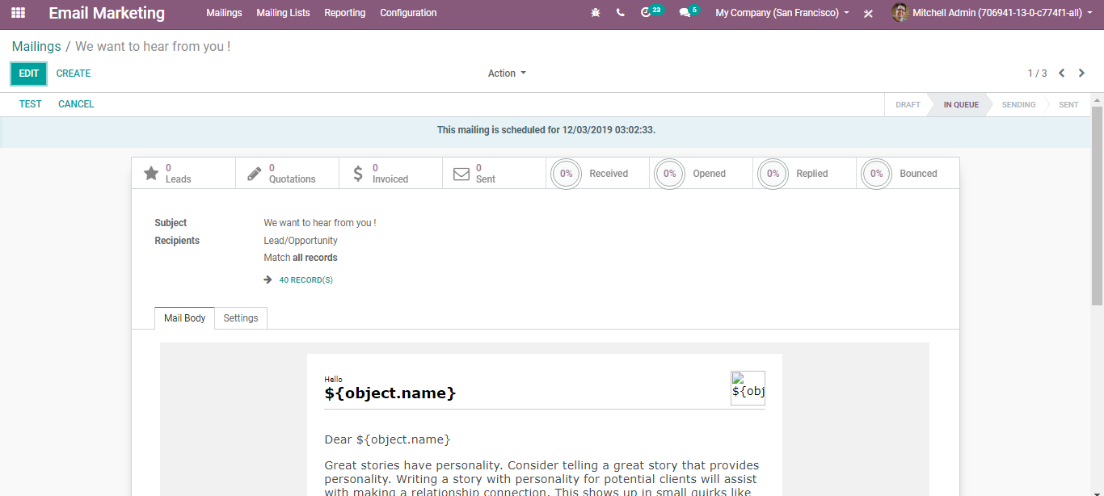

**Mailing Lists**

To create the mailing list for mass mailing, go to Email Marketing > Mailing Lists > Create

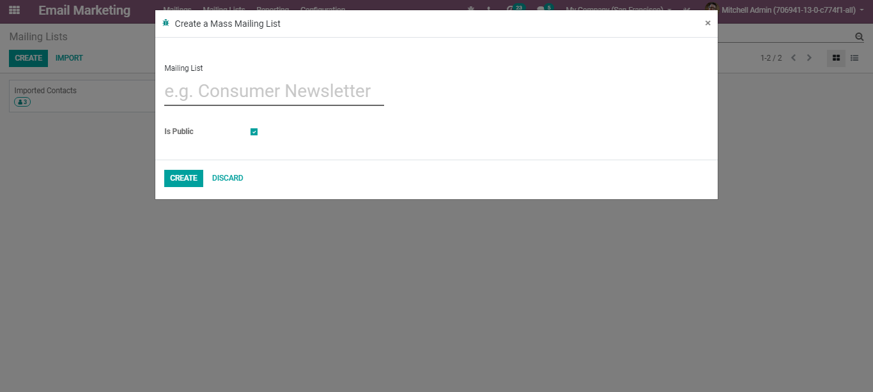

Upon ticking the option - Is Public, the mailing list will be accessible by the recipient on the unsubscription page, allowing him to update his subscription preferences.

When we create the mailing list, we can add recipients to that mailing list.

For that go to, Email Marketing > Mailing Lists > Mailing Lists Contacts> Create

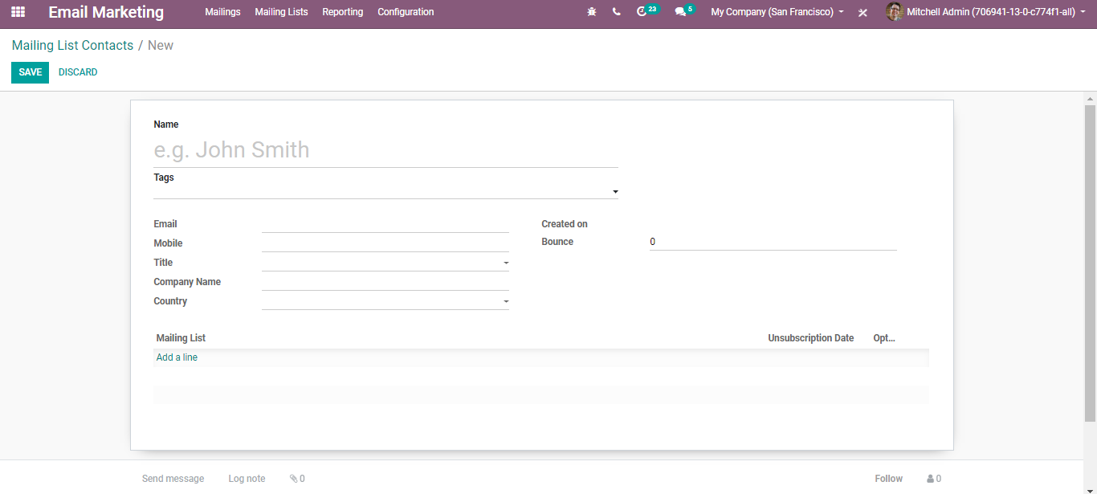

**Blacklist**

To blacklist a contact, go to email marketing > Configuration > Blacklist.

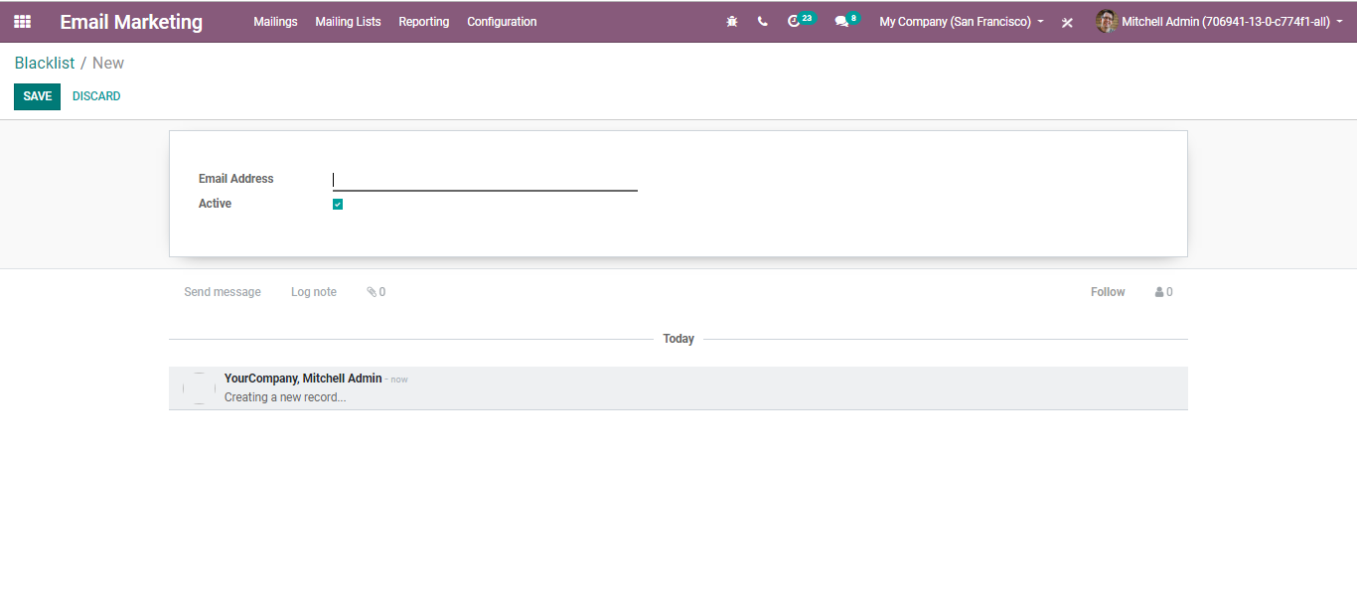

Here you can add an email address to the blacklist. Email addresses that are blacklisted refer to that state where the recipient does not receive any more mass mailing.

Upon going to Email Marketing > Configuration> Settings

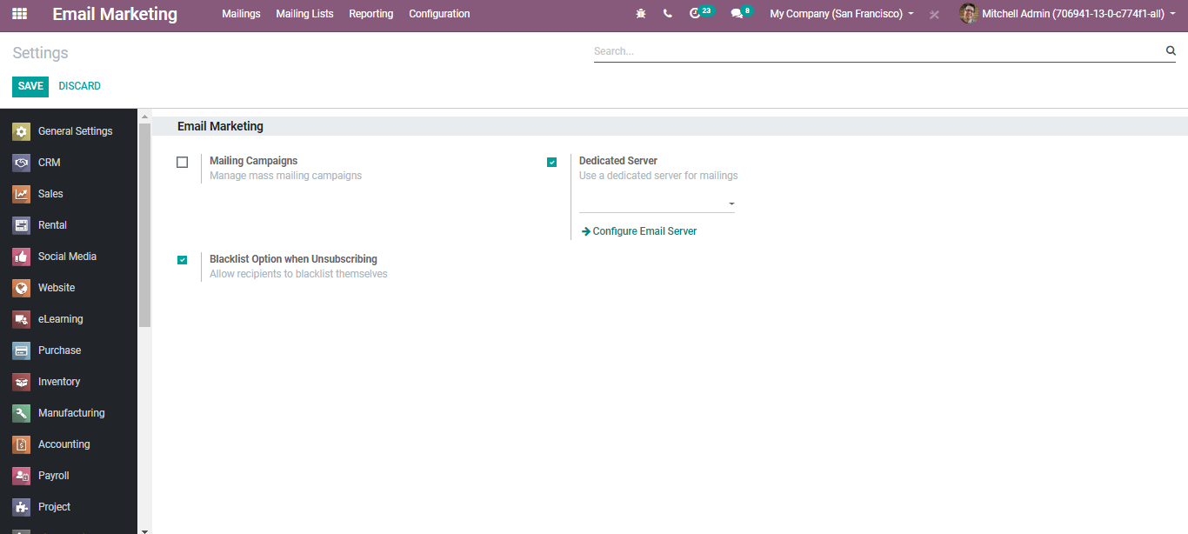

By enabling these options, one can manage Mass mailing campaigns, website Popups and many others.