## Employee Appraisal

Employee performance appraisal acts as a good medium to encourage employees. It helps in optimizing employee performance via regular assessment of the human resource.

BUSINESSBOXERP automates and simplify the appraisal process.

For that firstly install the Employee Appraisal Module.

For that firstly install the Employee Appraisal Module.

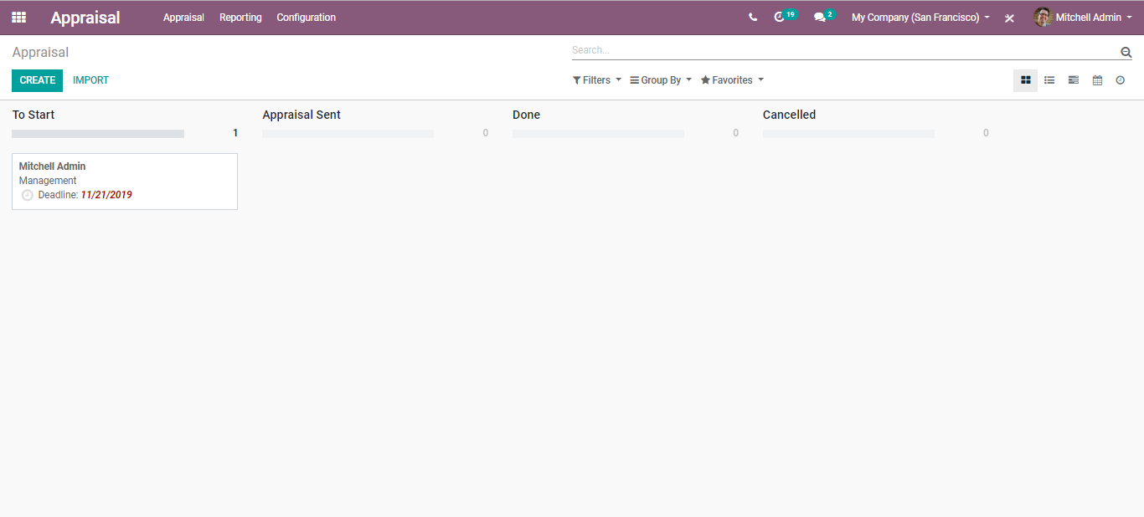

To create a new appraisal plan, click the CREATE button. You will be navigated to a new window like below:

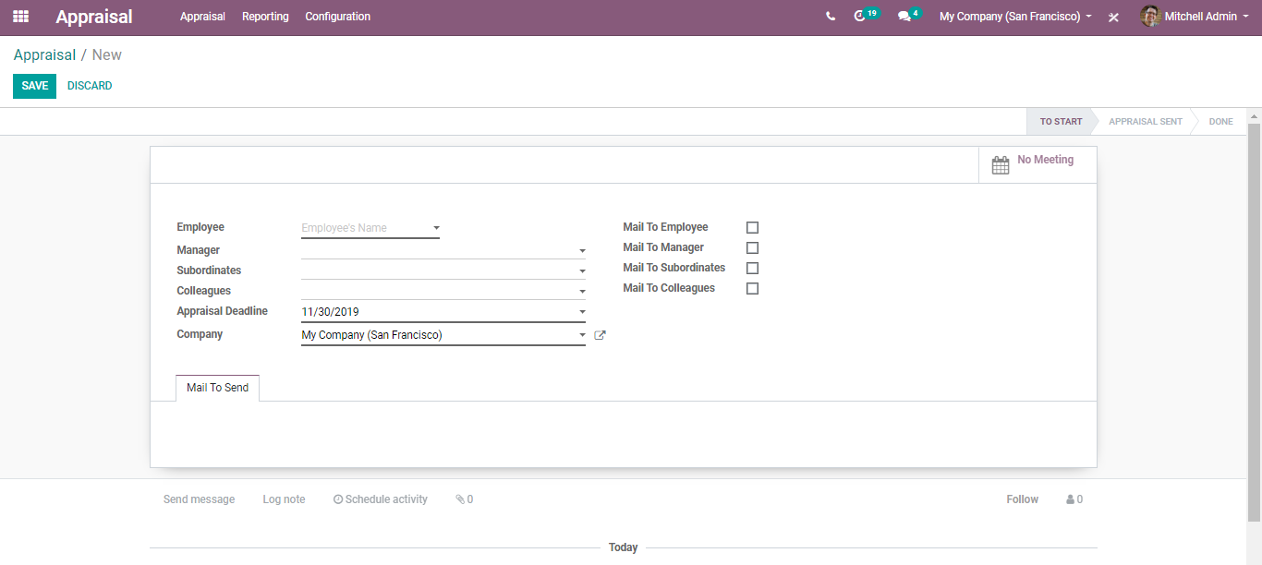

Here you can add the employee’s name, the manager, subordinates, colleagues, appraisal deadlines, company also to whom the appraisal should be sent.

Under Mail to Send, you can compose the matter for instance the Performance Appraisal Form.

After entering all the details, click SAVE to mark the changes.

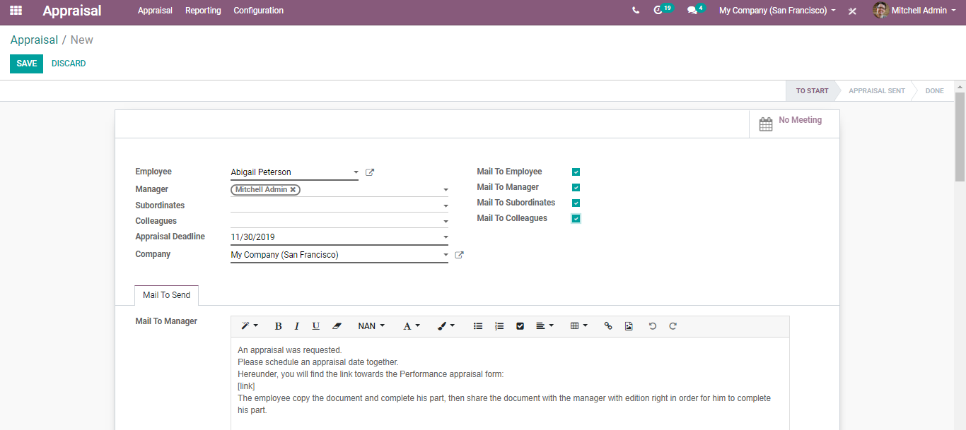

Upon clicking SAVE, you are navigated to a new window like below:

Here you can see the mail to the manager and other appraisal participants (based on selection).

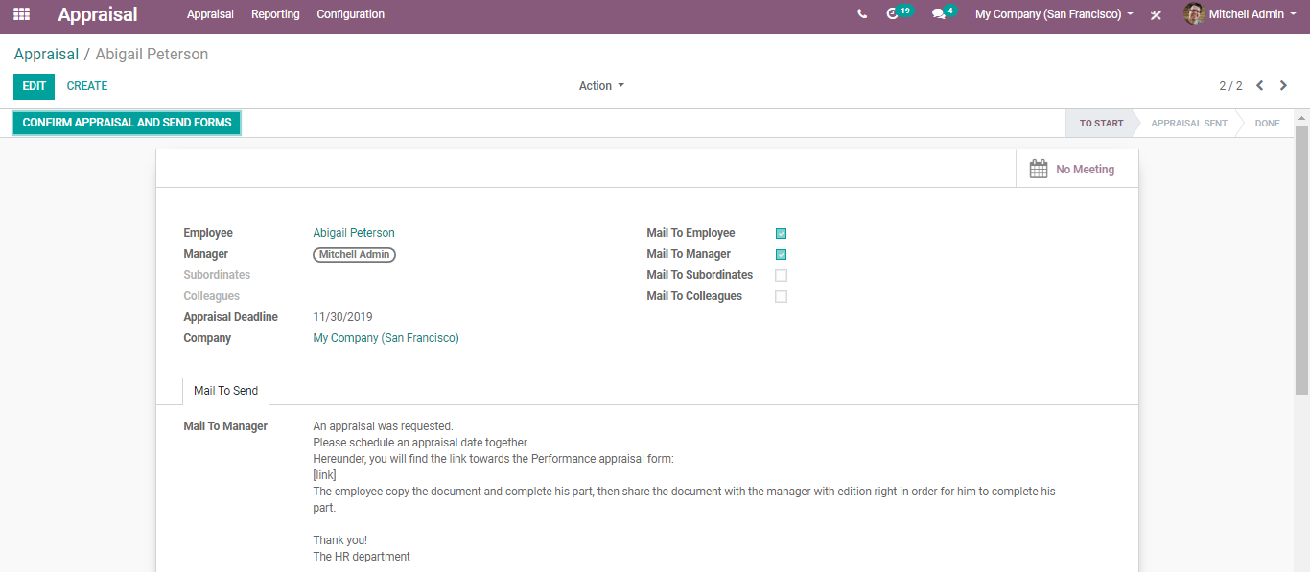

Click CONFIRM APPRAISAL AND SEND FORMS,

Upon clicking, each employee will get an email requesting to complete the Performance Appraisal Form with the link subjecting to it.

On clicking the link, employees will be redirected to the form page. Employees can answer all the questions and managers can review them.

Upon sending the forms to employees, the status gets changed from TO START to APPRAISAL SENT.

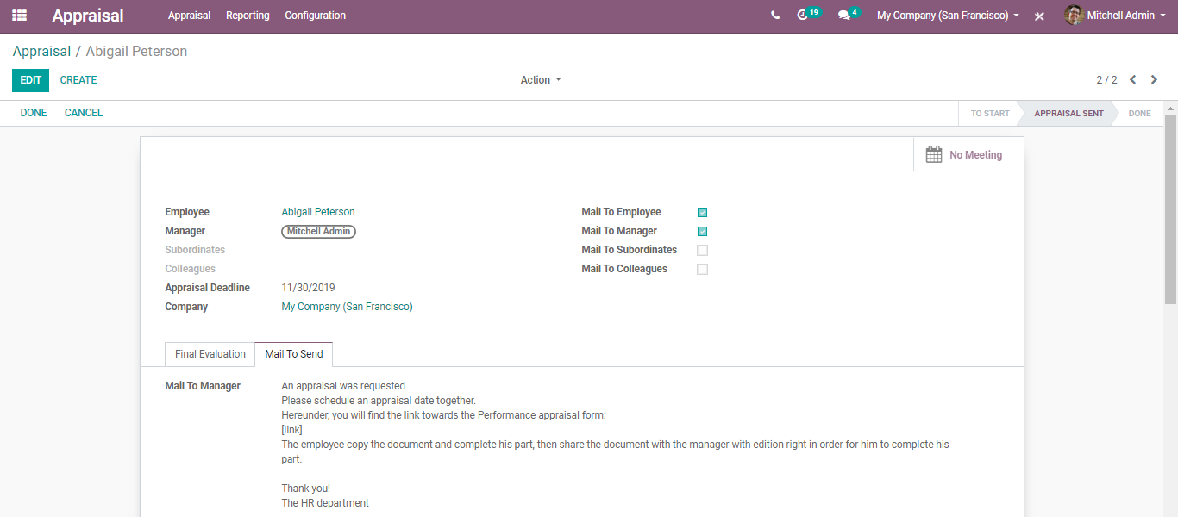

Upon clicking the edit button one can make the changes.

Upon clicking done, your appraisal will be changed as DONE.

You can see the created appraisal with its status in the appraisal dashboard.

Upon clicking the appraisal, you can see the history in the chatter. You can see when the Fill was done when the appraisal was initiated and so on.

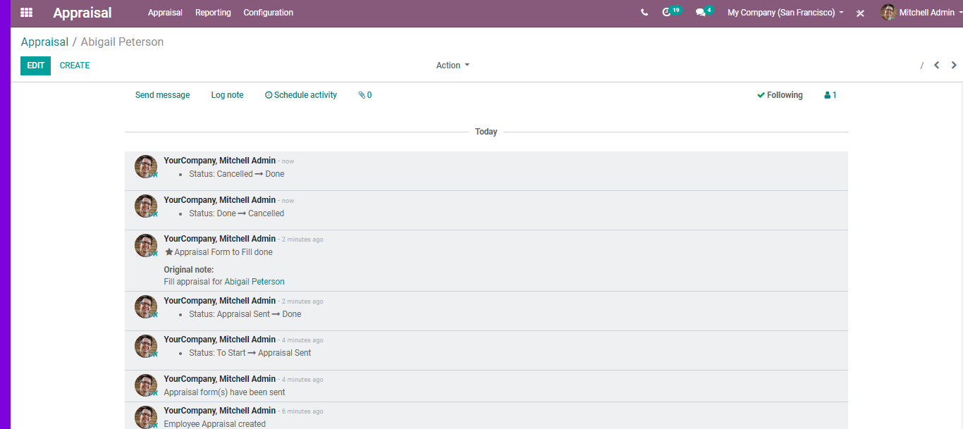

Under the general configuration setting of the Employee Appraisal, one can set the minimum/maximum time between appraisals, appraisal reminders, appraisal participants, appraisal invitations.

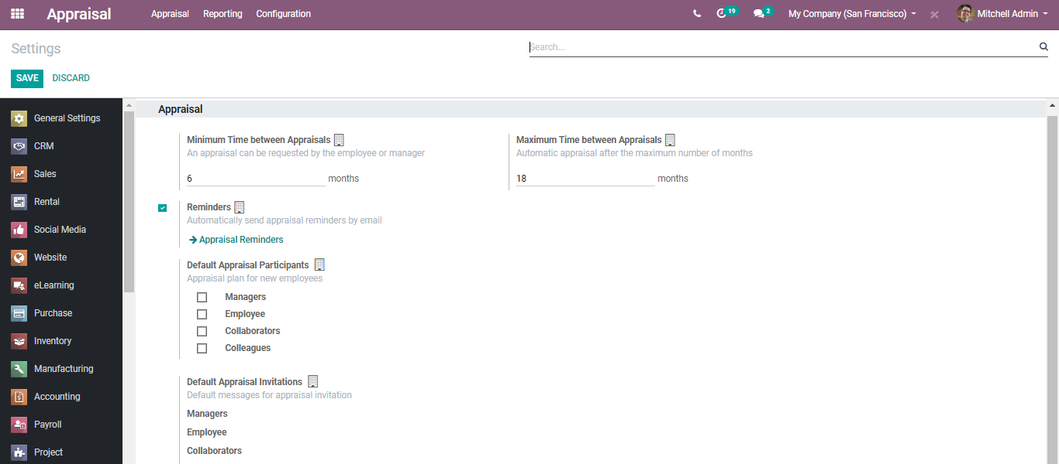

###### Appraisal Reminders

Automatically send appraisal reminders by email.

**Configuration:**

**Appraisal> Configuration> Appraisal Reminders> Create.**

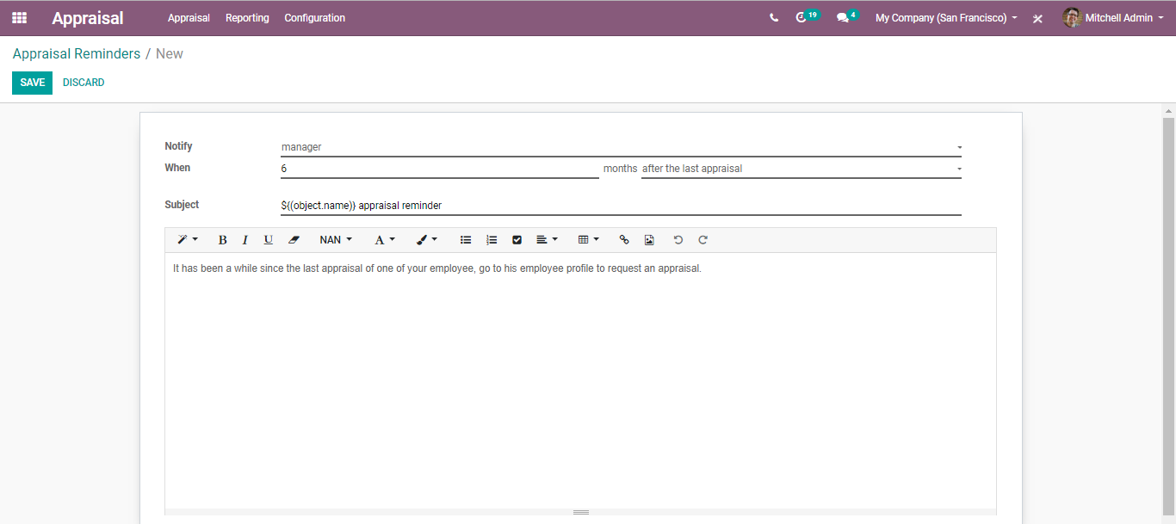

Under the tab, one can specify the name to whom the notice is to be sent, when it should be sent, and the subject.

