**Expense Management**

Managing your employees' daily expenses has never been an easier task. Whether it is travel expenses, office supplies, or any other employee expenditure.

One can access all these receipts and expense submissions from the BUSINESSBOXERP Expenses dashboard. The module makes it easier to create, validate, and refuse the expense in a button click.

Install the expense module from BUSINESSBOXERP apps.

Upon clicking, you are navigated to the dashboard of the expense module. There you can see the expenses created with its description, employee details, account details, status and so on.

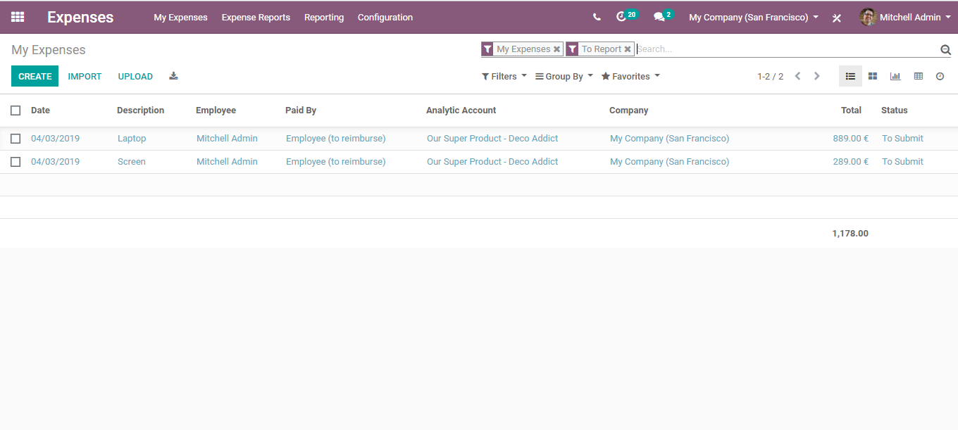

Next, go to the expense configuration menu,

Activate INCOMING EMAILS and REIMBURSE IN PAYSLIP

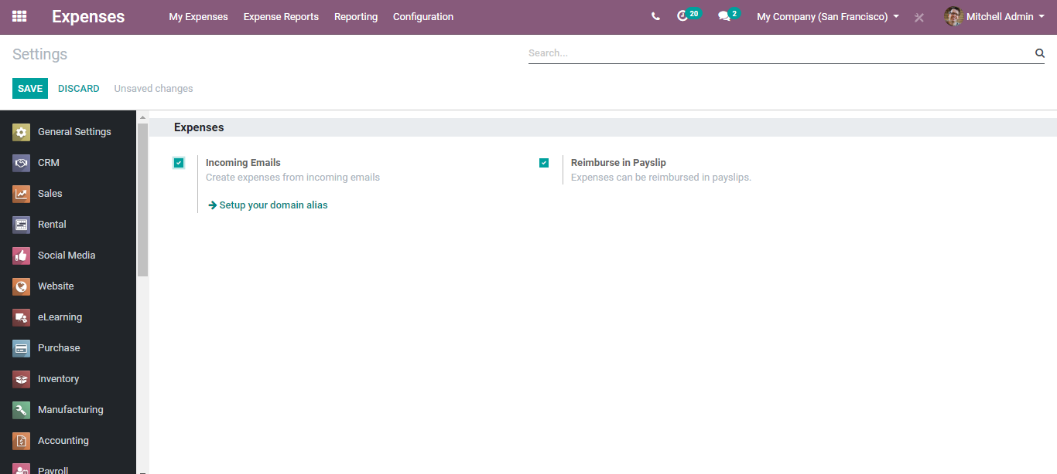

Activating the option, employees can record their expenses by email, and reimburse their expenses in Payslip.

**GENERATE AN EXPENSE**

Single expense creation

Expenses > My Expenses > Create

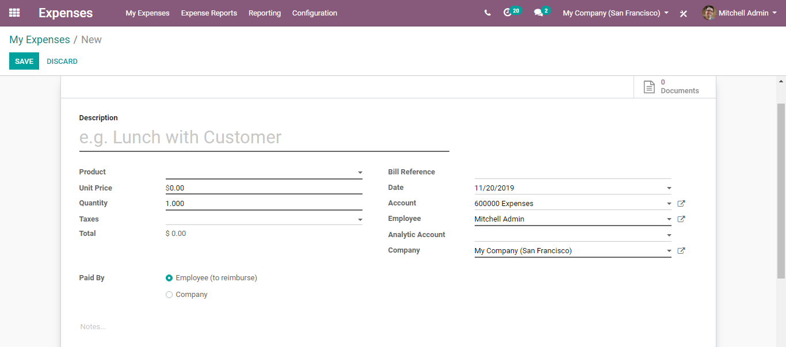

For every new expense, the employee should have:

* Description: This field embeds the reference to bill/ticket.
* Product: This field specifies the type of expense.
* Price: For instance, the accommodation or a quantity to reimburse. For example, if the employee has travelled in a vehicle, the quantity shall be a kilometre.

Fill in the fields and click SAVE.

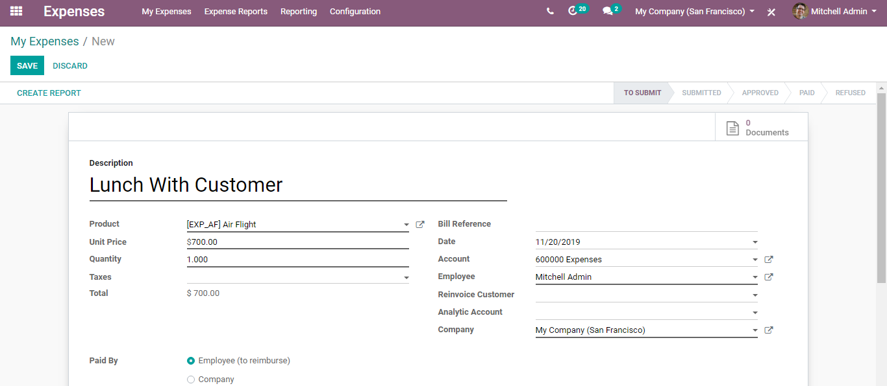

Upon saving, you will be navigated to a new window like below, where you can attach the documents, and create the report.

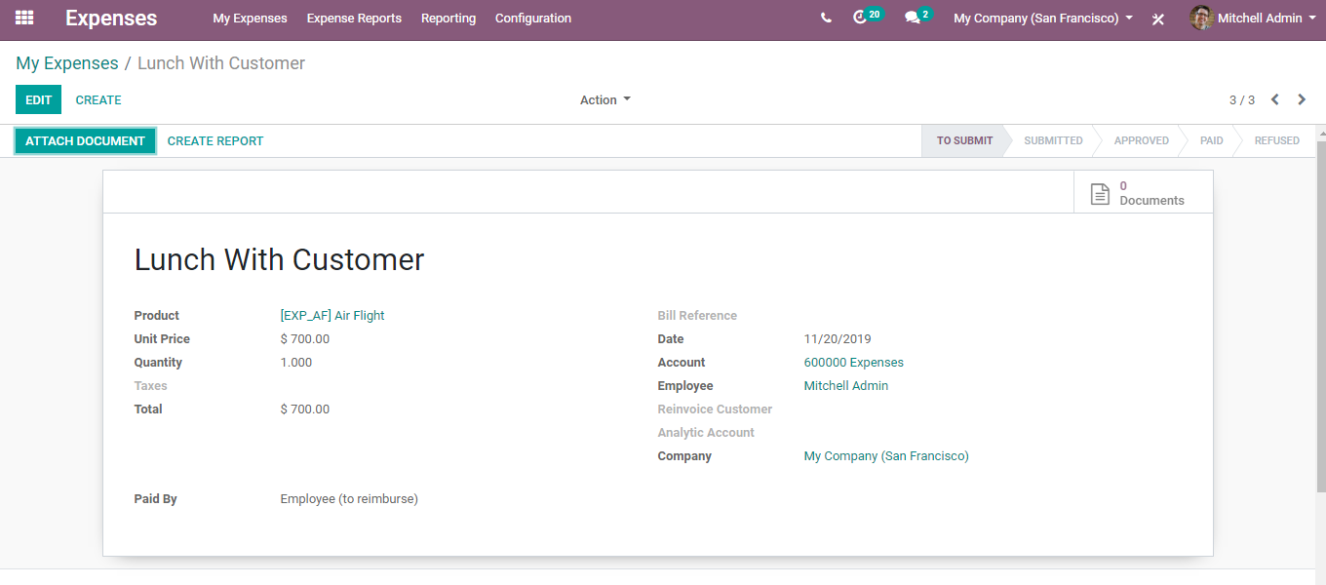

Upon submitting the documents and creating reports, click SUBMIT TO MANAGER button.

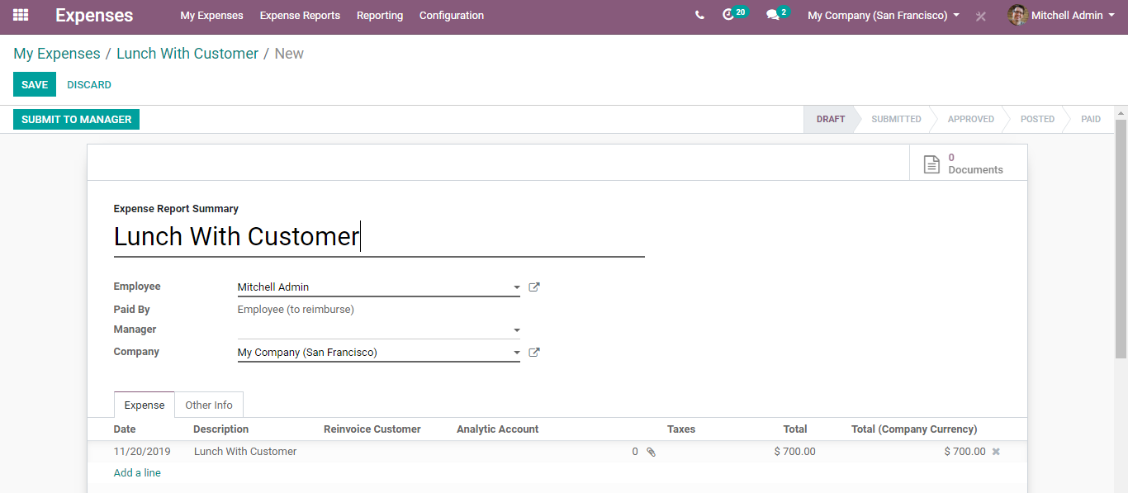

“You can add a greater number of items to the same expense bill.”

“Once the expense is submitted you can see the status of the expense changes”

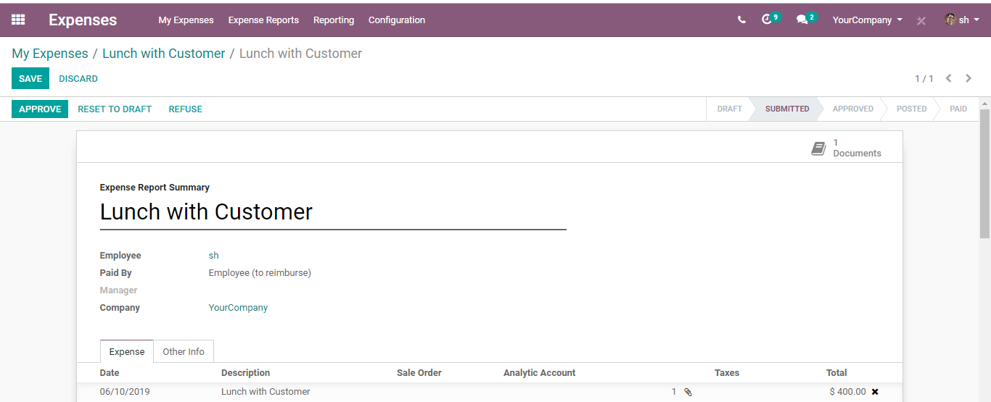

Note: - “Now it has to be approved by an officer level user. Posted means the Payslip is posted in Journal and finally Paid status indicate the actual Payment. All these state changes can be done by different users. Same Rule is Applicable to Expense Report also.”

**EXPENSE APPROVAL BY MANAGER**

Upon creating a record, the expense report must be sent across or submitted to the manager to get them approved.

**To Approve**

**Configuration**

**Expenses> Expense Reports >To Approve**

This provisions the manager to oversee all the expenses that are awaiting approval. From the list, the manager can select a submitted expense, scrutinize it, and take appropriate action.

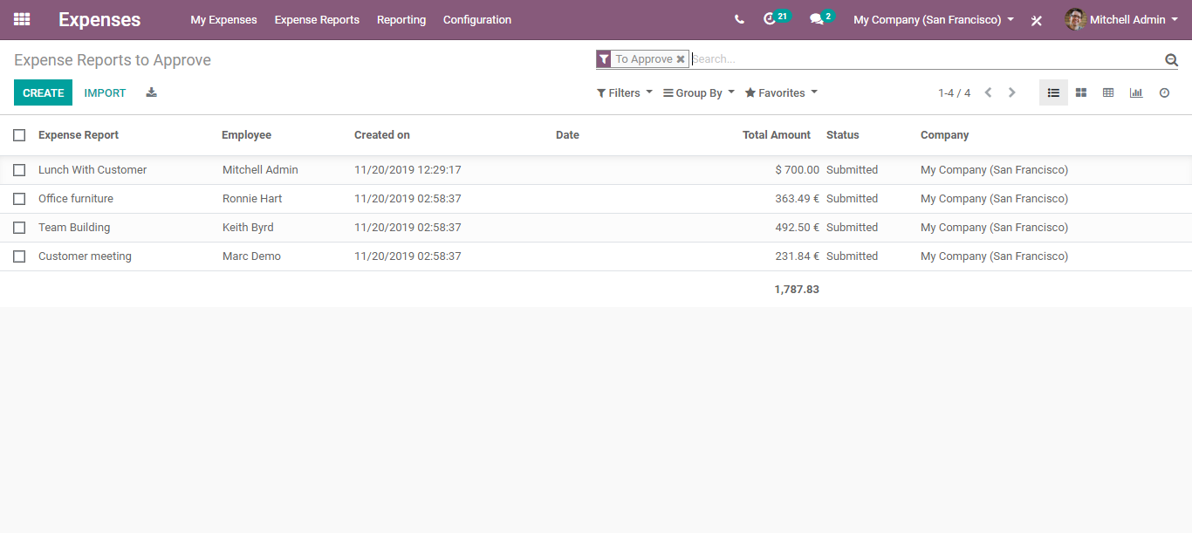

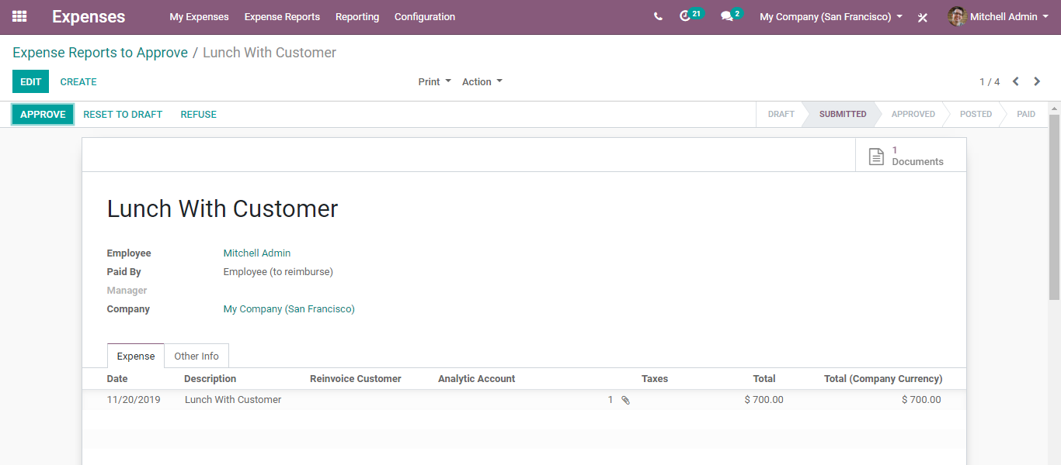

**To Post**

**Configuration**

**Expenses> Expense Reports> To Post**

From the dashboard, you get to see the Expenses Reports to post. From the list, the designated person can select the expense and post the journal entry.

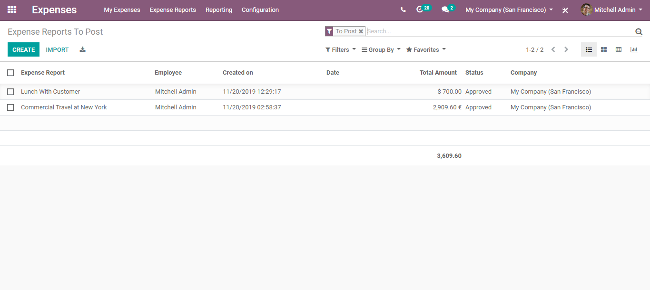

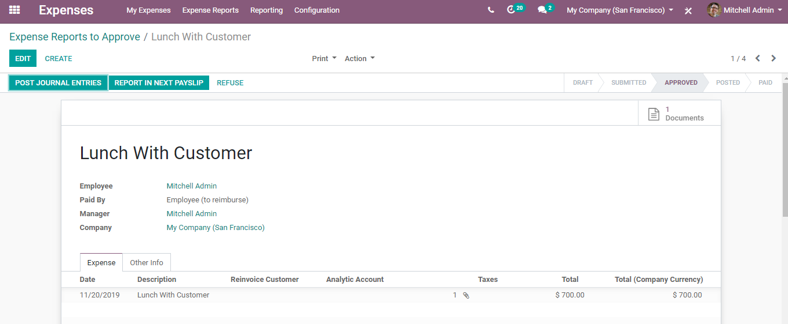

Upon clicking the POST JOURNAL ENTRIES button, the expense gets POSTED. One can see the change in the status bar from APPROVED to POSTED.

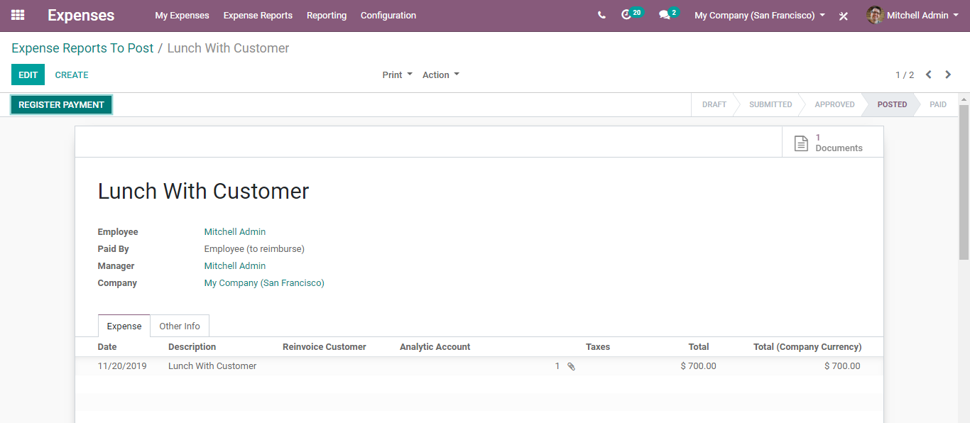

**To Pay**

**Configuration**

**Expenses> Expense Reports> To Pay**

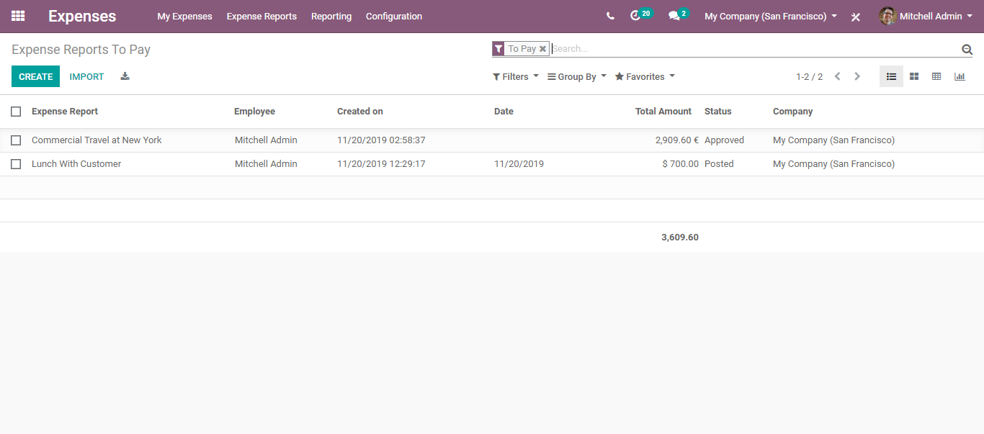

Select the Expense Report to pay from listed.

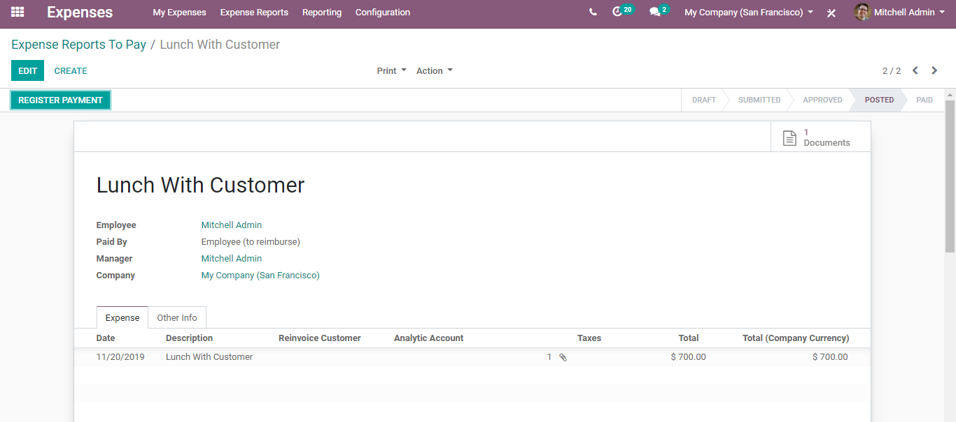

Click the REGISTER PAYMENT button, to make them pay.