## Helpdesk

BUSINESSBOXERP helpdesk helps the customer service teams keep customers happy. BUSINESSBOXERP helpdesk puts all your support tickets in one place so no ticket gets forgotten and your whole team can coordinate effortlessly. Helpdesk brings together tickets from every channel. Your customers can submit tickets by email, or through a fully customizable form on your website.

To start with, firstly install BUSINESSBOXERP Helpdesk from BUSINESSBOXERP Apps.

BUSINESSBOXERP Helpdesk dashboard gives you a top-level overview of all ticket activity. The dashboard lets you quickly access high priority tickets(starred), your unassigned tickets and assigned ones.

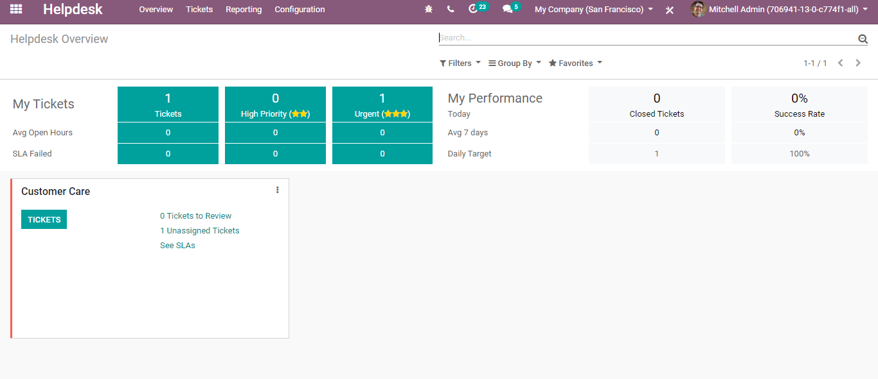

If you go to the configuration menu of the BUSINESSBOXERP Helpdesk, one can configure helpdesk teams, ticket tags, ticket types, stages, SLA Policies, Activity Types.

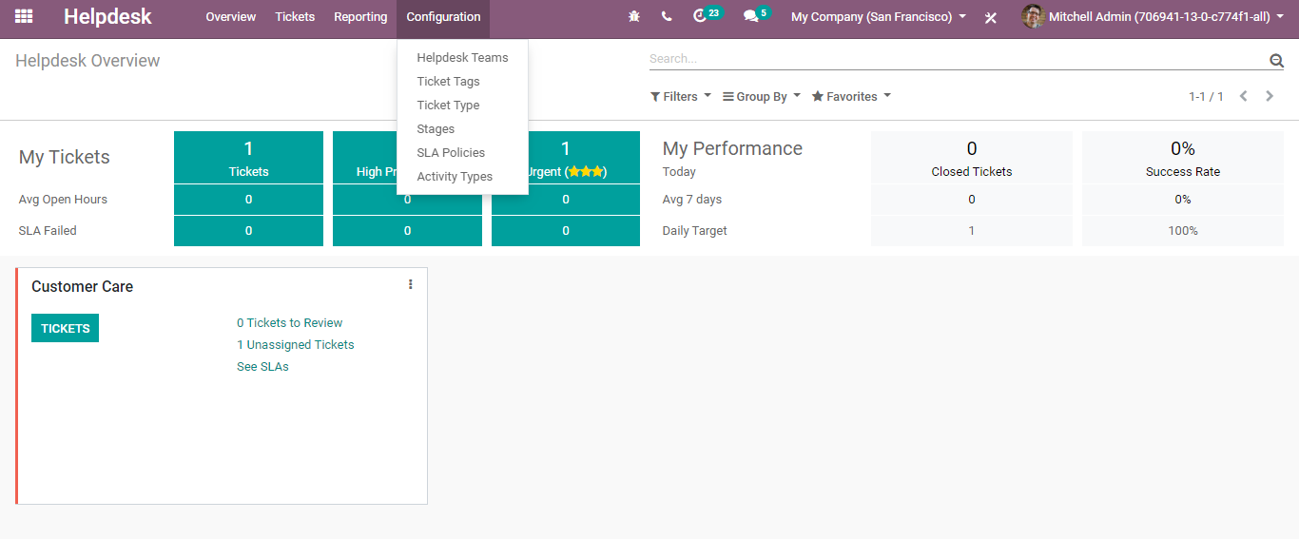

Configuring Helpdesk Team

For that go to **Helpdesk> Configuration>Helpdesk Teams.**

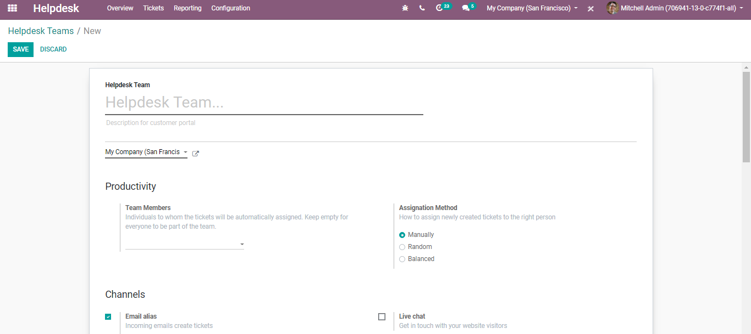

Here one can add the team’s name, description for customer portal, adding team members (Individuals to whom the ticket will be automatically assigned. Keep empty the field for everyone to be a part of the team.)

Assignation Method: How to assign newly created tickets to the right person-

* Manually: Manual assignation of tickets.
* Random: With random assignation, every user gets the same number of tickets.
* Balanced: With balanced assignation, tickets are assigned to the user with the least number of open tickets.

###### **Under channels,**

Channels are the different means for customers to create tickets. Your customers can submit tickets by email, or through a fully customizable form on your website. Even tickets can be created manually from a phone call, live chat conversation or anywhere else with the API.

To do so, you need to activate the following features.

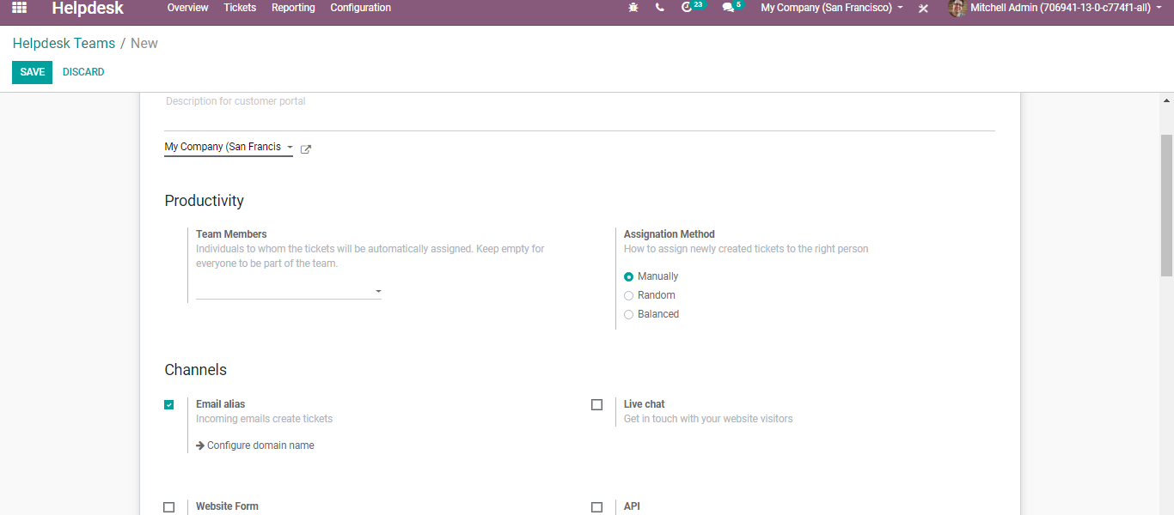

Email Alias: For incoming emails to create tickets. Here the subject line of the email and ticket will be the same.

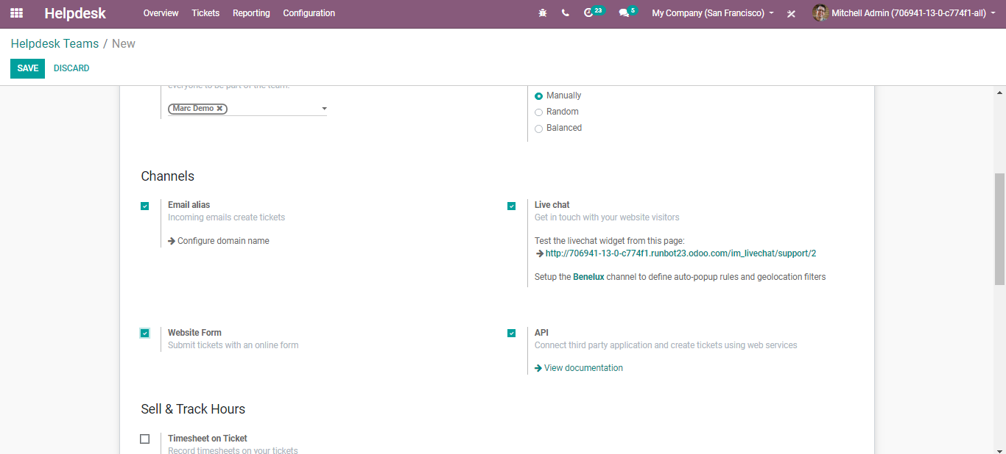

Live Chat: Via enabling the options customers can submit tickets through the live chat option. Customers can use the live chat option and the live chat operator to create the ticket.

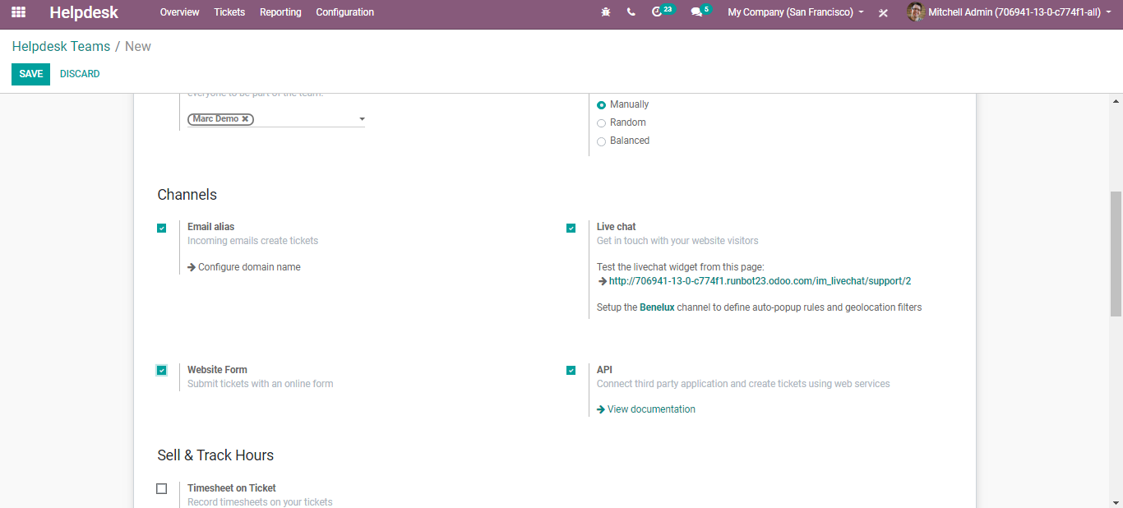

Website Form: With the website, form customers can go to your website and through the website form, they can submit a ticket.

API: Connect third party applications and create tickets using web services.

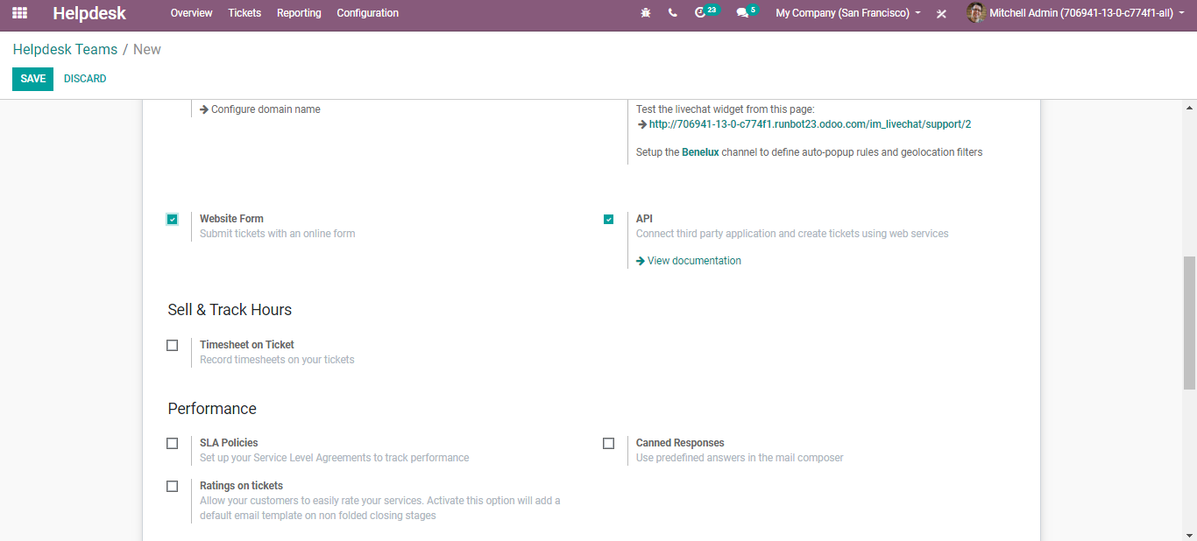

###### **Performances:**

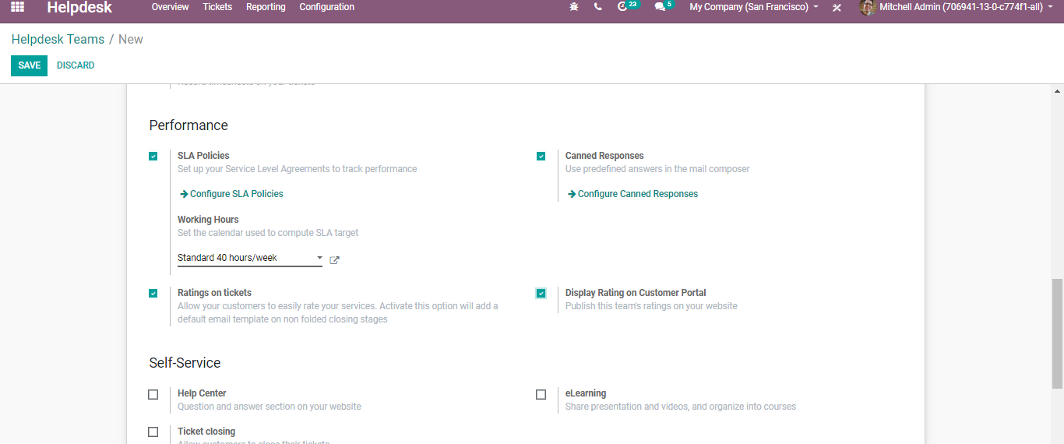

Under the Performances menu, one can set up the Service Level Agreements to track performance, Canned responses (predefined answers in the mail composer), Rating on tickets (Allow your customers to easily rate your services. Activate this option will add a default email template on non-folded closing stages.)

Canned responses and email templates save time on frequent questions.

###### **Self-Service**

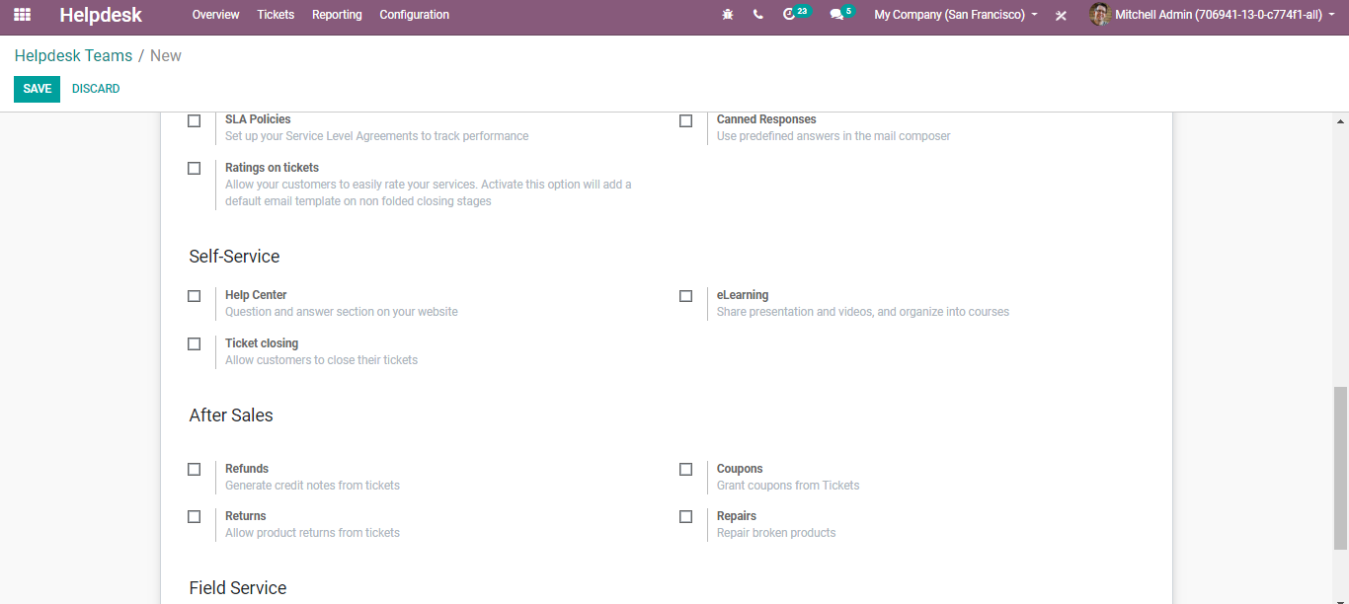

Here you have the option to set a help centre (question and answer section on your website), eLearning (Share presentations and videos), Ticket Closing (Allow customers to close their tickets when a ticket is solved).

###### **After-Sales**

Under after sales you have the options like Refunds – Generate credit notes from tickets, Coupons- Generate coupons from tickets, Returns- Allow product returns from tickets, Repairs-Repair broken products

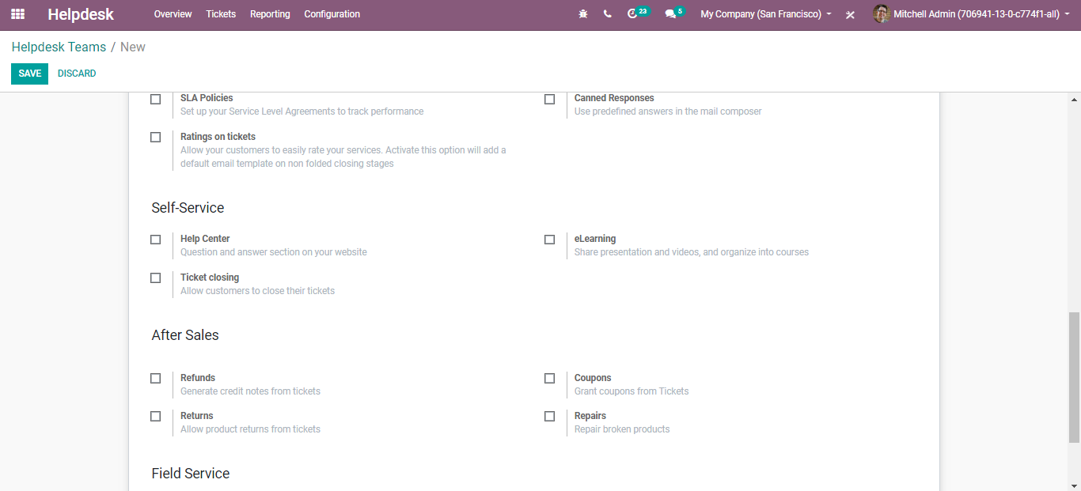

#### **Tickets**

Your customers can submit tickets by email, or through a fully customizable form on your website and all these tickets end up in your support pipeline where you can drag and drop them from stage to stage to track their progress.

**Configuration**

**Helpdesk> All Tickets**

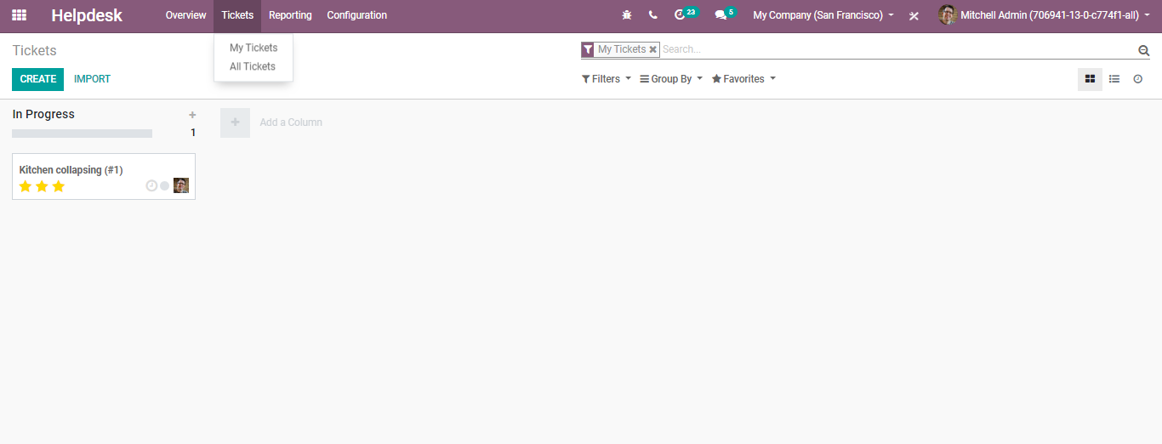

To create a new ticket, click CREATE button

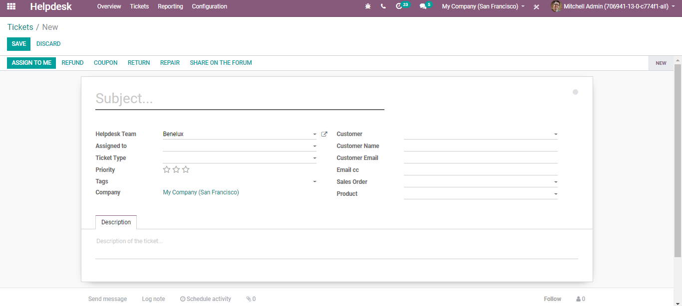

Here you can select the Helpdesk Team, Assigned To, Ticket Type, Set the priority, and many others.

One can even categorize a tag and assign it.

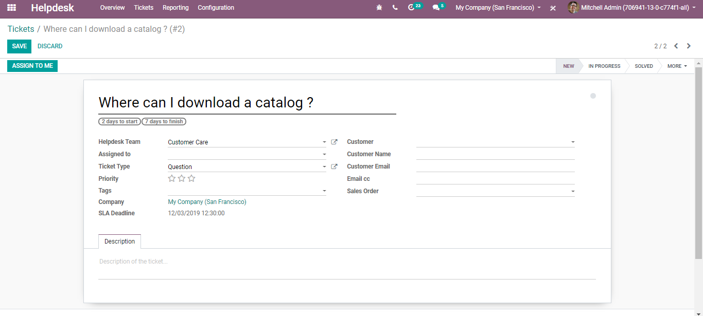

Click SAVE to mark changes.

Once the ticket is solved, the status gets changed to solved.

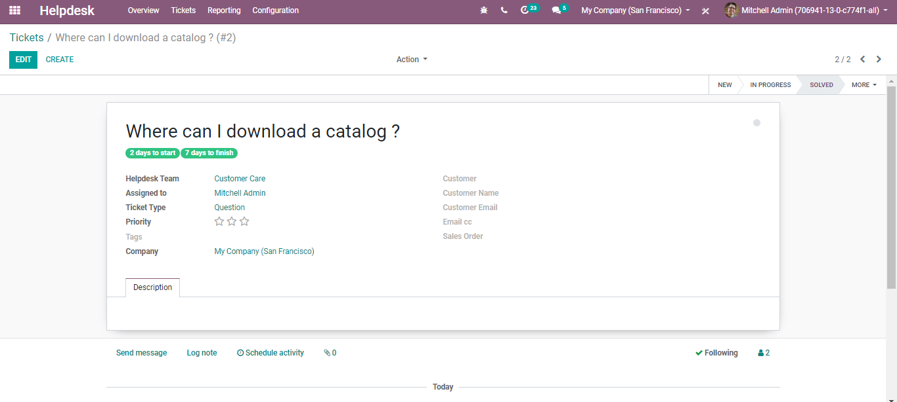

#### **Enhanced Communication**

All communication is centralized in chatter where the whole message history is recorded. So, one need not look far to find out what has been said and done.

One can also add log notes, schedule activities to the customer from the help desk.

