Inventory Management
  - Inventory is the heart of the business; it is from here all other parts of the business get sufficient energy to live. If effectively managed, the business remains healthy, otherwise always messy. BusinessBoxERP inventory management is a resourceful module that can be utilized by any business organization irrespective of its size. It is designed in such a flexible manner. BusinessBoxERP inventory is fully integrated with other applications, such as Purchase, Sales, or Inventory. But is not limited to those processes, it is also fully integrated with our e-Commerce, Manufacturing and Repairs applications. To Access the inventory and warehouse management module in your ERP, you must install the ‘Inventory Management’ app from BusinessBoxERP.
  - BusinessBoxERP inventory management makes a worthy product to use because of the following features.
  - Clean and Fast
  - BusinessBoxERP Double entry inventory management, flexible design, modern user interface, mobile control and tracking mechanisms make BusinessBoxERP a clean and fast performing ERP.
  - Basic operation support
  - Prepare delivery order in simple steps, control and manage incoming shipments, prepare inventory counts (cycle counts), multiple location management, barcode-based packing, efficient scrap management, stock transfer option etc. BusinessBoxERP supports all the basic and advanced operations taking place in a warehouse.
  - Advanced Routing
  - BusinessBoxERP advanced routing support operations like:
  - Drop-shipping: Deliver to customers straight from your supplier based on products, orders, or customers.
  - Cross-Docking: Unload incoming material and directly transfer to outbound gates with little to no storage in between.
  - Put away & Removal strategies
  - Define your storage and removal strategies, FIFO, nearest available zone, LIFO, etc.
  - Pick - Pack - Ship
  - Design your order process flow. Deliver to customers in one step (delivery order) or several steps: picking, packing, and shipping.
  - Push & Pull Routes
  - Design your product routes to automate transfer orders between warehouses or locations.
  - Multi-Warehouses
  - Manage all your warehouses with the same system and define replenishment rules between warehouses.
  - Replenishments
  - To keep your inventory properly replenished, BusinessBoxERP provides options like
  - Minimum Stock: Have proposition of purchase orders (or request for quotations) created by BusinessBoxERP based on your future stock forecast.
  - Purchase Propositions
  - Get purchase order propositions based on supplier lead times, product demand and inventory forecasts.
  - Make-to-Order
  - Purchase raw materials or manufacture products to order. Define your routes specific to warehouses, products, orders, etc.
  - Request for Quotations
  - Want to negotiate a price with suppliers every time you buy a specific product? BusinessBoxERP can trigger a request for quotations automatically based on future needs.
  - Traceability
  - Tracking your product inside and outside the inventory is a challenging task. But BusinessBoxERP traceability features like ‘Lots Tracking,’ ‘Activity Log,’ ‘Serial Numbers,’ ‘Perpetual valuation’ make it easier for you.
  - Product Types
  - BusinessBoxERP supports several product types that have different behaviour: physical products, consumables, services, digital products.
  - Kits
  - Seep’s kitting features allow your salesperson to sell a kit, but you will deliver a set of products.
  - Custom fields
  - Add as many custom fields as you want on products to handle your business needs.
  - Multi-Level Variants
  - Define multiple level variants in just a few clicks. Create a matrix based on colours, sizes, attributes, etc.
  - Multiple units of measures
  - BusinessBoxERP supports multiple units of measures and converts automatically for you: buy a pallet of beer, sell packs of beers.

  - Expiration Dates
  - Track expiration dates on products.
  - Multiple barcodes
  - Create custom barcodes with specific codes to implement desired behaviours, such as a specific promotion.
  - Business intelligence
  - The capability of BusinessBoxERP BI and reporting tools are already explained in many modules. BusinessBoxERP BI tools perform similar admirable jobs here in the Manufacturing module by providing reports like inventory forecast, customer transaction drill-down reports, perpetual inventory valuation reports etc.
  - If we compare BusinessBoxERP Inventory with proprietary ERP Microsoft Dynamics, we can find many features like Freight Carrier Integration, Consignee stock management, etc. are not available there. And if the comparison is between SAP and BusinessBoxERP, BusinessBoxERP has the advantage of features like multiple variant support, Up and Down traceability, more effective barcode support etc.
  - Before going to the detailed operations of BusinessBoxERP inventory management, let us first explore some of the terms used in the modules. It will give you a better understanding of the working BusinessBoxERP Inventory management system.
  - Warehouse: A warehouse in BusinessBoxERP is a location where you store products. It is either a physical or a virtual warehouse. It could be a store or a repository.
  - Location: Locations are used to structure storage zones within a warehouse. In addition to internal locations (your warehouse), BusinessBoxERP has locations for suppliers, customers, inventory loss counterparts, etc.
  - Lots: Lots are a batch of products identified with a unique barcode or serial number. All items of a lot are from the same product. (E.g., a set of twenty-four bottles) Usually, lots come from manufacturing order batches or procurements.
  - Serial Number: A serial number is a unique identifier of a specific product. Technically, serial numbers are like having a lot of one unique item.
  - Unit of Measure: Define how the quantity of products is expressed. Meters, Pounds, Pack of twenty-four, Kilograms etc. Unit of measure of the same category (ex: size) can be converted to each other’s (m, cm, mm) using a fixed ratio.
  - Consumable: A product for which you do not want to manage the inventory level (no quantity on hand or forecasted) but that you can receive and deliver. When this product is needed BusinessBoxERP suppose that you always have enough stock.
  - Stockable: A product for which you want to manage the inventory level.
  - Package: A package contains several products (identified by their serial number/lots or not). Example: a box containing knives and forks.
  - Procurement: A procurement is a request for a specific quantity of products to a specific location. Procurement is automatically triggered by other documents: Sale orders, Minimum Stock Rules, and Procurement rules. You can trigger the procurement manually. When procurements are triggered automatically, you should always pay attention to the exceptions (e.g., a product should be purchased from a vendor, but no supplier is defined).
  - Routes: Routes define paths the product must follow. Routes may be applicable or not, depending on the products, sales order lines, warehouse, etc. To fulfil a procurement, the system will search for rules belonging to routes that are defined in the related product/sale order.
  - Push Rules: Push rules trigger when products enter a specific location. They automatically move the product to a new location. Whether a push rule can be used depends on applicable routes.
  - Procurement Rules or Pull Rules: Procurement rules describe how procurements on specific locations should be fulfilled e.g.: where the product should come from (source location), whether the procurement is MTO or MTS etc.
  - Procurement Group: Routes and rules define inventory moves. For every rule, a document type is provided: Picking, Packing, Delivery Order, Purchase Order etc. Moves are grouped within the same document type if their procurement group and locations are the same.
  - Stock Moves: Stock moves represent the transit of goods and materials between locations.
  - Quantity On Hand: The quantity of a specific product that is currently in a warehouse or location.
  - Forecasted Quantity: The number of products you can sell for a specific warehouse or location. It is defined as the quantity on Hand - Future Delivery Orders + Future incoming shipments + Future manufactured units.
  - Reordering Rules: It defines the conditions for BusinessBoxERP to automatically trigger a request for procurement (buying at a supplier or launching a manufacturing order). It is triggered when the forecasted quantity meets the minimum stock rule.
  - Cross-Dock: Cross-docking is a practice in the logistics of unloading materials from an incoming semi-trailer truck or railroad car and loading these materials directly into outbound trucks, trailers, or rail cars, with no storage in between. (Does not go to the stock, directly from incoming to packing zone)
  - Drop-Shipping: Move products from the vendor/manufacturer directly to the customer (could be retailer or consumer) without going through the usual distribution channels. Products are sent directly from the vendor to the customer, without passing through your warehouse.
  - Removal Strategies: The strategy to use to select which product to pick for a specific operation. Example: FIFO, LIFO, FEFO.
  - Put away Strategies: the strategy to use to decide in which location a specific product should be set when arriving somewhere. (Example: cables go in rack three, storage A)
  - Scrap: A product that is broken or outdated. Scrapping a product removes it from the stock.
  - PRODUCT CONFIGURATION
  - CREATE NEW PRODUCT
  - For that go to Inventory > Master Data > Product > Create.
  - BusinessBoxERP will enlist a set of products for you. But one can create a product depending on the business requirement and needs via clicking the button CREATE.
  - 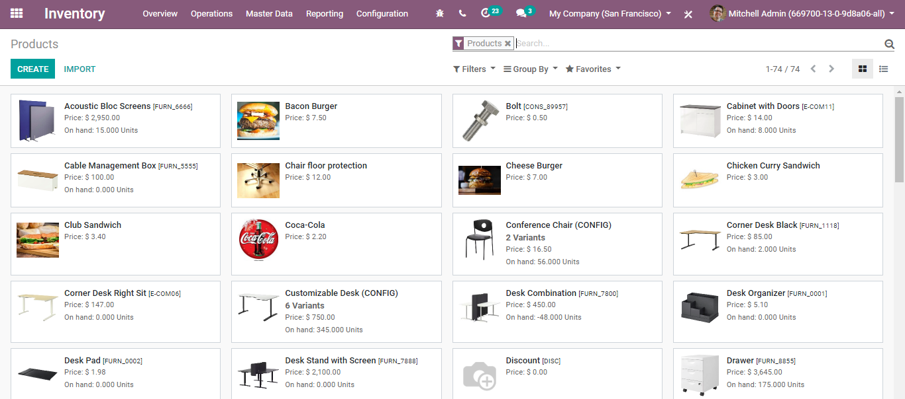
  - Via clicking the CREATE button, you will be navigated to a new window like below:
  - 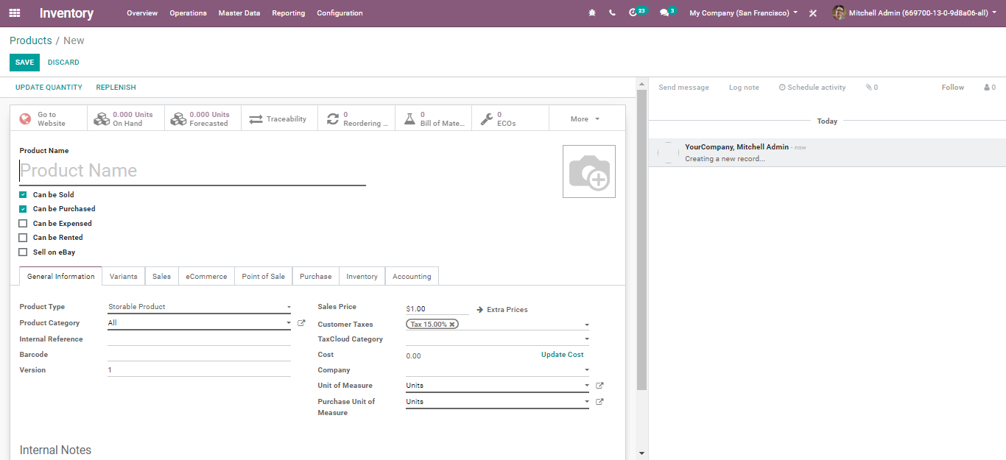
  - The create form has the following fields:
  - Product name: It is the name that will be displayed on all other screens that refer to this specific product.
  - Can be Sold: To remove a product from showing up on the ‘sales product’ list, uncheck the Can be Sold button. This is used while creating a raw material or a product for internal consumption.
  - Product Type: Product Type is the first option on the Information tab. There are three available product types:
  - 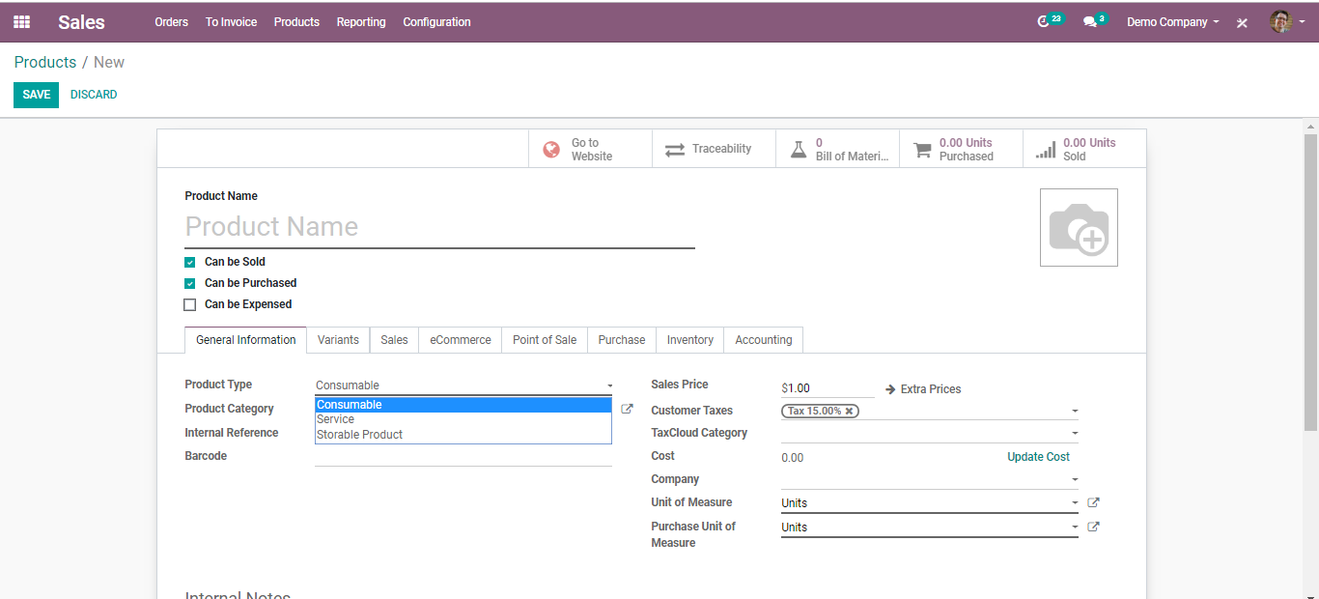
  - Services: A service is a non-material product that you provide. This type of product will configure at the time when your company is providing any type of service to your customers. Therefore, it does not appear in the various stock operations.
In BusinessBoxERP, the services are also considered as a product. But users cannot keep the stock of a service.
  - Consumables: A product for which the user does not want to manage the inventory (no quantity on hand or forecasted) but that can be received from the supplier or delivered to the customer. BusinessBoxERP assumes that the product always has enough stock.
  - Stockable: The product which is managed with Inventory. This product is used in stock management and its replenishment is automated by the rules defined in the system. In Stockable products, you can easily maintain your minimum stock level by defining the reordering rule for stock in your system, so that your stock will not reach out of stock. If you do not set the Reordering rule, BusinessBoxERP ERP will show up warning messages in the quotation if there is not enough balance in the stock. BusinessBoxERP ERP will prevent processing delivery orders that do not have balances in the stock, and it can be processed only by the force availability button in the delivery order.
  - Product Category: The user can organize the products under a specific category.
  - 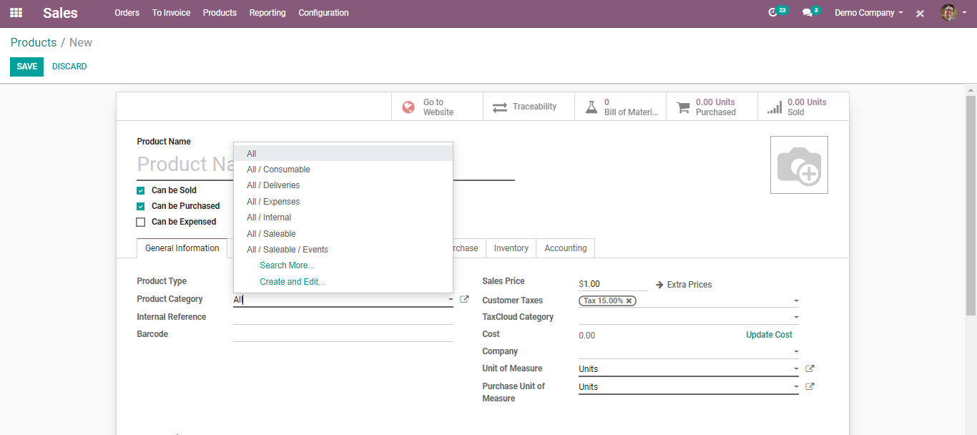
  - Internal Reference: BusinessBoxERP utilizes the Product Name field and the description when displaying product information. Commonly, a company may have a coding system for its products. The Internal Reference field is useful to enter an alternative product code or number for the product in that case.
  - Barcode: Especially, when the number of products is more, the probability of human error also increases. Now smartly and effortlessly add/update product quantity by scanning product barcodes while receiving or delivering products in your BusinessBoxERP.
  - Sales Price: The price at which the product is sold to the customer.
  - Consumer Tax: Default taxes used when selling the product. BusinessBoxERP's tax engine is very flexible and supports many different types of taxes: value-added taxes (VAT), eco-taxes, federal taxes, retention, withholding taxes, etc. For most countries, the chart of accounts you set up is automatically pre-configured with the main taxes of the country.
  - Under Sales Tab of a product.
  - 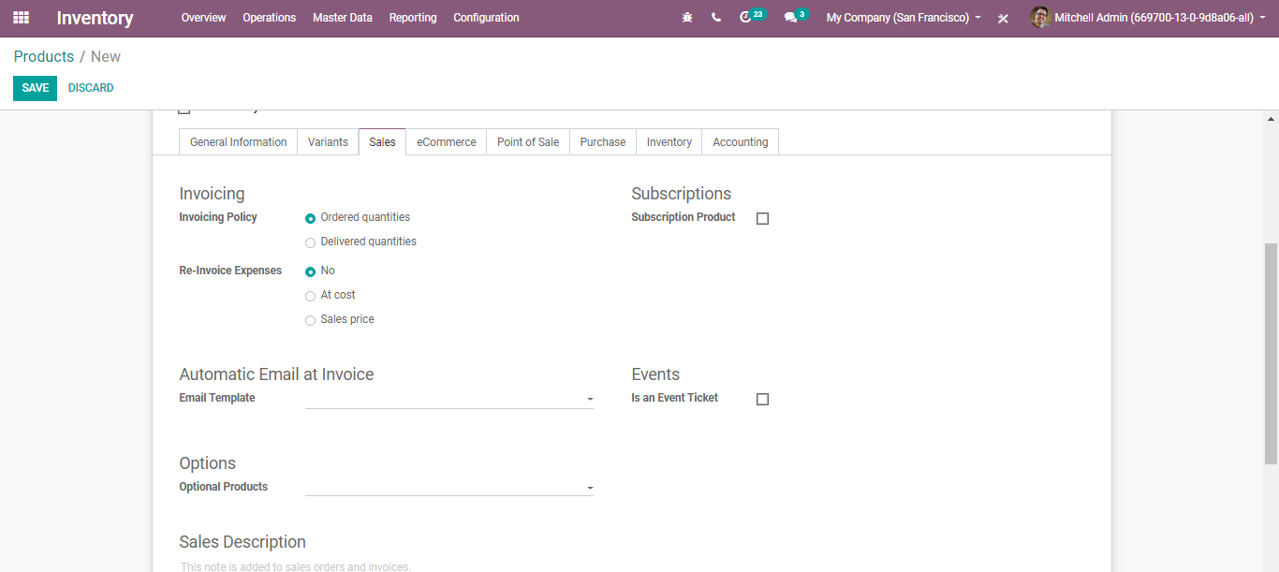
  - You have the following.
  - Invoicing Policy:
  - Ordered Quantity: Invoice quantities used by the customer.
  - Delivered Quantity: Invoice quantities delivered to the customer.
  - Subscription Product: If set, confirming a sale order with this product will create a subscription.
  - Email Template: Send a product-specific email once the invoice is validated.
  - Event Ticket: If checked this product automatically creates an event registration at the sales order confirmation.
  - Optional Products: Optional products are suggested whenever the customer hits the” Add to cart.”
  - Sales Description: A description of the product that you want to communicate to your customers. This description will be copied to every Sales Order, Delivery Order, and Customer Invoice/Credit Note.
  - Warning Message: Selecting the ‘Warning Option’ will notify the user of the message. Selecting “Blocking Message” will throw an exception with the message and block the flow. The message must be written in the text file.
  - Under the E-commerce Tab of product,
  - 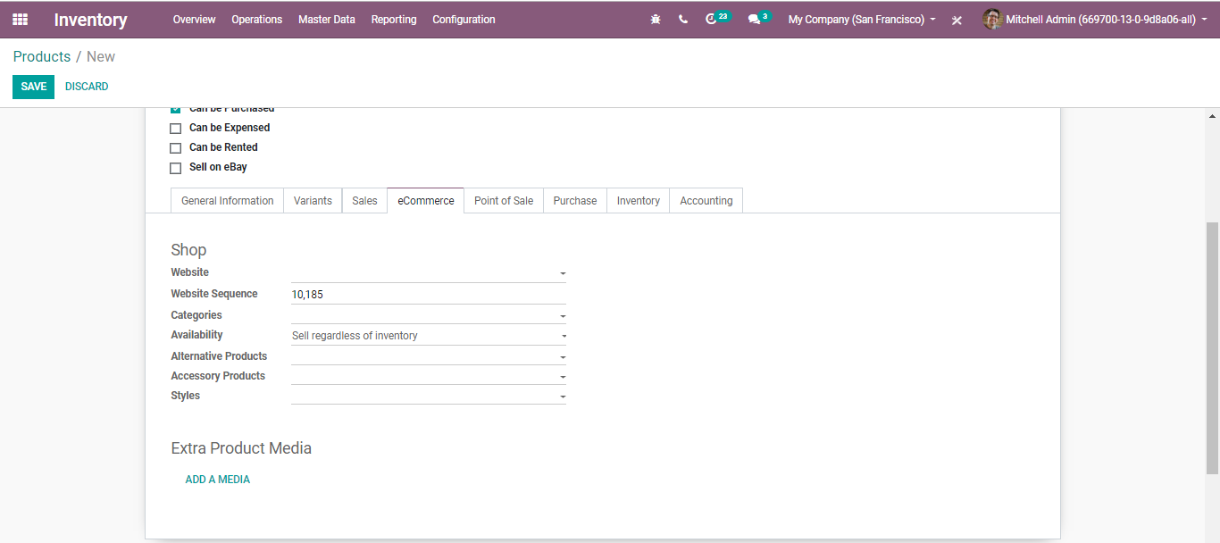
- Website: Option to restrict publishing to this website.
- Categories: The product will be available in each mentioned e-commerce category. Go shop>Customize and enable ‘E-commerce categories.
- Alternate Product: Suggest Alternatives to your customer (upselling strategy). Those products show up on the product page.
- Accessory Product: Accessories show up when the customer reviews the cart before payment.
- Extra Product Media:
  - 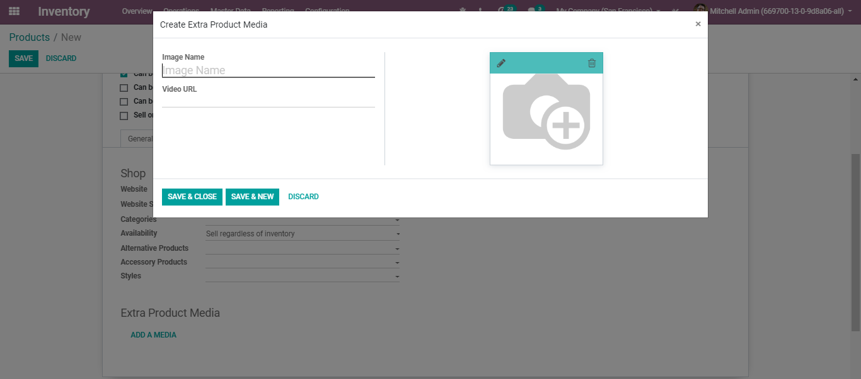
  - Under Point-of-Sale Tab of product
  - 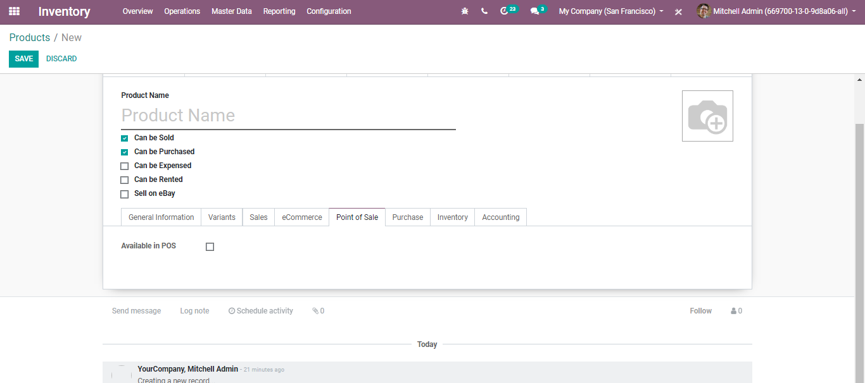
  - Available in POS: Check this if you want this product to appear in the POS.

  - Under Purchase Tab of product
  - 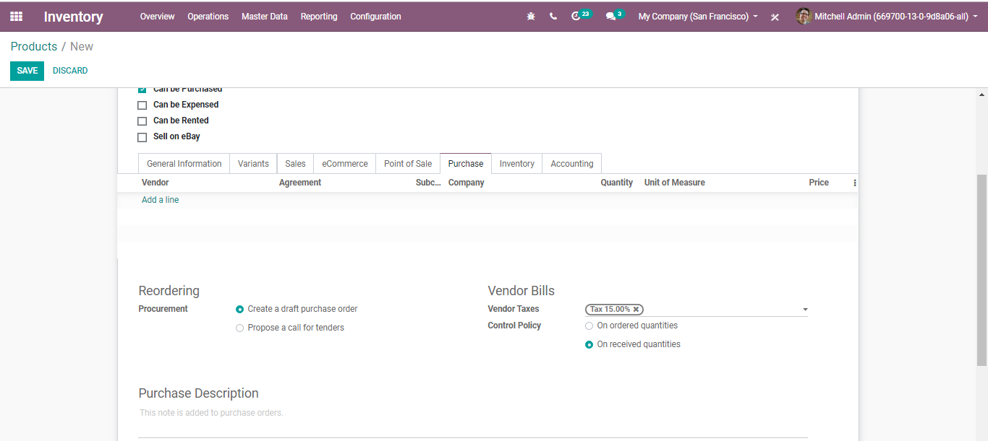
- Reordering:
  - Procurement:
Create a draft purchase order- Based on your product configuration, the system will create a draft purchase order.
Propose a call for tender-If the purchase requisition module is installed and this option is selected, the system will create a draft call for tender.
- Vendor Bills: Vendor Taxes- Default taxes used when buying the product.
- Control Policy:
- On ordered Quantities-Control bills based on ordered quantities.
- On received Quantities-Control bills based on received quantities.
- Purchase Descriptions: This note is added to purchase orders.

  - Under Inventory Tab of Product
  - 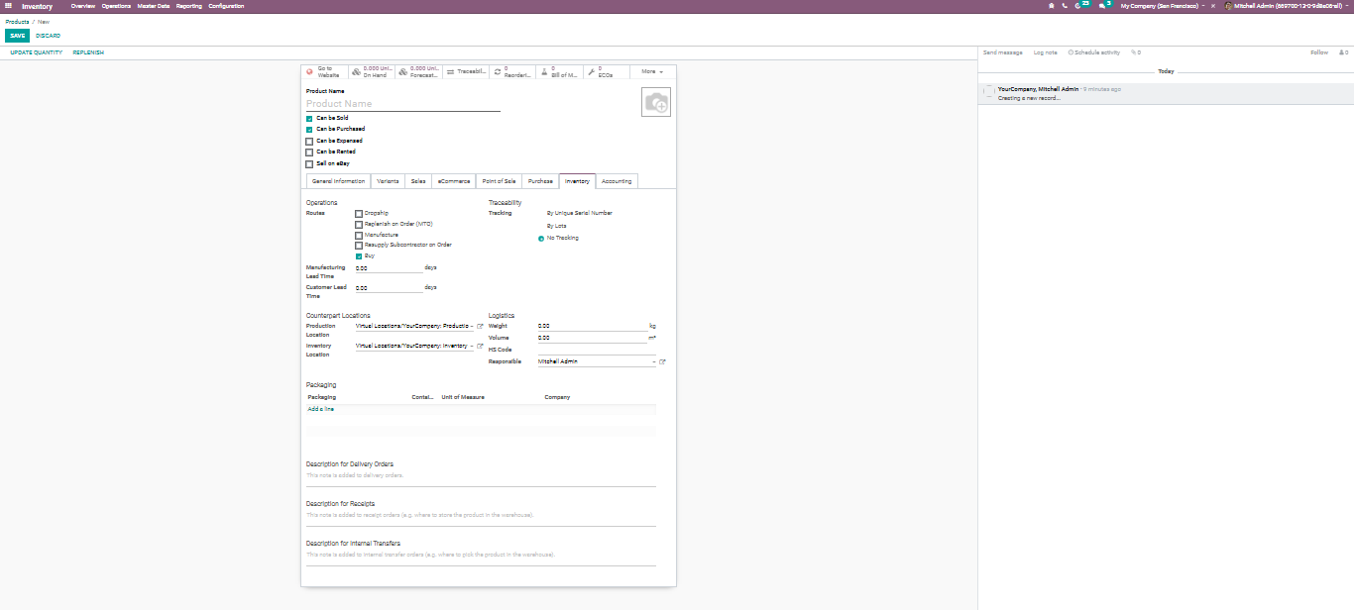
- Route: Depending on the module installed, this will allow you to define the route of the product. whether it will be bought, manufactured, replenished on order etc.
- Manufacturing Lead Time: Average lead time in days to manufacture this product. In the case of multi-level BOM, the manufacturing lead times of the component will be added.
- Customer Lead Time: Delivery lead time in days. It is the number of days, promised to the customer, between the confirmation of the sale order and the delivery.
- Packages: Gives different ways to package the same product.
- Tracking: Via enabling the option you ensure the traceability of a storable product in a warehouse.
  - 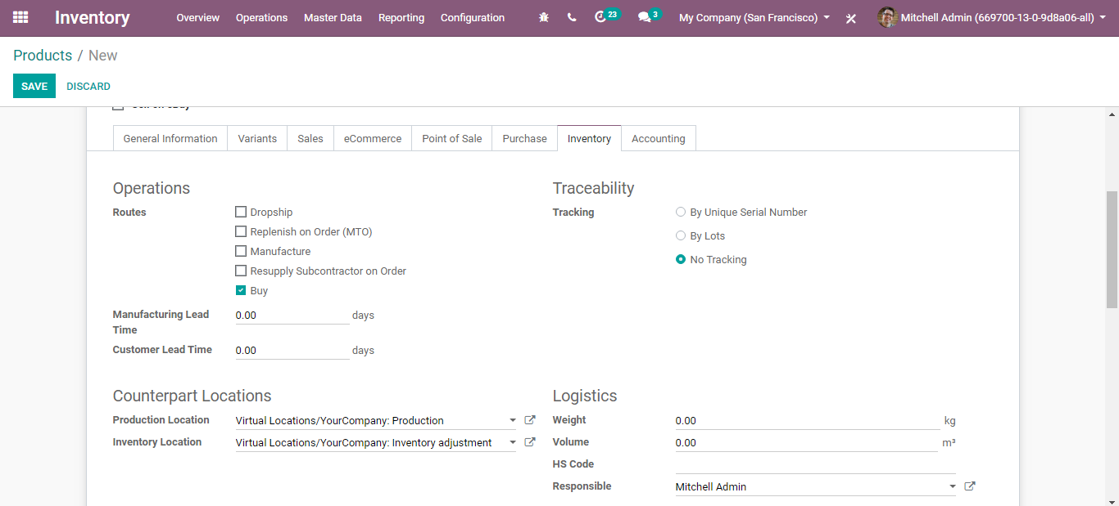
- Product Location: The stock location will be used instead of the default one, as the source location for stock moves generated by manufacturing orders.
- Inventory Location: The stock location will be used instead of the default one, as the source location for stock moves generated when you do an inventory.
- Logistics: Here, you can give away the Weight, Volume, HS Code: Standardized code for international shipping and goods declaration. Now only used for FedEx Shipping Providers. Also, you can assign the Responsible: The user will be responsible for the next activities related to logistics operations for this product.
- Description for Delivery Orders: This note is added to Delivery Orders.
- Description for Receipts: This note is added to receipt orders.
- Description for Internal Transfers: This note is added to internal transfer orders.

  - Under Accounts Tab of product
  - 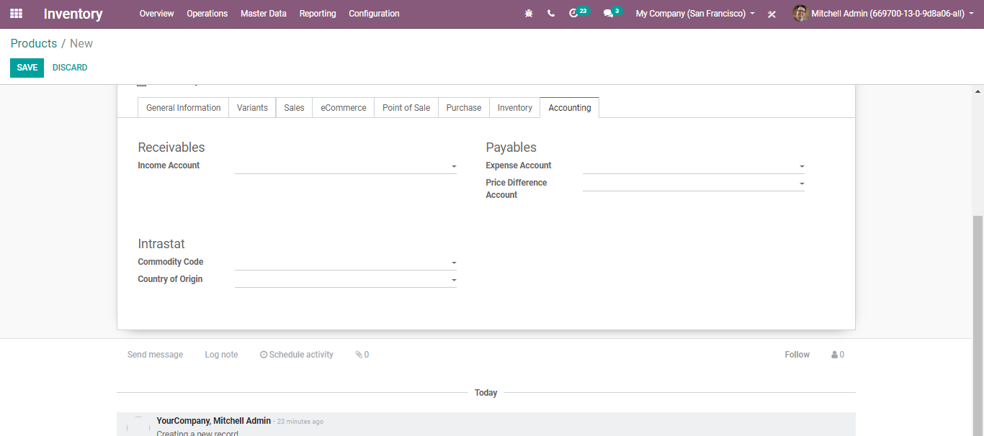
  - Income Account: Keep this field empty to use the default value from the product category.
  - Expense Account: Keep this field empty to use the default value from the product category. If Anglo-Saxon accounting with an automated valuation method is configured, the expense account on the product category will be used.

  - PRODUCT VARIANTS
  - Configure your products with variations and select optional product items
  - Product Variants
  - Product variations are utilized to oversee items having diverse varieties, like measure, shading, and so forth. It permits dealing with the item at the layout level (for all varieties) and the variation level (specific attributes).
  - For instance, an organization selling shirts may have the accompanying item:
  - B&C T-shirt
  - Sizes: S, M, L, XL, XXL
  - Hues: Blue, Red, White, Black
  - In this model, B&C T-Shirt is known as the item layout and B&C T-Shirt, S, Blue is a variation. Sizes and shading are properties or attributes.
  - To enable the choice, go to Inventory >Configuration> Settings and Activate Variants under Product.
  - 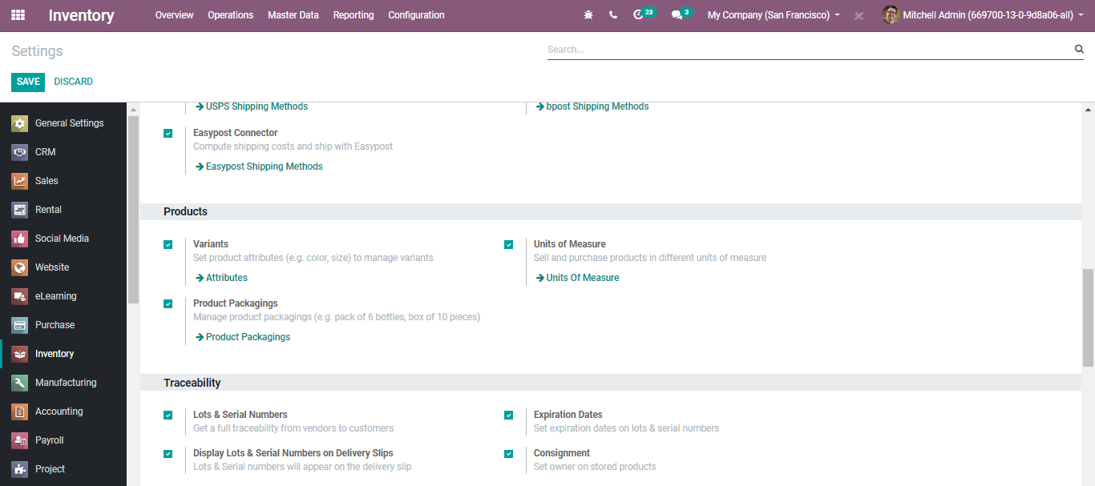
  - Upon clicking the attributes button, a window just like below will appear.
  - 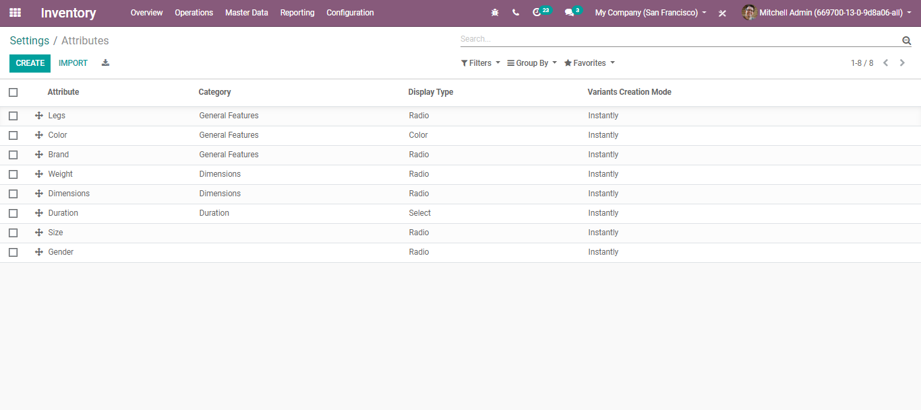
  - One can create a new attribute in BusinessBoxERP or import it from the list.
  - Upon clicking the CREATE button, you will be navigated to a new window like below:
  - 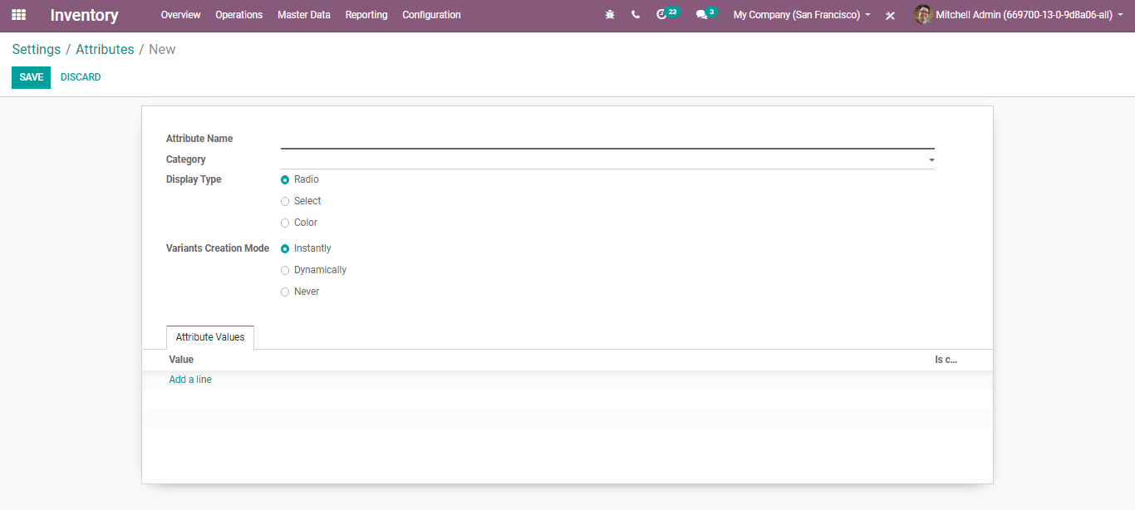
- Attribute Name: Name of the product variant.
- Category: Set a category to regroup similar attributes under the same section in the comparison page of eCommerce.
- Display Type: The display type used in the product configurator.
- Variants Creation Mode:
- Instantly: All variants are created as soon as the attribute and its values are added to a product.
- Dynamically: Each variant is created only when its corresponding attributes and values are added to a sales order.
- Never: Variants are never created for the attribute.
  - Note: the variants creation mode cannot be changed once the attribute is used on at least one product.

  - PRODUCTS IN DIFFERENT UNITS OF MEASURE
  - Now and again, dealing with products in various units of measures is vital. For instance, if you purchase items in a nation where the metric measuring standard is of utilization and sell them in a nation where the imperial framework is utilized, you should change over the units.
  - Another scenario is buying products in bigger packs from your supplier and later selling them in units to your customers.
  - BusinessBoxERP empowers to work with various units of measure for one item.
  - You can set up BusinessBoxERP to work with different units of measure for one product. For that go to, Inventory >Configuration> Settings and activate Units of Measure under Product.
  - 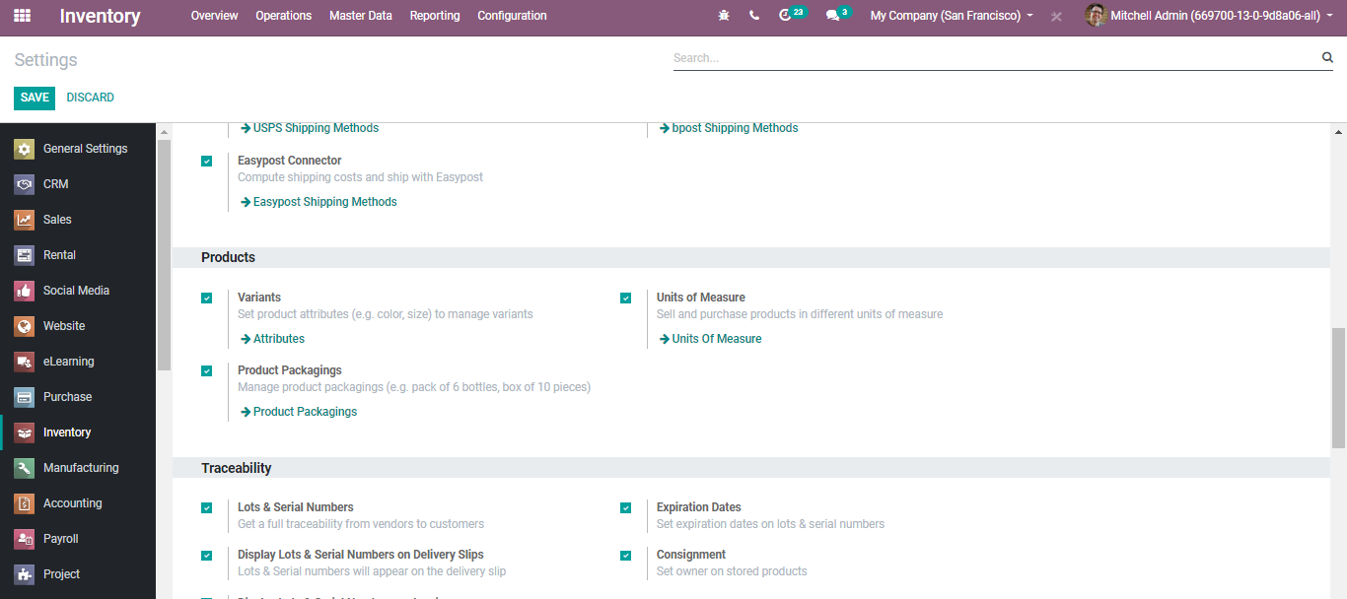
  - Upon clicking the Units of Measure button, you will be navigated to the new window like below:
  - 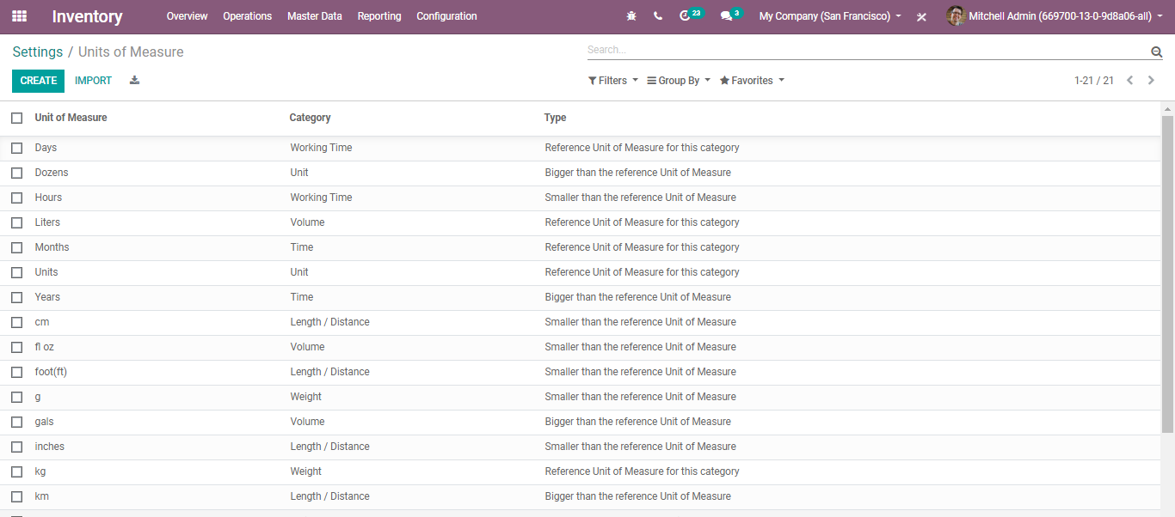
  - Upon clicking CREATE button, you can create new Units of Measure for your products.
  - 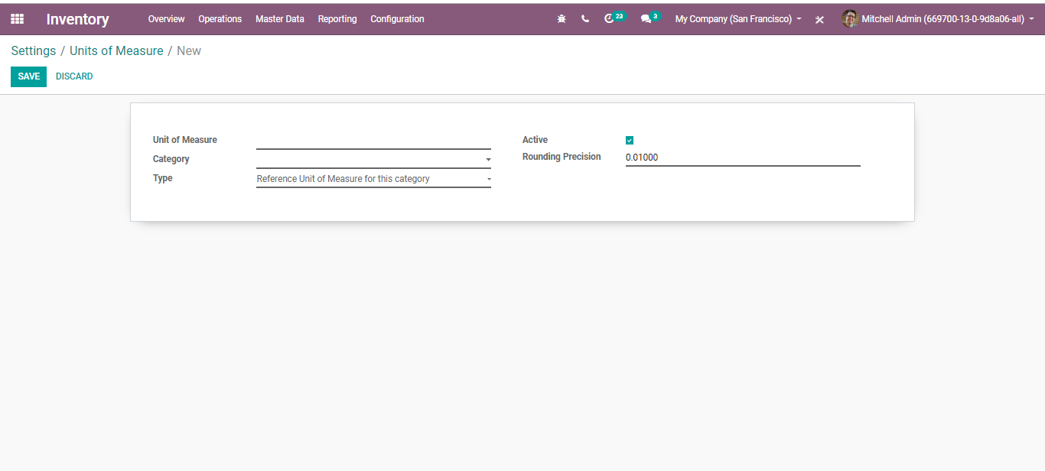
  - Here, you can name the unit of measure, define its category (conversion between two units of measure can happen only if they belong to the same category. The Conversion will be made based on the ratios.)
  - While doing inter-unit exchanges, the rounding adjustments are automatically done by BusinessBoxERP.
  - Setting up units on your products
  - In Inventory Control > Products, open the product which you might want to change the purchase/sale unit of measure and click on Edit.
  - 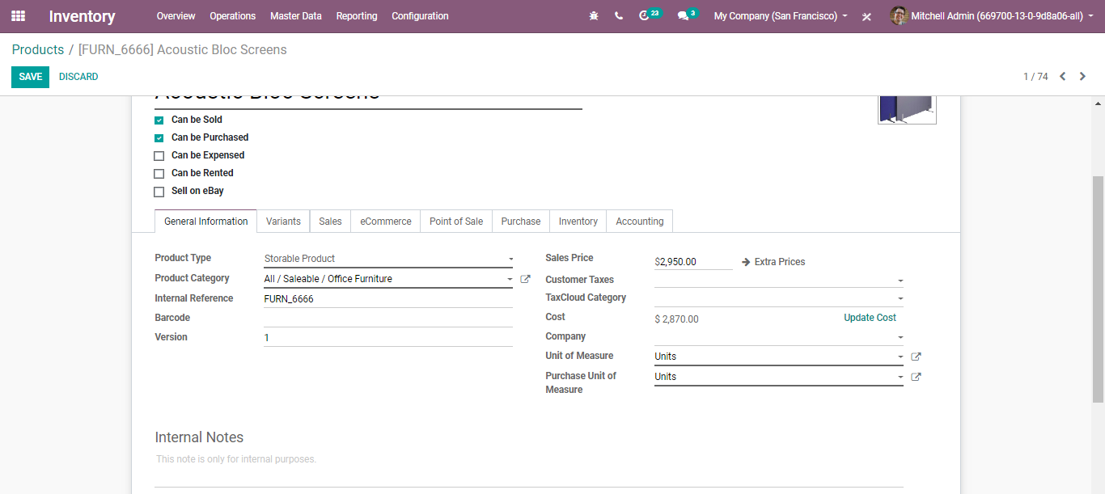
  - In the Unit of Measure area, select the unit in which the item will be sold and in which internal exchanges will be executed.
  - In the Purchase Unit of Measure area, select the unit in which you buy the item. When you are set, click on Save.
  - 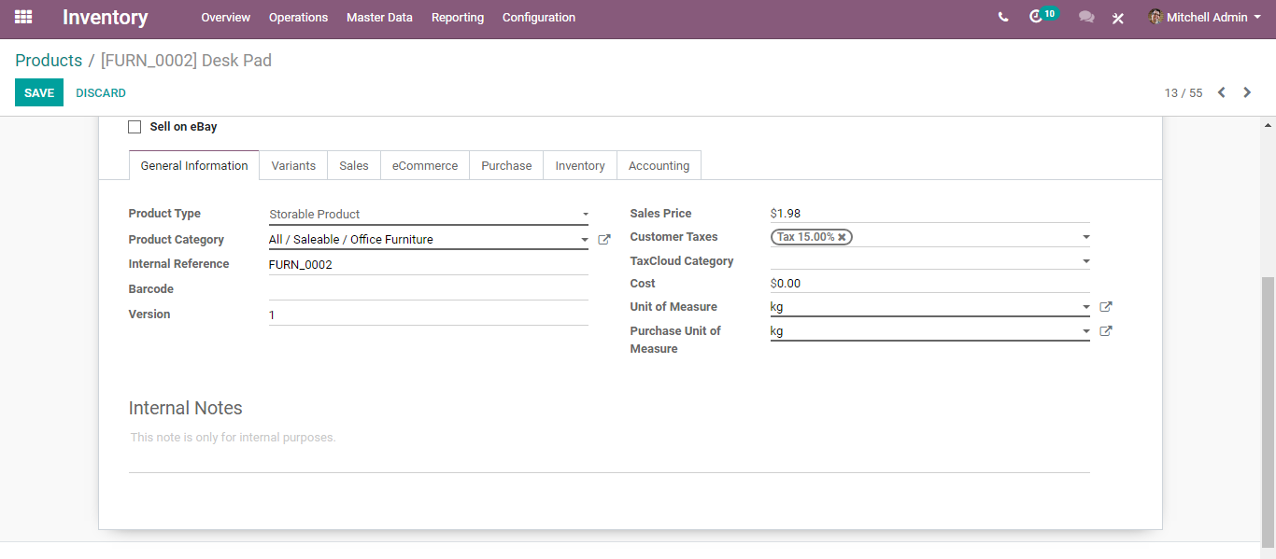
  - Upon clicking the edit button, you are provisioned to create a new unit of measures in BusinessBoxERP.
  - Transfer from one unit to another
  - While doing inter-unit exchanges, the rounding adjustments are consequently done by BusinessBoxERP.
  - The unit of measure can be changed all through the entire procedure. The only condition is that the unit of measure is a piece of a similar class.
  - Let us see how it works
  - Buy in the Purchase Unit of Measure
  - Under BusinessBoxERP Purchase, create a new RFQ adding a product with the different Units of Measure.
  - Later confirm it.
  - 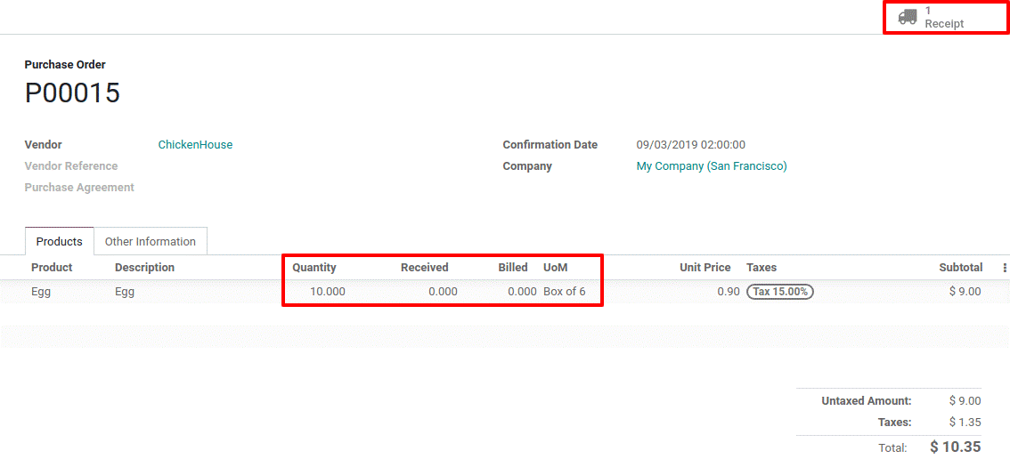
  - Upon creating RFQ, BusinessBoxERP automatically creates a purchase order. Here, Purchase UoM is Box of six. Upon entering receipt linked to purchase order, ten boxes of six units get converted to sixty units. You can see the stock is managed in units.
  - 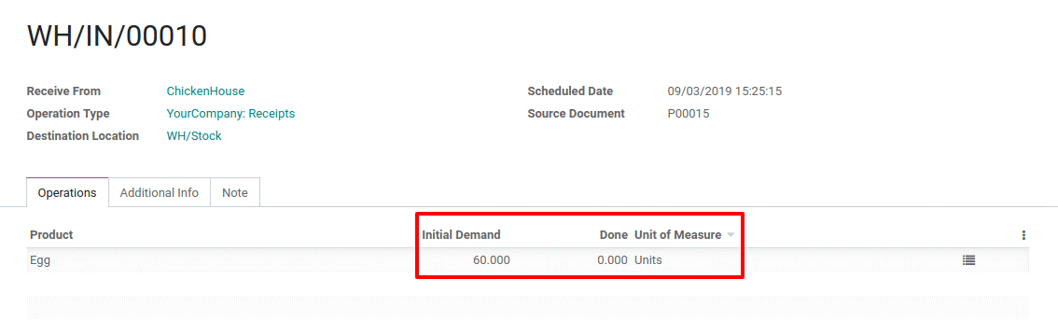
  - Replenishment
  - Upon clicking the Replenish button, one can change the unit of measure.
  - 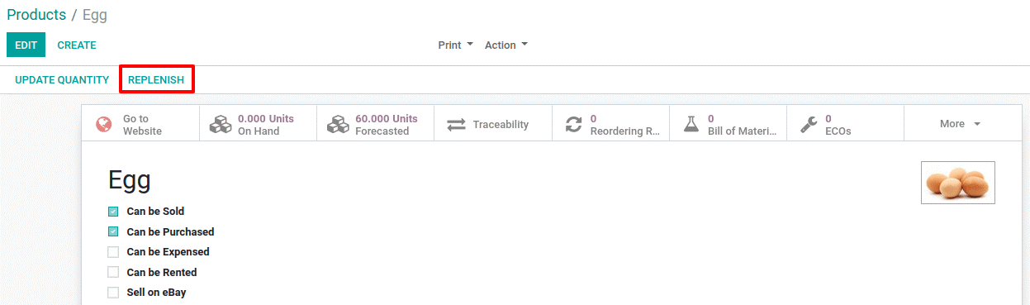
  - 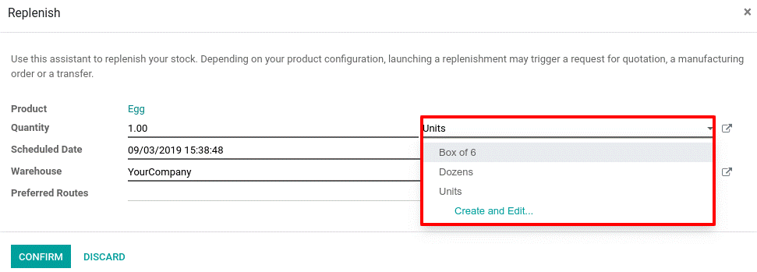

  - Sell in bigger UoM
  - Choose the desired unit of measure on the sale order. Here it is dozen. When doing so, the price automatically gets computed from Units UoM to selected UoM.
  - 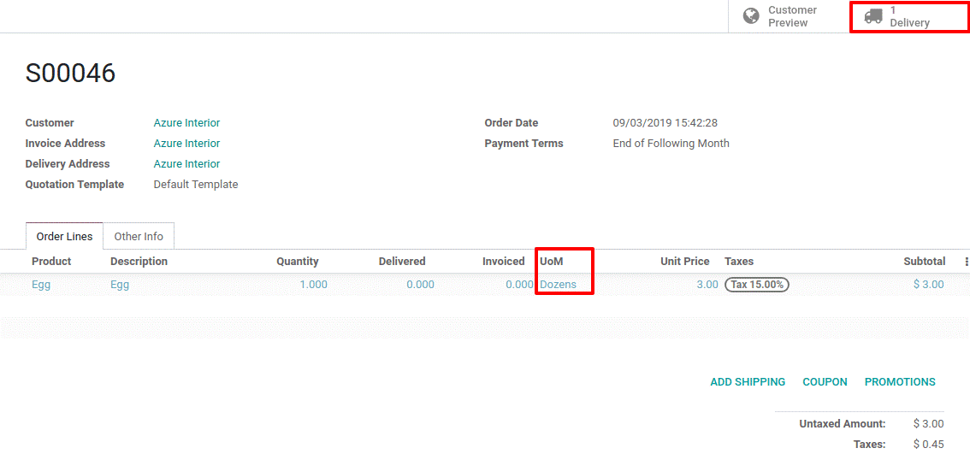
  - In delivery order, the UoM in sale order is converted to the UoM used for stock management (here are the units).
  - 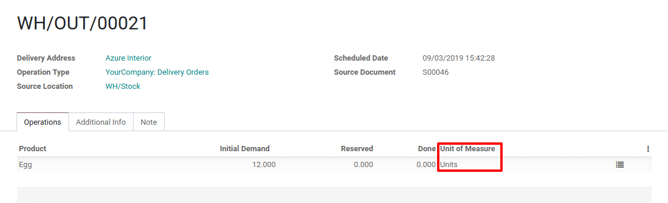

  - PRODUCT PACKAGING
  - The package is the physical container where you put one or a few items from a picking. For instance, when you deliver a product, you can simply separate the product quantity into two different packages/bundles. BusinessBoxERP enables you to have a report with the number of items for each bundle.
  - Configuration:
  - Go to Inventory>Configuration>Settings and activate Product Packages under the option Products.
  - 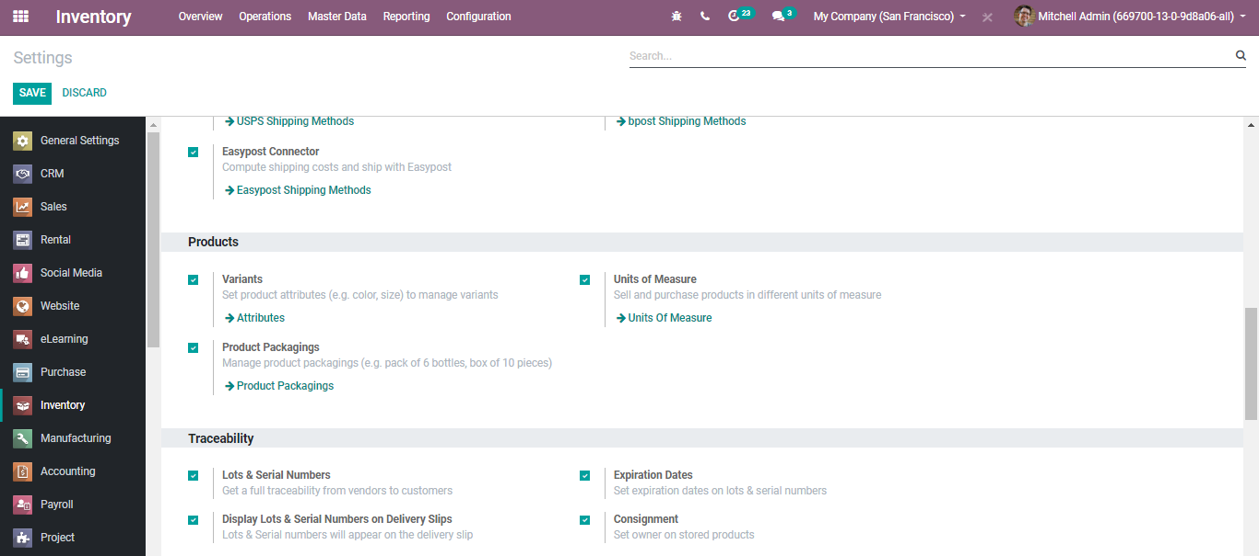
  - Upon clicking product packages, you will be navigated to a new window like below.
  - 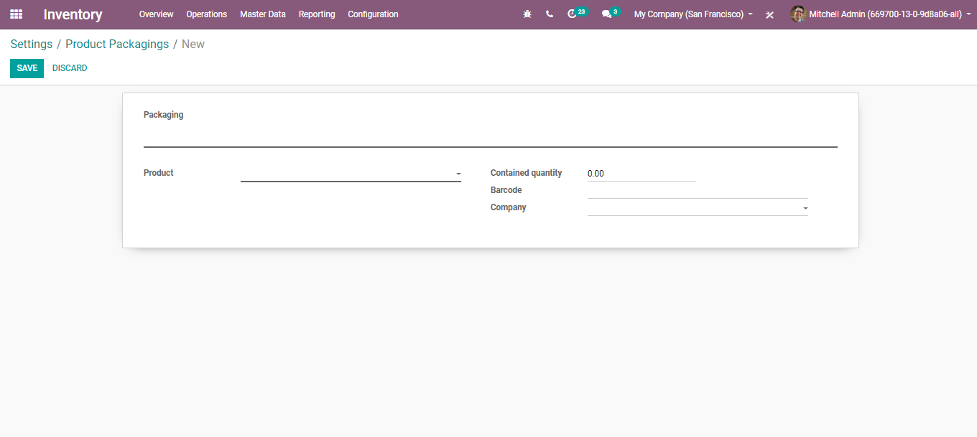
  - Here, you can define the Packaging Type, the products, quantity, barcode used for packaging identification, company.
  - A destination package can be made applicable if the company is transferring some goods to a certain location or to the customer itself. If all the products or product packages of different customers need to be sent to a particular location, then all the items can be put into a single container for easier transportation, then this container can be termed as a Destination package.
  - 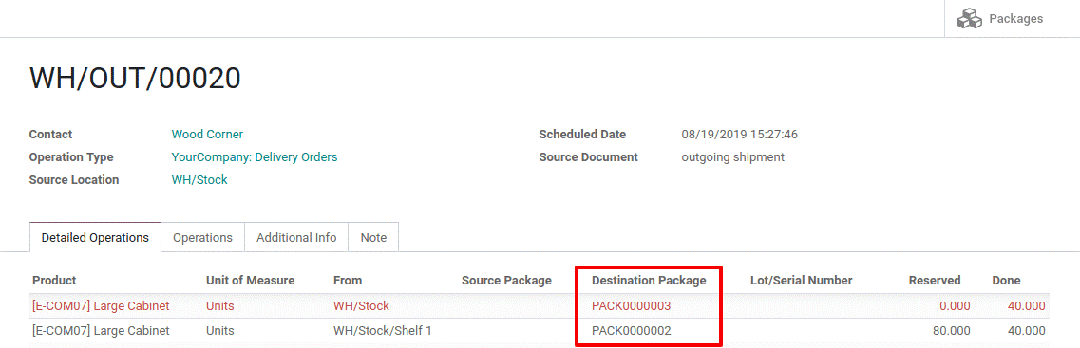

  - Packaging
  - The packaging is the physical container that protects your product. If you are selling computers, the packaging contains the computer with the notice and the power plug.
  - In BusinessBoxERP, the packaging is used for indicative purposes on sale orders. They can be specified on the product form, in the inventory tab.
  - 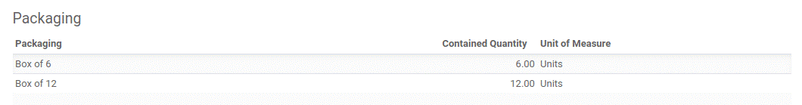
  - 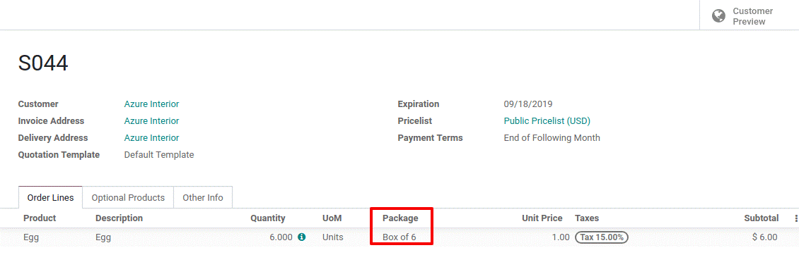

  - PRODUCT TRACEABILITY
  - To activate the product traceability in the warehouse, go to
  - Inventory> Configuration> Settings> Traceability
  - 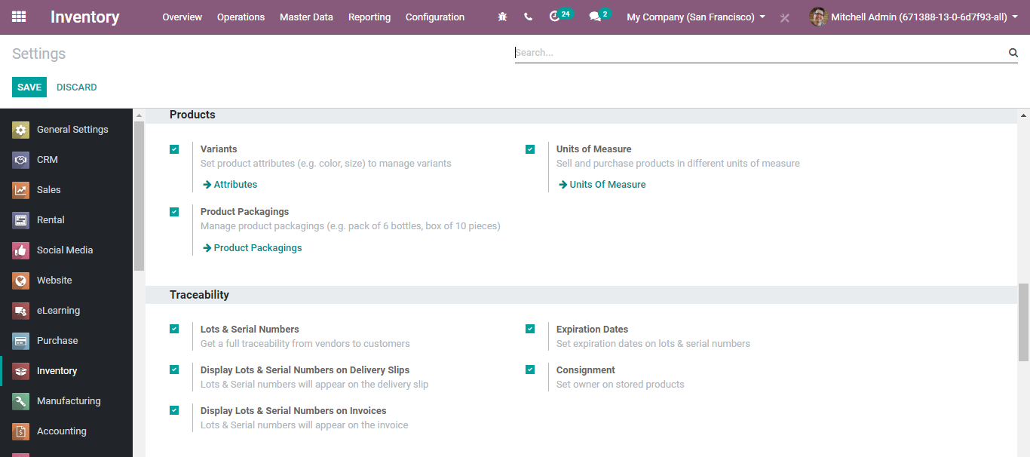
  - The lot and Serial Number
  - Lots and serial numbers have a commonality in their functional end, however, behaves differently in the situation. Lots and Serial numbers are widely used in apps like inventory, sales, and purchase for tracing products.
  - Where lot corresponds to a certain number of products that you received, which is stored in one single pack, Serial number performs like an identification number offered to one product. Be it a lot or the serial number, it helps in tracing the product journey from reception to delivery and post-sales.
  - Lots can be incredibly useful in those circumstances where you receive products in great quantity. Thus, lots can be made use for reporting, quality control and so forth.
  - On the other hand, serial numbers can be beneficial for those products that require after-sales service, for instance, electronic goods.
  - Managing Serial Numbers
  - The serial number tracking can be beneficial for tracing a product’s current location, also tracing their history when they are moved from one location to another.
  - To activate the feature, enable the option Lots & Serial Numbers under Accounting>Inventory>Settings> Traceability. Click the SAVE button to mark the changes.
  - 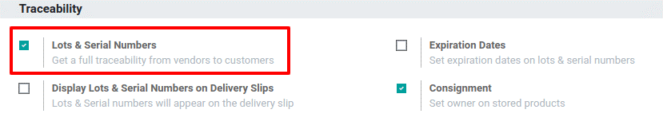
  - Creating Lot/Serial Numbers
  - To activate, Go to Inventory-> Master Data->Lots/Serial Numbers
  - 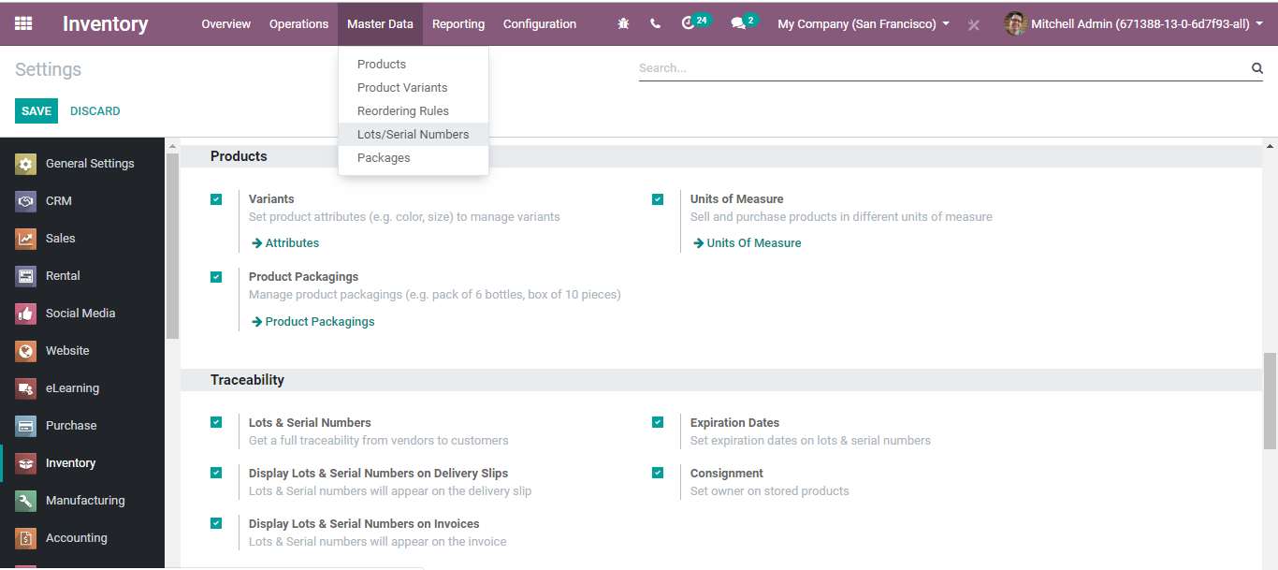
  - Upon clicking the lot/serial number You will find the lists of products with lot/serial numbers. To add a new product with a lot/serial number click the CREATE button.
  - A creation form like the below will appear:
  - 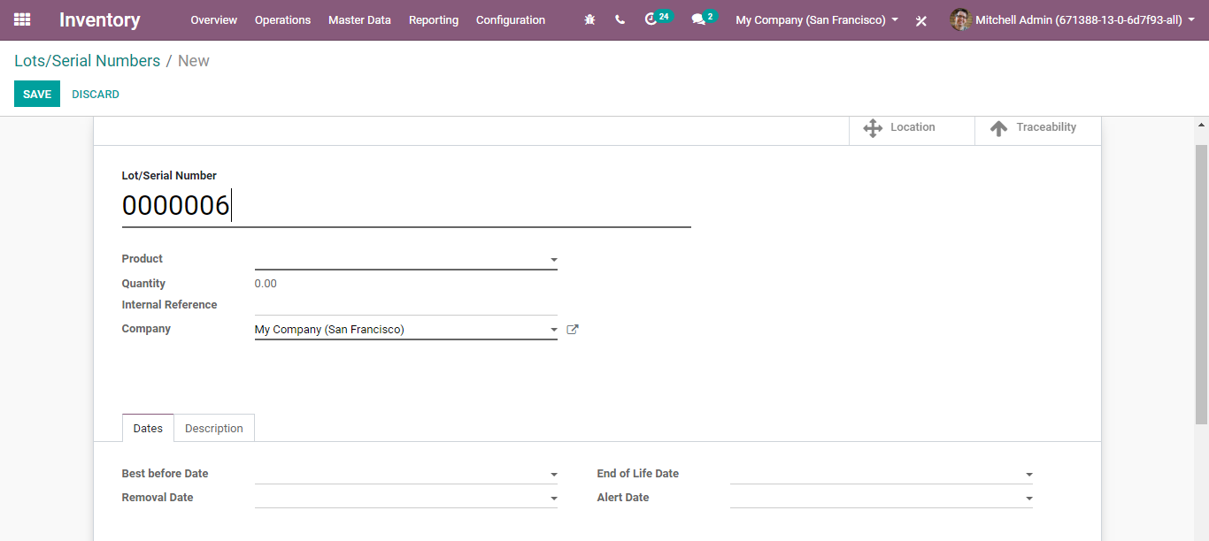
  - The fields include Product Name, Quantity, Internal Reference, Dates including Best Before Date, End of the Life Date, Removal Date and Alert Date. Dates can help track the products.
  - Let us see how it works.
  - Serial Numbers
  - Firstly, activate the tracking of lot numbers. For that go to Inventory > Configuration > Settings and enable Lots & Serial Numbers. Click SAVE to mark changes.
  - Product Configuration
  - Configure a product of your choice for which you want to track using serial numbers.
  - Go to Master Data > Products and open the product. Click the EDIT button and make changes. Select Tracking by Unique Serial Number in the Inventory tab. Then, click on save.
  - 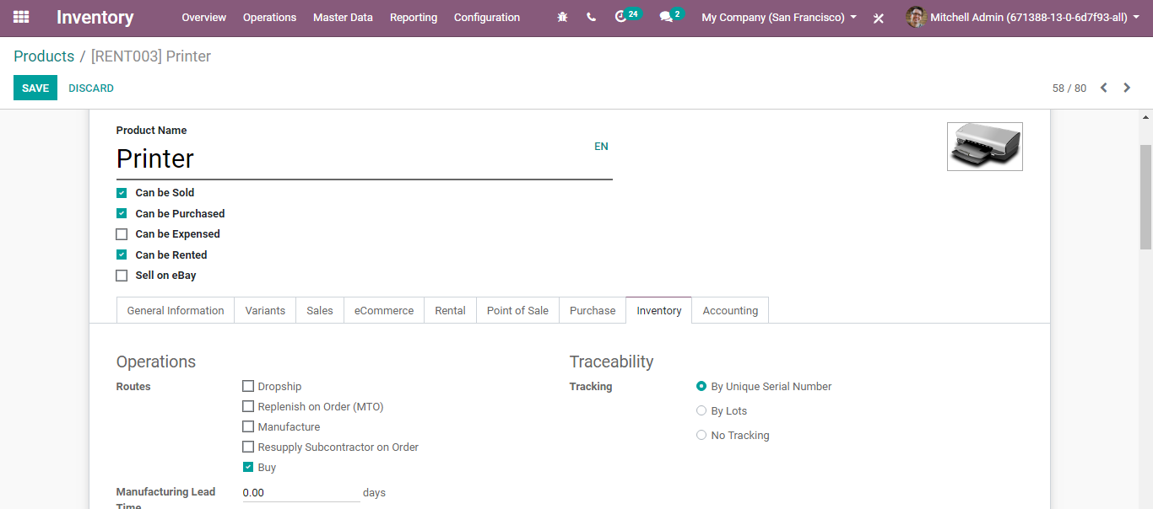
  - Manage Serial Numbers
  - Receipts
  - To receive an item that is tracked by serial number, you need to determine its serial number first. You have different ways of doing it.
- Manual assigning
- Multi-assignation
- Copy/pasting from an Excel file
  - No matter which way you select, firstly go to detailed operations of your picking.
  - To Manually assign different serial numbers, under detailed operations, click on Add a line. Under the field, you can fill in the serial number.
  - Once done, you can click again Add a line for registering a new serial number.
  - 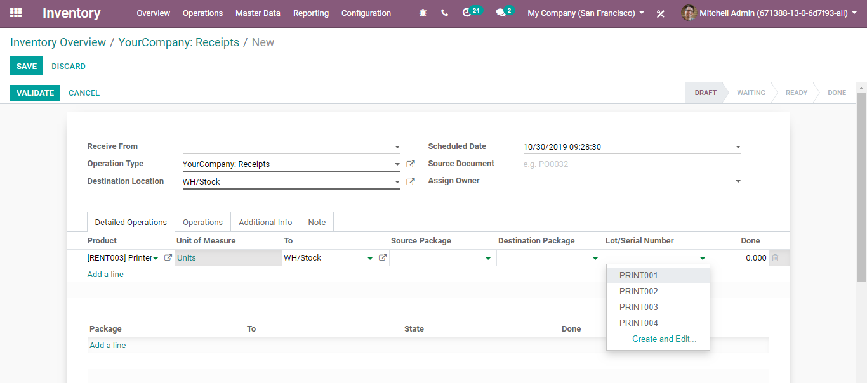
  - Multi-assignation
  - BusinessBoxERP automatically creates necessary lines under multi-assignation. All you need to do is enter the serial number for the product, also the number of products you must assign with the serial number.
  - Once the entries are marked, click Assign Serial Number. BusinessBoxERP automatically does the work.
  - 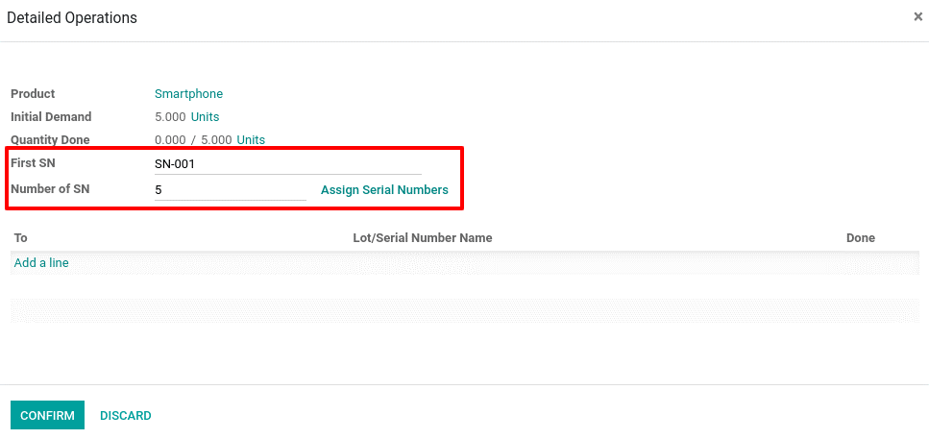
  - Copy/pasting from an Excel file
  - To utilize copy/paste, open the spreadsheet containing the serial numbers. Copy the list and past them in the Lot/Serial Number Name column. BusinessBoxERP automatically creates new lines
  - 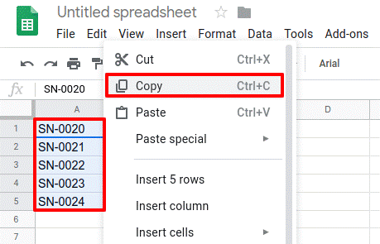

  - 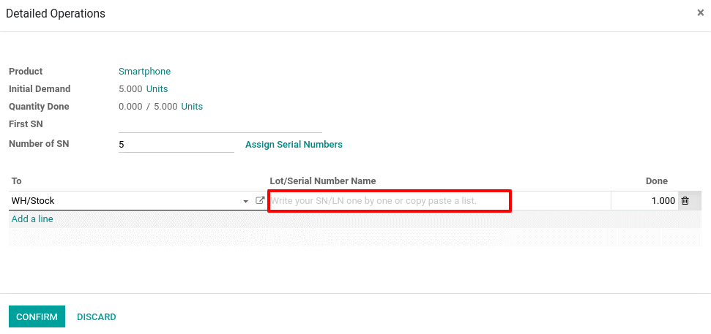
  - 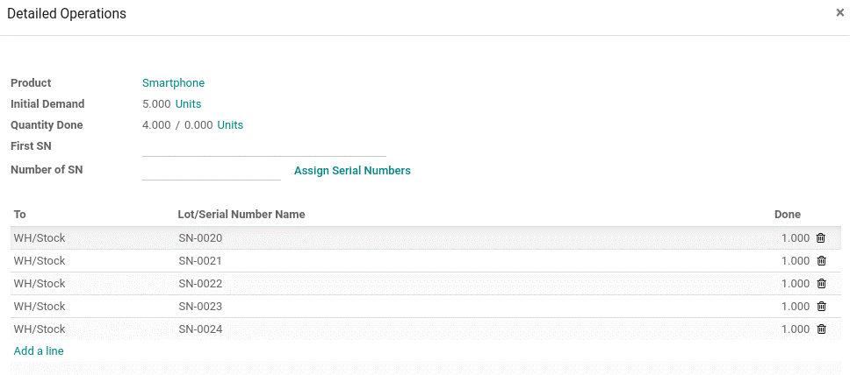
  - Operation types
  - One can also manage serial numbers for each activity type. To characterize it, go to Configuration > Operation Types in the Inventory application.
  - For each type, you can choose whether to go for a new serial number or utilize existing ones. However, by default, the new serial number /lot is only allowed at product reception.
  - 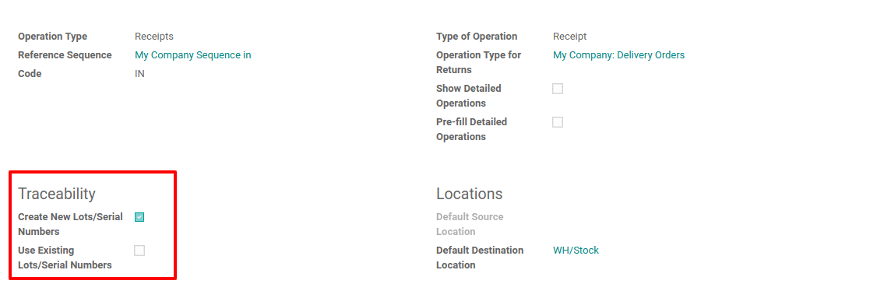
  - Serial Number traceability
  - Serial numbers help you to monitor where the items are received, placed in stock, to whom they were sold, and where they were dispatched to.
  - Open the Inventory application and go to Master Data > Lots/Serial Numbers and click on the serial number you are hunting. Click on the TRACEABILITY button and you find in which documents the serial number has been utilized.
  - 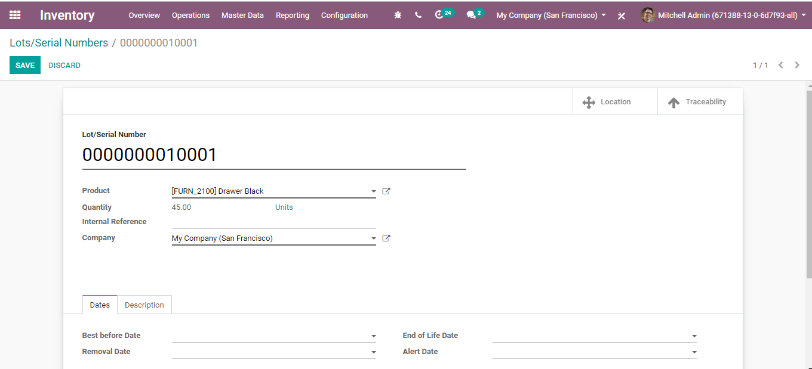
  - 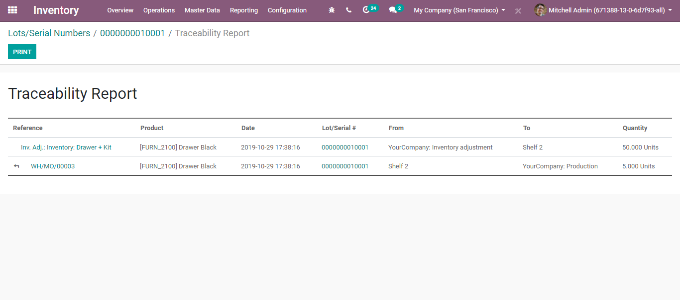
  - In case you need to locate a serial number, click the LOCATION button available on the serial number form.
  - 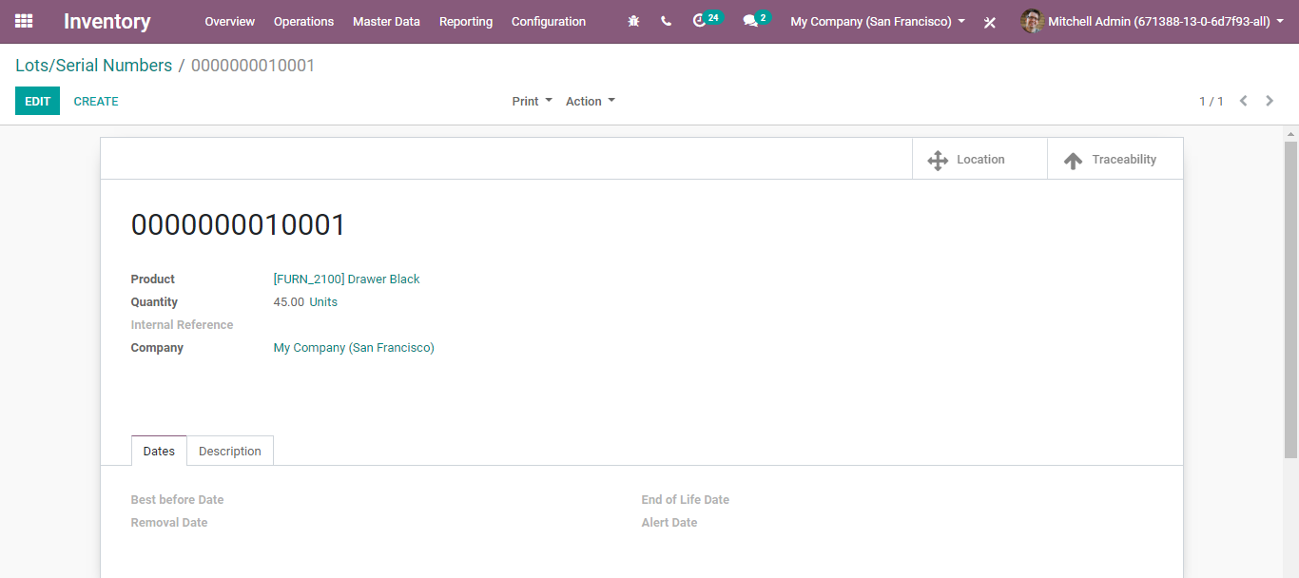
  - 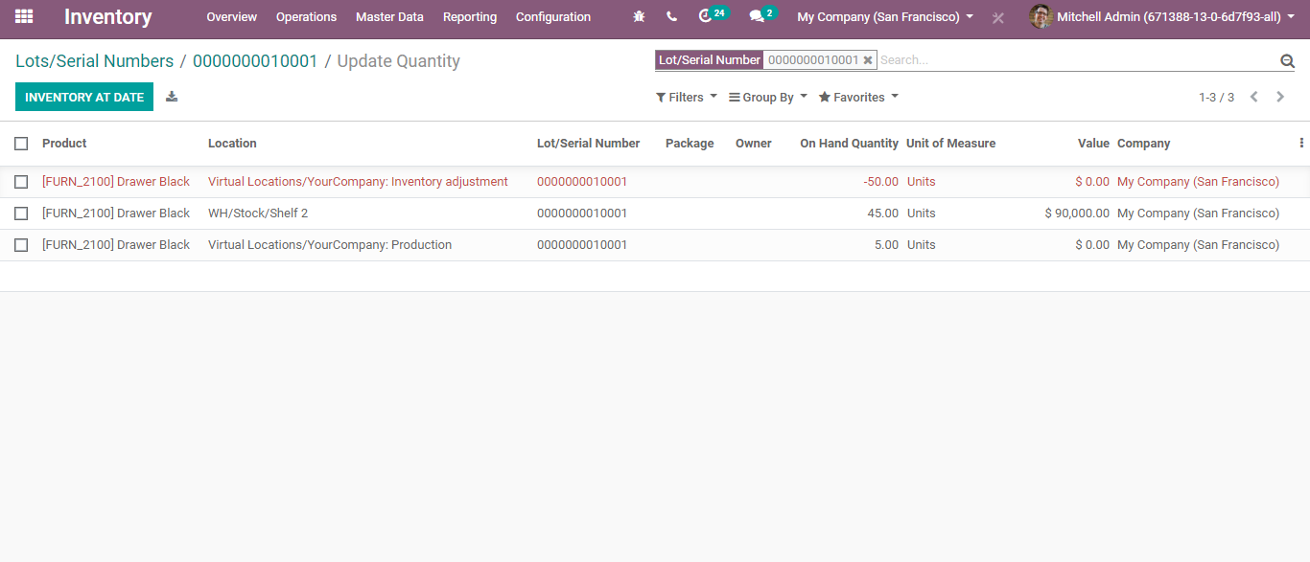
  - Managing Lots
  - Firstly, activate the tracking of lot numbers. For that go to Inventory > Configuration > Settings and enable Lots & Serial Numbers. Click SAVE to mark changes.
  - Product Configuration
  - Now configure a product that you want to track by lot numbers.
  - Go to Master Data > Products and open the product of your choice. There, click on Edit and select Tracking by Lots in the inventory tab.
  - 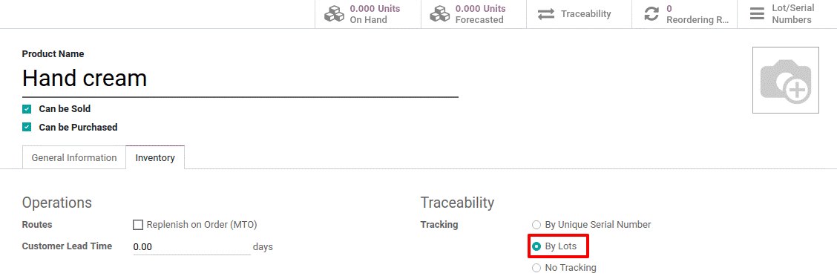
  - Manage Lots
  - Receipts
  - To receive a product tracked by lots, firstly specify the lot numbers. Like serial numbers, you have varied ways of managing lots:
- Manually assign the different lot numbers
- Copy/paste lot numbers from an Excel file
  - Manually assign the different lot numbers
  - Go to detailed operations, click on Add a line. There you can fill in the lot number. Once done, you can click on Add a line again to register a new lot number.
  - 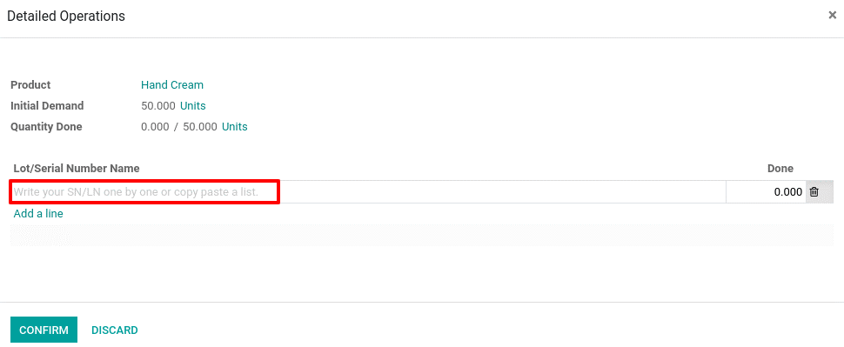

  - Copy/paste lot number from an Excel file
  - Open the spreadsheet containing lot numbers. Copy the list and past them in the Lot/Serial Number Name column for BusinessBoxERP to automatically create necessary lines. Enter the number of products contained in each lot.

  - 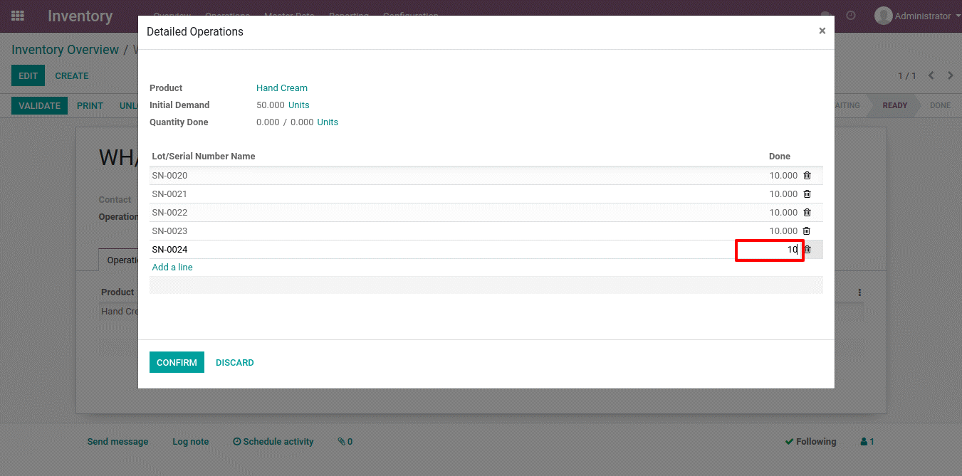

  - Operation Types
  - One can define lots for each operation type. For that go to the Inventory app and go to Configuration > Operation Types.
  - For each type (receipts, internal transfers, deliveries, …), you can decide whether to go for new lot numbers or use the existing ones. By default, the creation of new lots is only allowed at product reception

  - Lots of traceability
  - To track an item, open the Inventory module and, in Master Data > Lots/Serial Numbers, click on the lot number.
  - 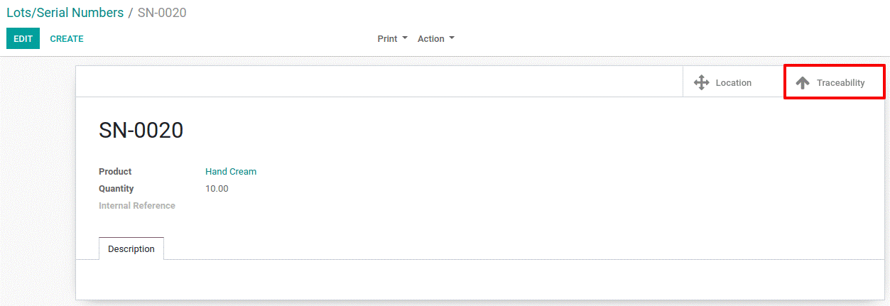
  - Via clicking the Traceability button, you see documents where lot number is used.
  - 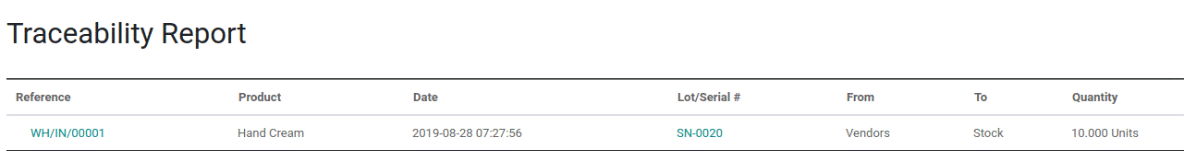
  - To locate the lot number, click on the on Location start button.
  - 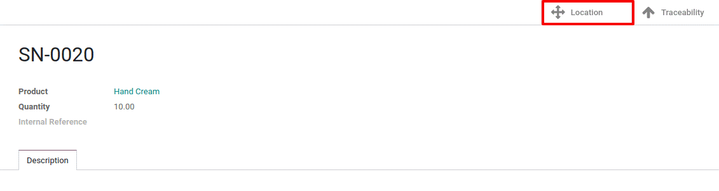
  - 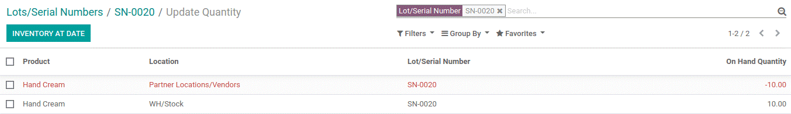

  - PRODUCT EXPIRY
  - Especially in the food and pharmaceutical industries, tracing stocks dependent on expiry dates is required to abstain from offering expired products to clients. With BusinessBoxERP, you can trace your items dependent on their expiration dates, regardless of whether they are tracked by serial number or lot number.
  - To activate the feature, go to Inventory>Configuration > Settings> Traceability
  - Activate Lots & Serial Numbers and Expiration Dates features.
  - 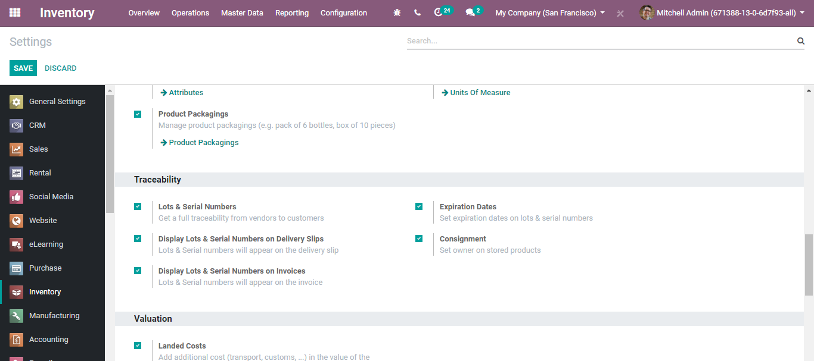
  - Click Expiration Dates to set the expiration dates on lots and serial numbers. Click Save to make the changes.
  - 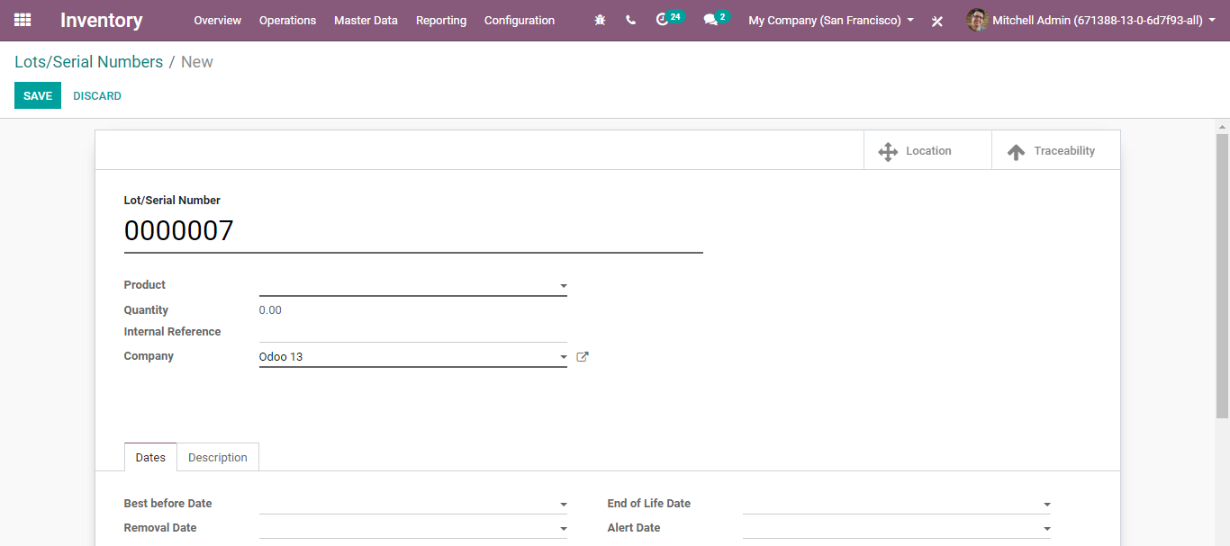
  - After applying this change, you have now a new option in the product form.
  - 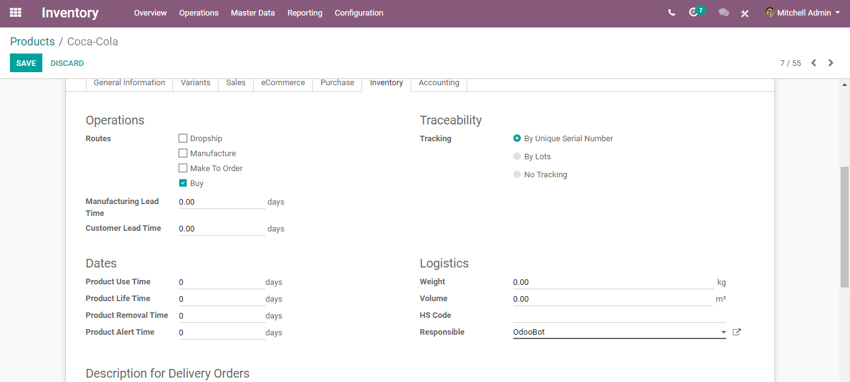
  - To set the product expiry, you can give the following attributes-
  - Product Lifetime: When a new Serial Number is issued, this is the number of days before the goods may become dangerous and must not be consumed.
  - Product Use Time: When a new Serial Number is issued, this is the number of days before the goods start deteriorating, without being dangerous yet
  - Product Removal Time: When a new Serial Number is issued, this is the number of days before the goods should be removed from the stock.
  - Product Alert Time: When a new Serial Number is issued, this is the number of days before an alert should be notified.
  - If you are not giving these days in the product form, you can give the dates after the creation of the lot/serial number also. When a new serial number is assigned to this product. These dates are automatically calculated and stored in the Lot/serial number.
  - 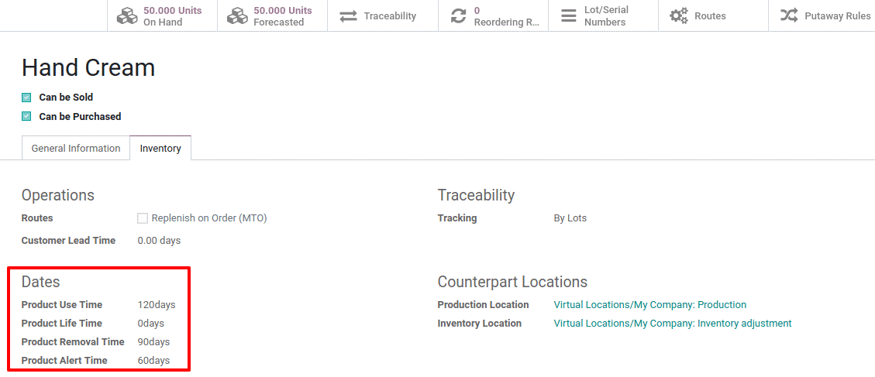
  - Expiration Alerts
  - To get access to expiration alerts, go to Master Data > Lots/Serial Numbers. Make use of the filter for knowing which all lots/serial numbers exceeded their alert date.
  - 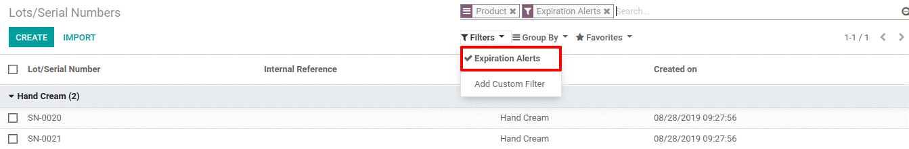

  - CONSIGNMENT
  - Configuration
  - Go to Inventory> Configuration> Settings> Traceability
  - Click on Consignment and Save to set owner on the stored product.
  - 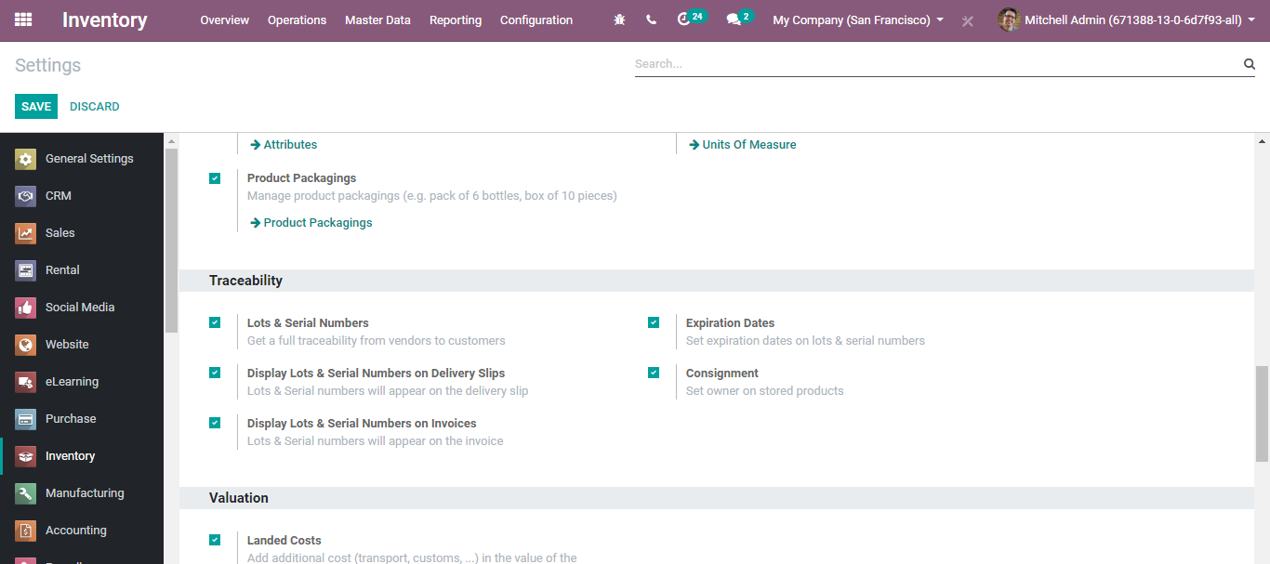
  - INVENTORY OPERATIONS
  - TRANSFER
  - The Dashboard gives you a glimpse of all the operations in your Warehouses.
  - 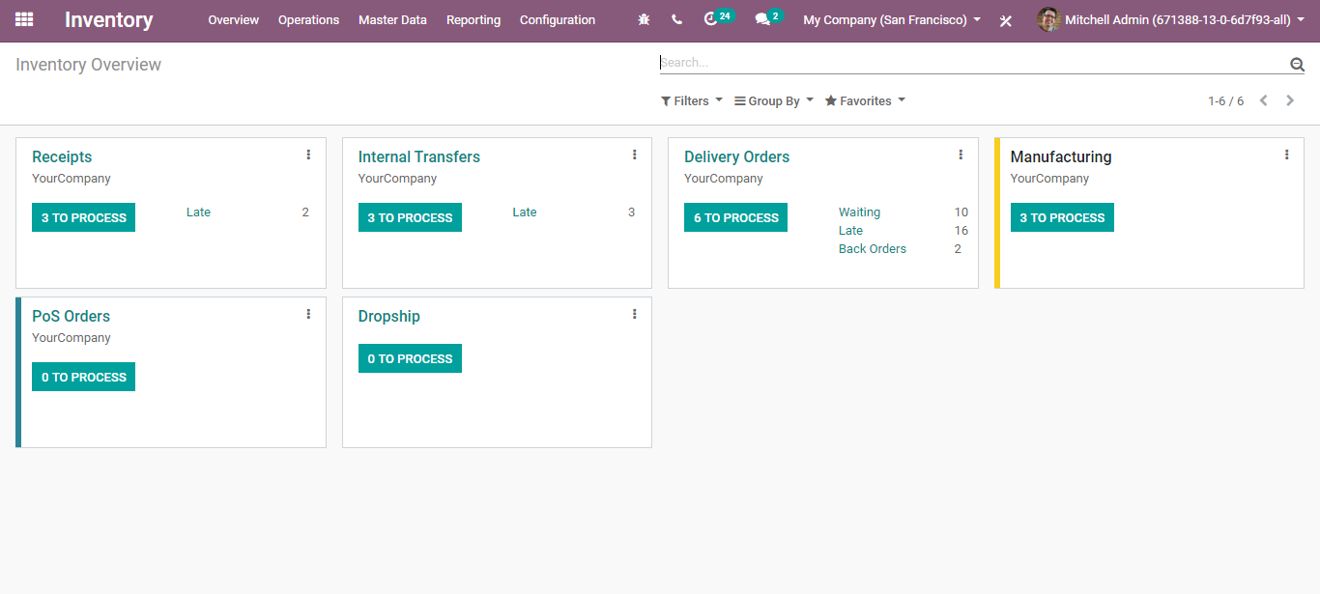
  - To view all the operations specified in the warehouse, Got to
  - Inventory -> Operations->Transfers
  - Transfers include receipts, delivery orders and internal transfers. You can see all listed here.
  - 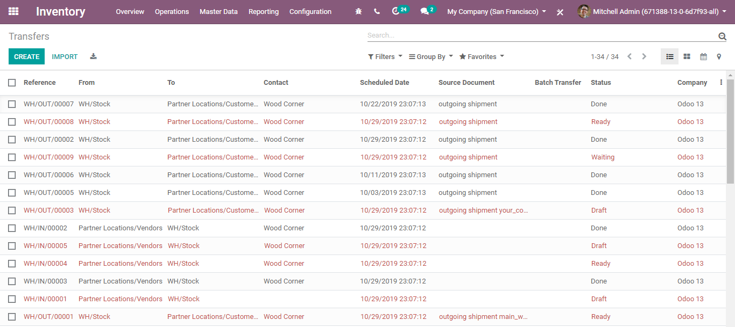
  - You can click and view the status of each one.
  - 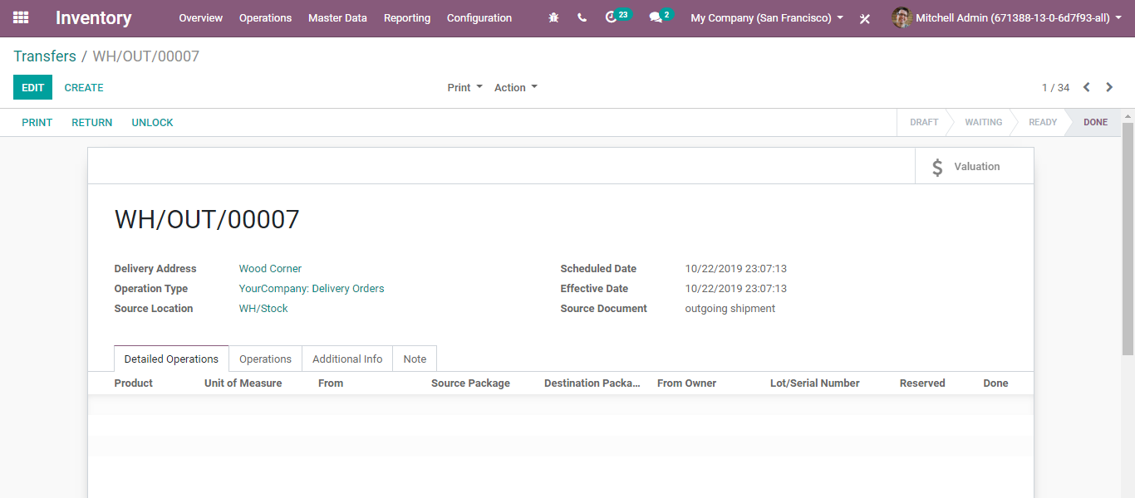

  - BATCH TRANSFER
  - Batch Transfer is defined as a group of transfers, picked together to make a batch. Here, transfers include the receipts, delivery orders and internal transfers.
  - In the usual scenario, the individual manages every transfer separately. This is quite strenuous and challenging. However, under batch transfer, one can pick together several transfers and bring them under a single batch This significantly reduces the transport time and allows the business to fulfil large batches of items in a single move.
  - To initiate Batch Transfer, go to Inventory>Operations>Batch Transfer
  - 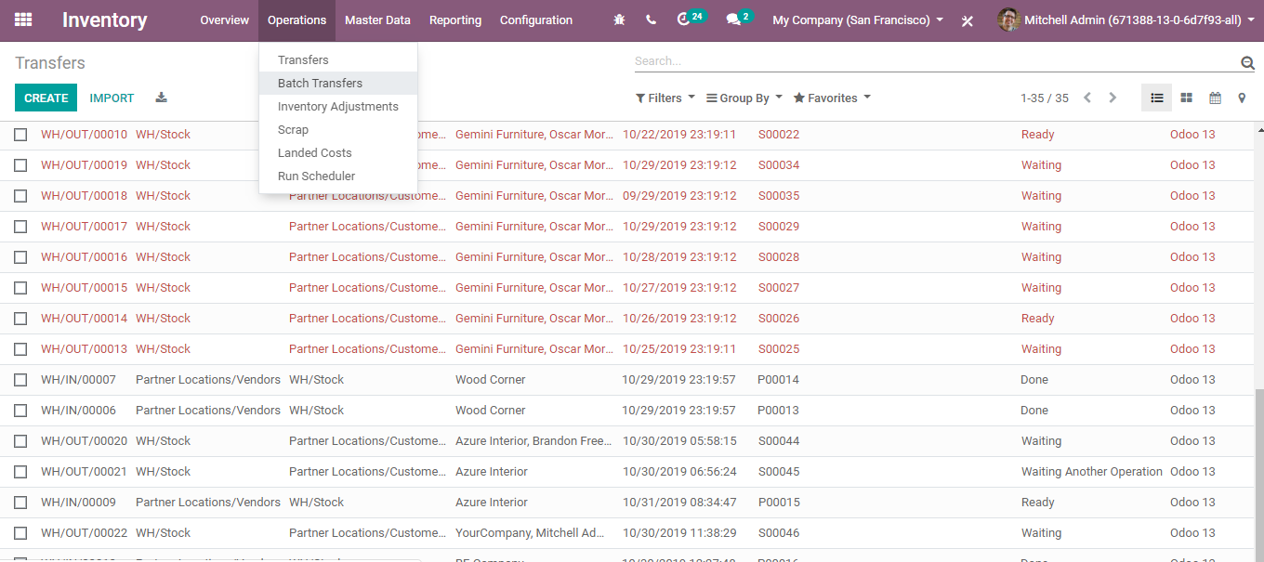
  - Create Batch Transfer
  - After enabling the settings, one can create a batch transfer.
  - Click CREATE button.
  - 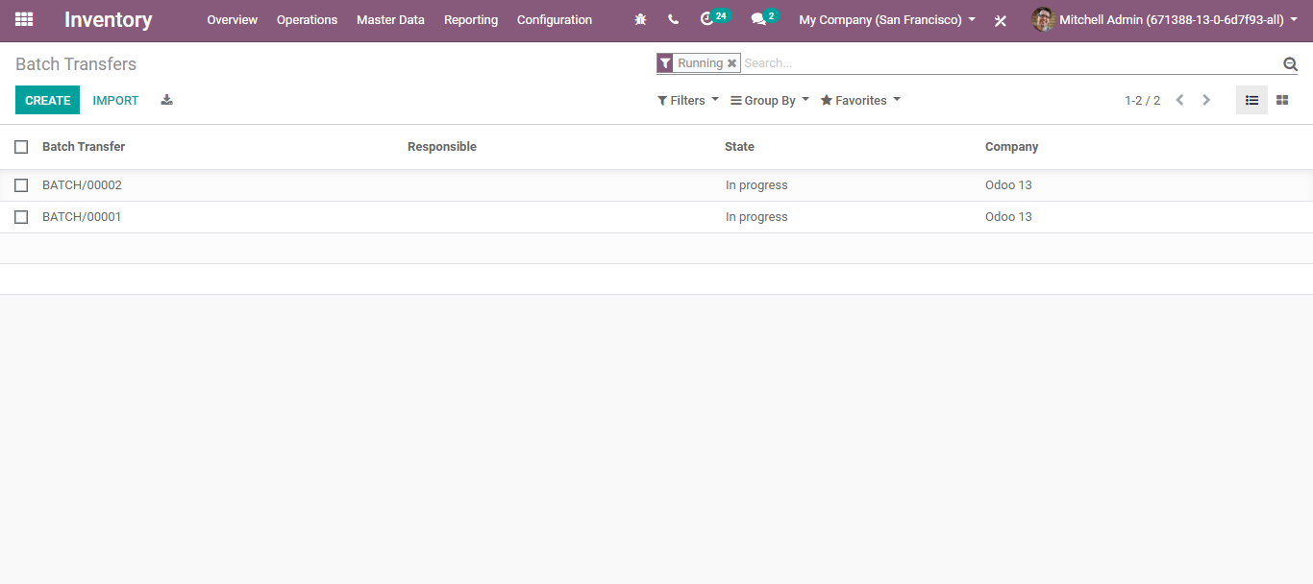
  - A creation form will appear like below:
  - 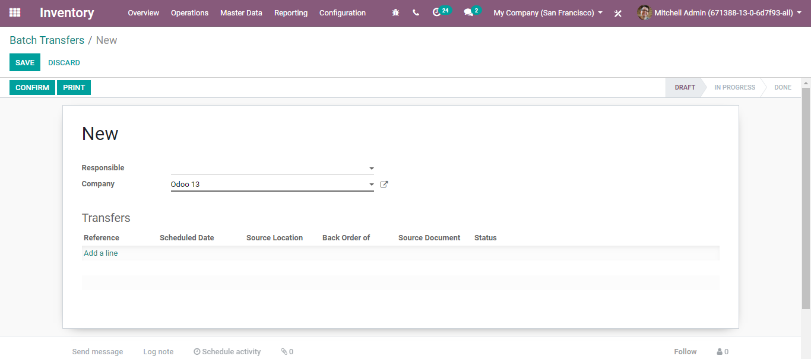
  - Responsible: Person Responsible for this Batch Transfer
  - Add a line: Here, one can add transfers for this batch.
  - 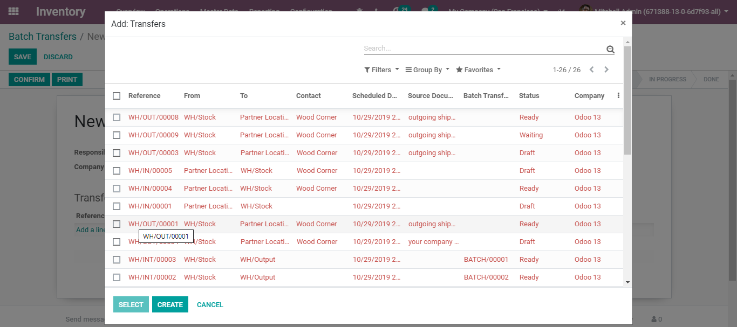
  - 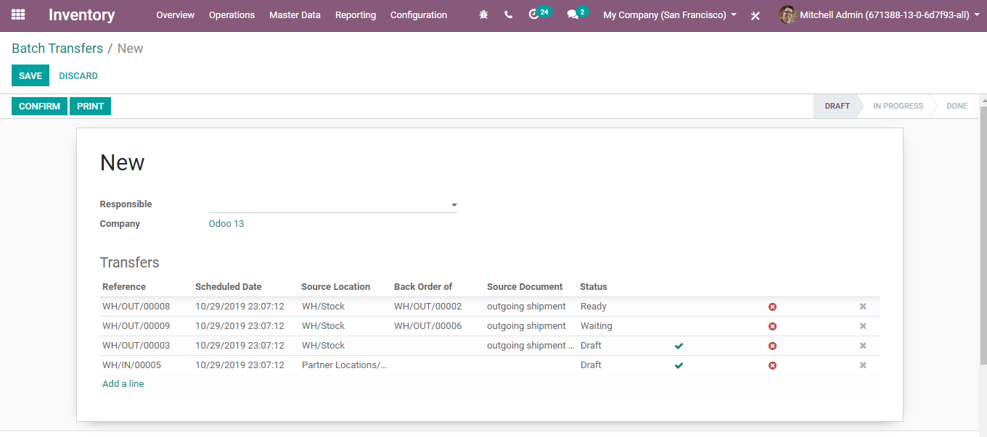
  - Via clicking CONFIRM button, you can make the Batch Picking.

  - INCOMING TRANSFER
  - Receive products in stock
  - Firstly, create products under Master Data > Products.
  - 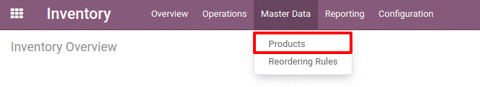
  - If you set your product type as Storable, you can track its stock, say how many units are available and what is the forecasted number of units. However, in case, if you do not want to track the stock, just add them in your receipts/delivery, you can set it as consumable.
  - 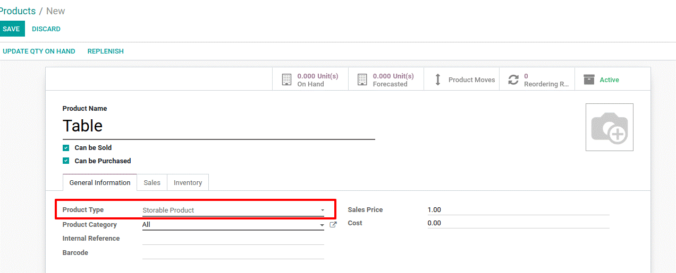
  - Receive Products in Stock
  - Now create a receipt to enter products from your supplier in stock.
  - 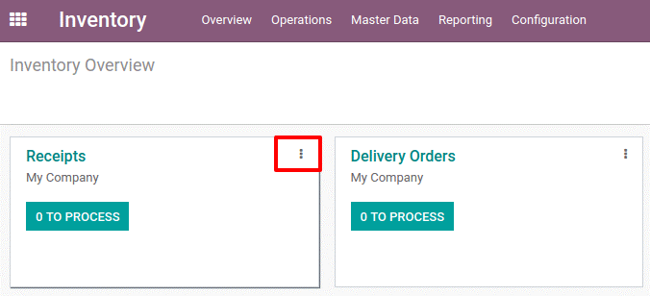
  - 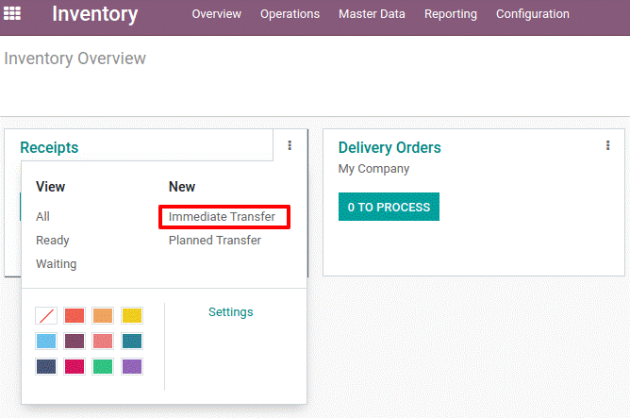
  - On the receipt document, you can specify the supplier (receive from), the number of various products. Once everything is added, click on VALIDATE button. Your products will enter the stock.
  - 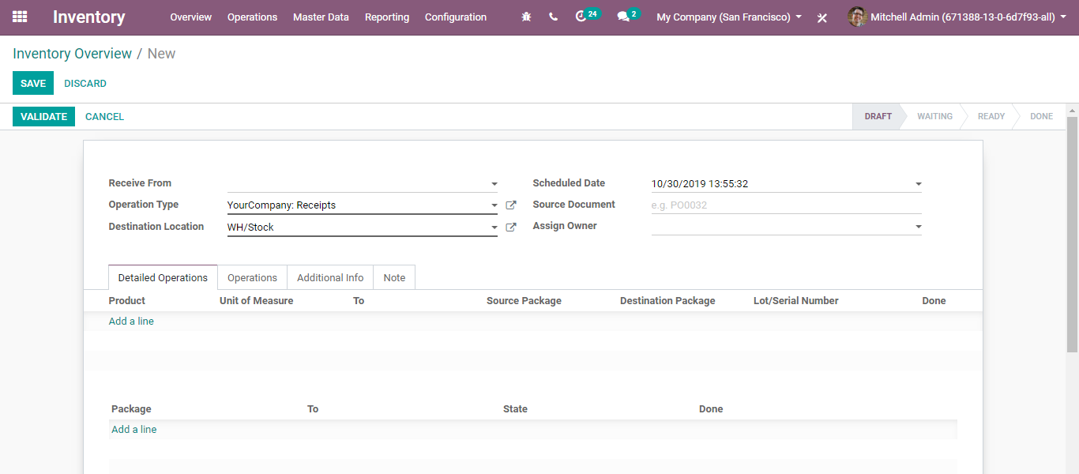
  - In case you have a planned transfer, you can create a planned receipt with a scheduled date.
  - 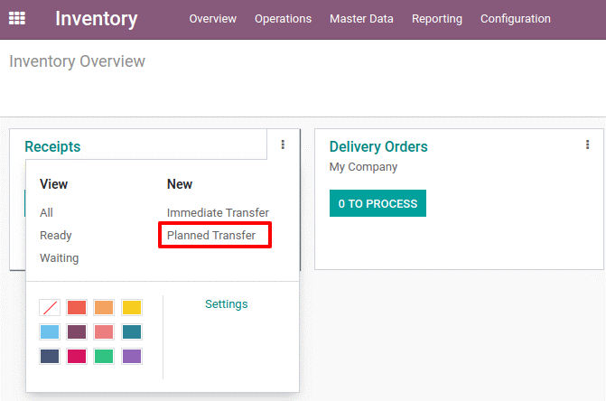
  - 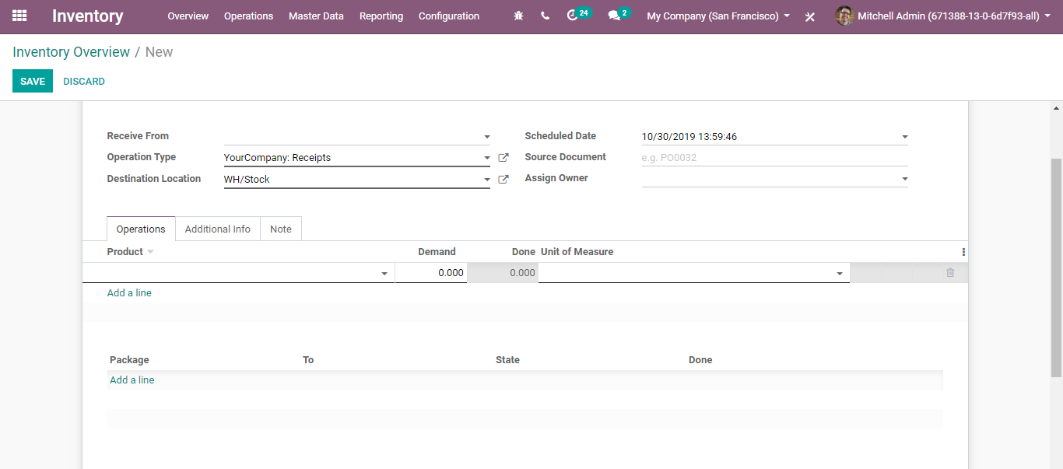
  - Insert here the initial demand for each product, corresponding to what the supplier ordered.
  - 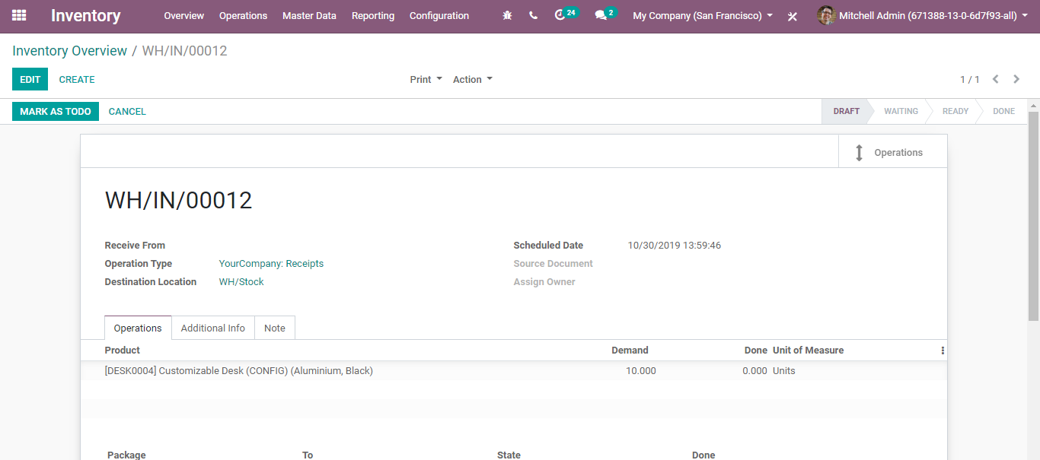
  - After entering click MARK AS DO for considering it in your forecast.
  - 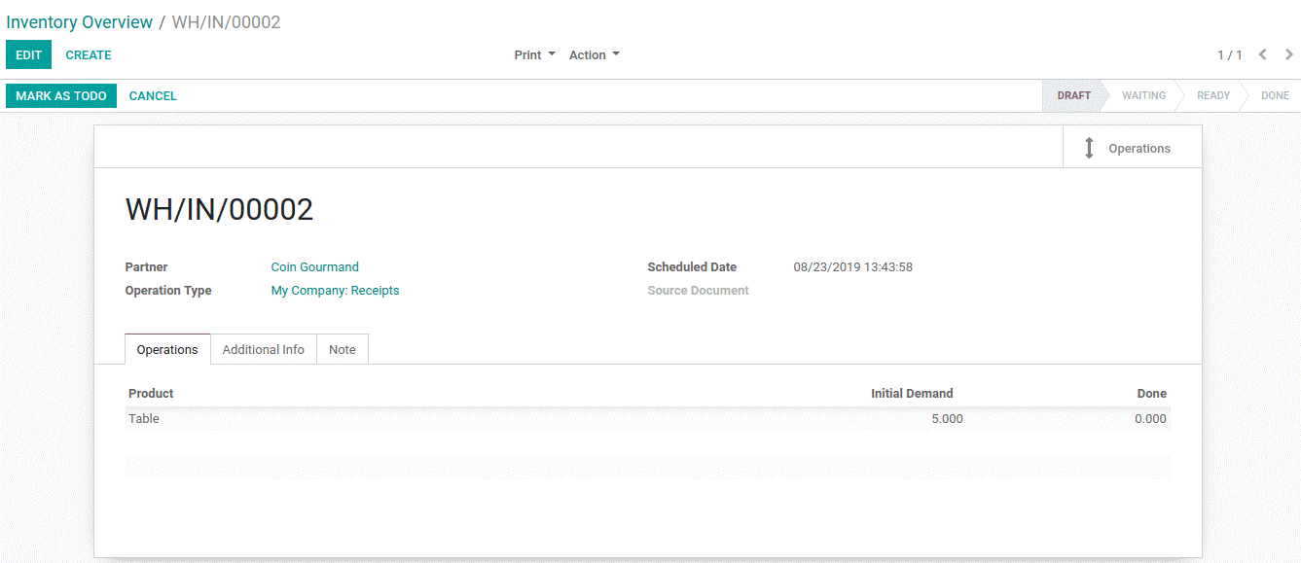
  - Receive Products in Stock from Purchase Orders
  - Validate the RFQ and create a receipt under the purchased app. The corresponding receipt will be visible on the purchase order.
  - 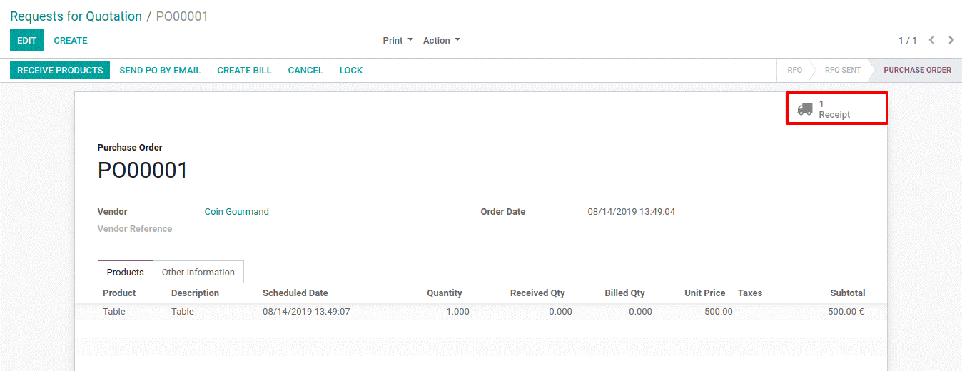

  - OUTGOING TRANSFER
  - Deliver products from stock
  - Firstly, create products under Master Data > Products.
  - If you set your product type as Storable, you can track its stock, say how many units are available and what is the forecasted number of units. However, in case, if you do not want to track the stock, just add them in your receipts/delivery, you can set it as consumable.
  - Deliver Products from Stock
  - As the products get ready, you can proceed with delivering products to customers. The step is as follows:
  - 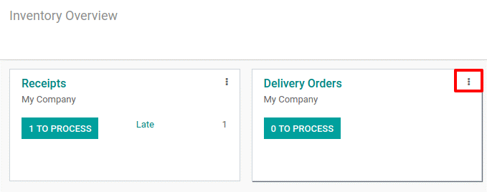
  - 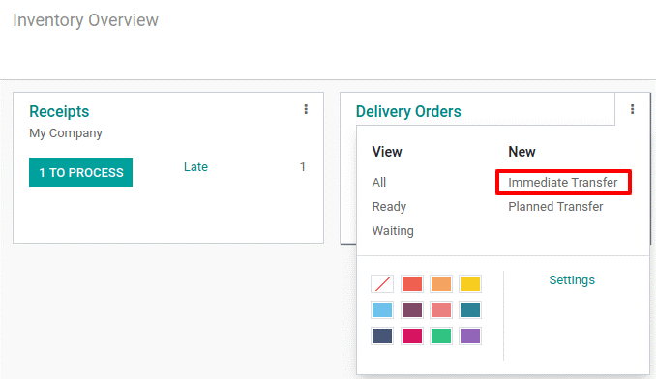
  - In case of immediate transfer, click the option and specify the partner (to whom products will have been delivered), products and their quantities. After delivery, click VALIDATE button. The products will be deleted from your stock.
  - 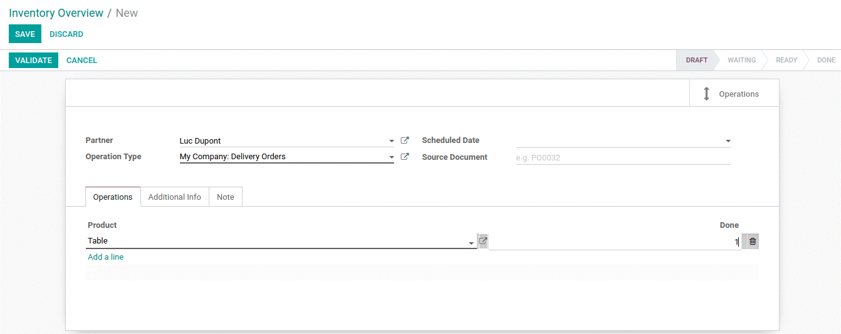
  - In case you have a planned delivery, you can create a planned delivery with a scheduled date. Also add initial demand for each product, corresponding customer order. After entering click MARK AS DO for considering it in your forecast.
  - 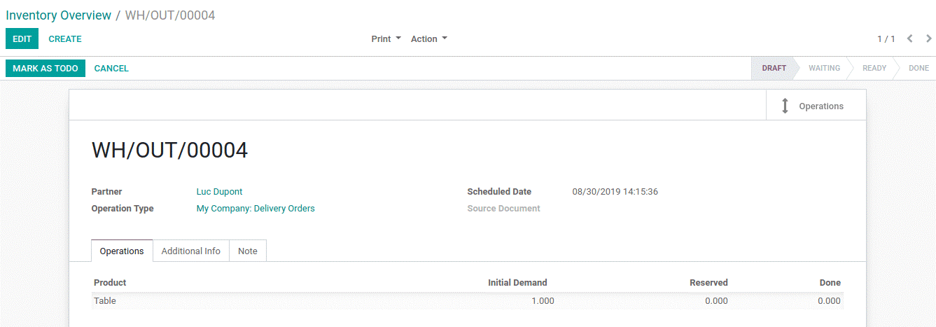

  - Deliver Products from Stock from a Sale Order
  - Product delivery can be initiated after validating a quotation. The corresponding delivery will be visible on the sale order.
  - 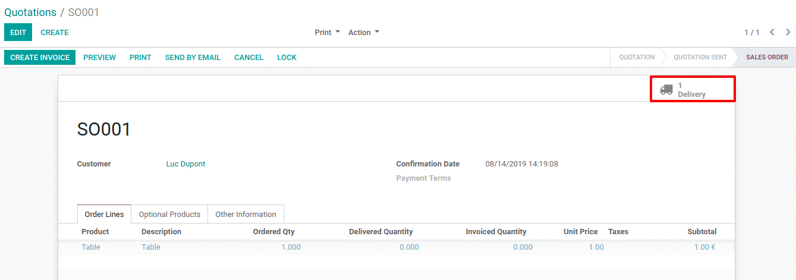

  - INVENTORY ADJUSTMENTS
  - Inventory Adjustments acts as a pivotal feature in warehouse management software to keep the inventory right. Once your products have been defined, it is time to make your initial inventory. You will reflect reality by inventorying the right quantities in the right locations.
  - So firstly, configure your product via going to Inventory>Master Data> Products.
  - Set the product type as Storable for tracking its stock and making inventory adjustments
  - Inventory Adjustment for one Product
  - As soon as you open your product form you get access to the UPDATE QUANTITY button. You can see here, zero products On Hand.
  - 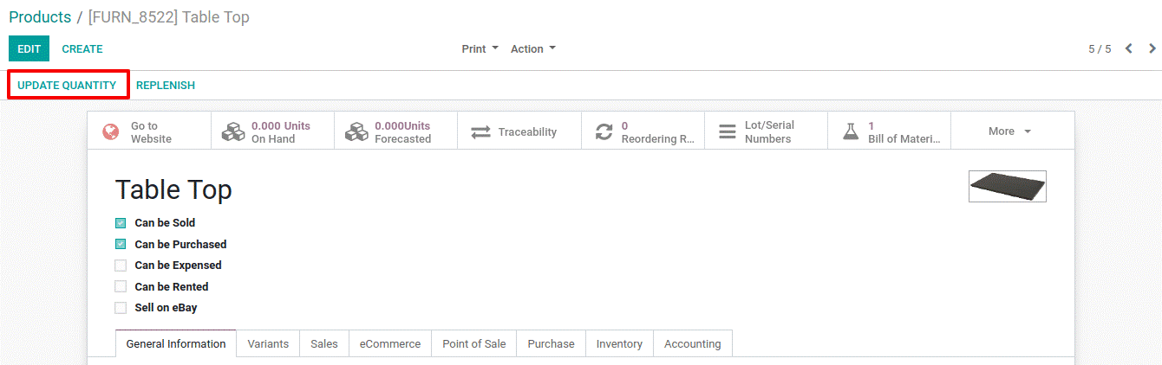
  - Click on the Update QTY on the Hand button.
  - Upon clicking, you can see the current stock for this product. You can make edits such as locations, packages, or add new serial/lot numbers.
  - 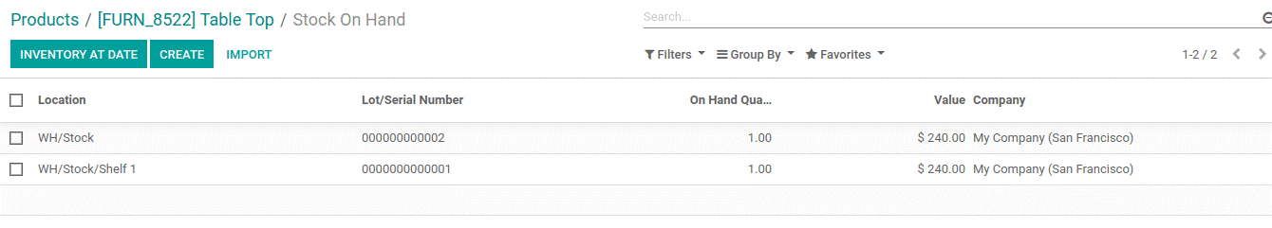
  - Once you come back to your product, you see that the quantity on hand is updated.

  - Inventory Adjustment for Multiple Products
  - Operations > Inventory Adjustments and create a new one.

  - 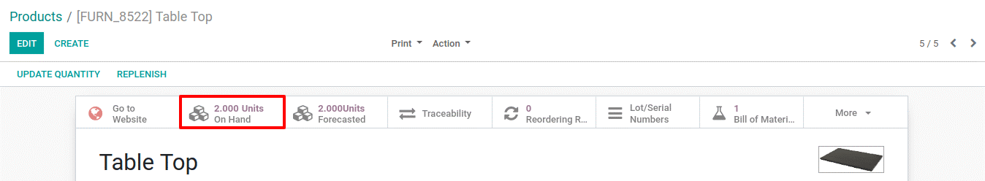
  - 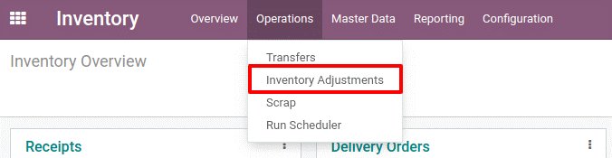
  - 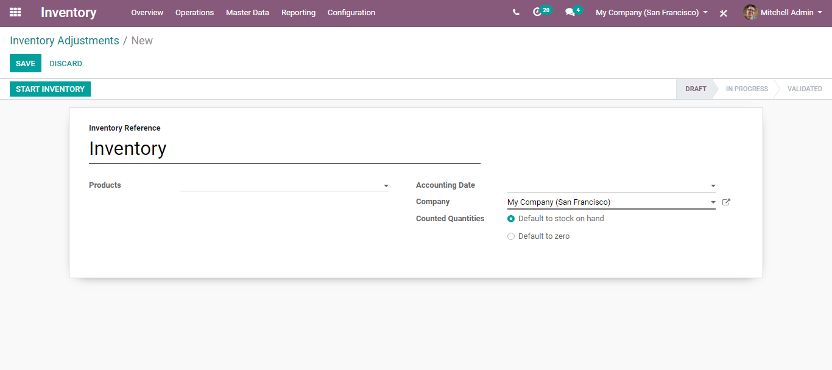

  - Here, you can define an inventory reference, a title for your inventory adjustment. Also, you can decide whether to proceed with the inventory adjustment for all products or some.
  - Then click START INVENTORY.
  - 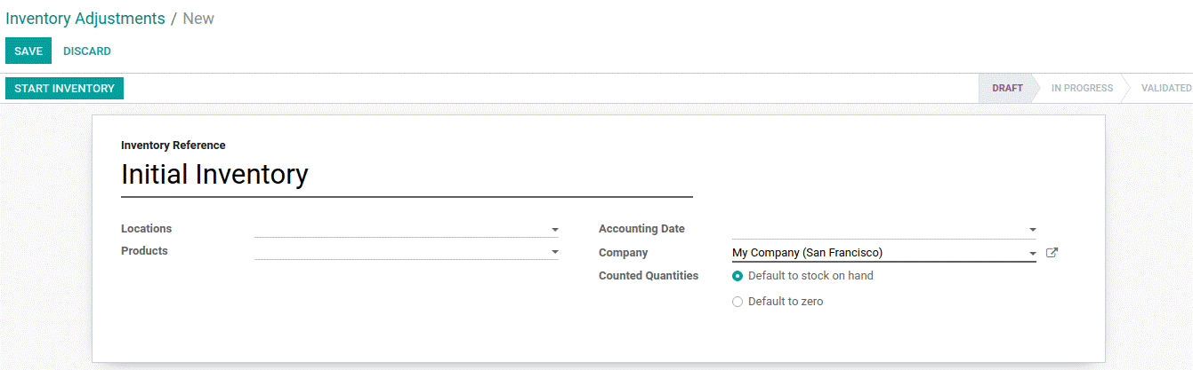
  - If there exist certain products in stock, BusinessBoxERP will add the lines corresponding to the theoretical quantity in stock. You can also add new lines with your other products.
  - 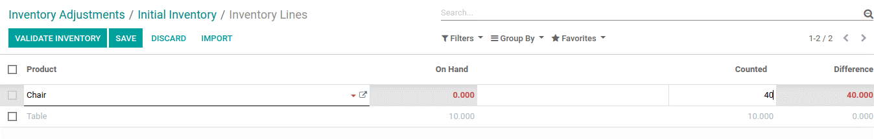
  - BusinessBoxERP will highlight in red if there comes a difference between the theoretical quantity on hand and the quantity that is manually entered. After entering every product, click VALIDATE INVENTORY. Eventually, the Quantities on hand of various products will be updated.

  - SCRAP MANAGEMENT
  - It is obvious to find scrap in your warehouse. Be it in the form of damage, expired or any other. Scrap is often noticed while picking a product. BusinessBoxERP helps you to manage scraps by moving these damaged goods to the scrap area.
  - Configuration
  - BusinessBoxERP automatically creates a scrap location under the name virtual location or scrap. However, one can create a new scrap location by going to
  - Inventory > Configuration > Settings and activating Storage Locations.
  - 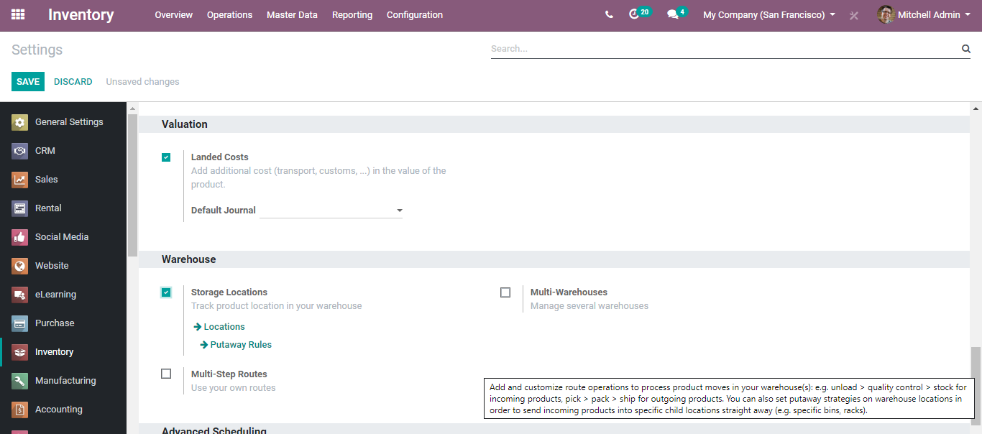
  - Now, go to Configuration > Locations and create your scrap location.
  - 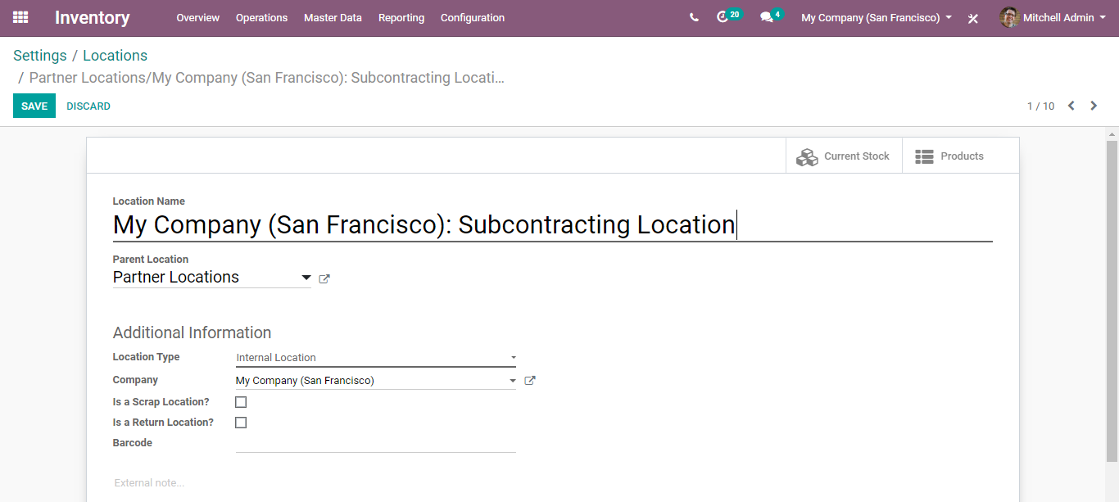
  - If you tick the option, is a scrap location, to allow using this location to put scrapped/damaged goods.
  - Ways to scrap products
  - One can scrap products from receipts, delivery orders, and internal transfers.
  - Scrap from receipt
  - Go to Inventory > Dashboard > Receipts
  - click on the 1 TO PROCESS button.
  - 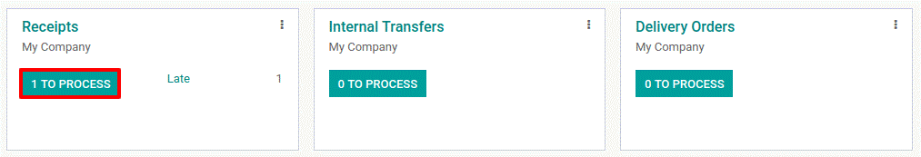
  - Open the receipt and validate the picking. As the products enter the stock, the SCRAP button appears on the receipt screen.
  - 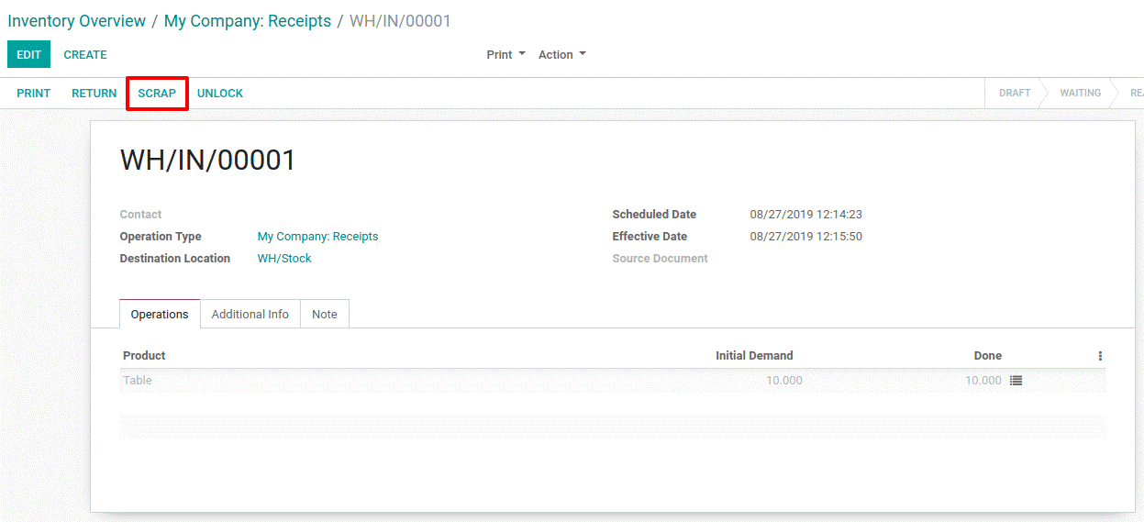
  - Click SCRAP to remove the damaged goods from the receipt.
  - Soon the products will be moved from the stock to the scrap location.
  - 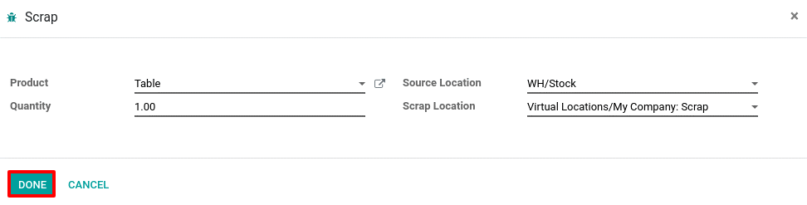
  - Scrap from delivery order
  - Go to Inventory > Dashboard > Delivery orders. Click the 1 TO PROCESS button.
  - 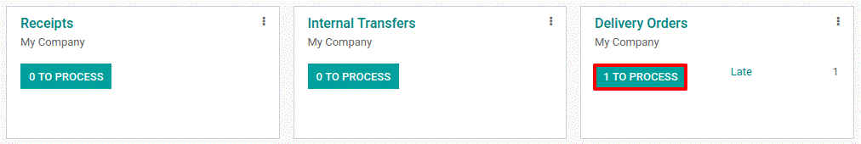
  - Once done, open the delivery order.
  - Click the SCRAP button on top.
  - Soon products shall be moved from the available stock to virtual scrap locations.
  - 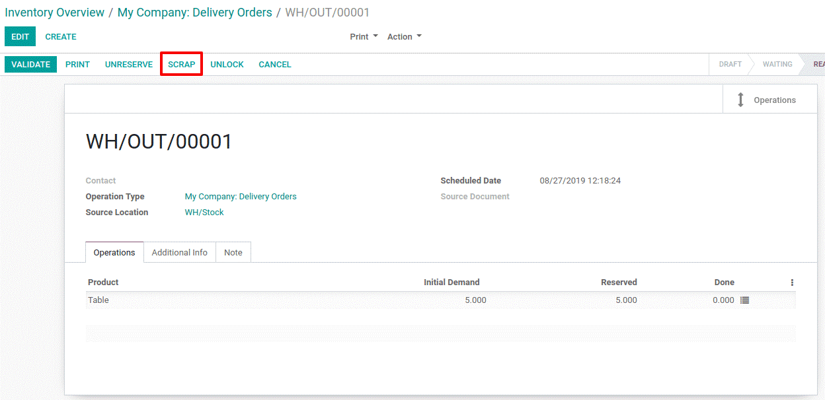
  - 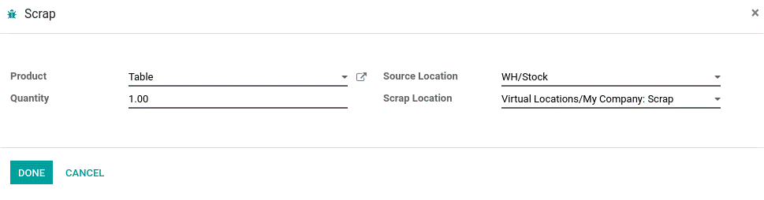

  - To view scrap orders,
  - 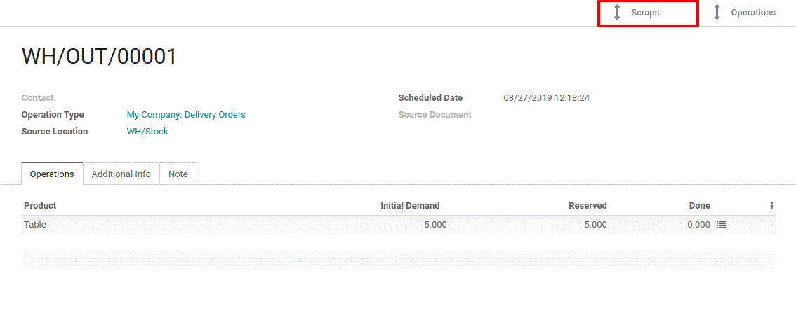
  - Scrap from an internal transfer
  - Go to Inventory > Dashboard > Internal Transfers.
  - 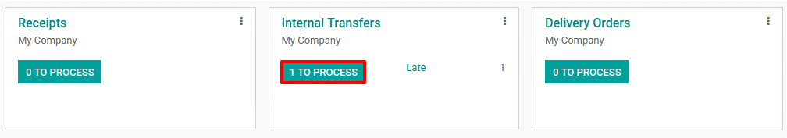
  - Open internal transfers and click on the scrap button.
  - 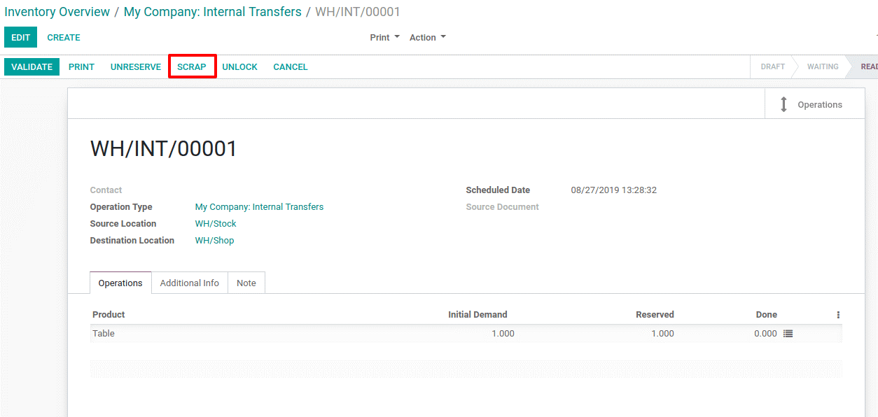
  - 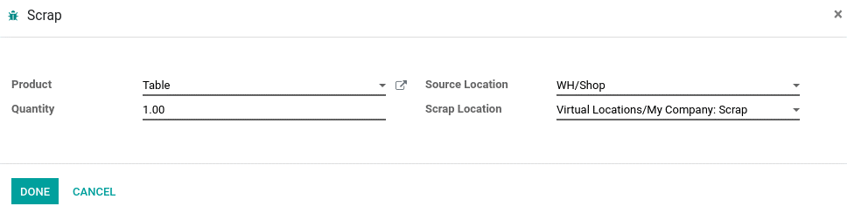

  - LANDED COST
  - Landed cost is the total price of a product once it has arrived at buyers’ hands. The total cost of a landed shipment including purchase price, freight, insurance, and other costs up to the port of destination. This includes the transportation fee, duty, handling fees, taxes, insurance, currency conversion, crating, handling, and payment fees, etc. These prices are added and divided to get the actual selling price of the product.
  - Landed Costs = The purchase price of the product + Any additional charges to get the product to the buyer’s hands.
  - The way of calculating landed cost will vary according to the company and products which they are managing, etc. In some instances, it may also include the customs duties and other taxes levied on the shipment.
  - Configuration
  - Inventory->Configuration-> Settings->Valuation->Landed Costs
  - 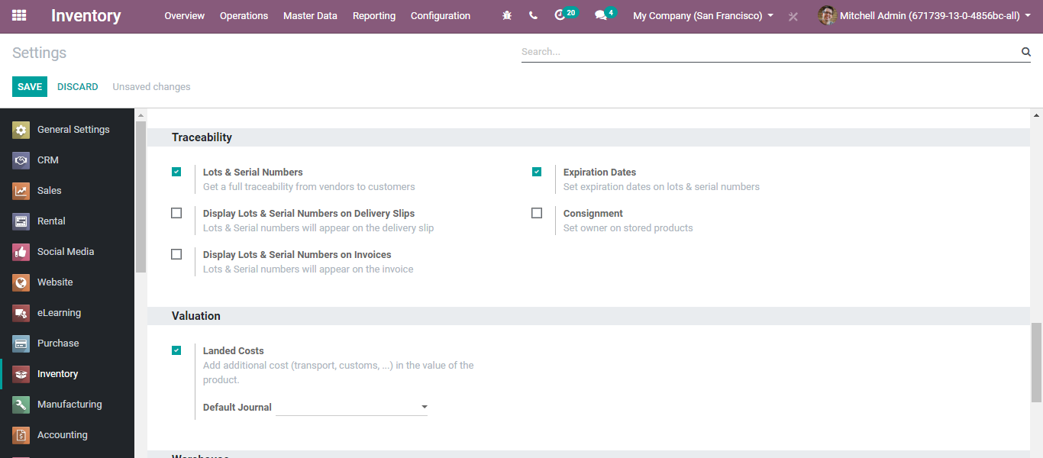
  - Now if you go to Inventory>Operations>Landed costs and click create button, you will be navigated to a new creation form like below:
  - 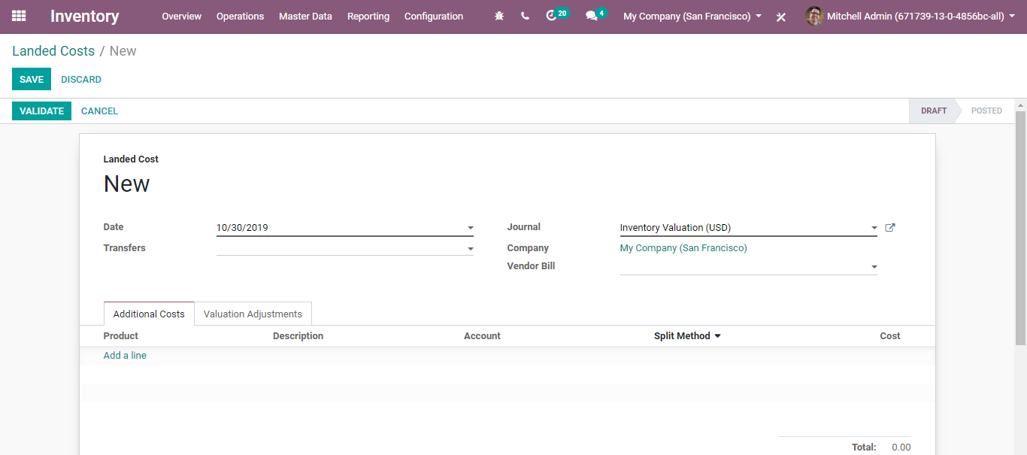
  - 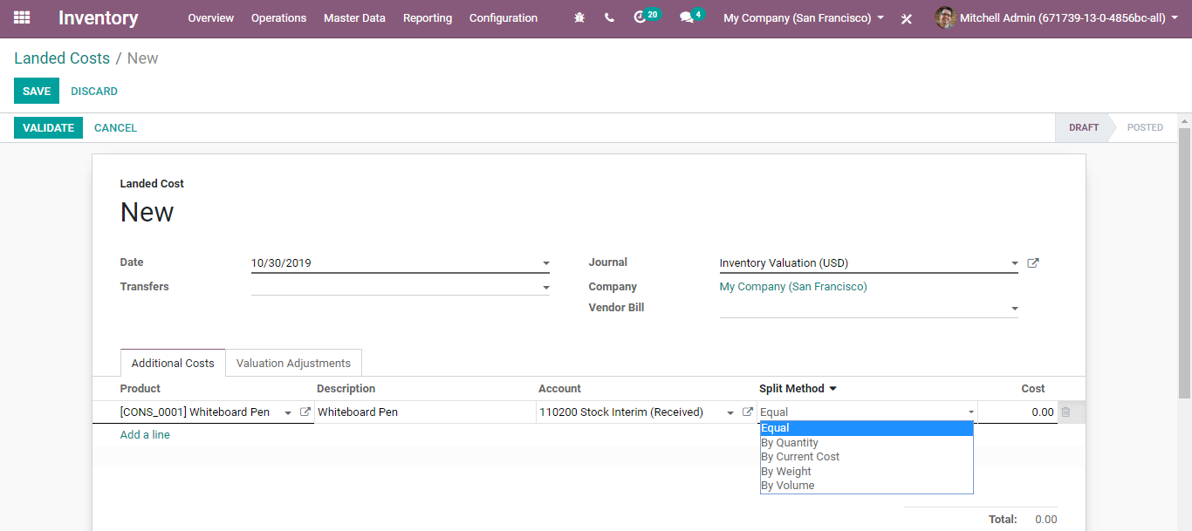
  - Click Add a line to define a product for which the landed cost type is created.
  - Split Method: The field defines the method of splitting the landed cost type.
  - 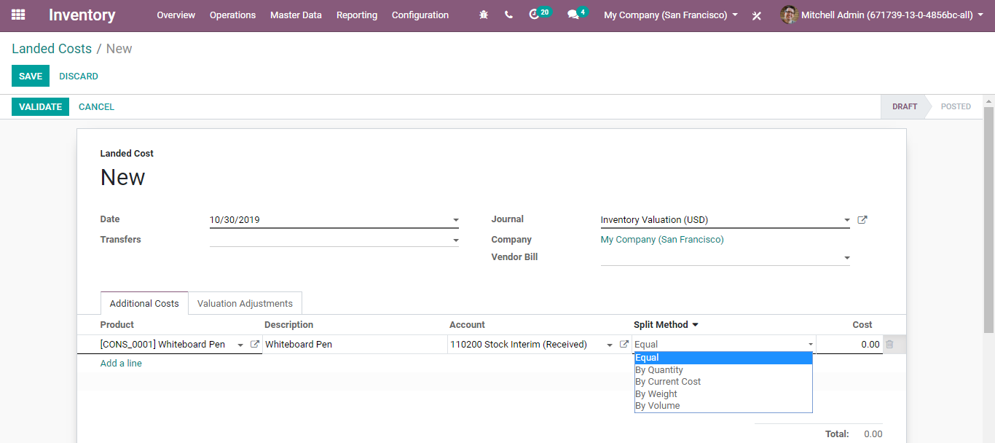
  - BusinessBoxERP provides five split method options:
- Equal: Selecting the option enables to equally divide the costs.
- By Quantity: Enabling the option, costs will be divided according to products quantity.
- By Current Cost: Enabling the option, costs will be divided according to the product’s current cost.
- By Weight: Enabling the option, costs will be divided depending on the product’s weight.
- By Weight: Enabling the option, costs will be divided depending on the product’s weight.
- By Volume: Enabling the option, costs will be divided depending on the product’s volume.
  - Cost: The field defines the cost used for stock valuation in Standard price and as a first price to set in average/FIFO. Also used as a base price for pricelists. Expressed in the default units of measure of the product.

  - RUN SCHEDULER
  - The scheduler is the calculation engine that plans and prioritizes production and purchasing automatically according to the rules defined on products. By default, the scheduler is set to run once a day (BusinessBoxERP automatically creates a Scheduled Action for this).
  - Calculating Requirements / Scheduling
  - Scheduling only validates procurements that are confirmed but not yet started. These procurement reservations will themselves start production, tasks or purchases depending on the configuration of the requested product.
  - You consider the priority of operations when starting reservations and procurements. Urgent requests, those with a date in the past, or requests with a date earlier than the others will be started first. In case there are not enough products in stock to satisfy all the requests, you can be sure that the most urgent requests will be produced first.
  - Configure and run the scheduler
  - Run the scheduler manually
  - This feature is not visible by default. You must enable debug mode to see this. To enable debug mode, go to Help ‣ About and click on Activate the developer mode.
  - You can also start the scheduler manually from the menu Inventory> Operations> Run Schedulers. The scheduler uses all the relevant parameters defined for products, suppliers, and the company to determine the priorities between the different production orders, deliveries, and supplier purchases.
  - 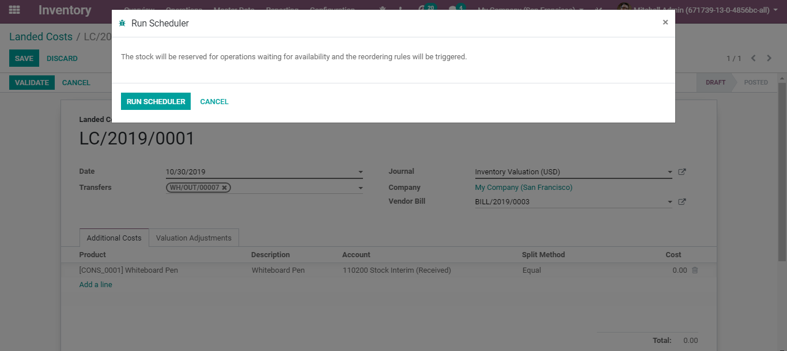
  - Configure and run the scheduler (only for advanced users)
  - This feature is not visible by default. You must enable debug mode to see this. To enable debug mode, go to Help -> About and click on Activate the developer mode.
  - You can set the starting time of the scheduler by modifying the corresponding action in the menu Settings ‣ Technical ‣ Automation ‣ Scheduled Actions. Modify the Run MRP Scheduler configuration.

  - WAREHOUSE MANAGEMENT
  - WAREHOUSE
  - In BusinessBoxERP, a Warehouse is a place where you stock your products. One can set up multiple warehouses, alongside creating transfers between warehouses.
  - To create a new warehouse, go to Inventory>Configuration> Settings > Warehouse and activate the manage several warehouses option.
  - 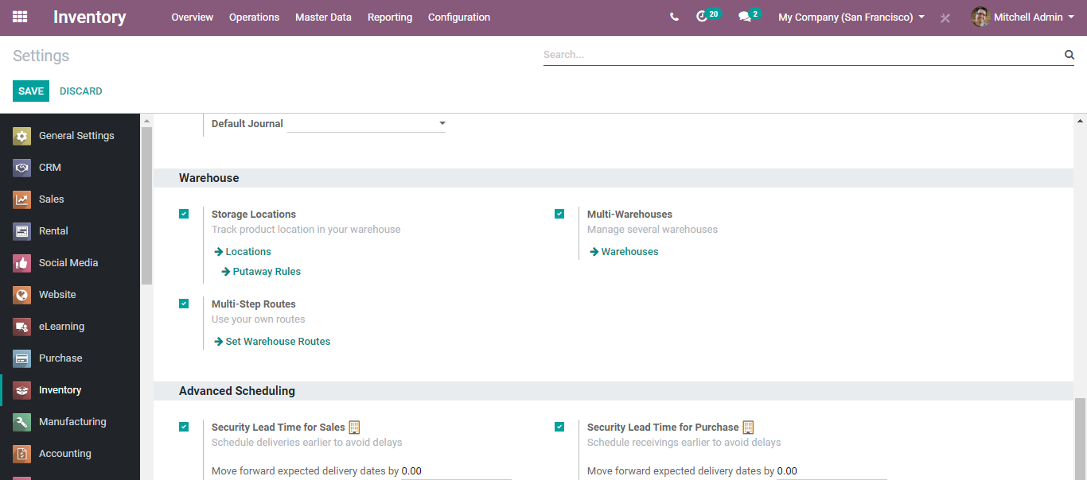
  - Next go to Inventory > Configuration > Warehouses.
  - 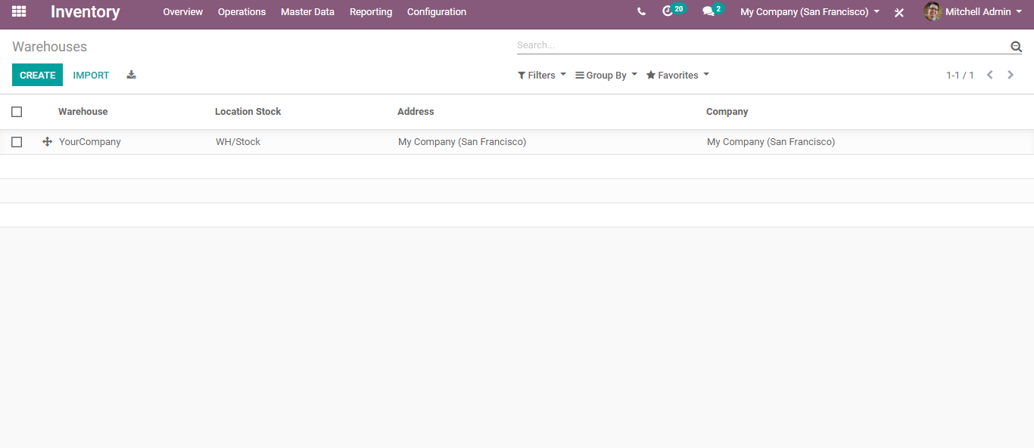
  - Click CREATE button to add a new warehouse
  - 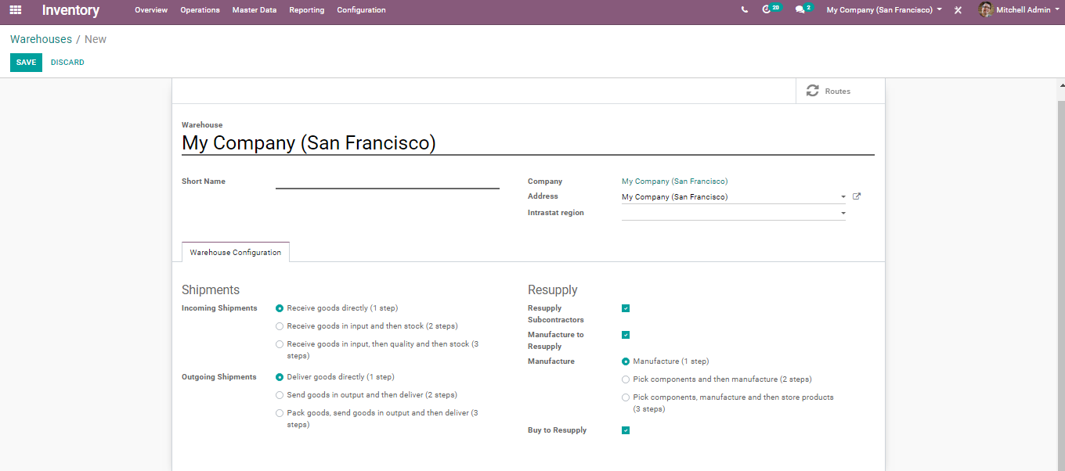
  - Warehouse: In the field, insert the full name of the warehouse.
  - Short Name field: insert a 5-characters code for your warehouse. Keep in mind that this code is the one that will appear in the lists, so make sure you choose a name that is easy to understand and easy to enter.
  - Address field: You can select an existing company or create one on the go. Therefore, the address of your warehouse will be the same as one of the companies you selected. You can also leave this field empty and edit it afterwards.
  - Save all the changes to create a new warehouse. Now in the Dashboard, you can see new operation types automatically created by BusinessBoxERP on account of the creation of a new warehouse.
  - 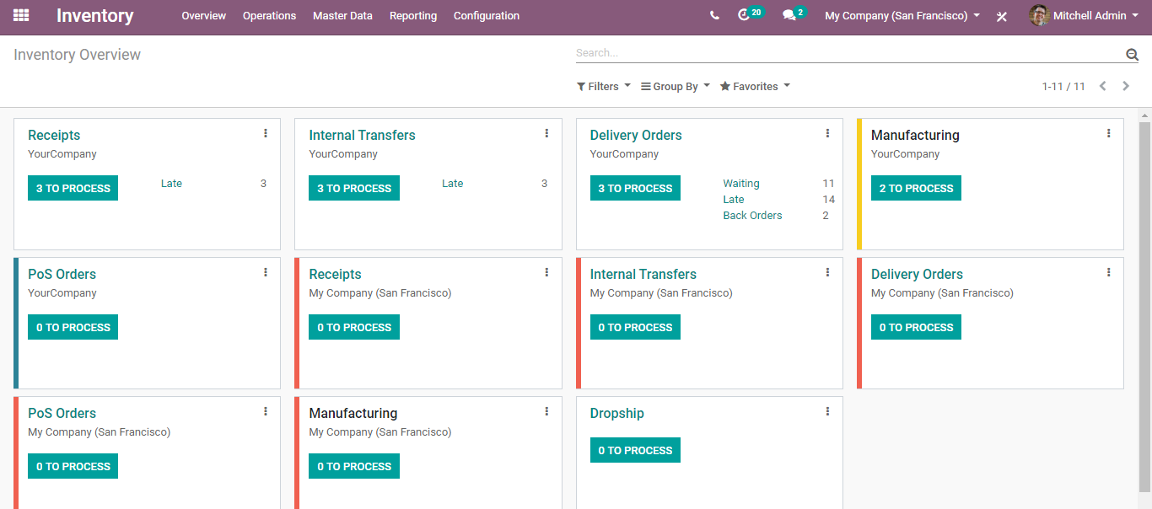
  - LOCATIONS
  - A location is nothing but a particular space within a warehouse says a shelf or floor. It can be called a sub-location of your warehouse. For this reason, one cannot link a location to multiple warehouses.
  - In BusinessBoxERP, one can configure multiple locations under a single warehouse. The location comes in three models.
  - Physical Locations: An internal location within a warehouse for which you are the owner.
  - Partner Locations: Spaces within a customer or vendor's warehouse for which you are not the owner.
  - Virtual Locations: Space that does not exist, but in which products can be placed when they are not physically in an inventory say when products are on their way to the warehouse (Procurements).
  - In BusinessBoxERP, locations are structured like a tree, dependent on a parent-child relationship.
  - Configuration
  - Go to Inventory application > Configuration > Settings> Warehouse and activate Storage Locations.
  - 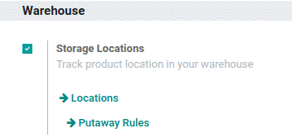
  - Next, go to Inventory application> Configuration > Locations to create new location
  - 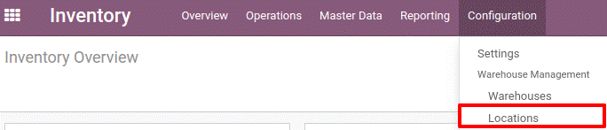
  - Upon clicking create button, you will be navigated to a new window like below:
  - 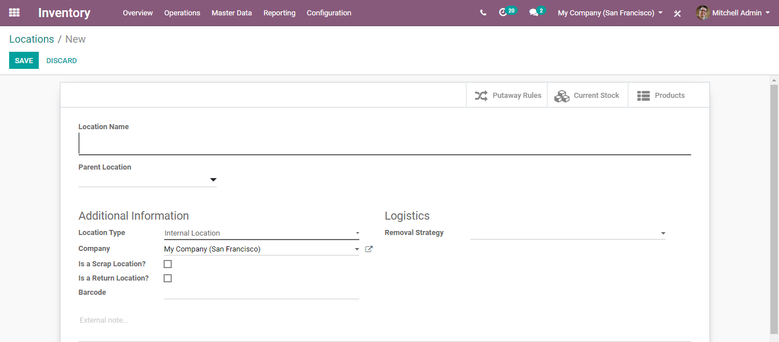
  - Here, you can define the Location Name, select the Parent Location from the list. Parent location can be a physical, partner or virtual location. Alongside, one can also add multiple sub-locations to a location.
  - In case you want to allow this location to keep the scrapped/damaged products, you can tick the Is a scrap location? Menu. and Is a Return Location? to allow using this location as a return location.
  - In case the Barcode application is installed, you can specify the barcode that corresponds to this location.

  - RULES & ROUTES
  - Procurement is the action of obtaining the desired or required amount of product rather than going for bulk, and the procurement inventory control system begins with a customer order. One of the prime advantages the end-user can acquire from the procurement rule is that he can evade the possibility of excess inventory. Here, the end-user is freed from the management or storing of excess stock. The procurement rule reduces the inventory levels and thereby the cost of storing the goods in the inventory.
  - Push Rule however involves forecasting inventory needs to meet customer demand. The disadvantage of the push inventory control system is -too much product is left in inventory as the sales are unpredictable. This eventually raises the cost of the company to store these goods. However, the advantage is a company will be always self-sufficient to meet customer orders
  - To satisfy a procurement, the system will scan for rules belonging to routes characterized in particular sale order.
  - Configuration
  - Go to the Inventory >Configuration>Settings> Warehouse->Multi-step Routes.
  - 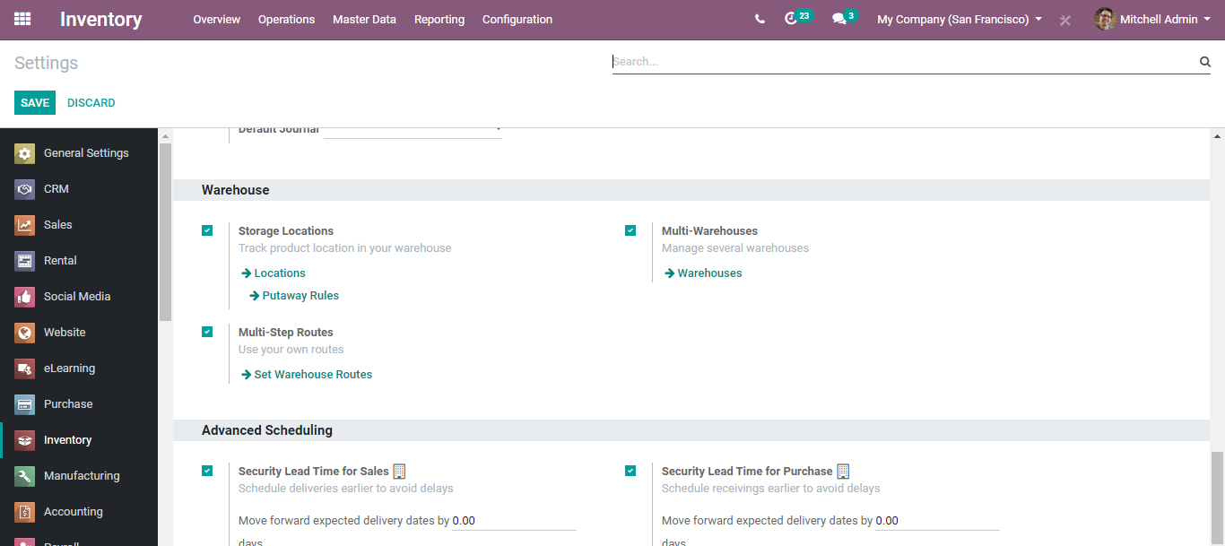
  - To create new rules or view the existing rules go to Inventory >Configuration >Rules.
  - 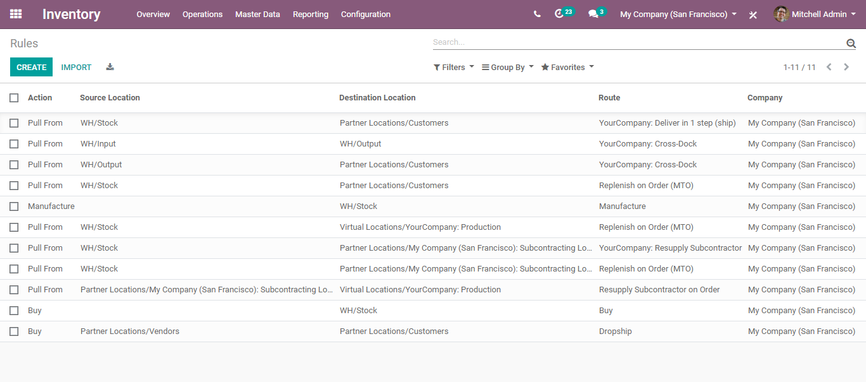
  - One can see the different actions set under the menu. To create a new rule, click CREATE button.
  - You will be navigated to a creation form like below:
  - 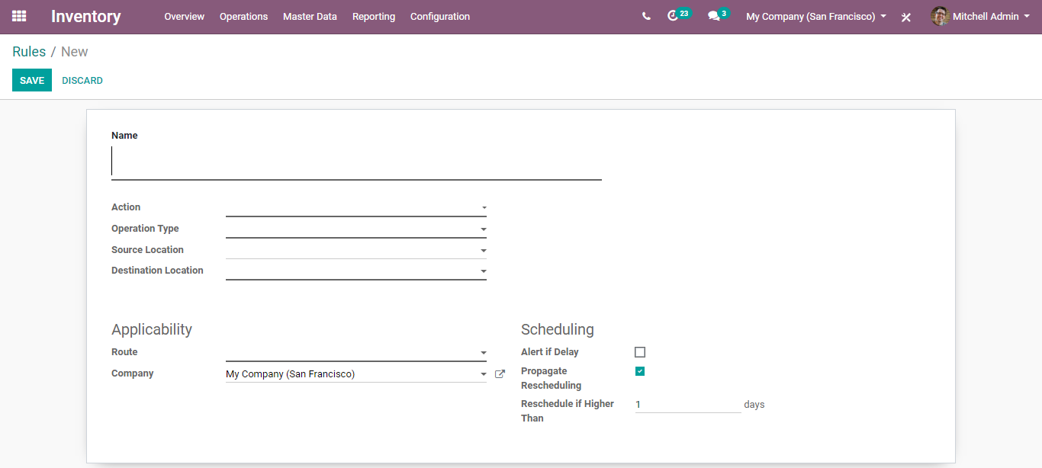
  - Here you can define:
  - Action
  - 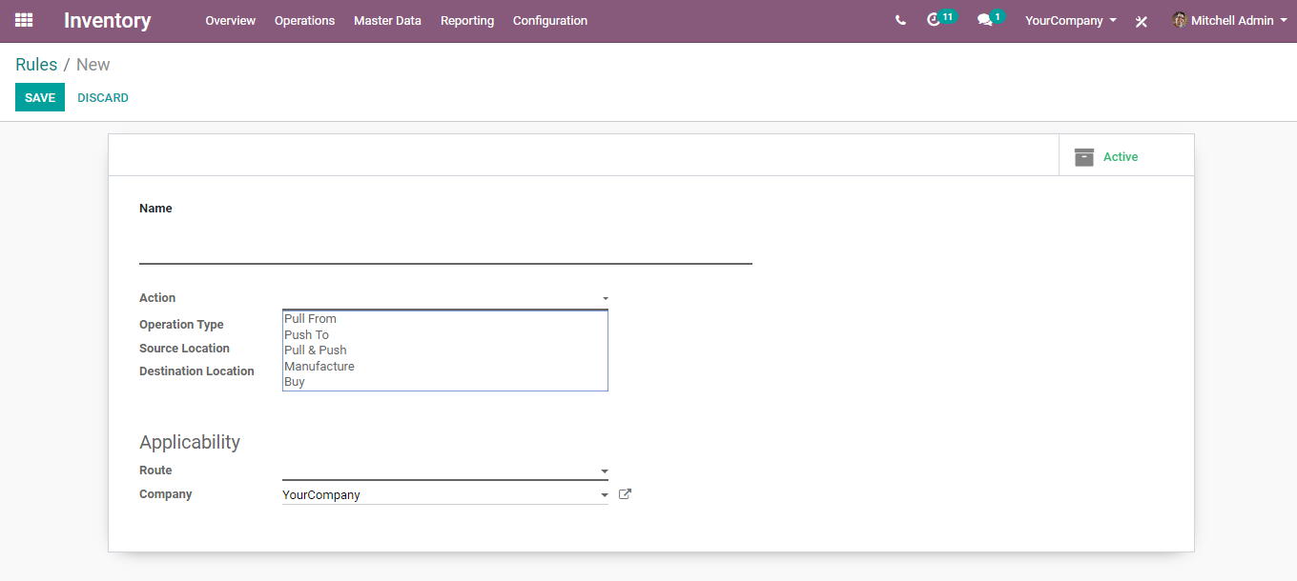
  - Operation Type:
  - 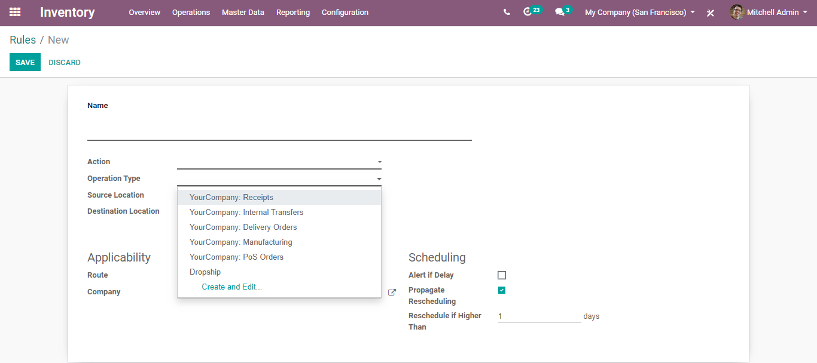
- Source Location
- Destination Location
- Routes for the product:
  - 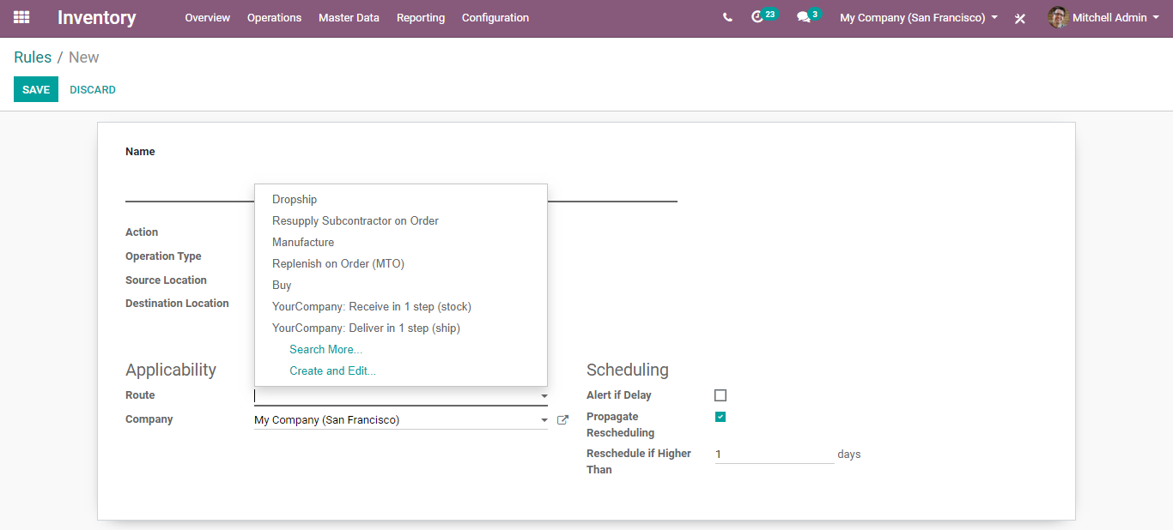

  - The default routes in BusinessBoxERP ERP includes Drop Shipping, resupply subcontractor on order, Manufacture, Buy and Make to Order.
- Drop Shipping: Under the Drop Shipping function, the vendor does not keep the products in stock, process the delivery of goods directly from the vendor to the customer. There will not be any stock housing during the transit.
- Buy: Buy proposes a purchase or manufacturing of the product.
- Re-supply Subcontractor on Order: Using this route, one can subcontract the production of some finished products through subcontractors.
- Manufacturer: Under this route, one can set up production plans and workflows for your customizable products.
- Replenish on Order/ Make to Order: The Make to Order function trigger a purchase order as soon as a sales order related to the product is generated. Here, the function does not evaluate the current stock and draft a purchase order even if the product quantity is inadequate. i.e., it triggers the purchase order regardless of the product quantity in hand.
  - One can see the routes for each product under the inventory tab of the product.
  - 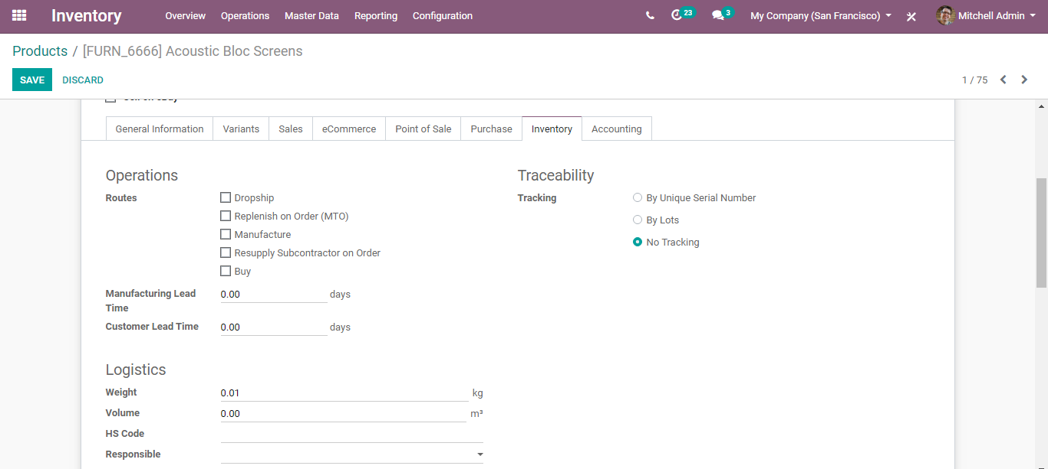

  - ROUTES
  - Routes are the different ways by which particular products are obtained or sold from the warehouse. Routes might be relevant or not appropriate relying upon the products, the sales order lines, the stockroom, and so on. BusinessBoxERP can manage advanced push/pull routes configuration for instance creating a route for managing the products manufacturing chain or say manage default locations per product.
  - Drop-shipping
  - Deliver to customers straight from your supplier based on products, orders, or customers.
  - Cross-Docking
  - Unload incoming material and directly transfer to outbound gates with little to no storage in between.
  - Put away & Removal strategies
  - Define your storage and removal strategies, FIFO, nearest available zone, LIFO, etc.
  - Pick - Pack - Ship
  - Design your order process flow. Deliver to customers in one step (delivery order) or several steps: picking, packing, shipping.
  - Push & Pull Routes
  - Design your product routes to automate transfer orders between warehouses or locations.
  - Multi-Warehouses
  - Manage all your warehouses with the same system and define replenishment rules between warehouses.
  - Inventory->Configuration->Settings->Warehouse
  - 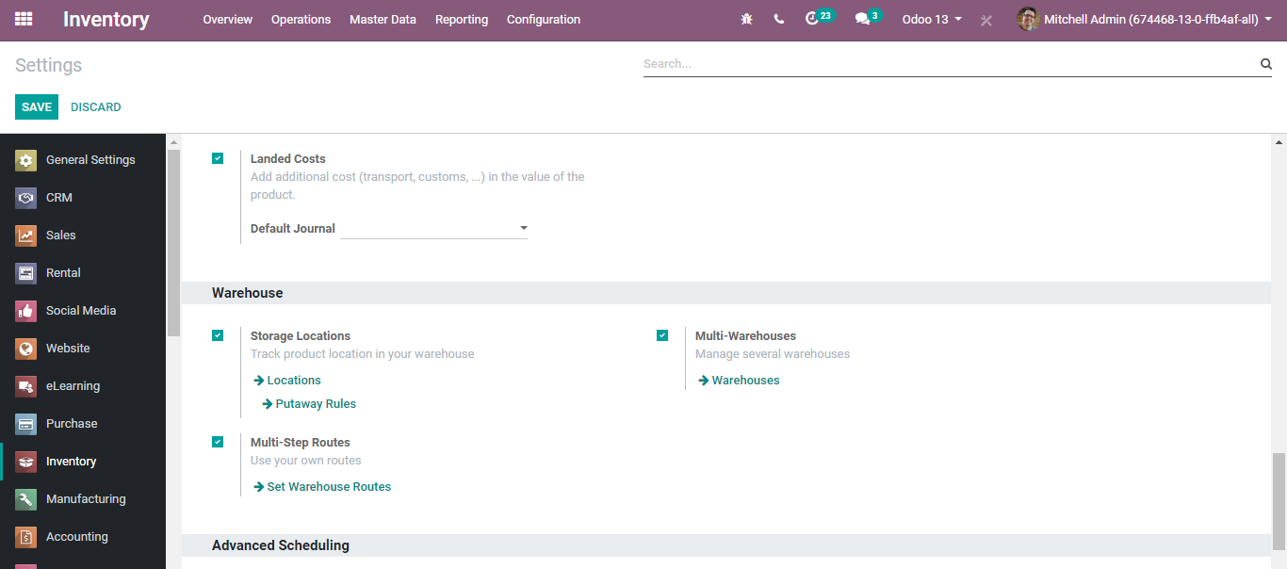
  - BusinessBoxERP embeds some pre-configured routes for your warehouses. To see them,
  - In the Inventory application, go to Configuration > Warehouses.
  - In the Warehouse Configuration tab, Set Warehouse routes options set some routes according to your choices.
  - 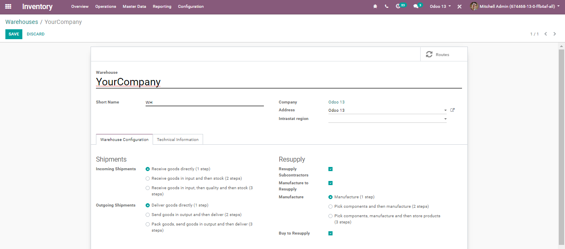
  - Under the form, you will find the fields such as:
  - Short Name: Short name to identify your warehouse.
  - Company: The Company is automatically set from your user preference.
  - Under Warehouse configuration
  - Incoming shipments: Default incoming routes to follow:
- Receive goods directly (1 STEP).
- Receive goods in input and then stock (2 STEPS).
- Receive goods in input, then quantity and then stock (3 STEPS).
  - Outgoing Shipments: Default outgoing routes to follow:
- Deliver goods directly (1 STEP)
- Send goods in output and then deliver (2 STEPS)
- Pack goods, send goods in output and then deliver (3 STEPS)
  - Under Resupply
  - Resupply Subcontractors: Resupply contractors with components.
  - Manufacture to Resupply: When products are manufactured, they can be manufactured in this warehouse.
  - Manufacture: Produce: Move the raw materials to the production location directly and start the manufacturing process. Pick/Produce: Upload the raw materials from the Stock to Input Location first, and then transfer them to the production location.
  - Buy to Re-supply: When products are brought, they can be delivered to this warehouse.
  - Custom Routes
  - Configuration
  - Go to Inventory> Configuration>Routes
  - Upon clicking routes, you will be navigated to a new window like below. You can see the existing list of routes, however, can create new routes via clicking the CREATE button.
  - 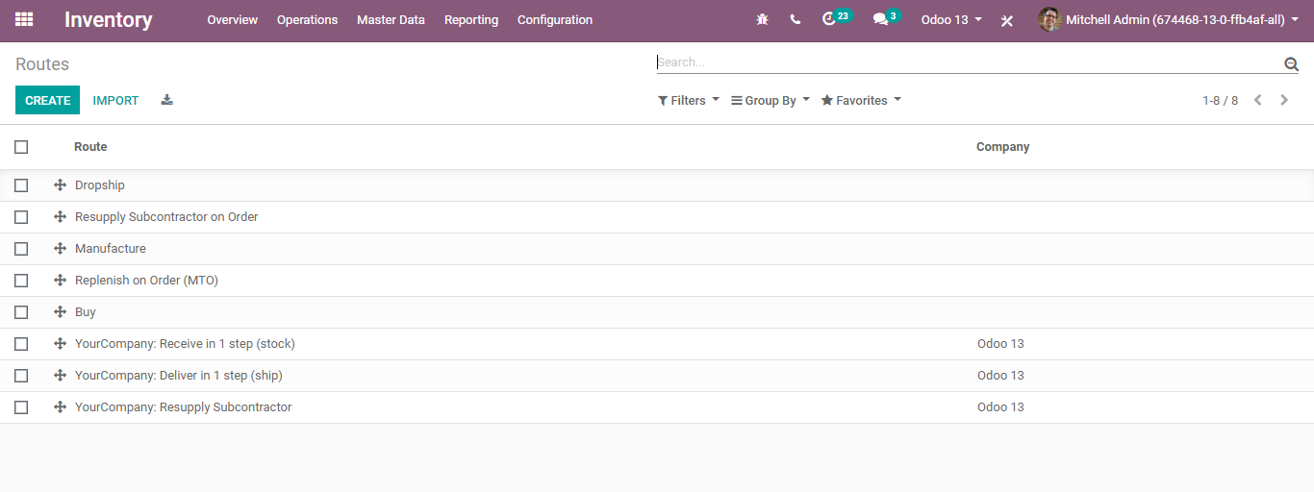
  - Upon clicking the CREATE button, you get navigated to a new window like below to create your custom route.
  - 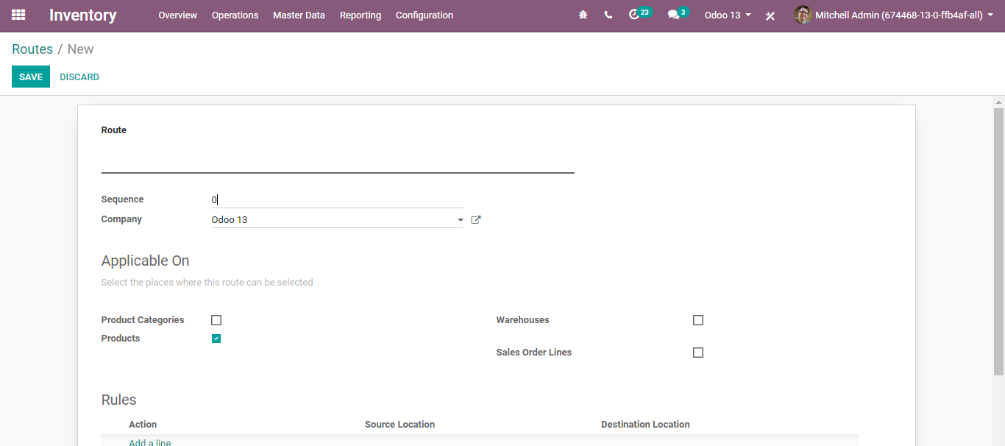
  - Here you can define the route name, sequence, company (leave this field empty if the route is shared between all countries), Option to select the place where this route can be selected- Product Categories, Products, Warehouses, Sales Order Lines) and Rules.
  - Routes applied on warehouses
  - If you tick Warehouses, you must choose which warehouse it will be applied to. The route will be set for all transfers in that warehouse that would meet the conditions of the procurement and push rules.
  - 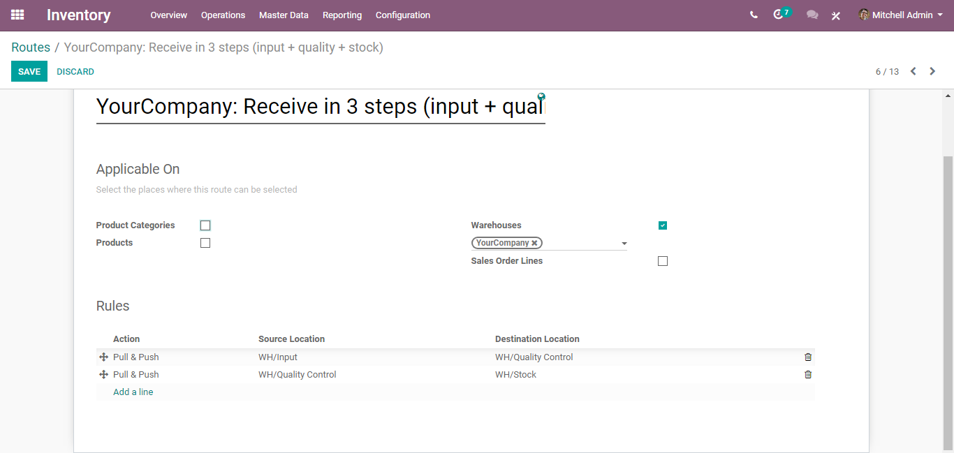
  - You can see the rules defined here
  - 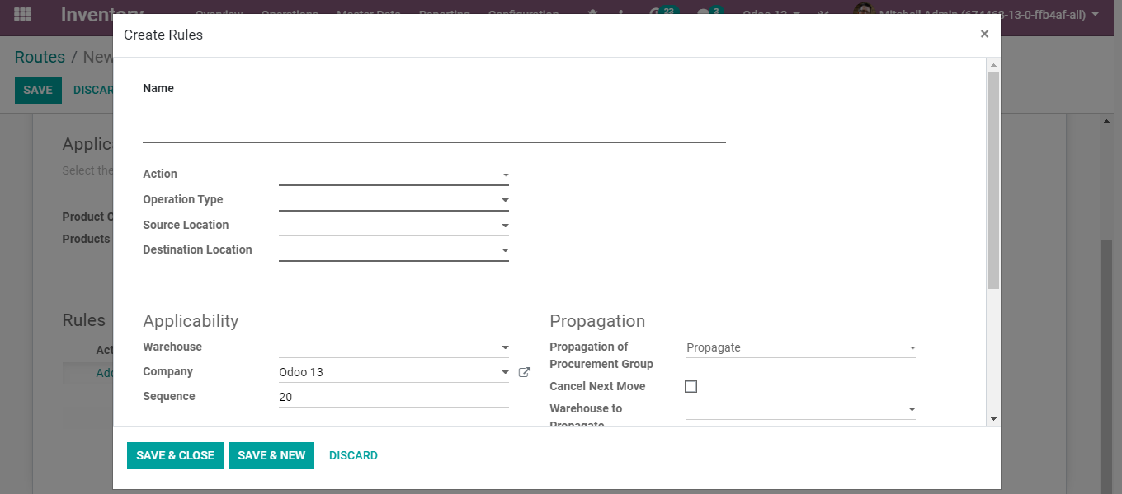

  - Routes applied on products
  - If you tick Products, you must manually set on which product it will be applied.
  - 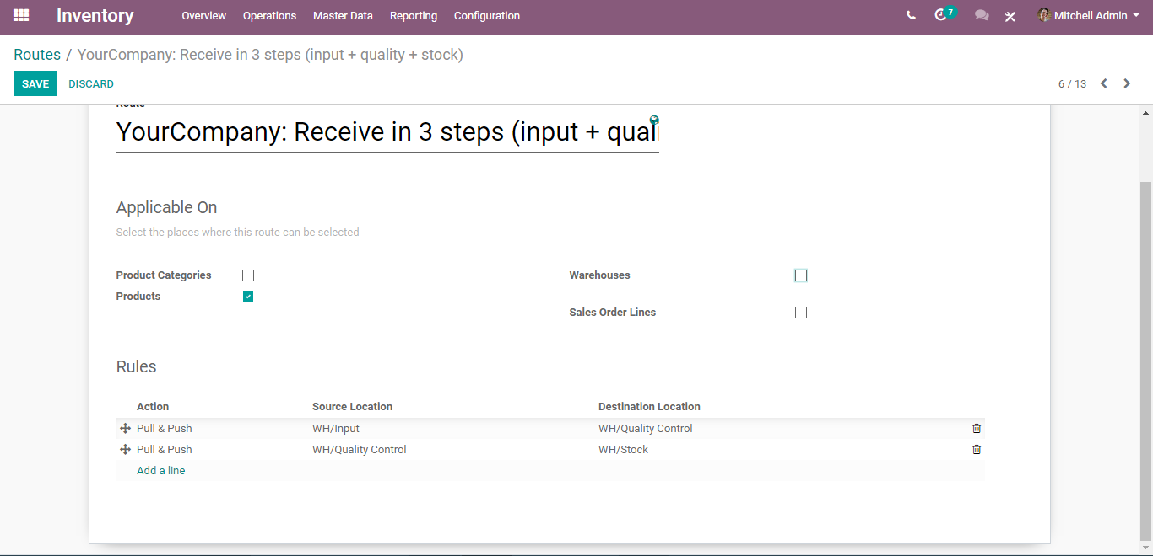
  - Open the product on which you want to apply the routes (Inventory ‣ Master data ‣ Products). In the Inventory Tab, select the route(s):
  - 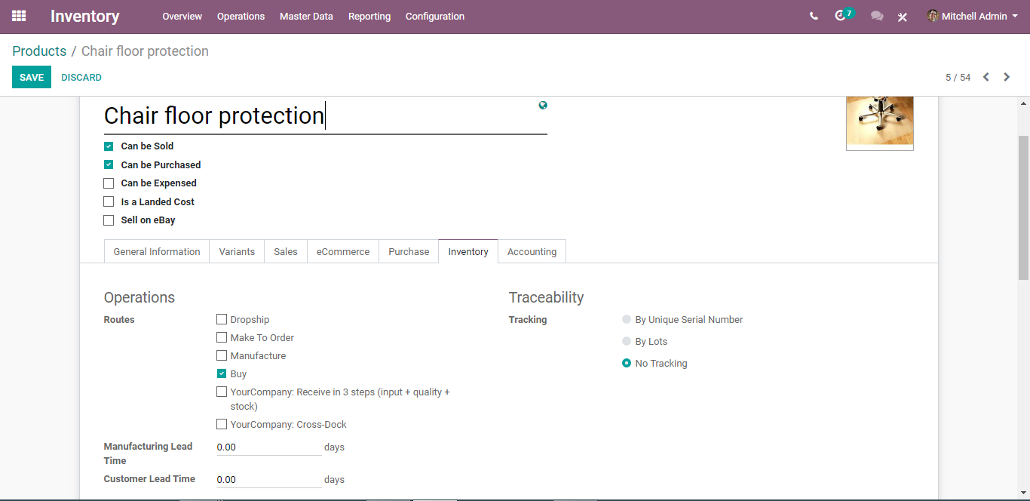

  - Routes applied on Product Category
  - If you tick Product Categories, you must manually set on which categories it will be applied.
  - 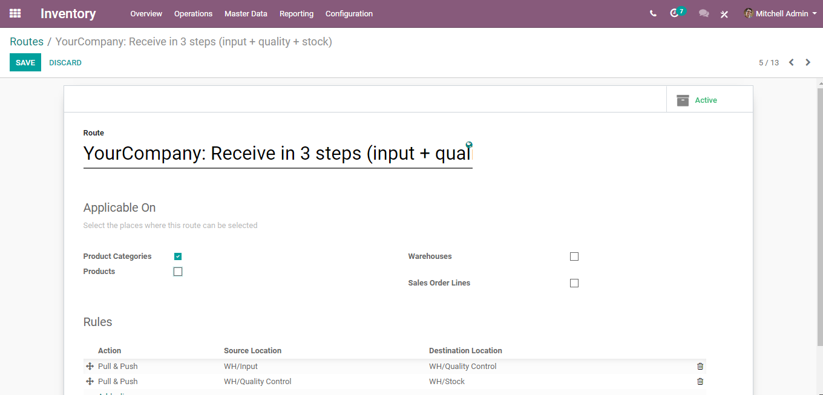
  - Open the product on which you want to apply the routes (Configuration ‣ Product Categories). Select the route(s) under the logistics section:
  - 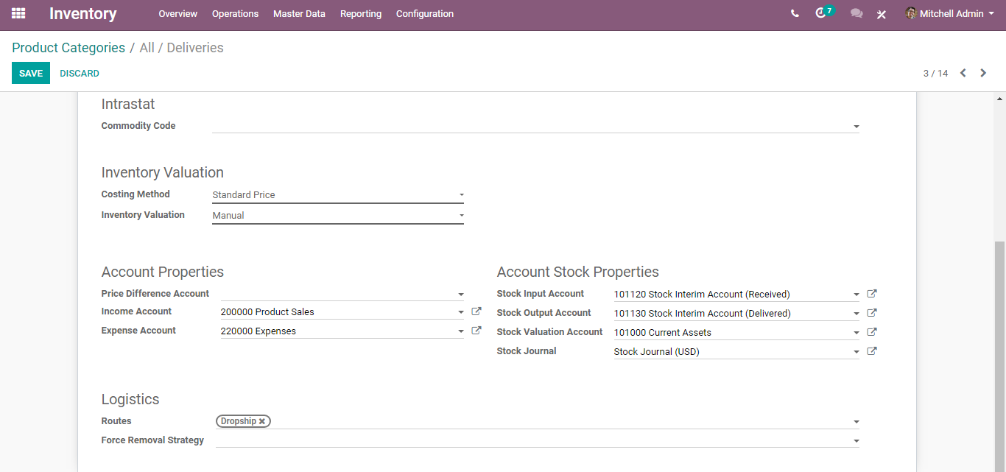
  - 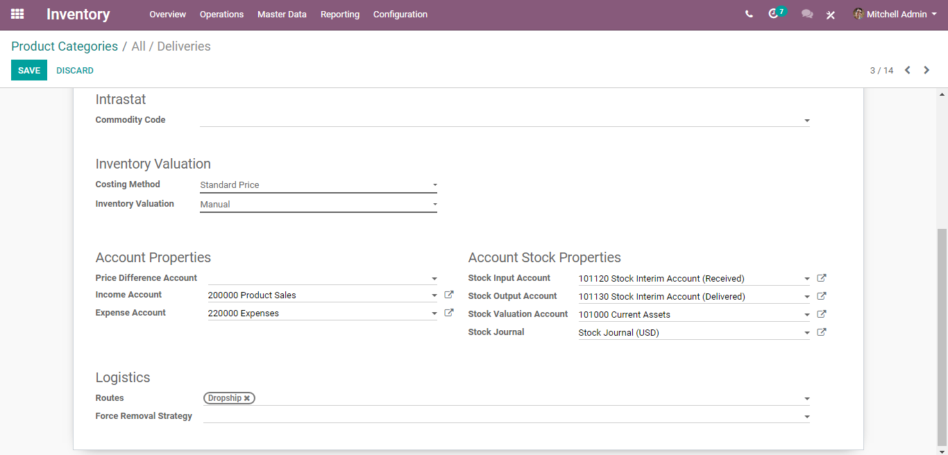
  - Routes applied on Sales Order lines
  - If you tick Sales order lines, you must manually set the route every time you make a sale order.
  - 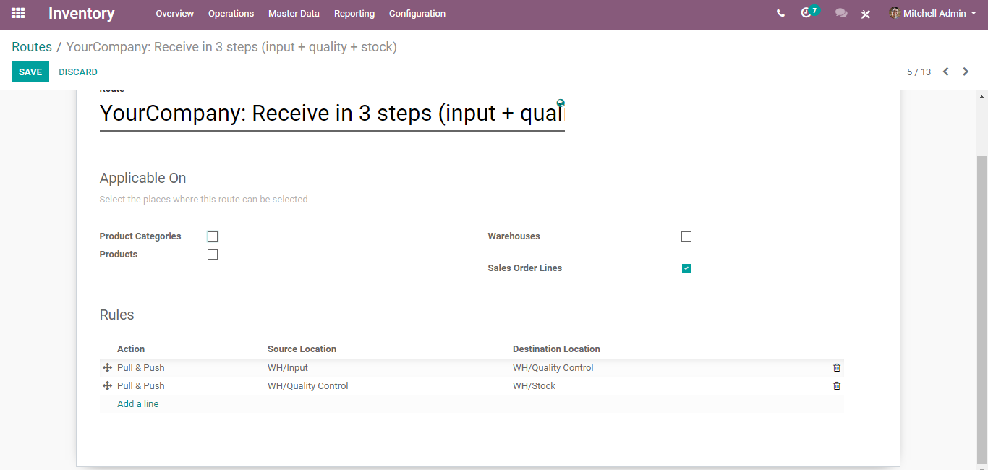
  - To make it work, you also must activate the use of the routes on the sales order.
  - In the Sales application, go to Configuration ‣ Settings and tick Choose specific routes on sales order lines (advanced).

  - You can now choose the routes for each line of your sales orders:
  - 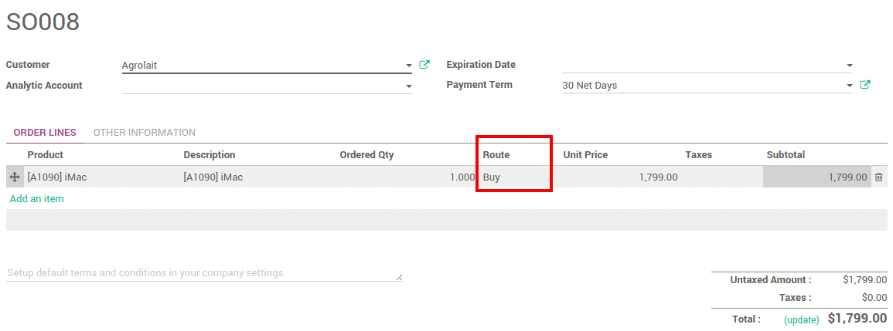
  - Make-to-Order Route
  - If you work with no stock, or with minimum stock rules, it is better to use the Make to Order route. Combine it with the route Buy or Manufacture and it will trigger automatically the purchase order or the Manufacturing Order when your products are out-of-stock.
  - PUTAWAY RULES
  - Put away is the way toward taking items off the receiving shipment and placing them in a safe area. For instance, your warehouse will have volatile substances, in that case placing every product together can cause a chemical reaction.
  - Configuration
  - Go to Inventory>Configurations>Settings> Warehouse and Activate setting Storage Locations.
  - 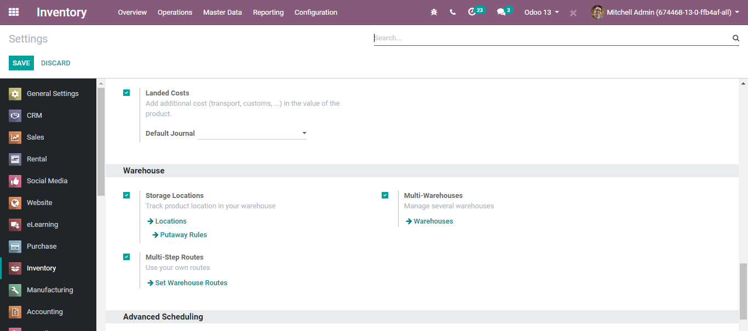
  - Put away strategies are defined at the location level.
  - If you go to Inventory> Configuration> Locations
  - You can see the put-away rules on the top of the location screen.
  - 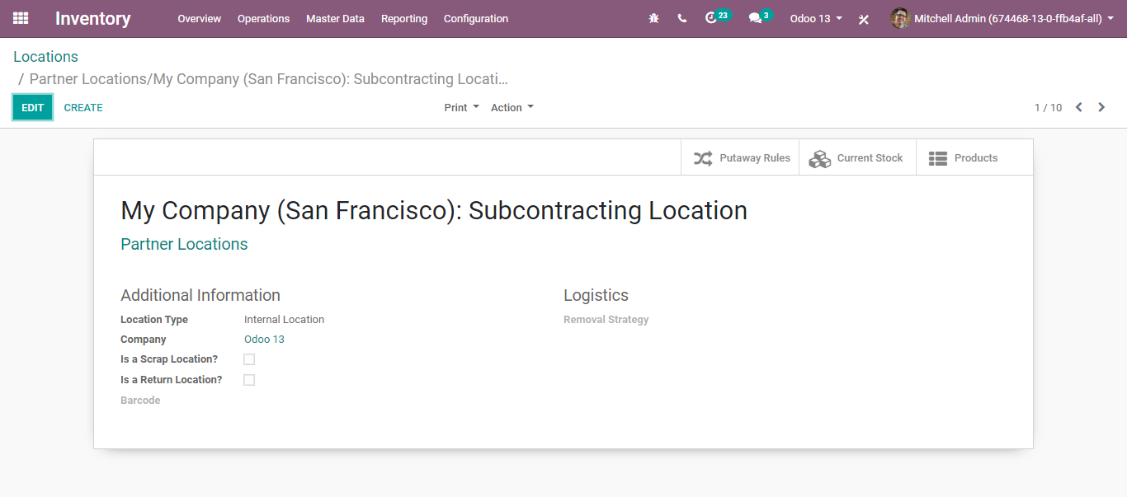
  - Via clicking the Put-away rules, you will be navigated to a new window like below:
  - 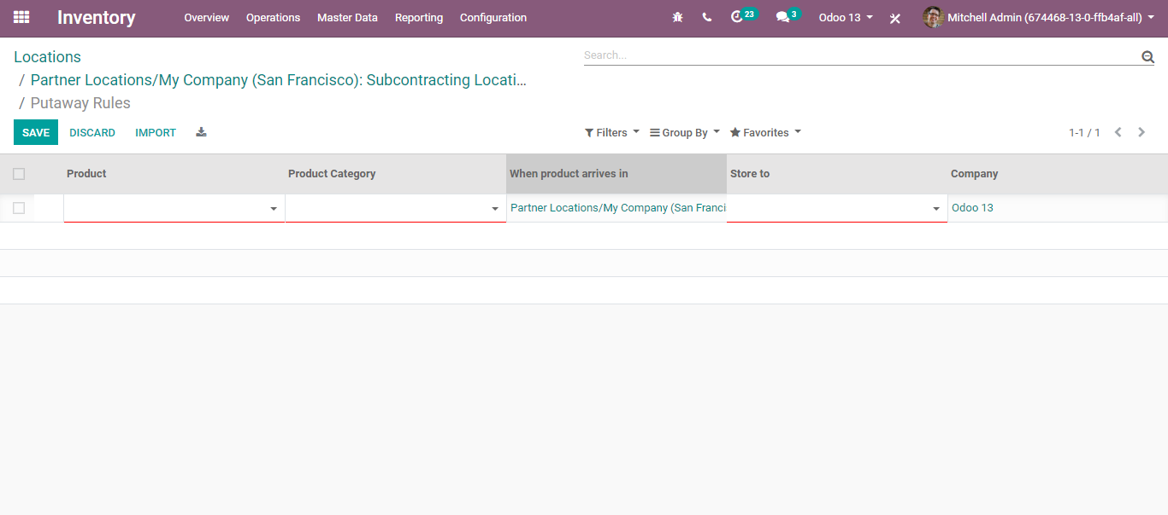
  - Here you can enter the Product name, Category of the product, Location to which that product arrives in and to which location the product should be stored. Defining these, the put-away rule will trigger the movement of goods/items correspondingly.
  - REMOVAL STRATEGIES
  - Removal strategies are usually in picking operations to select the best products to optimize the distance for the worker, for quality control purposes or due to reason of product expiration.
  - When a product movement needs to be done, BusinessBoxERP will find available products that can be assigned to shipping. The way BusinessBoxERP assign these products depend on the removal strategy that is defined on the product category or the location.
  - Configuration
  - Go to Inventory> Configuration> Settings and enable the option Set Put away Rules on Location, then click on Save.
  - 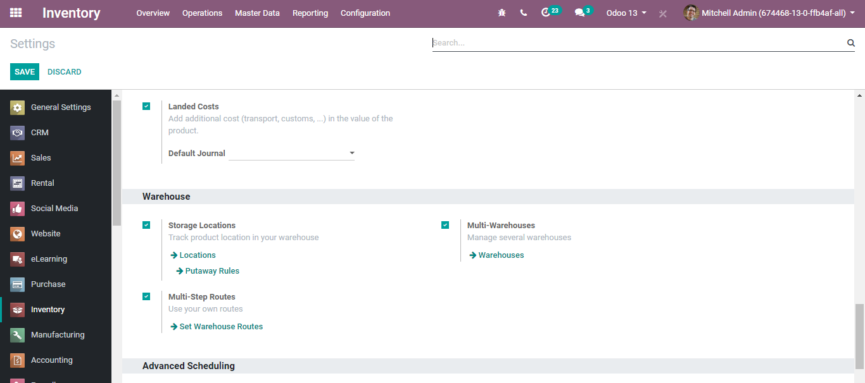
  - Then, open Inventory> Configuration > Locations and open the location on which you want to apply a removal strategy.
  - 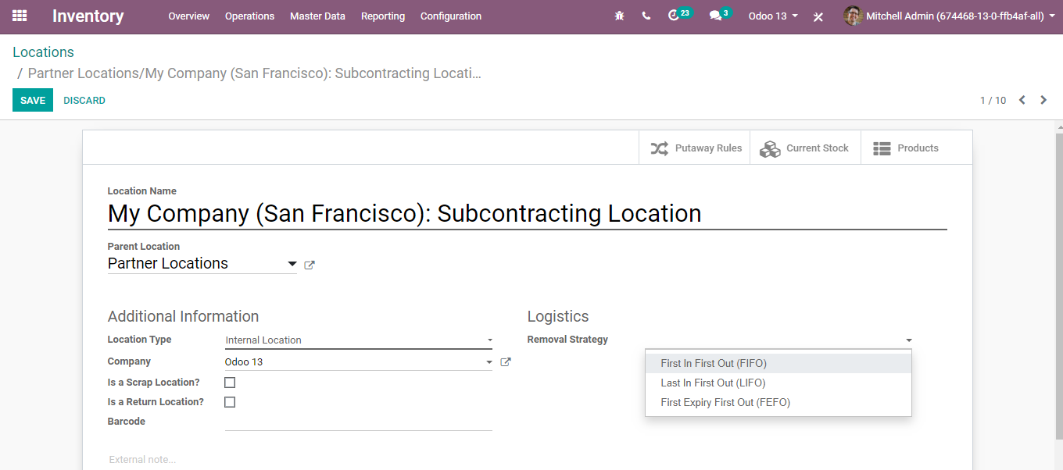
  - BusinessBoxERP enables three types of Removal Strategies:
- First In First Out (FIFO)
- Last in First Out (LIFO)
- First Expiry First Out (FEFO)

  - FIFO (First in First Out)
  - A First in First Out strategy implies that the products that were stocked first will move out first. Companies should use the FIFO method if they are selling perishable goods. Companies selling products with short demand cycles, such as clothes, also may have to pick FIFO to ensure they are not stuck with outdated styles in inventory.
  - Configuration
  - Go to Inventory ‣ Configuration ‣ Locations, open the stock location and set FIFO removal strategy.
  - LIFO (Last in First Out)
  - In this warehouse management, the products which are brought in the last move out the first. LIFO is used in the case of products that do not have a shelf life.
  - Configuration
  - Go to Inventory ‣ Configuration ‣ Locations, open the stock location and set LIFO removal strategy.
  - FEFO (First Expiry First Out)
  - In FEFO warehouse management, the products are dispatched from the warehouse according to their expiration date.
  - Go to Inventory ‣ Configuration ‣ Setting. Check the option Expiration date Then click on save changes.
  - 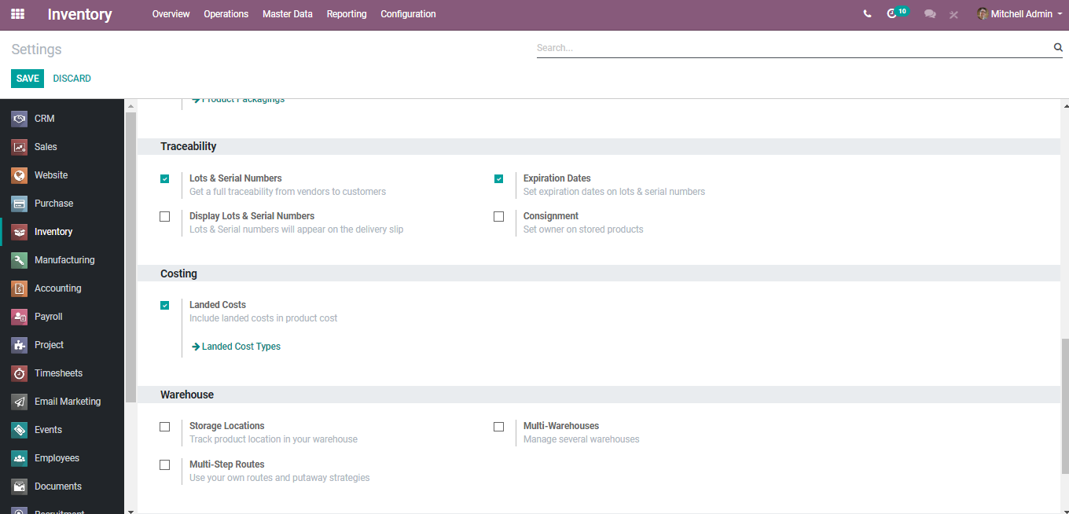
  - This will allow you to set four expiration fields for each lot or serial number: best before date, end of life date, alert date, and removal date. These dates can be set from Inventory Control ‣ Serial Numbers/Lots.
  - 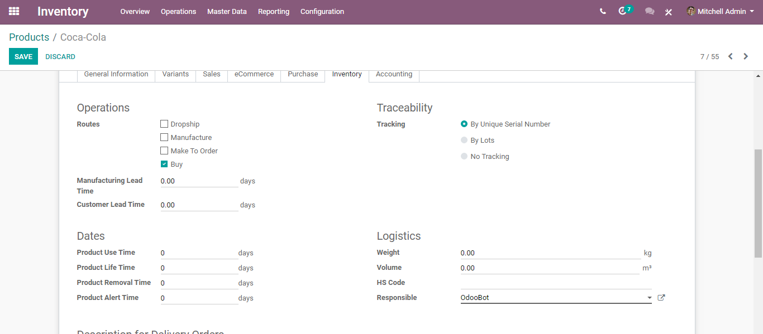
  - Product Lifetime: When a new Serial Number is issued, this is the number of days before the goods may become dangerous and must not be consumed.
  - Product Use Time: When a new Serial Number is issued, this is the number of days before the goods start deteriorating, without being dangerous yet
  - Product Removal Time: When a new Serial Number is issued, this is the number of days before the goods should be removed from the stock.
  - Product Alert Time: When a new Serial Number is issued, this is the number of days before an alert should be notified.
  - When a new serial number is assigned to this product. These dates are automatically calculated and stored in the Lot/serial number.
  - 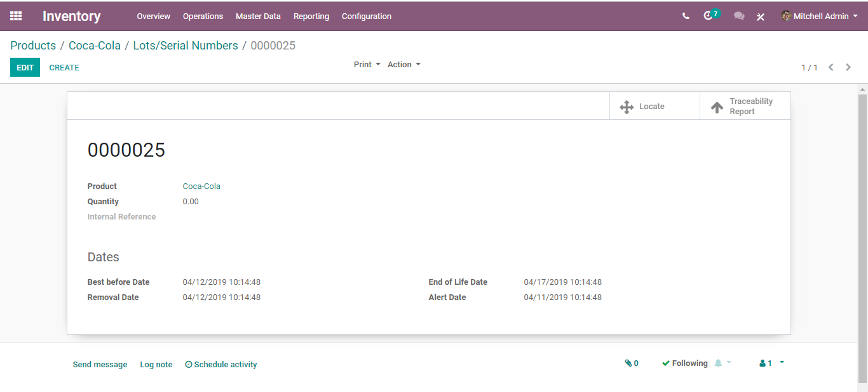
  - If you are not giving these days in the product form, you can give the dates after the creation of the lot/serial number also.

  - PRODUCT CATEGORIZATION AND INVENTORY VALUATION
  - Having a precise inventory valuation is critical because, it is the reported measure of the stock or the inventory that influences the expense of goods sold, the net profit, and the overall gain on the income statement. Also, the accurate inventory valuation measures the current resources, working capital, investors' or proprietor's equity reported on the balance sheet.
  - Product Categorization
  - Configuration
  - Go to Inventory->Configuration->Product Categorization
  - 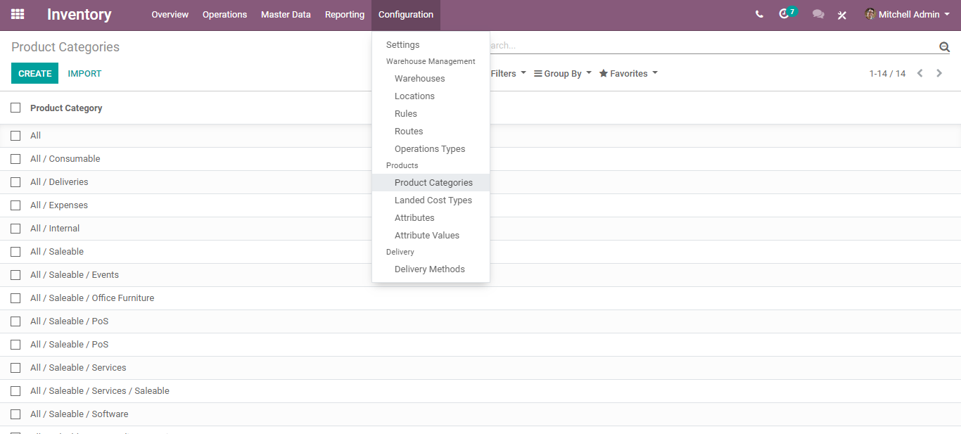
  - You can see a list of product categories in BusinessBoxERP.
  - 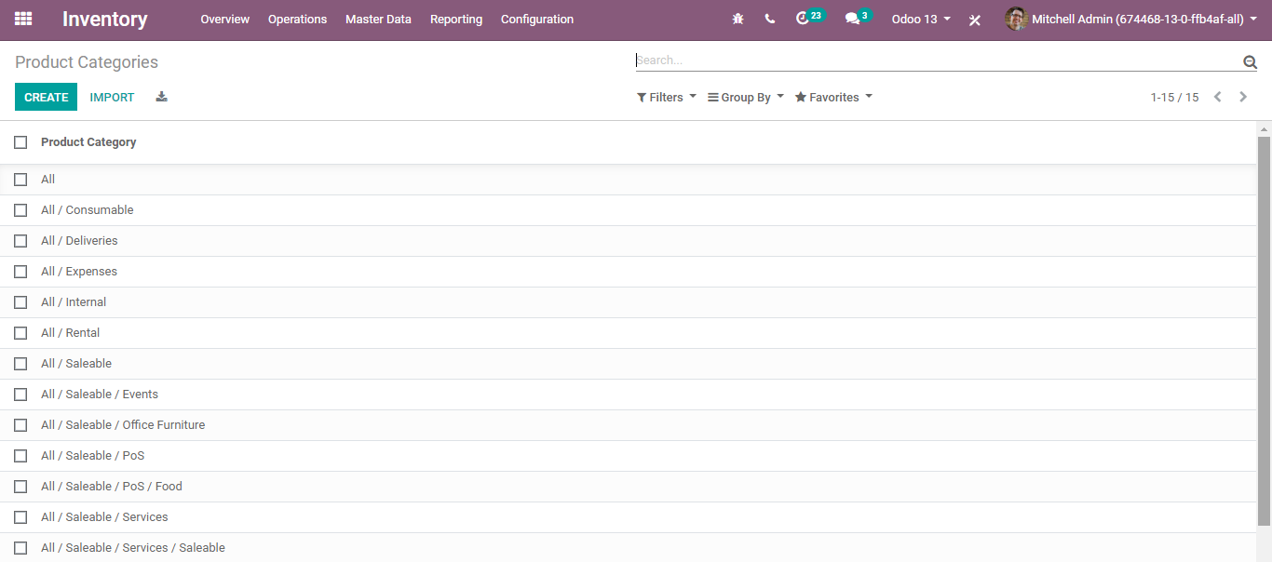
  - To create a new product category, click the button CREATE.
  - A creation form will appear like below:
  - 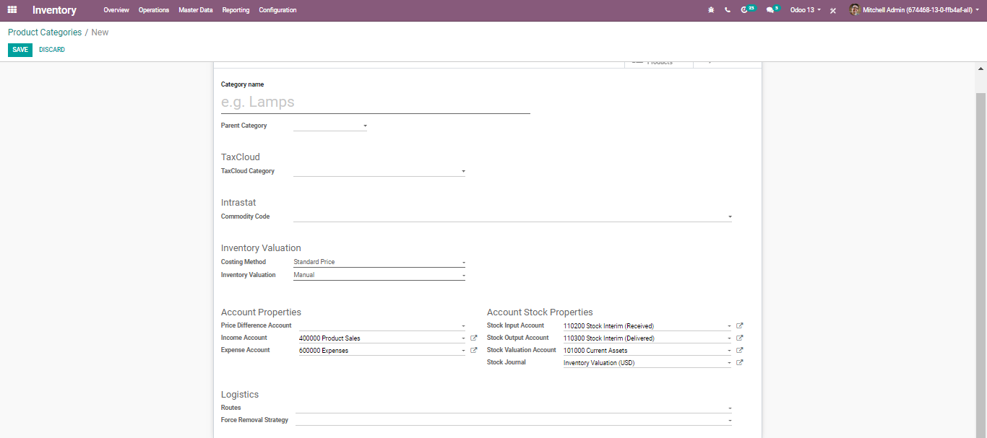
  - The field includes:
- Category Name: One can provide the new category name in the corresponding field
- Parent Category: One can create the hierarchy of the product category by choosing the parent category.
- Tax Cloud Category: This refers to Taxability Information Codes that are used by Tax Cloud to compute specific tax rates for each product type. This value is used when no TIC is set on the product. If no value is set here, the default value set in invoicing will be used.
- Inventory Valuation:
  - 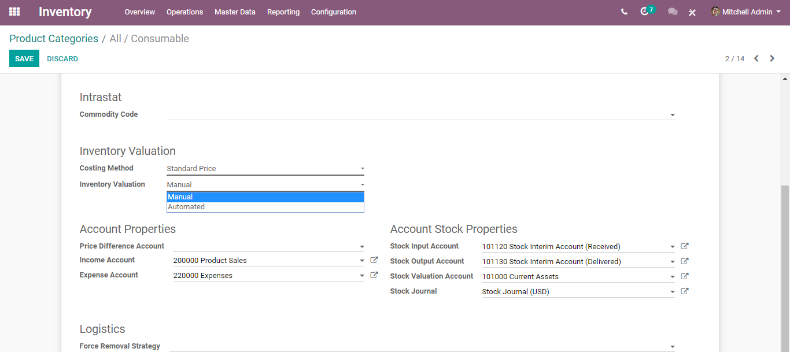
  - BusinessBoxERP offers two inventory valuation methods: Manual and Automated
  - Manual: The accounting entries to value the inventory are not posted automatically when a product enters or leaves the company.
  - Automated: An accounting entry is automatically created to value the inventory when a product enters or leaves the company.
  - Costing Method:
  - 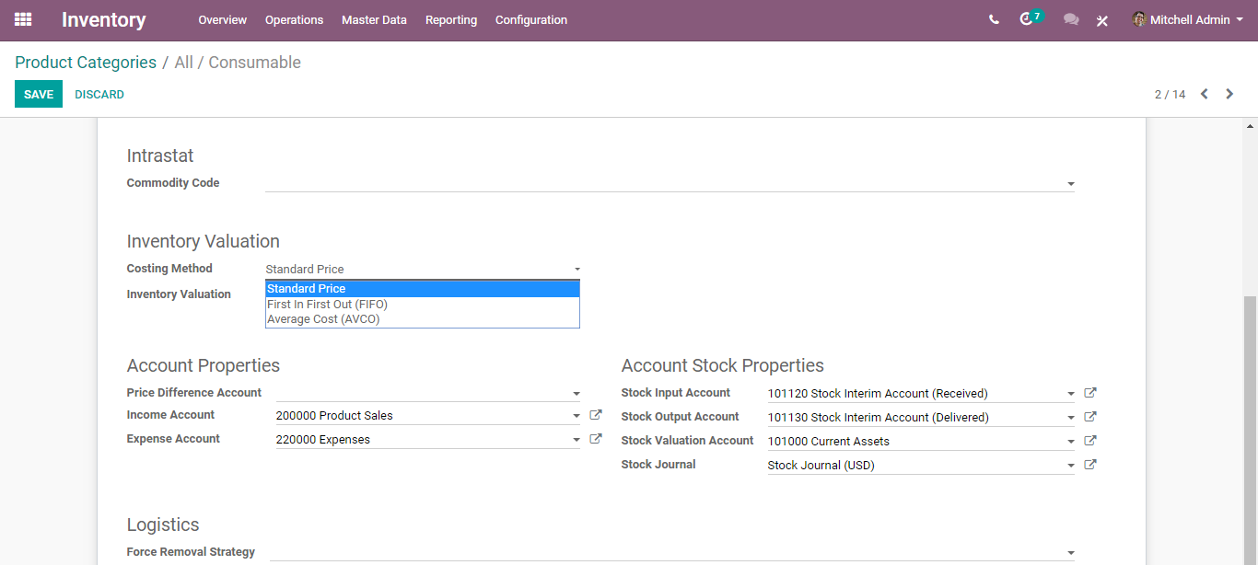
  - BusinessBoxERP provides 3 Costing Methods:
- Standard Price: The products are valued at their standard cost defined on the product. Value = Total quantity*Standard Price. For example, product quantity is 15 and the standard price of the product is Rs 80, then value= 15 * 80 = Rs 1200
- First In First Out (FIFO): The products are valued supposing those that enter the company first and will also leave first. First, I have purchased 10 products at Rs 80, then 15 products at Rs 90, and sold 5 products Then, Value = 5 * 80 + 15 * 90 = Rs 1750
- Average Cost (AVCO): The products are valued at weighted average cost. Value = Quantity * cost of the product. For example, if I have purchased ten products at Rs 80 and 15 products at Rs 90 and sold a total of ten products. In this case, the cost of the product equals eighty-six and Quantity 15. The Value equals 15 * 86 = Rs 1290
  - Force removal strategy: Select a specific removal strategy that will be used regardless of the source location for the product category. There are three types of force removal strategy available in BusinessBoxERP,
    - First In First Out (FIFO): The product which has arrived first will get removed first from the stock.
    - Last In First Out (LIFO): The product which has arrived last will get removed first from the stock.
    - First Expiry First Out (FEFO): The product which gets firstly expired will be removed first from the stock.
  - DELIVERY
  - SHIPPING METHODS
  - BusinessBoxERP can handle various shipping methods, but it is not activated by default. Shipping methods can be used for your sale orders, your deliveries but also on your e-commerce. Shipping methods allow you to manage the transport company, the price, and the destination. You can even integrate BusinessBoxERP with external shippers to compute the actual price and the packaging.
  - Configuration
  - To configure your shipping methods, Inventory > Configuration>Delivery > Shipping Methods.
  - 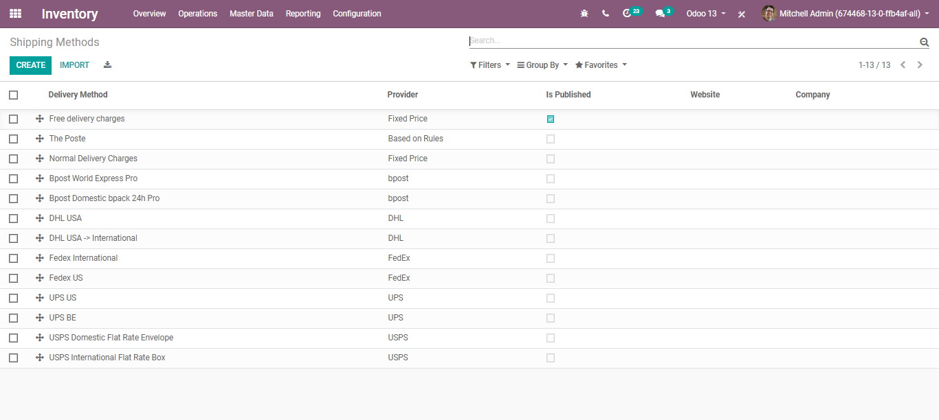
  - Upon clicking the CREATE button, you will be navigated to a new window with a creation form like below:
  - 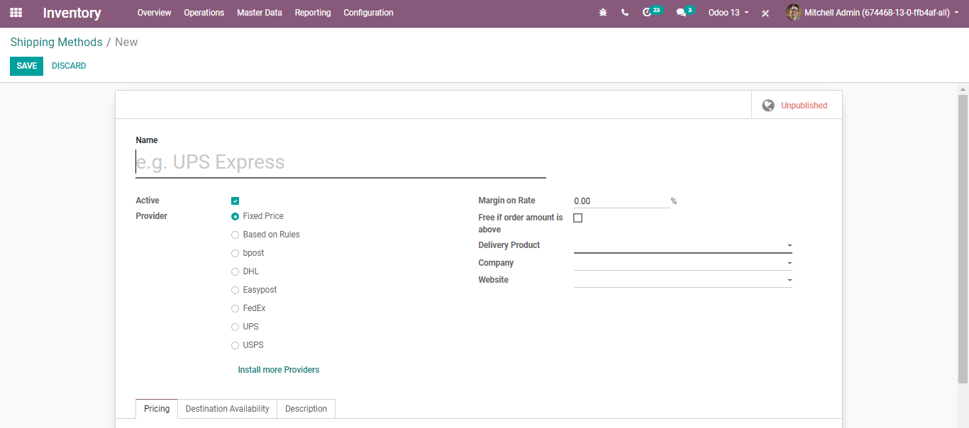
  - Here you can define the name for your shipping method, Select the provider, Margin on Rate (This percentage will be added to the shipping price), Select the option of Free Shipping, if the order amount is above, Delivery product, Company, Website etc.
  - Then you will have to set the pricing. It can be fixed or based on rules.
  - 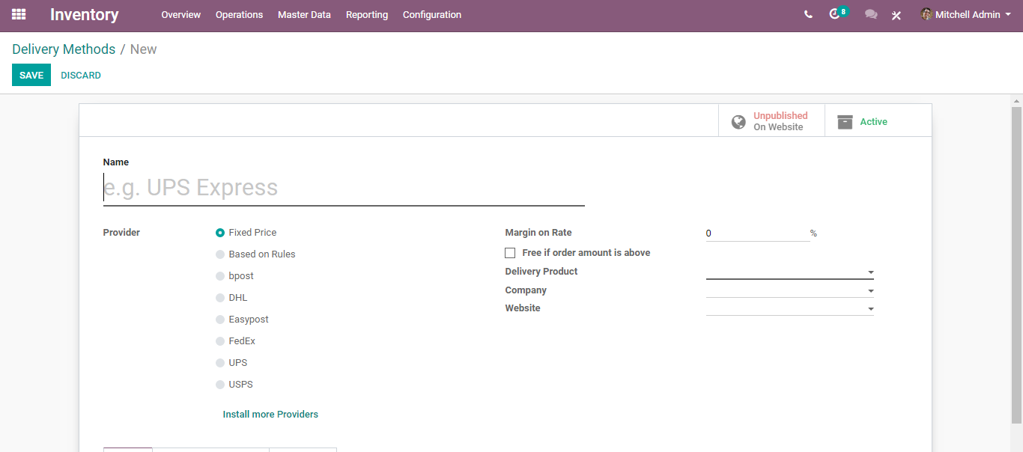
  - If the price varies according to rules, tick Based on Rules. Click on add an item to a pricing rule. Choose a condition based on either the weight, the volume, the price, or the quantity.
  - 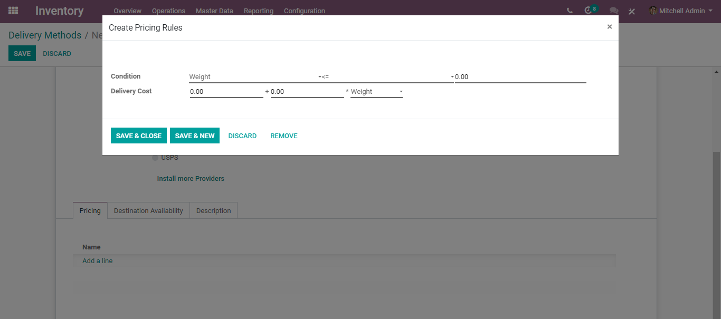
  - Finally, you can limit the shipping method to a few destinations. The limit can be applied to some countries, states or even zip codes. This feature limits the list of countries on your e-commerce.
  - 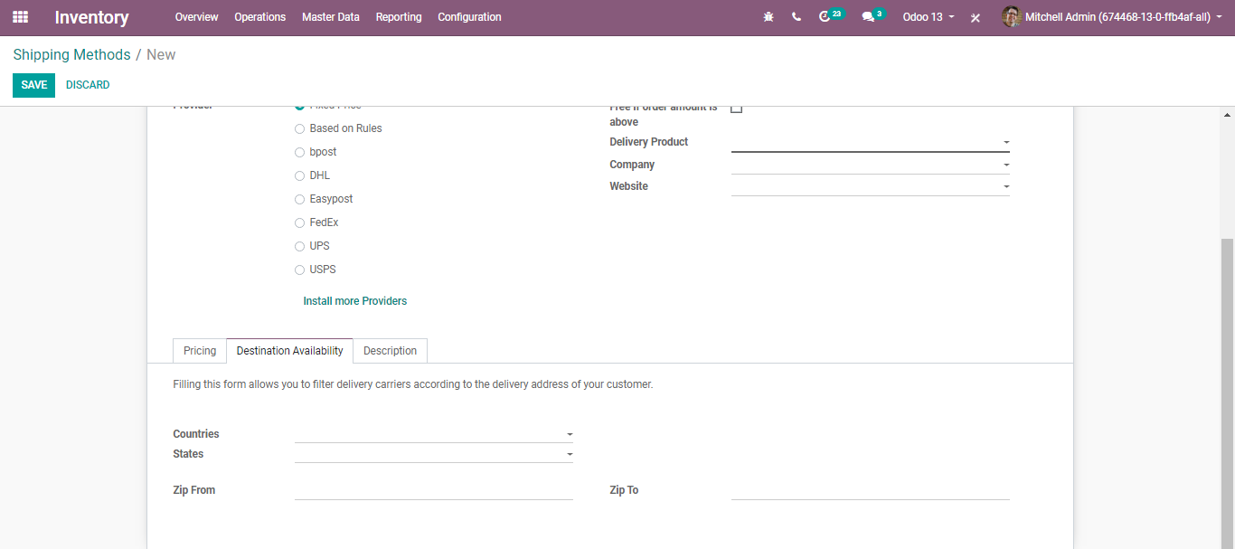
  - Note: You can integrate BusinessBoxERP with external shippers to compute the actual price and packaging and manage the printing of the shipping labels.
  - Integrating a third-party shipper
  - BusinessBoxERP can handle various shipping methods, including third-party shippers. BusinessBoxERP can be linked with the transportation company tracking system. It will allow you to manage the transport company, the real prices, and the destination.
  - Configuration
  - Inventory>Configuration> Settings> Shipping
  - 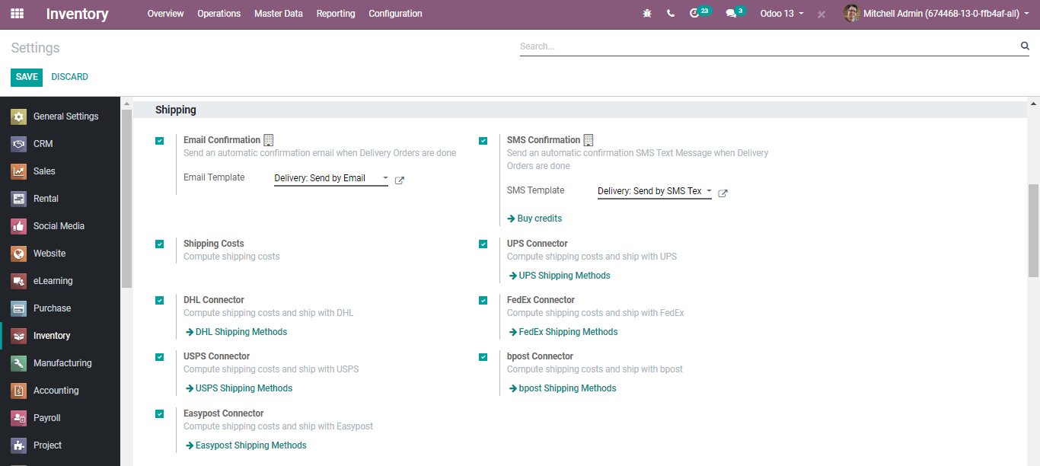
  - 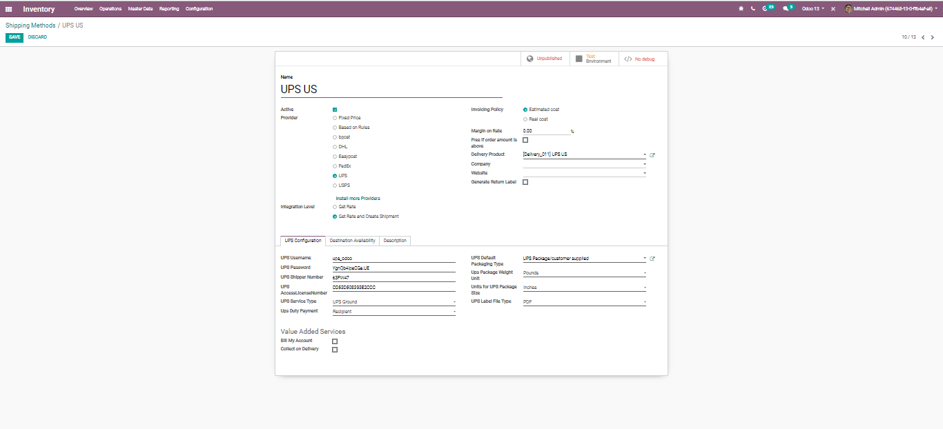
  - DELIVERY PACKAGES
  - Using BusinessBoxERP, one can deliver products under different packages based on their volume or weight.
  - Configuration
  - Go to Inventory> Configurations>Settings and activate Delivery Packages under Operations.
  - 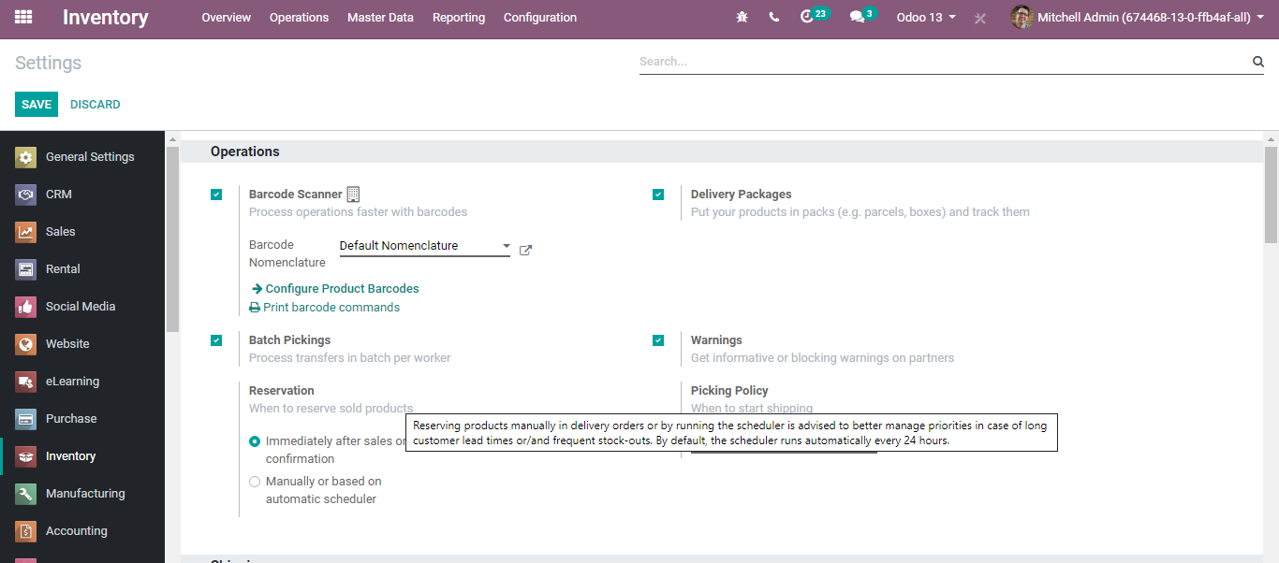
  - 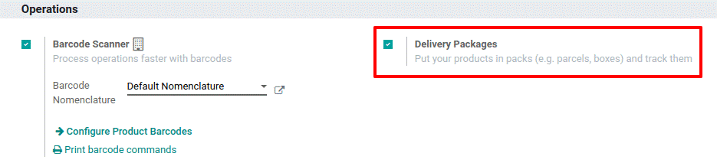

  - Proceed to a Delivery
  - Create a planned delivery with certain products inside. There you can create the new packages and assign them to the stock move lines.
  - 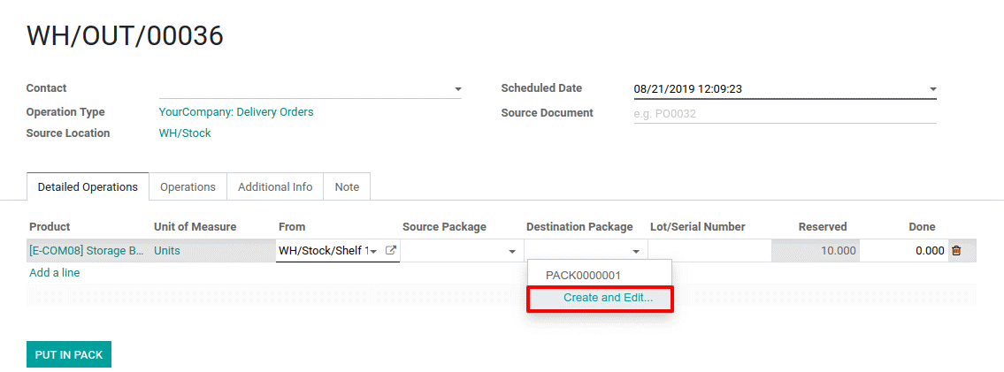
  - Define the package type. After validating the delivery order, you can retrieve which products are included in the package.
  - 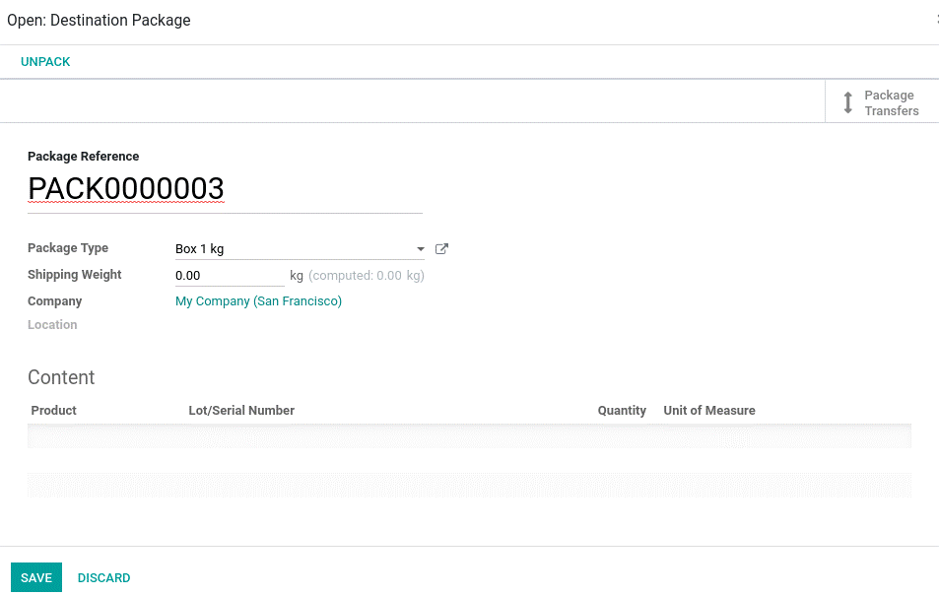
  - 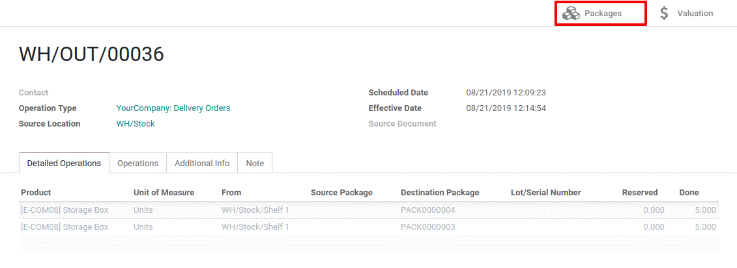
  - 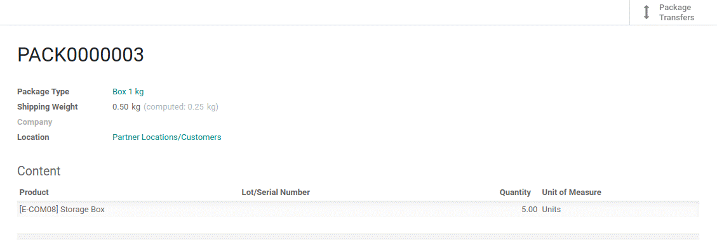

  - Put in Pack
  - Put in Pack button is yet another mode to put products in a pack. Via clicking the Put in Pack button, BusinessBoxERP automatically assigns a pack to the number of products that are set as Done. Also, duplicate the stock move line if necessary.
  - 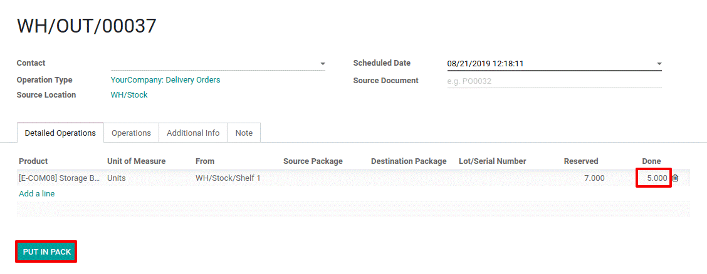
  - One can update the different packages created via tapping the PACKAGES button.
  - 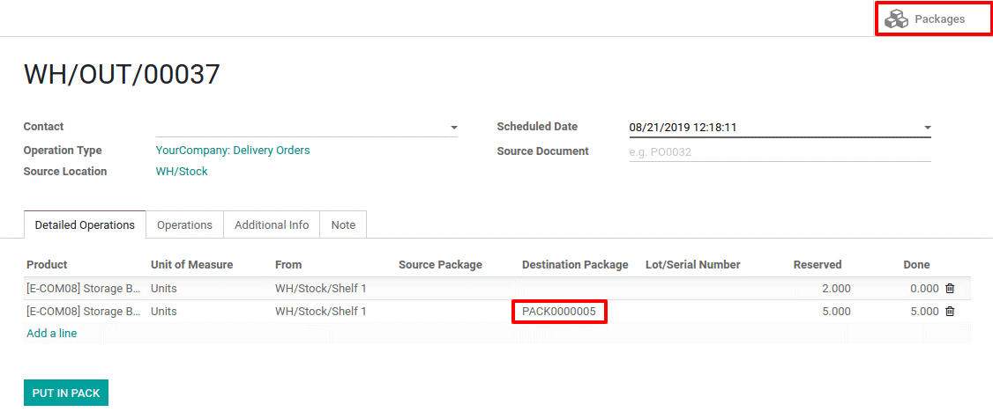
  - SEND AUTOMATED EMAILS AT DELIVERY
  - Configuration
  - Inventory>Configuration>Settings and activate the Email Confirmation feature.
  - 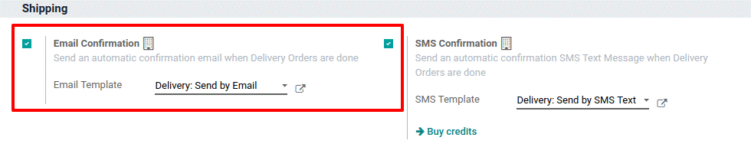
  - Activating the feature, BusinessBoxERP automatically creates an email template.
  - Send an email at delivery validation
  - 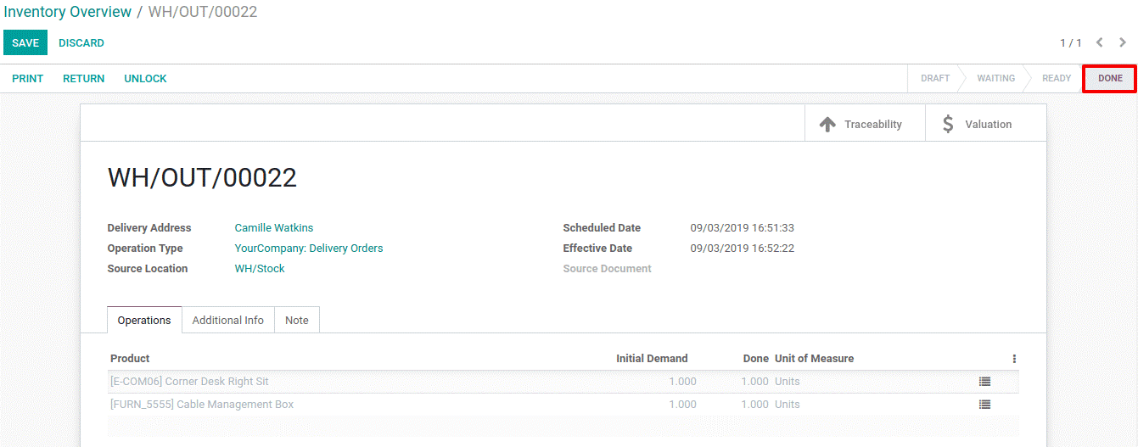
  - After validating the product and delivery, an automated email is sent. The information appears in chatter.
  - 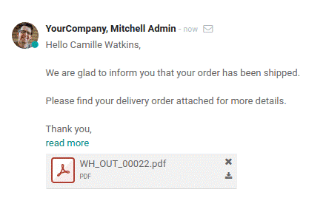
  - If you work with a shipping method, and then have a tracking link, it will be included in the standard email template.
  - 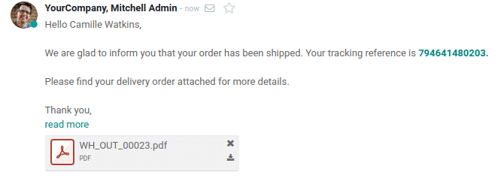
  - SEND AUTOMATED SMS AT DELIVERY
  - Configuration
  - Go to Inventory> Configuration> Settings and activate SMS Confirmation under Shipping.
  - 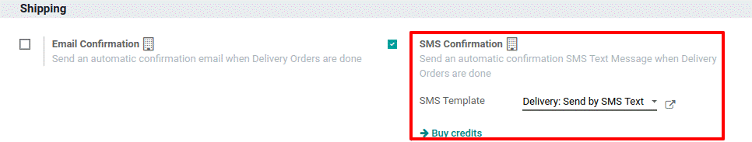
  - By default, there exists an SMS template. However, one can create a new template by clicking the arrow button.
  - 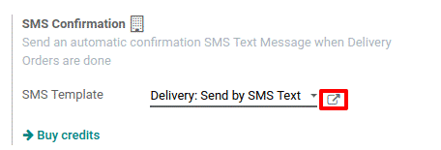
  - Send SMS at delivery validation
  - Create a delivery order for a specific partner and validate the delivery.
  - Now, the automated SMS appears in the chatter.

  - REPORTING
  - Warehouse Analysis
  - 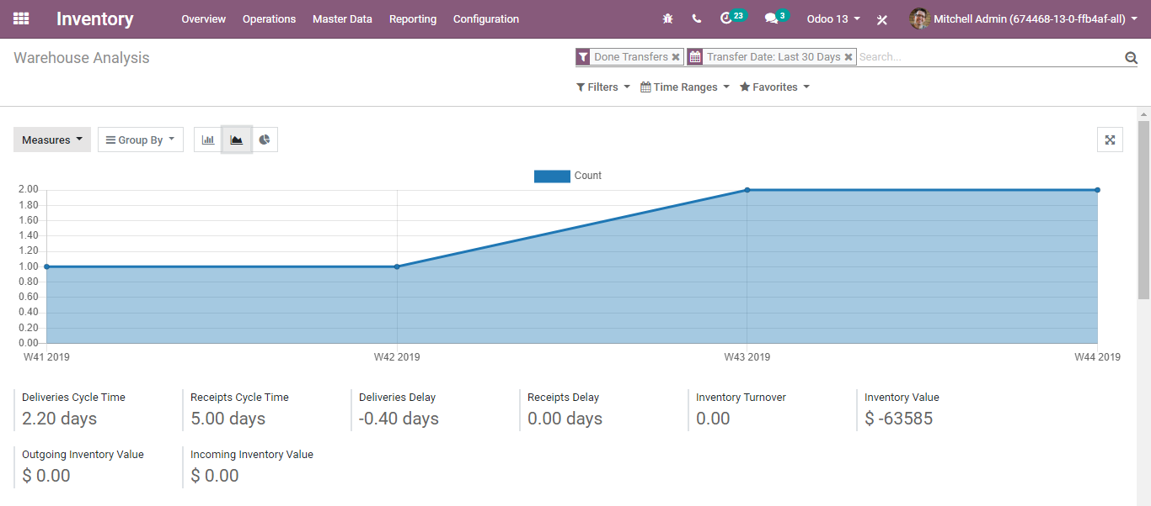

  - Inventory Report
  - 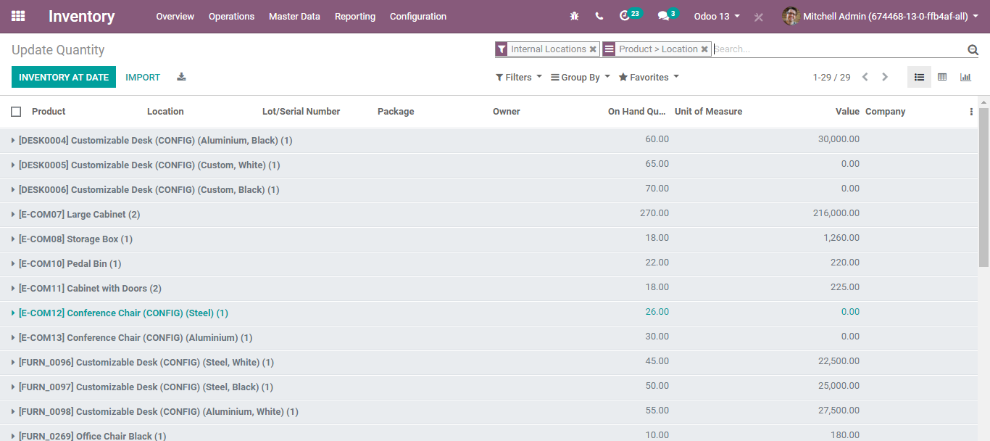
  - Forecasted Inventory
  - 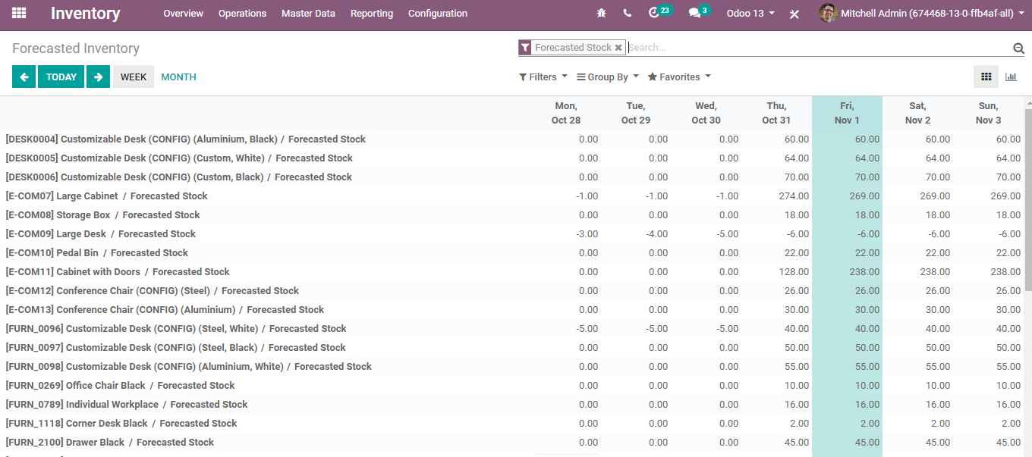

  - Inventory Evaluation
  - 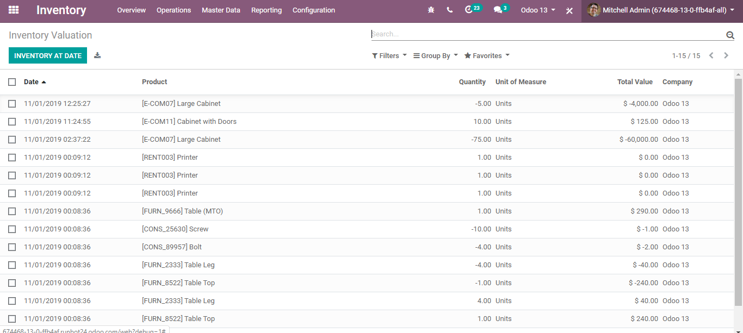
  - Stock Moves
  - 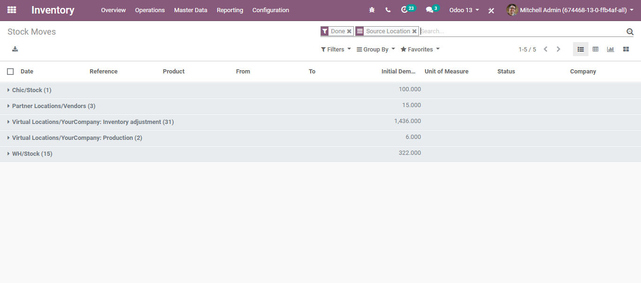

  - Product Moves
  - 