  - Manufacturing
  - Manufacturing is a procedure of changing over crude materials or segments into completed merchandise or items. For an organization that handle an enormous amount of Manufacturing items, they need to follow each manufacturing request proficiently. The Manufacturing Module under BUSINESSBOXERP helps the end-user to deal with the intricacy of Production, Manage Bills of Materials, Plan Manufacturing Orders, Track Work Orders and so on. The manufacturing module is one of the fundamental applications in BUSINESSBOXERP. One need to install the 'Manufacturing' application from BUSINESSBOXERP Apps to avail the benefit of this module on your ERP. Since the Manufacturing module is exceptionally coordinated with Inventory Management, the end-user can keep their stock automatically updated with each manufacturing procedure.
  - Working methodology is extremely simple in BUSINESSBOXERP manufacturing. One can make a Manufacturing Order of an item and pass it through your various stages in the production line and complete creation. One may redo or customize the producing methodology matching your organization's procedure utilizing WorkCentre and Routing concepts. One can without much of a stretch oversee 'Scraps' amid any phase of Manufacturing procedure and 'Un build' a made item if necessary. Association may dole out different level users to overlook the entire manufacturing method for successful administration of the whole procedure.
  - On the off chance, if we contrast the BUSINESSBOXERP manufacturing module and other ERP arrangements, as in every single other module, one can discover some unique features which BUSINESSBOXERP alone have. For instance, highlights like by-products, routing facility, single BOM for multiple product variants, MRP II scheduler, Master production scheduler, Kanban Planning, Production calendar, backward scheduling, Work orders, Repair etc. are not accessible in SAP ERP while BUSINESSBOXERP executes every one of them. Also, against Microsoft Dynamics, BUSINESSBOXERP has the upside of highlights like Equipment / Machine Management, Work Instructions on Work Orders, Maintenance Requests from Shop Floor Terminal, Production calendar etc.
  - The following features make the BUSINESSBOXERP manufacturing module an effective one.
  - Manage
  - Manufacturing order: Manage your items into assembling lines or manual gathering.
  - Work orders: Dispatch production of things required in the last assembling stage of products.
  - Repair orders: Oversee product repairs under guarantee or as a service.
  - Schedule and plan
  - Plan manufacturing: Get a reasonable view on your entire arranging and effectively reschedule manufacturing.
  - Organize work orders: Approach every single accessible asset and plan with your generation.
  - Manage Bill of Materials: Monitor accessibility of things in stock and production time.
  - Work Center Capacity: MRP II scheduler utilizing limits and calendars of Work Center.
  - Define Flexible Master Data
  - Create multi-level Bills of Materials: Set a Bill of Materials inside another to manufacture parts of an item in another Bill of Materials.
  - Optional routing: Create new routings for work orders to sequence your production depending on the routing used. Make new routings for work orders to sequence your creation relying upon the routing utilized.
  - Version changes: Enable your items to advance and include configurable alternatives while creating orders.
  - Phantom of Bill of Materials: Create phantom BoM to manufacture and sell products in kits or to build replacement parts.
  - Quality
  - Control Points: Automatically trigger quality checks, helping the manufacturing department.
  - Quality Checks: Deploy your statistical process control easily with checks.
  - Quality Alerts: Structure your work utilizing the Kanban view of quality alerts.
  - Maintenance
  - Preventive Maintenance: Trigger maintenance requests automatically dependent on KPIs.
  - Corrective Maintenance: Trigger corrective maintenance directly from the control centre panel.
  - Calendar: Schedule maintenance operations alongside calendar.
  - Statistics: Get all maintenance statistics computed for you: MTBF
  - Work Center Control Panel
  - Tablets: Set tablets in every work centre to organize their work efficiently.
  - Record production: Register productions, scan products, lots, or serial numbers.
  - Worksheets: Display worksheets directly on the Work Center with instructions for the operator.
  - Misc. Operations: Scrap products, create quality alerts, and perform checks, right from the Work Center.
  - Alerts: Use alerts to show changes or quality checks to the operator.
  - Business Intelligence
  - Get a definite examination report on your production line, investigate the exhibition of your work focuses and creation, plan elective generation methodologies and so on are a portion of the subjective measures BUSINESSBOXERP BI motor can recommend to you in assembling module.

  - Framework Users
  - As a matter of course there are two types of users in manufacturing modules.
  - Manager: He is the person who oversees everything, including Crete BOM, Work Order, Routing system and so on.
  - User: Generally, he can make an assembling request and procedure it. In any case, the supervisor can concede more authorization to this client if necessary.
  - Bill of Materials
  - To manufacture a product, you need the list of components and their quantity first. The Bill of Material is one such kind of document that defines the complete list of components required for carrying the manufacturing process. The Bill of Material (BoM) clearly defines the quantities required, also the routing and individual steps that are to be followed in the manufacturing process.
  - Utilizing BUSINESSBOXERP, the user can link multiple BoMs to each product, describing the multiple variants of it.
  - Setting up a BoM
  - In case you decide to manage your manufacturing operations using manufacturing orders, you can skip the assignation of routing to the Bill of Material. Here, the manufacturing process will be carried in a single step and necessitates no tracking of this step.
  - To create a new BoM, firstly you need to create a product using the BoM, also a component.
  - After that go to the option Bills of Materials under the Master Data menu.
  - 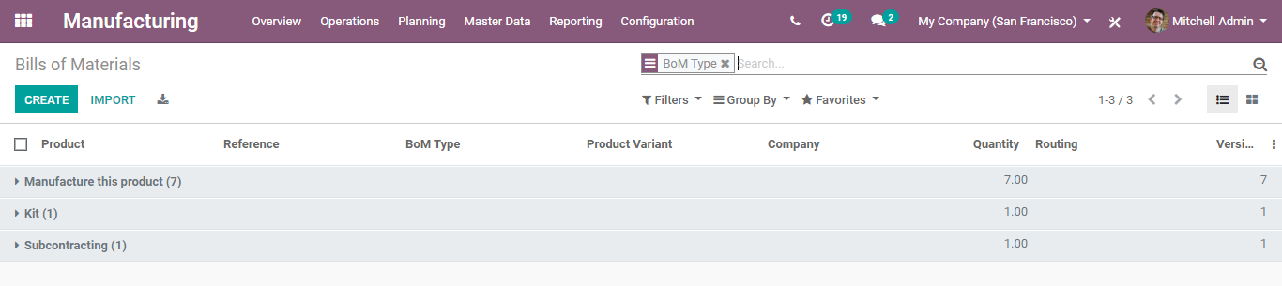
  - Upon clicking the CREATE button, you can create a new Bill of Materials.
  - 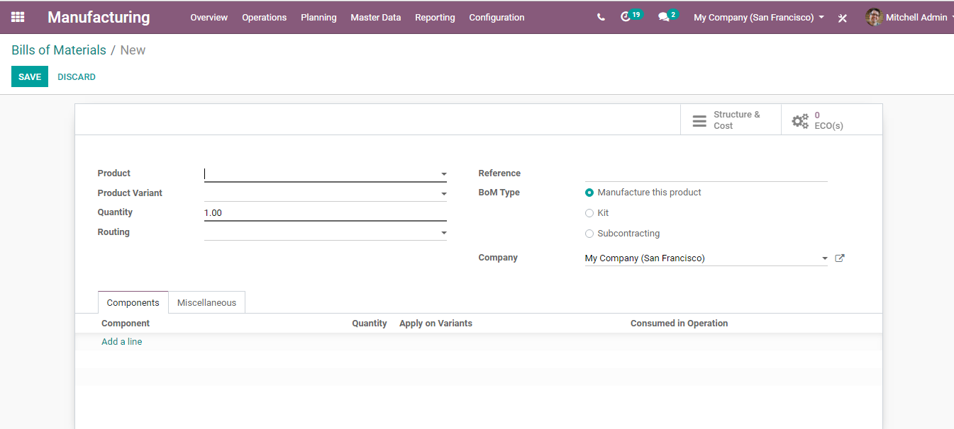
  - The create form includes the following attributes:
- Product: Select a product from the list. One can choose the product from the dropdown menu.
- Product Variant: If a product variant is defined, the BOM is available only for this product
- Quantity: Quantity to be manufactured.
- Routing: The operations for producing this BOM. When a routing is specified, the production orders will be executed through work orders, otherwise, everything proceeds in the production order itself.
- The reference field is used to distinguish Different BoM for the same product.
- Specify the BoM Type-Manufacture this product/Kit/Subcontracting.
- Click Add a line field and add the raw materials for your product.
  - 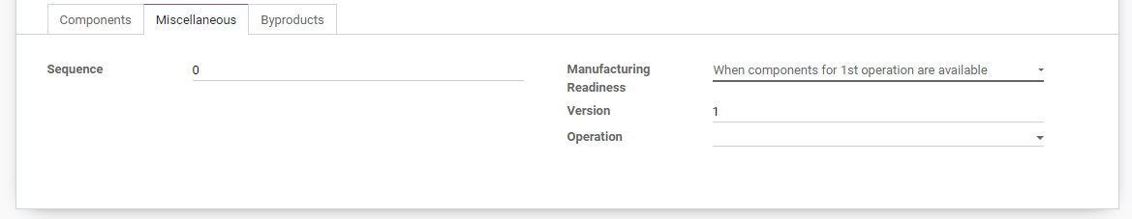
- Sequence defines the order in which your BoMs will be selected for production orders, with lower numbers having higher priority.
- Manufacturing Readiness defines when a manufacturing order is considered ready to be started.
- Operation: When a procurement has a ‘produce’ route with an operation typeset, it will try to create a manufacturing order for that product using a BoM of the same operation type. That allows defining stock rules which trigger different manufacturing orders with different BoMs.
  - Note: - A BoM can be later Updated/Deleted from the same menu i.e., Manufacturing > Master Data > Bill of Materials.
  - One can use BoM for Product Variants. If the Bill of Material is for a single variant, specify them in the Product Variant field. On the other hand, if the Bill of Material is for multiple variants, specify the variant on each component line. One can add several variants for each component.
  - 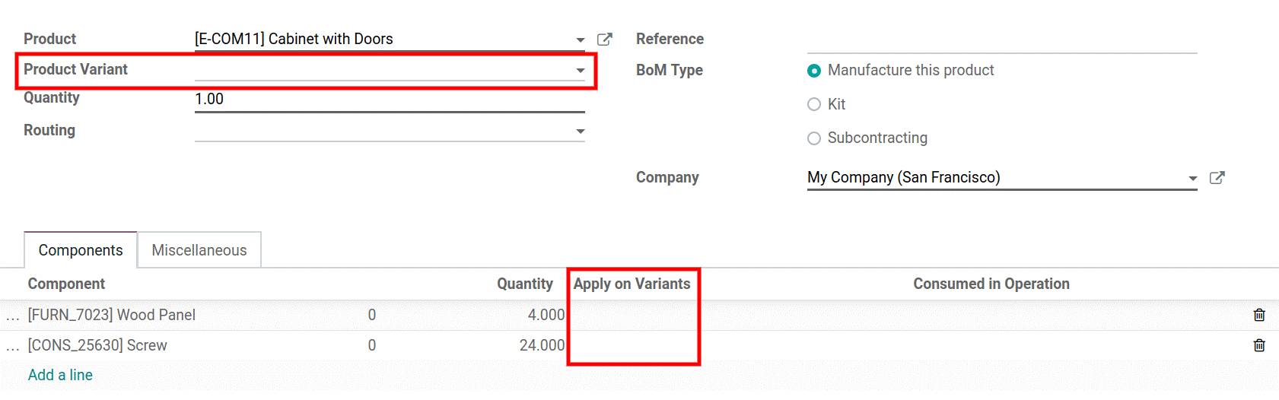
  - ADDING A ROUTING IN BOM
  - One can add routing to the BoM to define the operations to be carried in the manufacturing process. To enable the feature, go to Manufacturing > Configurations>Settings> Work Orders feature.
  - 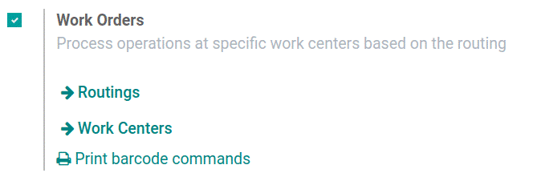
  - Note: Each BoM will have only a single routing, however, each routing can be used several times.
  - 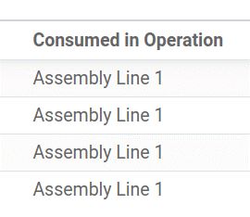
  - ADDING BY-PRODUCTS
  - A by-product in BUSINESSBOXERP is the product produced in addition to the primary product in Bill of Material.
  - To add by-products to a BoM, go to Manufacturing > Configurations>Settings> Work Orders feature.
  - 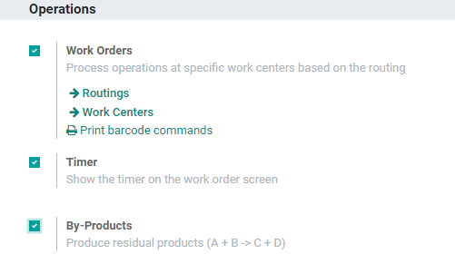
  - 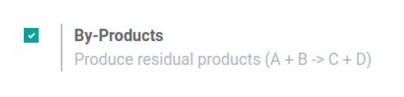
  - Click on the SAVE button, to mark the changes. After activating the feature in the settings, you can add your By-Products to your BoMs. One can add as many By-Products as they want. However, it should be registered during which operation the by-product is produced.
  - Manufacturing Order Management
  - Under the BUSINESSBOXERP manufacturing module, one can produce a product in two ways. Firstly, one can create a manufacturing order following simple default stages and complete the production. Secondly, one can create a product by customizing the work order by setting up a work centre and routing mechanisms.
  - MANAGE MANUFACTURING IN SINGLE-STEP/ WITHOUT ROUTINGS
  - On can go for simple steps i.e., manufacturing orders without routings in case your manufacturing process is limited to one place, one person and one step.
  - By default, BUSINESSBOXERP carries the manufacturing process without any routing.
  - Create a manufacturing order
  - To create a manufacturing order, go to Manufacturing> Operations> Manufacturing Order
  - 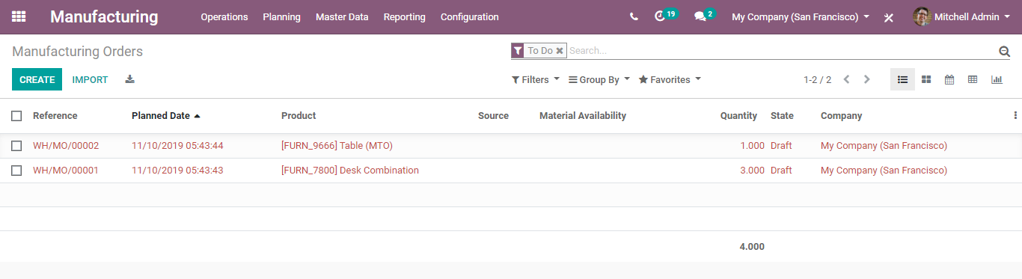
  - Upon clicking CREATE button, you can create new manufacturing order.
  - 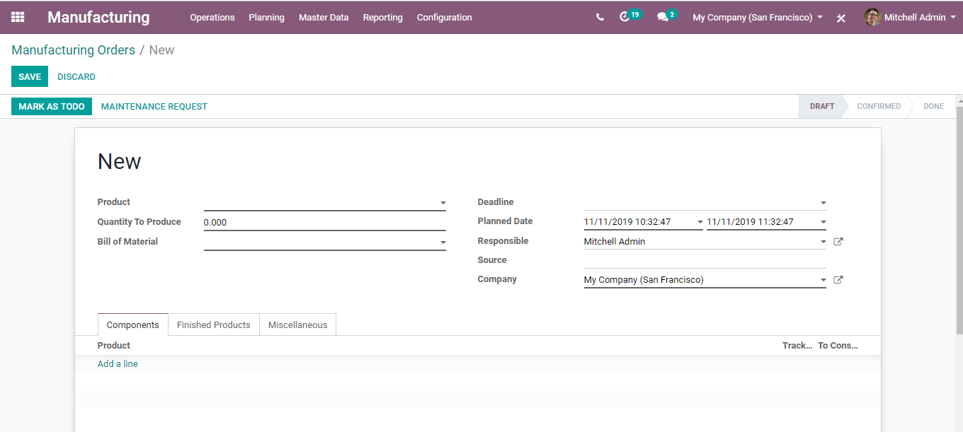
- Choose a product from the list (or you may create a new one).
- Choose Quantity to produce.
- Choose Bill of Material either from the list or create a new one.
- One can define the deadline for completing the production.
- Planned Date-Date at which you plan to start the production.
- You can add the Responsible for this manufacturing order.
- Source: Reference of the document that generated this production order request.
  - 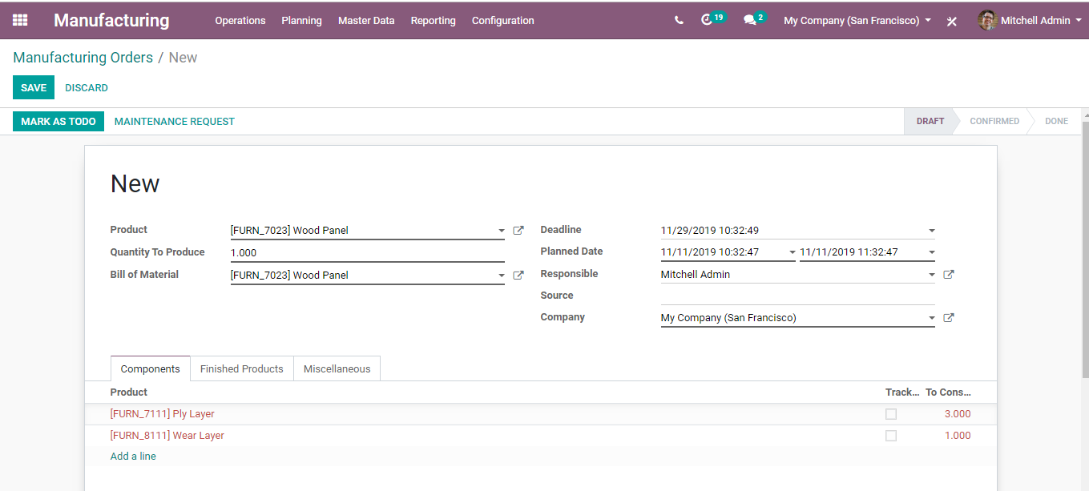
  - Click MARK AS TODO after entering all details.
  - 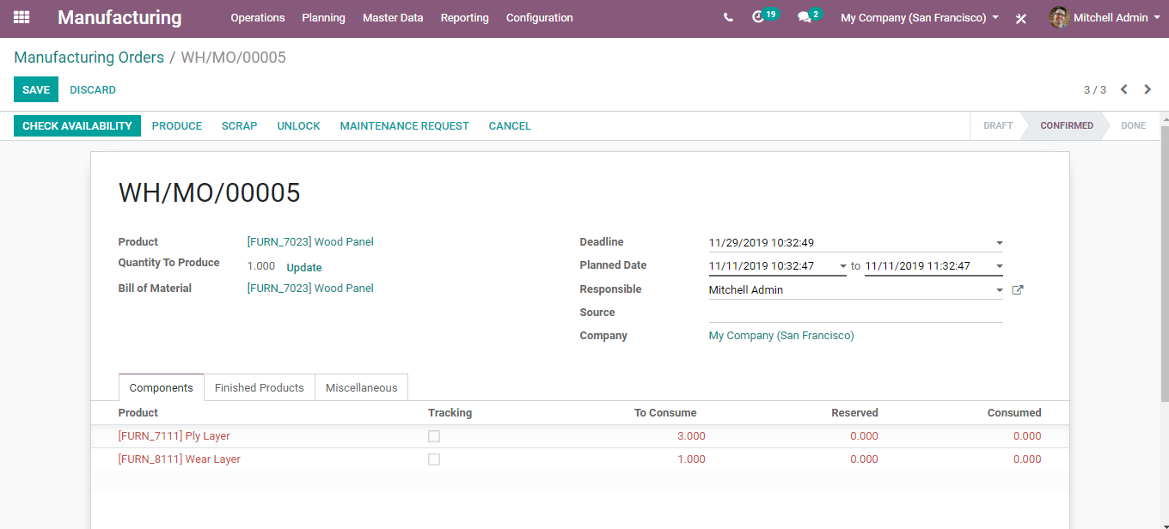
- Components Tab show you the product, unit of measure, tracking, products to consume, reserved product, and consumed product.
- The finished product tab will show you the number of finished products.
- Miscellaneous Tab gets you with the operation type, Components Location and Finished Product Location.
  - Click “Check availability” to see the availability of raw materials in inventory. If the red turned black, it denotes that the system holds sufficient stock in the inventory to start the production of the product.
  - 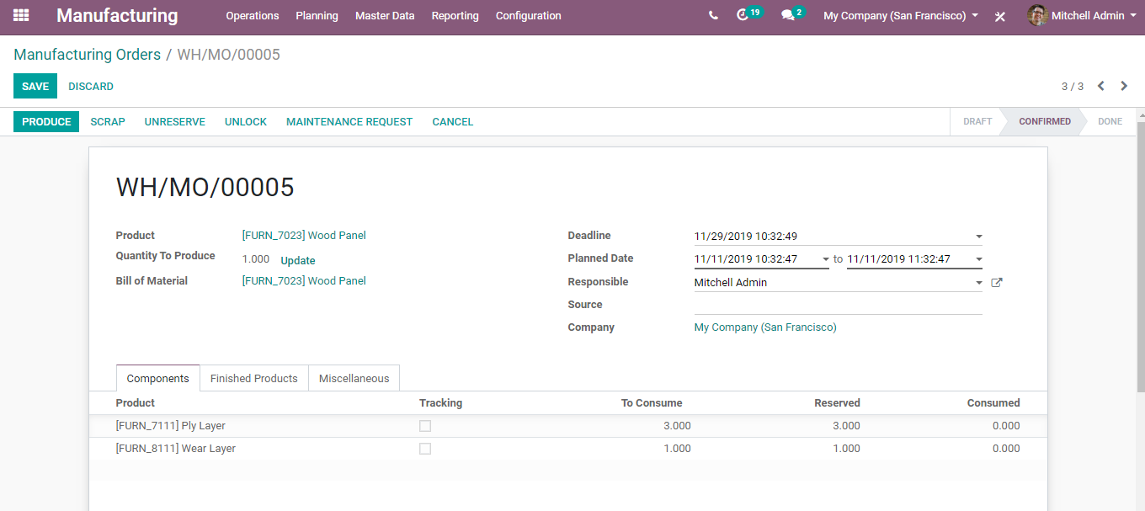
  - Since BUSINESSBOXERP offers negative inventory support, one can start production even without ensuring the raw material availability. Click “Produce” to start production.
  - You will be navigated to a new wizard-like below:
  - 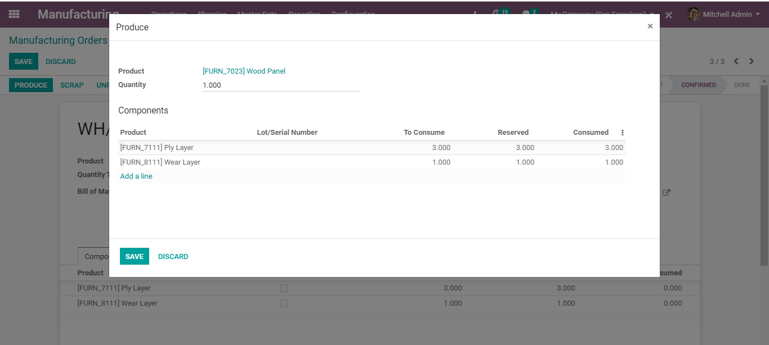
  - Click SAVE.
  - And once you start the production, the status bar will change as follows
  - 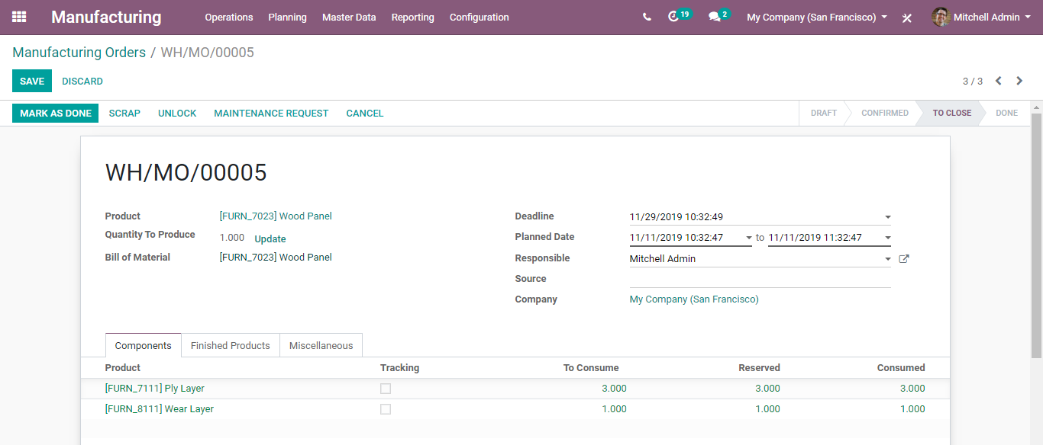
  - Click “Mark as Done” to complete the production process.
  - Now you can see the status bar changes to To-Done from to close.
  - 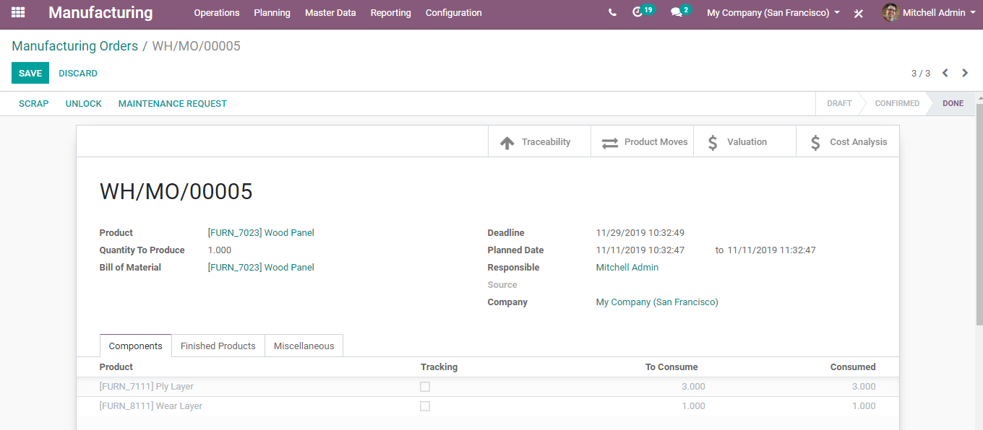
  - Here one gets the provision to avail the Traceability Report, from here.
  - 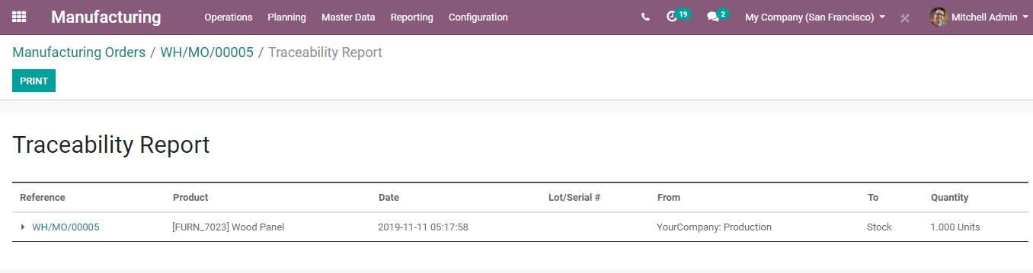
  - Product Moves
  - 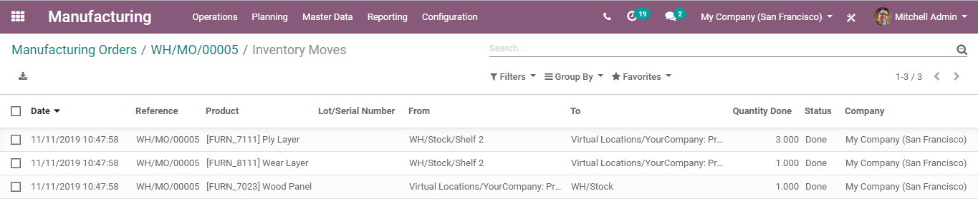
  - Stock Valuation
  - 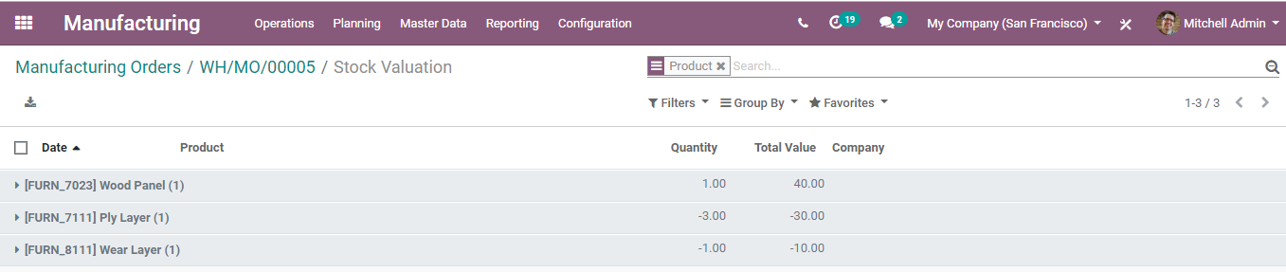

  - Cost Analysis
  - 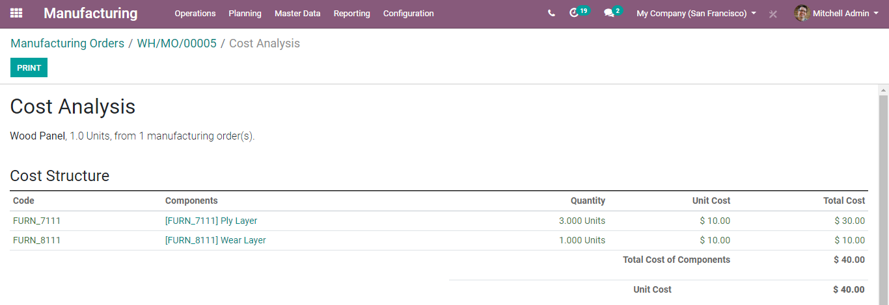

  - MANAGE MANUFACTURING WITH ROUTINGS AND WORK CENTERS
  - Compared to a simple method, manufacturing with routing and work centre is an advanced method of carrying the manufacturing process. The advanced method facilitates configuring more detailed manufacturing processes such as setting up Work Centres, Routing, Work Order management etc.
  - To enable this feature, Go to Manufacturing ->Configuration -> Settings and activate the Work Orders feature under Operations Menu.
  - 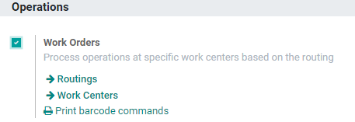
  - Click SAVE to mark the changes.
  - Now create a new manufacturing order by following the configuration
  - Manufacturing > Operations > Manufacturing Order > Create
  - 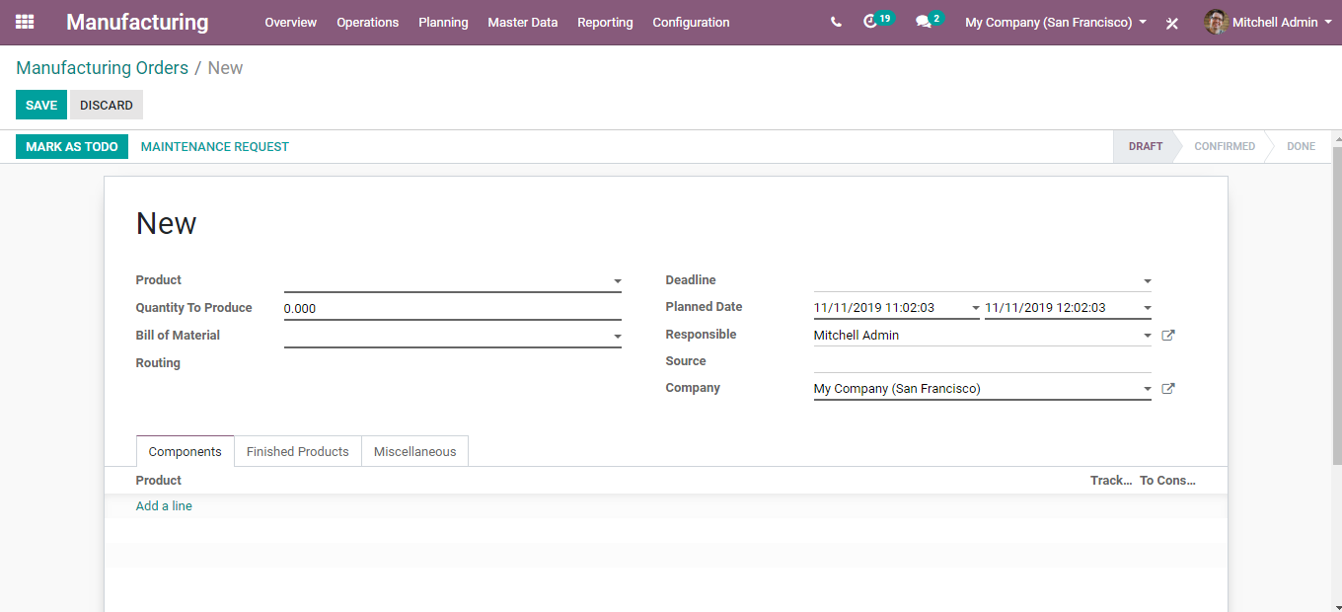
  - Fill the fields the same as before.
- Choose a product from the list (or you may create a new one).
- Choose Quantity to produce.
- Choose Bill of Material
- Now, add routings to BoMs and configure your operations taking place at different work centres. The Work Centres are the locations at which work orders are performed. ‘Routing’ mechanism, is automatically filled once you choose the BoM.
- One can define the deadline for completing the production.
- You can add the Responsible for this manufacturing order.
- Components Tab displays the product tracking, products to consume, reserved product, and consumed product.
- The finished product tab displays the number of finished products.
- The miscellaneous tab will show you the operation type, the location where the system stocks the raw material and the location where the system will stock the finished products.
  - Click MARK AS TODO after entering all details.
  - Click “Check availability” to see the availability of raw materials in inventory. If the red turns out to be black, it simply denotes the inventory stocks enough components to carry the production.
  - 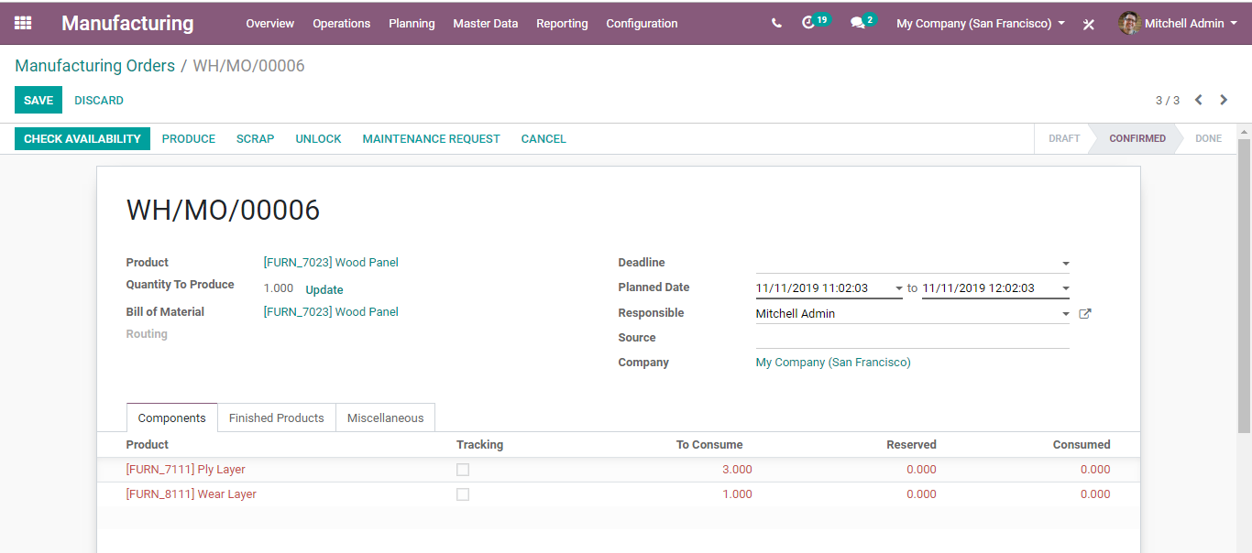
  - 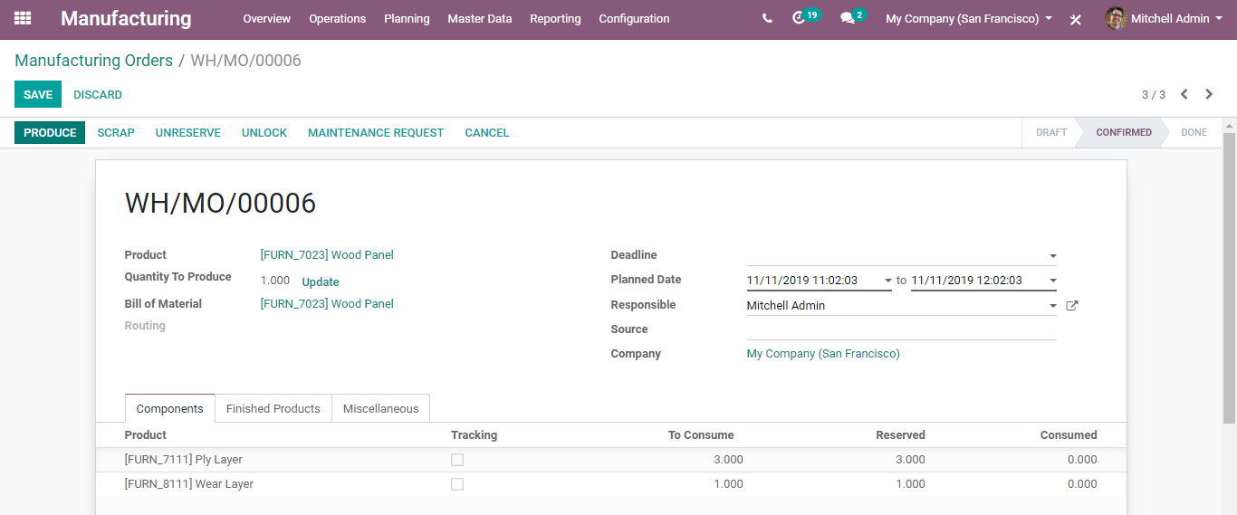

  - MANAGE PRODUCTION
  - Once you have created and confirmed a Manufacturing order, you can start production. BUSINESSBOXERP will list all the Manufacturing orders under Manufacturing > Operations > Manufacturing Orders. You can view the status of all ongoing manufacturing orders from this place.
  - 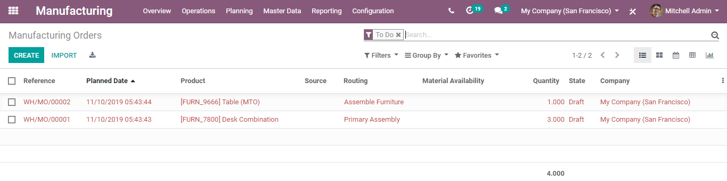
  - Select a Manufacturing Order from the list.
  - 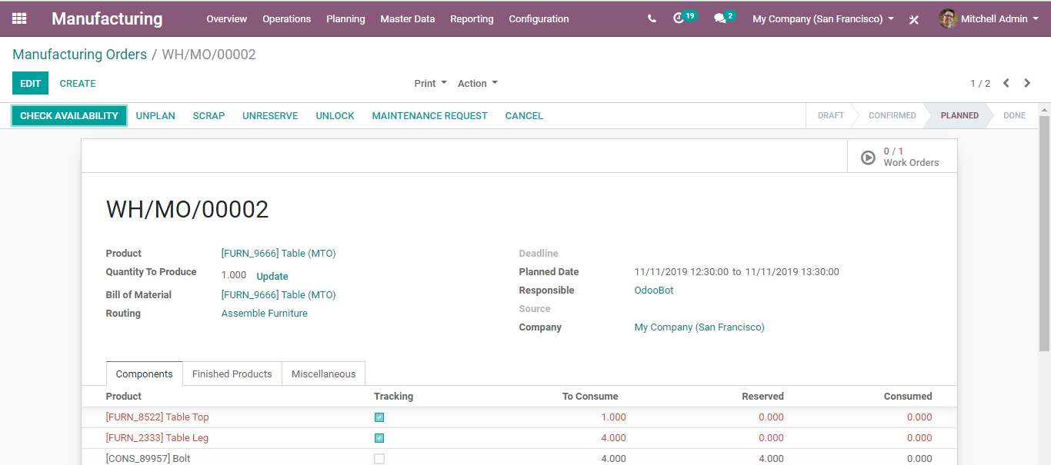
  - To start the work order, click on the play button in the top right corner.
  - You will be navigated to a new window listing the work order.
  - 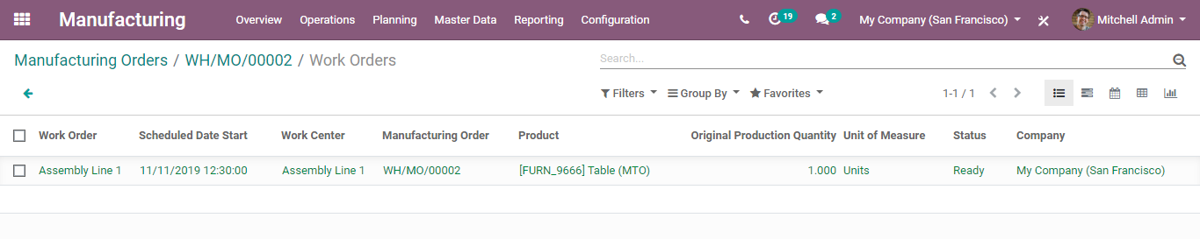
  - Upon clicking the Work Order,
  - Under the Work Instructions tab, you can see the instruction to be carried out in the production process.
  - One gets to see the work instructions, that must be referred before going to the production.
  - 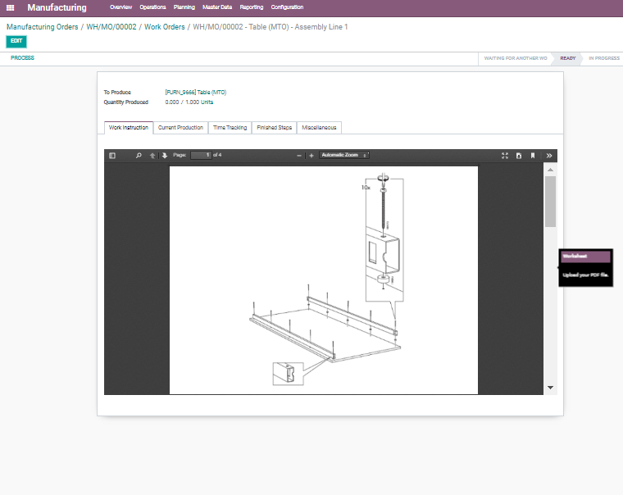
  - Under the Current Production Tab, one gets to see the quantity in production, component details.
  - 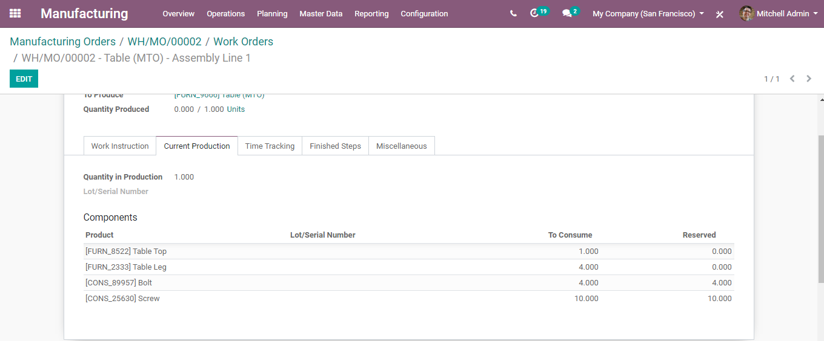
  - Under the Time tracking Tab, one can see the planned date, effective date, expected duration, and real-time duration.
  - 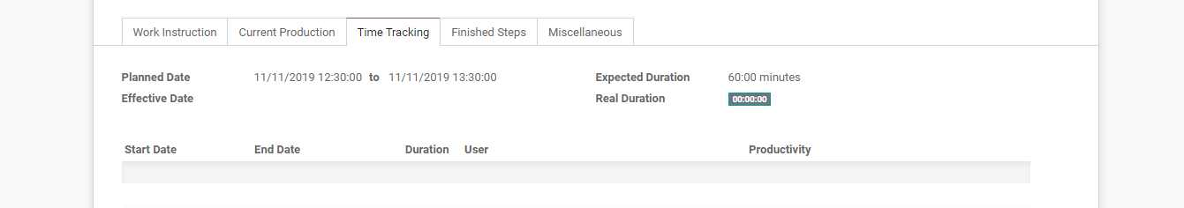
  - If you click PROCESS, the work order will start.
  - 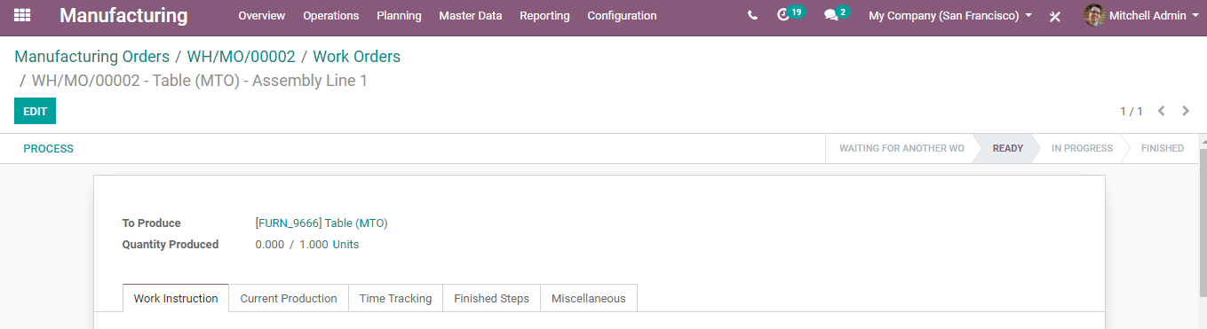
  - 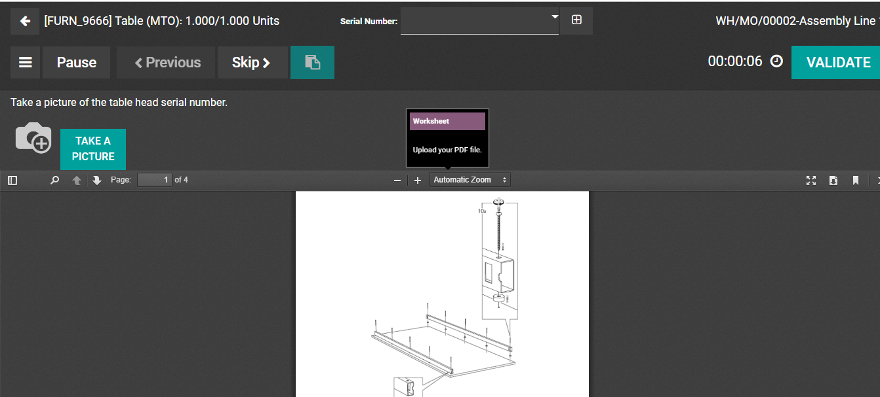
  - From here, one can PAUSE the production, SKIP the production, take a picture of the current state of production and many other options via using the dropdown menu set on the left side.
  - Utilizing a dropdown menu, one can BLOCK, SCRAP, ask for MAINTENANCE REQUEST and trigger QUALITY ALERT on specific components of the work order.
  - 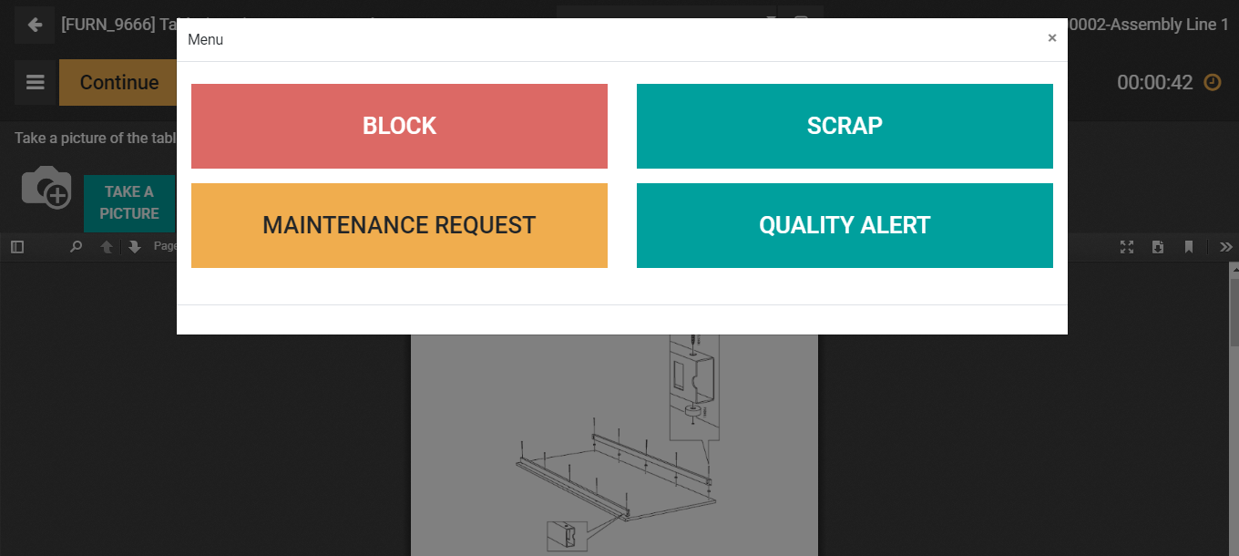
  - Upon clicking the BLOCK button, you will be navigated to a new wizard, where you will be asked to specify the lost reason for blocking the work centre from carrying the work order. One can also add additional descriptions if any.
  - 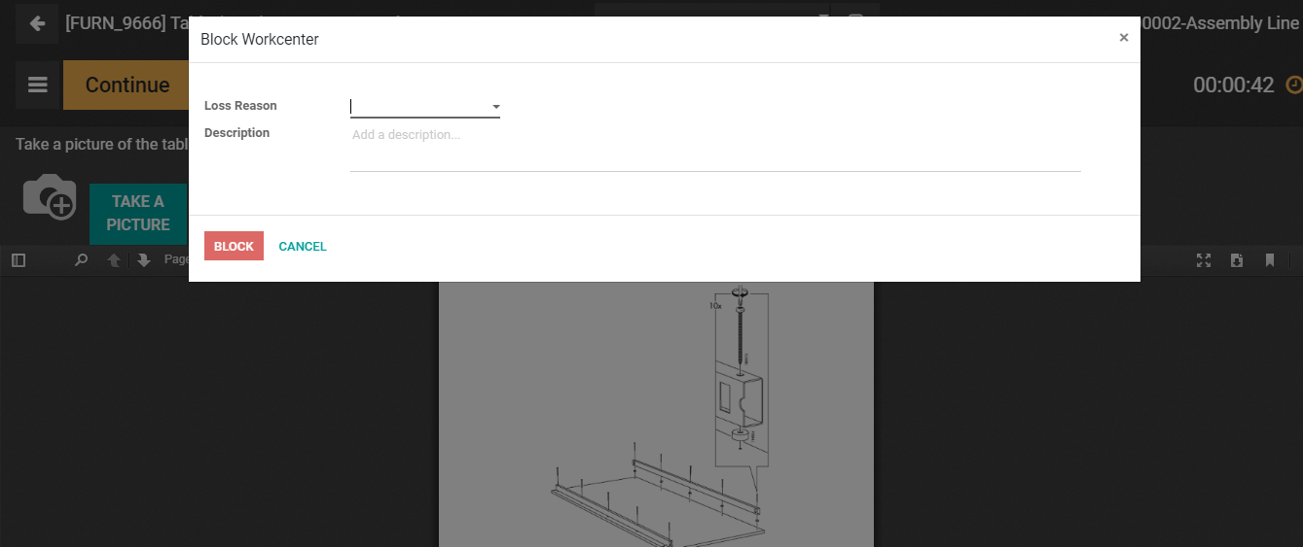
  - In case, you want to mark the products as SCRAP, click on the scrap button and you will be navigated to a new window:
  - 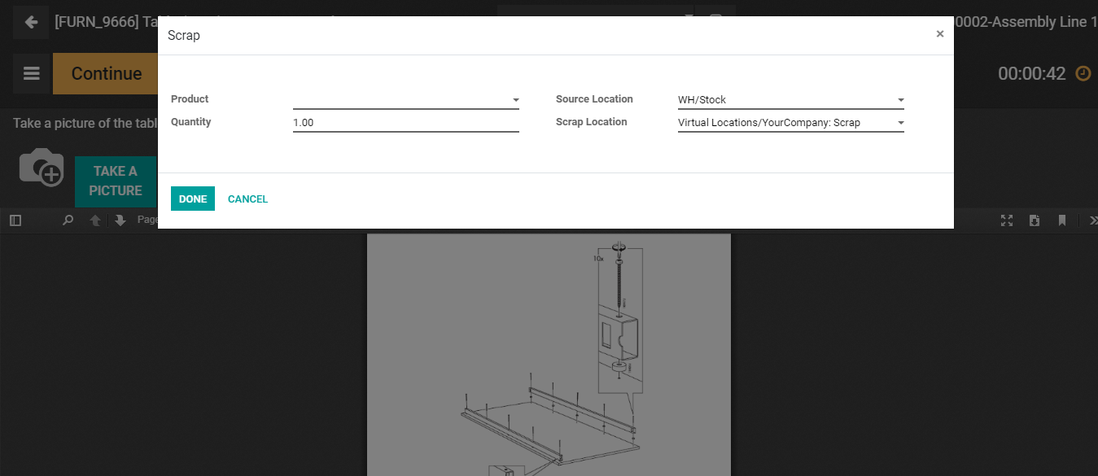
  - Here you can specify the product, quantity, lot, package, owner, work order, manufacturing order, location and more.
  - Upon clicking the MAINTENANCE REQUEST button, you will be navigated to a new window requesting the type of maintenance: Preventive or Corrective maintenance. Here, one can specify several other details like manufacturer, equipment, manufacturing order and so forth.
  - 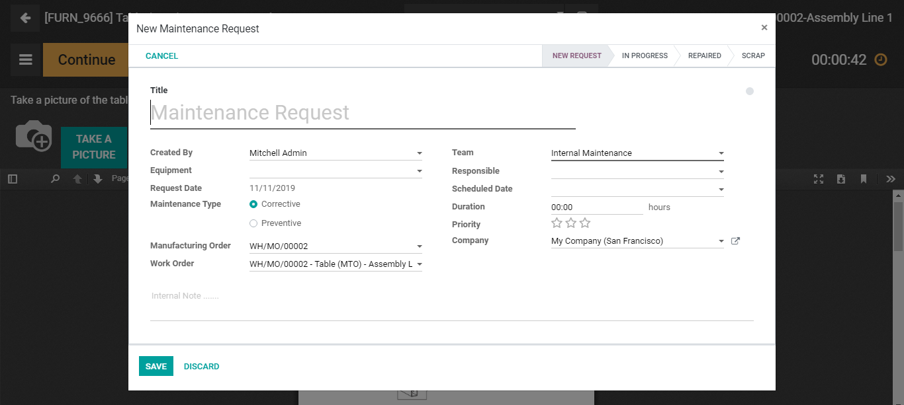
  - Upon clicking QUALITY ALERTS, you will be navigated to a new window like below.
  - 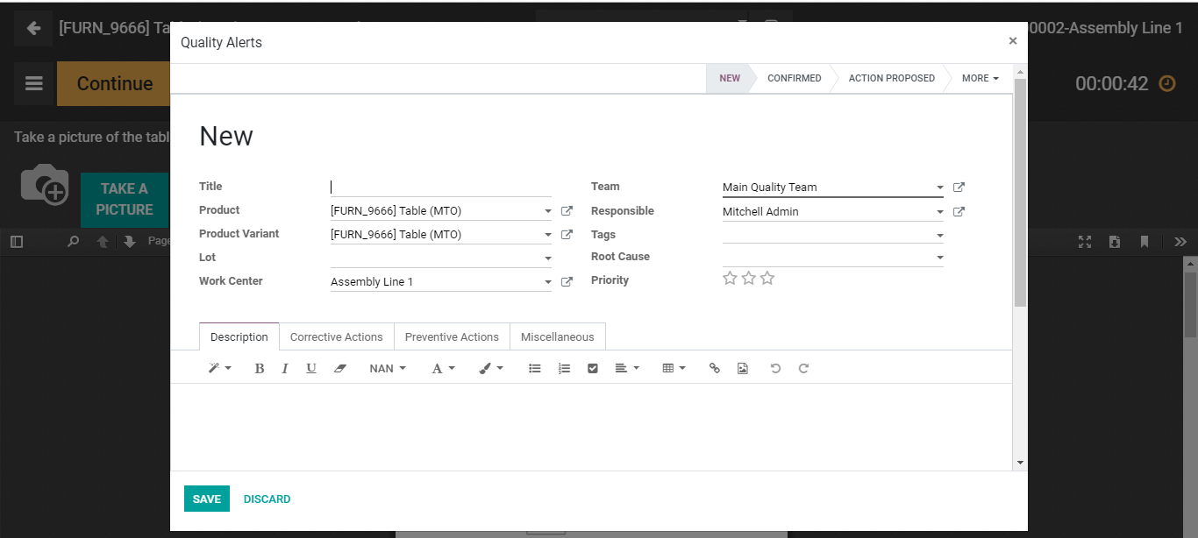
  - Here one can specify the desired details and set quality alerts on components of the work order.

  - PLANNING WORK ORDERS
  - At times, organizations need to plan their work orders. Doing as such, they can arrange the work for the entire day and be certain everything goes well. It also abstains from planning numerous work orders simultaneously, especially when you can't do it.
  - With BUSINESSBOXERP, organizations can schedule the beginning date for their manufacturing orders. What's more, if you plan two work orders at a similar work centre, at that hour, the subsequent one will be scheduled just after the first, keeping away from work superposition.
  - Configuration:
  - Manufacturing ->Configuration -> Settings and activate Work Orders feature under Operations Menu.
  - 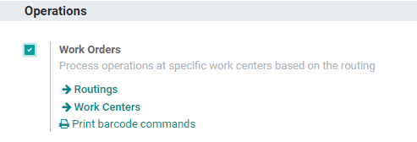
  - Click SAVE to mark the changes.
  - Now, go to Manufacturing> Operations> Manufacturing Orders. Create new order with the Planned Start Date.
  - 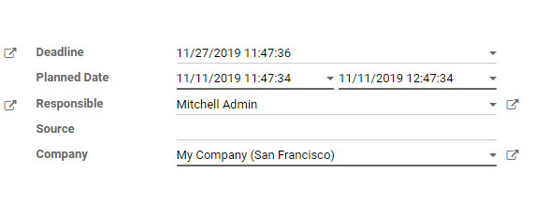
  - Mark your Manufacturing Order as to do and plan it. Via clicking the Planning menu, you can access the scheduled orders.
  - 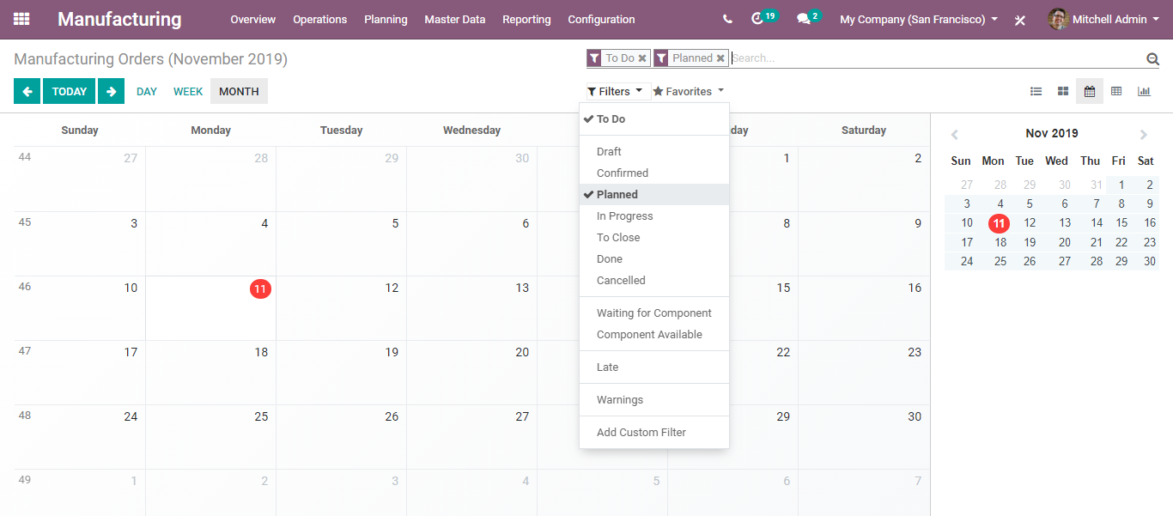
  - Here is the one we just created:
  - 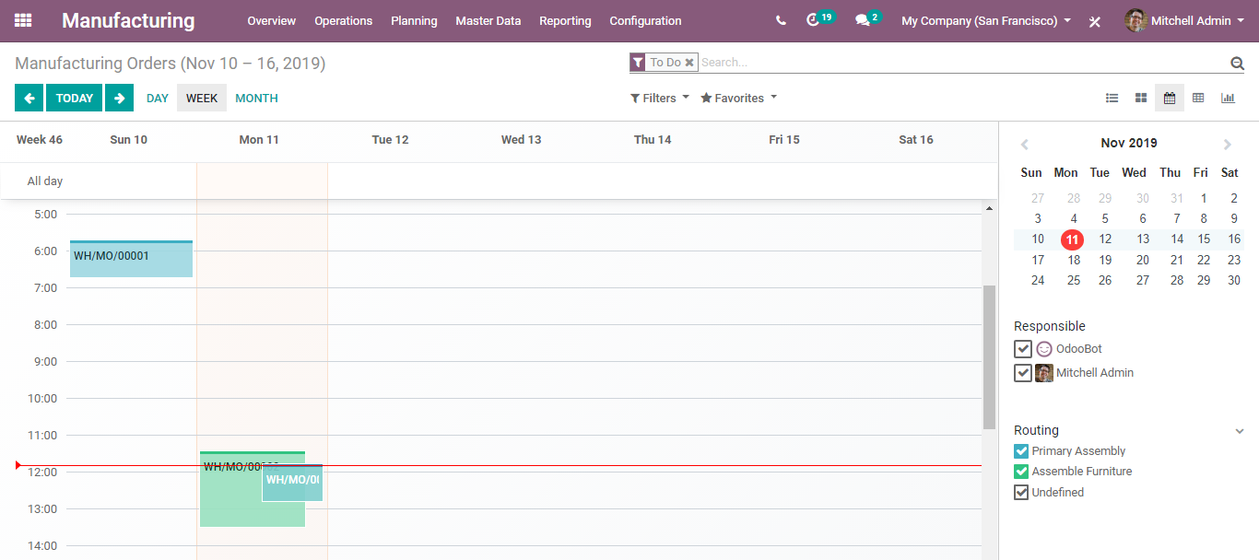
  - Work Centres and Routings
  - Utilizing the BUSINESSBOXERP manufacturing module, one can produce a product in two different ways. One is via creating a manufacturing order via following simple default stages and completing the production or via customizing the work order by setting up a work centre and routing mechanisms. To use this advanced manufacturing procedure, one needs to enable routing and planning in the manufacturing settings.

  - WORK CENTERS
  - As the name indicates, Work centres are the Physical place situated in one’s business firm, where different manufacturing processes can be done. One can create their work centre details with all its performance indices. Later they can use this data to analyse the efficiency and other details of each work centre.
  - Configuration
  - Manufacturing->Configuration ->Settings-> Operations->Work Orders
  - 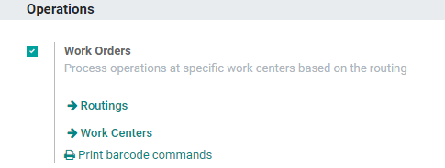
  - One needs to activate the option work orders. Click SAVE to mark the changes. The change will be reflected in the dashboard as you can see below.
  - 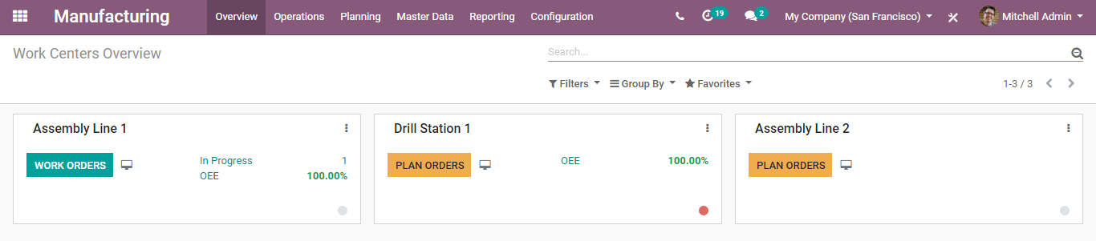
  - One can manage the work centres directly from the dashboard. The user can perform actions and take reports directly from this dashboard.
  - 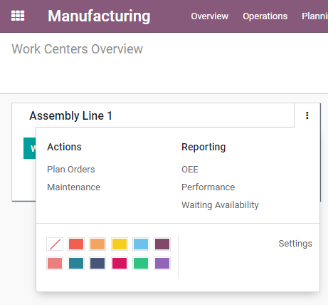
  - One can either add the work centres via directly clicking the button WORK CENTERS in the configuration menu or via going to Manufacturing->Master Data->Work Centres
  - 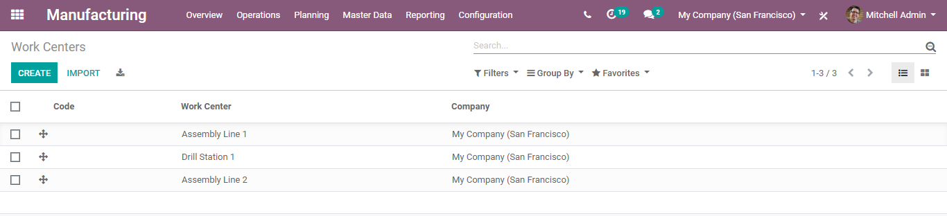
  - One can create a new work centre by clicking the CREATE button.
  - 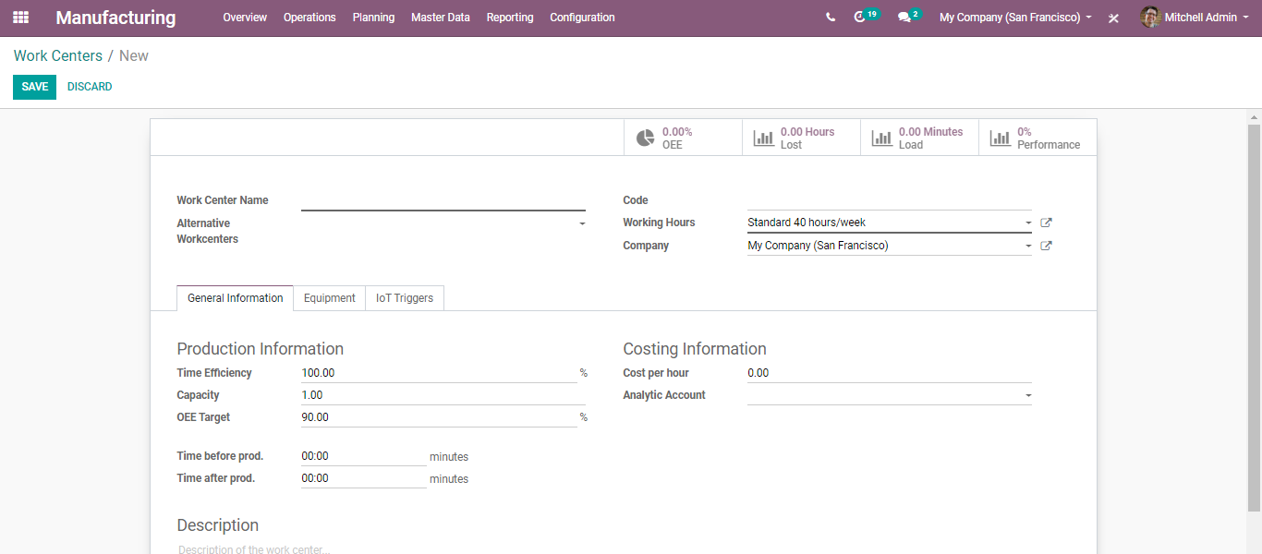
  - A creation form includes the following fields: -
- Work Center Name: The field defines the name of the work centre.
- Alternative Work Centres: Alternative Work Centres that can be substituted to this one to dispatch production.
- Code: The field defines the code for the work centre.
- Working hours: Define the schedule of a resource. One can either change or modify the working hours via clicking the modify button.
  - 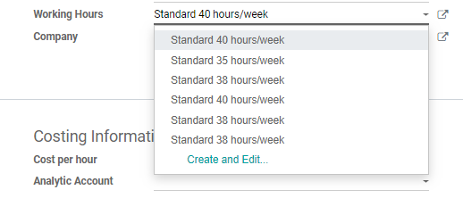
  - 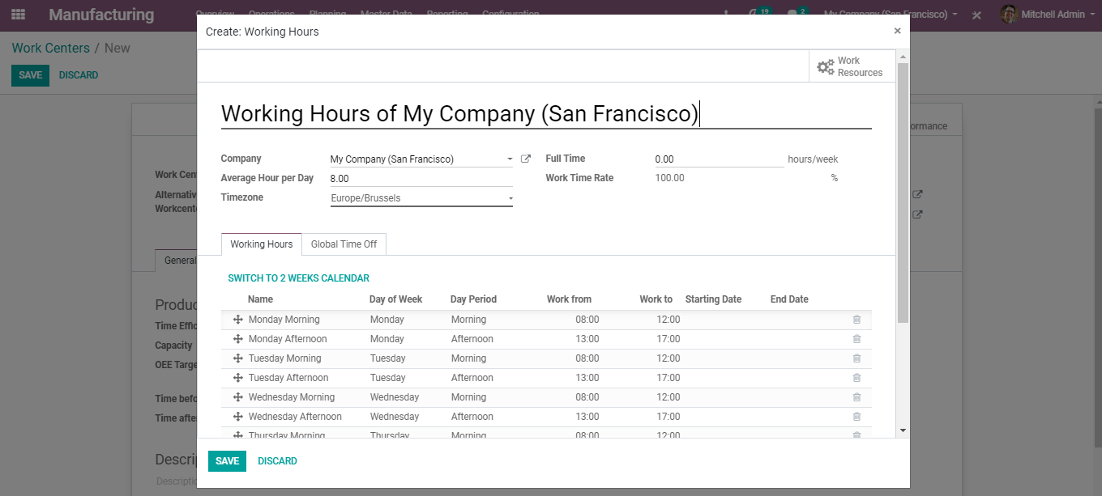
  - Under the General Information tab
- Time Efficiency: The field is used to calculate the expected duration of the work order at this work centre. For example: If a work order takes one hour and the efficiency factor is 100%, then the expected duration will be one hour. If the efficiency is 200%, however, the expected duration will be 30 minutes.
- Capacity: Number of pieces that can be produced in parallel.
- OEE Target: Overall Equipment Effectiveness Target in percentage.
- Time before prod: Time in minutes for the setup.
- Time after prod: Time in minutes for the cleaning.
- Cost per hour: Specify the cost of the work centre per hour.
- Analytic accounting: Fill this, only if you want automatic analytic accounting entries on production orders.
- Description: Description of the work centre.
  - So, once you start using these work centres, we can analyse what is happening in the work centre via clicking any of the buttons shown below.
  - 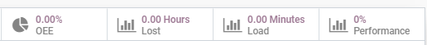
  - This helps in knowing what’s going on and how efficient the work centre is.

  - ROUTING
  - Routing has the records of the production operations or stages that one must follow to produce the finished product. During so, it enables the end-user to record the time spend on each manufacturing action and know what the next step is. More than that, it adds a new view in which the end-user can add different instructions related to the work so that one can avoid any mistakes possible. These steps are usually done by the engineering manufacturing department. Thanks to BUSINESSBOXERP feature, that one can go into the details and keep track of everything, they did and what they need to do next, to make the process better. With an easy to use, intuitive interface, BUSINESSBOXERP enables you to set everything in a few minutes and manage the manufacturing process.
  - Configuration
  - Manufacturing->Configuration ->Settings-> Operations->Work Orders
  - 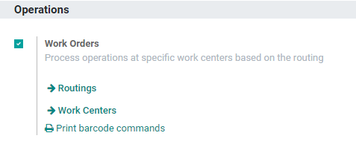
  - One can either create a new routing via directly clicking the button ROUTINGS or via going to Manufacturing->Master Data->Routings.
  - 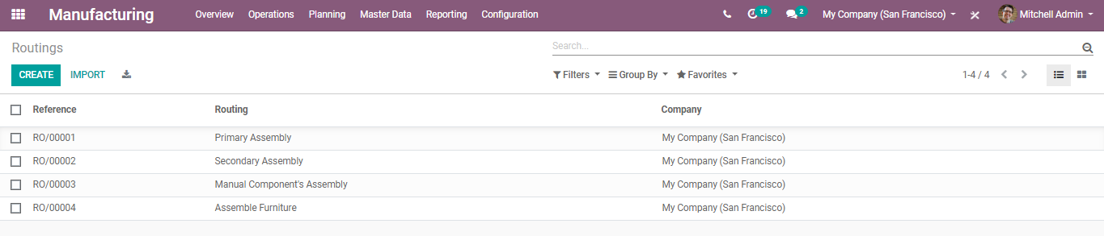
  - Each production process will have its routes. That means each production will go through many work centres prescribed by the route and finally the product is completed. Every company will have their manufacturing route for each product. They can configure it in BUSINESSBOXERP and carry out their operations.
  - Click CREATE button, to configure the new route.
  - 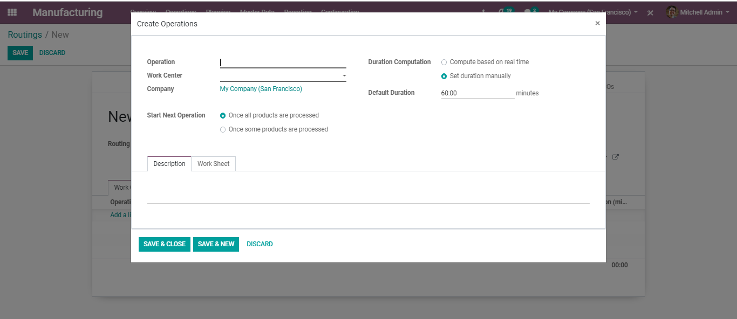
  - One can provide a name for the routing.
  - Click “Add a line” to add operations to work centres and time frame.
  - 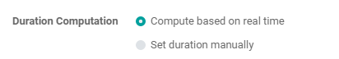
  - Under the wizard, you can enter the operation name, select the work centre and company.
  - Here, the duration of the operation can be set in two ways:
  - 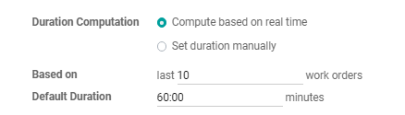
  - - Duration computation: In this method, one can calculate the time duration based on previous work orders.
  - 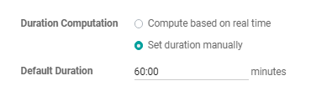
  - - Default Duration: in this method, one can enter the duration manually.
  - 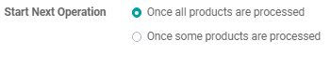
  - Start Next Operation: Set to schedule the next work order after the previous one. By default, there are two types: Once all products are processed and once a minimum number of products is processed.
  - 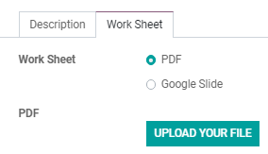
  - Description and Worksheet Tab
  - Under the ‘Description’ tab, one can explain the process involved with each operation. And under the Worksheet, one can upload the process flow as an attachment file.
  - 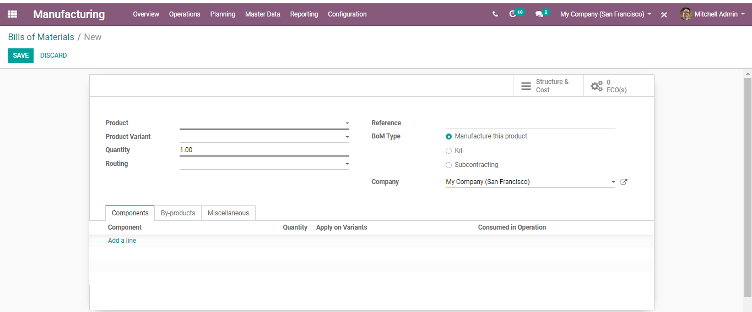
  - Linking ‘Route’ to a Manufacturing order.
  - Linking a created route to a product is done in BoM. Under the Bill of Materials (BoM), one can add the ‘routing’ for a particular product.
  - 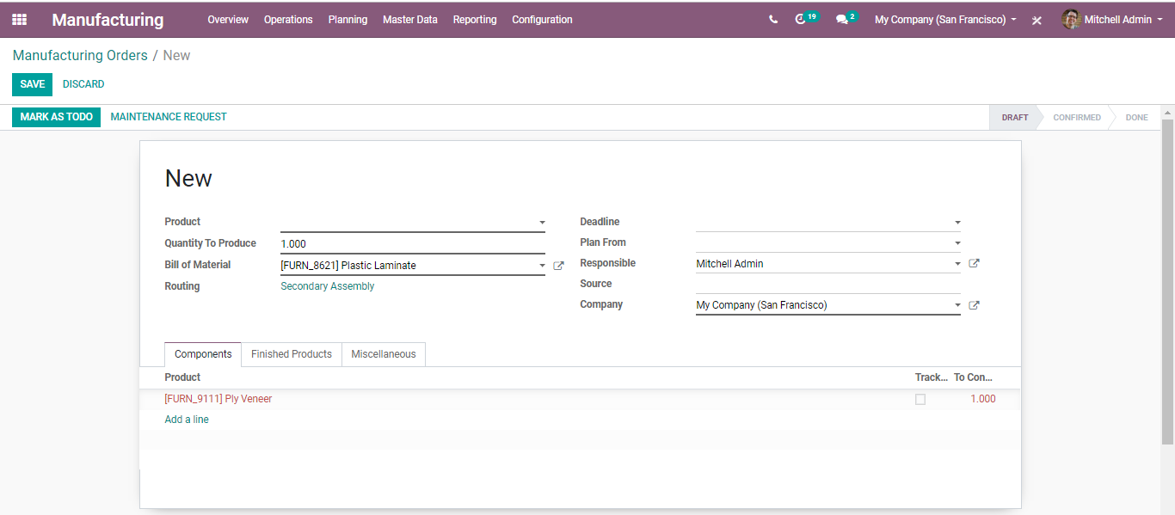
  - Since the manufacturing order is based on the BoM, the system will follow the route specified, during the manufacturing process. See the figure of a routing enabled manufacturing order.
  - 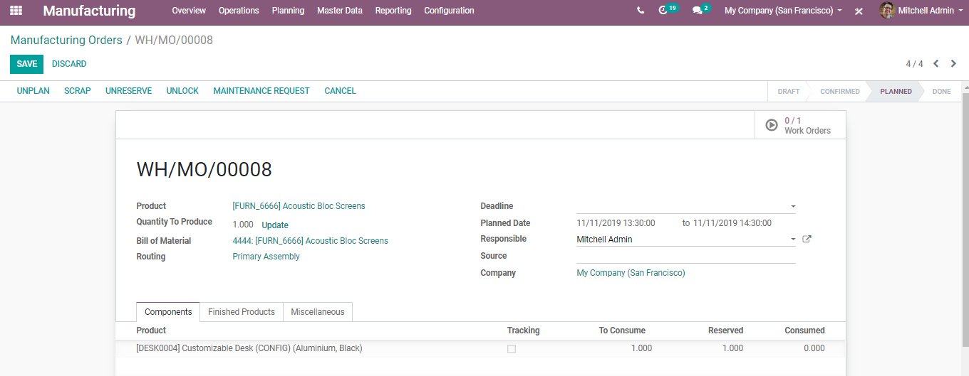
  - Check the availability of raw materials via clicking on the “Check availability” button. And click the ‘Work orders’, button to create all the work orders according to the routing.
  - 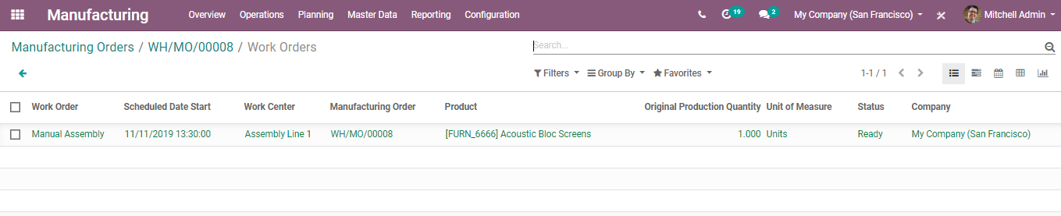
  - Upon clicking the work order button, one can see the work centre specified in the routing.
  - 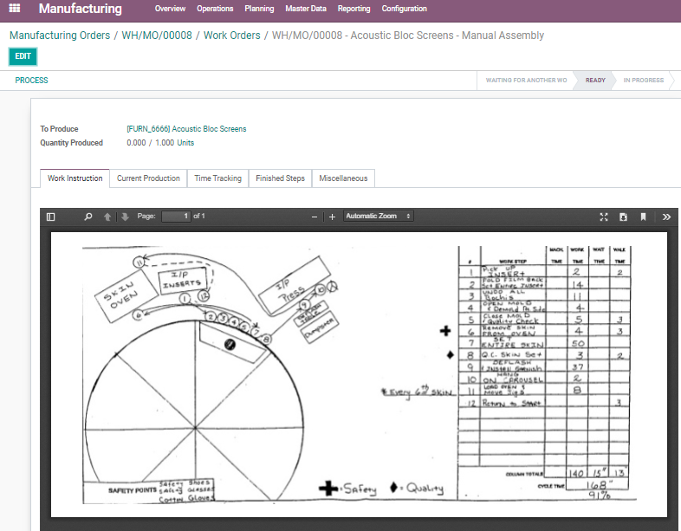
  - Click the work order to execute it.
  - 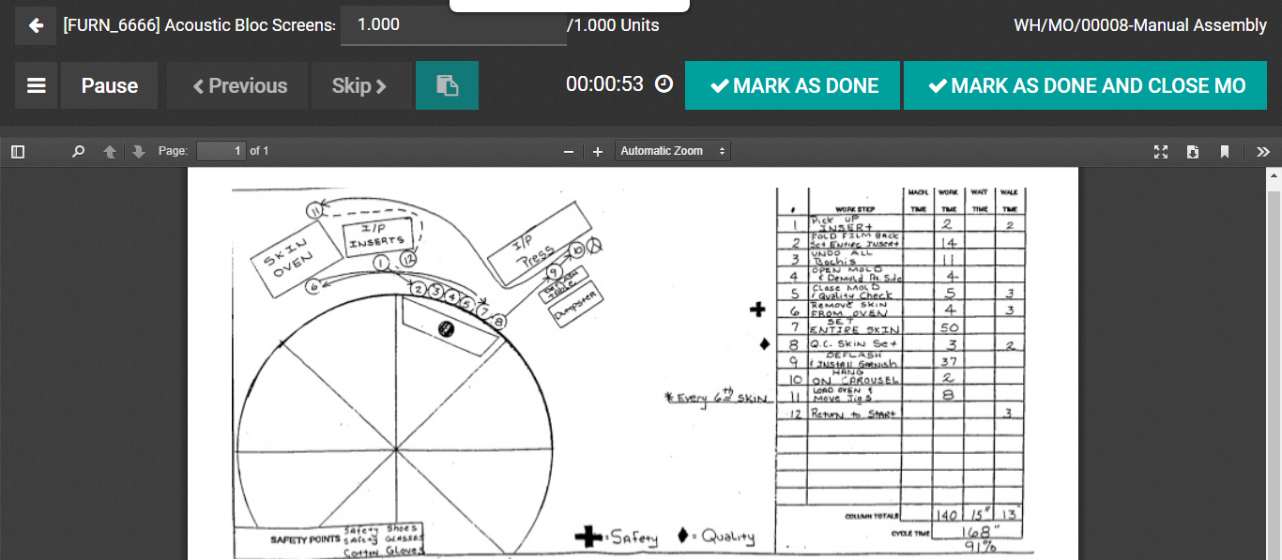
  - Click the ‘PROCESS’ button to start the production.
  - 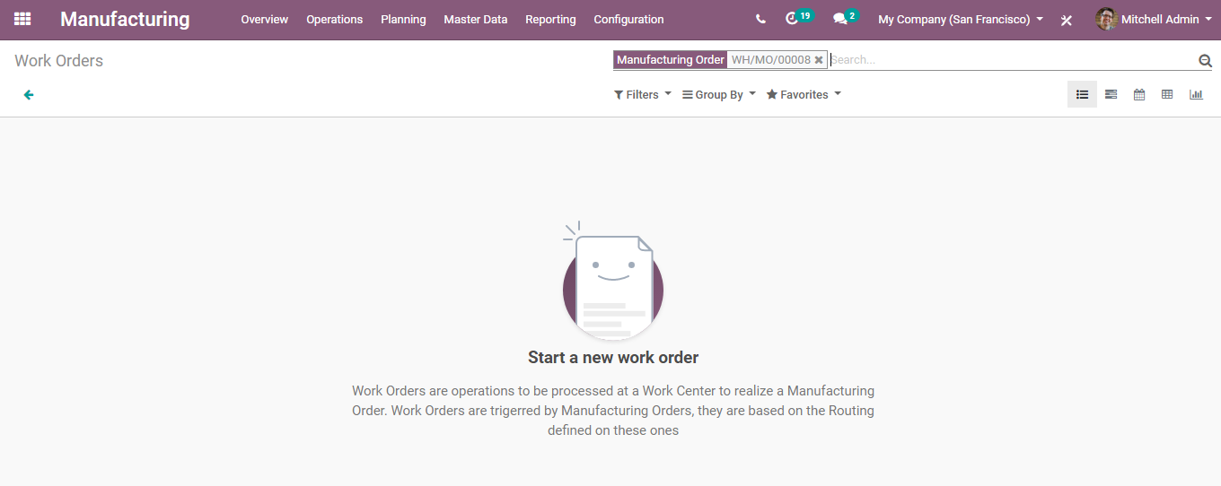
  - Click Mark as Done to start a new work order.
  - 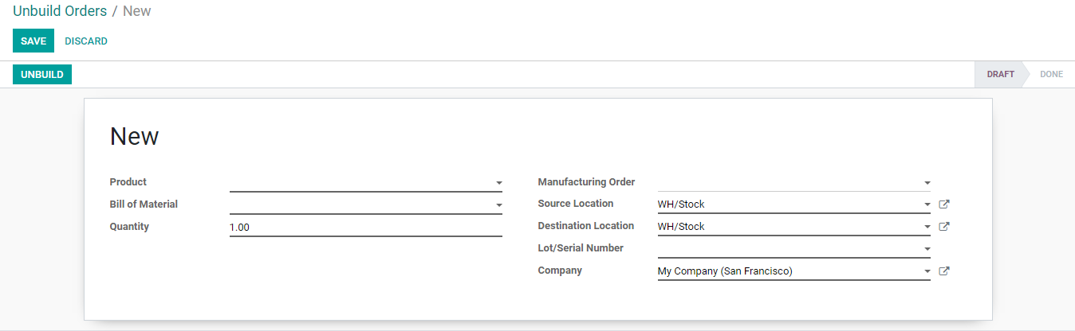
  - Unbuild a Product
  - Utilizing the BUSINESSBOXERP Manufacturing Module, the end-user can seamlessly unbuild the products. One can unbuild the products that are built by themselves or can unbuild the products that are received.
  - Let us take the primary case, where you are manufacturing items by yourself. In case, that one of your products shows some imperfection/defect, you may need to unbuild it as opposed to rejecting it totally, enabling you to reuse a few components of the product.
  - In the second case, you are purchasing products for the sole purpose of unbuilding them and reusing them.
  - How to Unbuild Order?
  - Configuration
  - Manufacturing->Operations->Unbuild Orders->Create
  - 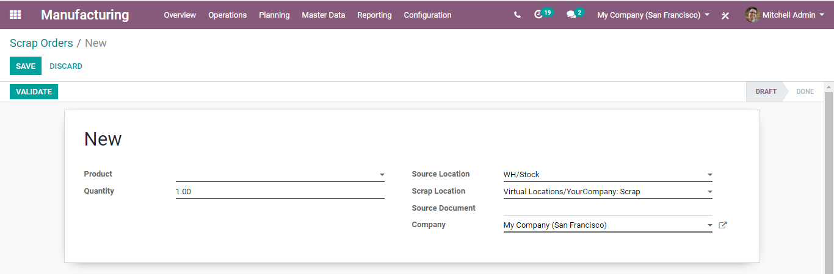
  - While creating a new one, select the manufacturing order if you are into unbuilding something you manufactured. And select only the product if you are into unbuilding something you received.
  - Once done, click the UNBUILD button.
  - In case of unbuilding the product that was manufactured before, the user gets back the components from MO in stock. However, unbuilding a product that is received, the user gets the components from BoM in stock.
  - Scrap Orders Management
  - One of the most useful features of BUSINESSBOXERP is that it provisions the end-user to create scrap at any stage of the production line. One will be enabled to view a Scrap button almost in all the stages of the production line. Upon clicking the SCRAP button, BUSINESSBOXERP creates instant scrap entry in the inventory. However, one can create a fresh scrap entry by going to
  - Manufacturing -> Operations -> Scrap Orders -> Create
  - 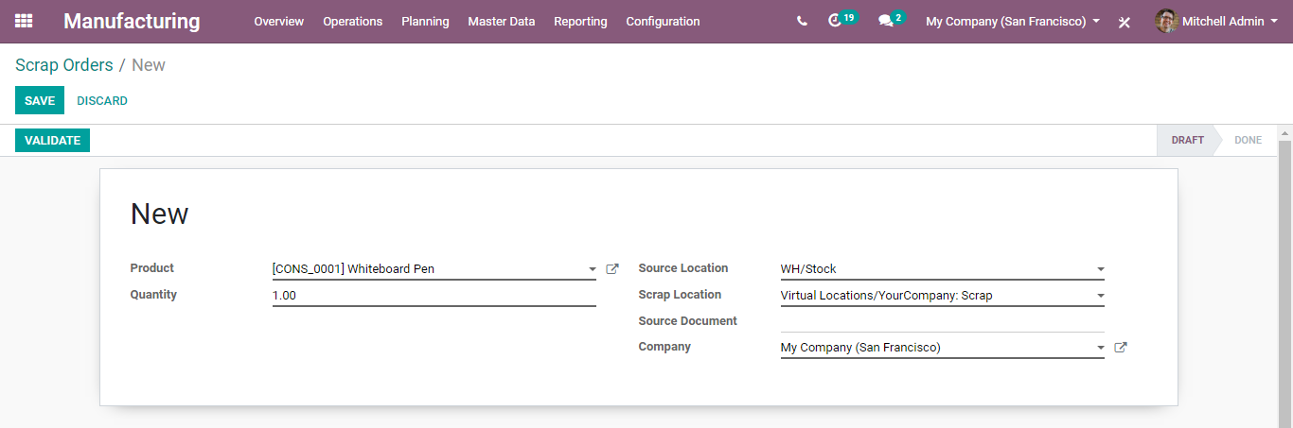
  - Under the creation form, one can specify which product should be scrapped, the total number of quantities, source location, scrap location, and source document if any.
  - Fill in the fields and Click “VALIDATE”.
  - 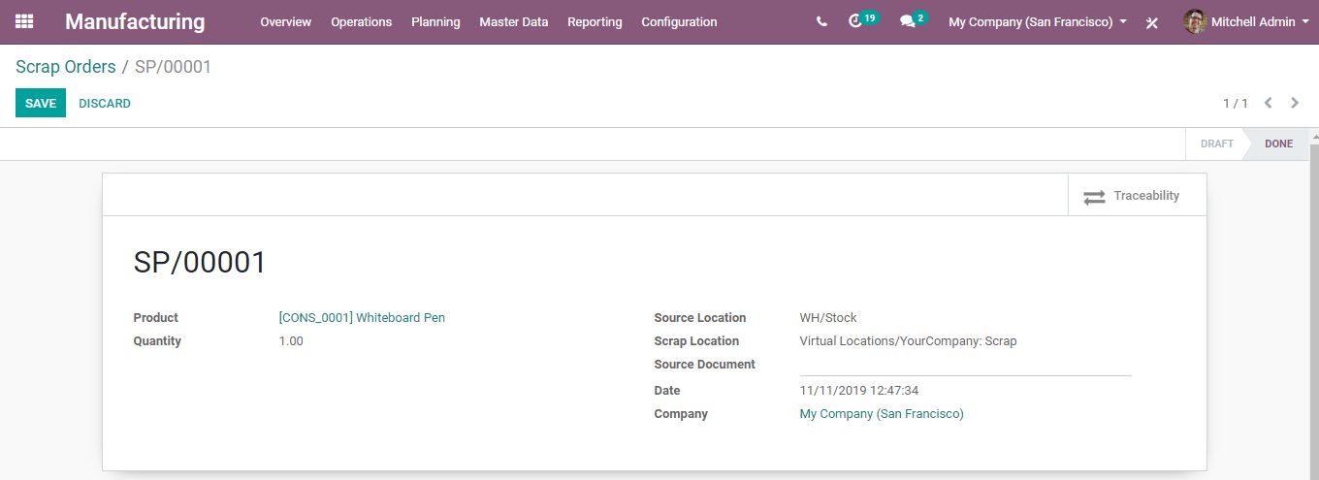
  - It will automatically get inserted into the inventory.
  - 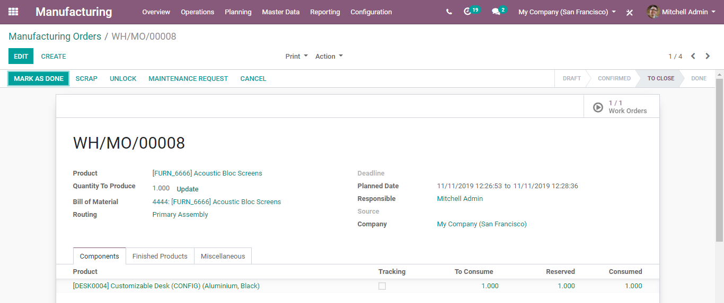
  - However, one can make a quick entry by clicking on the Scrap button available on almost all forms of production.
  - While MO is planned.
  - 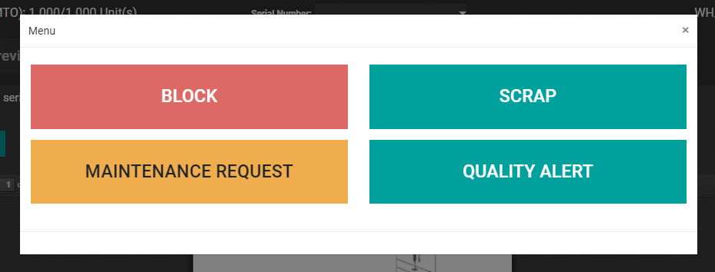
  - While the work order is processed.
  - 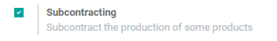

  - Subcontracting
  - It is a common scene in business to subcontract production of some finished products via subcontractors. In BUSINESSBOXERP, the subcontracting feature can be initiated via going to manufacturing settings.
  - Configuration
  - Go to Manufacturing > Configuration > Settings and activate Subcontracting feature under the Operations menu.
  - 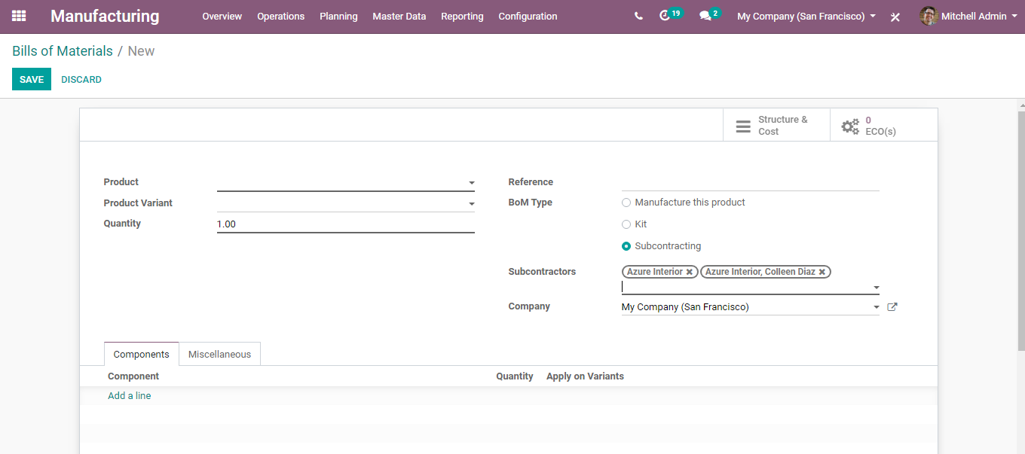
  - Next, create a Bill of Material. For that go to Manufacturing > Master Data > Bill of Materials
  - Upon clicking the CREATE button, you can create a new BOM. Later list the components that will be used by the subcontractor for manufacturing the subcontracted finished product.
  - Specify BoM type as Subcontracting.
  - Upon clicking the BOM type as Subcontracting, one can see a new field adjacent to the BOM type. Here you can define the subcontractors.
  - If the subcontractor field is kept empty, any subcontractor can access the BoM. However, upon defining names, the BoM will be only accessible for those subcontractors.
  - 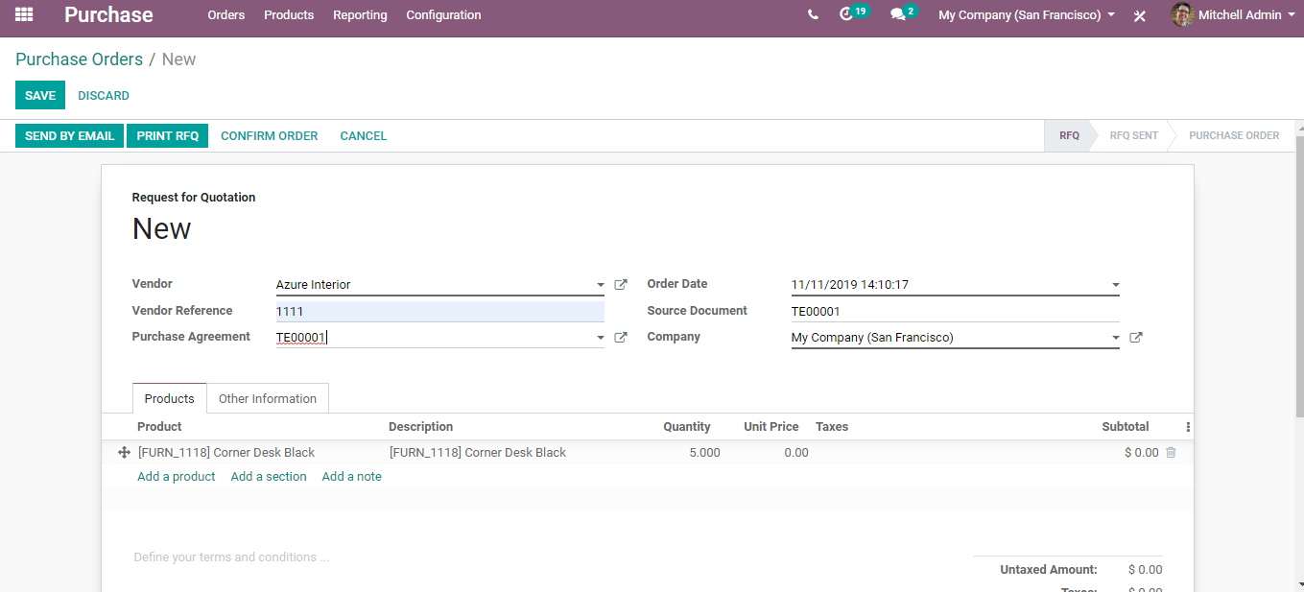
  - Receive or buy a subcontracted product
  - Under BUSINESSBOXERP, one can either buy the subcontracted product from your subcontractor or directly receive the subcontracted product.
  - Buying a subcontracted product from a subcontractor
  - For that go to BUSINESSBOXERP Apps> Purchase Module. Create a new purchase order.
  - 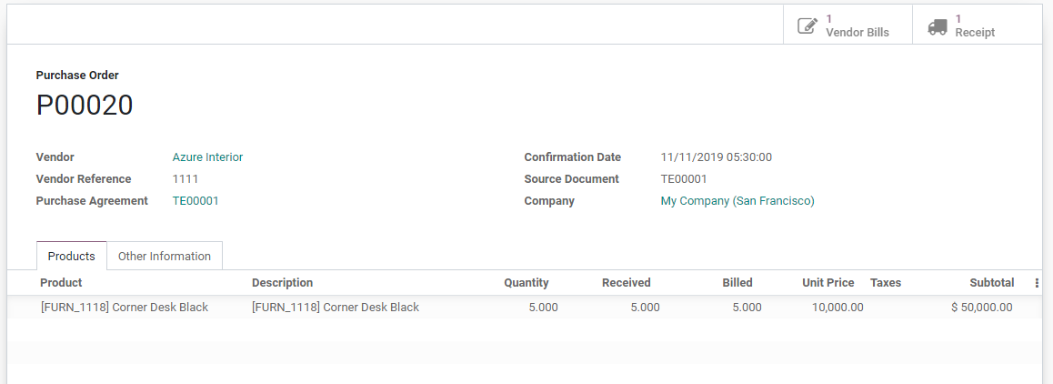
  - The vendor must be a subcontractor and the unit price should be the cost you are paying to the subcontractor for subcontracting the product.
  - 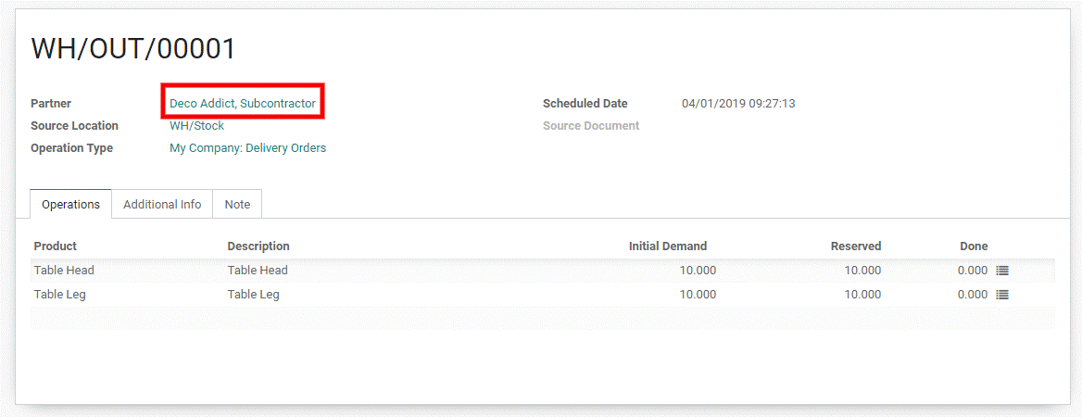
  - Upon validating the purchase order, it generates a receipt automatically.
  - Upon receiving the product, validate the receipt.
  - Stock moves get created:
- For components
  - Subcontracting-> Production
- For subcontracted product
  - Production -> Subcontracting
  - Subcontracting -> Stock
  - Subcontracting Location is the place at the subcontractor’s warehouse where products are stocked. An internal location, therefore, components sent to the subcontractor are still valued in stock.
  - To receive the subcontracted product, create the receipt manually with a partner of type subcontractor defined on it.
  - Resupply the subcontractor with the components
  - In BUSINESSBOXERP, there exist 3 ways to manage the resupply of your subcontractor:
  - Manually: Where you create a delivery order defining subcontractor as the partner, defining components to deliver.
  - 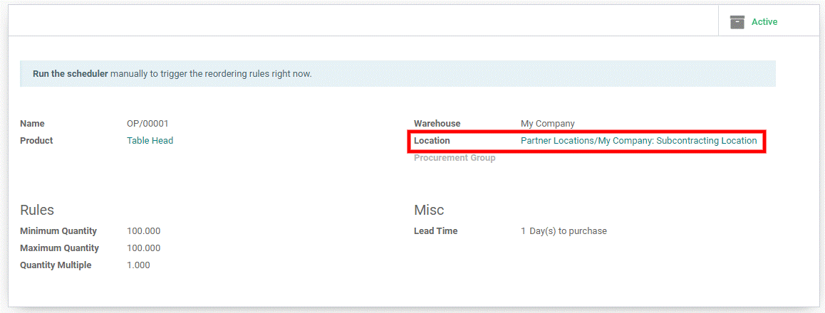
  - With reordering rules: Ensures subcontractors are supplied with sufficient components. When the reordering rule is triggered, a delivery order is created automatically for the product.
  - 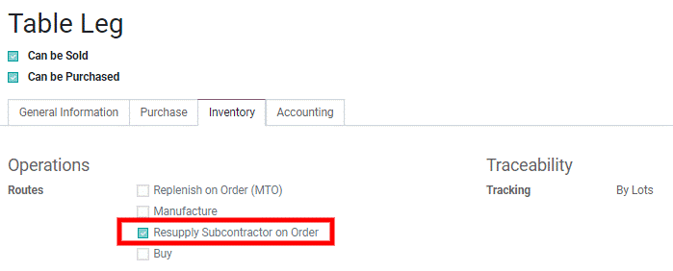
  - On order: Delivering components to your subcontractors each time you order a subcontracted product. To initiate the action, tick the route Resupply Subcontractor on Order on the wanted components.
  - 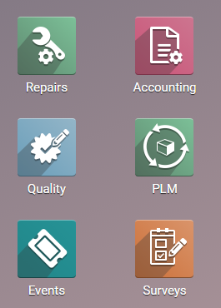

  - Product Lifecycle Management
  - Product lifecycle management (PLM) under BUSINESSBOXERP deal with engineering change orders (ECO). As the name implies, Engineering Change Orders (ECO) are the procedures carried for applying changes in the product components, documents, or assemblies. Changes can be concerning processes, work instructions or changes in the specifications.
  - For Instance, if the existing BoM for a product is not available in the market, and one must update the BoM. So here, one must use the ECOs.
  - Configuration
  - Install the Manufacturing module as well as the PLM module.
  - 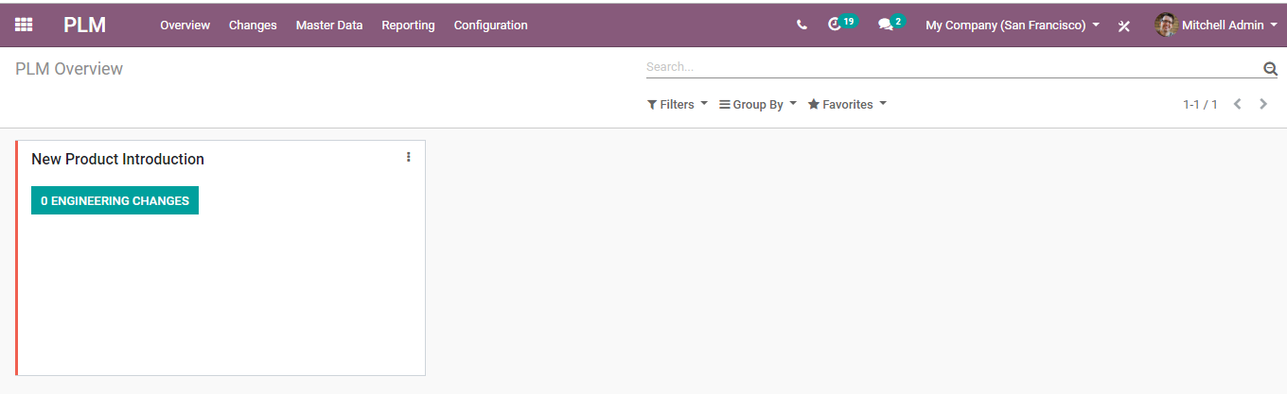
  - The available option under PLM includes:
  - Overview: Here, one can see all the engineering change order types and the number of changes going on in each ECO.
  - 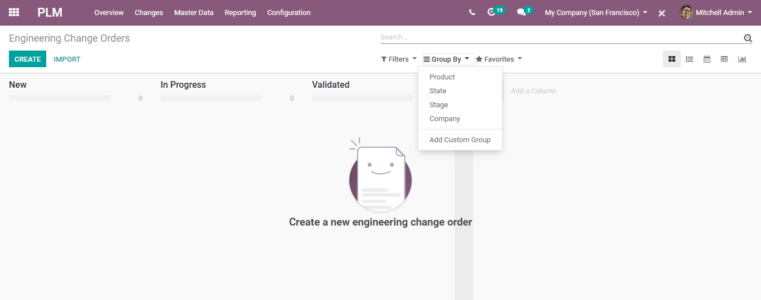
  - Changes: Here, one can view all the engineering change orders in different formats such as Kanban, list, calendar, pivot, graph. Also group them based on product, state, and stage or a custom group.
  - 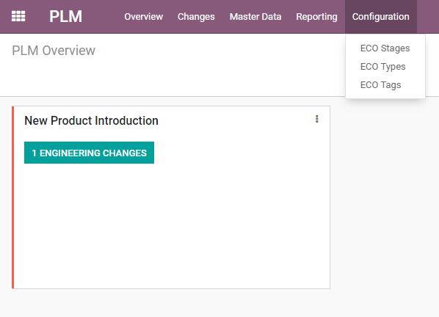
  - Master Data: Products, Bill of materials of products, Routings, and Work centres come under this section.
  - Reporting: Analyse all ECOs by reporting.
  - Configuration
  - Under the section, one can edit ECO stages, create ECO types and ECO tags.
  - 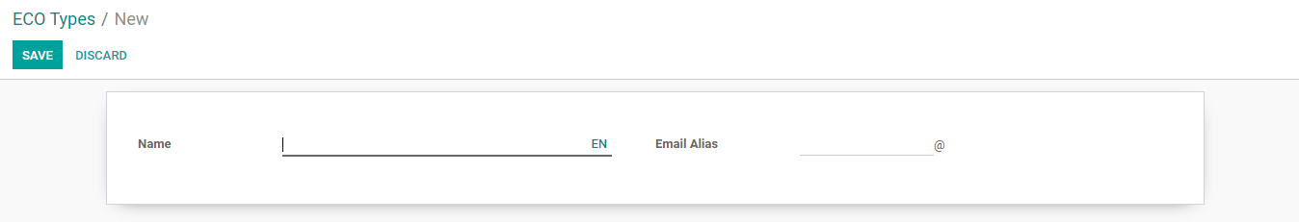
  - Creating ECO Types
  - 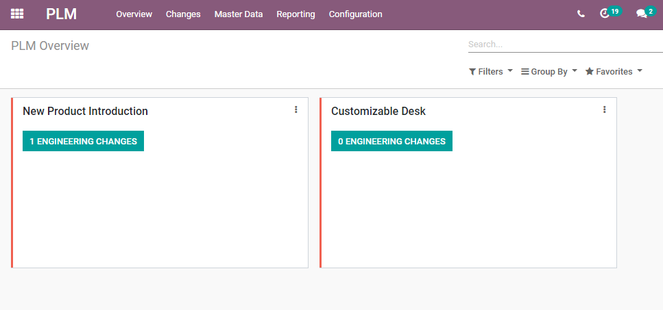
  - Enter the name and email alias. Click Save to mark changes.
  - Now, going back to the overview gets you a glimpse of the newly created ECO type.
  - 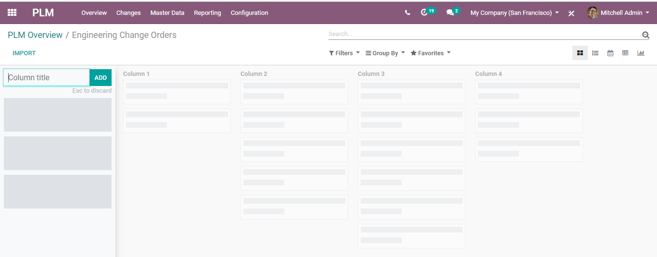
  - Now enter the ECO changes via clicking ENGINEERING CHANGES BUTTON. You will be redirected to a new page like below:
  - 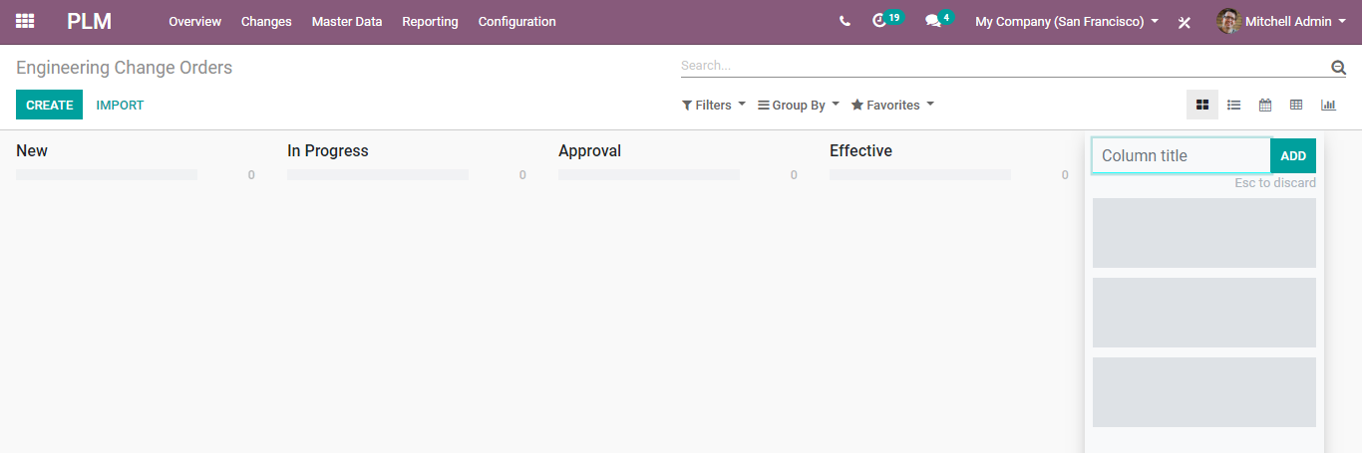
  - One can add different stages to the ECO type via adding columns.
  - 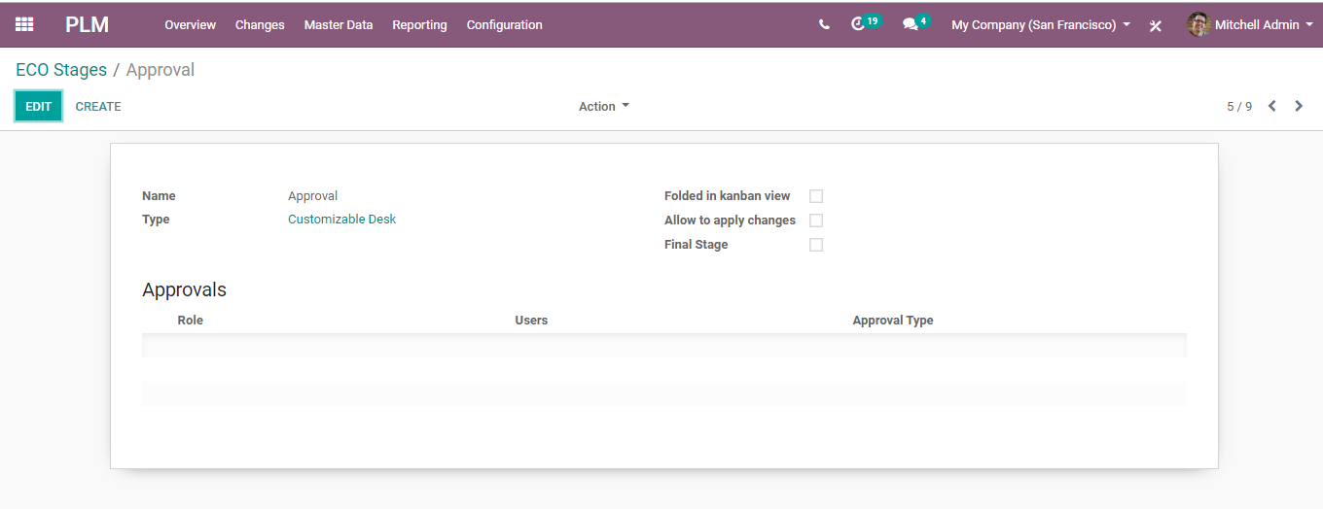
  - Here four stages are specified:
  - New: For creating new engineering change orders.
  - In progress: For the ECOs which are in progress.
  - Approvals: This stage is for getting approval for a change for the corresponding officials. Approvals for stages can be set in stage settings. Here one can add both officials and approval types.
  - 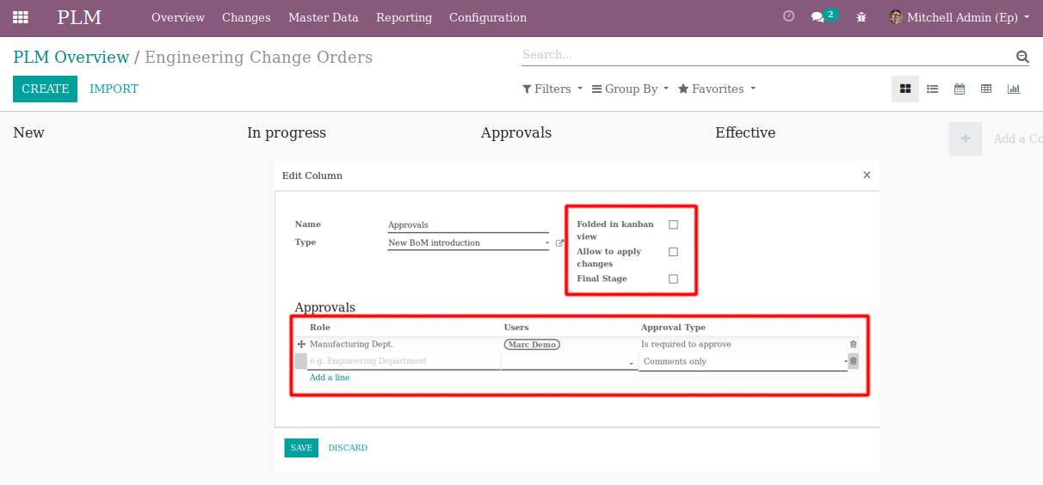
  - Effective: This stage is used for confirmed ECOs. Here one can apply changes and this stage will be marked as the final stage in the stage settings, also select allow to apply changes for applying ECO changes.
  - 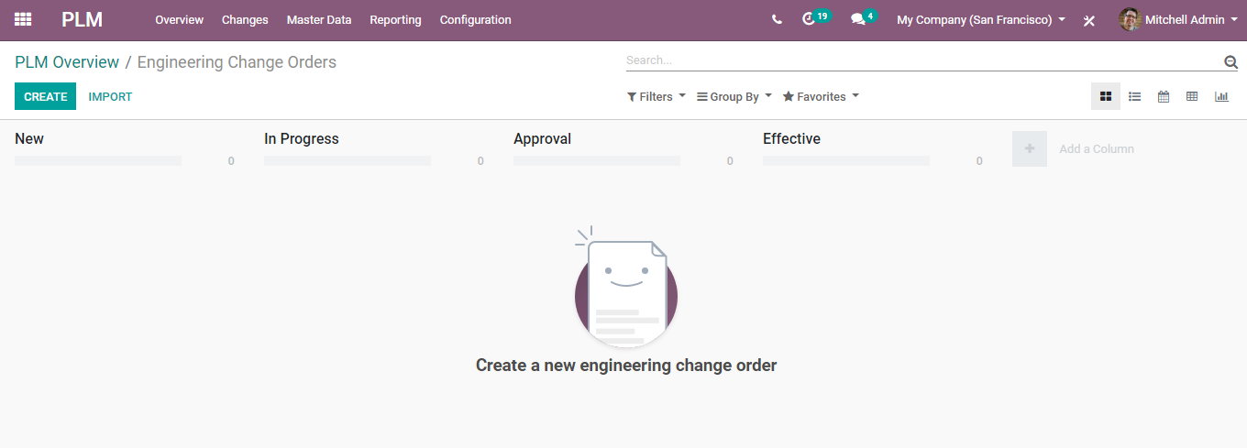
  - CREATING AN ENGINEERING CHANGE ORDER.
  - Configuration
  - For that go to PLM Overview> Engineering Change order
  - 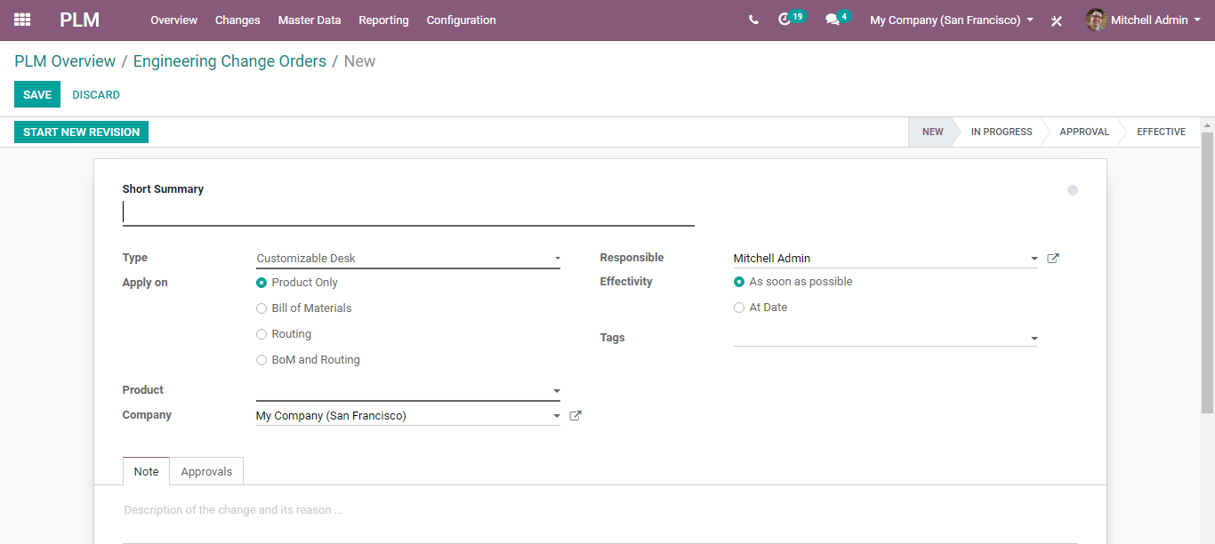
  - Click CREATE button, to create a new ECO.
  - 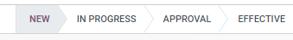
  - Under the field, one can see different stages through which ECO passes.
  - 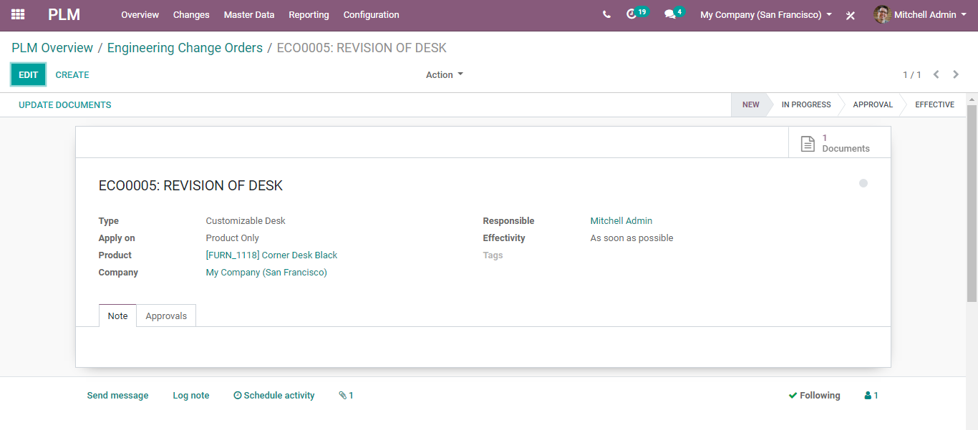
  - Summary: Under the option, one can give a summary of the ECO.
  - Type: Here one can choose the ECO type.
  - Apply on: Utilizing the option, one can decide where the order must be applied. Apply on Product Only/ BoM/ Routing /BOM and Routing.
  - Effectivity: Date on which the changes should be applied.
  - One can add tags for the ECO, description related to the change and its reason under the note tab. Later save the changes and confirm start new revision.
  - 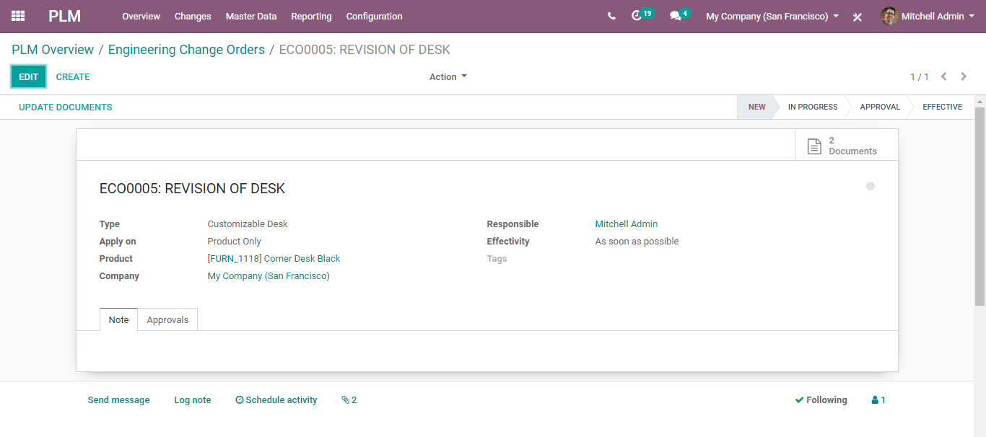
  - Any changes made say new documents uploaded, then the corresponding number of revisions will be notified on top of the ECO.
  - 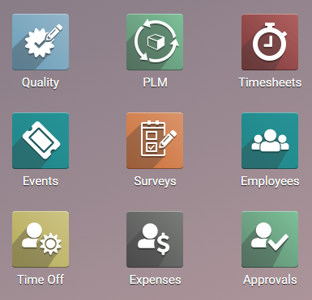
  - This is the engineering change order of the Product in the PLM module. Like this, one can create ECO in the bill of material, routing, both routing and BoM. ECO in the product will allow the end-user to update the documents related to that product. One can find the updated documents as attachments of the product. Also, if the product undergoes an engineering change order based on the product, it comes under the components of another product.

  - Quality Management
  - In a business, you must provide your customers with good quality products. To offer good quality products, the business must conduct several quality checks, before bringing final. The products must be evaluated in different stages to assure their standard compliance. This concept is more relevant to the manufacturing business, as the industry is involved with the production process. Utilizing BUSINESSBOXERP, one can set quality checks at different stages in different ways.
  - For that install the Quality module.
  - 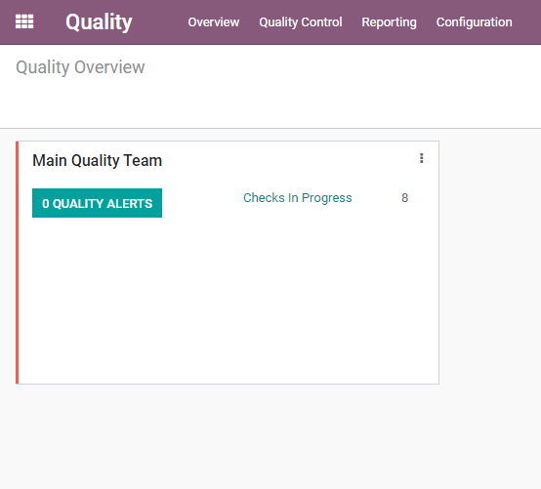
  - The first view of the quality module is a Quality Overview; it is a Kanban view of the Quality Teams.
  - 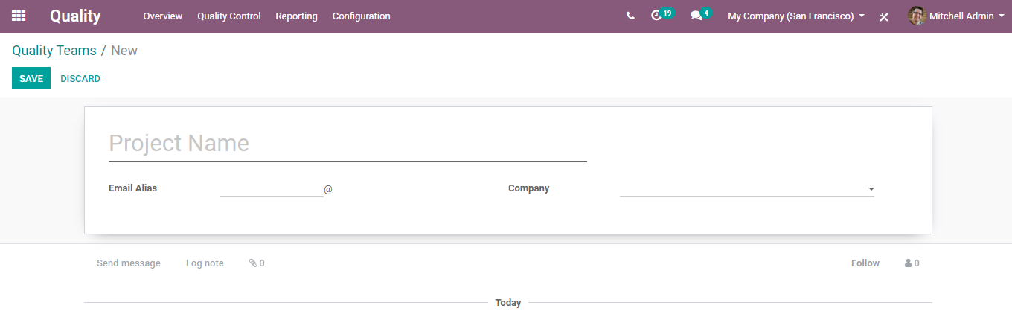
  - If a company has multiple teams for quality check, BUSINESSBOXERP allows creating multiple quality teams. From the Overview, the user can analyse the overall status and the work progress of each quality team.
  - If a company has multiple teams for quality check, BUSINESSBOXERP allows creating multiple quality teams.
  - To create a new Quality Team, go to
  - Quality -> Configuration -> Quality Teams -> Create
  - 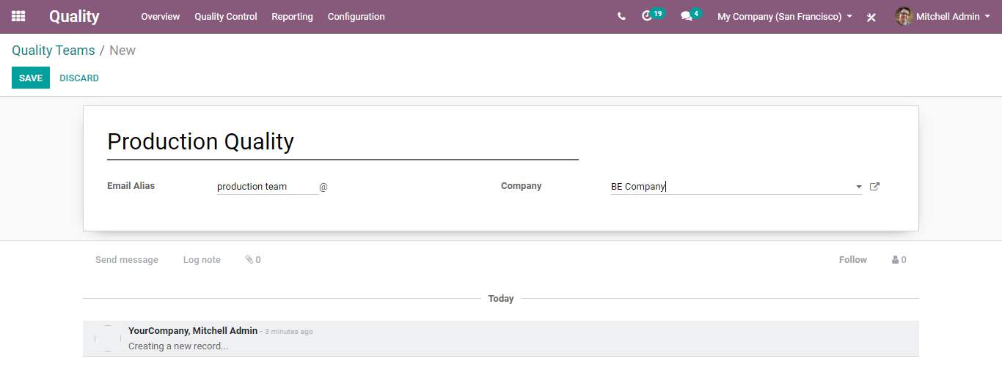
  - Here, you would find three fields –Name, Email Alias and Company. Upon entering them, click on the SAVE button to mark changes.
  - 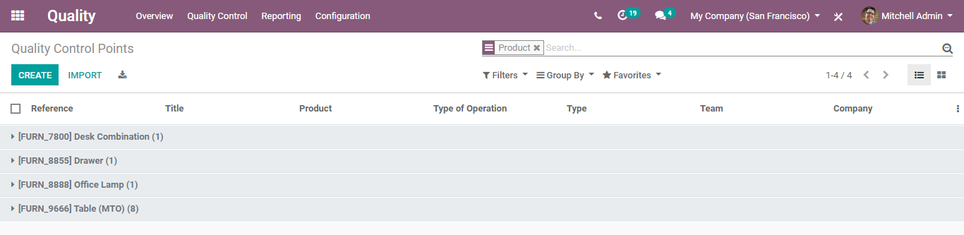
  - QUALITY CONTROL POINTS
  - Under quality control points, the user can define when the product must be checked, how it should be checked and what to be checked. To set control points, go to
  - Quality -> Quality Control -> Control Points
  - 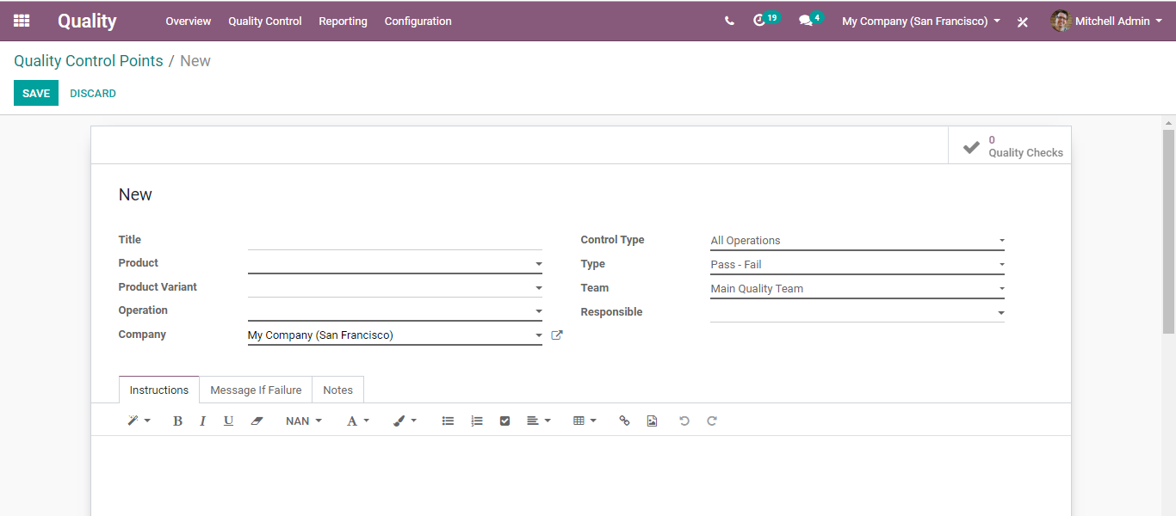
  - Upon clicking the CREATE button you can create a new CONTROL POINT.
  - 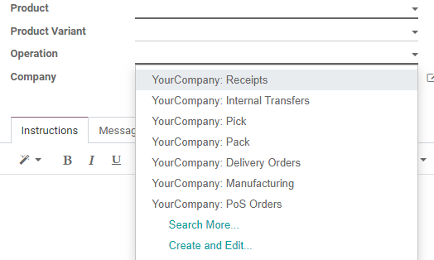
  - The above is the creative form of the control points. The form includes:
- Title: Title for the control point.
- Product: Choose the product for which quality must be checked.
- Product Variant: If the product has multiple variants, choose one variant.
- Operation: Operation denotes the time of quality check.
  - 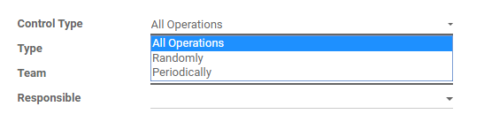
  - There are mainly 3 types of operations.
- Receipts: When a product is received to business (which means receives purchase order)
- Delivery Orders: At the time of delivering a product (which means delivery of a sales order)
- Manufacturing: Quality check at the time of manufacturing.
  - NOTE: If the user is involved with multi-companies, it is embedded with 3 different other options as displayed in the picture.
  - Control Type: This field defines the interval of the quality check. There are three options under this:
  - 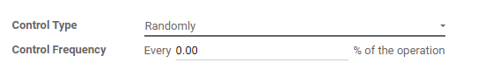
- All Operations: Quality check for every operation.
- Randomly: One can set to check quality randomly. When choosing randomly, there will be shown another field Control Frequency. Quality checks can be generated based on this Control Frequency.
  - 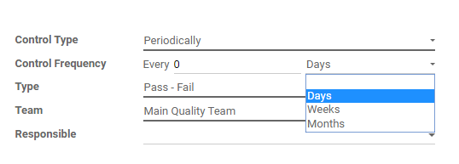
- Periodically: A quality check can be done periodically. Here we have 3 options to set an interval: Day, Week and Month.
  - 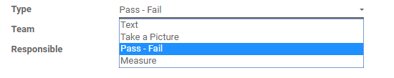
  - Type: Quality will be checked based on the selected type. There are four options:
  - 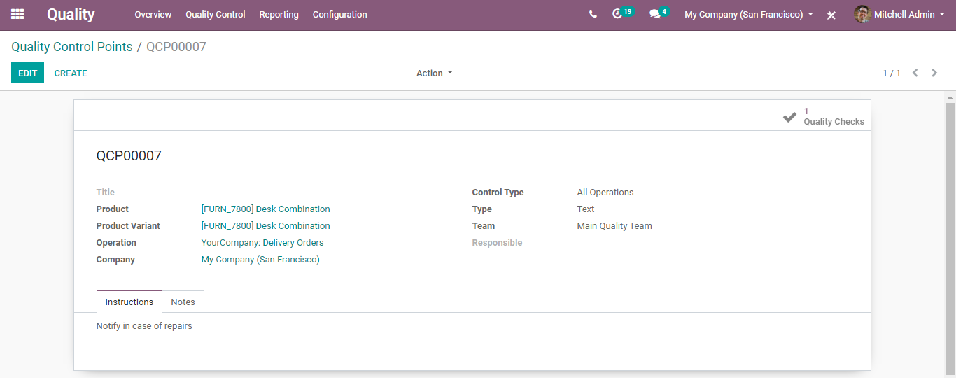
  - Team: Assign a quality check team.
  - Responsible: Select a user as the responsible person for the quality check.
  - Working:
  - Here configured a quality control for Desk Combination at the time of delivery. Just added some instructions to understand.
  - 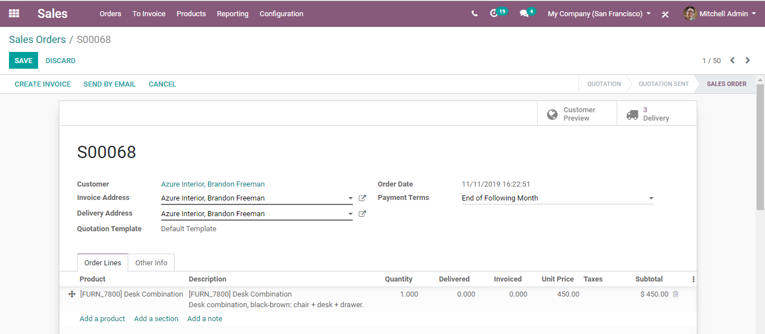
  - Create a sales order for the corresponding item.
  - 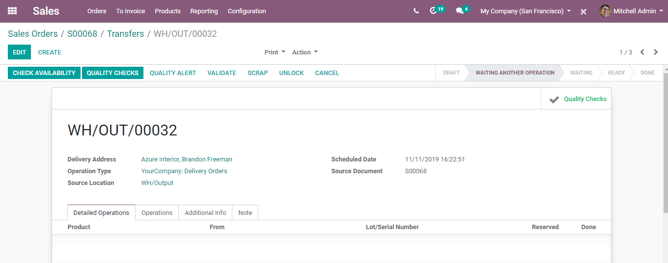
  - Click on the Delivery button. In the delivery stage, one can see Quality Checks Button as Active. Click Quality Checks.
  - 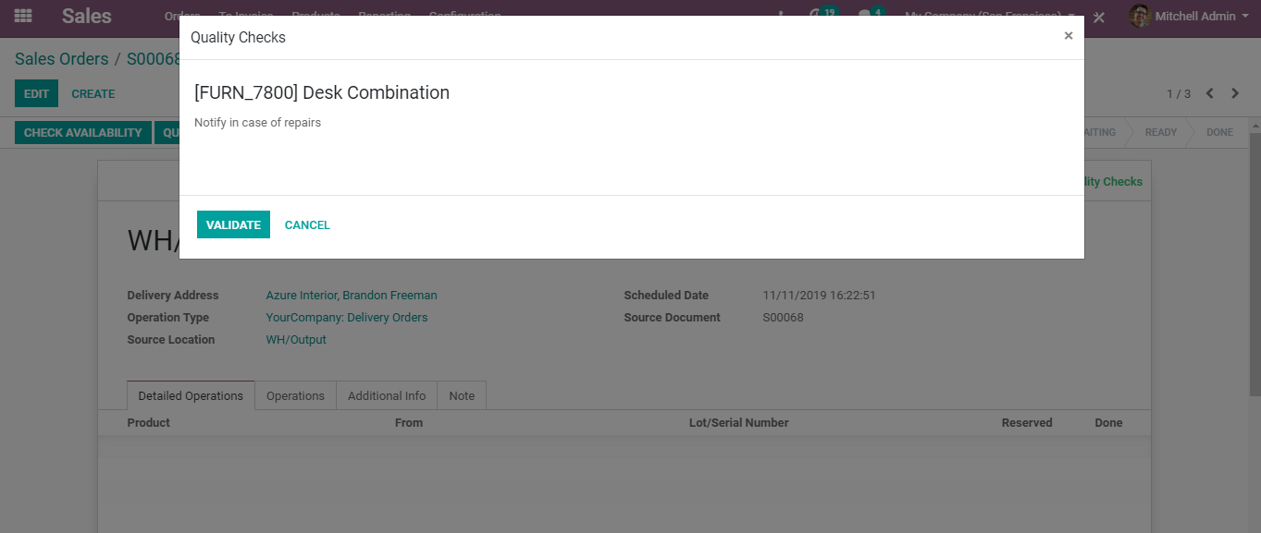
  - A window will pop up with the product name and instructions as mentioned earlier. Also, there comes the button Validate.
  - 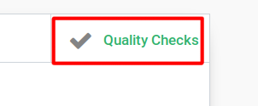
  - The status of this quality check will be in Quality Check Smart Button in the delivery order.
  - 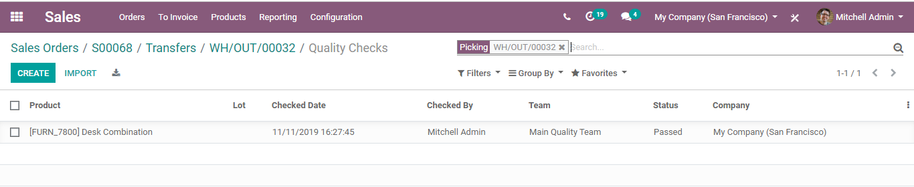
  - 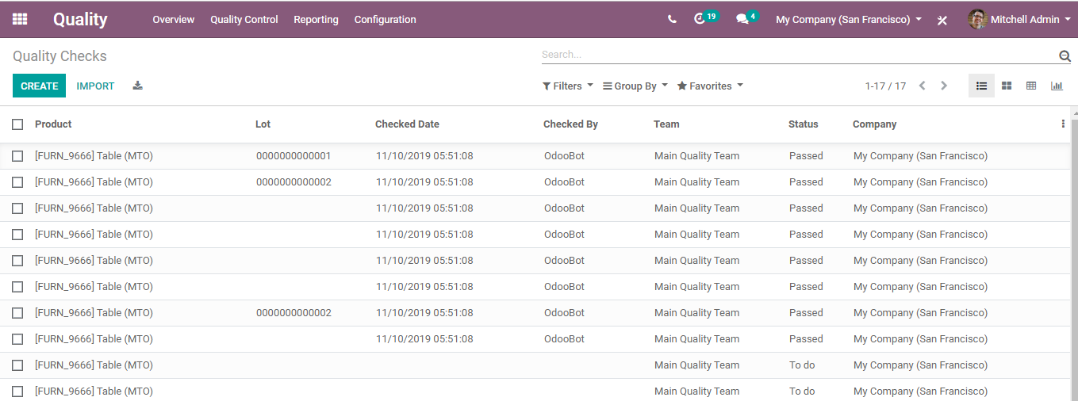
  - Quality -> Quality Controls -> Quality Checks
  - All Quality Checks will be shown here with the Status.
  - 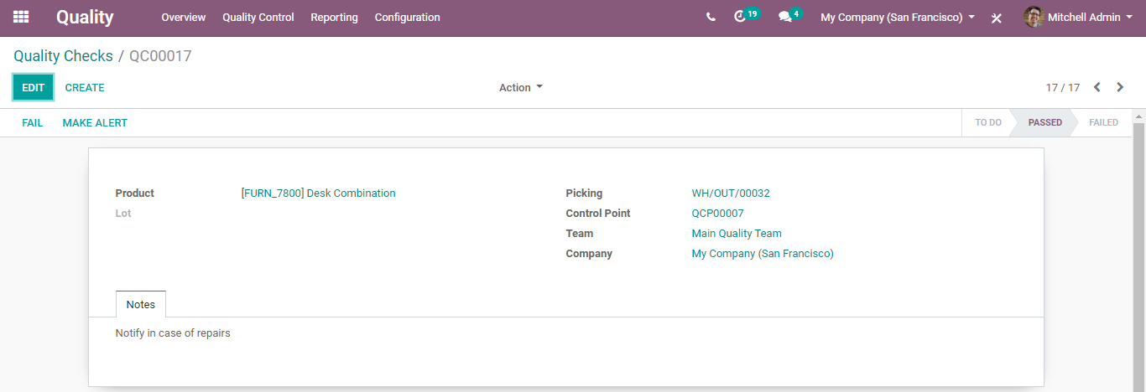
  - If a product happens to notice with damage or mistake, mark it as failed.
  - 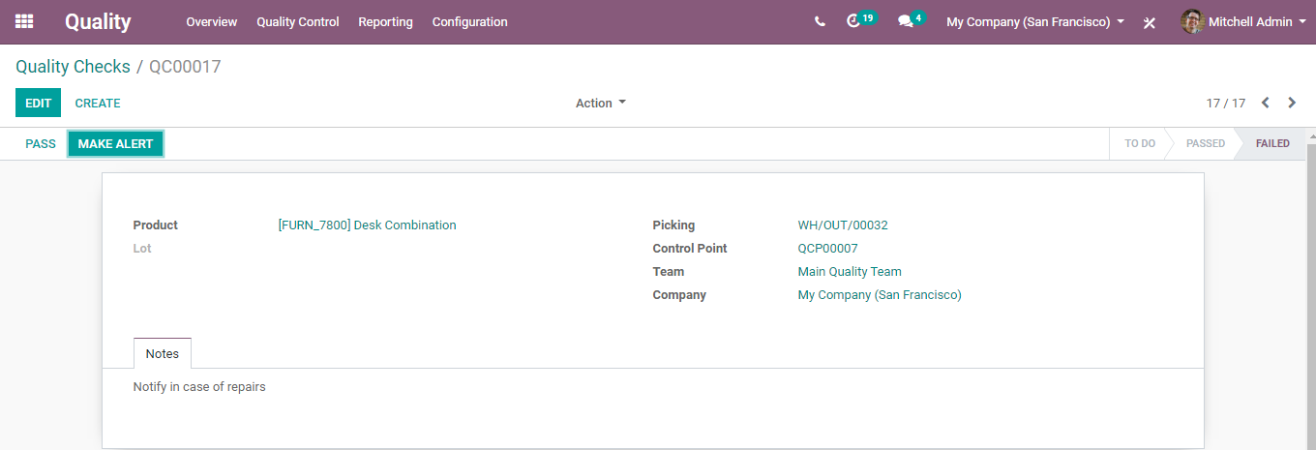
  - Upon the action, the Quality Alert button will be activated.
  - 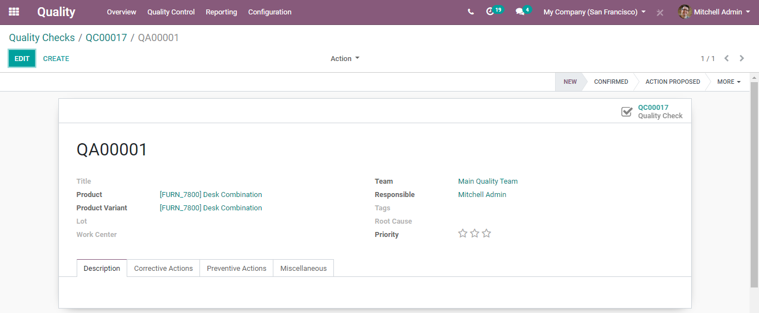
  - 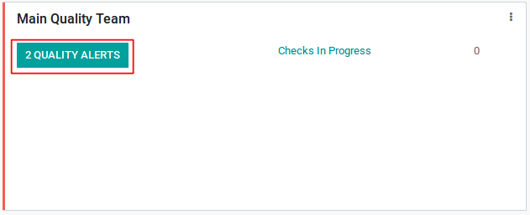
  - If a product has a Lot Number/Serial Number, set them in Lot. A user can add or create tags for understanding the quality issues.
- Root Cause: The reason for occurring a quality issue.
- Priority: Quality alerts will be shown based on priority. Alert of high priority will be shown first.
- Description: Mention any description of quality issues.
- Corrective Actions: Under Corrective Actions, set actions for correcting quality issues.
- Preventive Actions: Preventive Actions is to take precautions against the type of quality problem.
  - These 3 notes display on the Quality Alerts. The Quality Team can refer to these notes and take actions based on these descriptions.
  - Created Quality Alerts will be shown in the overview for each Quality Team.
  - 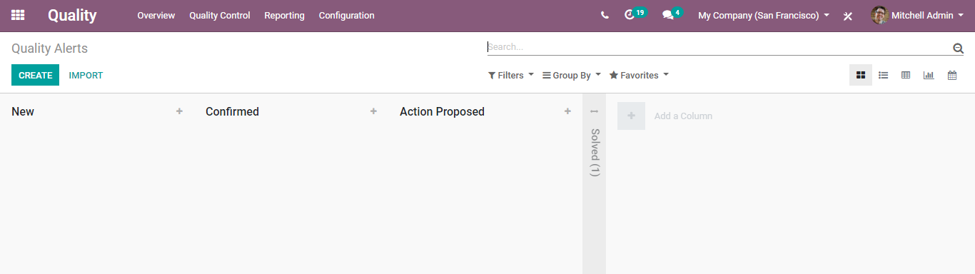
  - Quality Alerts will be shown in different stages based on the status of the alert.
  - 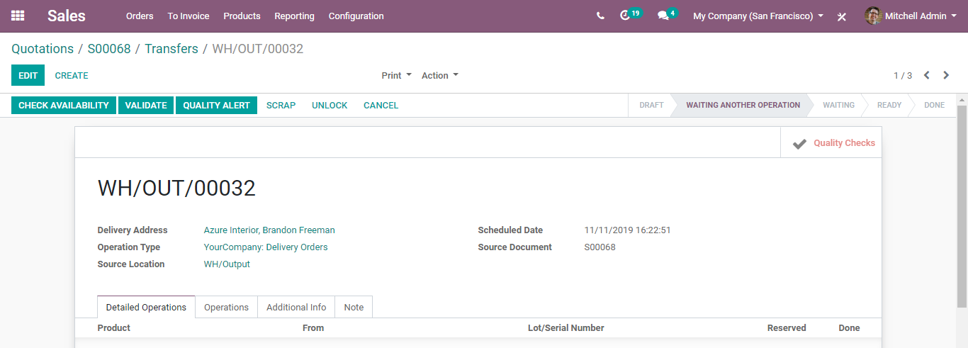
  - As we already mentioned, alerts will be listed based on priorities. The solved stage is folded. When a Quality Alert reaches a Solved state, a quality alert will be removed from the overview of the Quality Team.
  - Note: Quality Alert directly notifies the Quality Team. And in Sale Order, the Quality Check Smart Button transforms to red colour.
  - 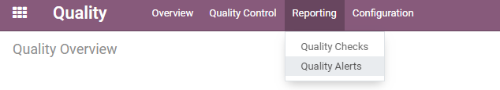
  - QUALITY REPORTING
  - Configuration:
  - Quality> Reporting
  - 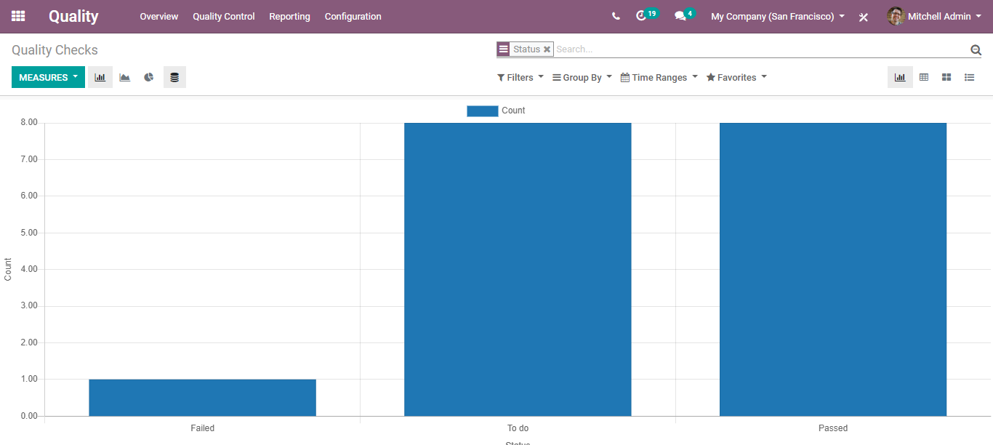
  - There are two types of Quality Reporting in BUSINESSBOXERP
- Quality Alerts
- Quality Checks

  - Quality Checks
  - 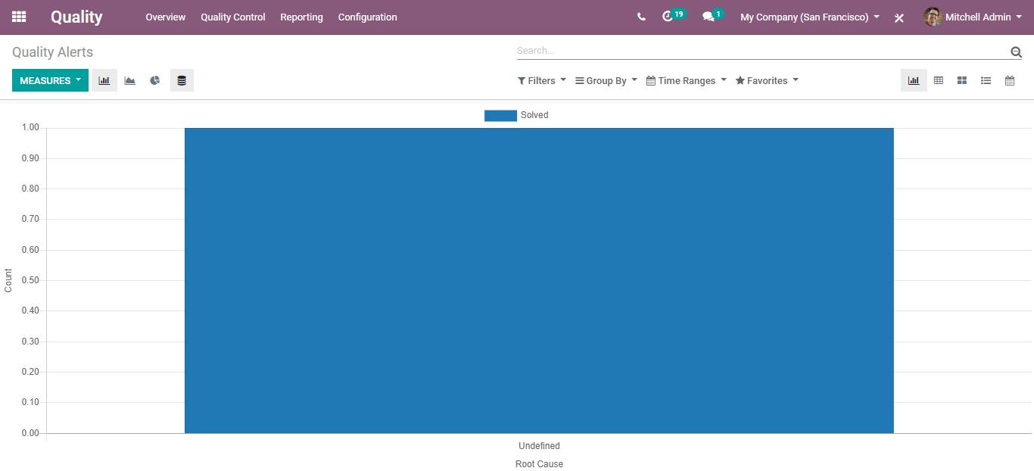
  - Quality Alerts
  - 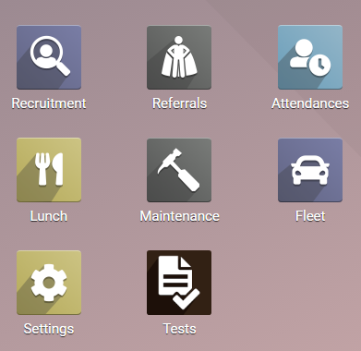

  - Maintenance Management
  - While manufacturing a product, it is the prime responsibility of the manufacturing department to assure product performance. Product quality should be assured in each stage of its production to bring in qualitative and high end- performing products.
  - To assure the same, BUSINESSBOXERP has brought in a maintenance module. BUSINESSBOXERP computes standard statistics to provide you with maintenance protocols like tracking equipment and maintenance requests. Utilizing BUSINESSBOXERP, product maintenance can be carried in two ways:
- Preventive
- Corrective
  - Preventive maintenance is a support that is routinely performed on equipment to decrease its probability of coming short. It is performed while the equipment is still working. It is carried before equipment notifies of any fault/failure. Preventive maintenance in other words can be called servicing of equipment, carried in regular intervals.
  - On the other hand, corrective maintenance is a support task performed to distinguish, segregate, and redress an issue so that the faulty equipment can be re-established to an operational condition.
  - The prime motto of conducting equipment maintenance is that it reduces downtime as well as make the manufacturing process more proficient. Via servicing the equipment over regular periods, the risk of equipment failure can be brought down to a great extent.
  - Firstly, install the Maintenance module:
  - 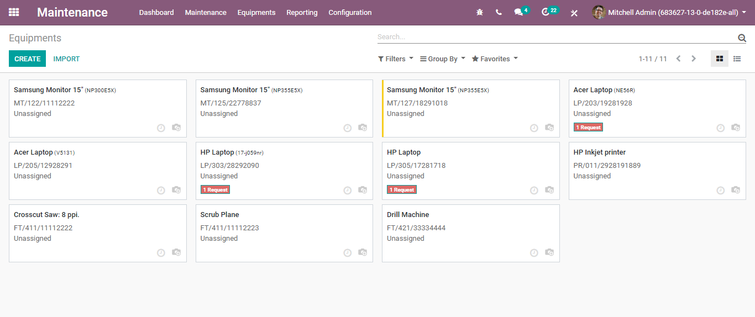
  - Under this, one can seamlessly create equipment.

  - CREATING EQUIPMENT
  - To create equipment,
  - Go to Equipment -> Machines and Tools -> Create.
  - 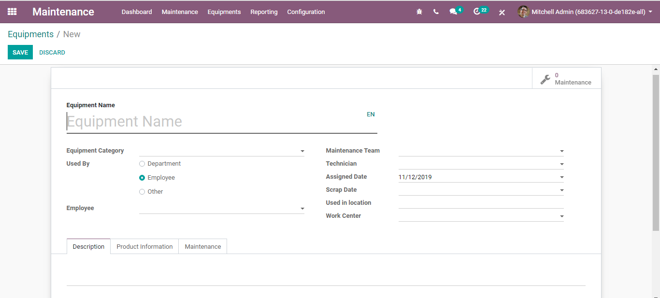
  - Upon clicking the CREATE button, you will be navigated to a new window like below:
  - 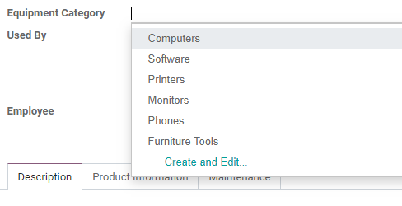
  - The creation form will have the following fields:
  - Equipment Name: Name of the equipment.
  - Equipment Category: Category of the equipment.
  - 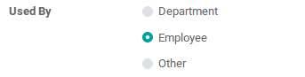
  - Employee: Employee who owns the equipment.
  - Used By:
  - 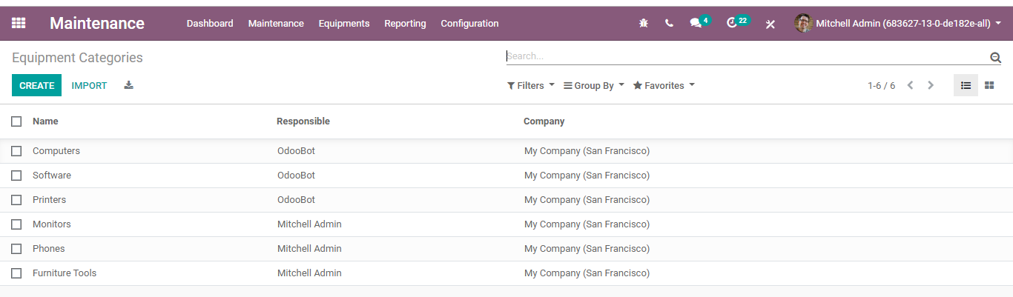
  - Department: Choose a department if this equipment is used by a specific department.
  - Employee: Choose an employee if this equipment is used by a specific employee.
  - Other: To choose an employee under a department. One can select both department and employee if chose the option other.
  - Maintenance team: One can create/choose the maintenance team.
  - EQUIPMENT CATEGORY
  - Configuration:
  - Maintenance > Configuration > Equipment Categories
  - 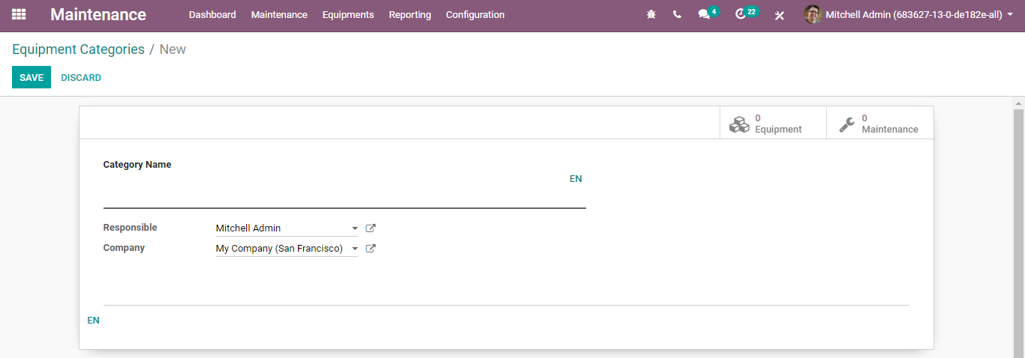
  - Upon clicking CREATE button, you can create a new equipment category.
  - 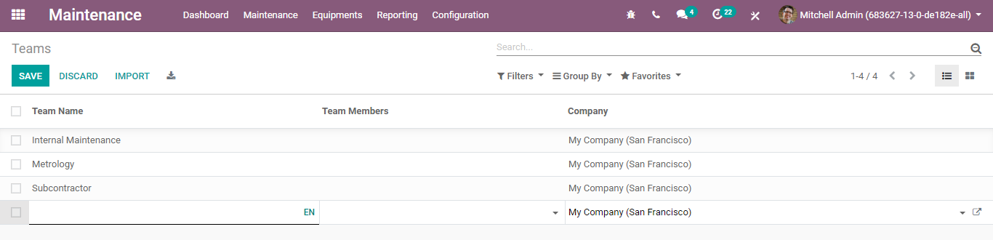
  - Under the create form, one can specify the equipment category name, responsible person, and company.

  - CREATING MAINTENANCE TEAM
  - Configuration:
  - Maintenance > Configuration > Maintenance Teams> Create.
  - 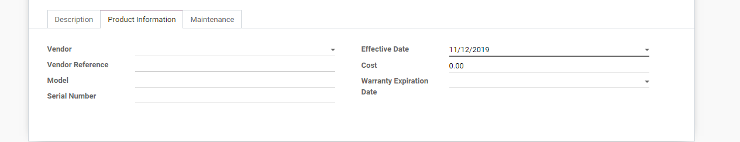
  - Here, one can add the team’s name, team members, and choose a company for creating a maintenance team.
  - Coming back to creating equipment,
- Technician: Technician who is undertaking the equipment.
- Assigned Date: One can add an assigned date if any. For instance, if the equipment is used by an employee, one can add the specific date on which the equipment was assigned to that employee.
- Scrap date: One can add scrap date based on its durability.
- Used in a location: Location where equipment is used.
- Work Center: One can add the work centre of the equipment if any.
  - Under the Product Information tab
  - One can add details about the equipment, for instance when it was bought.
  - 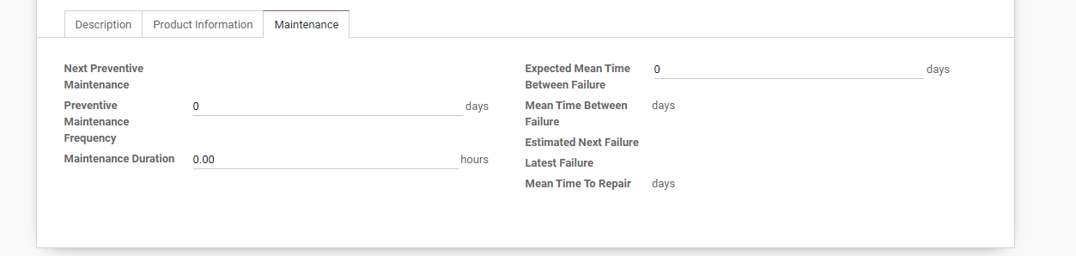
  - Here, one can add the vendor associated with the equipment, vendor reference, the equipment model, serial number, Effective date (the date at which the equipment became effective. This date will be used to compute the Mean Time Between Failure), equipment cost and warranty expiration date.
  - Under Maintenance tab
  - Details about the maintenance are displayed.
  - 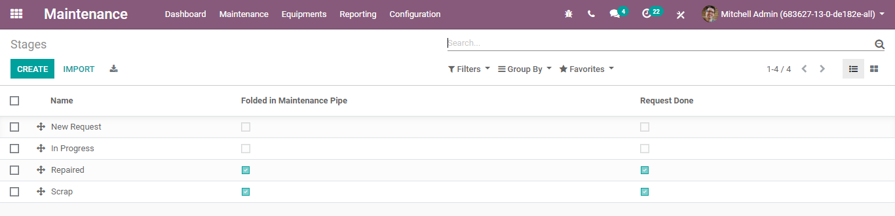
- Preventive Maintenance Frequency: One can set the frequency of preventive maintenance in several days.
- Next Preventive Maintenance: Once preventive maintenance is set, following preventive maintenance will get automatically set based on that. In the initial case, it will be calculated based on the effective date.
- Maintenance duration: Duration of maintenance in hours.
- Expected Mean Time Between Failure: One can set the expected mean time between failures in days.
- Mean Time Between Failures (MTBF): It is computed based on the done corrective maintenances.
- Estimated Next Failure: Computed as Latest Failure Date+ MTBF.
- Latest failure: Last failure date will be updated automatically.
- Mean Time to Repair (MTTR): Mean time between maintenance and repair in days. If the maintenance started on 2nd May and equipment got repaired on 3rd may. In that case, the meantime to repair will be 1 day.

  - CREATING MAINTENANCE STAGES
  - Configuration:
  - Maintenance > Configuration > Maintenance stages
  - 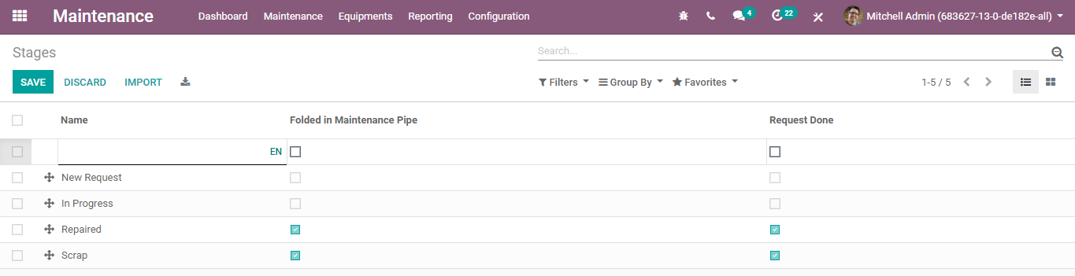
  - Upon clicking the CREATE button, you can create a new maintenance stage.
  - 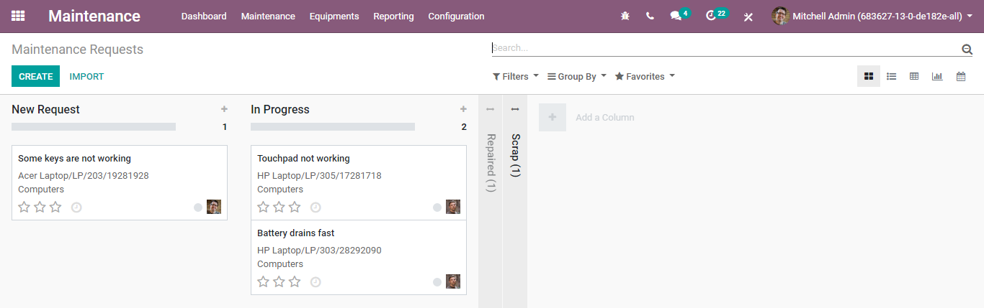
  - Here you can fill in the name of the stage and specify if it is folded stage or not, request done or not.
  - CREATING MAINTENANCE REQUEST
  - Configuration:
  - Go to Maintenance > Maintenance requests> Create.
  - 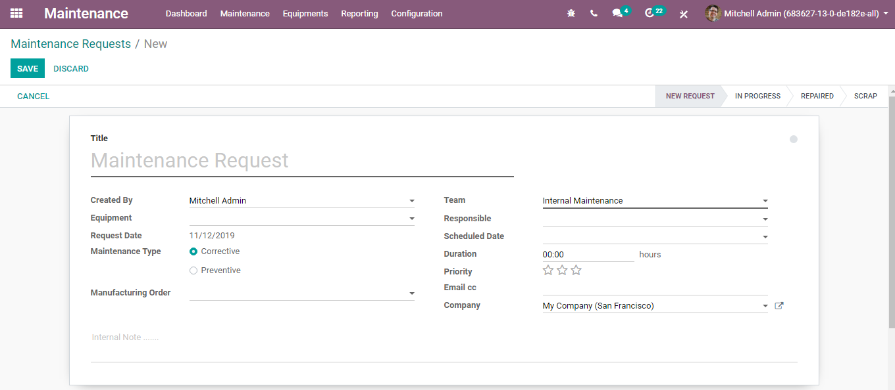
  - Here, you can see the ongoing maintenance requests with their status.
  - Upon clicking CREATE button, you can create new requests.
  - 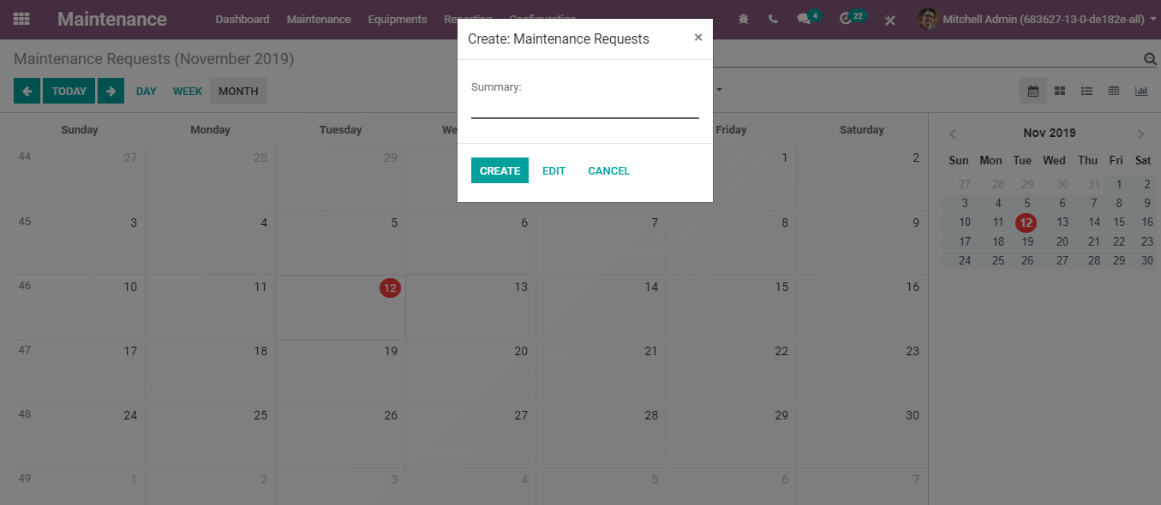
  - The create form has the following fields.
- Title: One can give a name for the maintenance request.
- Created by: Employee who create maintenance request.
- Company: Company that requests maintenance.
- Equipment: Choose the equipment for maintenance.
- Request date: Date requested for the maintenance to happen.
- Close Date: Date on which maintenance is completed.
- Maintenance type: Maintenance is of 2 types, Corrective and Preventive.
- Manufacturing order: When equipment failure happens in between manufacturing orders, one can choose the manufacturing order here.
- Teams: Choose a maintenance team for the maintenance.
- Responsible: Responsible person for the maintenance request.
- Scheduled date: Date on which the maintenance team plans the maintenance. It should not differ much from the requested date.
- Duration: Duration of the maintenance.
- Priority: Priority can be set to maintenance requests.
  - Note: Maintenance requests can be created/viewed from the calendar. For that, go to Maintenance>Maintenance Calendar.
  - Here, one can choose the date and create a maintenance request. For that click on a date,>> edit.
  - 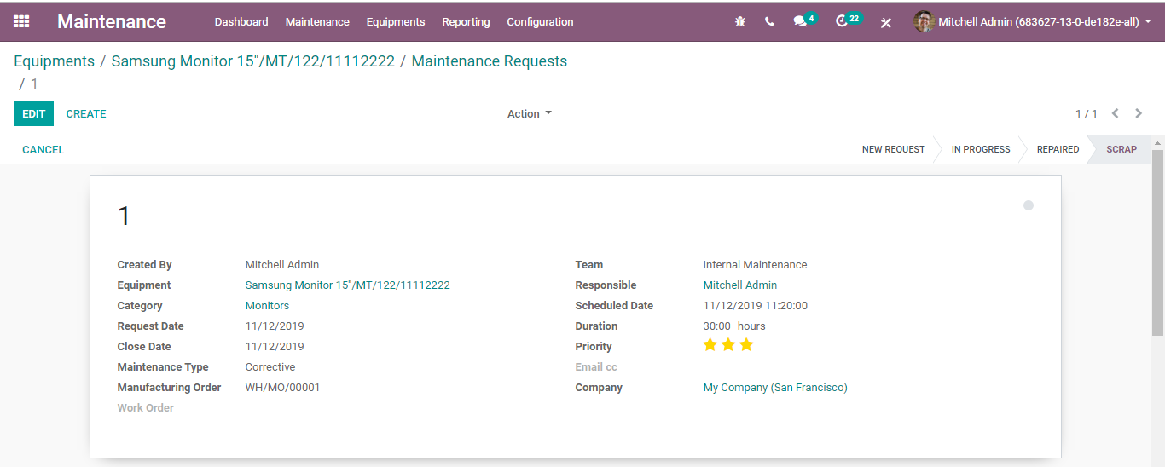
  - Upon clicking the EDIT button, you will be navigated to a new maintenance request creation form.
  - CORRECTIVE MAINTENANCE REQUEST
  - Once the maintenance is in progress, the state gets changed to IN PROGRESS. Once the equipment gets repaired, the state automatically gets changed to REPAIRED. If the equipment is scraped, the state gets changed to SCRAP.
  - 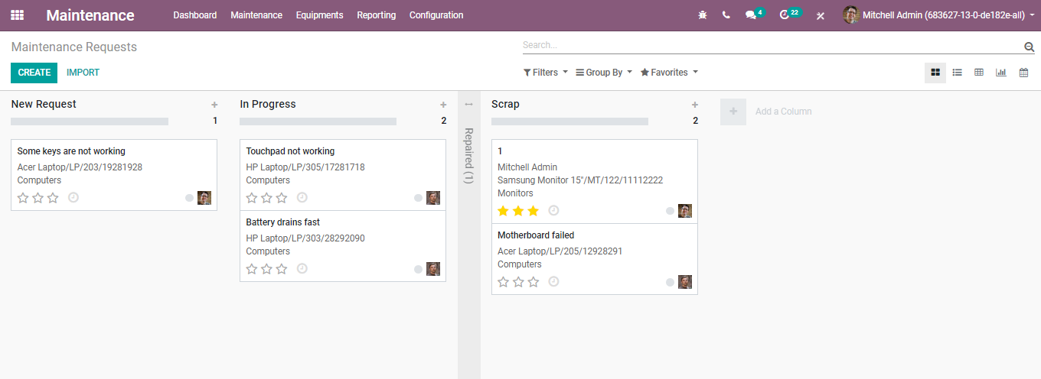
  - 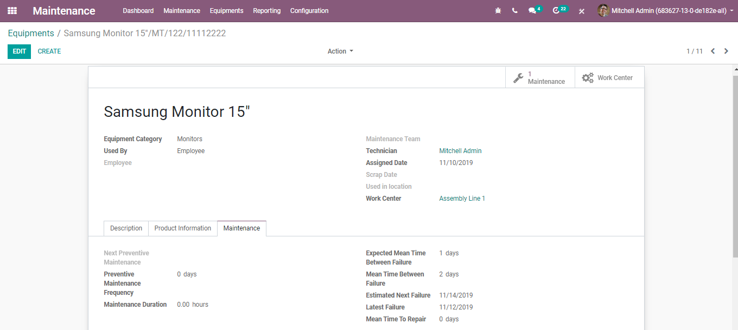
  - Once the state is repaired or scraped, the close date will be automatically added. Also Expected Next Failure date over equipment correspondingly changes.
  - To view, go to Maintenance >Equipment.
  - 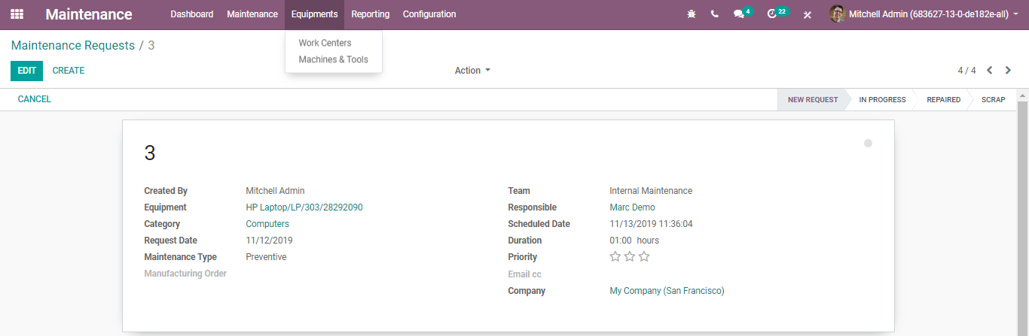
  - PREVENTIVE MAINTENANCE REQUEST
  - When preventive maintenance request is saved. Corresponding to that, the next preventive date will be automatically set as the maintenance requested date in the equipment.
  - Create a maintenance request with type Preventive.
  - Here the maintenance request date is 12/11/19.
  - 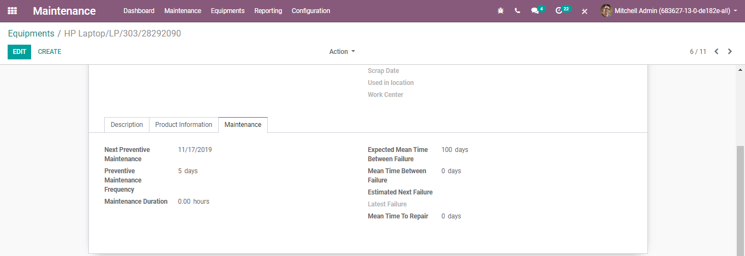
  - When preventive maintenance gets resolved, the next preventive date will be automatically calculated based on the preventive maintenance frequency set in the equipment.
  - Here you can see in the below image, the next preventive maintenance after 5 days (as the preventive frequency was 5 days duration).
  - 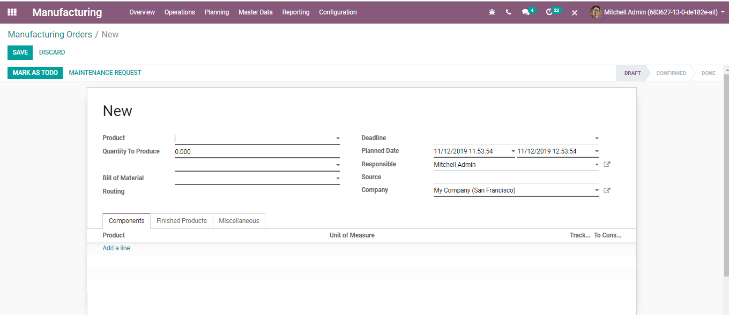
  - One can also create maintenance requests from manufacturing orders and work orders. For that Go to > Manufacturing Module
  - Under the manufacturing order form, you can see the MAINTENANCE REQUEST button.
  - 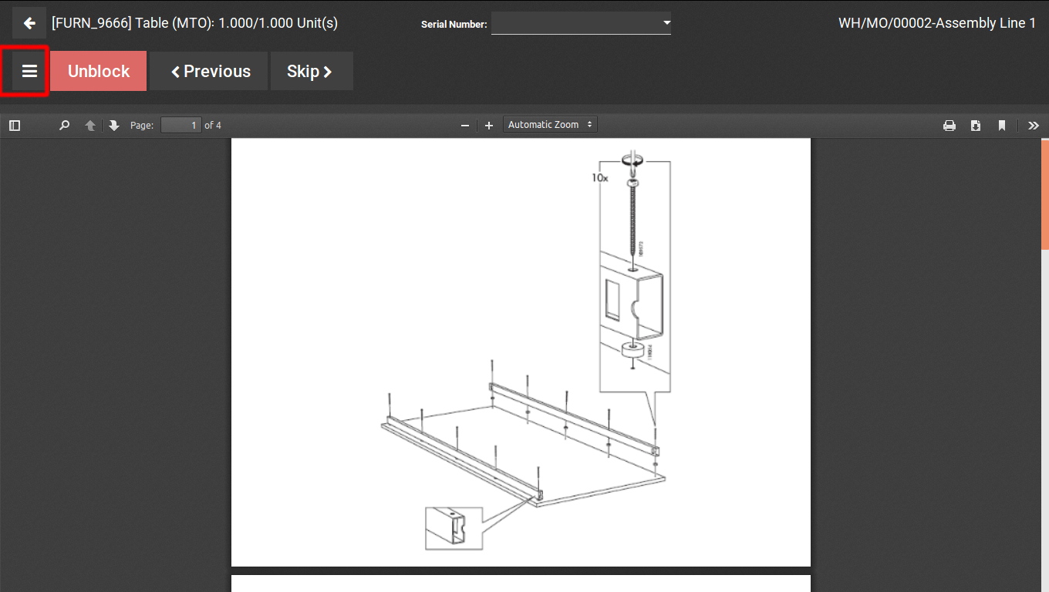
  - If the equipment fails while the process is on the run, then also the maintenance request can be created from the work orders. For that, click on the menu as shown below.
  - Upon clicking the menu, one can see an option maintenance request as shown in the below image.
  - 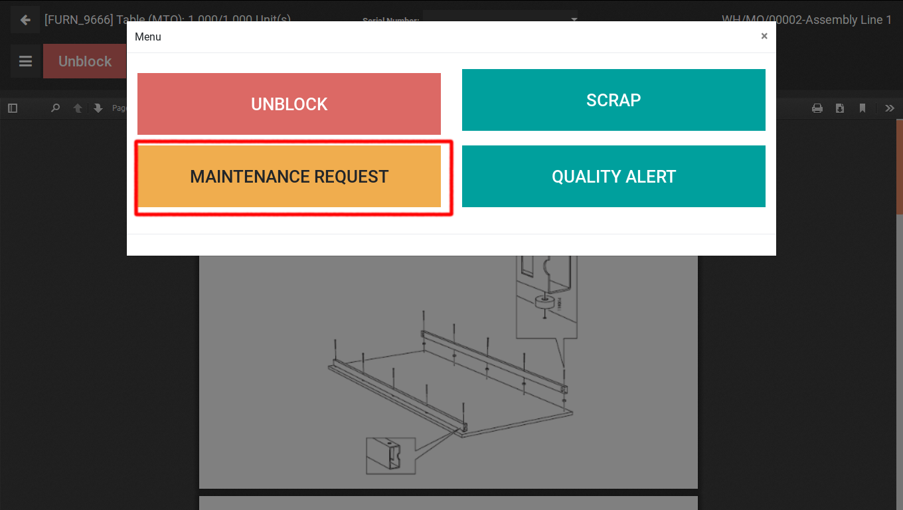
  - 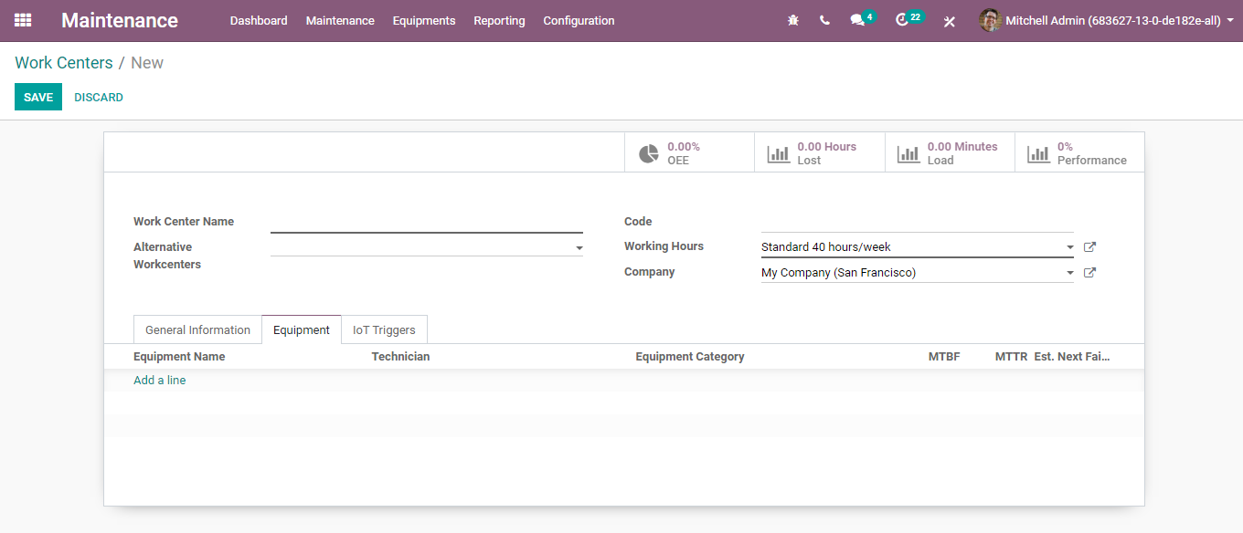
  - This option will allow you to create a maintenance request.
  - WORK CENTERS
  - Under the maintenance module, one can set work centres to carry the maintenance of equipment created for the certain manufacturing process.
  - Configuration:
  - Maintenance> Equipment > Work Centres> Create
  - 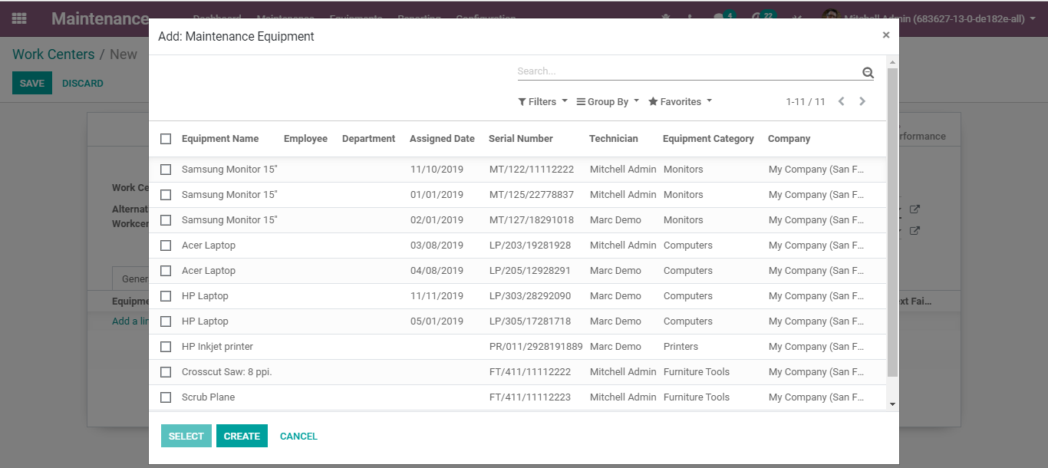
  - Here, under the Equipment Tab, of the work centre, one can add the equipment,
  - 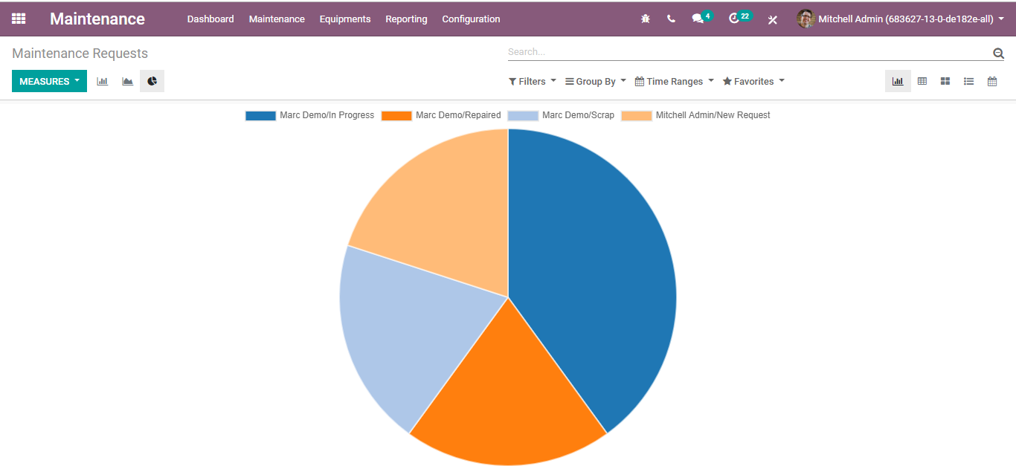
  - The technician responsible for the maintenance, the category belongs to, MTBF, AND Est. Next Failure.

  - REPORTING
  - The user can avail of the Maintenance Requests report via going to
  - Maintenance> Reporting> Maintenance Requests
  - 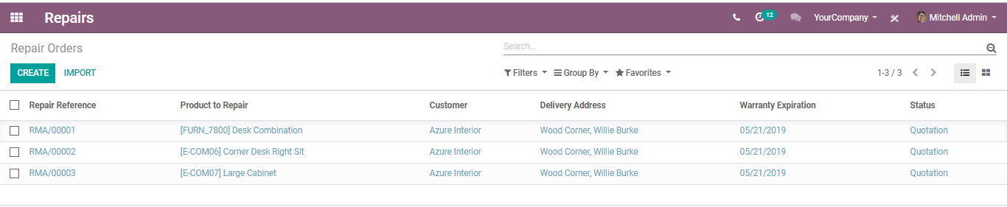
  - One can get the filter, group by, and see maintenance request reports in Bar Chart, Line Chart and Pie Chart.

  - Repair Management
  - The BUSINESSBOXERP Repair application enables the end-user to fix products you have made or manufactured in case that they present a defect/imperfection.
  - CREATING A REPAIR ORDER
  - As soon as you enter the module you will get listed with existing repair orders.
  - 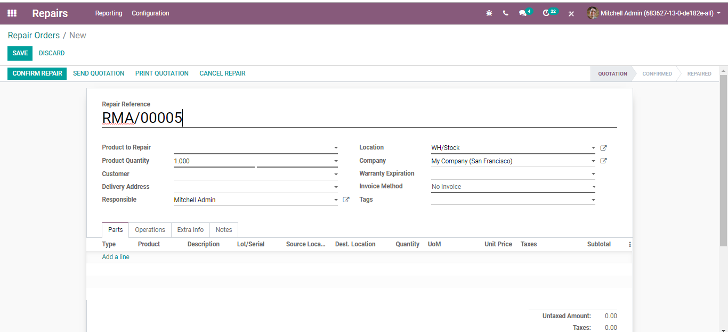
  - When a client sends you a product for a fix, create another Repair Order. For creating a new repair order click CREATE.
  - A create form will appear like below:
  - 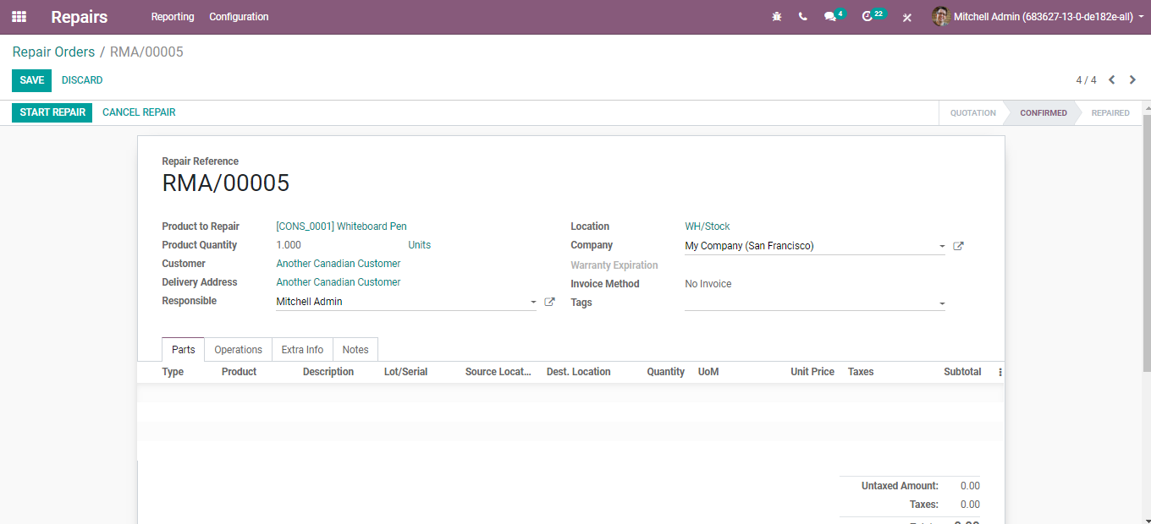
  - Fill it in with all the data you may need, for example, product to repair, product quantity, Lot/Serial, the customer, Invoicing method whether it must be invoiced after or before the repair, the parts you may require, and so forth.
  - The end-user can send the repair quotation to its customer. In the event, the repair quotation gets approved, one can confirm the repair via clicking the CONFIRM REPAIR button.
  - Eventually, the end-user shall be able to start and later end the repair upon its completion.
  - Upon clicking the CANCEL REPAIR button, he can cancel the repair request.

