**Purchase Management**

Purchase is an act of buying products, services, raw materials, and extra parts from the providers for a business organization. Purchase management is one of the standouts amongst the most urgent segment in a business. The procedure towards a purchase in an organization thus ought to be given the most extreme consideration. If there arises an issue in the purchasing department, overall, the same issues will emerge in the production section, sales department, eventually decreasing the performance execution of the business association. Consequently, saying, successful purchase management is an inevitable segment of any association.

BUSINESSBOXERP purchase management can improve your purchase work process dependent upon stock levels/dimensions, sales orders, and forecasted producing orders. Much the same as sales, it is simple to oversee the purchase, utilizing BUSINESSBOXERP. One can consistently produce quotations, convert them later to a sales order and create bills in all respects effectively. Sales and Purchase vouchers, Purchase and MRP management, Purchase requisitions are some other supportive applications that can additionally upgrade the purchase management functionalities.

Here is the standard workstream in BUSINESSBOXERP:

* **Call for Tender** to demand offers from various merchants to get the most fascinating cost(optional).
* You start with a Request for Quotation (RFQ) to convey to your vendor(s).
* Once the seller has acknowledged the RFQ, confirm the RFQ into a Purchase Order (PO).
* Confirming the Purchase Order creates an Incoming Shipment if you obtained any Stockable items.
* Upon accepting a Vendor Bill from your Vendor, approve the bill with items got in the past in advance to guarantee precision.

**PRODUCT MANAGEMENT**

To purchase any product, one must initially make a product in the system. Although it is an action done under inventory, the BUSINESSBOXERP Purchase module gives a fast connection under the **Purchase > Products** tab to perform product management capacities like Add Product, Update Stock and so forth.

**CREATING PRODUCTS**

Creating products in BUSINESSBOXERP is much essential for speedy and proficient buying. All you need to do is -go to the Products submenu under Purchase and click CREATE.

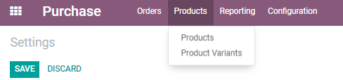

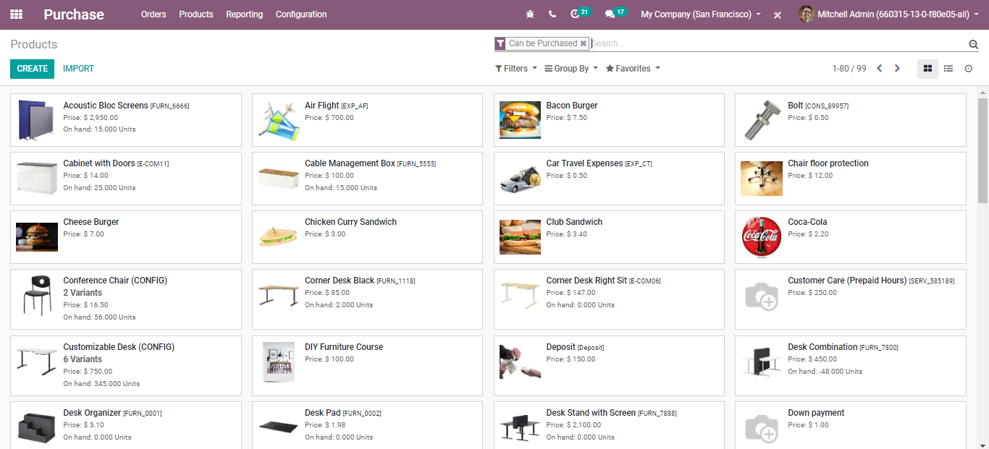

As soon as you click on the **CREATE** button, you will be navigated to a new window with product info. There you can click on the **EDIT** button and make all the necessary changes to the product and its associated attributes.

The creation form will look like the below image:

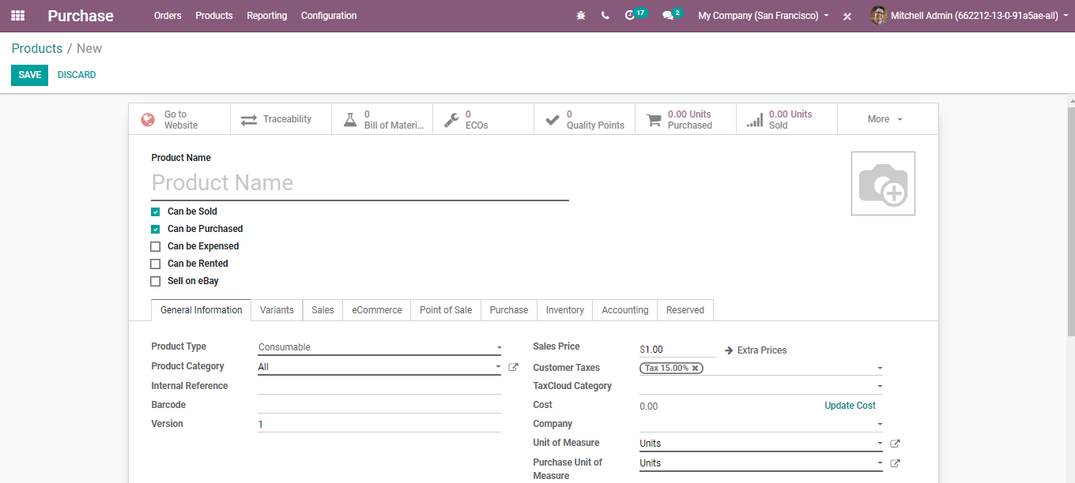

You have the following fields under the product form-

**Product name:**It is the name that will be displayed on all other screens that refer to this specific product.

**Can be Sold:** To remove a product from showing up on the ‘sales product’ list, uncheck the Can be Sold button. This is used while creating a raw material or a product for internal consumption.

**Can be Expensed:** Specify whether the product can be selected from an expense.

**Can be Rented:** If ticked the option, you allow renting of this product.

**Under the General Information tab**

**Product Type:**Product Type is the first option on the Information tab. There are three available product types:

**Consumables:** A product for which the user does not want to manage the inventory (no quantity on hand or forecasted) but that can be received from the supplier or delivered to the customer. BUSINESSBOXERP assumes that the product always has enough stock

**Stockable:** The product which is managed with Inventory. This product is used in stock management and its replenishment is automated by the rules defined in the system. In a Stockable product, you can easily maintain your minimum stock level by defining the reordering rule for stock in your system, so that your stock will not reach out of stock. If you do not set the Reordering rule, BUSINESSBOXERP ERP will show up warning messages in the quotation if there is not enough balance in the stock. BUSINESSBOXERP ERP will prevent processing delivery orders that do not have balances in the stock, and it can be processed only by the force availability button in the delivery order.

**Product Category:**The user can organize the products under a specific category.

**Internal Reference:** BUSINESSBOXERP utilizes the Product Name field and the description when displaying product information. Commonly, a company may have a coding system for its products. The Internal Reference field is useful to enter an alternative product code or number for the product in that case.

**Barcode:** Especially, when the number of products is more, the probability of human error also increases. Now smartly and effortlessly add/update product quantity by scanning product barcodes while receiving or delivering products in your BUSINESSBOXERP.

**Version:**Defines the current version of the product.

**Sales Price:** The base sale price of the product, the product may be different if there are variants available.

C**onsumer Tax:** BUSINESSBOXERP's tax engine is very flexible and supports many different types of taxes: value-added taxes (VAT), eco-taxes, federal taxes, retention, withholding taxes, etc. For most countries, the chart of accounts you set up is automatically pre-configured with the main taxes of the country.

**Tax Cloud Category:**The Tax Cloud category in BUSINESSBOXERP allows you to correctly calculate the sales tax for every address in the United States and keeps track of which products are exempt from sales tax and in which states each exemption applies. Tax Cloud calculates sales tax in real-time for every state, city, and special authority in the United States.

**Cost:** Cost used for stock valuation in the standard price and as a first price to set in average/FIFO.

**Unit of Measure:** Default unit of measure used for all stock operations.

¬ Purchase Unit of Measure: Default unit of measure used for purchase orders. It must be in the same category as the default unit of measure.

**Under the Product Variants tab**

Under the Product variants tab, one can deal with the products having distinctive varieties, like measure, shading, and so on. It permits dealing with the product at the template level (for all varieties) and the variant level (specific attributes).

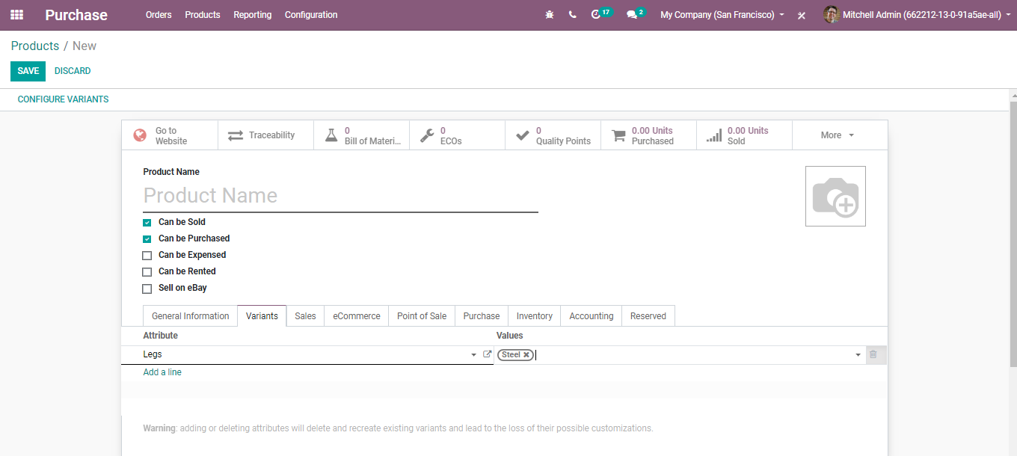

If you click on the attributes button, you will get a drop-down rundown with attributes. One can likewise include new characteristics or attributes via clicking the choice **CREATE AND EDIT**.

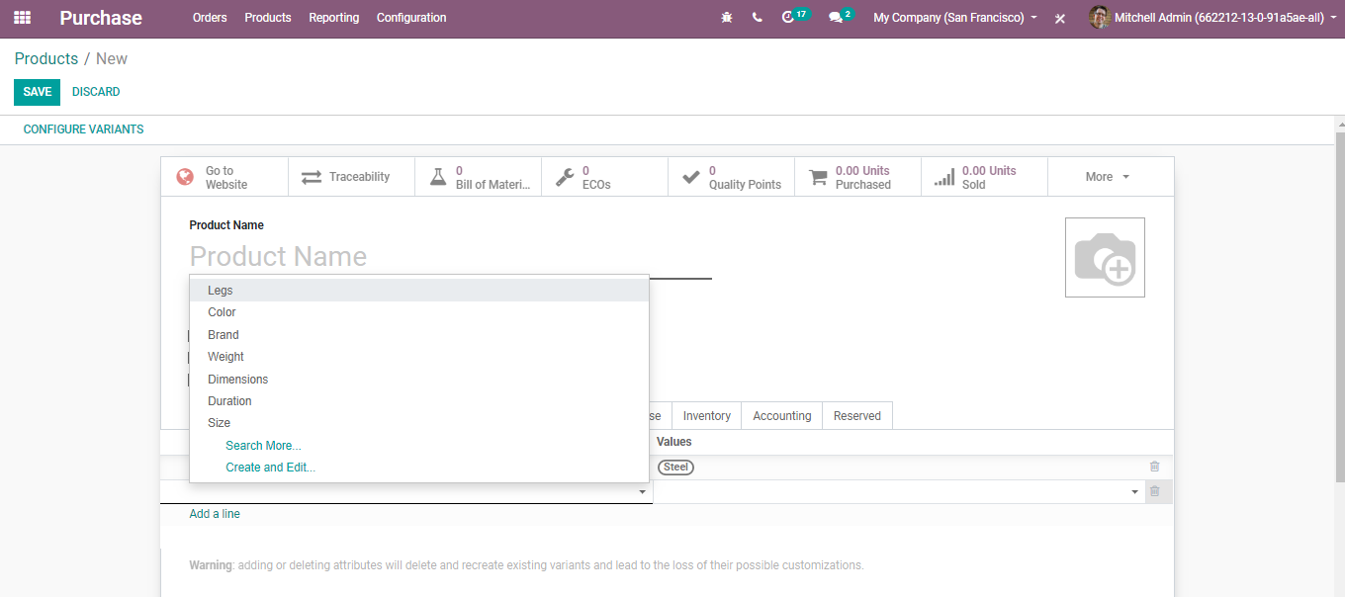

One can without much of a stretch set the attribute type, attribute values, in BUSINESSBOXERP.

**Under the Sales Information tab**

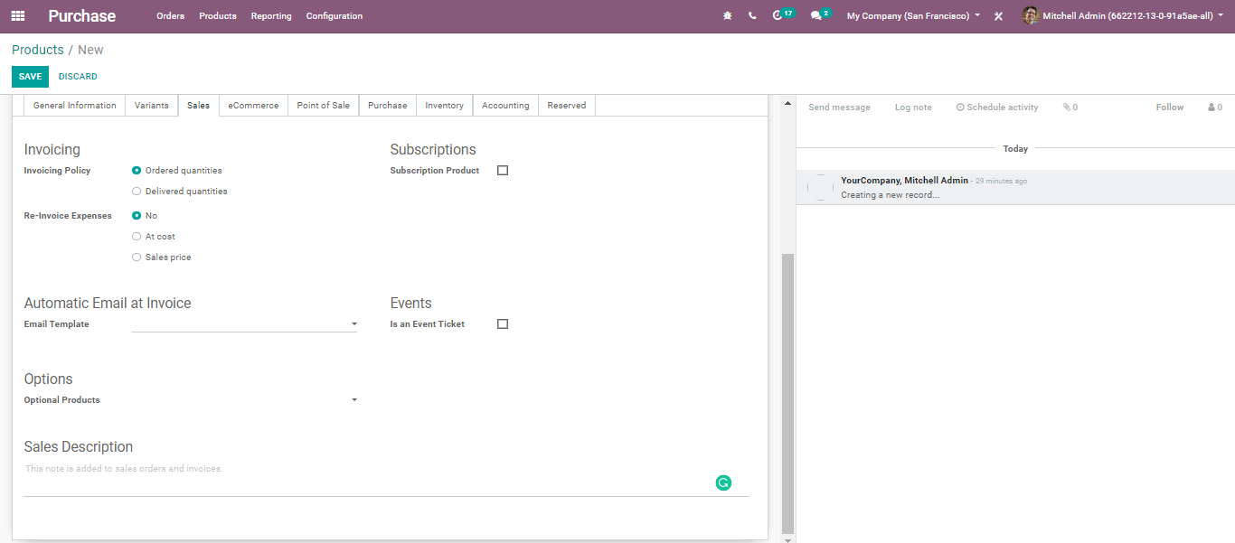

**Invoicing Policy:**

Ordered Quantity: Invoice quantities ordered by the customer.

Delivered Quantities: Invoice quantities delivered to the customer.

**Re-invoice Expenses:** Expenses and vendor bills can be re-invoiced to a customer. With this option, a validated expense can be re-invoice to a customer at its cost or sales price.

**Subscription Product:** If set, confirming a sales order with this product will create a subscription.

**Email Template:** Send a product-specific email once the invoice is validated.

**Optional Products:** Optional products are suggested whenever the customer hits the” Add to cart.”

**Sales Description:** A description of the product that you want to communicate to your customers. This description will be copied to every sale order, delivery order, customer invoice/credit note.

**Under E-commerce Tab**

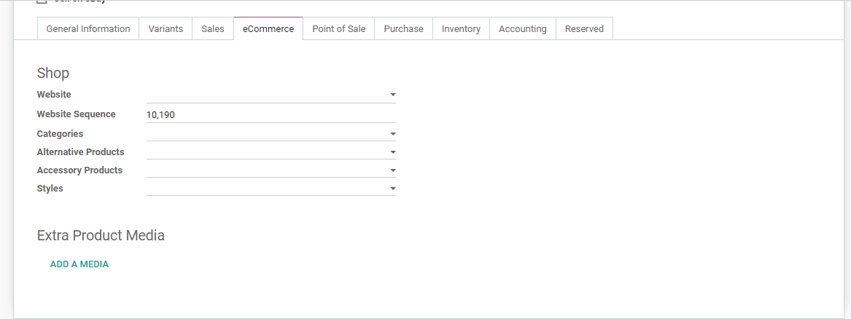

**Website:**Option to restrict publishing to this website.

**Categories:**The product will be available in each mentioned E-commerce category. Go **shopping>Customize>**and Enable **‘E-commerce categories’** to view all e-commerce categories.

**Alternative Products:** Alternatives to your customer (upselling strategy). Those products show up on the product page.

**Accessory Products:**Accessories show up when the customer reviews the cart before payment (cross-selling strategy).

**Styles:** Determines how shall be displayed on the website. For instance, full image/ sales ribbon and so forth.

**Extra Product Media:**

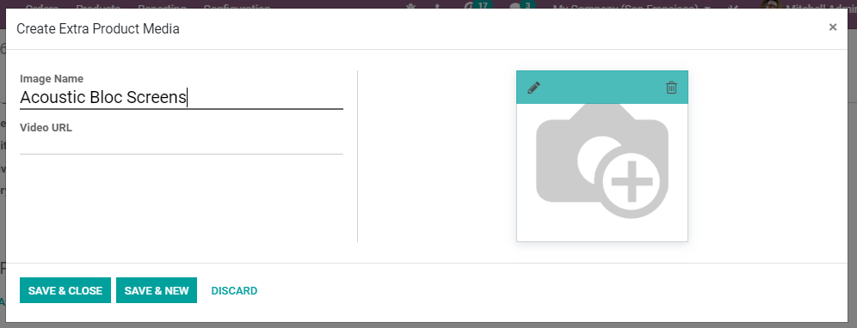

**Under Point-of-Sale Tab**

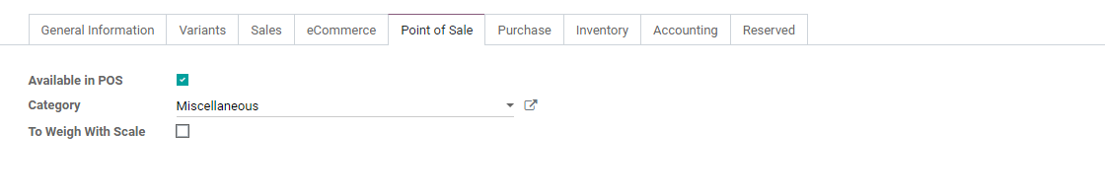

**Available in POS:**Check this if you want this product to appear in the POS.

**Category:**Category used in the POS.

**To Weigh with Scale:** Check if the product should be weighed using the hardware scale integration.

**Under Purchase Tab**

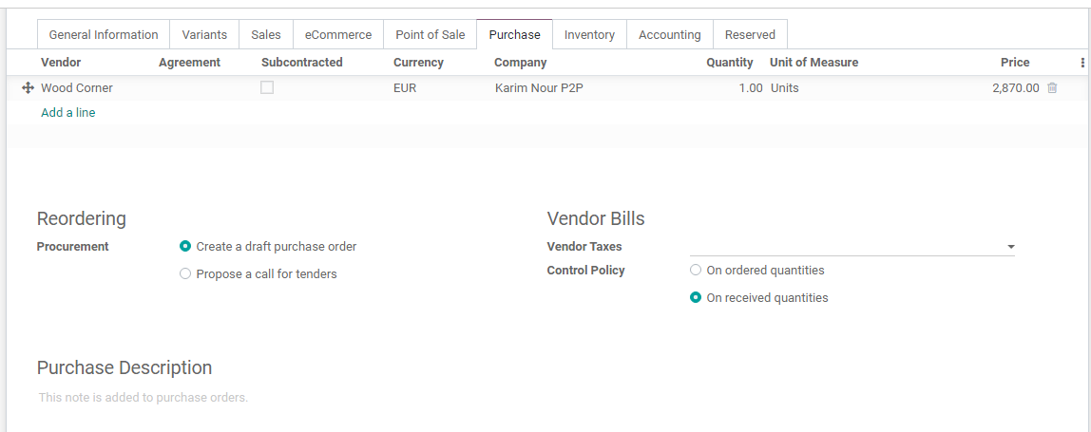

**Reordering:**

Procurement: **Create a draft purchase order -** Based on your product configuration, the system will create a draft purchase order. **Propose a call for tender** -If the purchase requisition module is installed and this option is selected, the system will create a draft call for tender.

**Vendor Bills:** Vendor Taxes- Default taxes used when buying the product.

**Control Policy: On ordered Quantities** -Control bills based on ordered quantities. **On received Quantities** - Control bills based on received quantities.

**Purchase Descriptions:** This note is added to purchase orders.

**Under Inventory Tab**

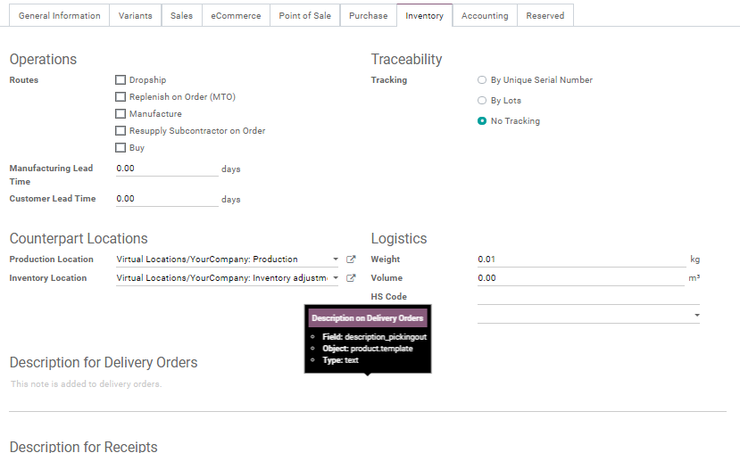

**Route:**Depending on the module installed, this will allow you to define the route of the product. whether it will be bought, manufactured, replenished on order etc.

**Manufacturing Lead Time:** Average lead time in days to manufacture this product. In the case of multi-level BOM, the manufacturing lead times of the component will be added.

**Customer Lead Time:** Delivery lead time in days. It is the number of days, promised to the customer, between the confirmation of the sale order and the delivery.

**Tracking:** To ensure the traceability of a storable product in your warehouse. It can be either via unique serial numbers or lots.

**Product Location:** The stock location will be used instead of the default one, as the source location for stock moves generated by manufacturing orders.

**Inventory Location:** The stock location will be used instead of the default one, as the source location for stock moves generated when you do an inventory.

**Logistics:** Here, you can give away the Weight, Volume, HS Code: Standardized code for international shipping and goods declaration. Now only used for FedEx Shipping Provider. Also, you can assign the **Responsible:** The user will be responsible for the next activities related to logistics operations for this product.

**Description for Delivery Orders:** This note is added to Delivery Orders.

**Description for Receipts:** This note is added to receipt orders.

**Under Accounting Tab**

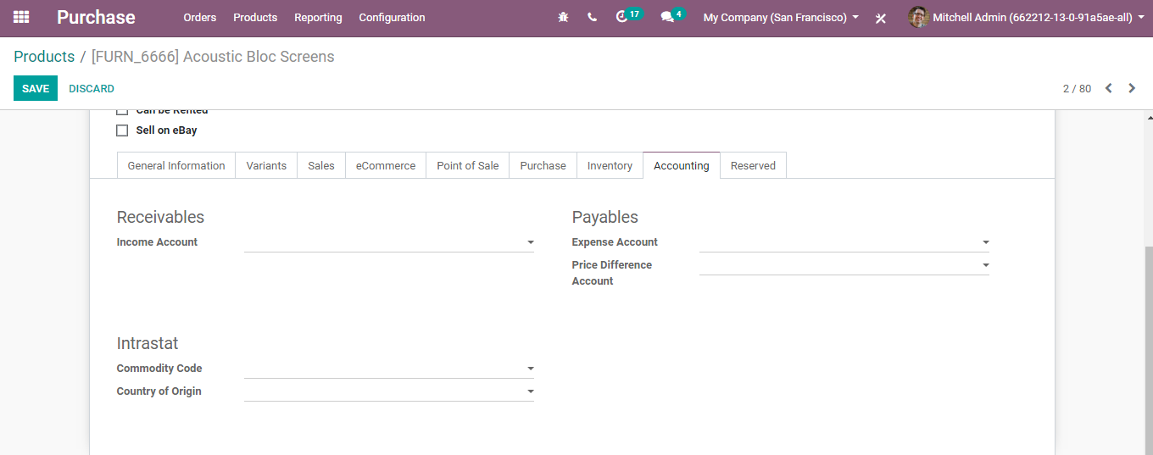

**Income Account:** Keep this field empty to use the default value from the product category.

**Expense Account:** Keep this field empty to use the default value from the product category. If Anglo-Saxon accounting with an automated valuation method is configured, the expense account on the product category will be used.

**Price Difference Account:** This account is used in the automated inventory valuation to record the price difference between a purchase order and its related vendor bill when validating this vendor bill.

**Under the Reserved Tab,**

You can see the confirmed sale order waiting for the delivery. BUSINESSBOXERP reserves the product based on two criteria. One is immediately after-sale order confirmation, second is manually or based on an automatic scheduler.

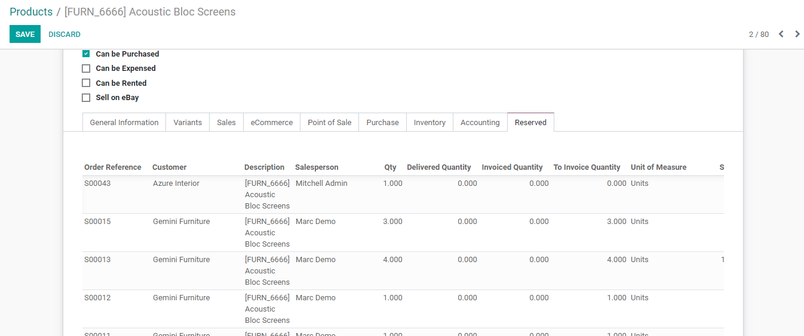

**ADDING VENDORS TO THE PRODUCT**

There are two different ways of adding merchants to the product.

If you issue a sales order for the first time, BUSINESSBOXERP will consequently connect the seller and it is cost to the product.

Secondly including the merchants manually

**SETTING MULTIPLE VENDORS ON A PRODUCT**

On the off chance that you end up with the need to purchase from numerous sellers for one product, BUSINESSBOXERP can let you link multiple vendors with a specific product/item.

**Add vendors in a product**

To utilize this feature, go to **Purchases > Products**.

Select a product.

From that point, you can add existing merchants to your product or make another one on the fly.

Note that every first time the product is obtained from another seller or vendor, BUSINESSBOXERP will automatically link the contact and cost with the product.

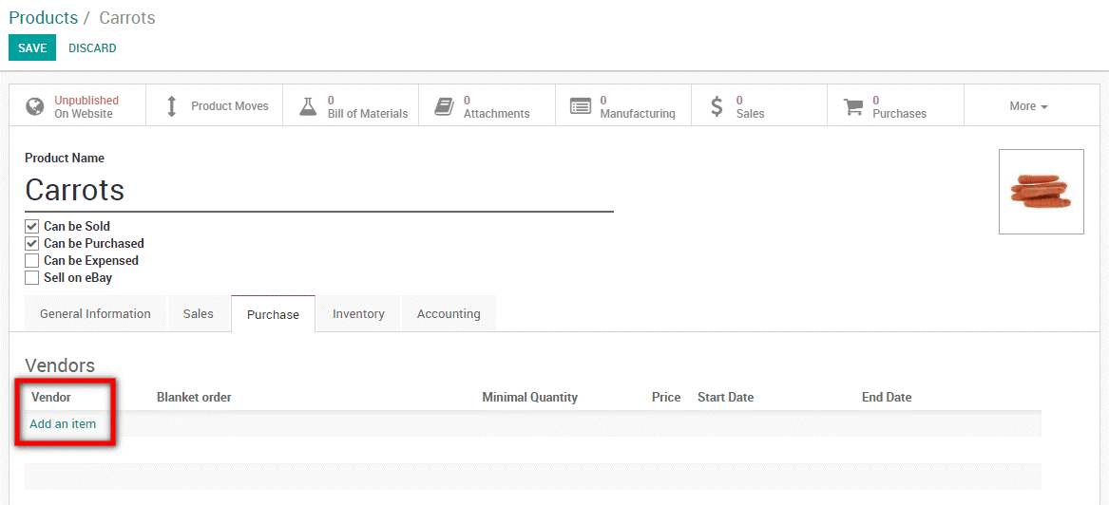

Alongside adding the vendor to a product, you can add the following:

* Vendor product name
* Vendor product name code
* Minimal Quantity
* Price
* Validity period
* Delivery Lead Time

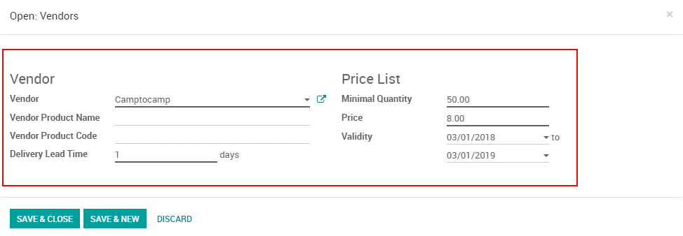

**HANDLING PRODUCTS IN DIFFERENT UNITS OF MEASURE**

Now and again, dealing with products in various units of measures is vital. For instance, if you purchase items in a nation where the metric measuring standard is of utilization and sell them in a nation where the imperial framework is utilized, you should change over the units. BUSINESSBOXERP empowers to work with various units of measure for one item. BUSINESSBOXERP comes in favour of collaborating with different units of measure for one product.

**Configuration**

Under Inventory application, go to **Configuration ‣ Settings. And under the Products section**, tick the option Units of measure.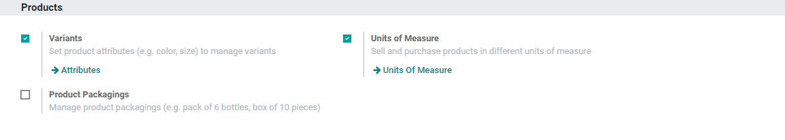

**Setting up units on your products**

In**Inventory Control > Products,** open the product which you might want to change the purchase/sale unit of measure and click on Edit.

In the **Unit of Measure area,** select the unit in which the item will be sold and in which internal exchanges will be executed.

In the **Purchase Unit of Measure area,** select the unit in which you buy the item. When you are set, click on Save.

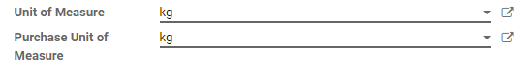

Upon clicking the edit button, you are provisioned to create a new unit of measures in BUSINESSBOXERP.

**Transfer from one unit to another**

While doing inter-unit exchanges, the rounding adjustments are consequently done by BUSINESSBOXERP.

The unit of measure can be changed all through the entire procedure. The only condition is that the unit of measure is a piece of a similar class.

**PURCHASE IN DIFFERENT UNITS OF MEASURE THAN IN SALES**

It is not mandatory that your purchaser prefers or follows the very same unit of measure that you follow while selling the product. In case there exists a difference in the unit of measure among the seller and purchaser, there can cause various kinds of problems in the transaction. For instance, you need to invest a surplus amount of time in converting the units of measure. However, with BUSINESSBOXERP you are freed with this tension. BUSINESSBOXERP helps with seamless management of different units of measure between sales and purchase.

To do so makes sure you have installed the Purchase and Sales Module.

Secondly, Enable the Unit of Measures option under the purchase module. Go to **Configuration> Settings and tick the Some products may be sold/purchased in a different unit of measures (advanced)**box.

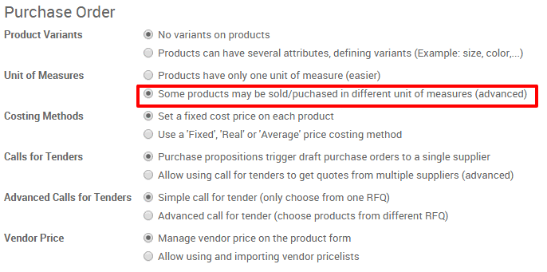

**Specify sales and purchase a unit of measures**

It is very much essential that units of measure between sales and purchase belong to the same/ common category. The categories include- Unit, Working Time, Volume, Weight and so forth. Also, BUSINESSBOXERP makes it easy to create a new category and unit of measure if it does not fall under the standard category of BUSINESSBOXERP.

Assume that the product says water is bought from the vendor in Gallons, however, it is sold to the client in Litres. Let us see how BUSINESSBOXERP manages the different units of measure between sales and purchase.

For that firstly select the product. You can go to the purchase module select your products. Either you can create a new product or select from the existing products. Later go to **General Information**Tab, under the Product. Here, you can select the**Unit of Measure** (that will be used in sales, inventory etc) and the **Purchase Unit of Measure** (for purchase).

Taking our example into consideration, you can now select Litres as Unit of Measure and Gallons as Purchase Unit of Measure.

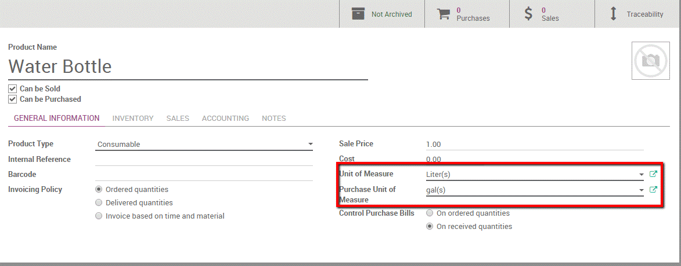

Create your unit of measure and unit of measure category

Assume you buy curtains from a supplier who sells the curtains in a rolling unit. However, you sell them in square meters. Now as you see, both these units belong to distinct categories, and one cannot relate them as they fall into two separate measuring categories. Thus here, we need to create a **Measure Category** for relating two units of measure that belong to two different categories.

To do so, go to **Sales >Configuration> Products > Unit of Measure.** Create a new unit of Measure Category.

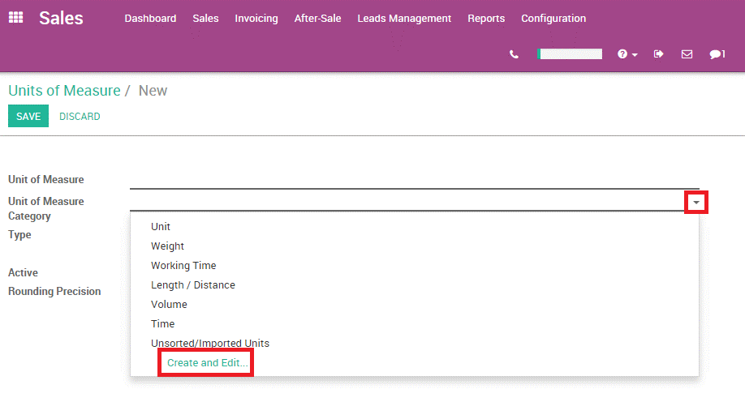

Create a new unit of measure. You can name it. Here we will call the category as Inter-Category-Computation.

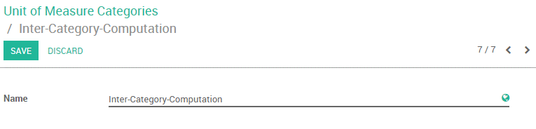

Next, create two units of measure - Rolls and Square meter and link them to the new category. To do so, **Go to Purchase Module> Configuration >Products >Units of Measure.**

**Create two new units:**

The unit **Roll**comes under Inter-Category-Computation and is the **Reference Unit type**. Every other measure will be converted depending on this reference unit measure. E.g.: 1 roll = 10 square meters, 2 rolls = 20 square meters.

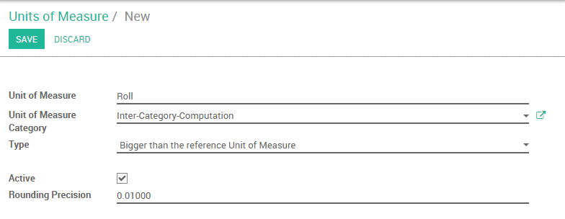

For the Square Meter, we will specify that 1 Roll = 10 square meters of the curtain. Therefore, under Type, you need to specify that the square meter is bigger than the reference unit. The Bigger Ratio is 10 as 1 Roll = 10 square meters.

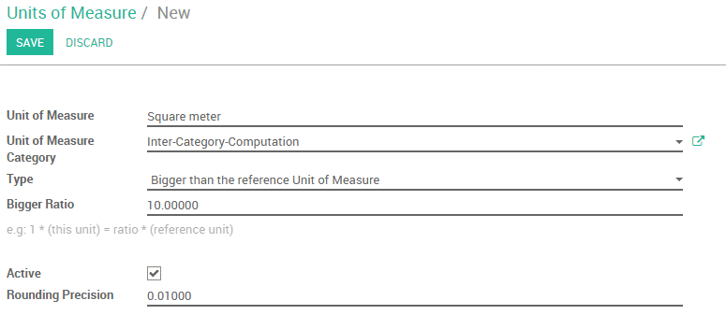

Now under the product form, you can seamlessly give Square Meters as Unit of Measure for the curtain and Roll as its Purchase Unit of Measure.

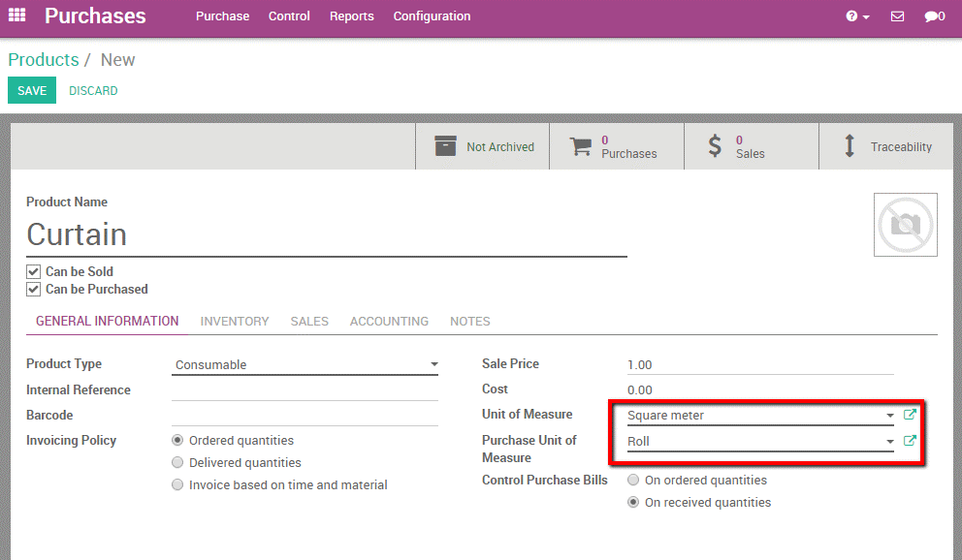

**VENDOR MANAGEMENT**

Monitoring your vendors or merchants can be a tedious task in everyday business life. Costs can change and you may have a few providers for one item. With BUSINESSBOXERP, you can straight get linked with merchants with the corresponding product/item and indicate the costs when you make a purchase.

Since BUSINESSBOXERP Sales and Purchase module is related to CRM, there is no different vendor management in the purchase, it gets to the Partner management subsystem simply like in the Sales module. Utilizing this module, one can add people to their framework who can act either as Customers or Vendors or Both. In the purchase module, one can get to this feature under **Purchase > Orders> Vendors**.

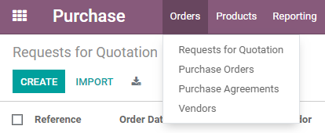

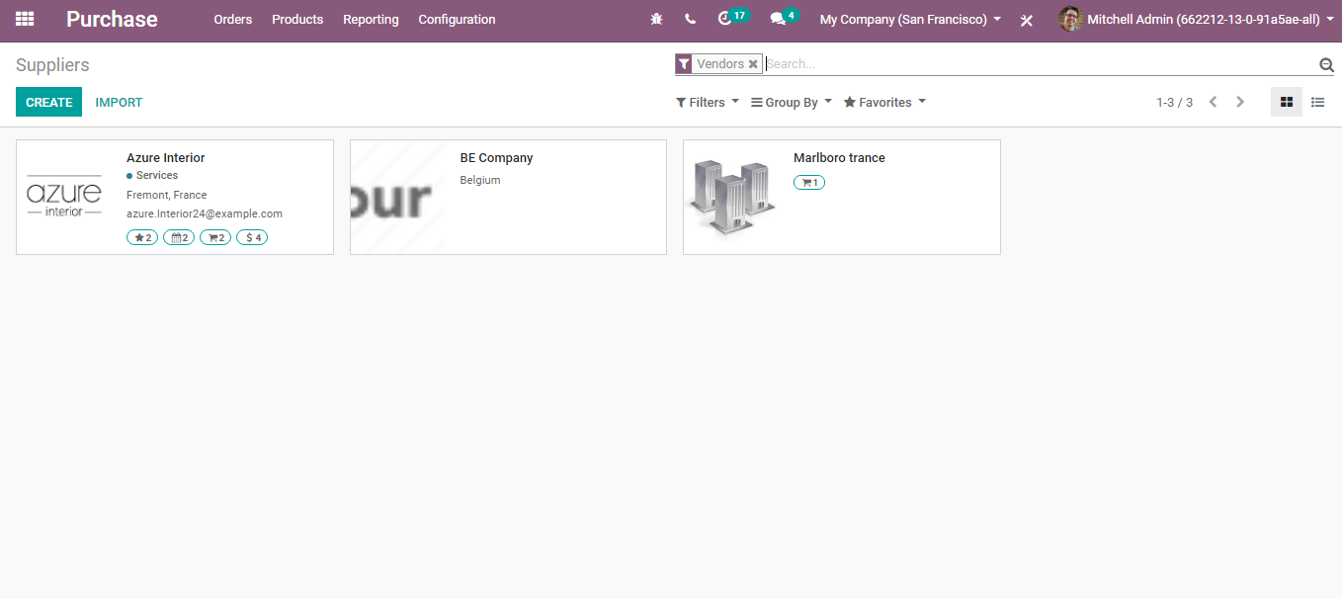

**CREATING VENDOR**

Upon clicking the **CREATE** button, a creation form will appear like below:

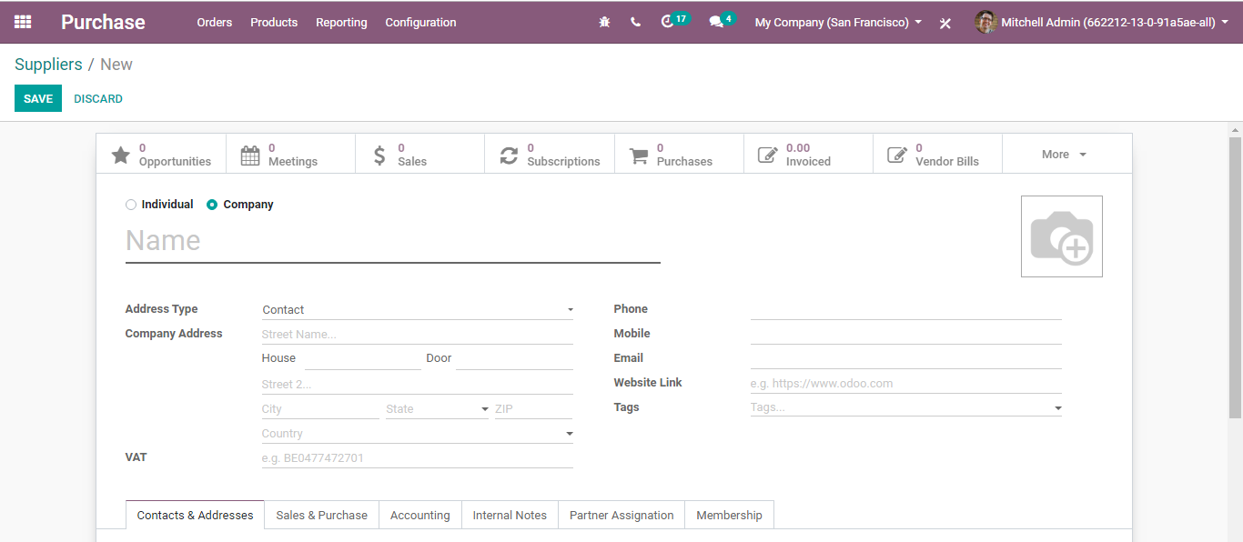

BUSINESSBOXERP gets you with two types of vendors:

* Individual
* Company
* **Contact and Address Tab:** Here you have the option to completely configure a new vendor of yours via adding his name, address, phone, mobile, email id, website links, tags (specializations) etc.

**Under Sales and Purchase Tab:**

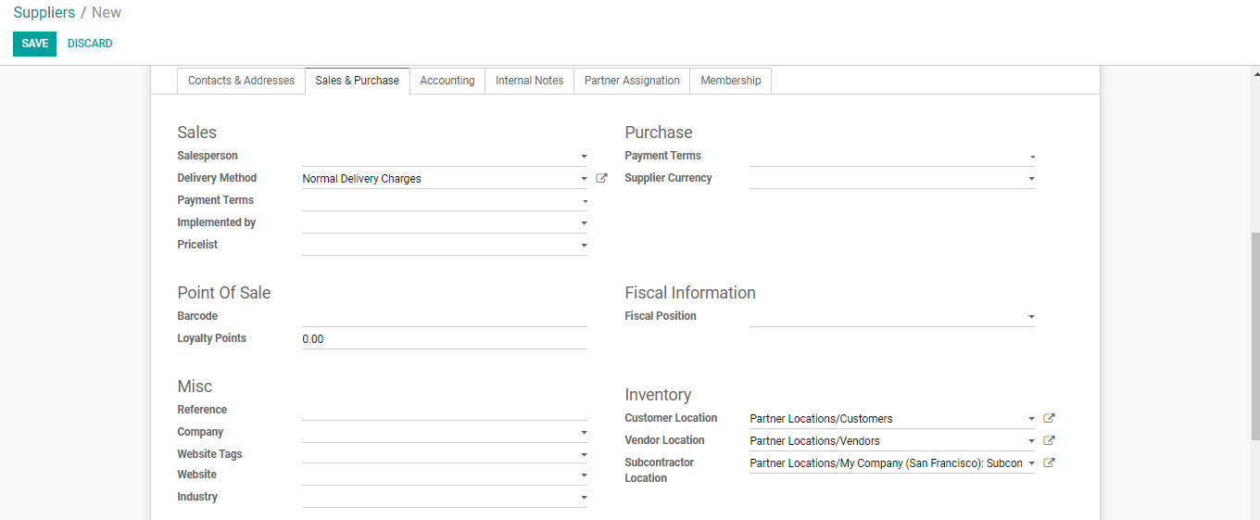

**Under Sales you have-**

**Salesperson:** The internal user in charge of this product.

**Delivery Method:** Default delivery method used in sales orders.

**Payment Terms:** This payment term will be used instead of the default one for sales orders and customer invoices.

**Price lists:** The selected price list will be used instead of the default one, for sales to the current partner.

**Under Purchase-**

**Payment Terms:** This payment term will be used instead of the default one for purchase orders and vendor bills.

**Supplier Currency:** This currency will be used instead of the default one for purchases from the current partner.

**Under Point of Sale-**

**Fiscal Position:** The fiscal position determines the taxes/accounts used for this contract.

**Barcode:** Use a barcode to identify this contract from the point of sale.

**Loyalty Points:** These are the points that users won as a part of the loyalty program.

**Under Inventory**

**Customer Location:** The stock location is used as a destination when sending goods to this contract.

**Vendor Location:**The stock location is used as a source when receiving goods from this contract.

**Subcontractor Location:**The stock location is used as a source and destination when sending goods to this contract during a subcontracting process.

**Under Accounting Tab**

Enables to add the basic accounting details about the customer. The creation form will look like this:

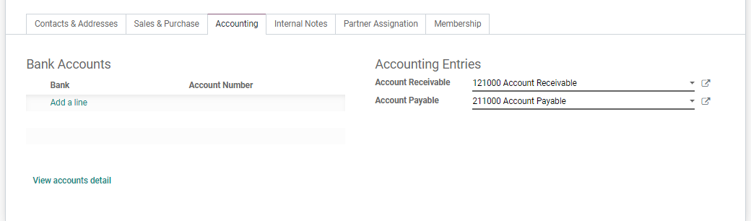

**Bank:** The name of the bank, where the customer holds the account.

**Account number:** The customer’s registered account number.

**Account Receivable:**This account will be used instead of the default one as the receivable account for the current partner.

**Account Payable:**The account will be used instead of the default one as the payable account for the current partner.

**Internal Notes Tab**

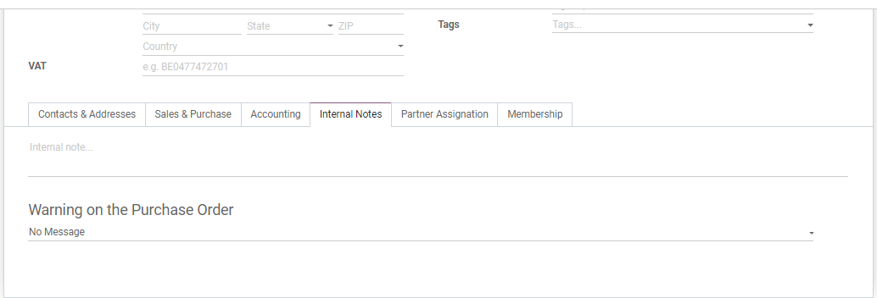

The internal note is a functional feature that you put comments without disturbing followers. If you want to notify a particular seller, rather than disturbing all others, you can insert an internal note in the customer form.

**Under Membership Tab**

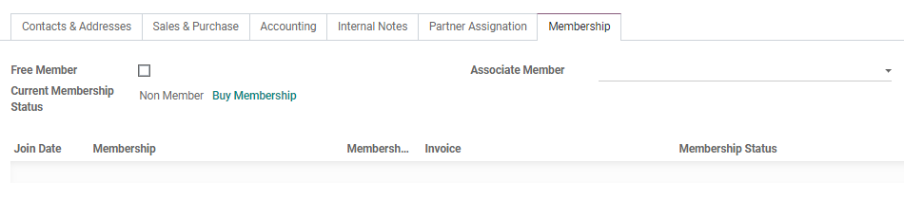

**Free Member:**Tick the option if you want to give free membership option to the vendor.

**Current Membership Status:** Indicates the membership state (Non-Member/Cancelled member/ Old Member/Waiting Member/Invoiced Member/Paying Member etc).

**Associate Member:** A member with whom you want to associate your membership. It will consider the member state of the associated member.

**VENDOR PRICELISTS**

Importing the vendor pricelists can be of great advantage when it comes to staying abreast with product pricing for a business organization.

**Configuration**

To enable the feature, go to **Purchases ‣ Configuration ‣ Vendor Pricelists.**

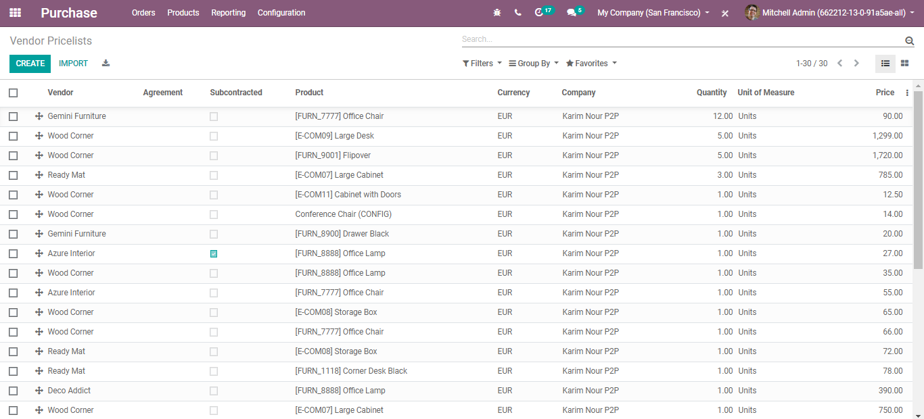

Upon clicking the **CREATE** button, you can create new **VENDOR PRICELISTS**.

The creation form will look like below:

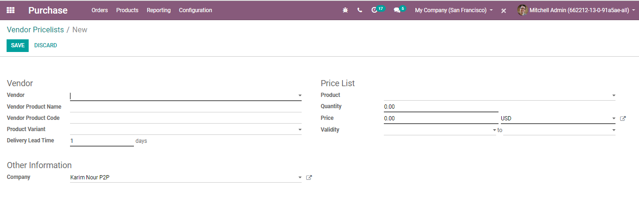

* **Vendor:** Vendor of this product.
* **Vendor Product Name:** This vendor’s product name will be used when printing a request for quotation. Keep empty to use the internal one.
* **Vendor Product Code:**This vendor’s product code will be used when printing a request for quotation. Keep empty to use the internal one.
* **Product Variant:** If not set, the vendor price will apply to all variants of this product.
* **Delivery Lead Time:**Lead time in days between the confirmation of the purchase order and the receipt of the products in your warehouse. Used by the scheduler for automatic computation of the purchase order planning.

**IMPORTING A PRICELIST**

To import a price list, you can click on the Import button next to the create button under Purchase ‣ Vendor Pricelists.

Load your file, then you can check if everything is correct before clicking import.

See below a template of the columns used.

**REQUEST FOR QUOTATION AND PURCHASE ORDER**

**CREATING REQUEST FOR QUOTATION**

Any purchase procedure begins with a purchase order and finishes with the gathering of goods/services. In BUSINESSBOXERP, you can either directly make a purchase order (PO) or you can demand a quotation and make a PO only upon confirming the quote by the merchant. You can go for Purchase Tender if there is a case of competitive bidding. Nevertheless, in each purchase, you will have a purchase order and the PO will produce an invoice and relying upon the agreement with your provider, you will be required to pay the receipt before or after the delivery.

A **Request for Quotation** (RFQ) is utilized when you intend to buy a few products and you might want to get a quote for those products. In BUSINESSBOXERP, the Request for Quotation is utilized to send your rundown of wanted or desired items to your provider. When your provider has answered your quotation, you can proceed with the offer. Either you can purchase or turn down the offer.

**Configuration**

Go to the Purchases module, open **Purchase > Orders> Requests for Quotation** and click on **Create**.

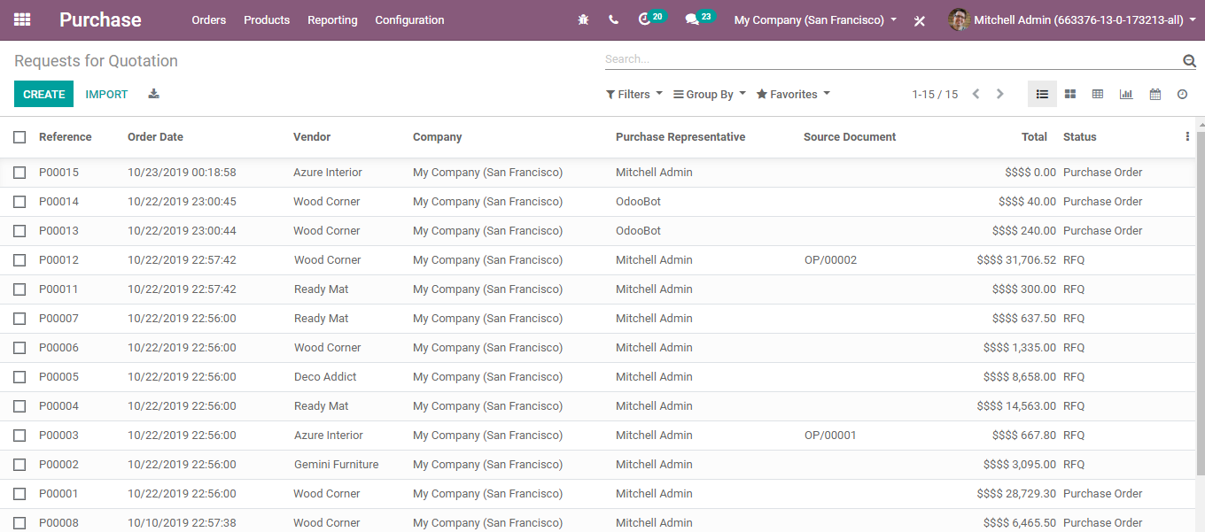

Upon clicking the **CREATE** button, you will be navigated to a new window with **Request for Quotation/New.**

The creation form will look like this:

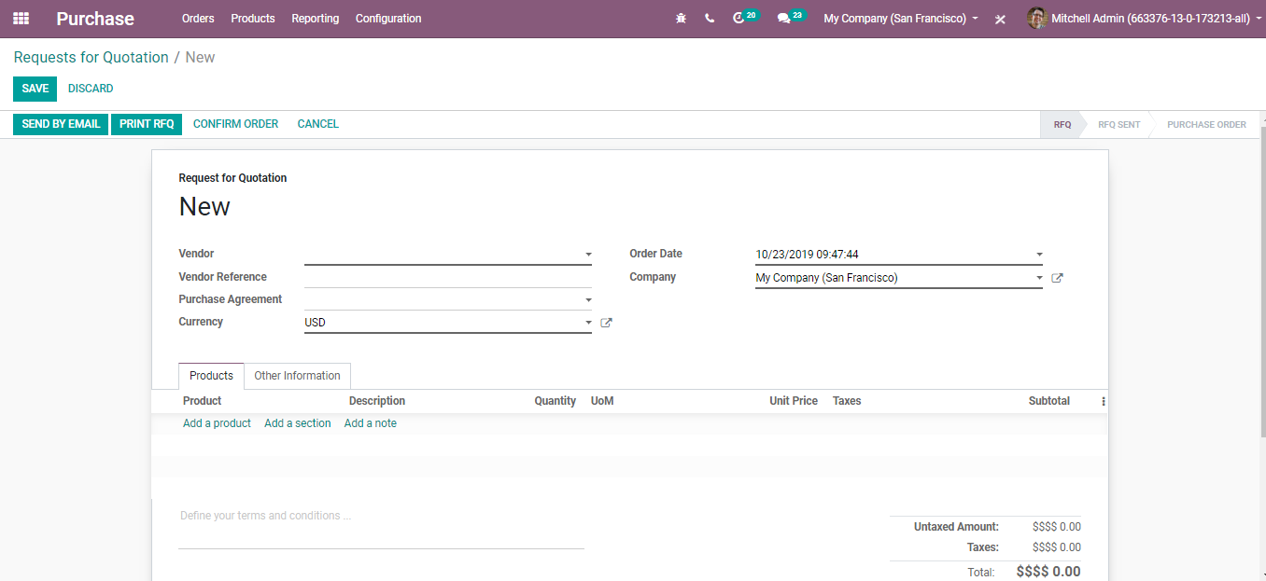

**Vendor:** Under the option, one can select the**Supplier/Vendor.** One can find a vendor by its Name, TIN, Email, or Internal Reference. One can select the supplier from the Vendor menu,

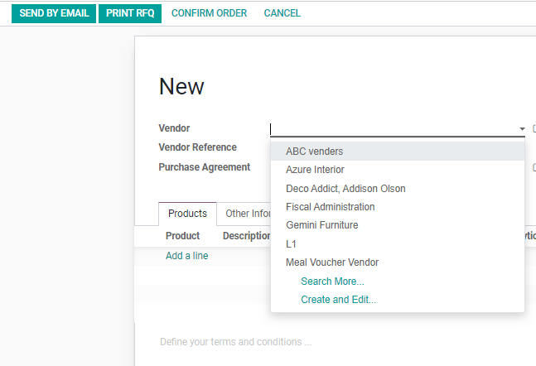

or create it on the fly via clicking on **Create and Edit.**

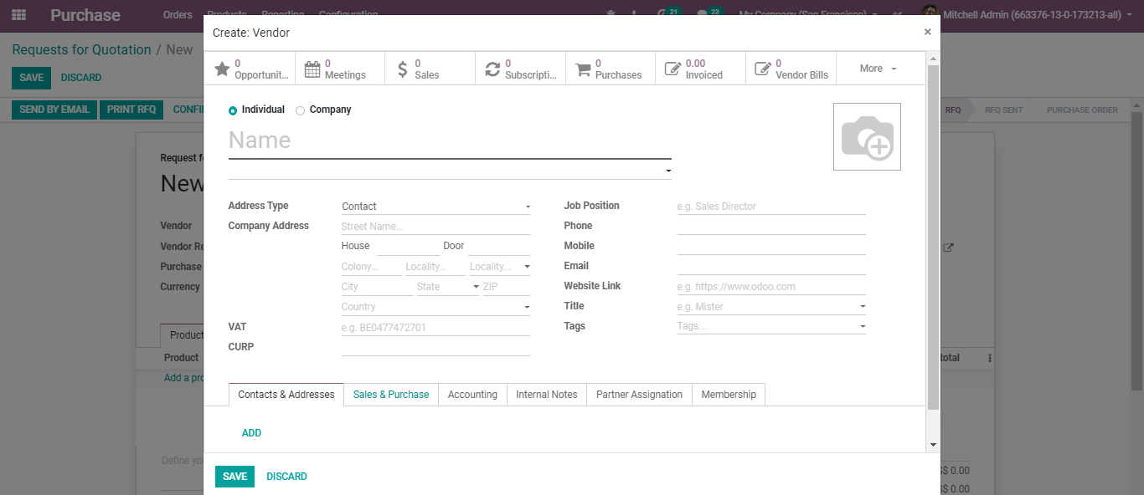

* **Vendor Reference:**It is the reference of the sales order or offer sent by the vendor. The vendor reference is typically composed of the delivery order sent by your seller and is used to do the matching of your items while you receive it.
* **Purchase Agreement:** A purchase agreement is a legal document illustrating the diverse conditions and terms that are identified with the sale of products. It makes a legally binding contract between the purchaser and the vendor. By default, the Purchase Agreements is not initiated in BUSINESSBOXERP.
* To initiate the Purchase Agreements-In the Purchases module, open the Configuration menu and click on Settings. In the Order section, you will find the Purchase Agreements. Tick the option and click on SAVE to mark the changes.

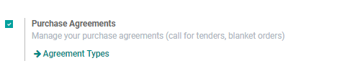

Under the Agreement Type field, the end-user would find two options: Call for Tender and Blanket Order.

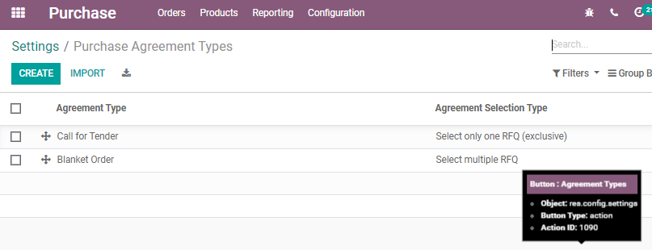

* **Call for Tender:** A Call for Tender is a unique method to demand offers from various merchants to get the most fascinating cost.
* **Blanket Order:** A Blanket Order is an agreement between you (the client) and your provider. A blanket order is preferred when there is a recurring need for expendable goods. Blanket orders are preferred when customer purchases goods in large quantities.

**SETTING PURCHASE AGREEMENTS**

Upon clicking the create button under Purchase Agreement Types, you will be navigated to a new creative form like below:

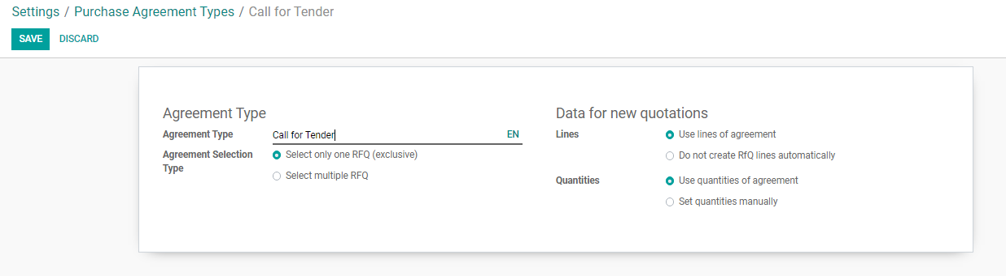

The creation form has the following fields:

* **Agreement Types:** Blanket Order/Call for Tender.
* **Agreement Selection Type:**
* Select only one RFQ: When a purchase order is confirmed, cancel the remaining purchase order.
* Select Multiple RFO: Allows multiple purchase orders. On confirmation of a purchase order, it does not cancel the remaining orders.
* **Lines:**Use lines of agreement/do not create RFQ lines automatically.
* **Quantities:** Use quantities of agreement/Set quantities manually.

**Managing Blanket Orders**

A Blanket Order as defined above is a kind of purchase order that a customer gives off to the supplier, offering the feasibility of multiple delivery dates over some time.

Configuration

**Purchases > Configuration >Settings** and activate the Purchase Agreements feature

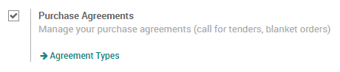

**Starting a Blanket Order**

Upon creating a purchase agreement, select Blanket Order as the Agreement Type.

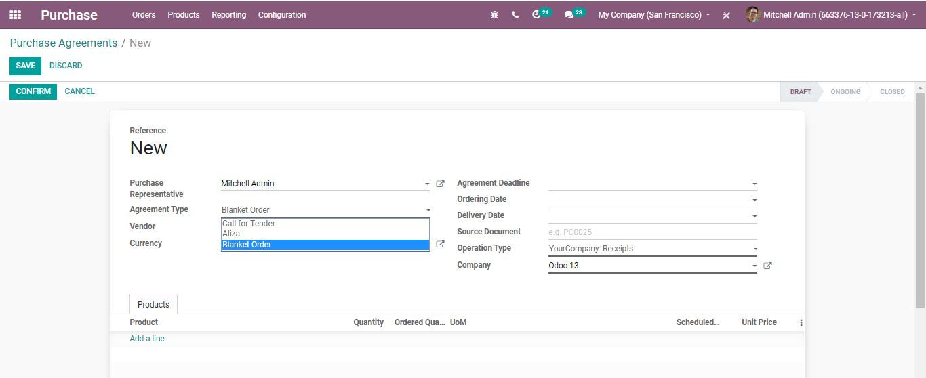

Later then, you can make a new blanket order via filling in other fields such as purchase representative, vendor, agreement deadline, ordering date, delivery date and so on.

Once satisfied with the purchase agreement, confirm it via tapping the **CONFIRM** button.

Thus, you can see its status getting changed from DRAFT to ONGOING. Also, new RFQs/Orders will appear on the top right-hand side of the page.

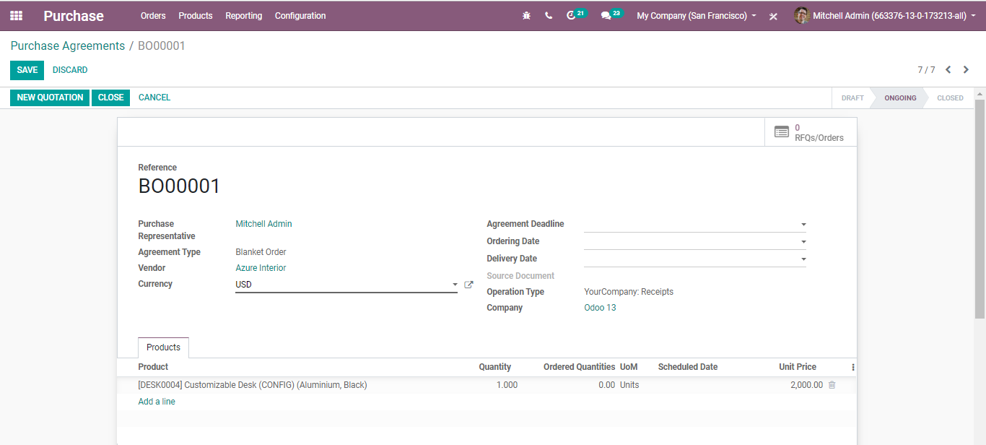

**RFQ from the Blanket Order**

From the created blanket order, the user can create a new quotation.

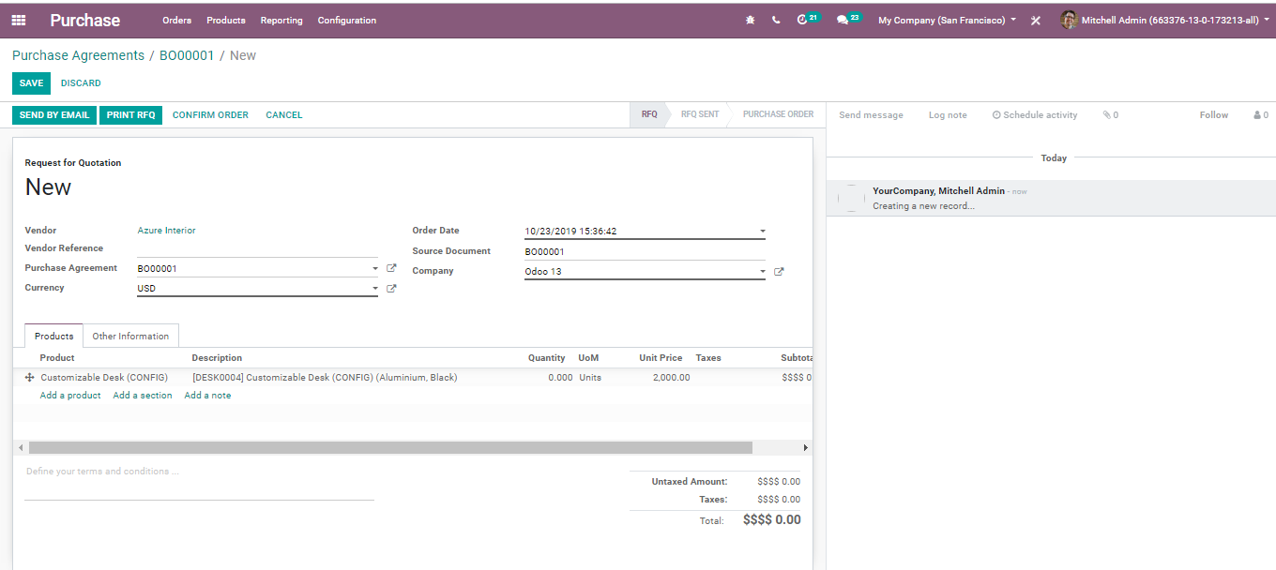

Note: BUSINESSBOXERP auto-fills the quotation document with all details using blanket order. One needs to choose only the quantity and later confirm the order.

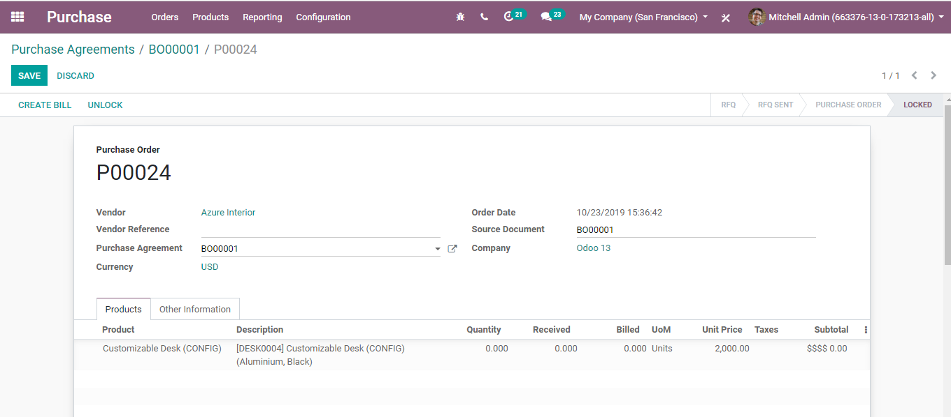

Now if you go back to the blanket order, you can get a vicinity over the quantities you ordered from your blanket order.

**Vendors prices on your product**

Upon validating the blanket order, a new vendor line gets added to the product. Thus, one can identify which all are linked to a blanket order.

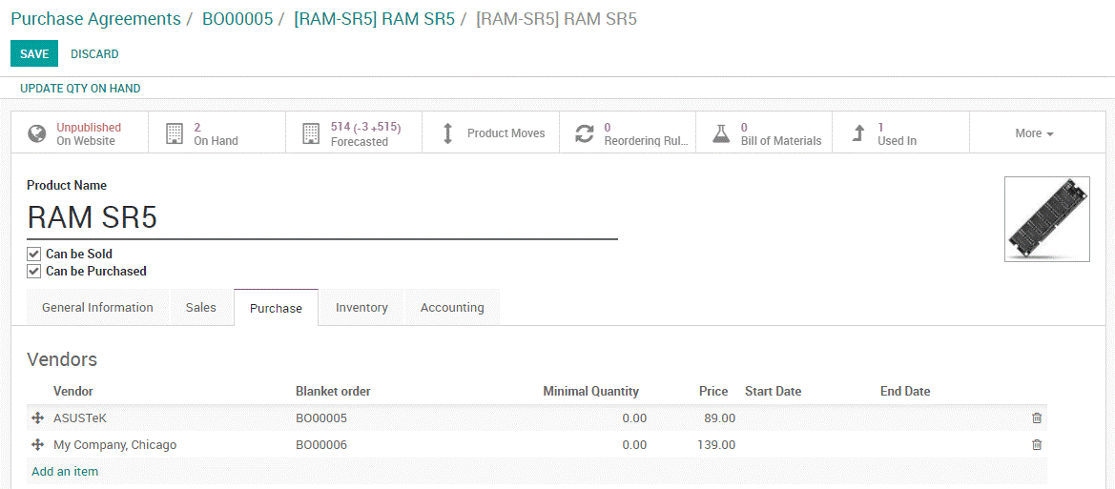

**Managing Call for Tender**

For that Go to **Purchase > Configuration >Settings** and activate the **Purchase Agreements** feature.



**Creating a Call for Tender**

Upon creating a purchase agreement, select Call for Tender as the Agreement Type.

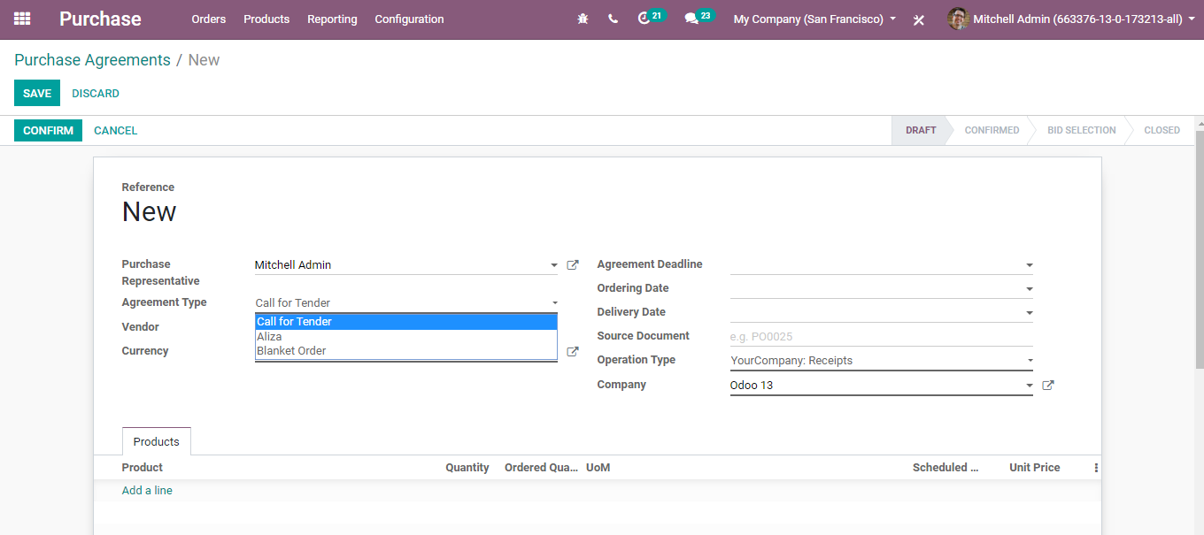

Later then, you can start a call for tender via filling in other fields such as purchase representative, vendor, agreement deadline, ordering date, delivery date and so on.

Once satisfied with the purchase agreement, confirm it via tapping the **CONFIRM** button. You can see the status changing from DRAFT to CONFIRMED. Also, new RFQs/Orders appears on the top right corner of the page.

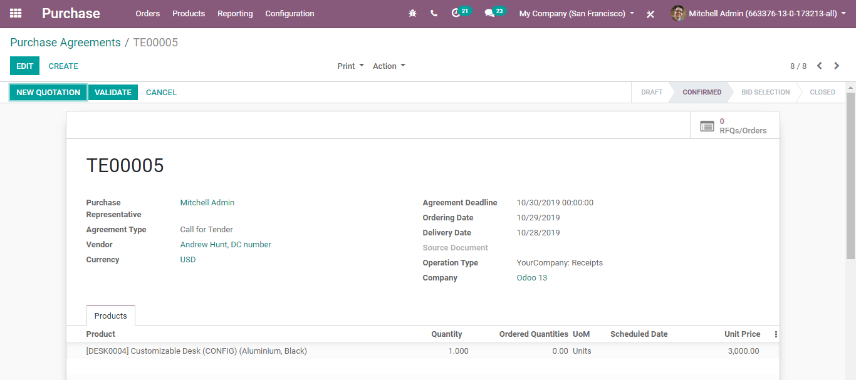

**Request new quotations from the Call for Tender**

From the Call for Tender, BUSINESSBOXERP auto-fills the RFQ.

You can select the best offer from various RFQs, and orders linked to the Call for Tenders, under the RFQ/Order button.

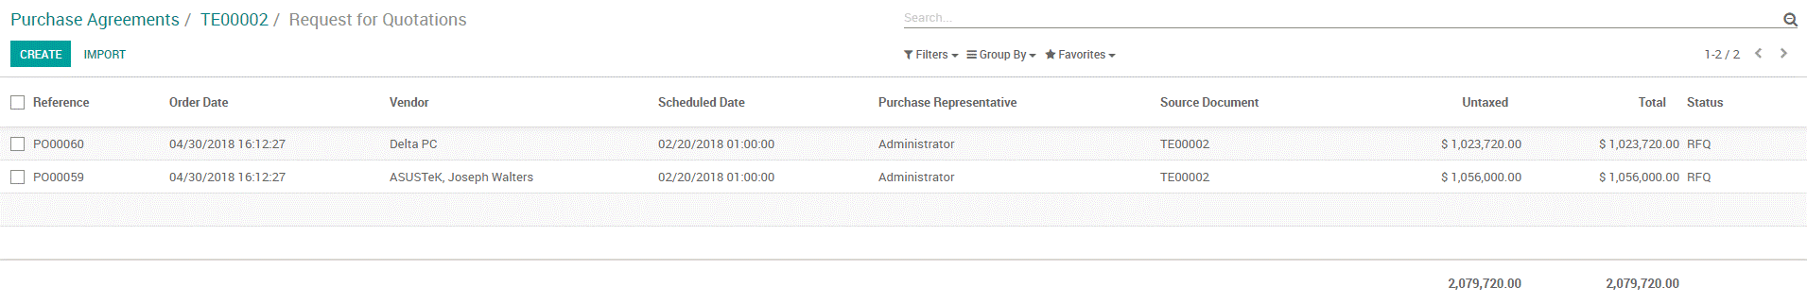  
**Close the Call for Tender**

Once you are done with Call for Tender. Tap the CLOSE button.

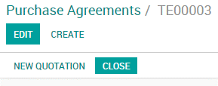

This is how we manage purchase agreement types.

Coming back to our RFQ, other fields in the creation form includes:

**Order Date:** The purchase order date is the date that the buy request or a purchase order is produced by the purchaser, yet it can likewise mean the date that the vendor gets the purchase order. In the Order Date field, select the date to which you wish to continue to the actual order

odoo-purchase

**Product:** Under Products, click on Add an item. Select the product you wish to order in the Product menu.

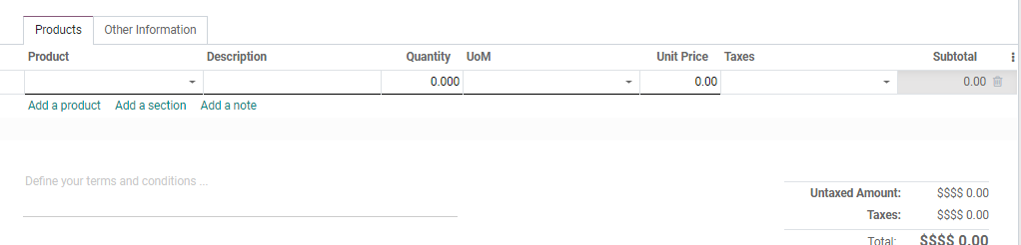

Also, you can specify here, the product quantity and unit of measure for the product. In the Unit Price field, you can specify the price at which you shall offer the product.

**SENDING REQUEST FOR QUOTATION BY MAIL**

Once you have entered every essential in the RFQ, **click**on the **SAVE button**.

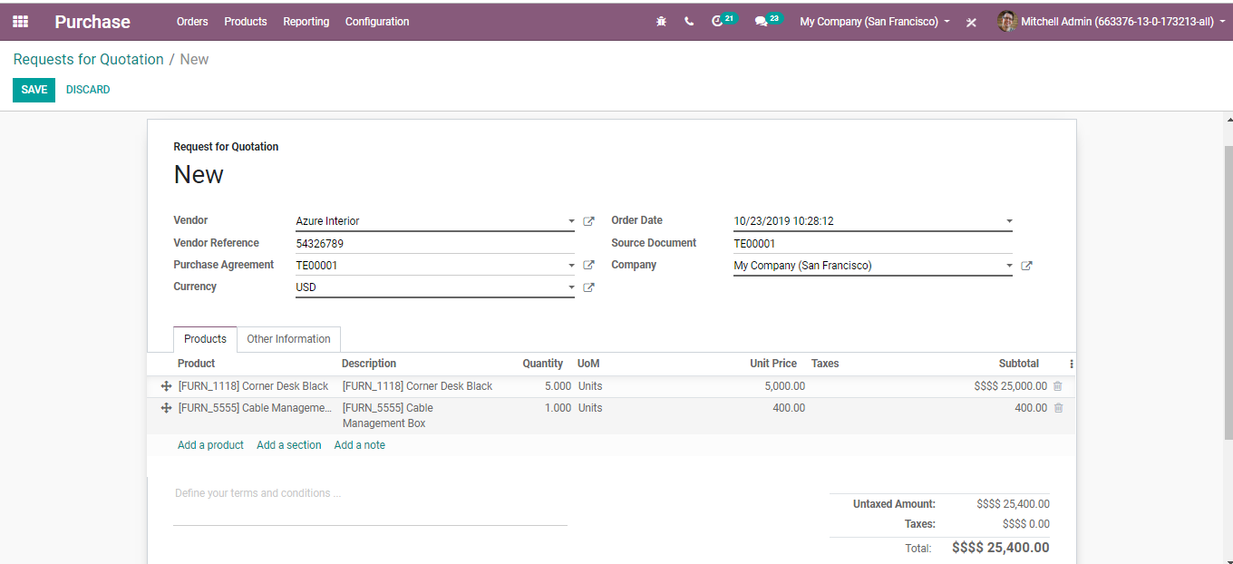

You will be navigated to a new window like below:

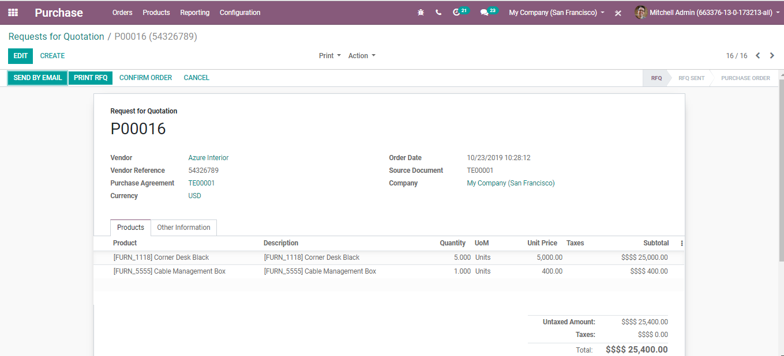

You can either **Print RFQ or Send RFQ by email** (make sure you have specified an email address to the supplier).

Upon clicking the Print RFQ button, you will get the pdf copy of your QUOTATION.

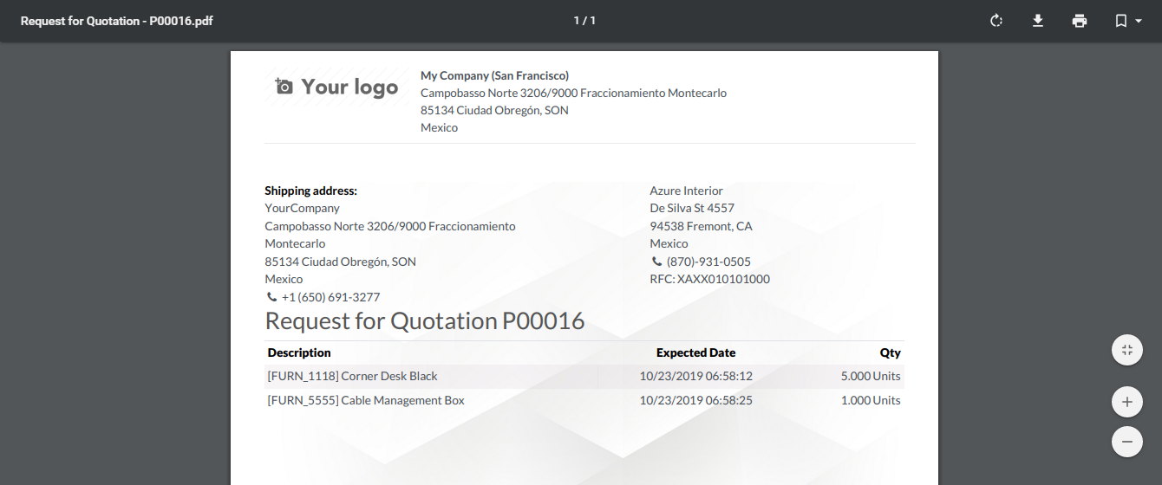

Upon clicking Send by Email,

An automated email will be readied dependent on the predefined layout. One can seamlessly review the email content and can include the extra substance if you wish to do. Later send by clicking on the **SEND** button.

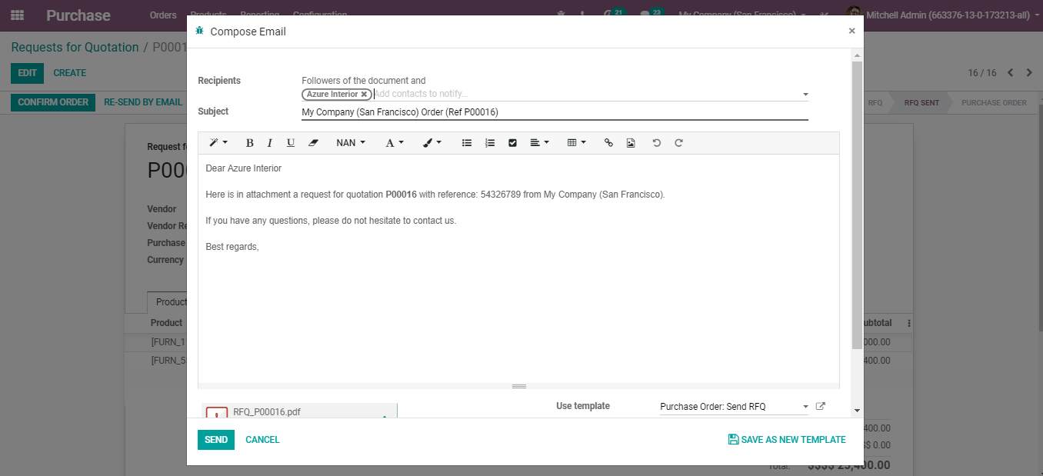

Once you send the MAIL, RFQ's status will switch over from **RFQ to RFQ Sent**.

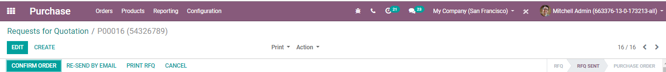

Once your supplier reverts to the quotation, you can proceed with the order.

**PURCHASE ORDER**

**CREATING PURCHASE ORDER**

Soon after getting the reply (with offer) from the supplier, update the RFQ via clicking on Edit to fit the quotation (prices, taxes, expected delivery lead time, payment terms, etc.), Later click on Save for issuing a Purchase Order.

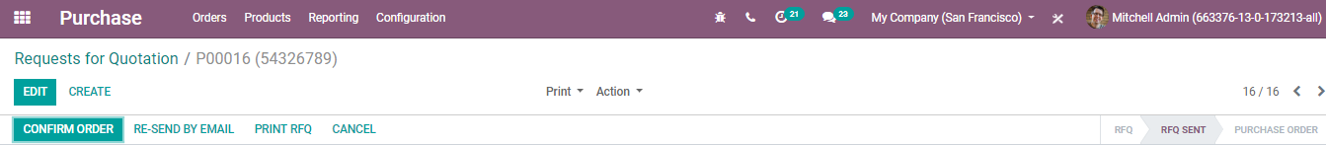

Click **CONFIRM ORDER** to send the order to the supplier. As soon as you confirm the ORDER, the RFQ status gets changed to the **Purchase Order**.

**LOCK A PURCHASE ORDER**

Upon confirming the order, the end-user can lock their purchase order from further interruptions.

To activate the feature, Go to **Purchase > Configuration >Settings. Activate the Lock Confirmed Orders feature.**

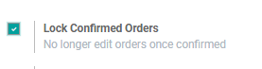

**Lock an order**

While working on a purchase order, when you CONFIRM it, you would then be able to lock the request forestalling any further adjustment on the order.

odoo-purchase

BUSINESSBOXERP automatically lock the purchase order. You can see the changes in the status bar like shifting from**Purchase order to Locked**.

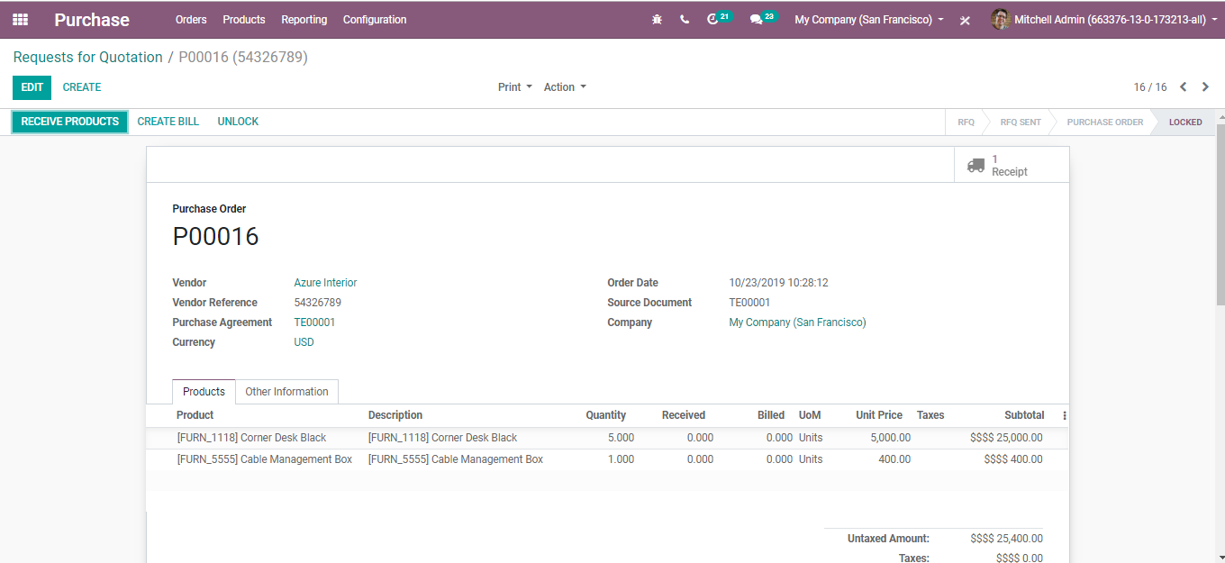

You can also **unlock** the purchase order via tapping the **UNLOCK BUTTON** if you need to further make the changes.

odoo-purchase

**Receive the products.**

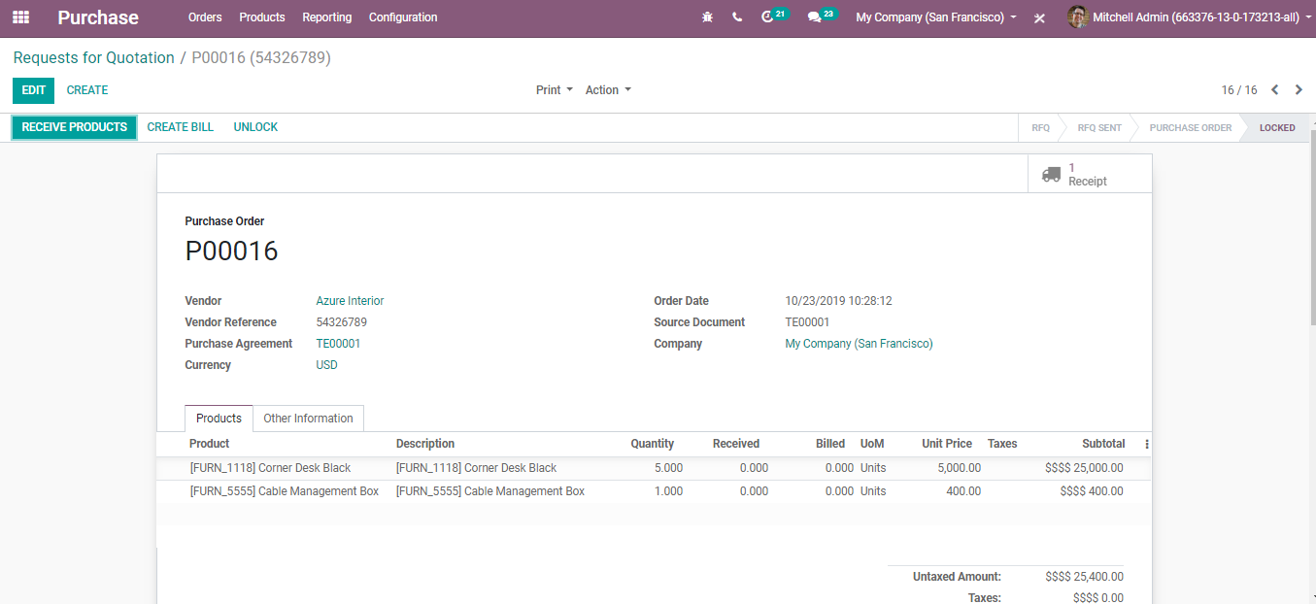

Upon clicking the RECEIVE PRODUCTS button, you will be navigated to a new window like below:

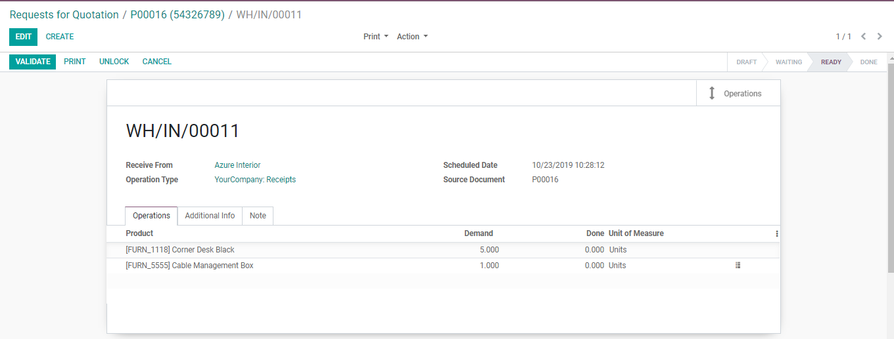

**Validate the stock picking**. Here you can see various pieces of information about the purchase order you created. This includes- product location, received from, operation type, scheduled date, source document and product info.

**Under the Other Information tab,**

You get to know the Receipt Date, Purchase Representative responsible for the order, Billing status, Payment terms also an option Print Variant Grid. If the option Print Variant Grid is selected, the matrix of configurable products will be shown on the report of this order.

Upon clicking the print button, you get the pdf copy of your **PURCHASE ORDER**.

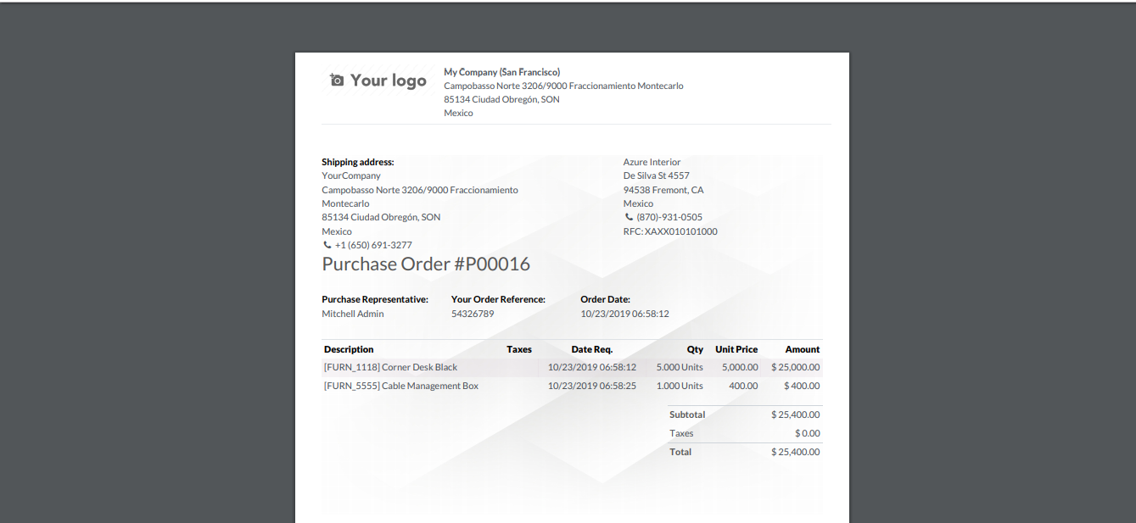

**CANCELLING PURCHASE ORDER**

Because of false impressions, human blunders, or changes of plans, we may at times have to drop or cancel the purchase order sent to providers. BUSINESSBOXERP enables you to do it. One can cancel the purchase via **tapping the cancel** button.

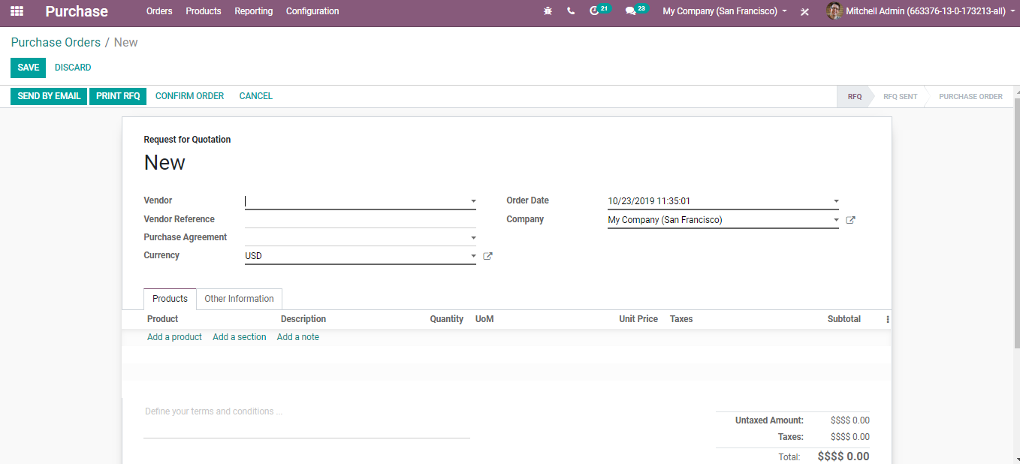

BUSINESSBOXERP consequently cancels the outstanding shipments associated with this purchase order. Change occurs in the status bar from **Purchase order to Cancelled.**

**REQUESTING MANAGERS APPROVAL FOR EXPENSIVE PURCHASE ORDERS**

In case of expensive purchases, you must get the approval of the concerned authority to validate your orders. BUSINESSBOXERP embeds this provision under the configuration setting and one can easily set that up.

**Configuration**

For this feature to work, go to **Purchases > Configuration >Settings. Activate the Purchase Order Approval feature** under Order Section.

One can set the base sum or minimum amount required to initiate this feature.

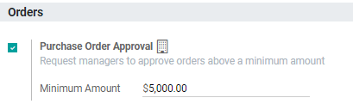

While dealing with another new quotation request, if the request is made by a client and not the manager and the order amount is exceeding the minimum amount you determined, a new **To Approve** status will be presented then.

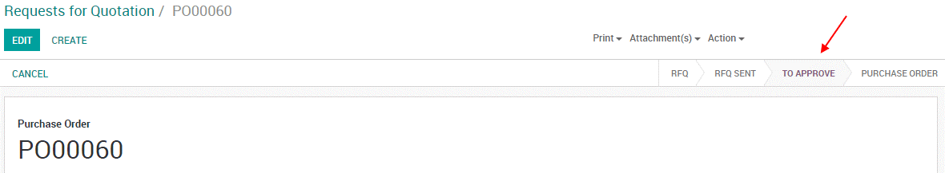

Approve the order

If you are the purchase manager, you would now be able to go to the purchase order and approve them if everything is ok in it. Giving you full control of what your clients can or cannot do.

Upon confirming, the purchase order pursues the ordinary procedure.

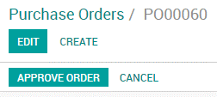

**SETTING WARNINGS ON PURCHASE ORDERS**

BUSINESSBOXERP enables a warning feature in the purchase module to raise warnings or block messages on purchase orders based on a vendor or a product.

For example, if you often face a problem with a vendor, you might want to raise a warning when conducting a purchase from that vendor.

Secondly, if a product is about to be discontinued, in that case, you may want to raise a blocking message on the purchase order concerning that product.

**Configuration**

For availing of this feature, go to **Purchase> Configuration > Settings. Activate the Warnings feature** under the orders category.

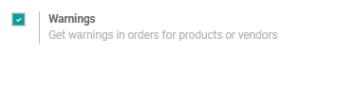

**Add a warning on a vendor**

Upon activating the feature, you get a new option under the Internal Notes tab on vendors. One can inscribe a simple warning or a blocking message here.

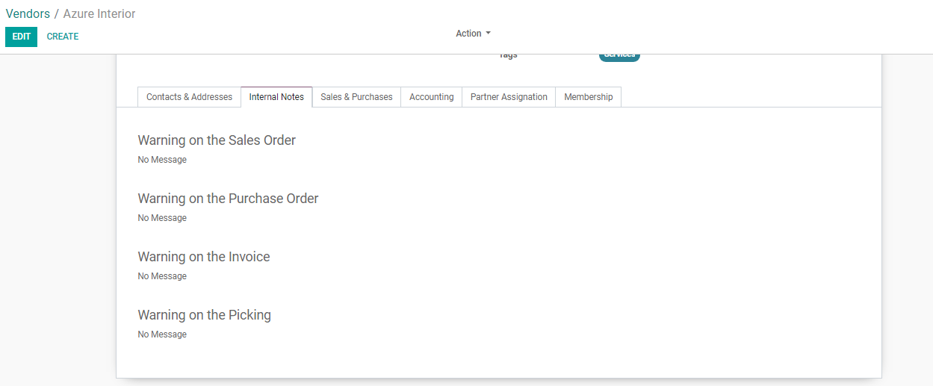

**Buying with warnings or blocking messages**

If the end-user tries to validate a Purchase Order from a vendor or with a product that comes along with a warning, the action will trigger a message. The end client can ignore the message via clicking the OK button.

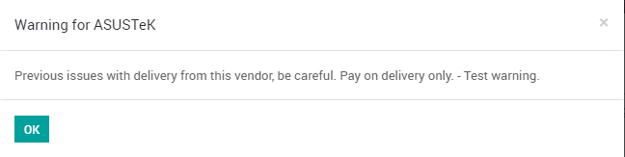

However, if it is a blocking message, the end-user cannot ignore them simply.

**VENDOR BILLS**

A vendor bill is a receipt or an invoice concerning services and products bought from sellers. Hence the bill is considered as a cost for the organization. One can send a request utilizing purchasing a request first and after that convert the received items into vendor bills.

With BUSINESSBOXERP, one can easily take control over the bills i.e., using the Bill Control option you can either initiate a practice of supplier sending bills based on **Ordered quantity** i.e., before receiving the goods or based on **Delivered quantity** i.e., sending bills after receiving the goods.

To activate the**Bill Control** Option,

Go to **Purchase >Configuration> Settings**. Activate the Bill Control option under Invoicing.

And select the mode in which you want to control the bills.

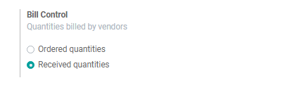

**Change the control policy**

Remember Ordered quantities will be your default method of bill control. However, you can make the change in the control policy via clicking the control policy under the purchase tab of the product. You can make the necessary changes based on the product types.

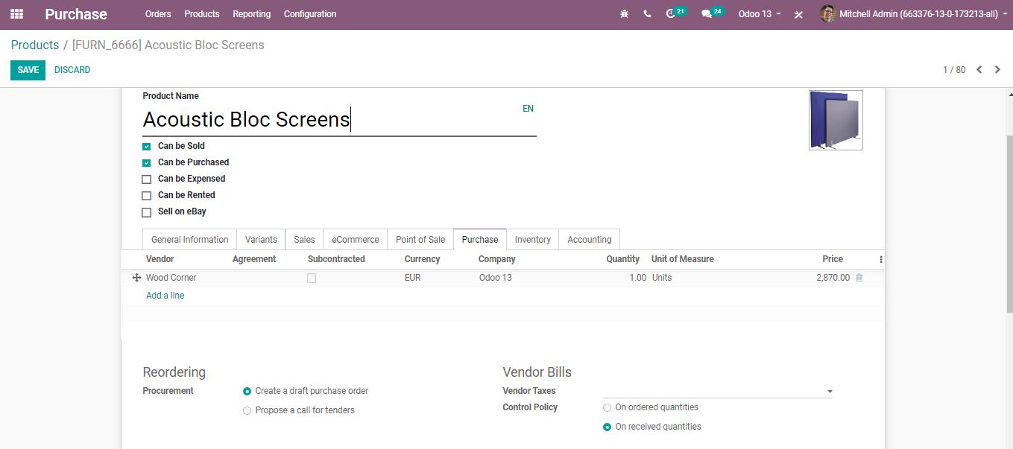

**Verify your Vendor Bill**

If your vendor bill is based on Ordered quantity, BUSINESSBOXERP initiates a bill for the units ordered.

However, if the vendor bill is based on Received quantity, BUSINESSBOXERP initiates a bill for zero.

**3 Way Matching-Purchases, Receptions and Bills**

In certain enterprises, you may get a bill from a merchant before receiving ordered products. However, you do not need to make the bill payment before the product is received at your workplace.

To define whether the merchant bill ought to be paid or not, you can utilize what is known as 3-way matching. It alludes to the comparison of the data showing up on the Purchase Order, the Vendor Bill, and the Receipt.

The 3-way matching encourages you to abstain from paying erroneous or deceitful vendor bills.

**Configuration**

Go in **Purchase > Configuration > Settings** and activate the **3-way matching**.

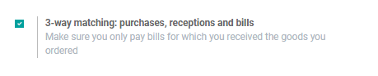

**Would it be an innovative idea for me to pay this vendor bill?**

When this setting has been enacted, another data shows up – **Should be paid** on the vendor bill. You can find the new line under the other info tab.

This way BUSINESSBOXERP directs you whether to make the bill payment or not.

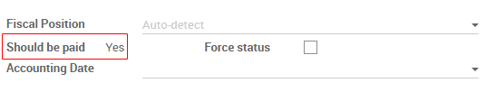

**Drop shipping Products**

Drop shipping is a technique in which the seller does not keep items in stock but exchanges the items directly from the provider to the client.

For activating the feature,

Go to **Purchase> Configuration> Settings** and activate **Drop shipping**under the logistics section.

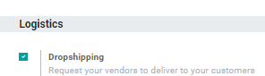

Presently a new route of Drop shipping has been made. You can go for an item and tick the drop shipping route. You likewise need to characterize to which vendor you will purchase the item. Now, each time this item will be sold, it will be drop-shipped.

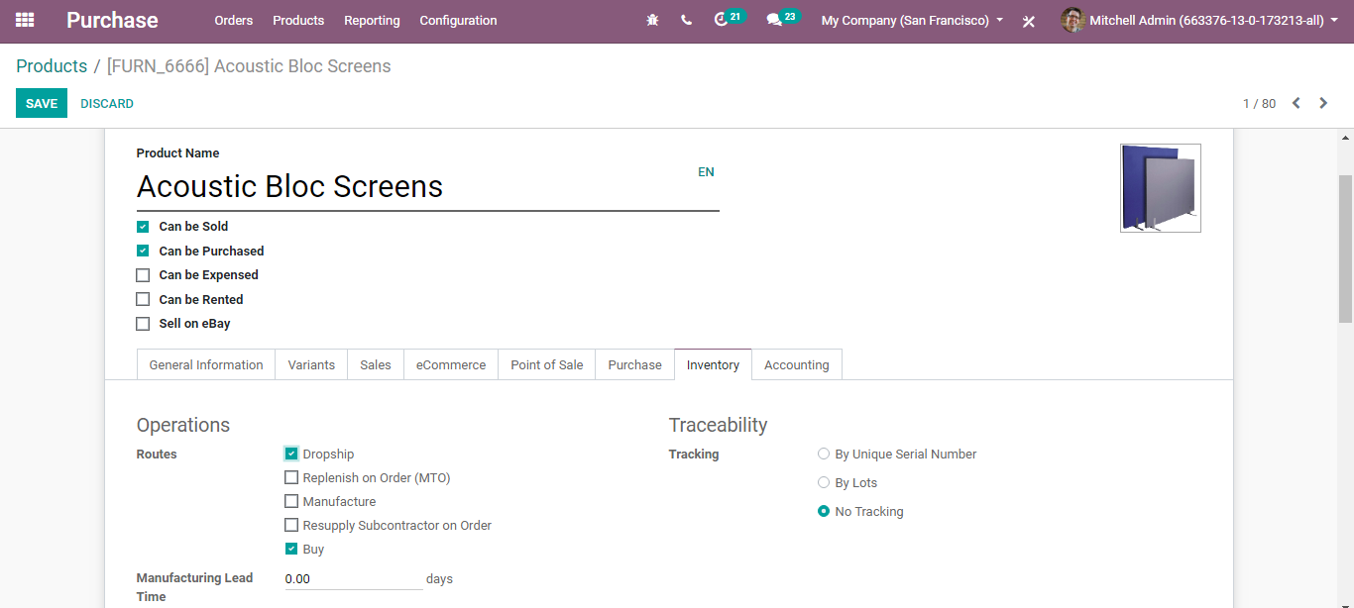

If you want to avoid, drop shipping of this product every time, you can go to Sales ‣ Configuration ‣ Settings and tick the box next to Order-Specific Routes.

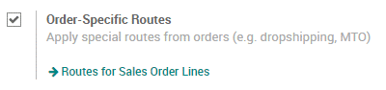

When you make a quotation or sales order, you would now be able to choose, order line per order line, which products ought to be drop-shipped by choosing the drop shipping route on the SO line.

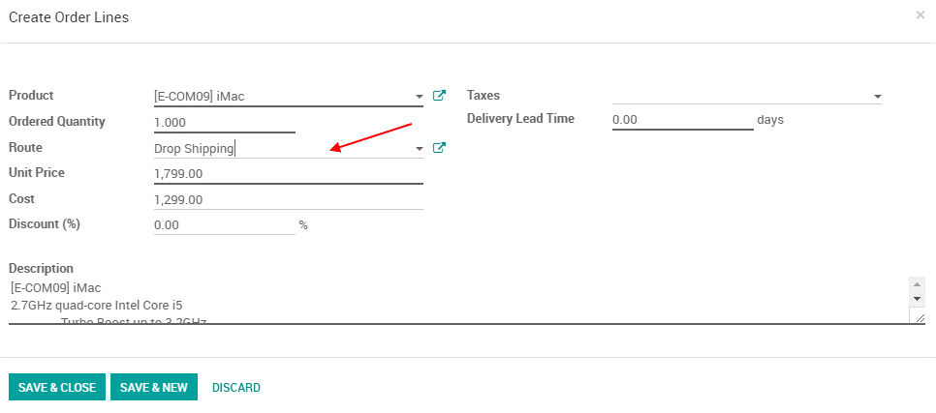

**Dropship a product**

When a sales order with products to drop ship is confirmed, a request for quotation is created by BUSINESSBOXERP to purchase the item from the seller. If you confirm that demand for quotation into a purchase order, it will make a transfer from your vendor straightforwardly to your client. The items do not go through their stock.

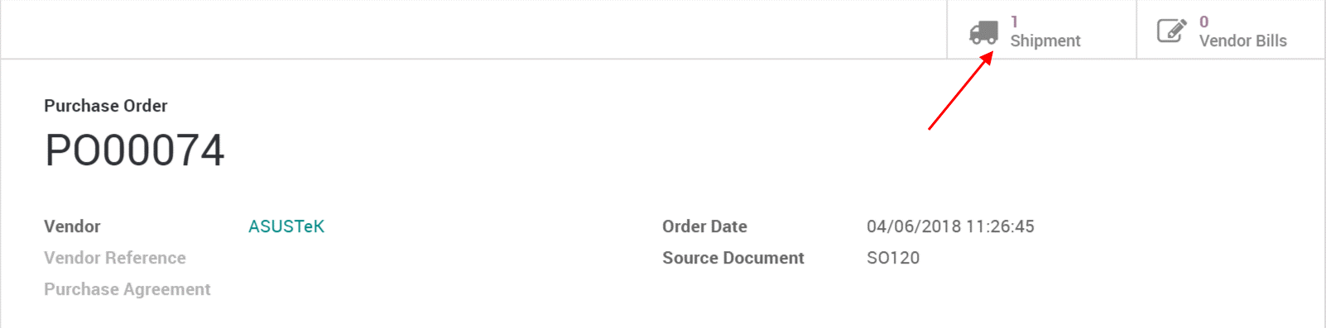

**Reporting**

**Analyse the performance of my vendors**

If your organization normally purchases items from several providers, it is indeed helpful to get insights on your buys. There are several reasons to follow and analyse your seller's performance: From the BUSINESSBOXERP Purchase reporting function, the end client can without much of a stretch see all the appropriate advancements and happenings in business operation. BUSINESSBOXERP reporting empowers you to get adaptable reports on merchant performances.

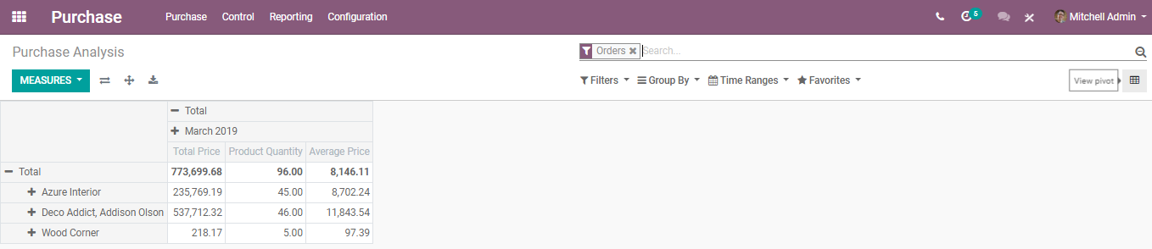

Tip

By clicking on the + and - symbols, you can drill up and down your report to change how your data is shown. For instance, if I need to see every one of the items purchased for the present month, I must tap on the + symbol on the vertical hub and after that on "Items".

Depending upon the information you need to feature, you may need to show your reports in an increasingly visual view. BUSINESSBOXERP encourages you in changing your report in only a tick in three diagram perspectives: a Pie Chart, a Bar Chart and a Line Chart: These perspectives are available through the symbols featured on the screen capture underneath.

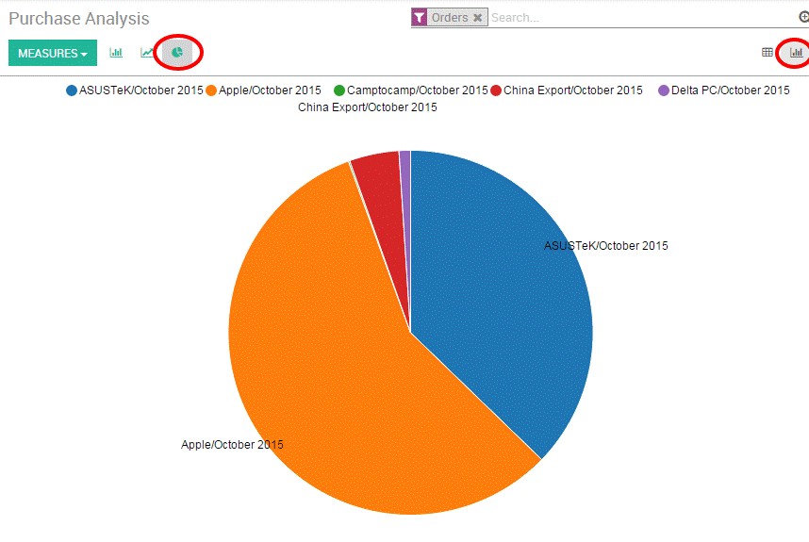

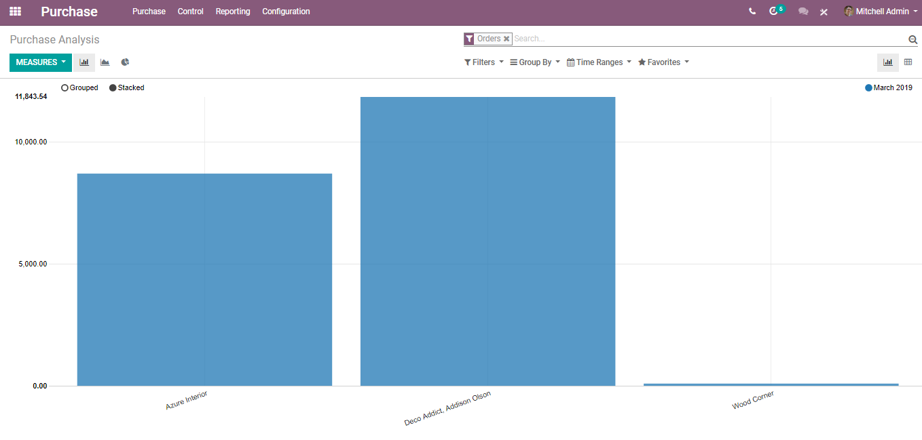

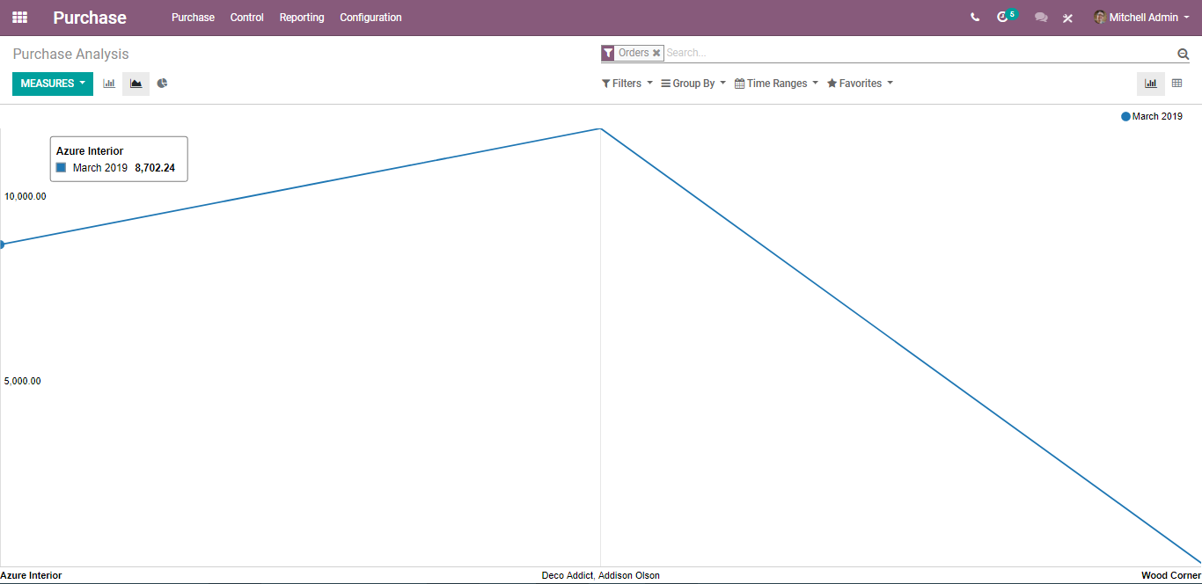

**Customized reports**

Under BUSINESSBOXERP, one can likewise effectively modify their purchase reports relying upon the business needs. To do as such, utilize the advanced search view situated on the right-hand side of your screen, by tapping on the magnifying glass icon towards the finish of the search bar button. This capacity enables you to feature just chosen information on your report. The filter option is valuable to show a few classes of pieces of information, while the Group by option improves the intelligibility of your reports. Note that you can filter and group by any existing field, making your customization truly adaptable and incredible.

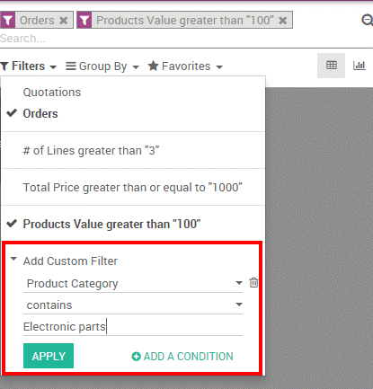

You can save and reuse any customized filter by tapping on Favourites from the Advanced search view and afterwards saving the current search. The saved filter will at that point be available from the Favourites menu.