  - Referral
  - BUSINESSBOXERP Referral app helps you to share job positions that are open at your workplace. One can easily refer their friends using this intuitive tool. The job board gets you with all the information that you need to know about the open position. One can thereby, choose the perfect job position for your friend and share them via mail or social networks.
  - Firstly, install the BUSINESSBOXERP Referral App.
  - 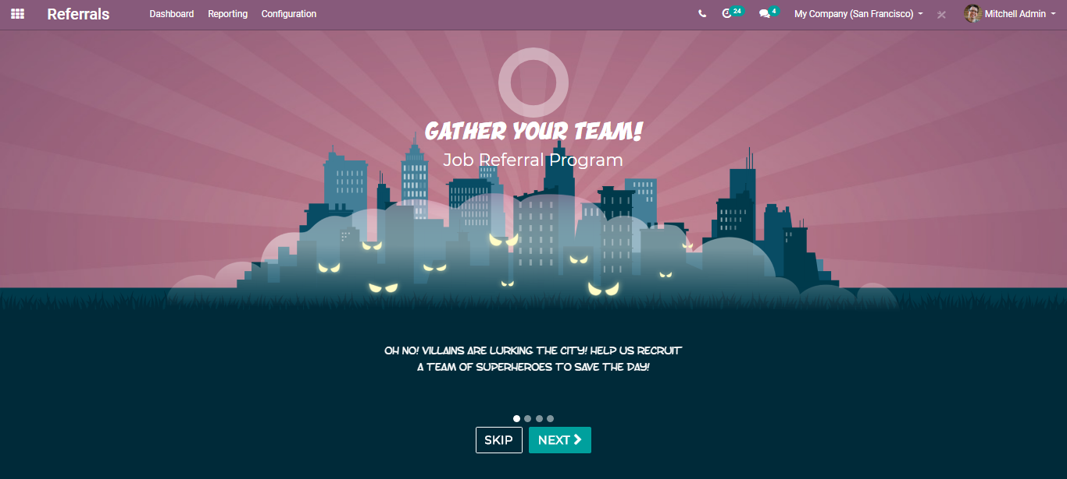
  - 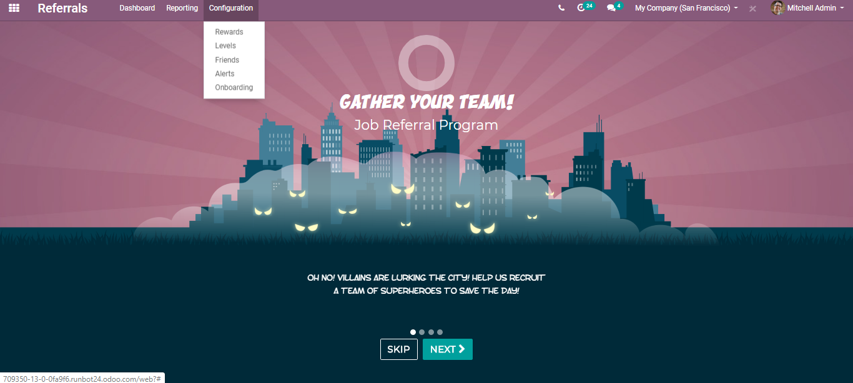
  - Upon clicking Configuration, one can configure rewards, levels, friends, alerts, and onboarding.
  - To configure rewards, go to Referral> Configuration> Rewards
  - 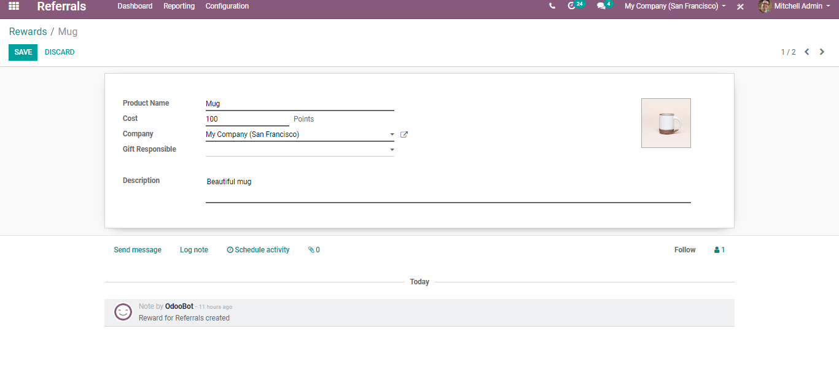
  - One can add here the reward name, cost i.e., points, image, the user responsible for this reward.
  - To configure levels, go to Referral> Configuration> Levels
  - 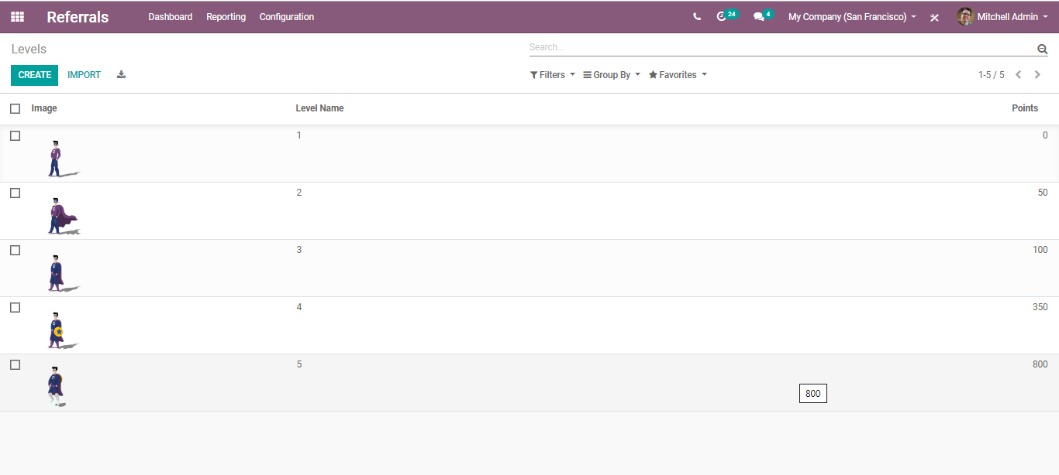
  - 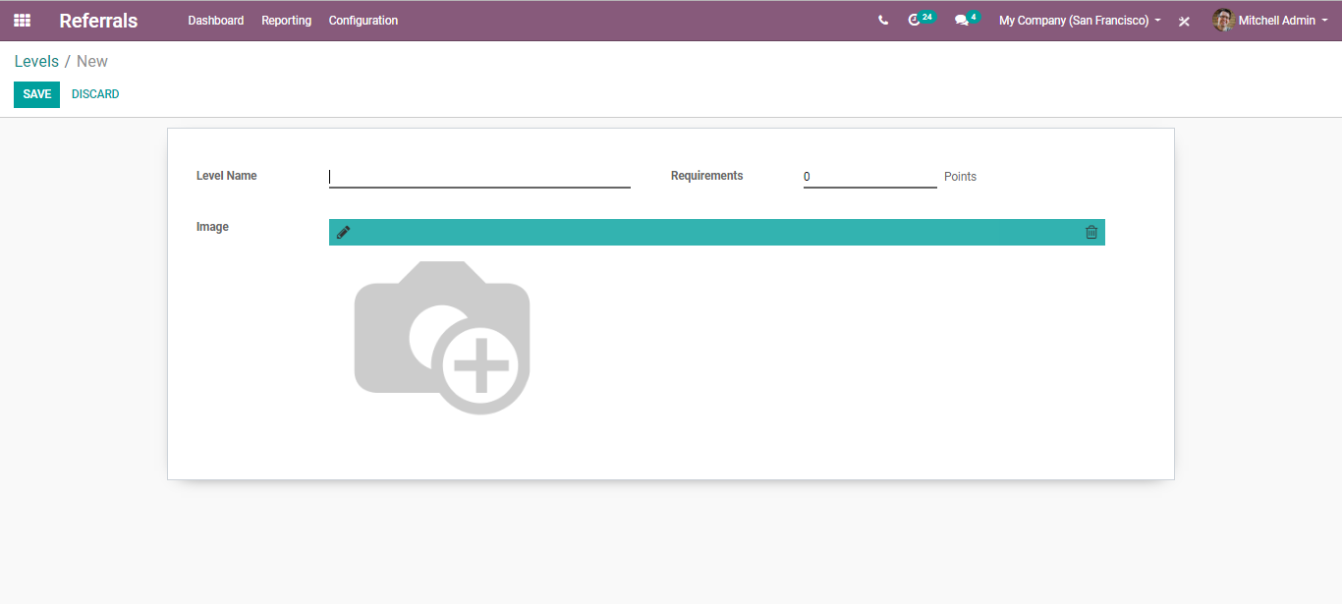
  - One can define here the level name and requirement points to reach this level. Also, add the image.
  - To configure Friends, go to Referral> Configuration> Friends
  - 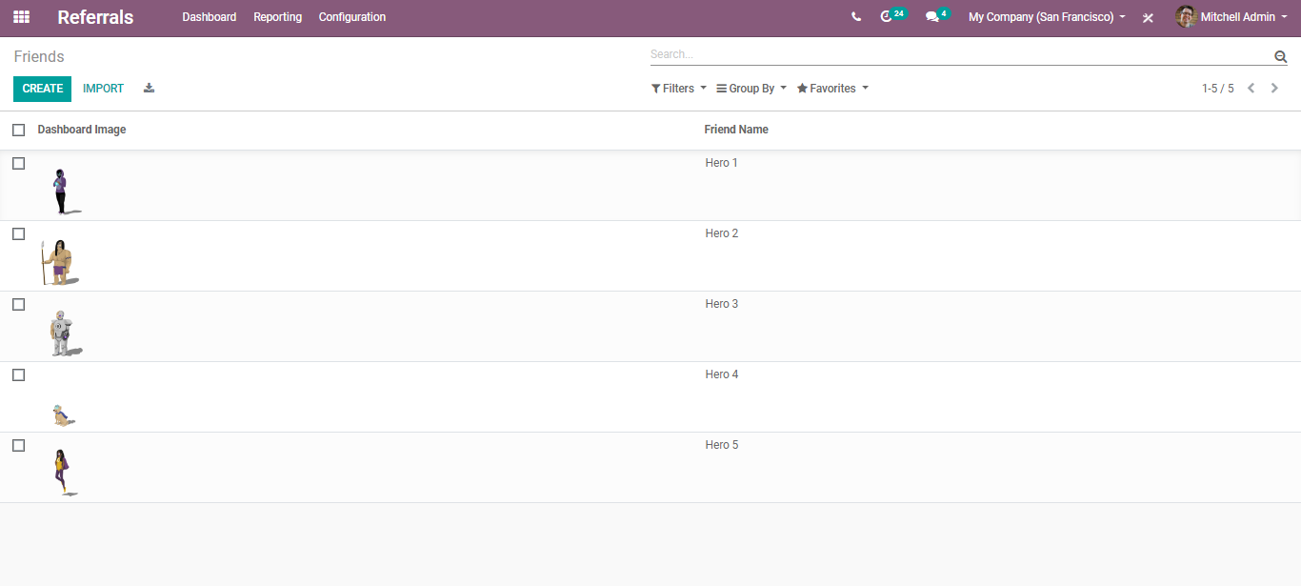
  - 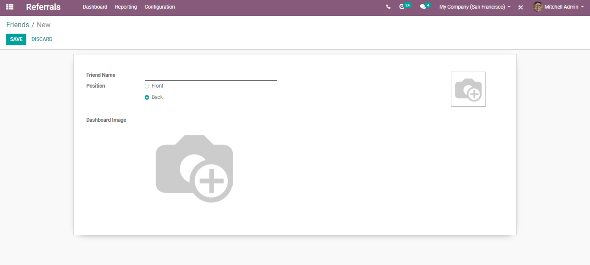
  - Here you can select the dashboard image, friend name and Position (If it is a small friend like a dog, you must select front, it will be displayed in the front of the dashboard, above the superhero.)
  - To configure Alerts, go to Referral> Configuration> Alerts
  - 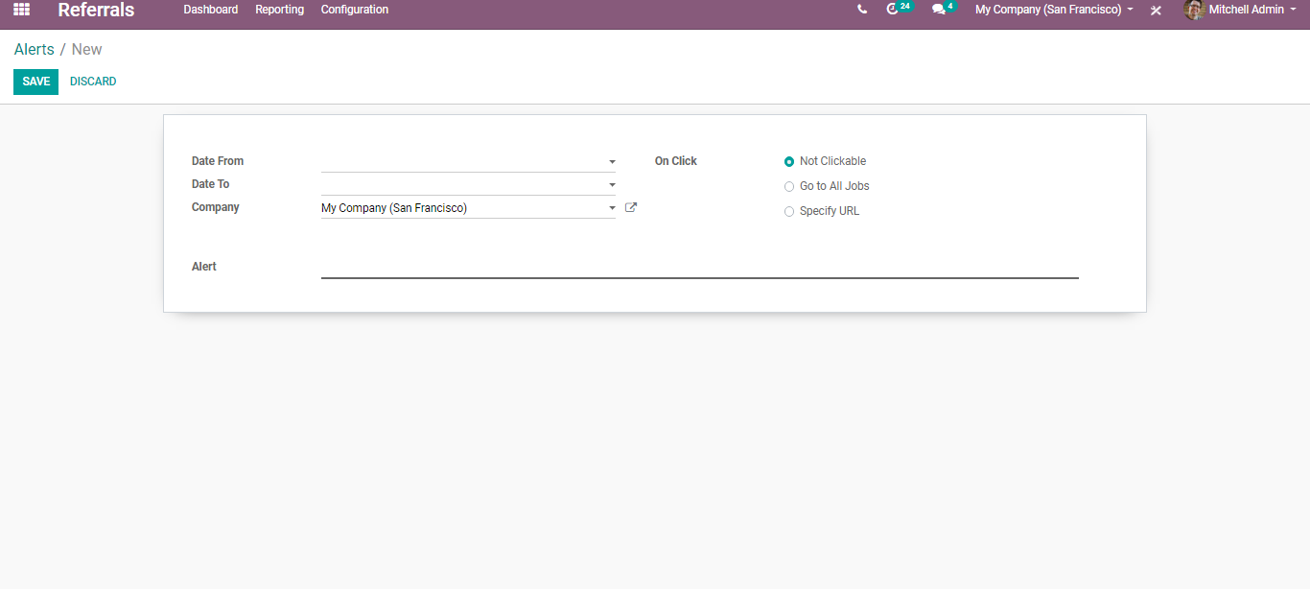
  - One can set the duration of alert, alert on all jobs/URLs.
  - To configure onboarding, go to Referral> Configuration> Onboarding
  - 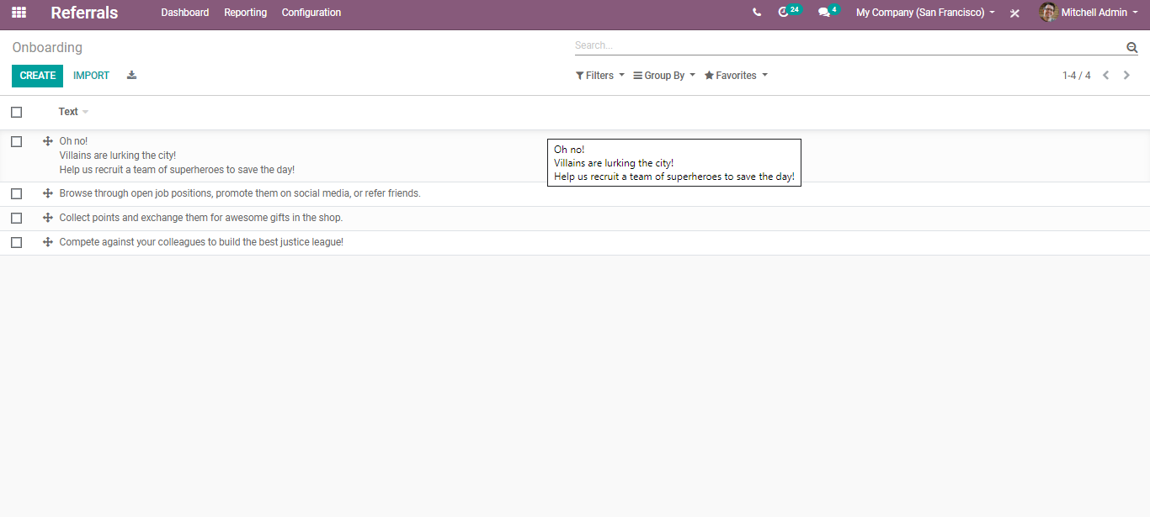
  - 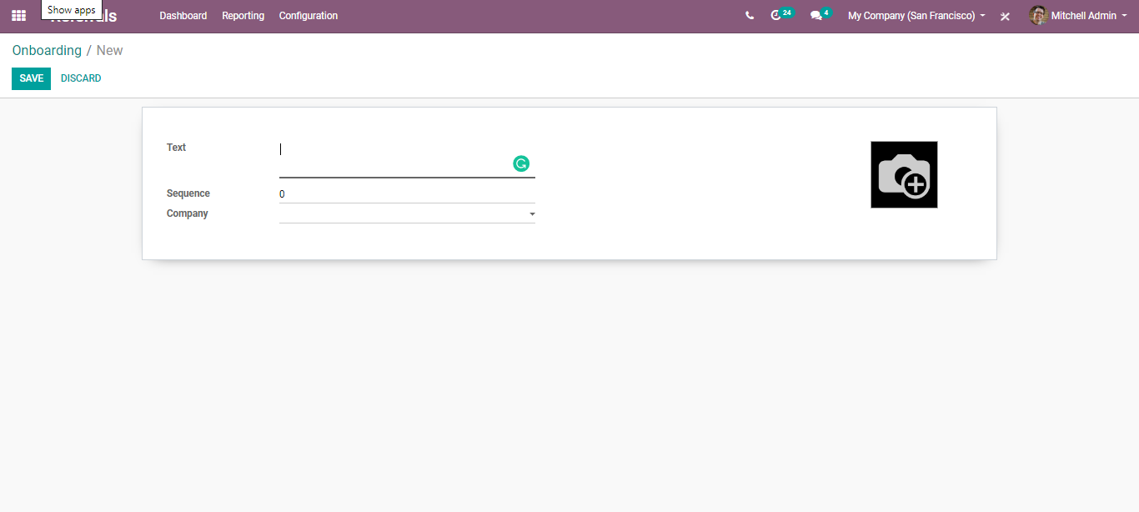
  - One can set here the text, sequence, and company.
  - To start with the app, Go to Dashboard. Click START NOW.
  - 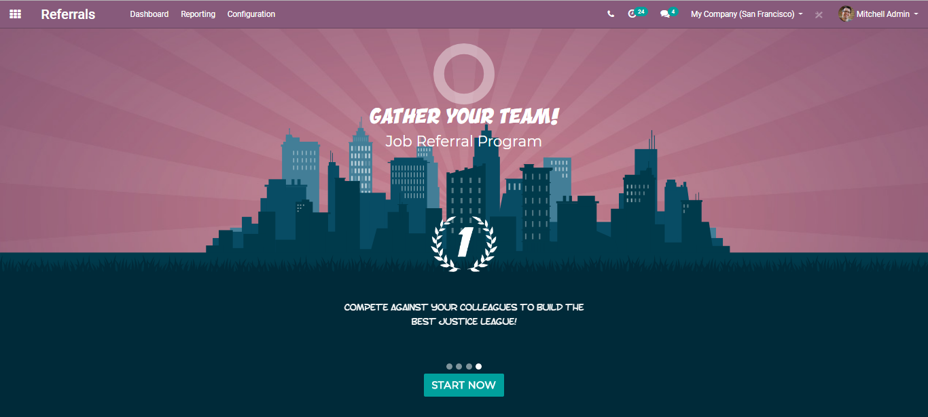
  - Choose an avatar for your new friend.
  - 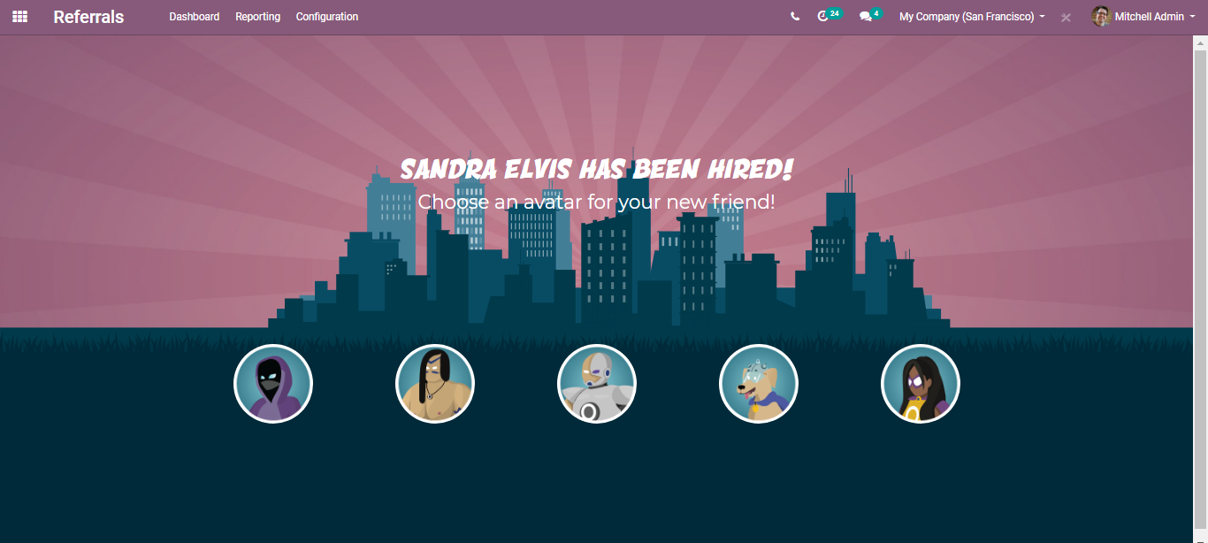
  - You will be navigated to a new window like below:
  - 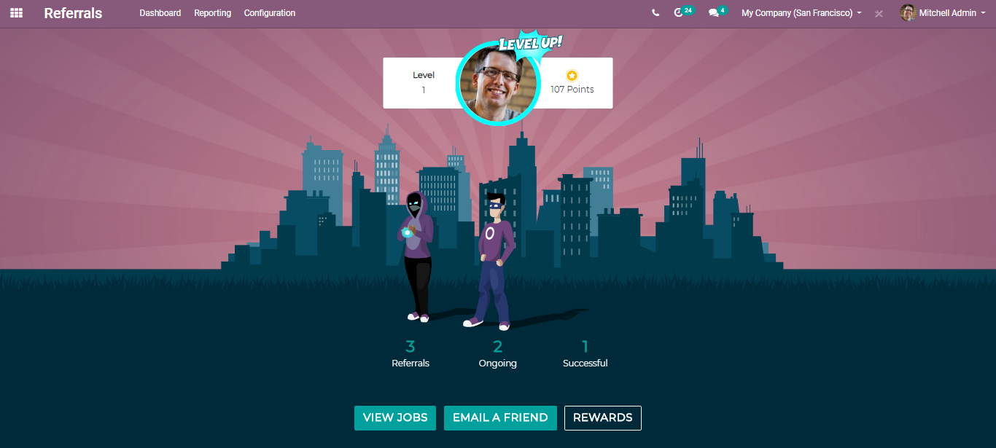
  - From here, one can view the opened positions, see the rewards also email the friend.
  - Upon clicking view jobs, you will be navigated to a new window like below:
  - 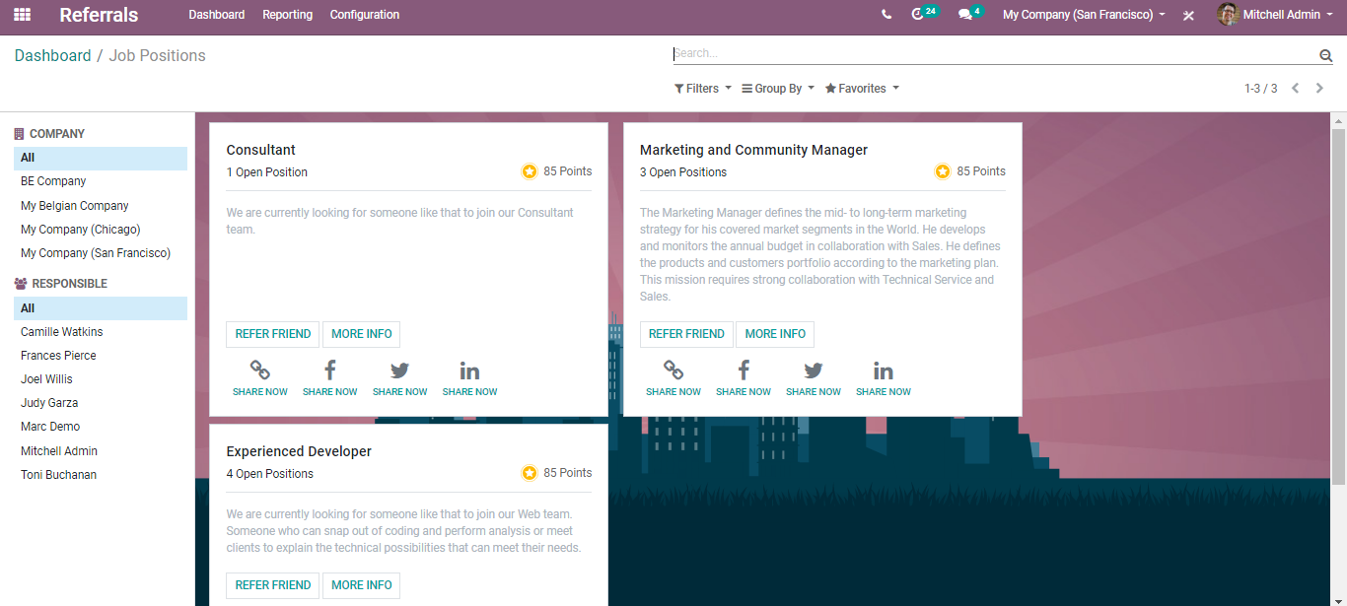
  - Via clicking REFER FRIEND you can refer your friend for the job position. And via clicking more info, you get redirected to the webpage of the opened job position.
  - 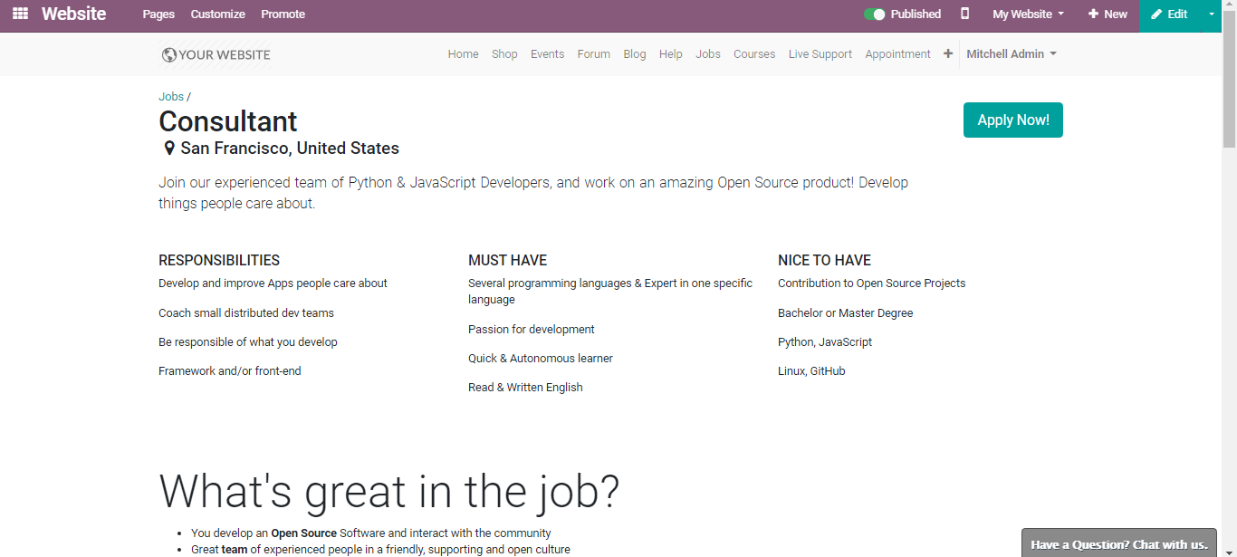
  - Via clicking REFER A FRIEND, you can send a job offer by email.
  - An auto-generated email template appears, and you can add the email id and send it to your friend.
  - 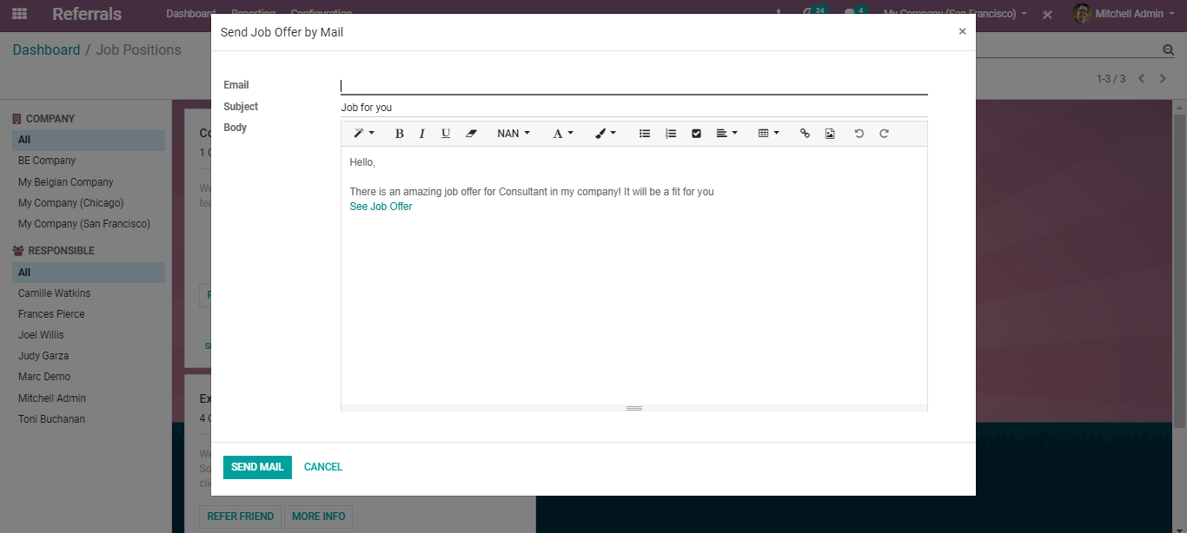
  - One can also share the openings in social media for that you can click the SHARE NOW buttons provided.
  - 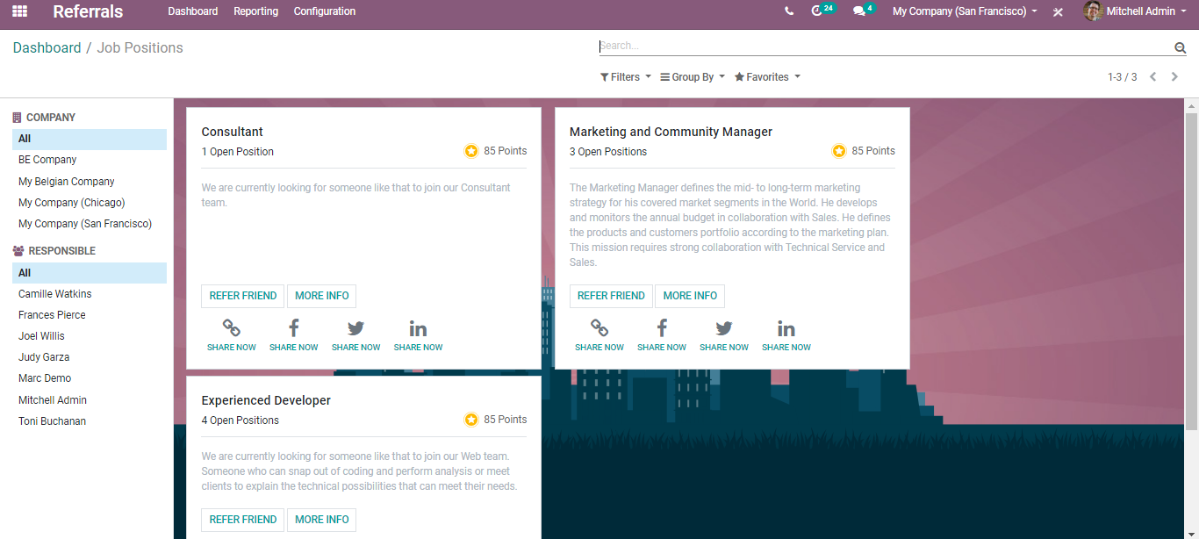
  - 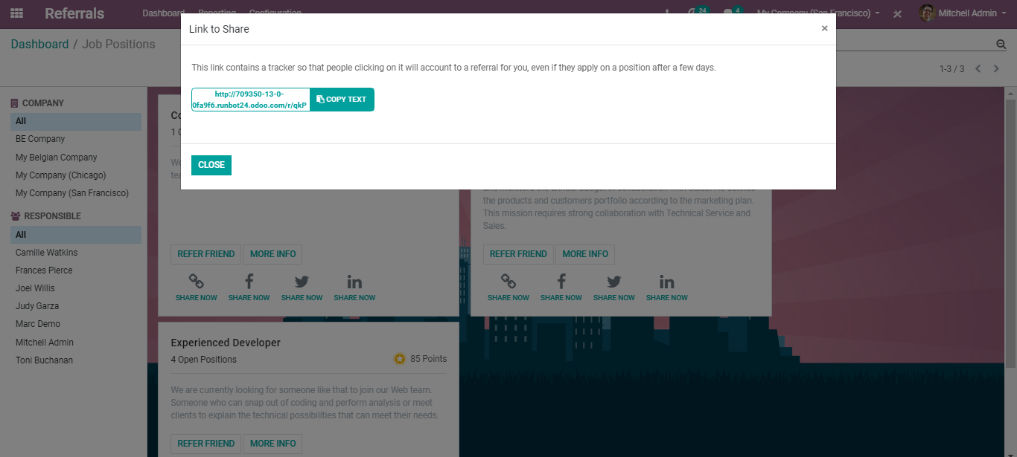
  - Upon clicking the default Facebook or Twitter media, you will be redirected to the corresponding page of the network.
  - 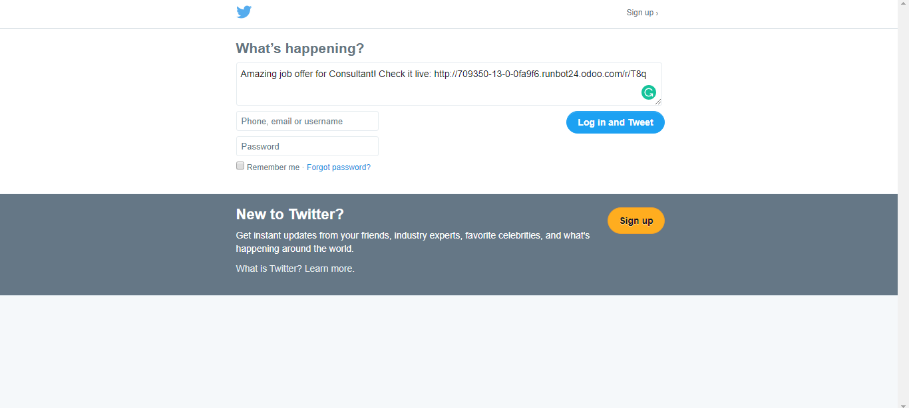
  - And via going to reporting, one gets to see the employee referral analysis.
  - 