  - Sales and Invoicing
  - Products
  - Each business is identified with at least one product. What is a product? A product can be anything in a form that can be offered to a market that may fulfil the customer’s specific wants or need. In retailing, products are called stock. In manufacturing, products are purchased as raw materials and are sold as completed merchandise.
  - The beginning stage of any ERP programming includes the product generation task. All the data concerning a product is put away in the framework for better management of the product. BUSINESSBOXERP has a striking product management department. Utilizing it, the client can determine the features of the product like the picture, name of the product, type of the product, procurement status, stock status, purchases, and bookkeeping subtleties.
  - A decent ERP programming like BUSINESSBOXERP will likewise store the product subtleties like reordering rules, bill of materials if the item is saleable, also draft the manufacturing request if the item is available, and related sales request and buy orders and so on.
  - The client can set diverse depictions of the product to the provider and the client under BUSINESSBOXERP.
  - As you open the sales module and select the product button, you can see that BUSINESSBOXERP has just enrolled a couple of items for your need. Anyway, one can make another new product in understanding to the business need.

  - CREATE NEW PRODUCT
  - All you need to do is Go to Sales->Product->Create
  - 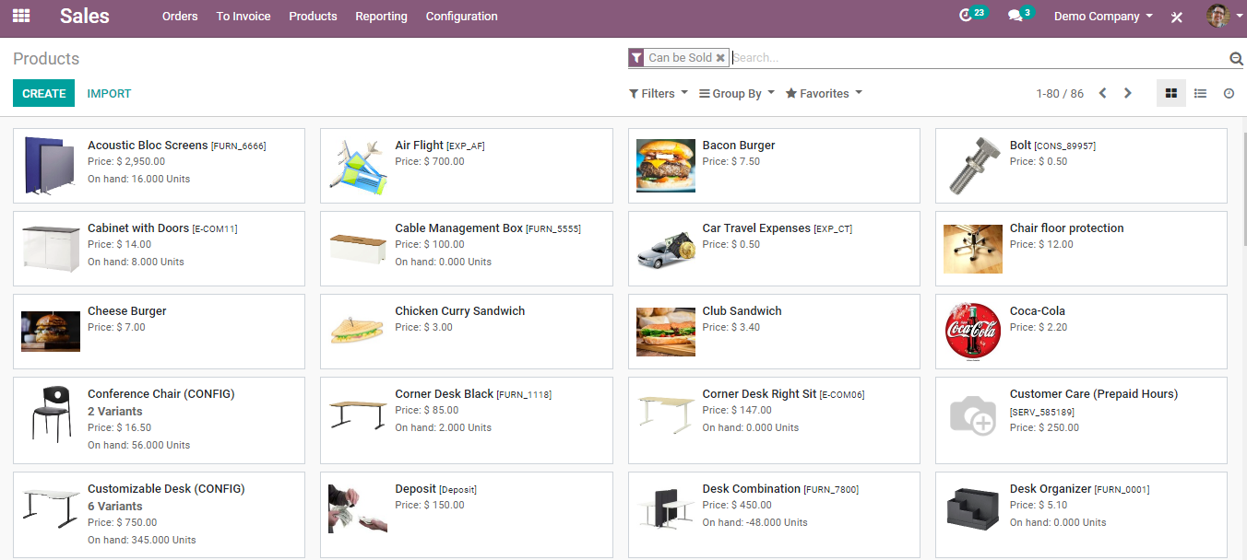
  - As soon as you click on the CREATE button, you will be navigated to a new window with product info. There you can click on the EDIT button and make all the necessary changes to the product and its associated features.
  - The creation form will look like this:
  - 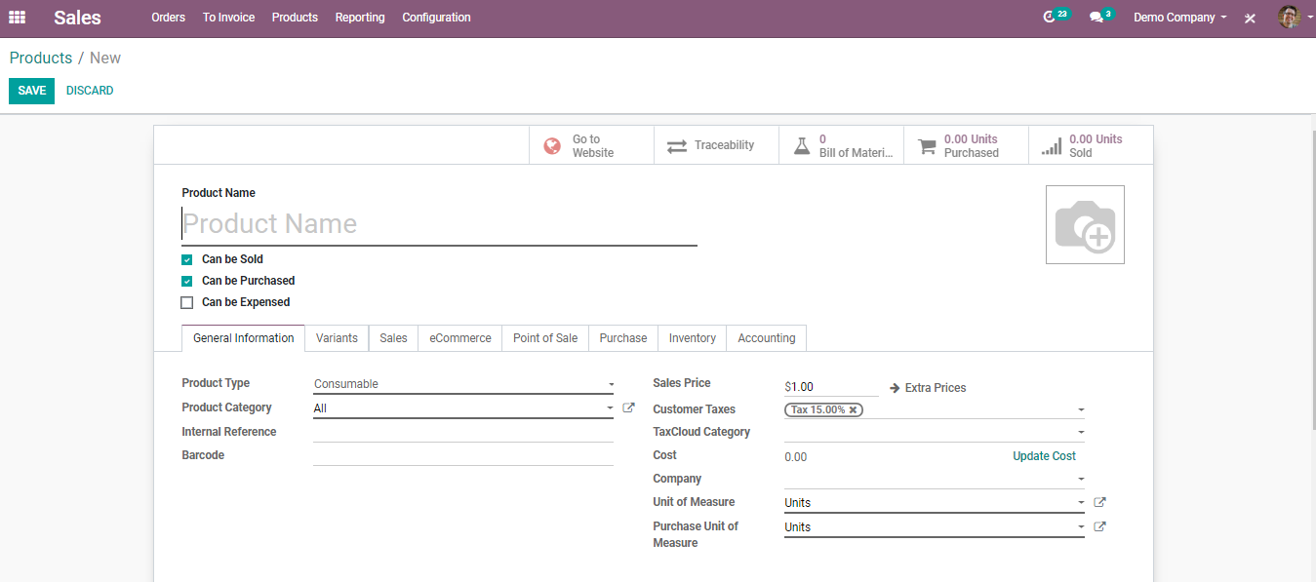
  - Product name: It is the name that will be displayed on all other screens that refer to this specific product.
  - Can be Sold: To remove a product from showing up on the ‘sales product’ list, uncheck the Can be Sold button. Generally, this is used while creating a raw material or a product for internal consumption.
  - Product Type: Product Type is the first option on the Information tab. There are three available product types:

  - 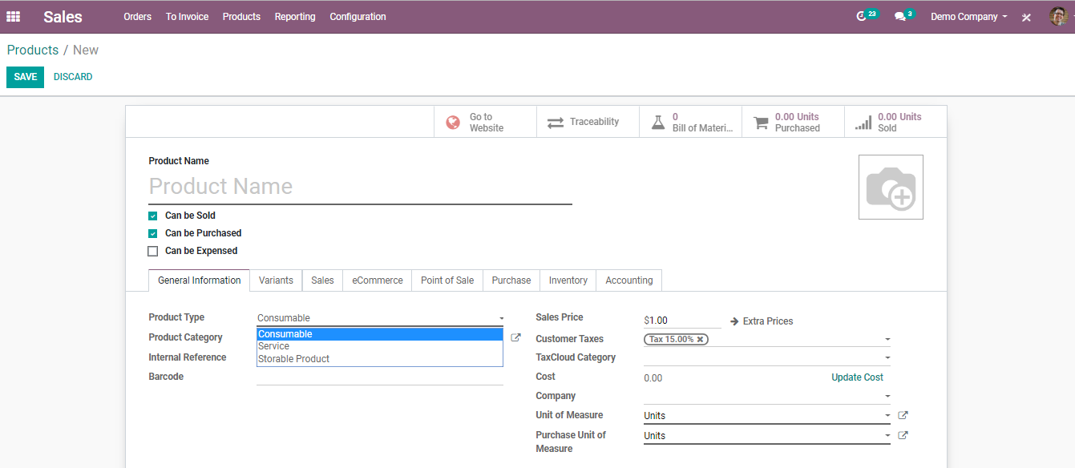
  - Services: A service is a non-material product that you provide. This type of product will configure at the time when your company is providing any type of service to your customers. Therefore, it does not appear in the various stock operations. In BUSINESSBOXERP, the services are also considered as a product. But users can't keep the stock of a service.
  - Consumables: A product for which the user doesn't want to manage the inventory (no quantity on hand or forecasted) but that can be received from the supplier or delivered to the customer. BUSINESSBOXERP assumes that the product always has enough stock.
  - Stockable: The product which is managed with Inventory. This product is used in stock management and its replenishment is automated by the rules defined in the system. In a Stockable product, you can easily maintain your minimum stock level by defining the reordering rule for stock in your system, so that your stock will not reach out of stock. If you do not set the Reordering rule, BUSINESSBOXERP ERP will show up warning messages in a quotation if there isn’t enough balance in the stock. BUSINESSBOXERP ERP will prevent processing delivery orders that don’t have balances in the stock, and it can be processed only by the force availability button in the delivery order.
  - Product Category: The user can organize the products under a specific category.

  - 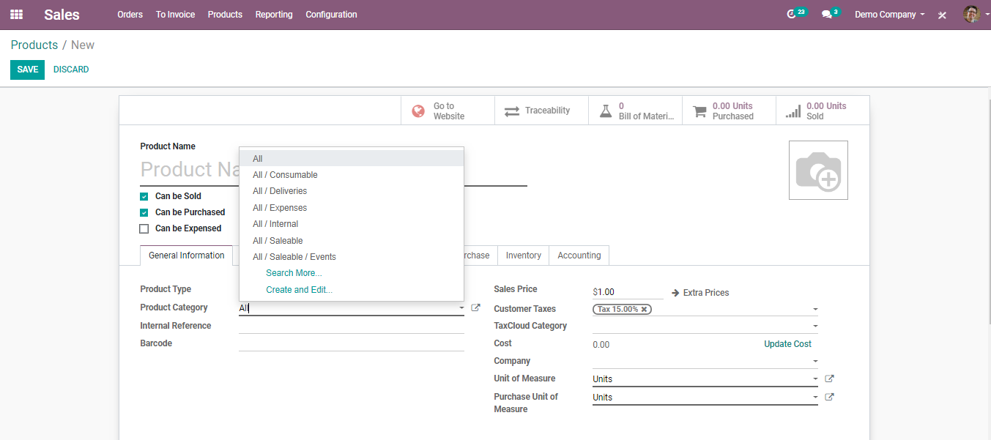
  - Internal Reference: For the most part, BUSINESSBOXERP utilizes the Product Name field and the description when displaying product information. Commonly, a company may have a coding system for its products. The Internal Reference field is useful to enter an alternative product code or number for the product in that case.
  - Barcode: Especially, when the number of products is more, the probability of human error also increases. Now smartly and effortlessly add/update product quantity by scanning product barcodes while receiving or delivering products in your BUSINESSBOXERP.
  - Sales Price: The price at which the product is sold to the customer.
  - Consumer Tax: Default taxes used when selling the product. BUSINESSBOXERP's tax engine is very flexible and supports many different types of taxes: value-added taxes (VAT), eco-taxes, federal taxes, retention, withholding taxes, etc. For most countries, the chart of accounts you set up is automatically pre-configured with the main taxes of the country.
  - Under Sales Tab of the product.
  - 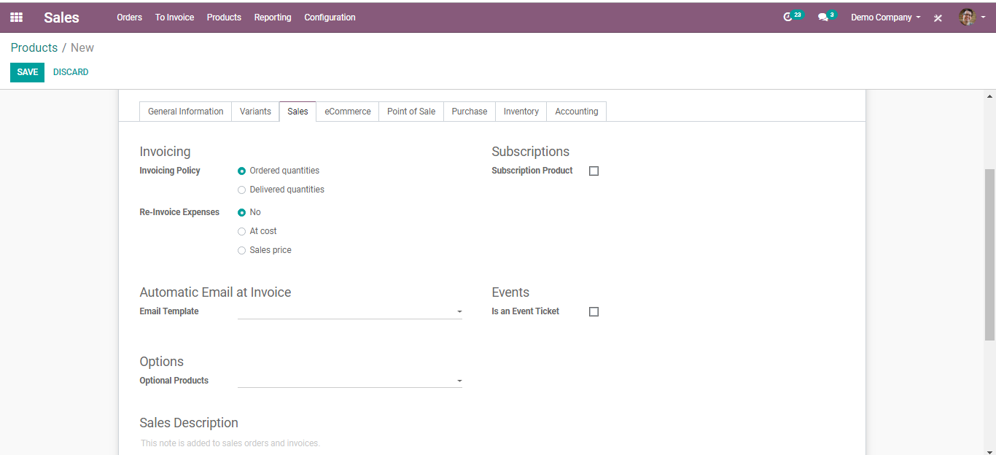
  - Invoicing Policy: Ordered Quantity: Invoice quantities used by the customer.
Delivered Quantity: Invoice quantities delivered to the customer.
  - Subscription Product: If set, confirming a sale order with this product will create a subscription.
  - Email Template: Send a product-specific email once the invoice is validated.
  - Event Ticket: If checked this product automatically creates an event registration at the sales order confirmation.
  - Optional Products: Optional products are suggested whenever the customer hits the “Add to cart.”
  - Sales Description: A description of the product that you want to communicate to your customers. This description will be copied to every Sales Order, Delivery Order, and Customer Invoice/Credit Note.
  - Warning Message: Selecting the ‘Warning Option’ will notify the user of the message. Selecting “Blocking Message” will throw an exception with the message and block the flow. The message must be written in the text file.
  - Under the E-commerce Tab of product,
  - 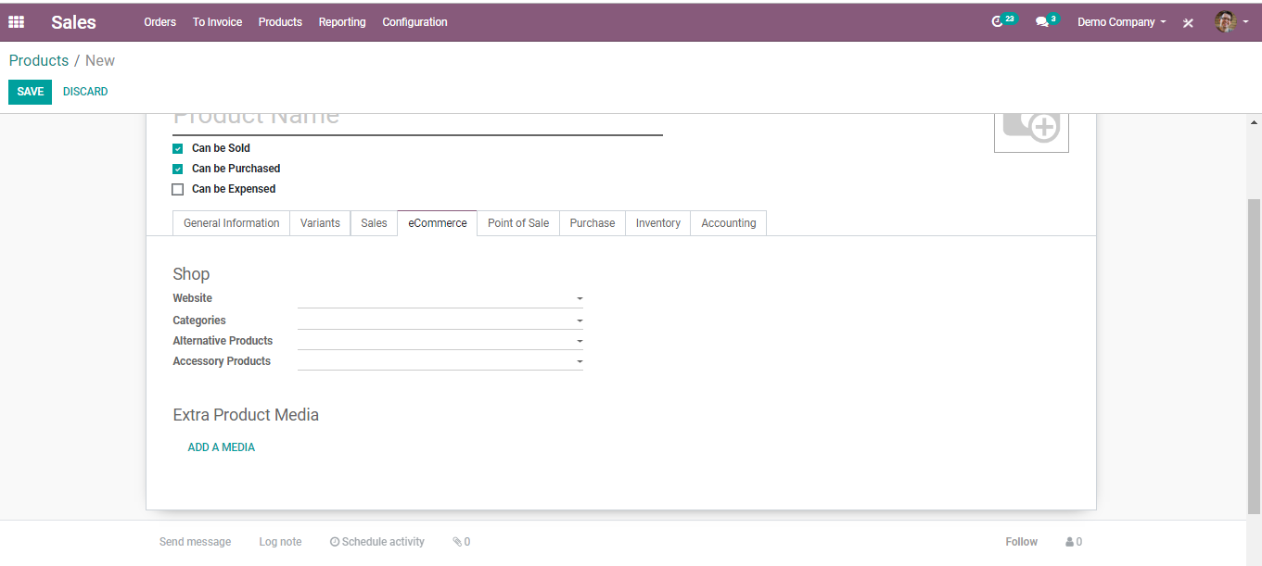
  - Website: Option to restrict publishing to this website.
  - Categories: The product will be available in each mentioned e-commerce category. Go shop>Customize and enable ‘E-commerce categories.
  - Alternate Product: Suggest Alternatives to your customer (upselling strategy). Those products show up on the product page.
  - ACCESSORY Product: Accessories show up when the customer reviews the cart before payment.
  - Extra Product Media:
  - 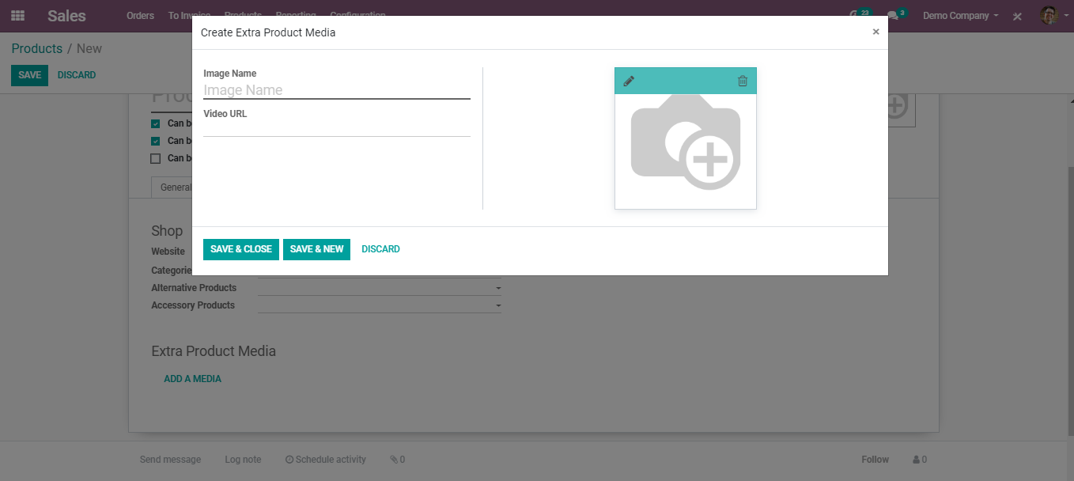
  - Under Point-of-Sale Tab of product
  - 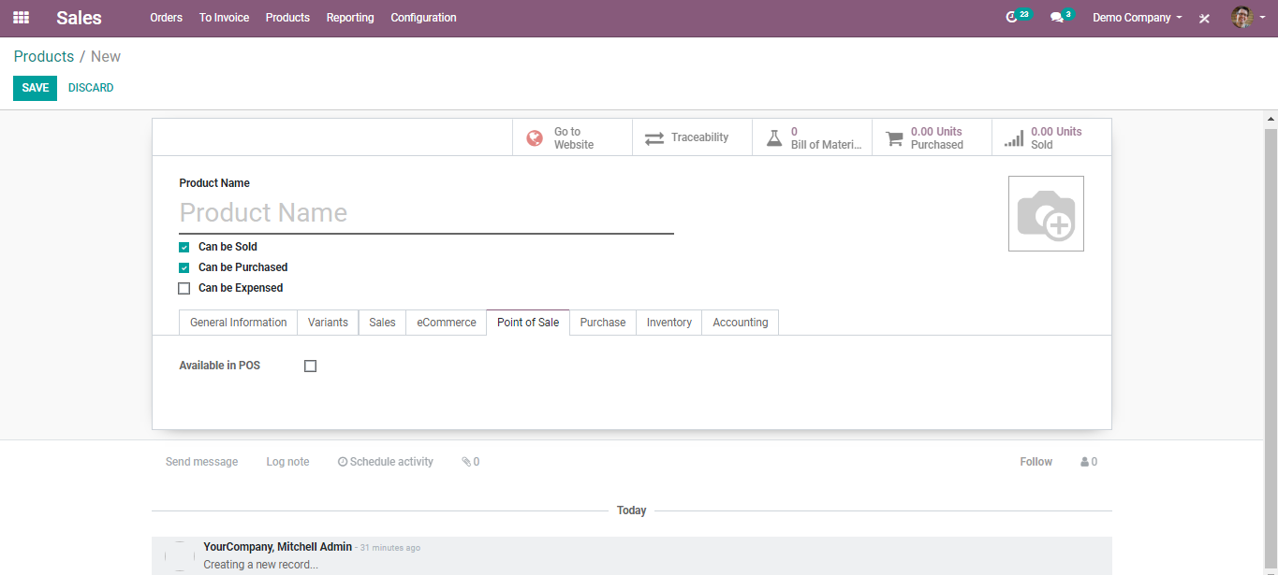
  - Available in POS: Check this if you want this product to appear in the POS.
  - Under Purchase Tab of product
  - 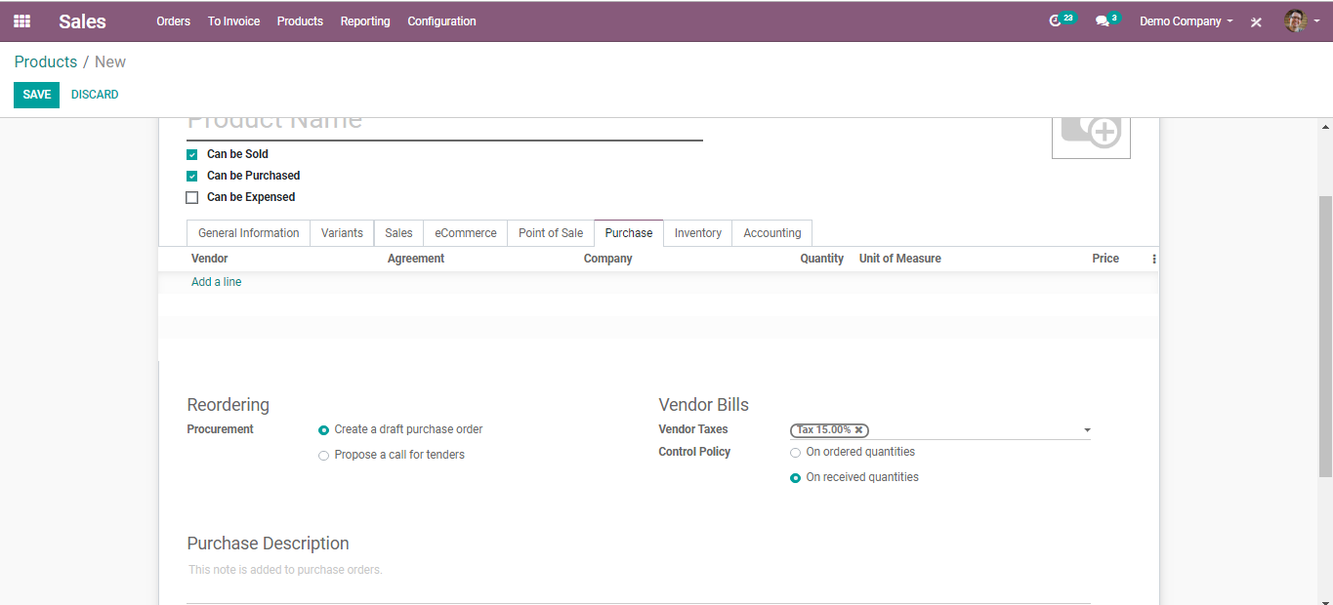
  - Reordering: Procurement: Create a draft purchase order - Based on your product configuration, the system will create a draft purchase order. Propose a call for tender -If the purchase requisition module is installed and this option is selected, the system will create a draft call for tender.
  - Vendor Bills: Vendor Taxes- Default taxes used when buying the product.
  - Control Policy: On ordered Quantities-Control bills based on ordered quantities. On received Quantities - Control bills based on received quantities.
  - Purchase Descriptions: This note is added to purchase orders.
  - Under Inventory Tab of Product
  - 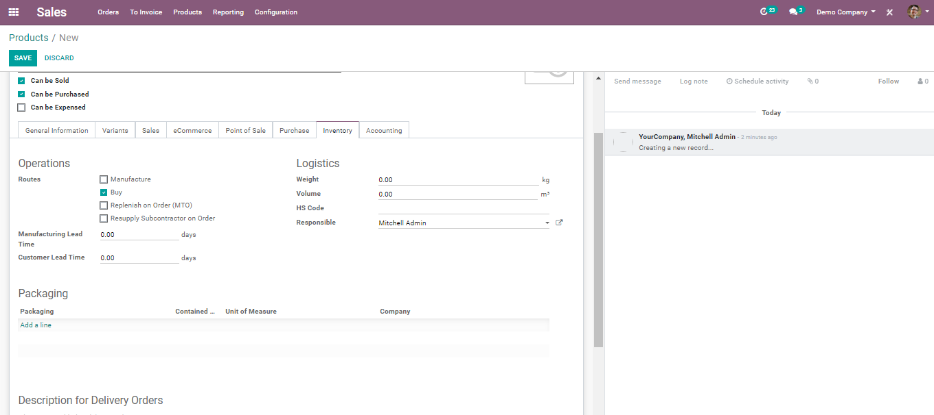
  - Route: Depending on the module installed, this will allow you to define the route of the product. whether it will be bought, manufactured, replenished on order etc.
  - Manufacturing Lead Time: Average lead time in days to manufacture this product. In the case of multi-level BOM, the manufacturing lead times of the component will be added.
  - Customer Lead Time: Delivery lead time in days. It is the number of days, promised to the customer, between the confirmation of the sale order and the delivery.
  - Packages: Gives different ways to package the same product.
  - Under Accounts Tab of product
  - 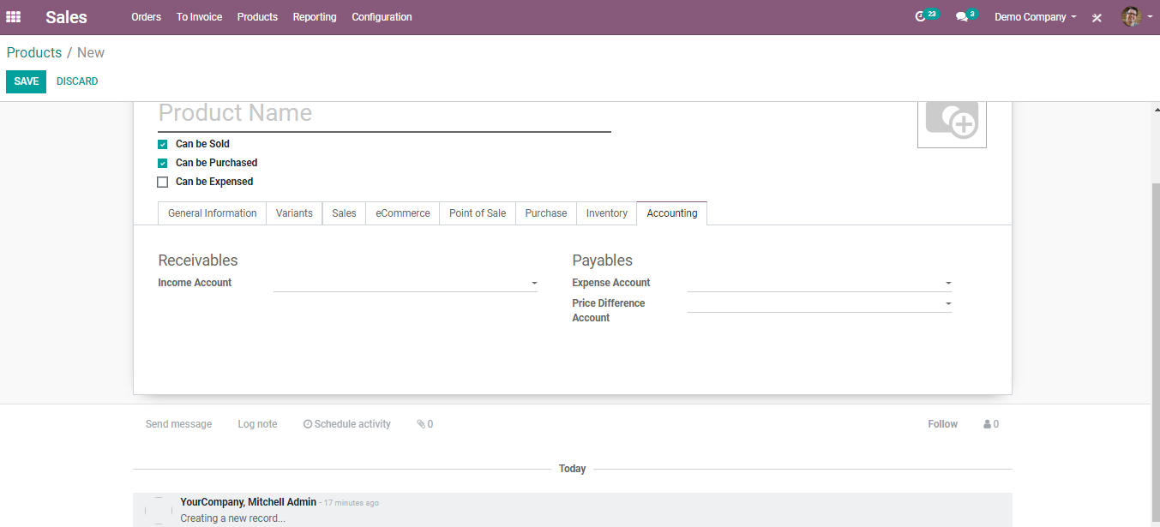
  - Income Account: Keep this field empty to use the default value from the product category.
  - Expense Account: Keep this field empty to use the default value from the product category. If Anglo-Saxon accounting with an automated valuation method is configured, the expense account on the product category will be used.
  - PRODUCT VARIANTS
  - Configure your products with variations and select optional product items
  - Product Variants
  - Product variations are utilized to oversee items having diverse varieties, like measure, shading, and so forth. It permits dealing with the item at the layout level (for all varieties) and the variation level (specific attributes).
  - For instance, an organization selling shirts may have the accompanying item:
  - B&C T-shirt
  - Sizes: S, M, L, XL, XXL
  - Hues: Blue, Red, White, Black
  - In this model, B&C T-Shirt is known as the item layout and B&C T-Shirt, S, Blue is a variation. Sizes and shading are properties or attributes.
  - To enable the choice, go to Sales/Configuration/Settings and Activate Variants Under the Product Catalogues Option.
  - 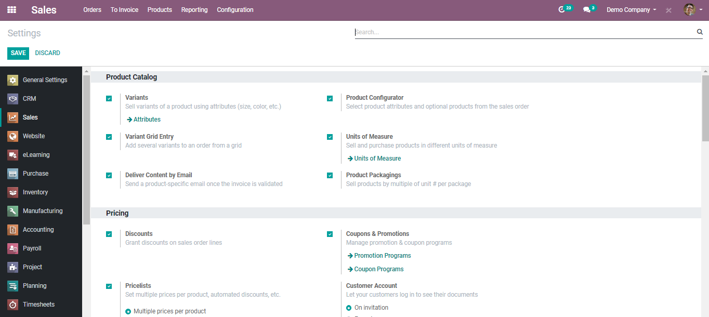
  - On the off chance if you click on the attributes button, a window simply like beneath will be showed up.
  - 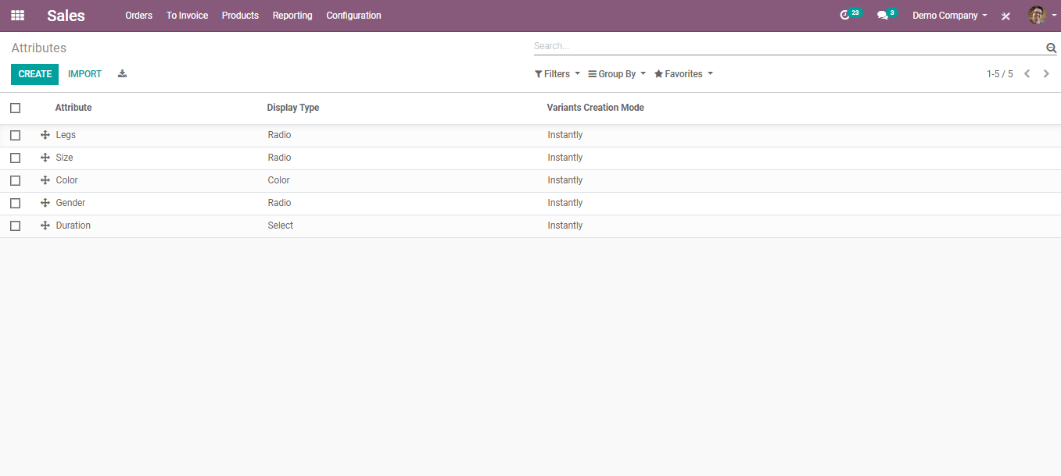
  - However, to make a new attribute, you can click on the CREATE BUTTON. Also, can import the attribute from the rundown.
  - 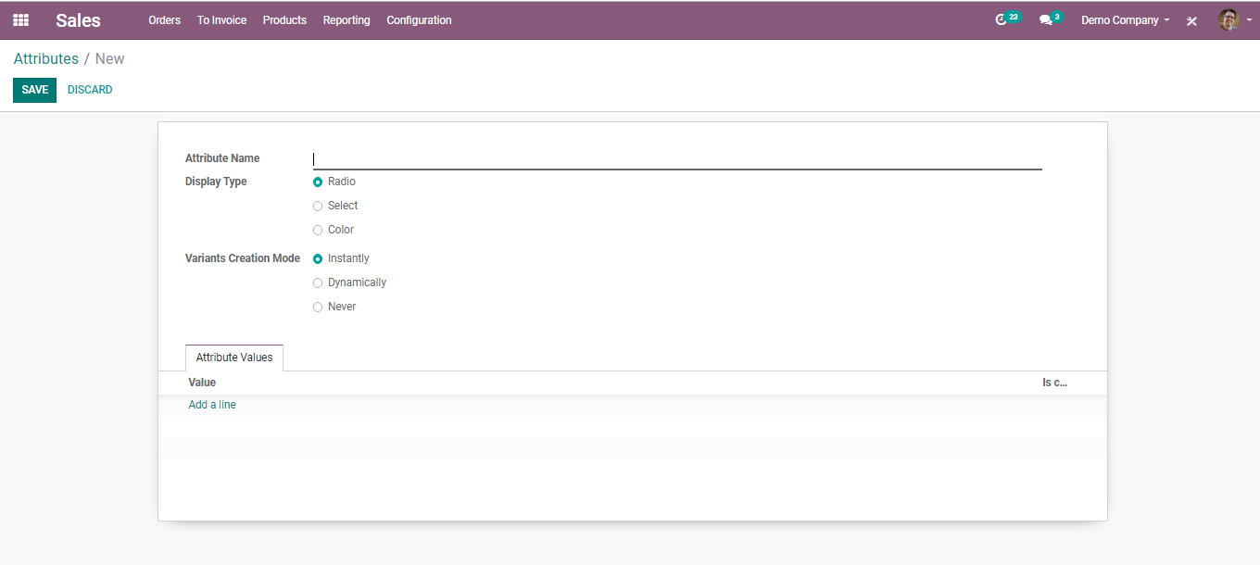
  - Display Type: The display type used in the product configurator.
  - Variants Creation Mode:
  - -Instantly: All possible variants are created as soon as the attribute and its values are added to a product.
  - -Dynamically: Each variant is created only when its corresponding attributes and values are added to a sales order.
  - -Never: Variants are never created for the attribute.
  - Note: the variants creation mode cannot be changed once the attribute is used on at least one product.
  - CUSTOMERS
  - Under BUSINESSBOXERP one can choose the customer from the listed option or create a new customer.
  - CREATE NEW CUSTOMER
  - 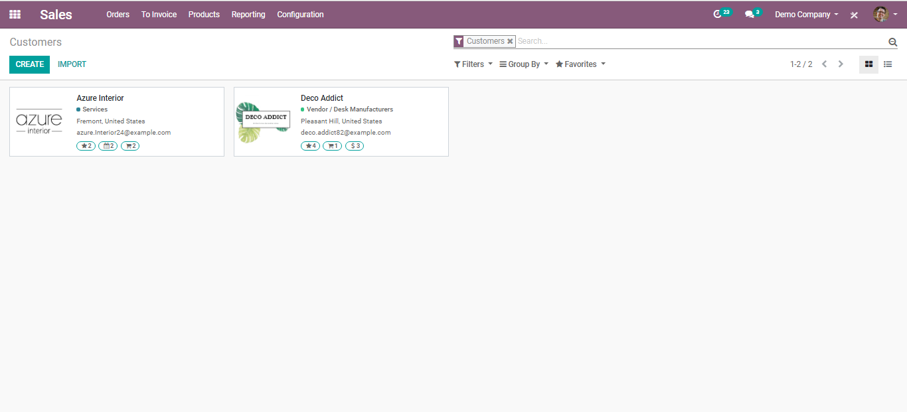
  - Upon clicking CREATE button, you get a creation form like the below image:
  - 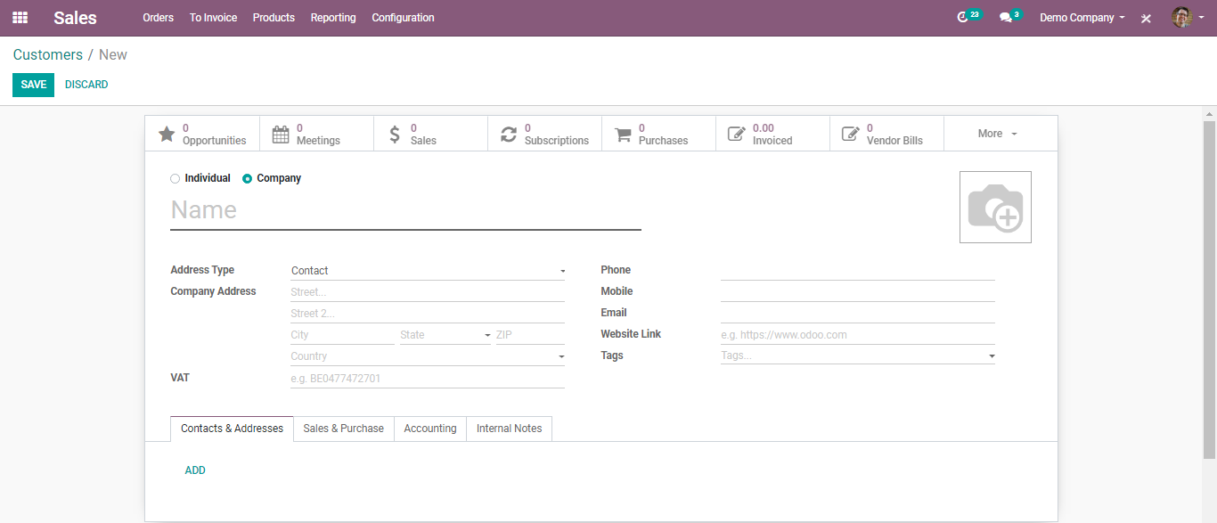

  - Under BUSINESSBOXERP you have two types of customers:
  - Individual
  - Company
  - Under Contact and Address Tab
  - 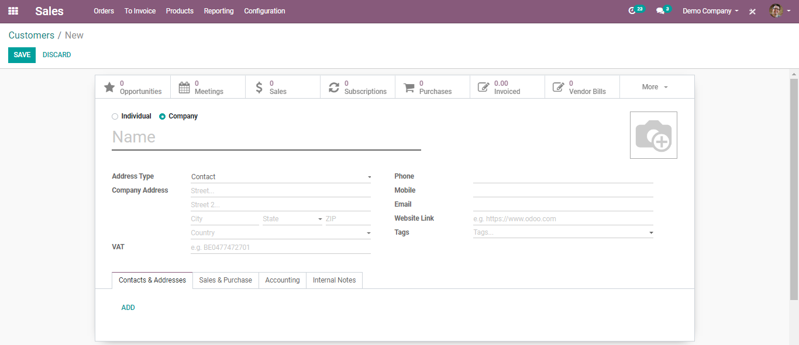
  - Here you have the option to completely configure a new customer of yours via adding his name, address, phone, mobile, email id, website, his preferred language (to send invoice), tags(specializations) to make it more specific etc.
  - Under Sales and Purchase Tab
  - 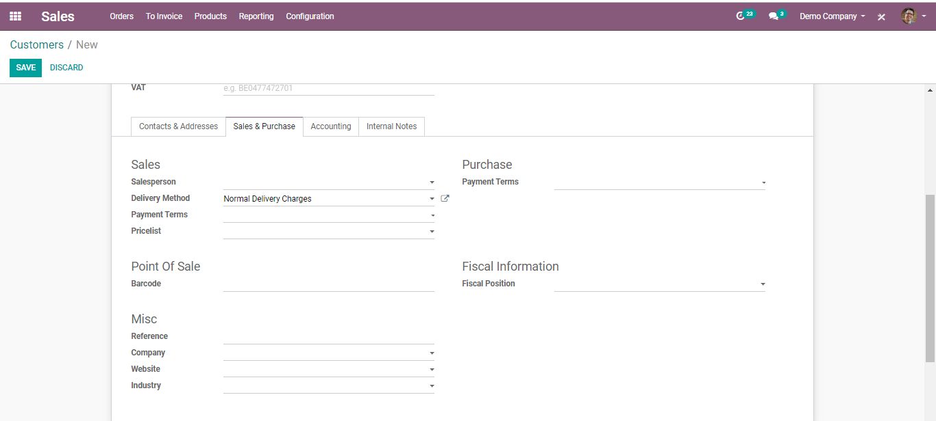
  - Salesperson: The internal user in charge of this contract.
  - Delivery Method: Default Delivery method used in sales order.
  - Payment Terms: This payment term will be used instead of the default one for the sales order and customer invoice.
  - Pricelist: This price list will be used instead of the default one, for sales to the current partner.
  - Barcode: Use a barcode to identify this product from POS.
  - Fiscal Position: Fiscal position determines the taxes/accounts used for this contract.
  - Under Accounting Tab
  - 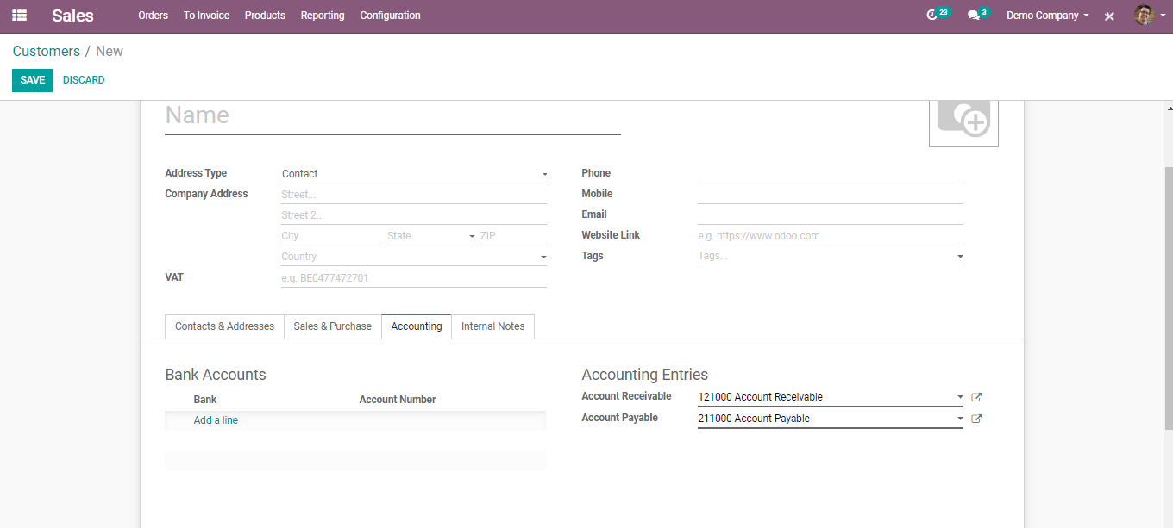
  - Bank: The name of the bank, where the customer holds the account.
  - Account number: The customer’s registered account number.
  - Account Receivable: This account will be used instead of the default one as the receivable account for the current partner.
  - Account Payable: The account will be used instead of the default one as the payable account for the current partner.
  - Internal Note Tab: Internal note is a functional feature that you put comments without disturbing followers. If you want to notify a particular seller, rather than disturbing all others, you can insert an internal note in the customer form.

  - SALES QUOTATIONS
  - Sales Quotation gives away the information to the purchaser what expenses would be included for the work, they might want to have done. Numerous organizations provide services that can't have a forthright cost, as the costs included can differ. This can be because of the materials that would be utilized, and the labour that would be vital.
  - You can select the option QUOTATIONS from the Order list in Sales Module.
  - 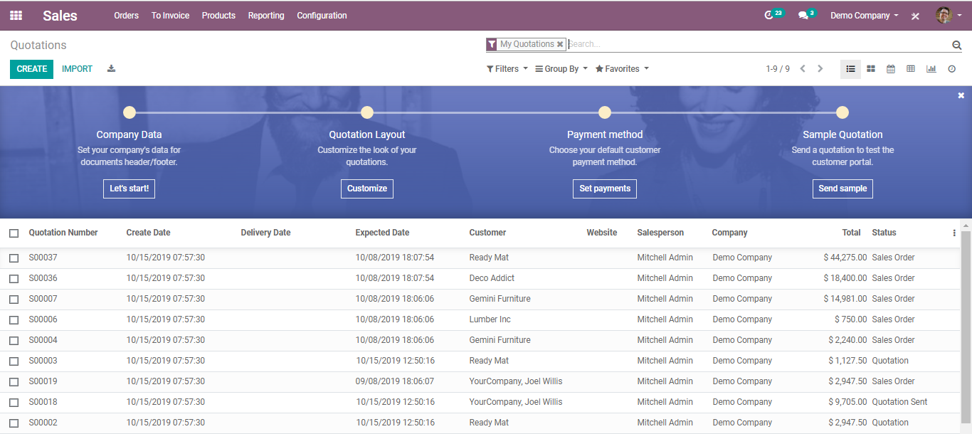

  - CREATE NEW QUOTATION
  - To make a new quotation, go to Sales - >Quotations and click on CREATE.
  - A form like below will appear.
  - 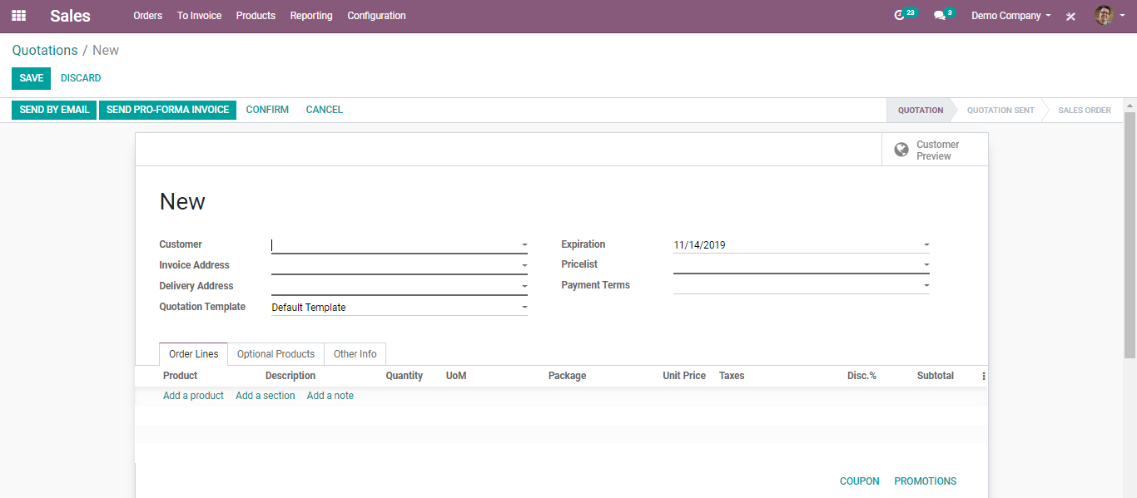
  - Here you can enter the Customer and Products. They are the most essential components to add to any quotation. Customer- the individual you will send your quotation to and Products- you need to sell.
From the quotation form, you can pick the prospect from the Customer drop-down rundown
  - 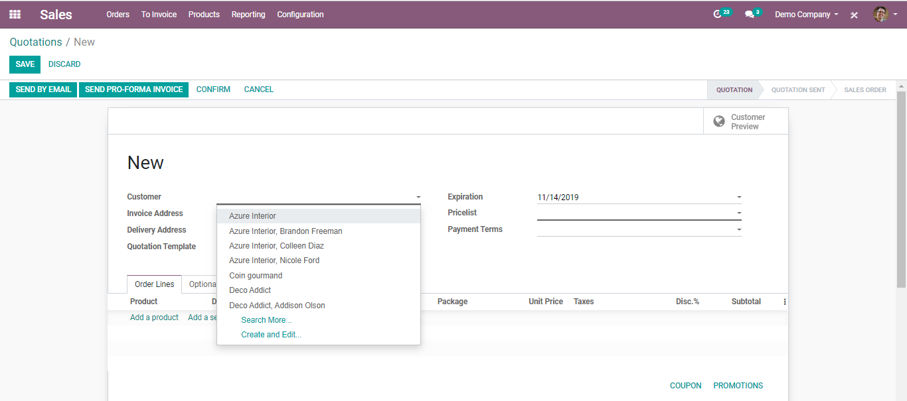
  - furthermore, under Order Lines, click on Add a product to select your item that is intended for selling. Remember to physically include the number of things under Ordered Quantity and the Discount % if applicable.

  - 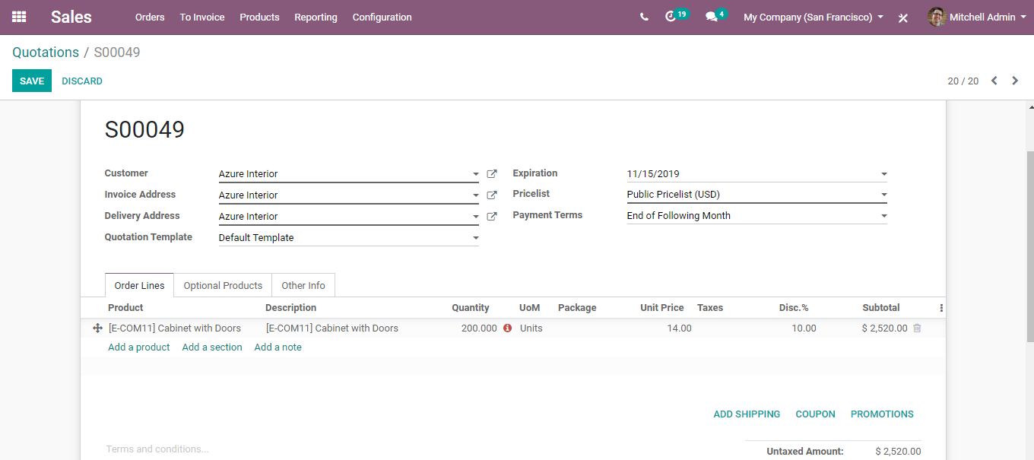
  - Also, you can add here the Quotation Template, Pricelist, Payment Terms, Shipping, Coupon and Promotions, Terms and Conditions

  - Let us look one by one.
  - QUOTATION TEMPLATE
  - Create quick quotations using quotation template.
  - If you frequently pitch similar products or services to a prospect, you can spare a great deal of time by making custom quotation layouts in BUSINESSBOXERP. By utilizing a template format, you can send a complete citation in a matter of moments.
  - To avail of the feature, go to Sales ‣ Configuration ‣ Settings and activate Quotations Templates.
  - 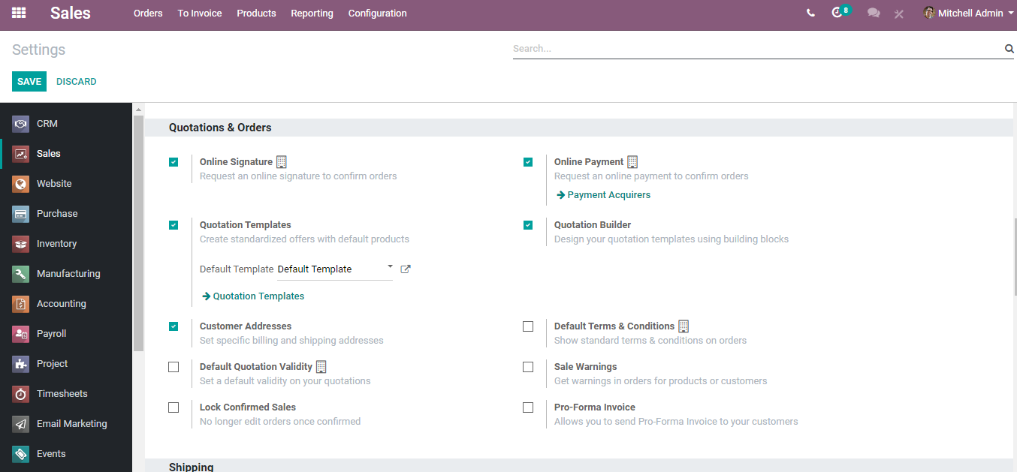
  - Create your first template
  - You will discover the templates menu under Sales >Configuration> Quotation Templates.
  - One can either create a new quotation template or edit the existing one.
  - 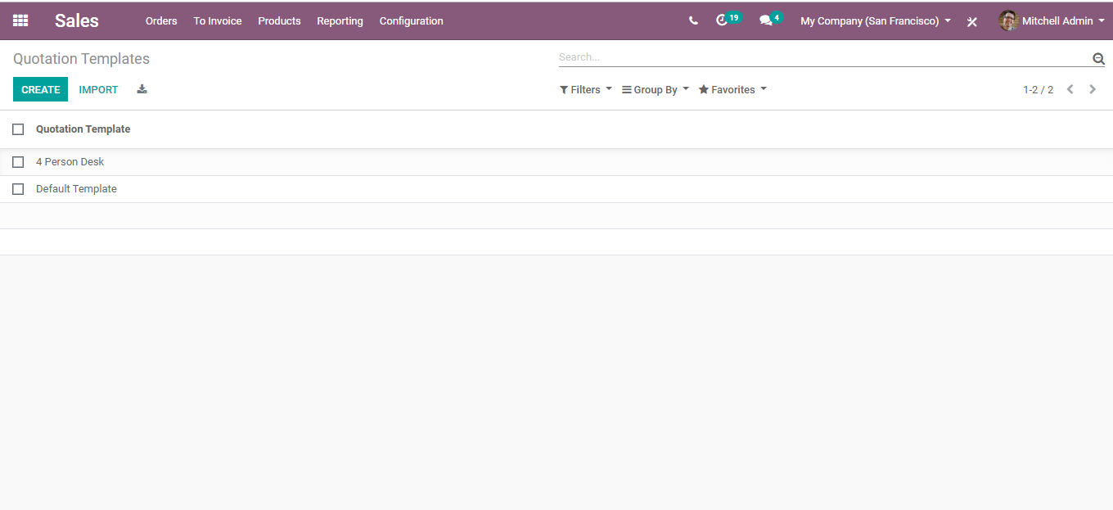
  - 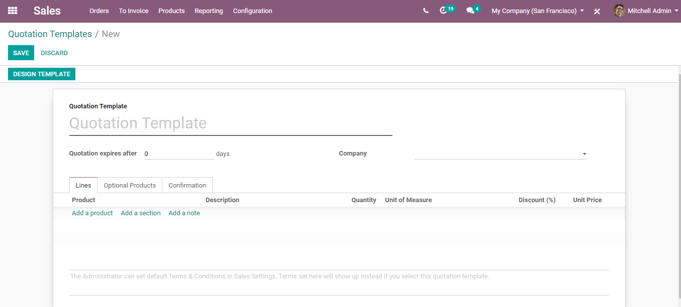
  - After naming the quotation template, you can select the product, product quantity as well as expiration time for the quotation.
  - 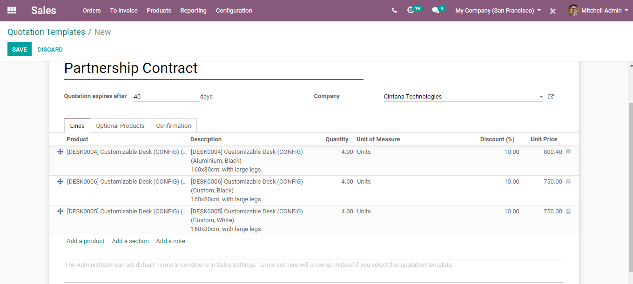
  - You can likewise also add discounts to the products if you have activated the discounts option in the sales settings. The base price is set in the product configuration and can be alternated by customer pricelists.
  - Marking Quotation Deadlines
  - It is imperative to mark a due date or deadline in the wake of sending the quotation. This practice helps in drawing your client without hesitation with the dread of passing up an offer. Furthermore, deadline helps to shield the vendor from satisfying a request that isn't financially savvy.

  - Set a due date/deadline
  - On each quotation or sales order, one can include an Expiration Date.
  - Use due date/deadline in templates
  - You can likewise set a default due date or deadline in a Quotation Template. Each time when the template is utilized in a quotation, that due date is applied.

  - 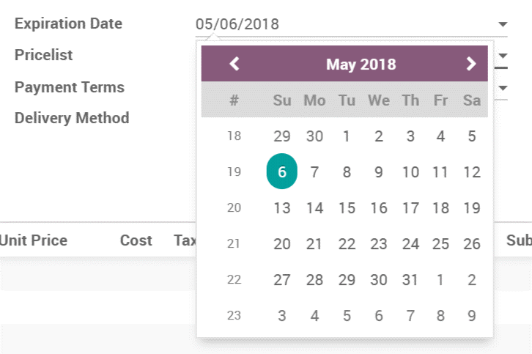
  - On the client-side, they will see this.
  - 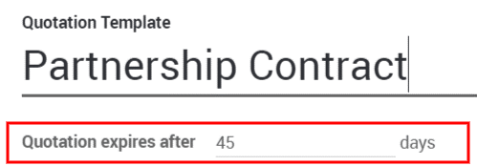
  - Editing Quotation Template
  - One can edit the customer interface of the template via clicking the Edit Template in the quotation editor.
  - 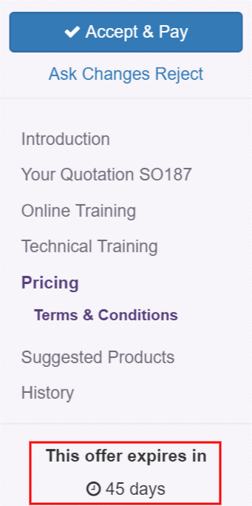
  - 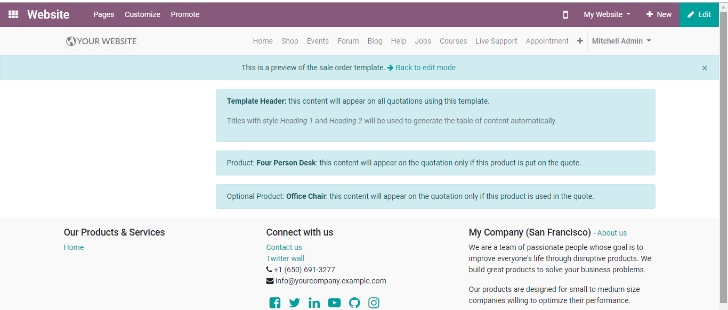
  - Note: The product description set shall remain uniform in all quotation’s templates containing those products.

  - Use a quotation template
  - When creating a quotation, simply select the desired template. All product(s) included in the template will be added to your quotation.
  - 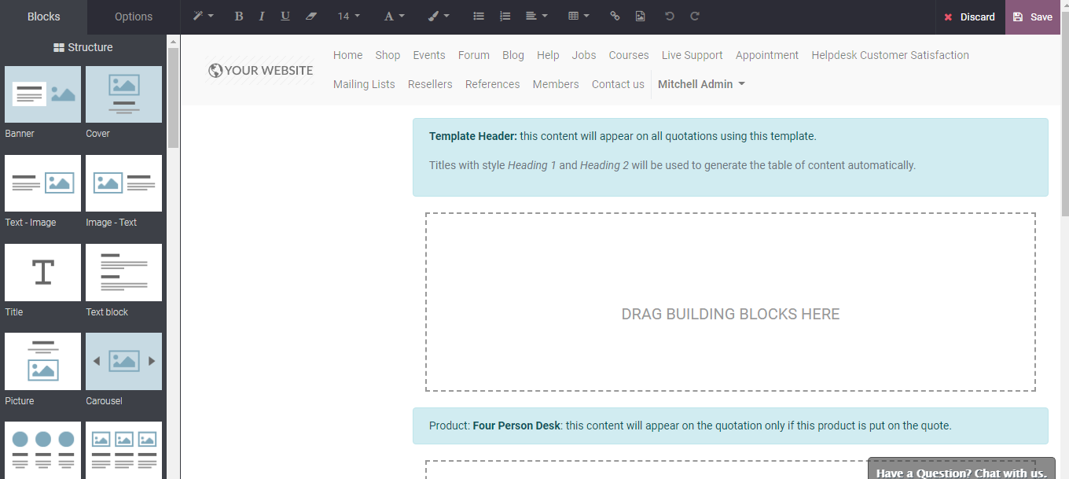
  - The confirmation process can be set within the templates themselves. Either via digital signature or online payment.
  - 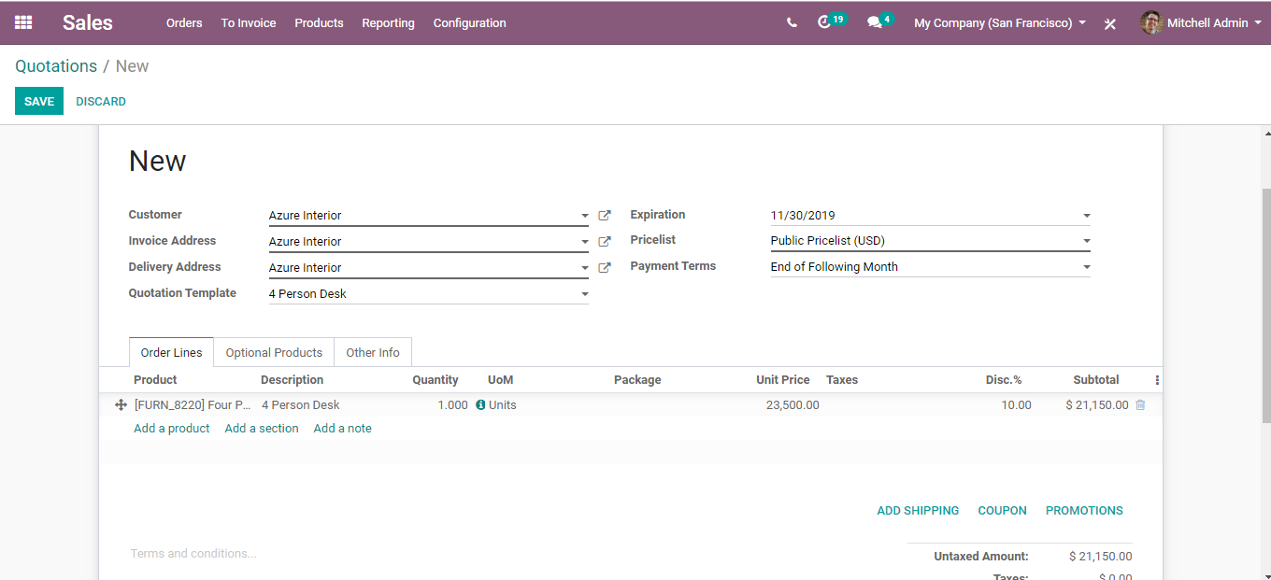
  - Every quotation will have this setting added within. However, users can change them and make them specific for each quotation.

  - PRICELISTS
  - Price lists are nothing but the lists of prices of products on sale. Using the price list feature one can easily manage(control/modify) the product prices for a specific customer/vendor or transaction, depending on the company needs.
  - To manage pricelists in BUSINESSBOXERP, Go to Sales>Configuration>Settings and tick the checkbox Multiple Sales Prices per product and save changes.
  - 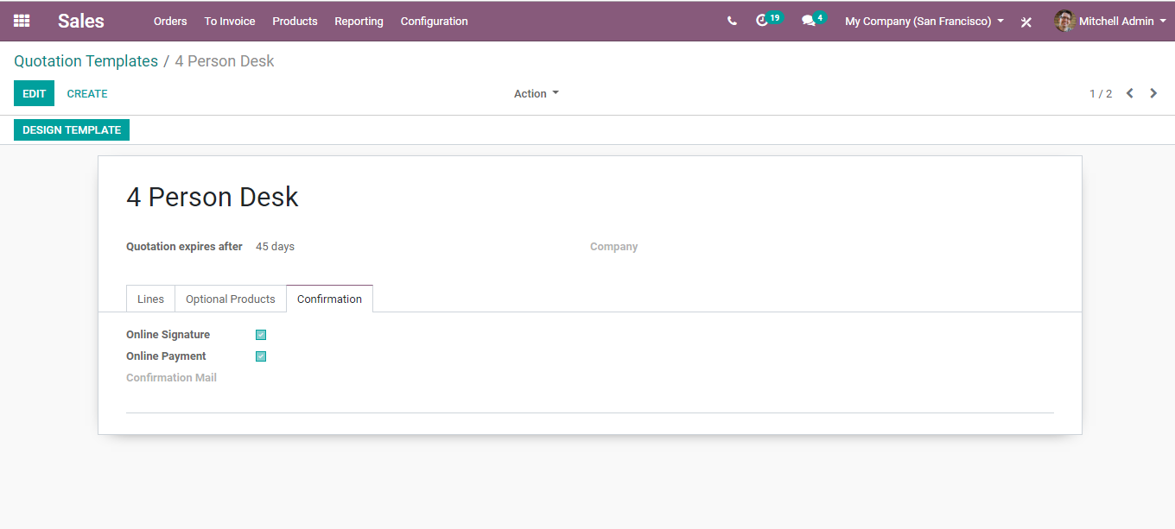
  - There are 2 types of sales pricelists in BUSINESSBOXERP.
  - Multiple prices per product (e.g., customer segments, currencies): This option allows you to create price lists for your customer segments or is used to set different pricelists with different currencies.
  - Prices computed from formulas (discounts, margins, rounding): This option allows to set price change rules. Changes can be relative to the public price, product cost price, or to another pricelist. Calculation of changes is made upon the surcharges and discounts making it fit the minimum and maximum margin set by the user. Further, BUSINESSBOXERP enables the rounding of prices to the nearest cent or dollar or even the multiple of both.
  - Pricelists Under Multiple prices per product
  - To create a new pricelist, Go to Sales>Products>Pricelists
  - 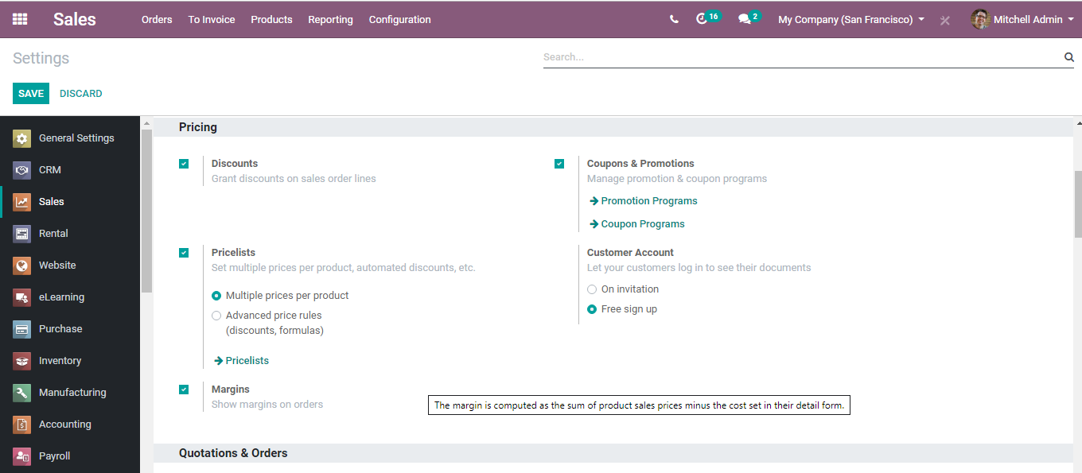
  - Click CREATE button to create a new pricelist.
  - A form will appear like below
  - 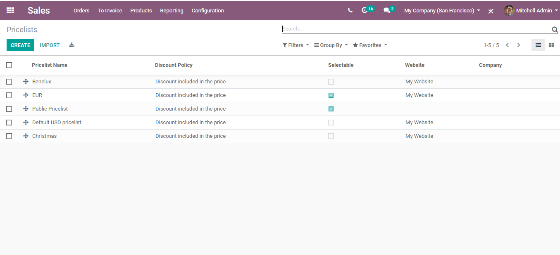
  - Here, you can add the company, and price rules for the product. Underneath products, click Add a line option to add products.

  - 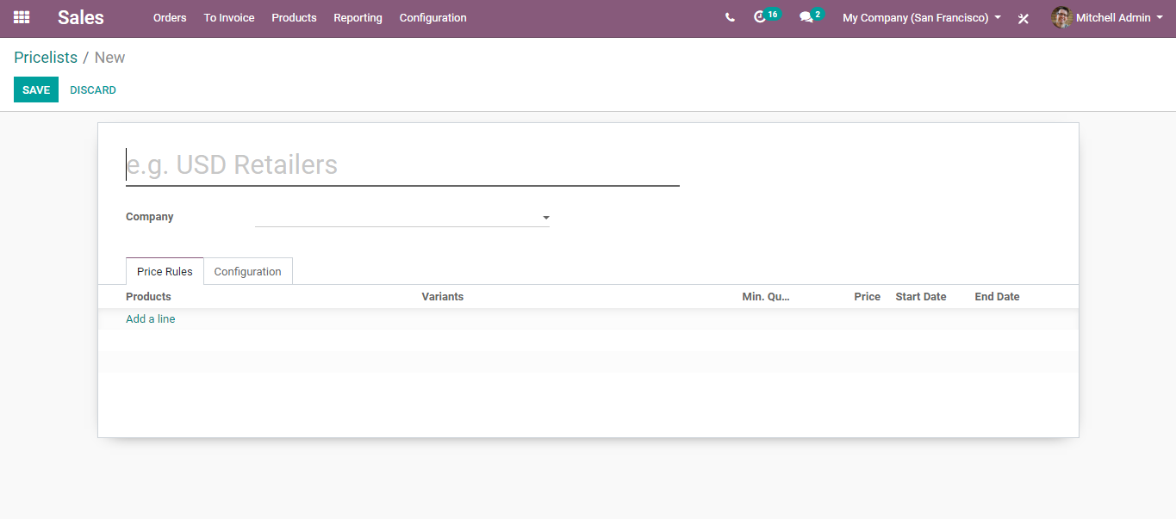
  - Also, one can add the product variants if any, minimum quantity, product price, also the start date and the end date for the price list.
  - Under the configuration tab, you have the following options
  - 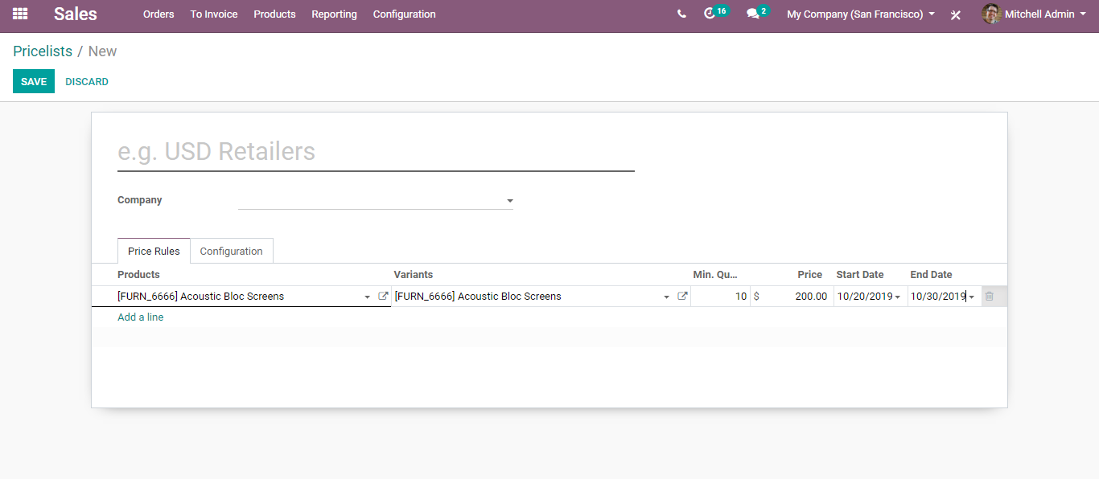
  - Discount Policy
1. Discount included in the price
  - 2. Show the public price and discounts to the customer.
  - Country Groups: One can select the country groups, where one wants to restrict the application of that specific pricelist.
  - Website - If the website option is enabled, allows the end-user to view the pricelists from the website.
  - E-commerce promotional code: These codes are used to apply any kind of discount.
  - Pricelists computed from Formulas
  - Go to Sales>Products>Pricelists and enable the second option Prices computed from formulas (discounts, margins, rounding). Tick the option and save changes.
  - 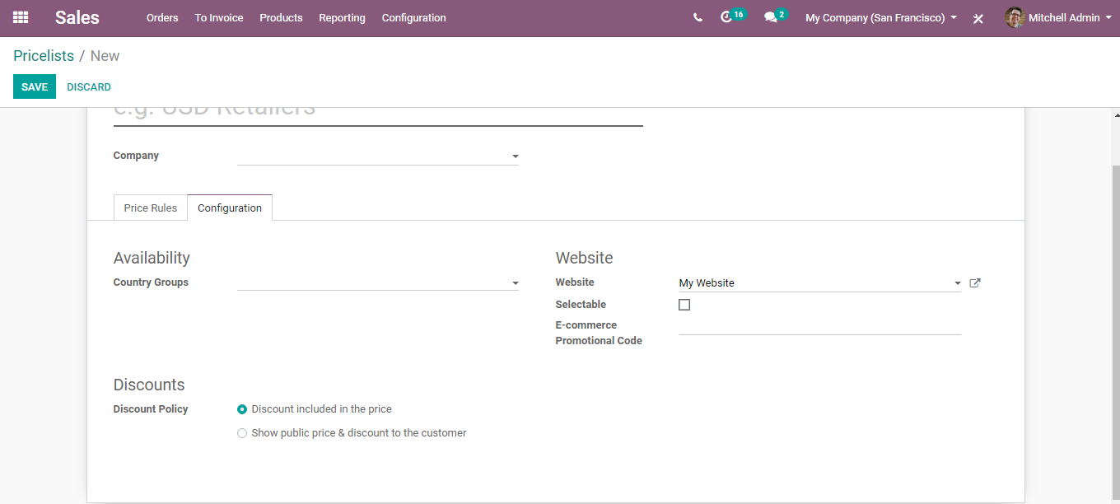
  - To create a new pricelist, Go to Sales>Products>Pricelists
  - Click CREATE button to create a new pricelist.
  - A form will appear like below
  - 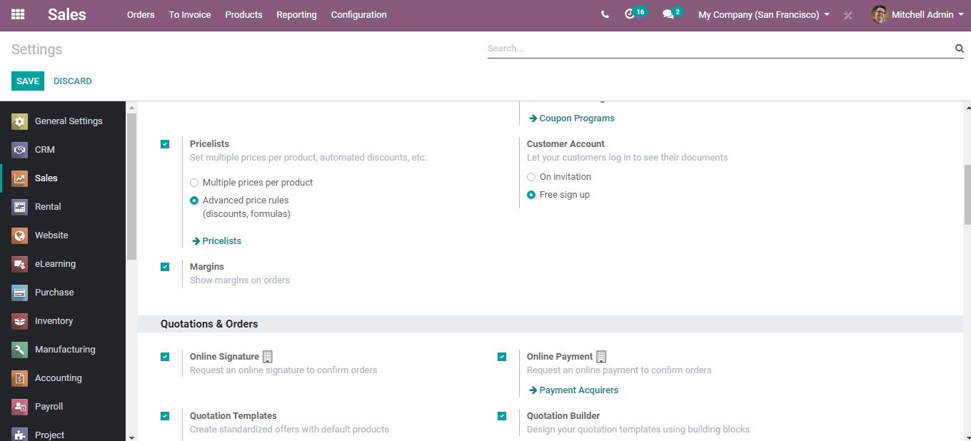
  - Upon clicking Add a line option, you will be navigated to a new window like below:
  - 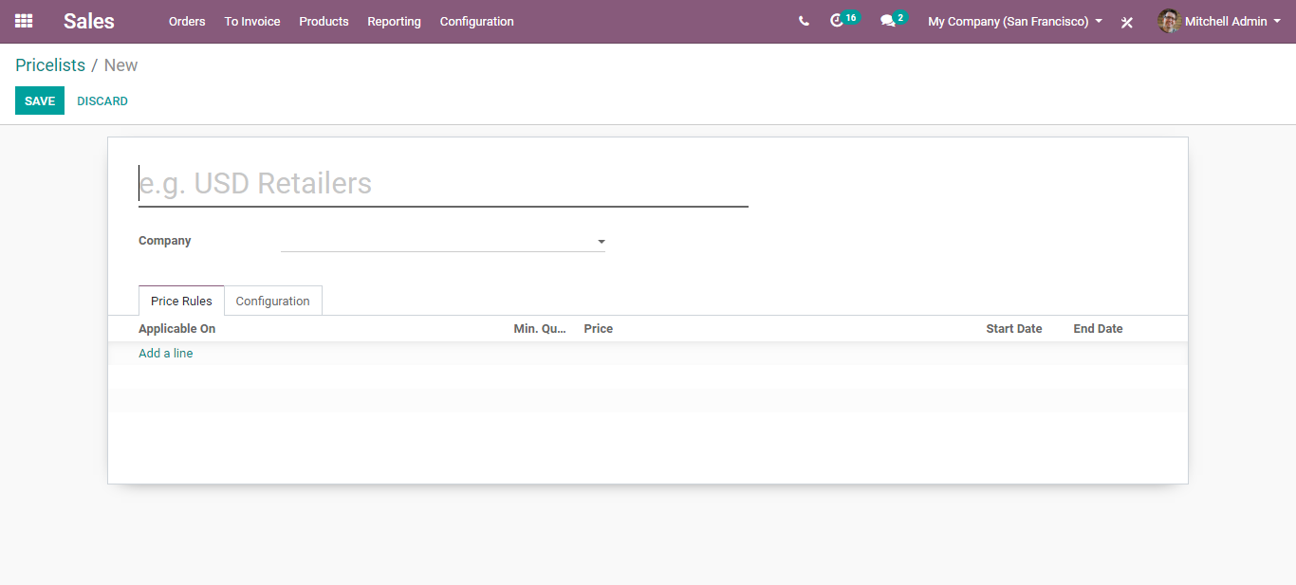
  - Here define certain parameters for creating the price list.
  - Apply on: One can apply the rule by following options.
  - All products: To apply a price list on all products.
  - Product Category: To apply pricelist on selected product category (e.g., sealable, fruits, electronics)
  - Product: To apply a price list on a specific product.
  - Product Variants: To apply a price list on specific product variants.
  - Minimum Quantity: Minimum quantity that is required to apply the Price list rule.
  - Start Date: Starting date for applying pricelist.
  - End Date: Ending date for applying pricelist.
  - Price computation: Used for calculating the price in different methods.
  - Fixed price: To apply a fixed price for a product or group of products.
  - Percentage (discount): To define a percentage discount on the sales price of products/product variants/product category.
  - Formula: The price of the product will be calculated by using the formula.

  - 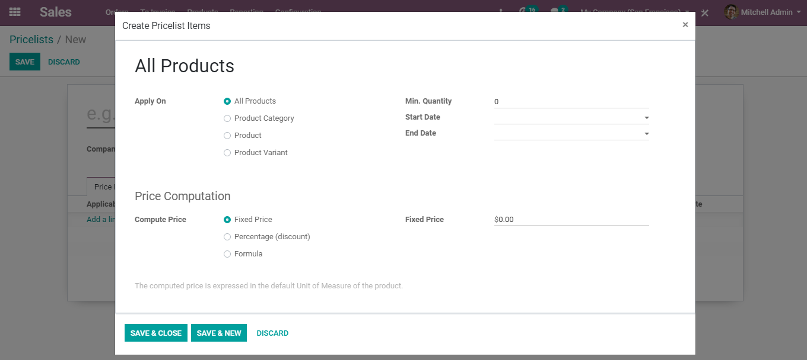
  - Now moving back to framing sales quotation, one can also add the Payment Terms in the sales quotation.
  - One can change the payment terms of the quotation by selecting them from the drop-down menu. This offers adaptability to both dealer and prospect to choose over the deal.
  - 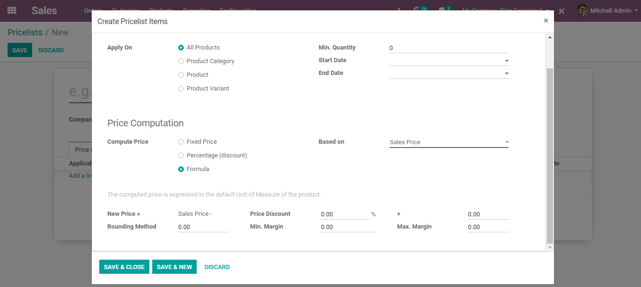
  - Apart from the above, using a pricelist one can also manage different prices for the product from the sales tab.
  - 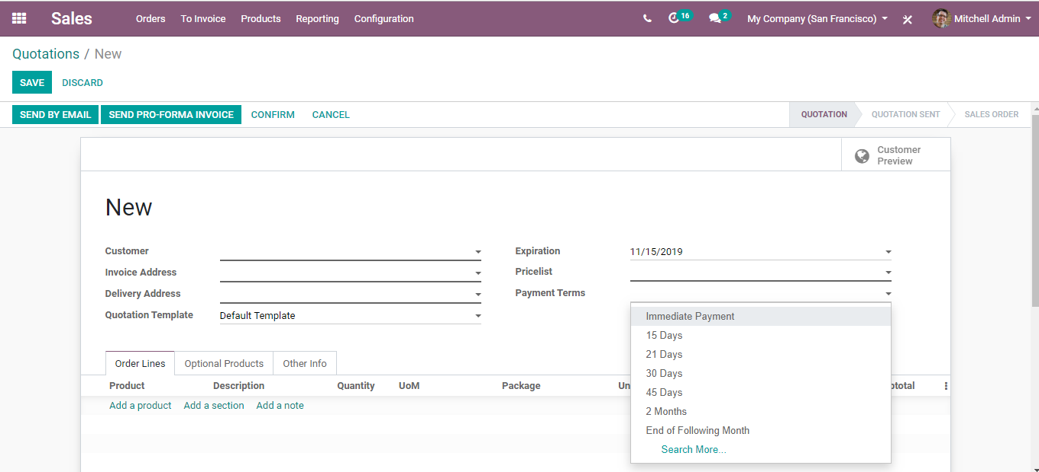
  - Upon clicking the Extra Price Button,
  - 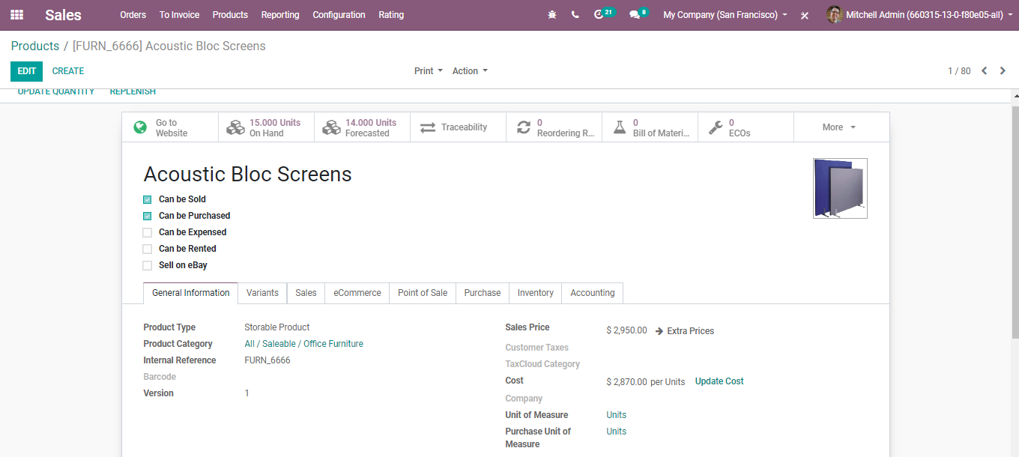
  - You can create a new price list for the product.
  - Next comes the most advantageous feature: Optional Products

  - OPTIONAL PRODUCTS
  - It enhances sales by recommending products to the customer. One can upgrade the sales by offering the alternatives like related and valuable items to clients. For example, a customer obtaining a cellphone could be offered a defensive case, a screen spread, and a headset as recommendations. This will prompt the client to purchase the needful extras from that point itself producing more deals or sales.
  - On the template or quotation, one can see the Optional Products tab where they can include the related items or services.
  - 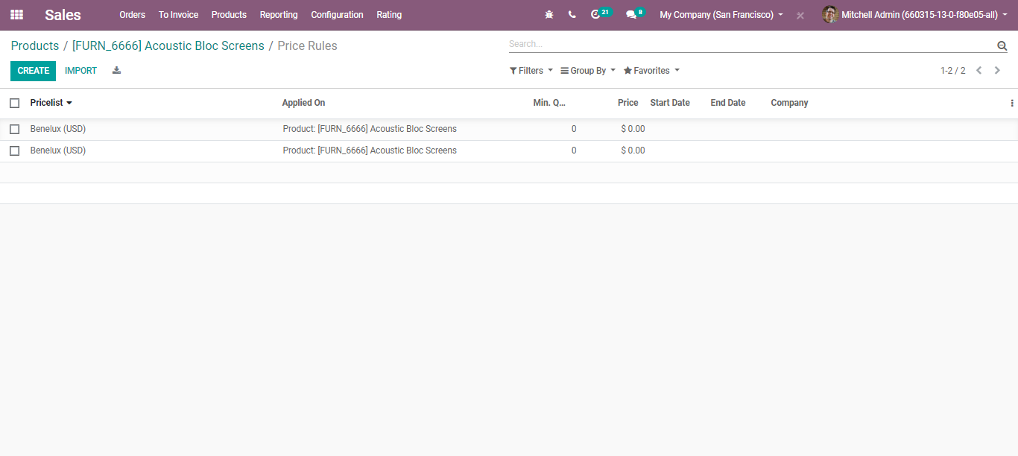
  - Add suggested/optional products to the quotation
  - The customer can add the suggested products to the order when they receive the order via email.
  - 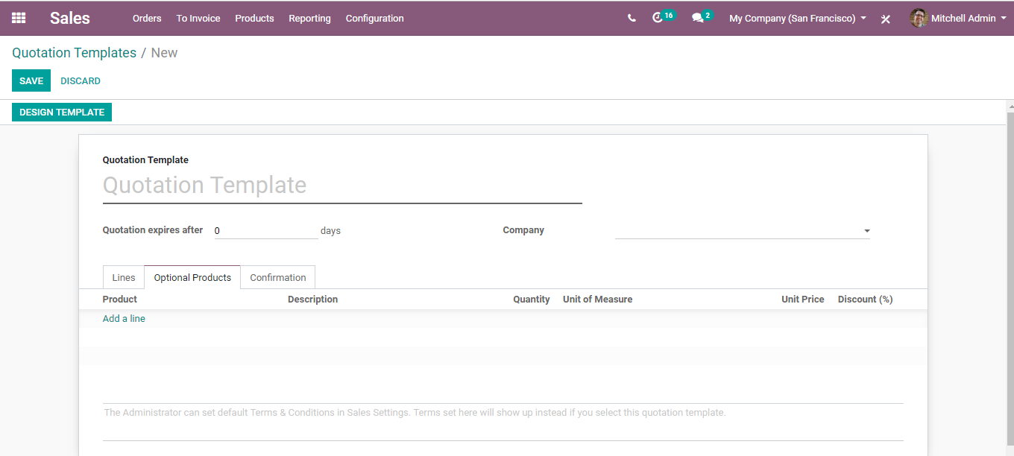

  - 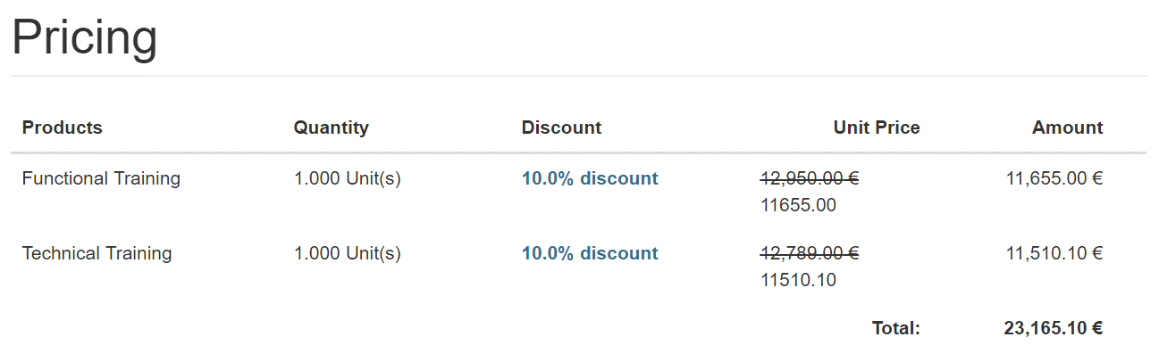
  - The product(s) get instantly added to the customer’s sales quotation upon clicking the little carts.
  - 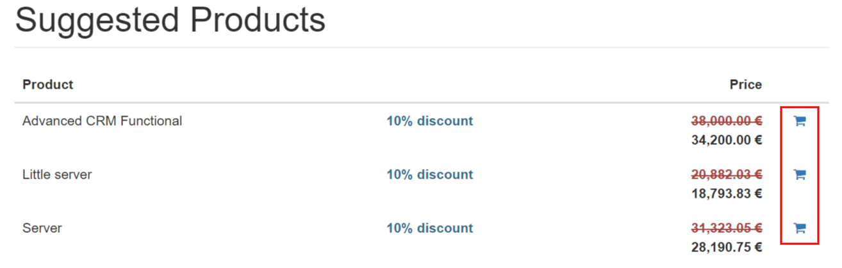
  - Each move done by the customer to the quotation can be tracked by the salesperson in the sales order.
  - 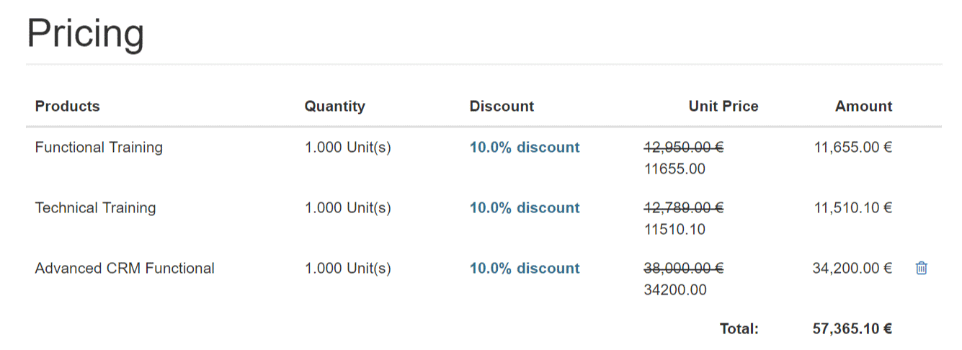

  - DISCOUNTS
  - Permitting discounts on quotations improves the opportunity of changing over the prospect into a client and promising the prospect to settle the negotiations rapidly.
  - To enable discounts in a quotation, Go to Sales>Configuration>Settings
  - Under-pricing, tick the option discounts
  - 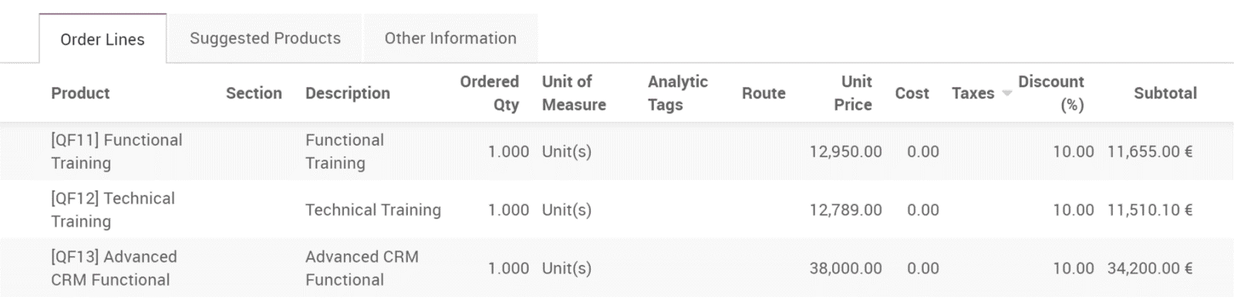
  - After enabling the option, you can see them activated in your sales quotation.
  - 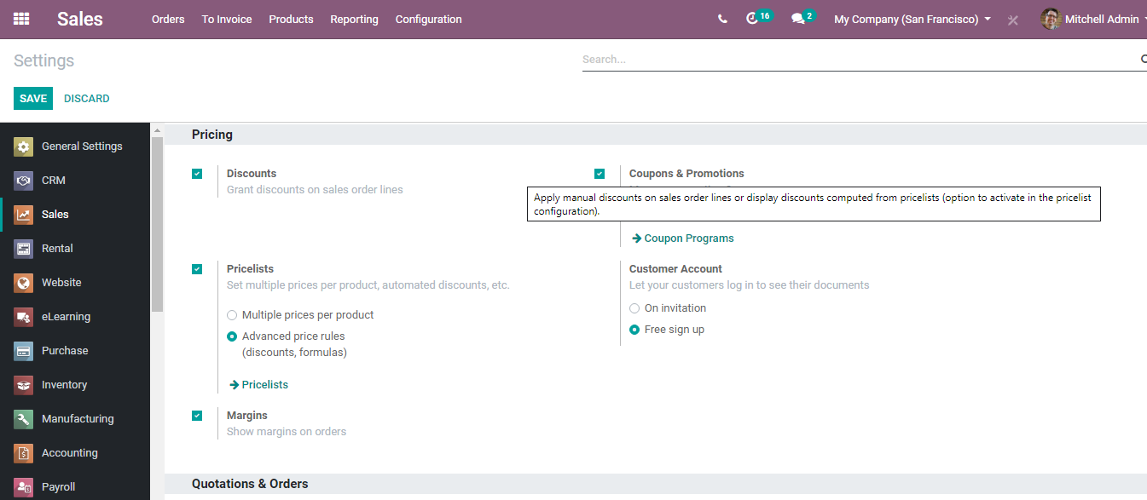
  - COUPONS AND PROMOTIONS
  - To ensure business profits and manage the sales most efficiently BUSINESSBOXERP presents Coupons and Promotion Programs. It helps the end-user to promote their products as per the current needs. Promotional programs can be used as a marketing tool where you can target a specific audience and can implement a loyalty program.
  - Promotions
  - To activate the feature in a quotation, Go to Sales>Configuration>Settings. Activate Coupons and Promotion Option.

  - 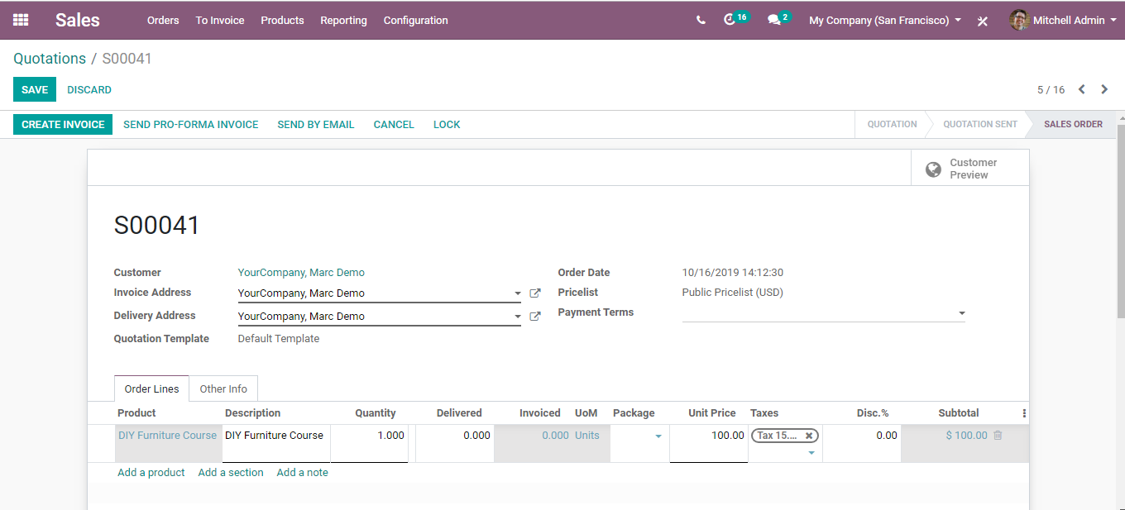

  - If you click the Promotion Programs, you will be navigated to a new window like below:
  - 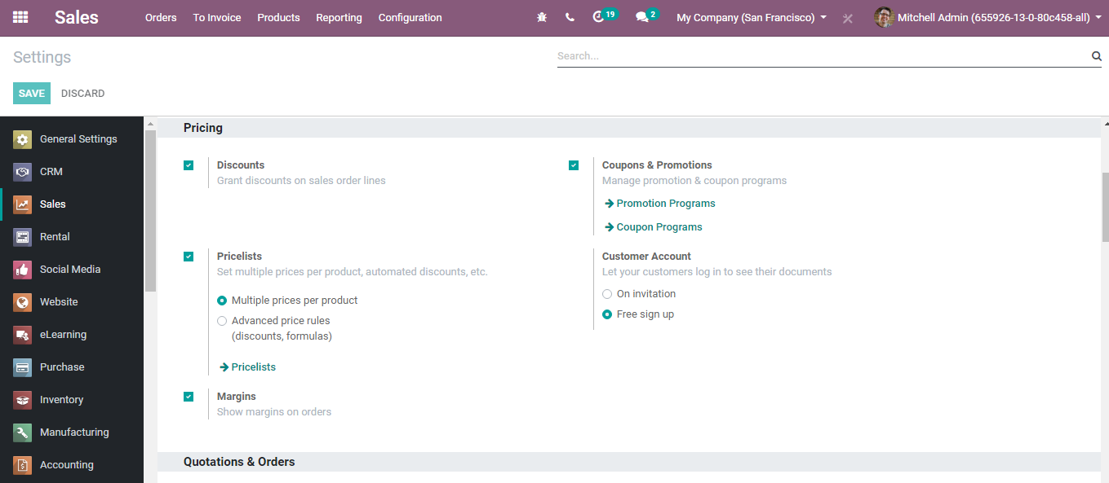
  - To create a new promotion program, click the CREATE button,
  - 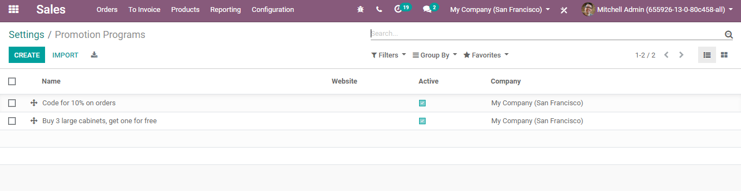
  - Coming to promotion programs, there are different fields in BUSINESSBOXERP
  - Program Name: The name for the promotion program
  - - Conditions
  - Based on customers:
  - This coupon program will be applied to the selected customers only.
  - One can filter the customers according to the need.
  - By default, all the customer records will be taken
  - Based on Products:
  - On purchase of these selected products rewards will be given.
  - On purchase of these selected products rewards will be given.
  - By default, all products records that can be sold will be taken.
  - Quantity
  - Minimum required product quantity to get rewarded
  - Minimum purchase Of
  - Minimum required amount to get rewarded
  - Promo code Usage
  - Automatically Applied
  - No code is required. If the rule is met, the reward is applied (Except global discount)
  - 2. Use code
  - If the program rule is met the valid code needs to add the reward.

  - Rewards
  - 1. Apply on current order
  - A reward will be applied to the current order.
  - 2. Apply on next order
  - Generate a coupon for the next order.
  - * Reward
  - 1. Discount
  - The reward will be given as a discount
  - Apply discount: give the discount in two methods Percentage
  - Amount: Fixed amount discount will be provided
  - Discount Apply on
  - On order
  - Discount will be given on the whole order
  - On cheapest product
  - Discount on the cheapest product on the order
  - On specific Product
  - Discount will be given to a selected specific product
  - Max Discount amount
  - A maximum amount of discount should be provided.
  - 2. Free product
  - The reward will be given as the product
  - 3. Free Shipping
  - Validity
  - Apply On
  - Maximum number of sales orders in which reward can be applied
  - * Start date & End date
  - Coupon programs start date and end date

  - Coupons
  - To activate the feature in a quotation, Go to Sales>Configuration>Settings. Activate Coupons and Promotion Option.
  - 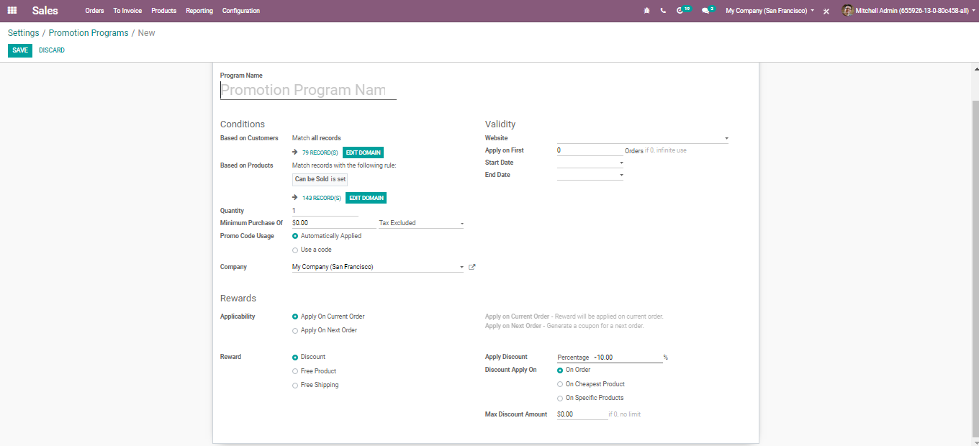
  - Upon clicking the Coupon Programs, you will be navigated to a new window like below:
  - 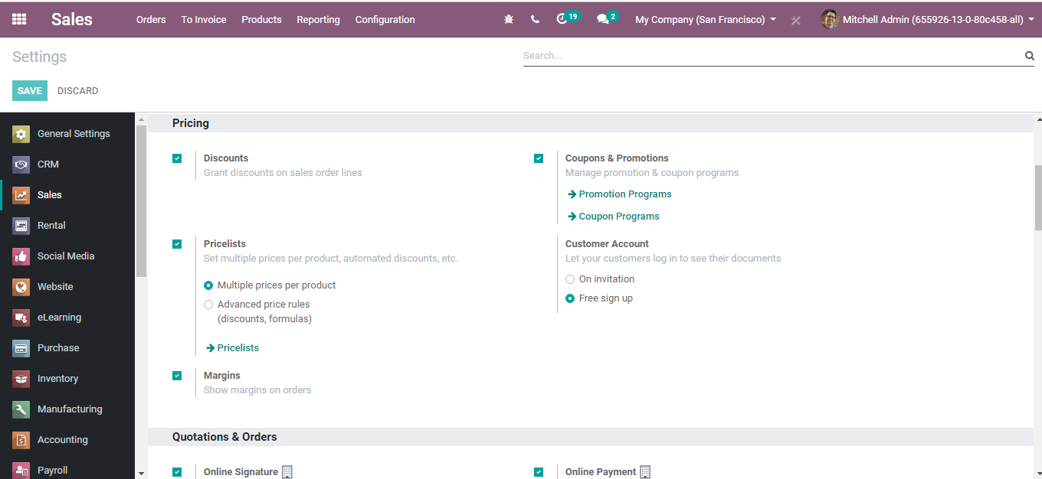
  - To create a new coupon, click the CREATE button.
  - 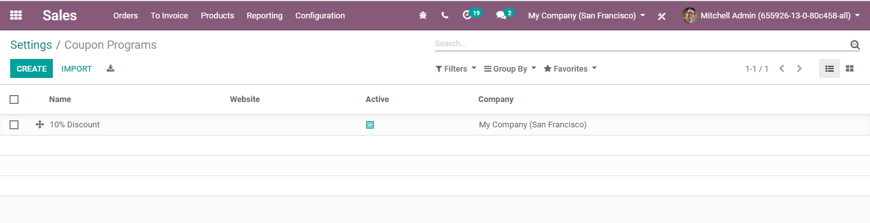
  - Coupons are used to generate limited discounts. A coupon is a one-time use code that will generate a discount for the customers.

  - TERMS AND CONDITIONS
  - Terms and conditions dependably help in keeping up great relations between the partners. Same as adding terms and conditions to quotations help in structuring great connection among customer and merchant. A merchant needs to pronounce all information as for products and company policy, so the customer gets a thought preceding focusing on anything.
  - BUSINESSBOXERP helps in setting default terms and conditions on each quotation, sales order, and receipt. To trigger the activity,
  - Go to SALES ‣ Configuration ‣ Settings and activate Default Terms & Conditions. Under the box, one can include default terms and conditions. They will at that point show up on each quotation, SO and receipt.
  - 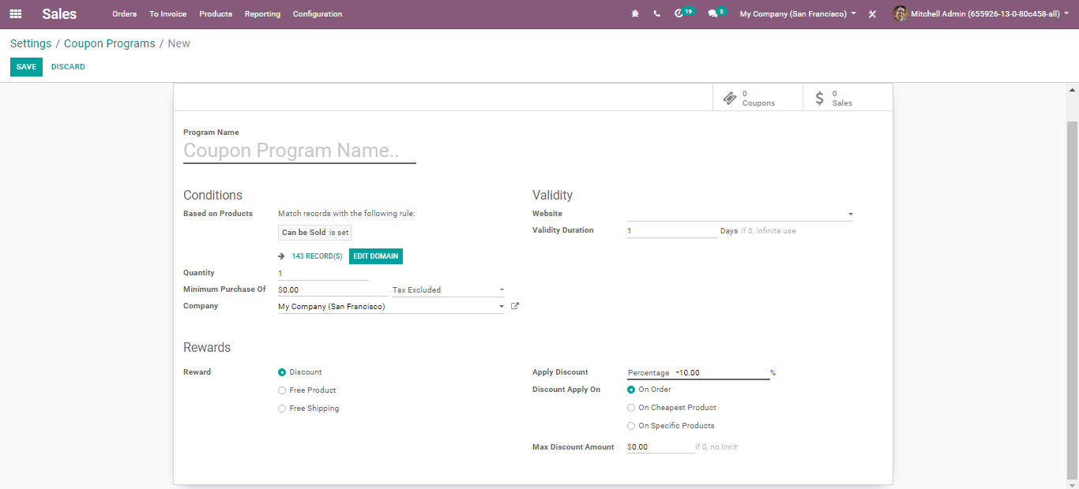

  - SHIPPING COSTS
  - BUSINESSBOXERP deals with various shipping methods, however, it is not activated by default. BUSINESSBOXERP ERP gives the alternative to arrange different delivery techniques in it. It will rearrange the tasks like transportation mode, conveyance cost figuring, shipment tracking and so forth. BUSINESSBOXERP delivery integration is accessible for DHL, FedEx, Temando, UPS, USPS and the sky is the limit from there. Shipping Methods enable you to deal with the transportation company, the cost, and the destination. You can even integrate BUSINESSBOXERP with outside shippers to compute the genuine cost and the packaging.
  - To activate the feature, Go to Sales->Configuration->Settings->Shipping costs,
  - One can seamlessly compute their shipping costs on orders. Meanwhile, the end client needs to choose their delivery methods from the enlisted option.

  - 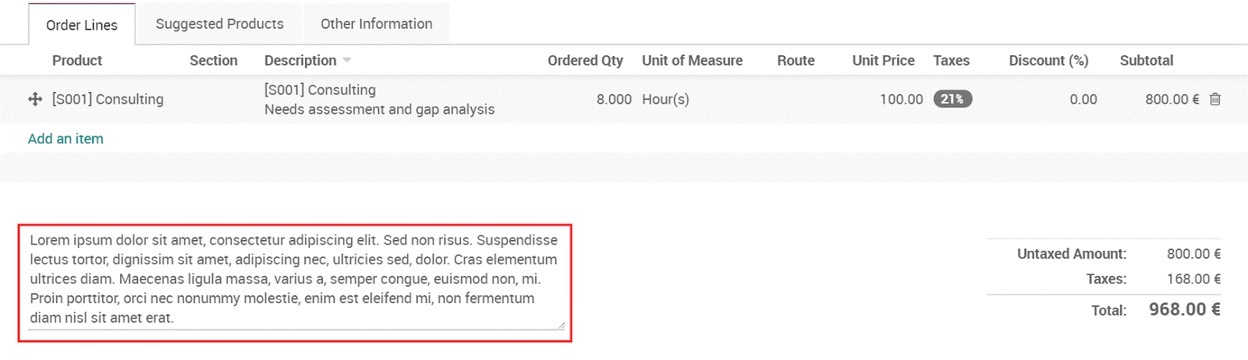
  - Upon clicking the Shipping Costs, you will be navigated to a new window like below:
  - 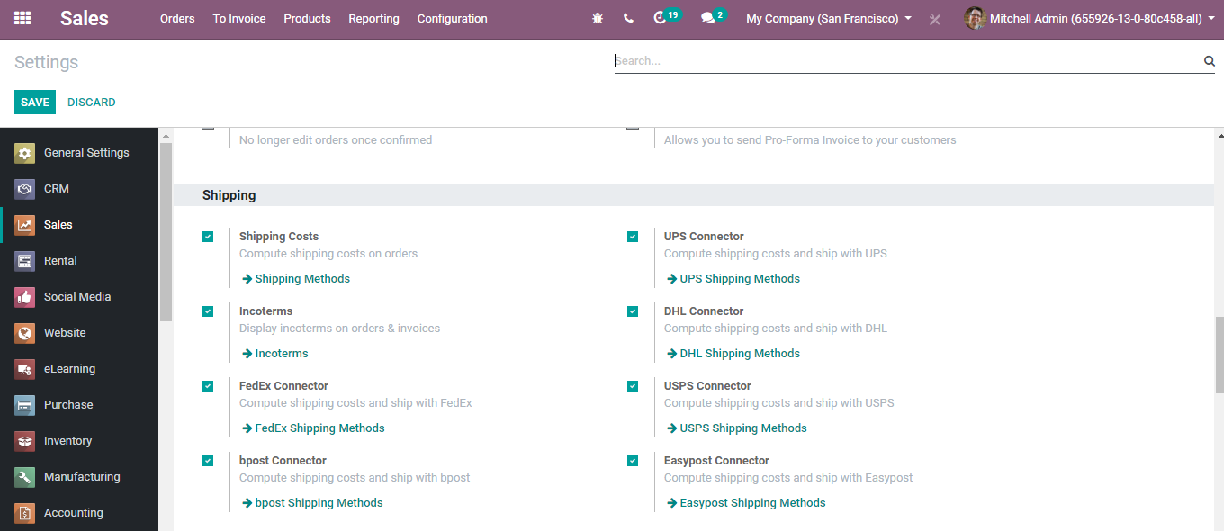
  - Right off the bat, name the new delivery method. Next is the Provider field, which can be either Fixed price or Based on Rules. If selected the fixed price option, at that point the shipping cost will be a fixed sum.

  - 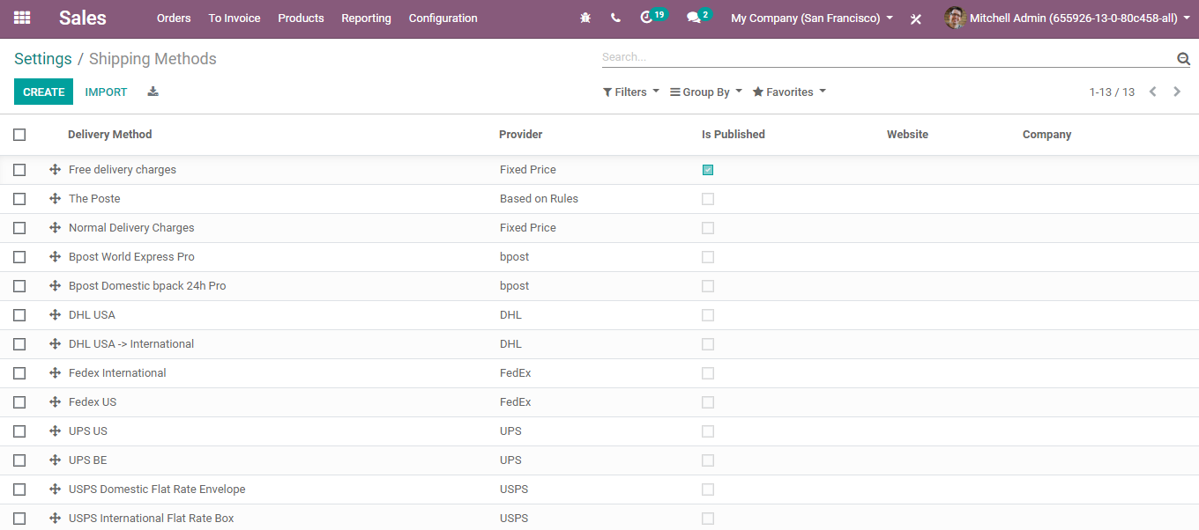
  - However, if it is set as based on rules, it enables you to set the expense dynamically.
  - 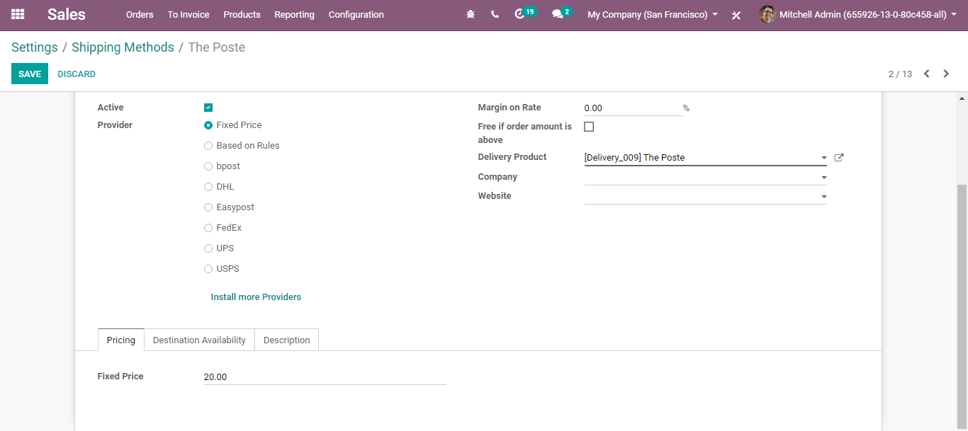

  - 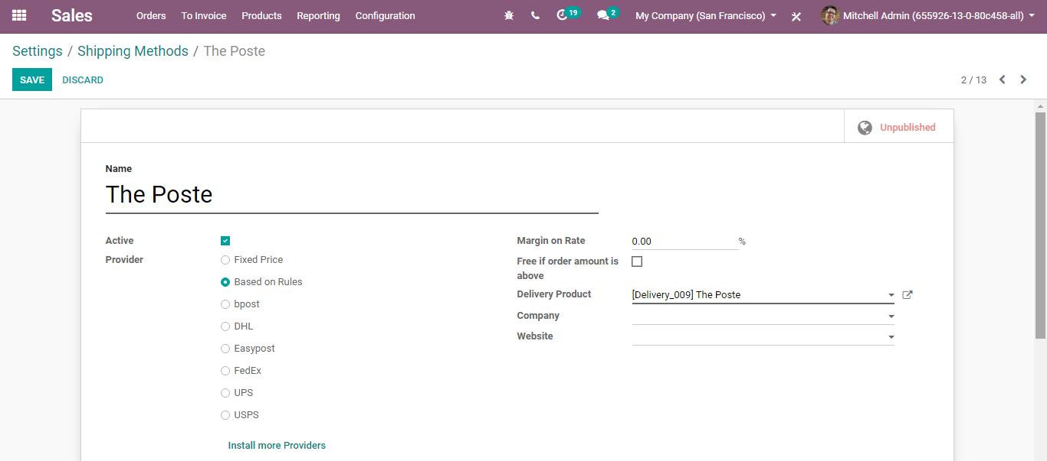
  - One can create a new price rule via clicking Add a line option.
  - 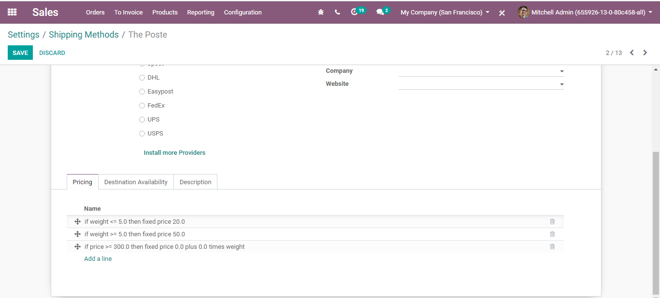
  - Because of rules, the shipping costs get calculated based on certain guidelines. You can see the conditions like:
  - Weight
  - Volume
  - Weight *volume
  - Price
  - Quantity

  - E.g.: If the product weight is greater than some esteem, the sales price will be a certain sum.
  - If weight<=5.0 then fixed price 20.0
  - If weight>=5.0 then fixed price of 50.0
  - If price>=300.0 then fixed price 0.0 plus 0.0 times weight
  - Utilizing this choice one can characterize distinctive standards for shipping.
  - One can likewise set limitations on the shipping methods. The shipping destination can be confined to explicit nations, states or even postal divisions. It will redo the shipping method as indicated by geographic area.

  - 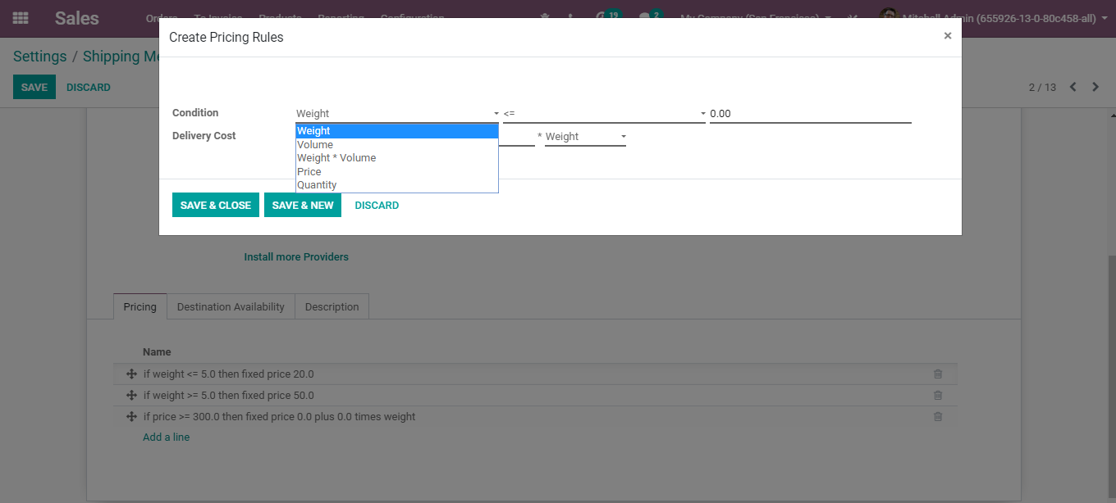
  - So, make a sales order and select the delivery method.

  - SENDING SALES QUOTATION AND SALES ORDERS
  - Coming back to the sales quotation, once we have added all the fields such as Customer Name, Products, Quotation Template, Pricelist, Payment Terms, Shipping, Coupon and Promotions, we can send the quotation to the customer.

  - 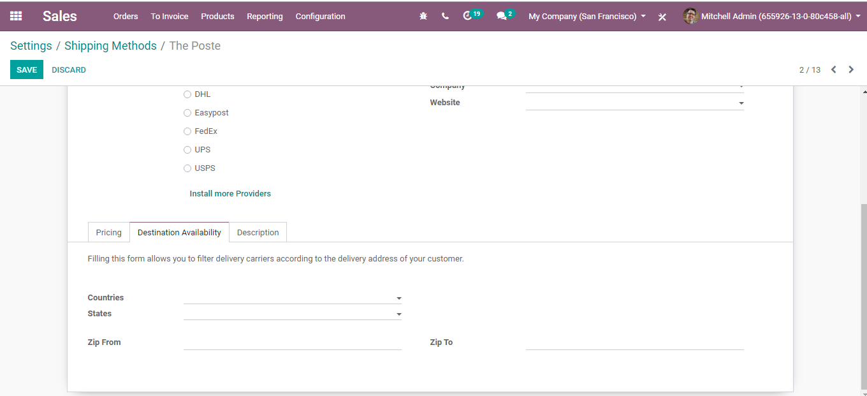
  - Upon clicking the Customer Preview Button on the top right corner of the quotation template, you can see the website view of the quotation. The customer can view his quotation from the website and readily confirm the quotation by instantly signing it.
  - The Sign & Pay button can be used for instantly confirming the quotation, the Feedback button can be used for clarifying or seeking any modification in the quotation by the customer and lastly, the Reject button can be used for rejecting the quotation if the customer isn’t happy about the quote drafted by the seller.
  - 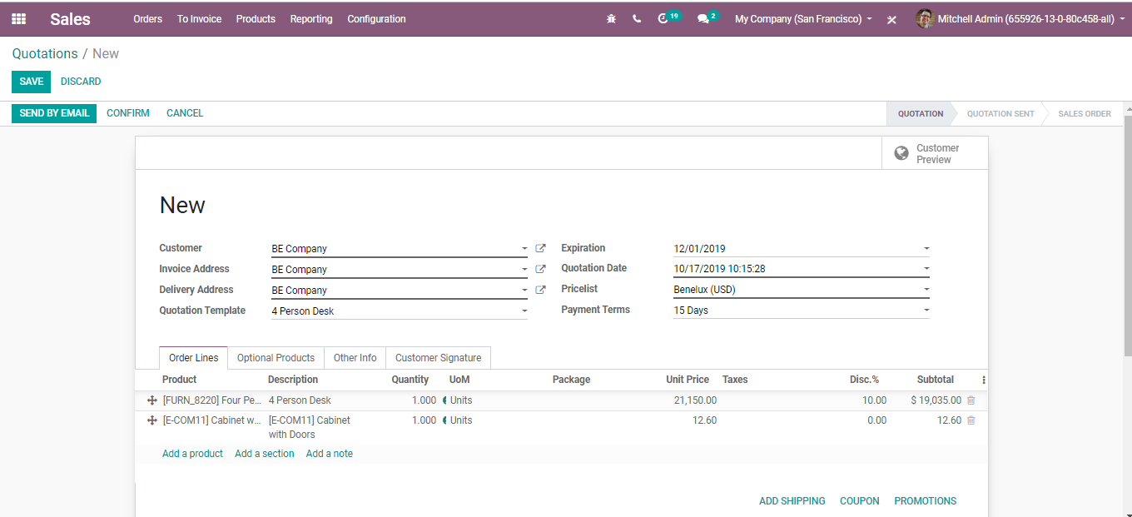
  - SENDING QUOTATIONS BY EMAIL
  - In the customary business process, individuals use to send the citation by dispatch, it isn't an effective route as it defers the exchange and quotation affirmation process, BUSINESSBOXERP enables you to send the quotation by email and produce constant examination (real-time discussion) through email on the quotation.
  - Send via mail
  - Assumed that the quotation is arranged and prepared to be imparted to the prospect, click on the SEND BY EMAIL button to send the quotation by email.
  - 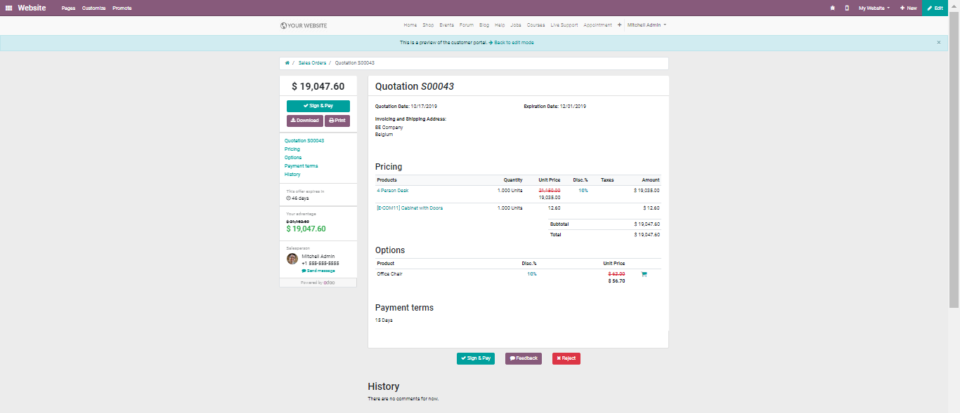
  - You can either send the quotation to an Individual or a Company.
  - 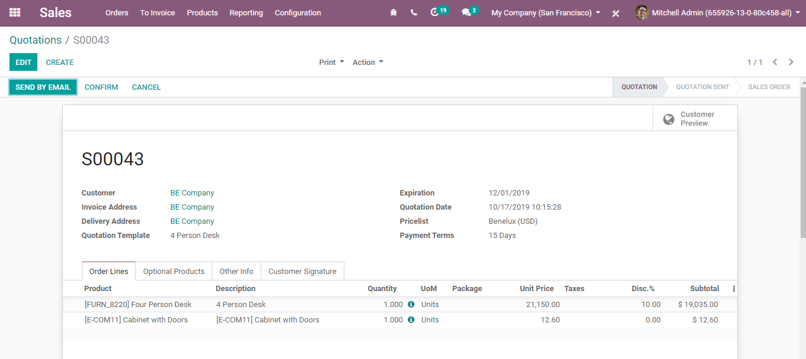
  - One can add the Job position if it is an Individual, his Email id and phone number. Click SAVE to mark the changes.
  - An automated email will be readied dependent on the predefined layout (set up the wonderful email with substance and attachments). One can without much of a stretch review the email substance and can include the extra substance if you wish to do. Later send by clicking on the SEND button.
  - 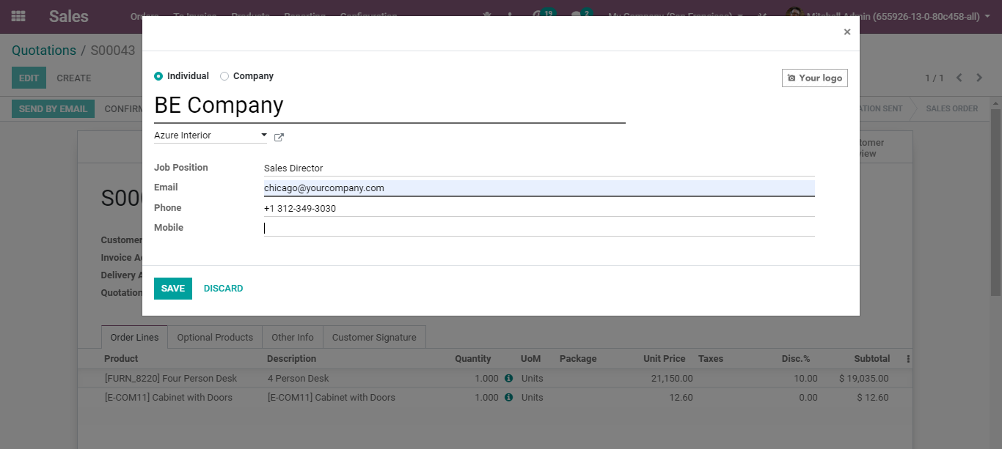
  - Once the email is sent to the customer, you can see the status changes from QUOTATION TO QUOTATION SENT.
  - 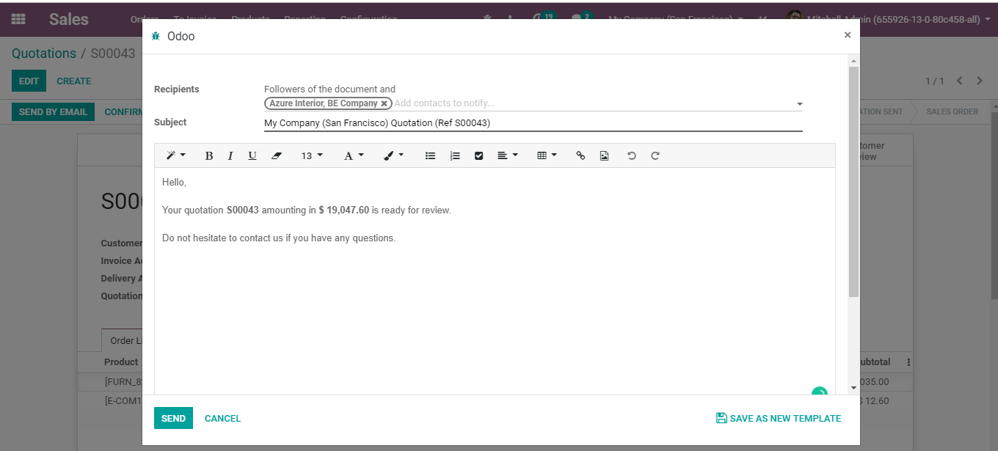
  - Upon clicking the CONFIRM button, you can see the status changed from QUOTATION to SALES ORDER.
  - 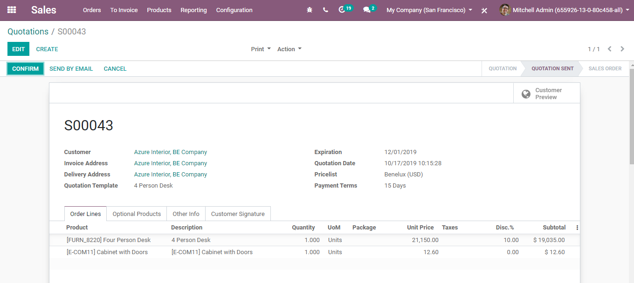

  - CONFIRMING THE SALES ORDER
  - Online customer approval on a quotation
  - Sending an online quotation can accelerate the exchange procedure as the client can negotiate and approve the quotation online without any moment’s delay. The advantage of online approval is that it can help in boosting the sales process and limit the sales cycle.
  - Online signature
  - BUSINESSBOXERP provisions to utilize online signature to get orders consequently confirmed. Both the merchant and the client can spare time by utilizing this component, unlike customary procedure say, courier.
  - To activate Online Signature Option, Go to SALES > Configuration >Settings and activate the Online Signature & Online Payment feature.
  - 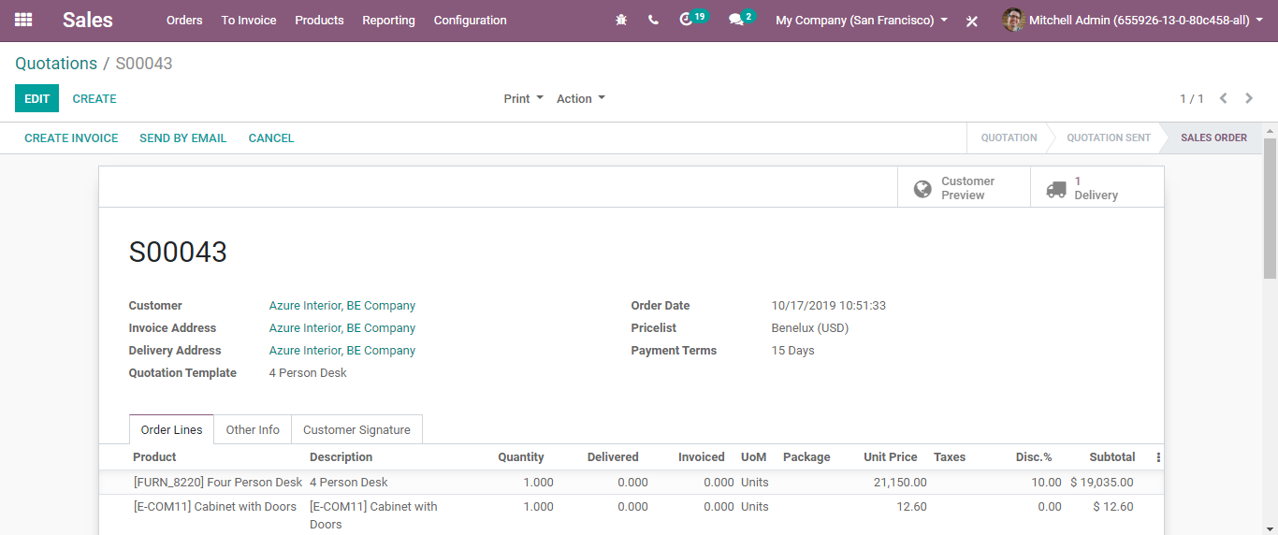

  - VALIDATE AN ORDER WITH A SIGNATURE
  - Once the quotation is sent to a customer, he/she can accept the quotation and instantly sign it.
  - 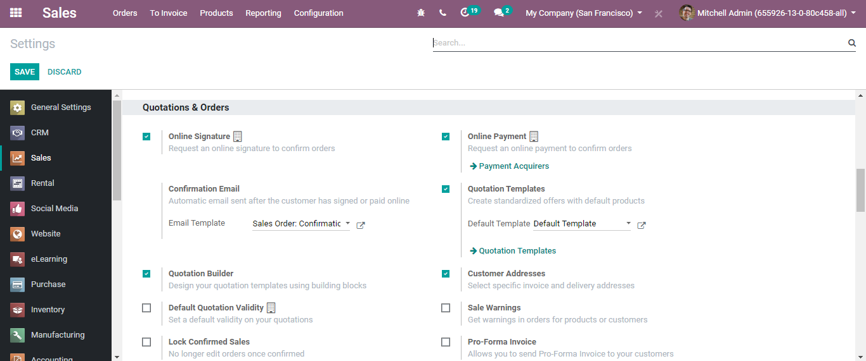
  - If the customer signs the quotation, it is assumed that the quotation is confirmed. Soon follows the delivery.

  - CONFIRMING ORDER VIA GETTING PAID
  - Under BUSINESSBOXERP, one can utilize online payments to get the requests automatically confirmed. This activity helps in sparing the time of both client and merchant.
  - Activate online payment
  - Go to SALES>Configuration > Settings and activate the Online Signature & Payment feature.
  - 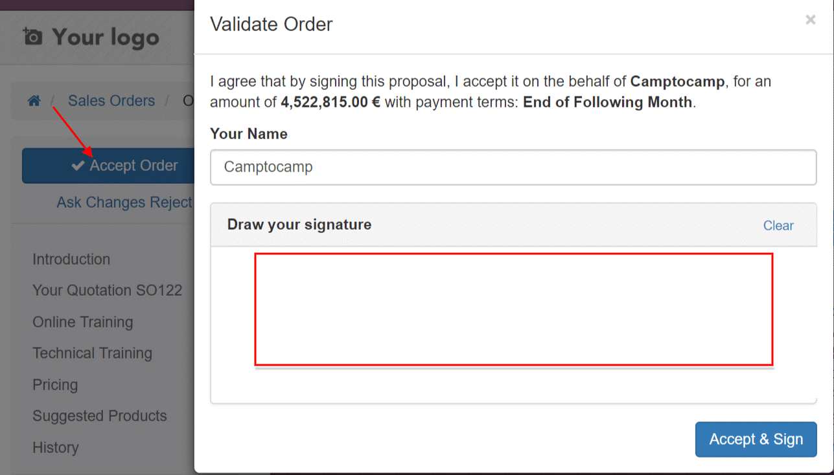

  - Under the Payment Acquirers menu, one can select and configure the acquirers of your choice.
  - 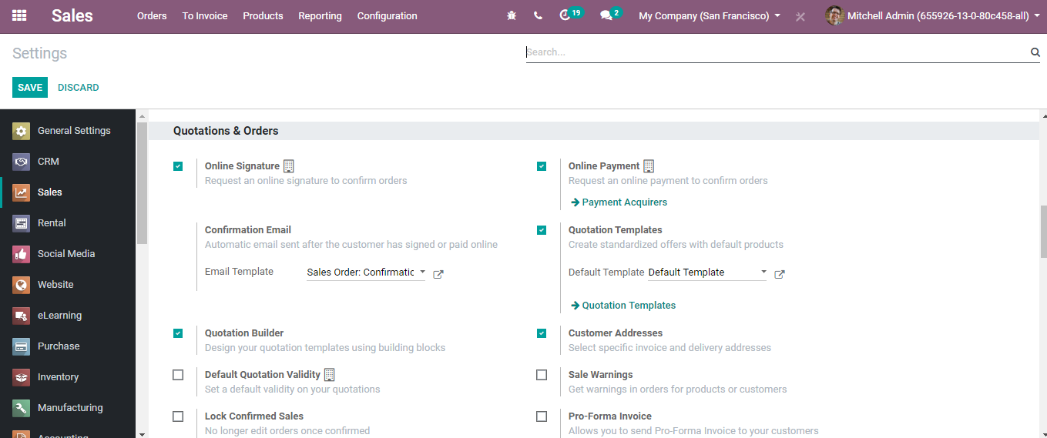
  - Registering the payment
  - From the sent quotation email, the customer can make payment online.
  - 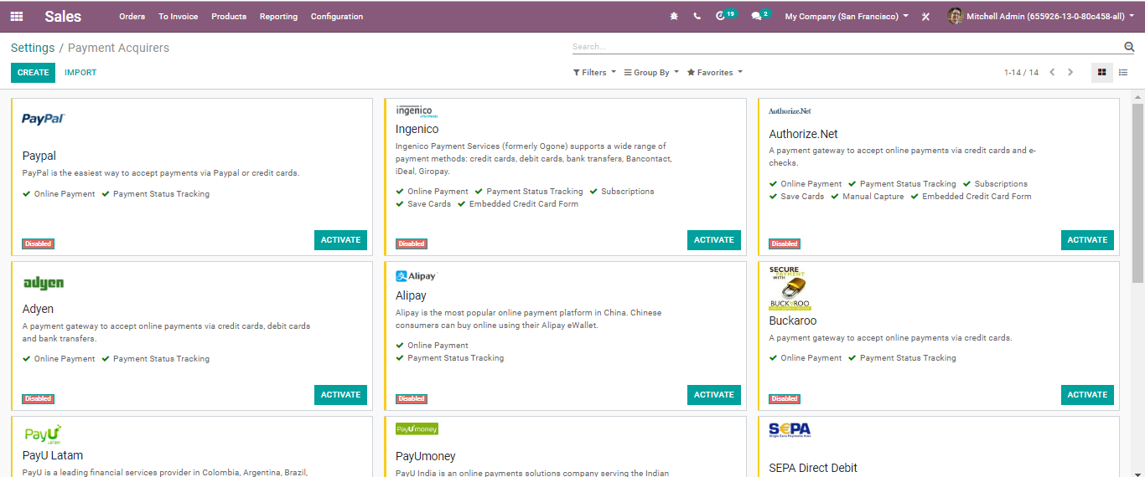

  - CHATTER
  - All the communication exchanged regarding a quotation can be followed in the chatter. The messages send over to the client or got from the client will be made accessible beneath the quotation. All the correspondence history will be safeguarded and will be made accessible when the quotation gets changed over to sales order.

  - 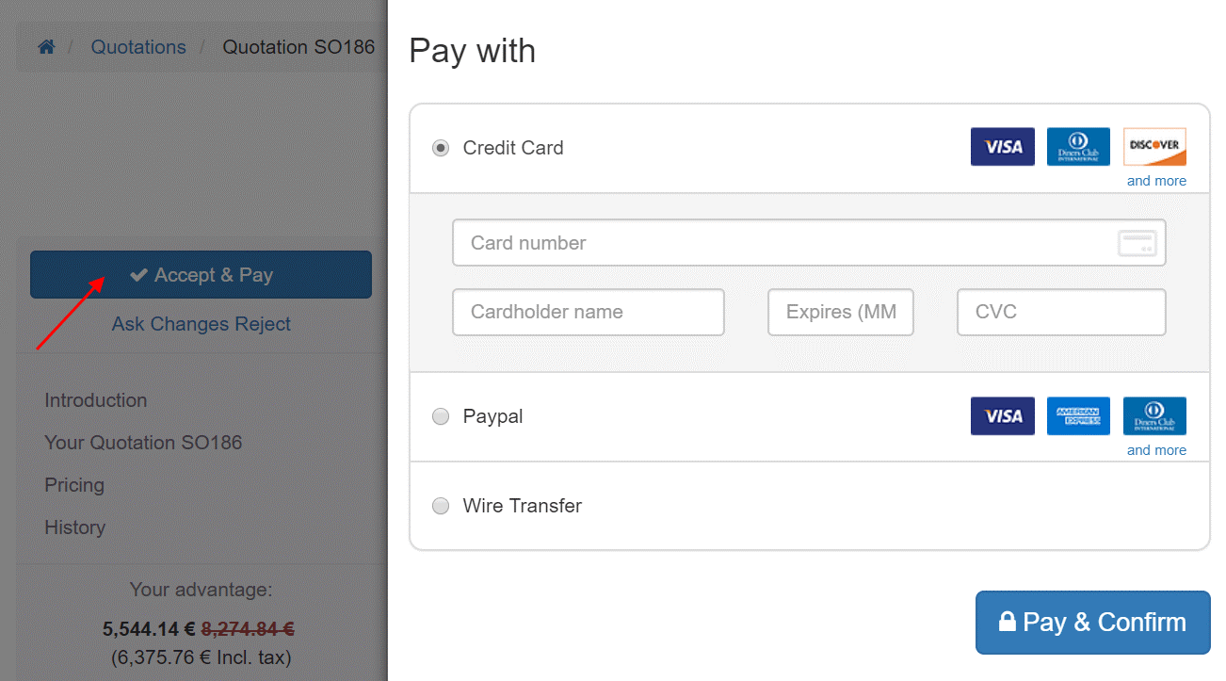

  - INVOICES
  - Post confirming the sale order from the client, next you can send the invoice to the customer. The seller can send the invoice to the customer containing the sale transaction info such as products, quantities, agreed prices and so forth. Payment terms are also stated in the invoice.
  - 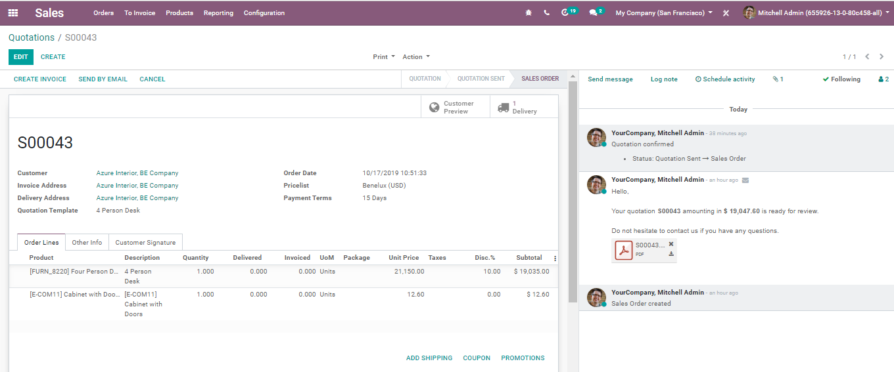
  - Upon clicking the CREATE invoice button, you will be navigated to a new window like below:
  - 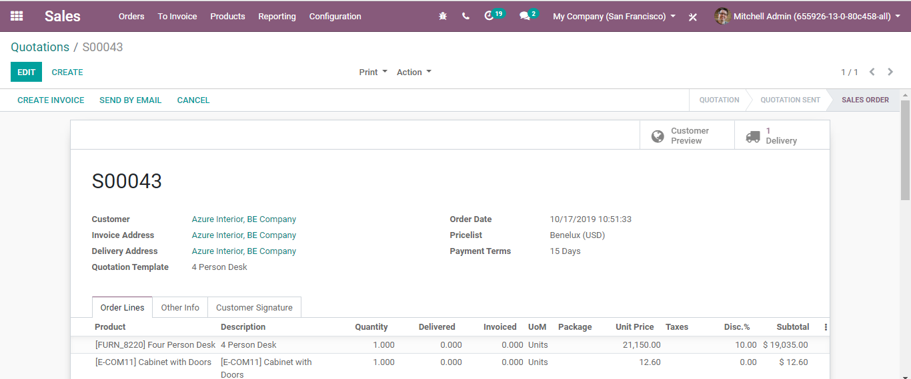
  - You have the options like:
  - Regular Invoice
  - Down Payment (percentage)
  - Down Payment (Fixed Amount)
  - Upon selecting a down payment option, you have two options- fixed amount and percentage of the total amount. You can select here the income account and a tax setting that will be used for every following down payment.
  - 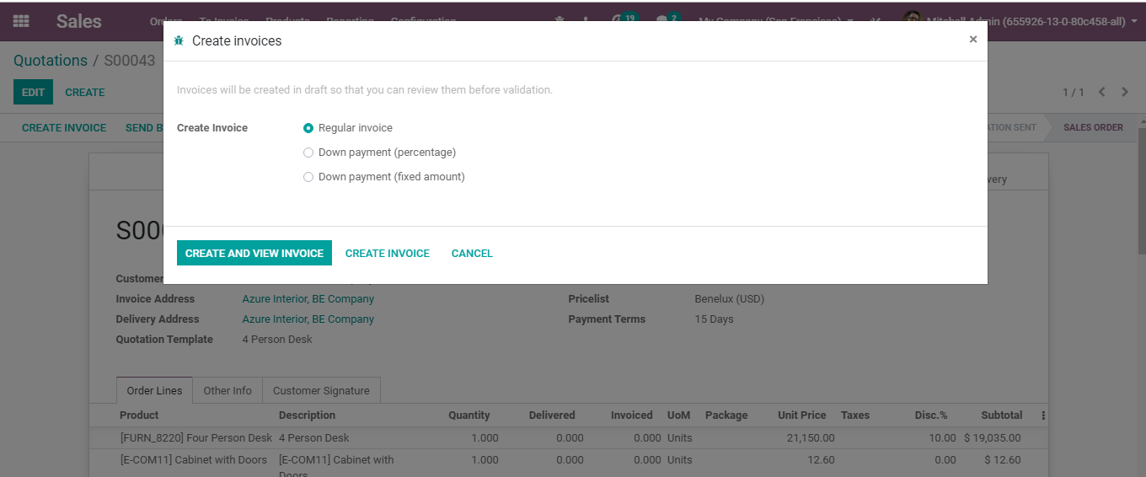
  - Upon clicking the CREATE AND VIEW INVOICE BUTTON, you will be navigated to a new window like below:
  - 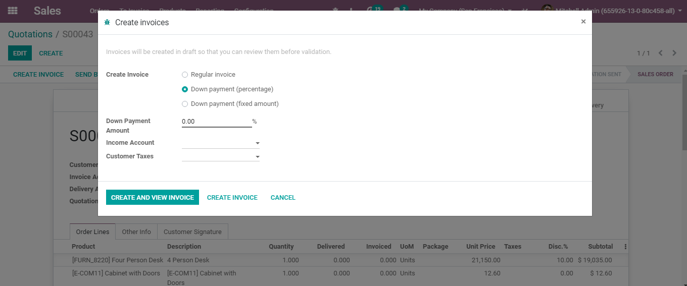
  - You can see the invoice for the down payment:
  - 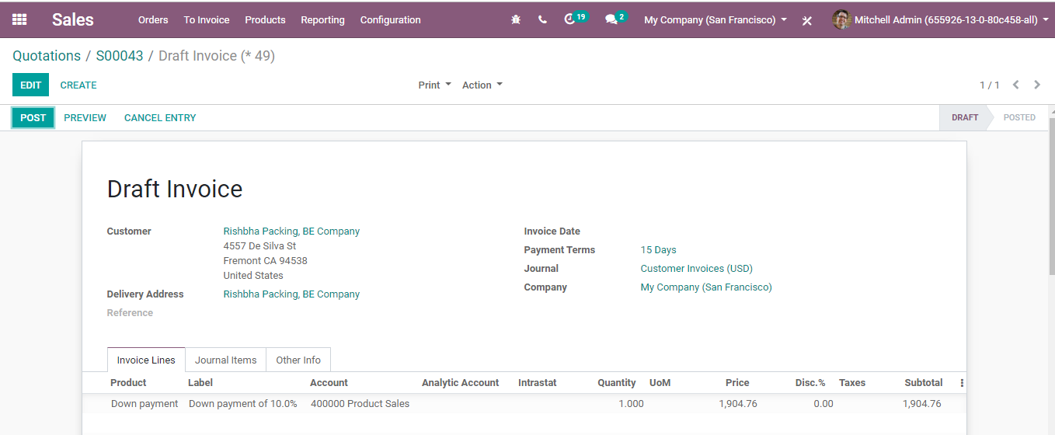
  - As this is a DRAFT INVOICE, one can make necessary changes in the invoice here via clicking the EDIT button.
  - Upon clicking the PREVIEW button, one can see the website view of the invoice.
  - 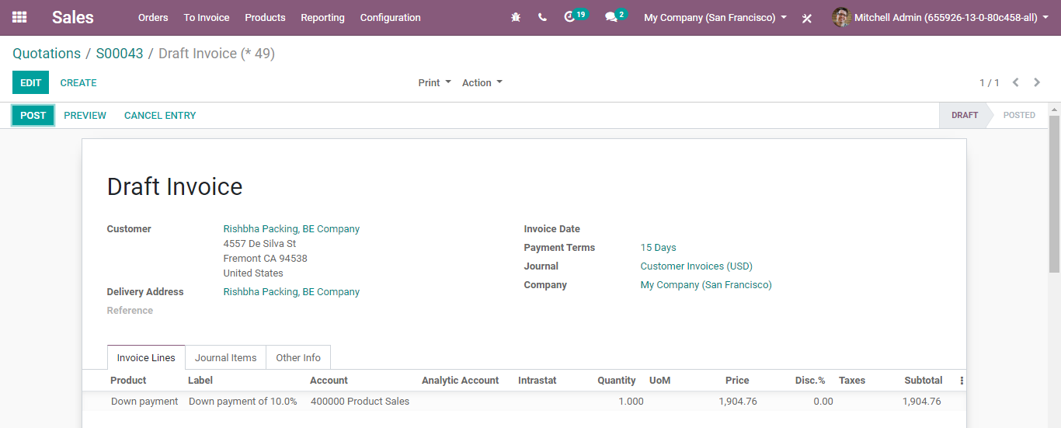
  - In case, there are no changes to be made, one can confirm it via clicking the button POST.
  - Upon clicking the POST button, you will be navigated to a new window like below:
  - 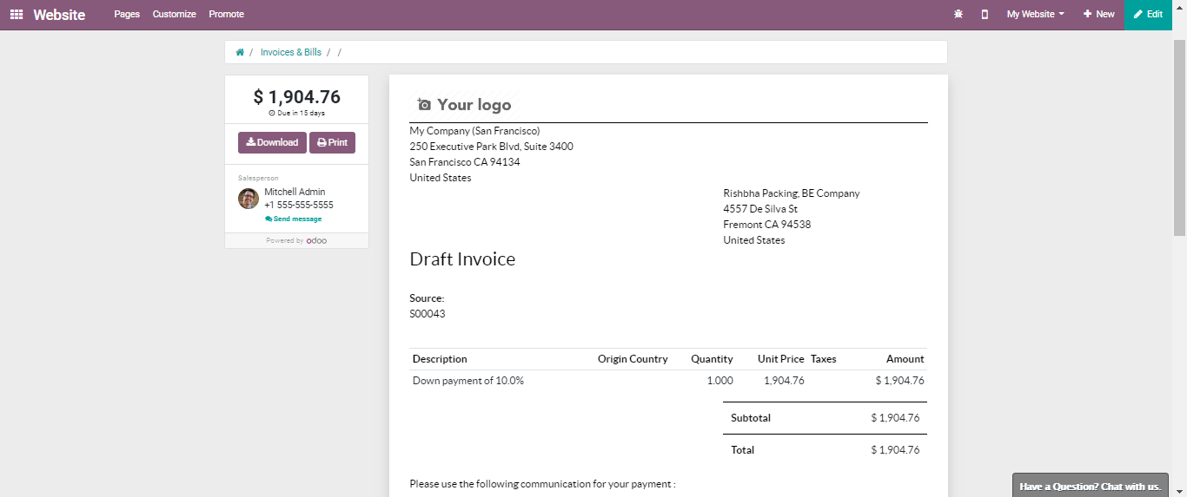
  - Click SEND & PRINT button to send the invoice.
  - A default email template will be opened.
  - 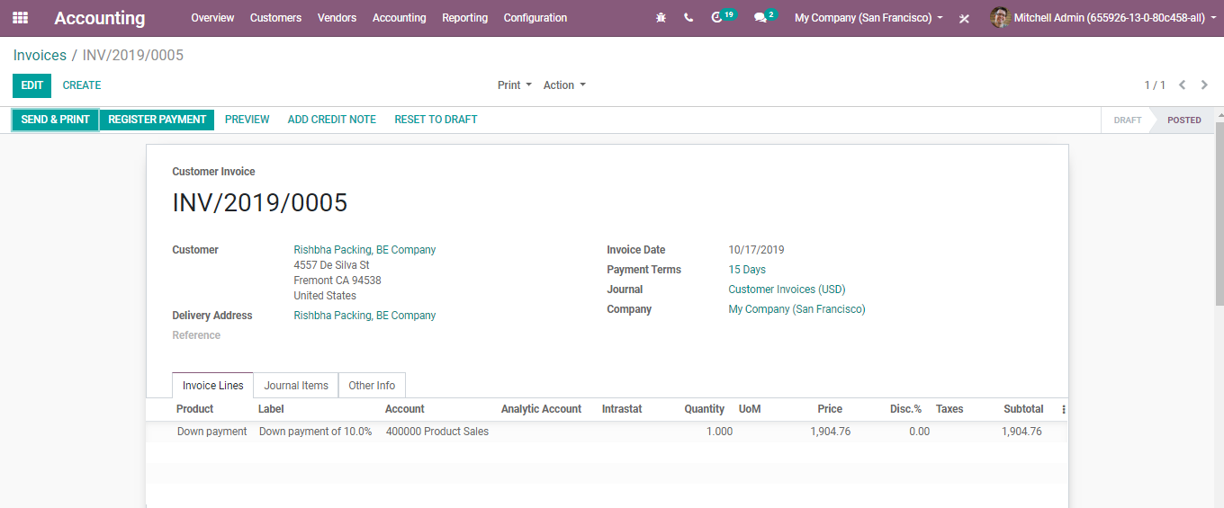
  - Also, one can configure the document layout of the invoice here.

  - 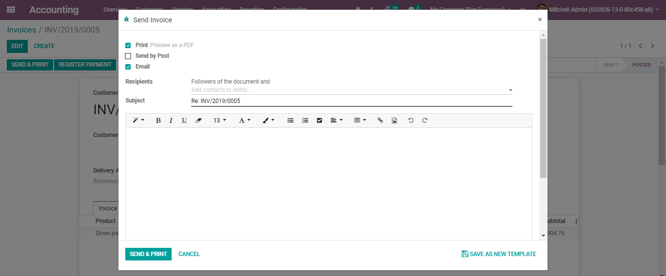
  - You can make desired changes in the document layout such as adding a background to the invoice, adding boxes, logos, changing colours and fonts etc. One can also add a company tagline and footer to the invoice.
  - 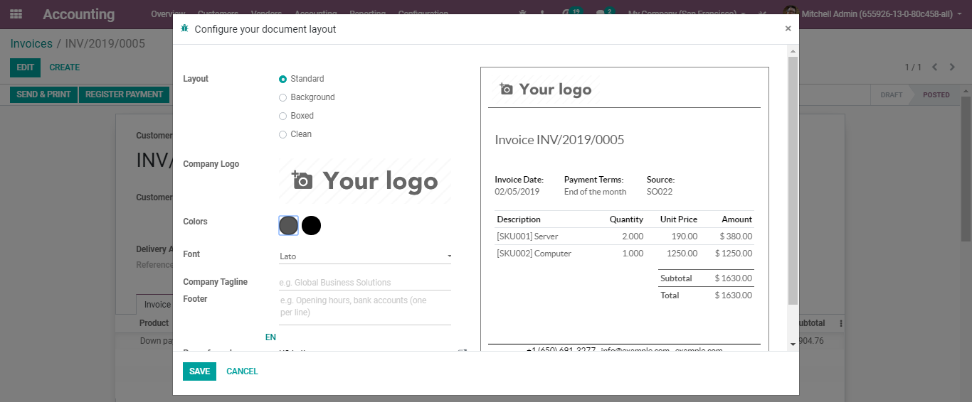
  - Print out of the invoice looks like below:
  - 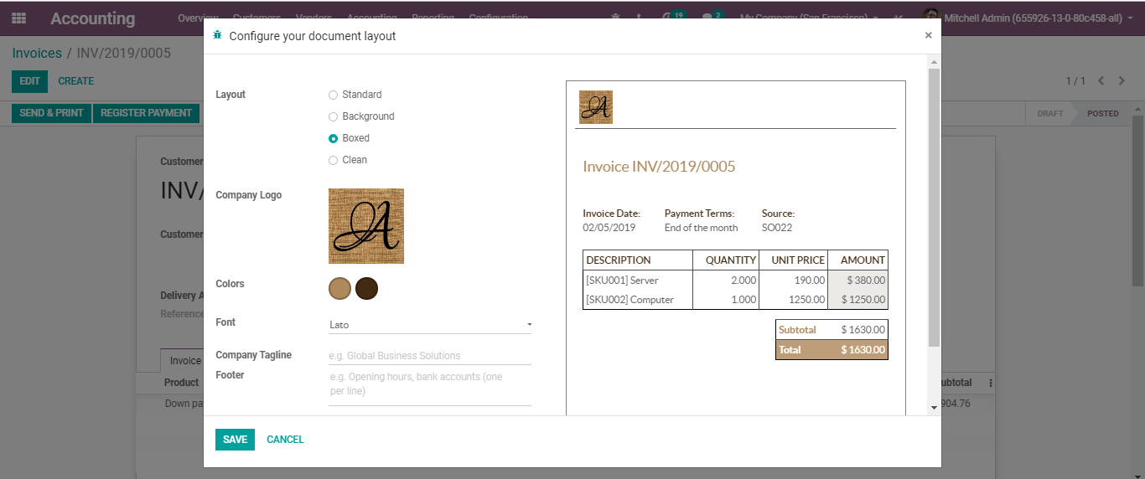
  - The next step is Registering for Payment.
  - Upon clicking the REGISTER PAYMENT button, you will be navigated to a new window like below:
  - 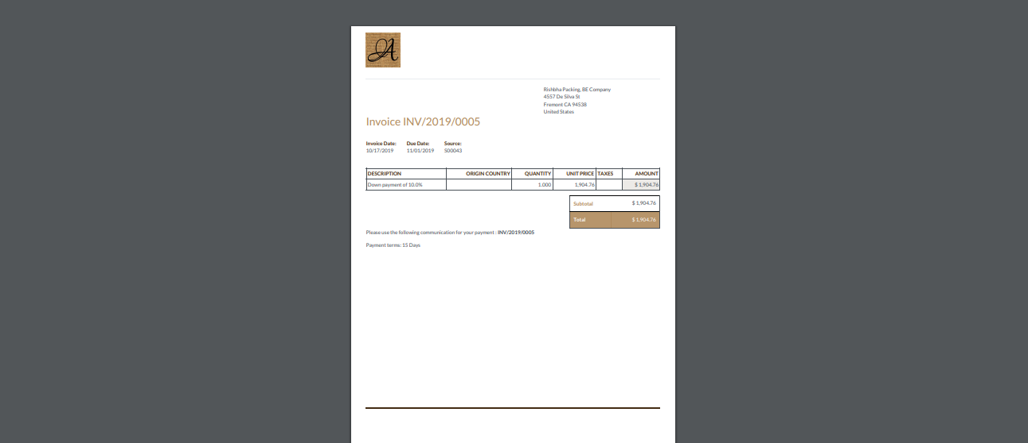
  - Here, you can select the Journal

  - 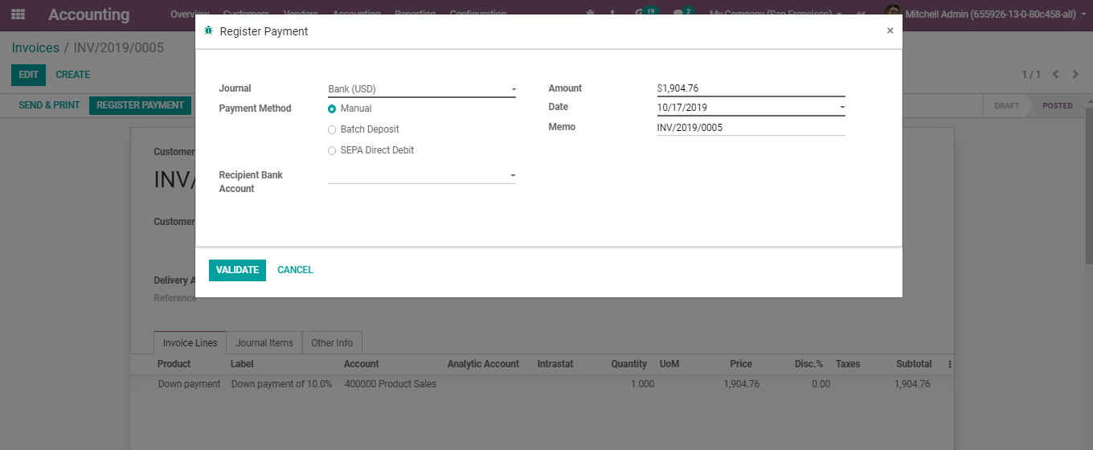
  - And Payment Method
  - 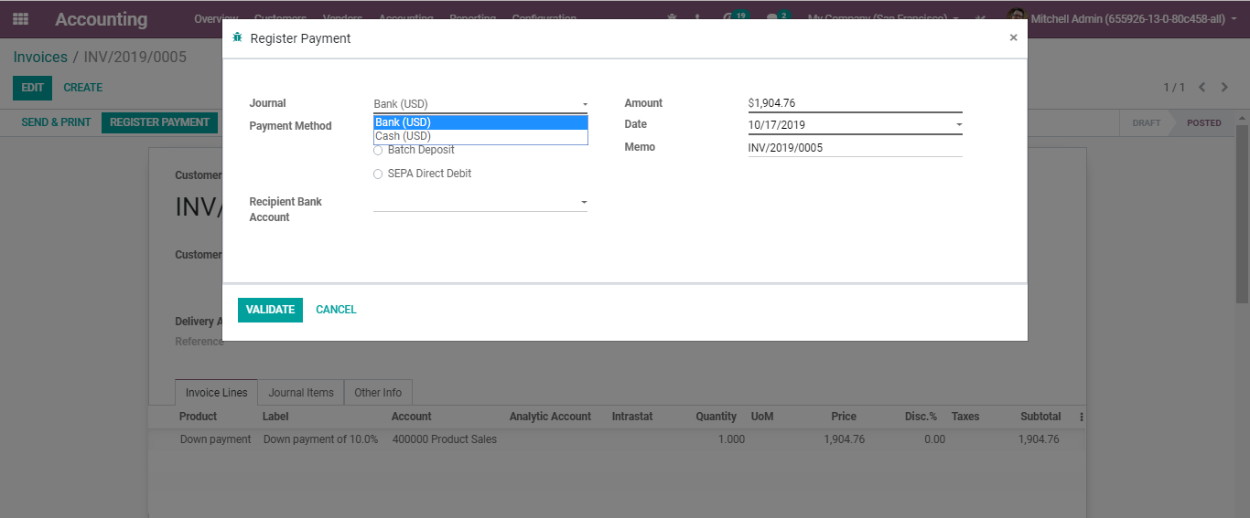
  - Upon clicking the VALIDATE button, you will be navigated to a fresh window, confirming your payment.

  - 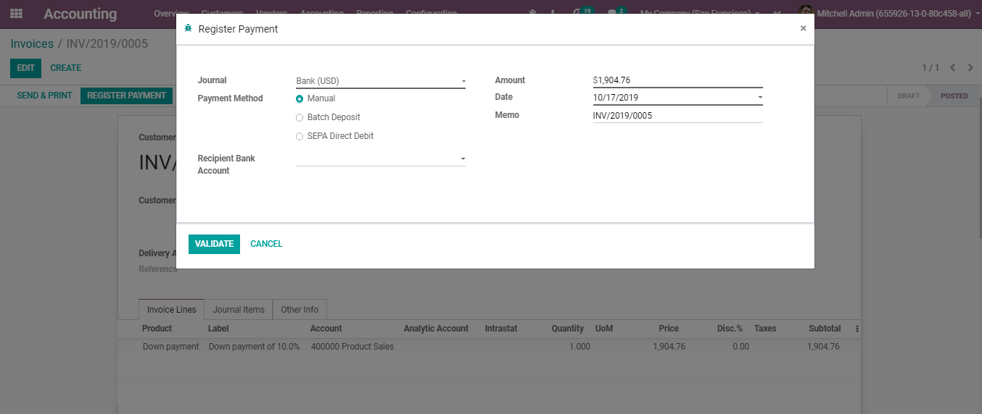
  - You can see the ribbon widget notifying the status of an invoice as PAID.

  - Invoice preview
  - Clicking the PREVIEW button, you can see the website view of a paid invoice.
  - 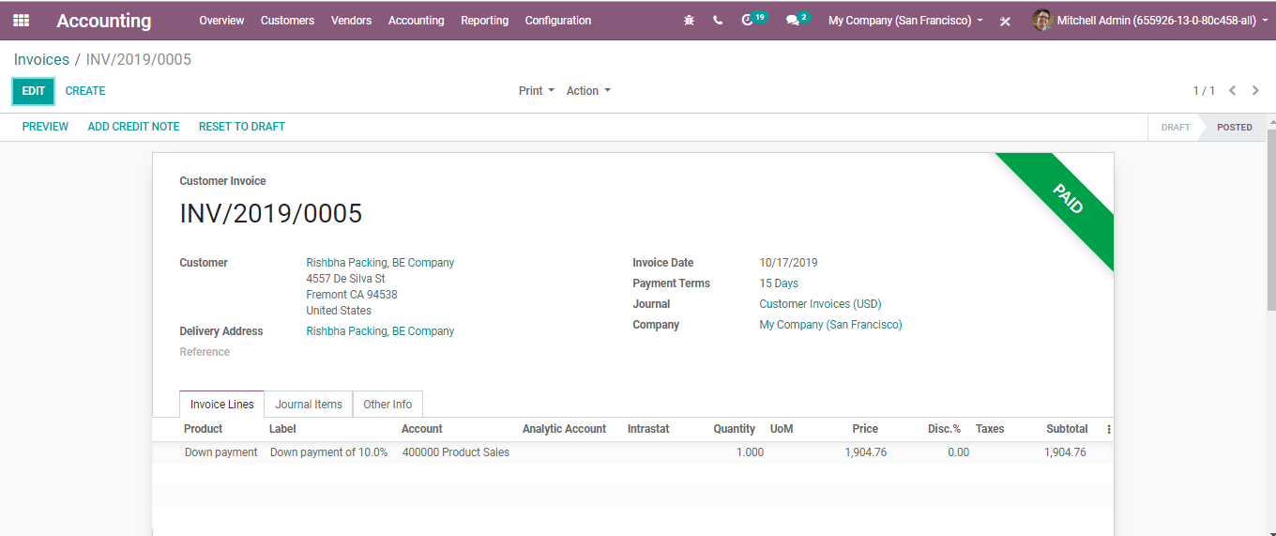
  - The above-cited is an Invoice based on the delivery order. However, under BUSINESSBOXERP, you have two invoicing policies.

  - INVOICING POLICY
  - BUSINESSBOXERP enables two options for invoicing
  - Invoice what is ordered: invoice the full order as soon as the sales order is confirmed.
  - Invoice what is delivered: invoice on what you delivered even if it's a partial delivery.
  - To enable the desired invoicing policy, Go to Sales>Configurations>Settings. Select the invoicing policy under Invoicing Option.
  - 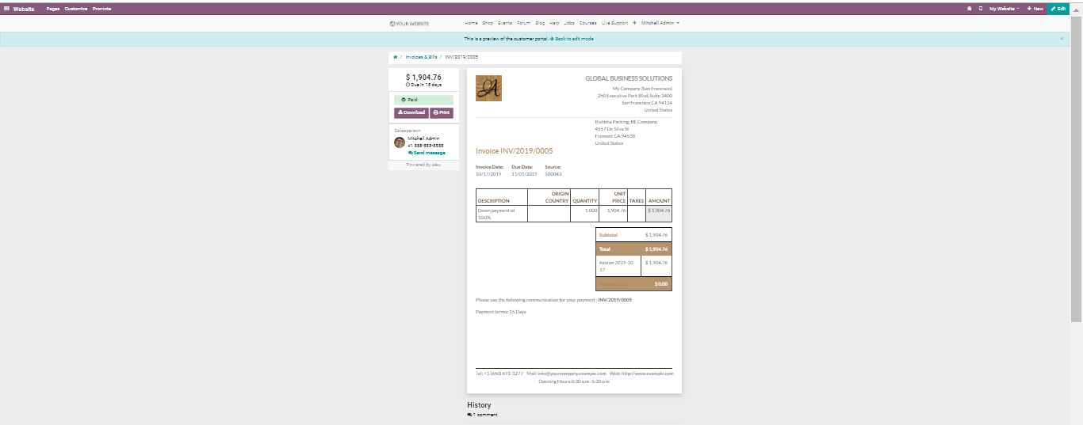
  - The default mode is Invoice on the ordered quantity. However, the benefits of Invoice on delivered quantity depends on your business type. For instance, if you are selling materials like foods in large quantities, there is always a risk that quantity may diverge a little. In that case, it will be good for the seller to invoice the delivered quantity.
  - Upon confirming the sale, one can see the delivered and invoiced quantities.
  - 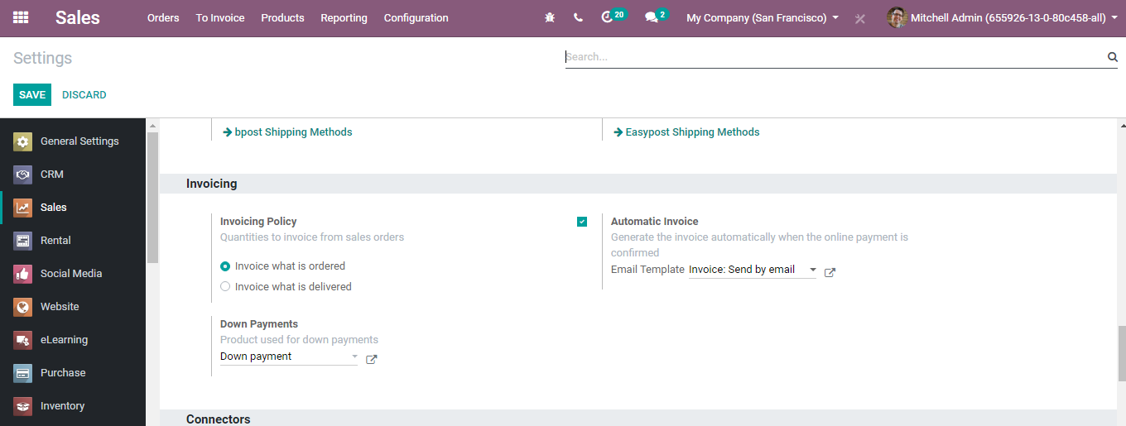

  - If the invoicing policy is set as ordered quantities, one can invoice as the sale gets confirmed.

  - 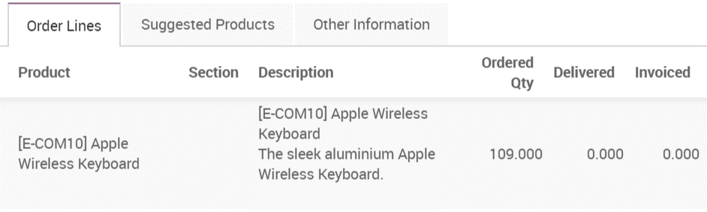
  - 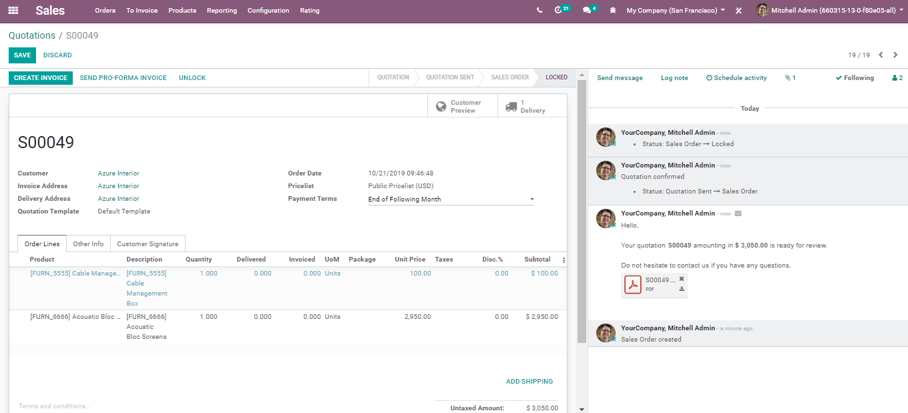

  - 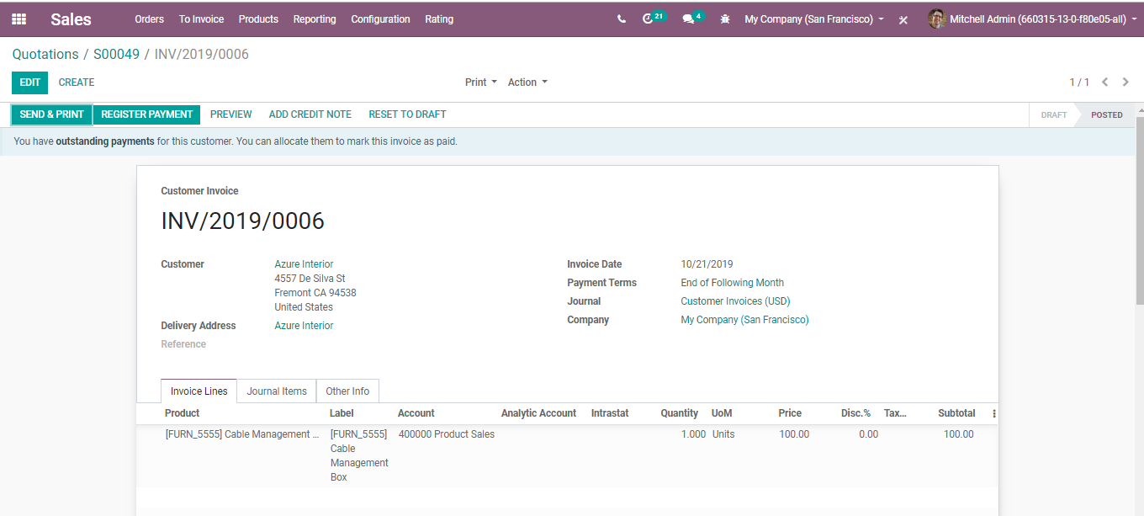
  - On the other hand, if invoice policy is set as delivered quantities, one needs to firstly validate the delivery. And after the products get delivered, you can invoice a customer. In case if you carried a partial delivery, BUSINESSBOXERP will automatically add the quantities to the invoice based on how many you delivered.

  - AUTOMATIC INVOICE
  - BUSINESSBOXERP enables the generation of the invoice automatically when the online payment is confirmed.
  - To trigger the action, go to Sales>Configuration > Settings and Activate Automatic Invoicing under Invoicing
  - 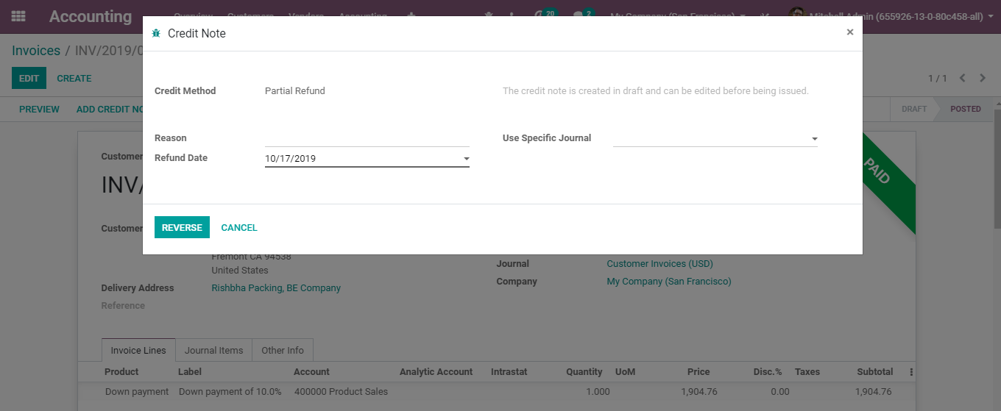

  - REFUND
  - In BUSINESSBOXERP, it's impractical to change an invoice that has been approved and sent to the client. In case a mistake was made on an approved receipt, the legitimate method to deal with that is to refund the receipt, reconcile it with the first invoice receipt to close them and make another receipt.
  - Via clicking the ADD CREDIT NOTE button, you can initiate the refund of the receipt.

  - 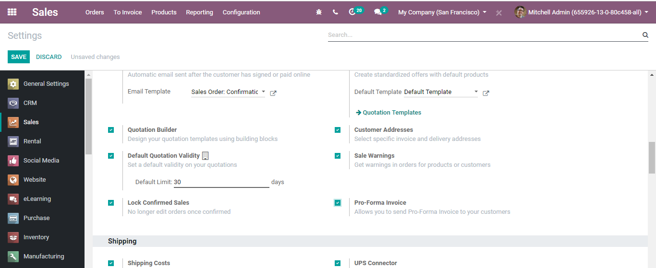
  - Via clicking ADD CREDIT NOTE button, you will be navigated to the new window like below.

  - 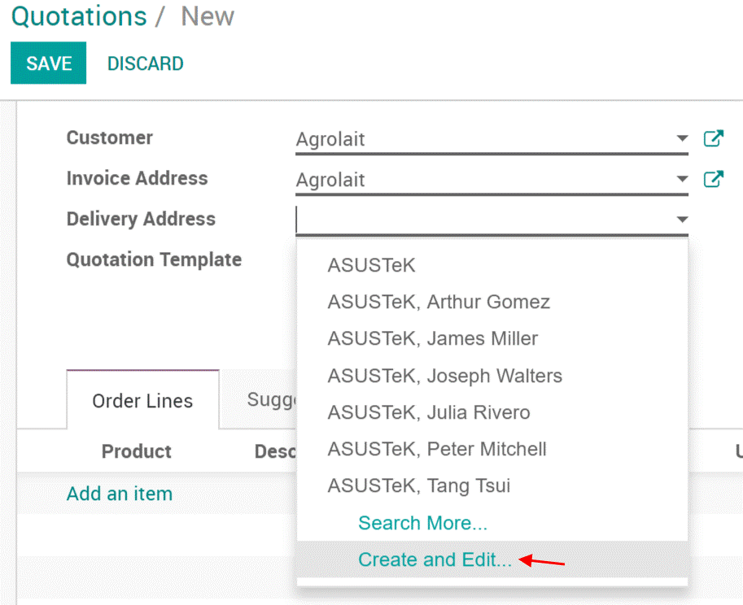
  - Here you can choose the CREDIT METHOD: Whether it is a PARTIAL REFUND [refund], FULL REFUND [cancel], FULL REFUND AND NEW DRAFT INVOICE [modify]. Also, can add the Reason for asking for the refund. Other fields are Refund date and Journal.

  - SETTING DIFFERENT ADDRESSES TO DELIVERY AND INVOICE
  - BUSINESSBOXERP enables the alternative to configure distinctive addresses for delivery and invoicing as not every person will have a similar delivery location as their receipt location.
  - To activate the feature,
  - Go to SALES ‣ Configuration ‣ Settings and activate the Customer Addresses feature.

  - Add different addresses to a quotation or sales order
  - If you select a client with an invoice and delivery address set, BUSINESSBOXERP will automatically utilize those for conveyance or delivery. On the off chance that there's solitary one location set, then in that case BUSINESSBOXERP will utilize that one for both delivery and invoicing. However, one can transform it quickly and make another one ideal from quotation or sales order.
  - 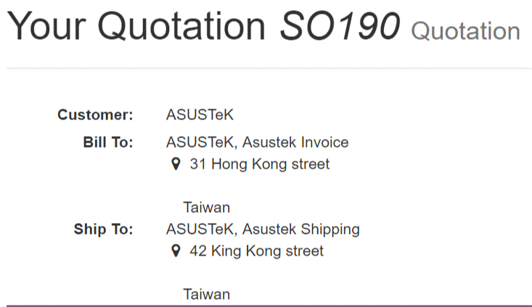

  - Adding of invoice & delivery addresses to a customer
  - If you need to add them to a client before a quotation or sales order, they are added to the client form. Go to any customer's form under SALES ‣ Orders ‣ Customers.
  - From that point, you can add new addresses to the client.
  - 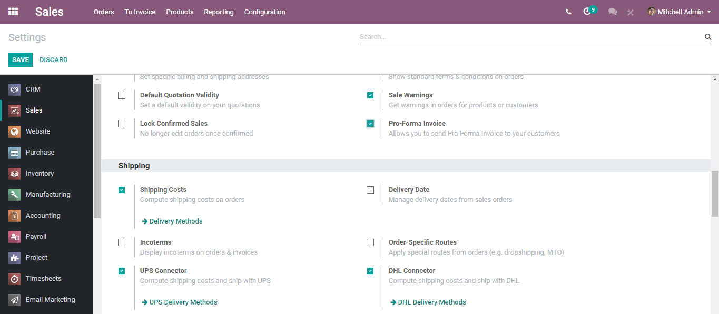

  - Different locations on the quotation/sales orders.
  - These two addresses will at that point be utilized on quotation or sales orders you send by email or print.

  - SENDING PRO-FORMA INVOICE TO CUSTOMER
  - The Pro-forma Invoice is mainly utilized as an essential receipt with quotations ahead of time of product delivery. It takes note of the kind and quantity of merchandise, their esteem, and other significant data, for example, weight and transportation charges. The pro-form invoice contrast to a typical invoice is not being demanded or requested for payment.
  - To trigger the action
  - Go to SALES > Configuration > Settings and activate the Pro-Forma Invoice feature.

  - 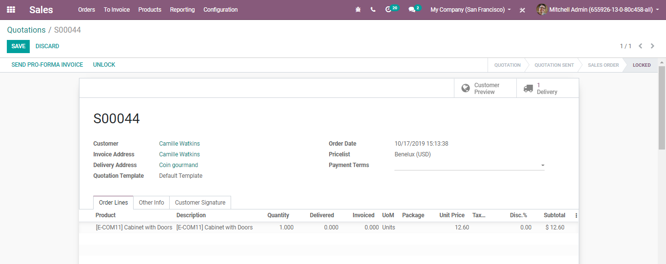
  - Send a Pro-forma invoice
  - One can send the Pro-forma invoice from any quotation or sales order.
  - 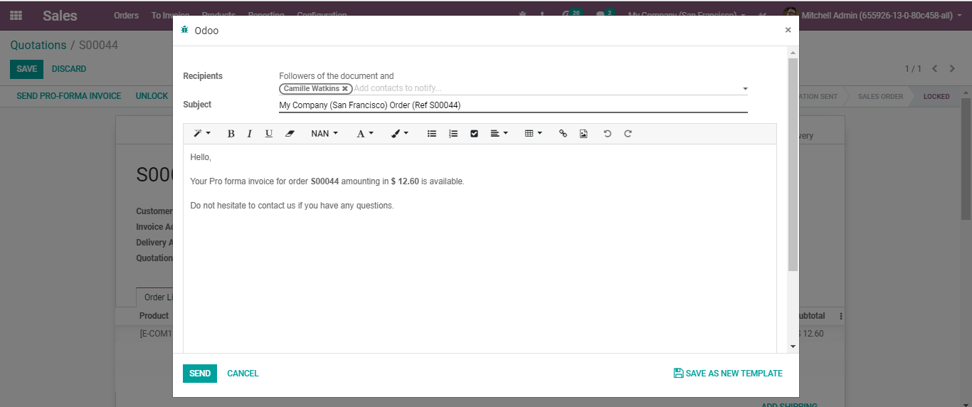

  - 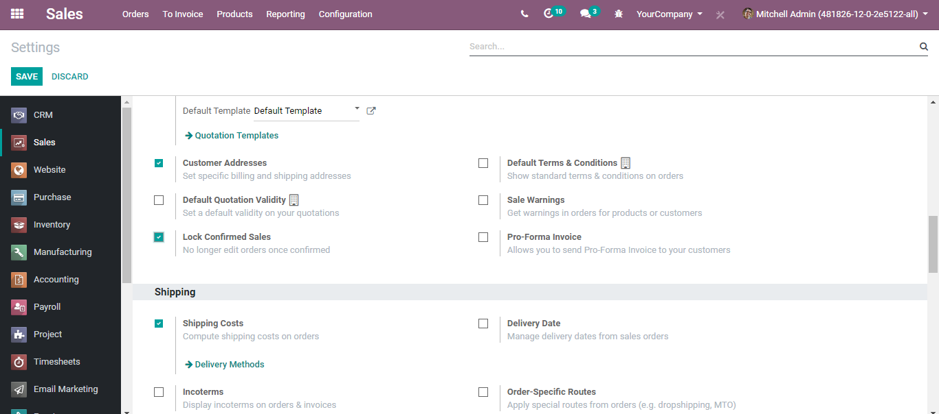

  - LOCK CONFIRMED SALES
  - When a sale order is confirmed, you can lock it counteracting any further altering.
  - To activate the feature, go to Sales > Configuration > Settings and activate the Lock Confirmed Sales feature
  - Lock an order
  - Activating the feature, while you soon confirm the quotation/ order, you can see the status getting changed to LOCKED.
  - However, via clicking the UNLOCK button, you can unlock the order.

  - SALES WARNINGS
  - The Warnings feature enables you to raise alerts or block messages on buy orders dependent on a merchant or an item.
  - For instance, if you frequently have an issue with a merchant, you should need to raise a notice. On the off chance that an item is going to be suspended, you might need to raise a blocking message on the buy request.
  - To activate the feature, go to Sales> Configuration>Settings. Activate the option Sales Warnings under Quotations &Orders.

  - 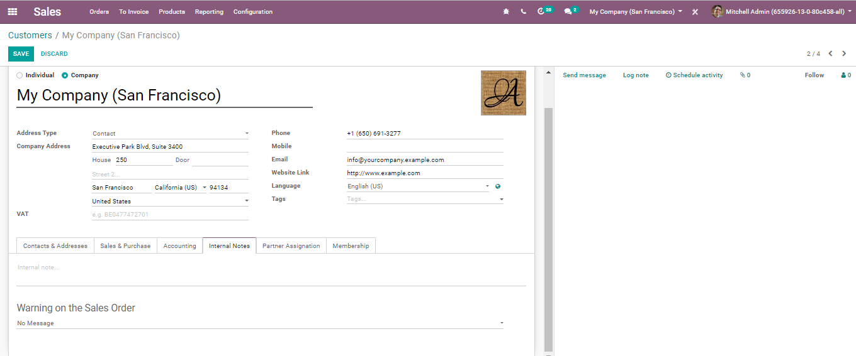
  - Add a warning on a vendor
  - When you activate the warnings feature, you get another alternative under the Internal Notes tab on merchants. You can choose to compose a basic cautioning or a blocking message.

  - 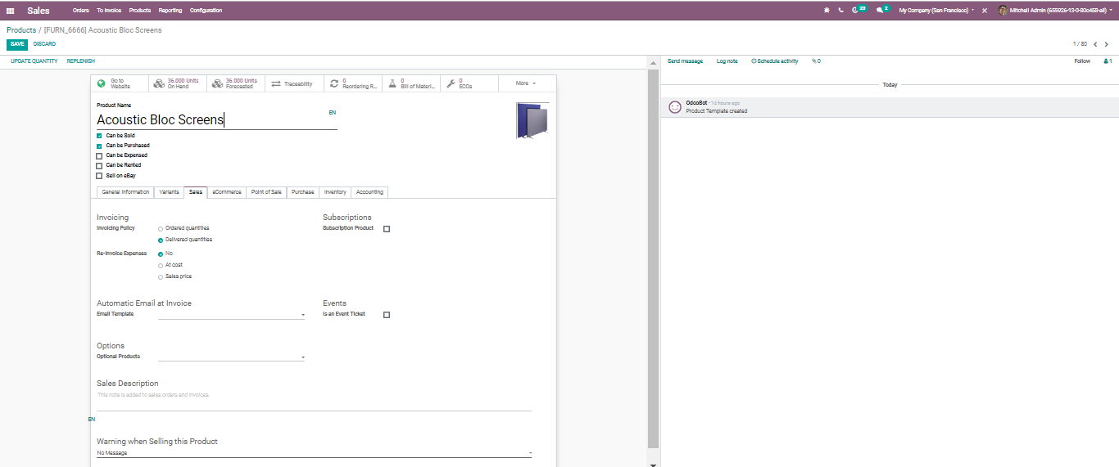
  - Add a warning on a product
  - When you enact the feature, you get another choice under the sales tab on the product page where you can include a notice or a blocking message.

  - 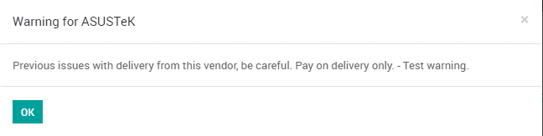
  - While attempting to purchase the products with alerts or blocking messages
  - If you attempt to approve a Purchase Order from a seller or with an item with a notice, a message will be raised. You can disregard it by clicking OK.

  - 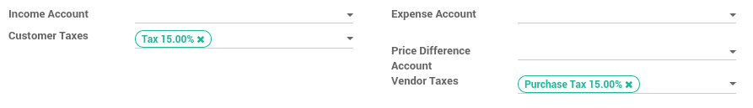

  - PRODUCT AND TAXES
  - APPLYING DEFAULT TAXES ON PRODUCTS OR SALES ORDER
  - Tax/Duties connected in your nation are installed automatically for general confinements say localization. Default charges set in sales order and invoices originate from every product’s Invoicing tab. Such expenses are utilized when you pitch to organizations that are in a similar nation/state to you.
  - All the new products/ items made in the BUSINESSBOXERP take the default charge set in the Accounting/Invoicing settings.

  - 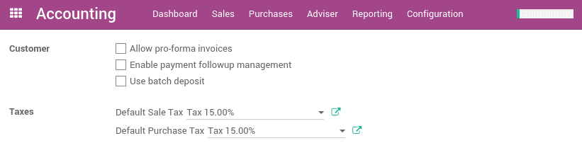
  - To change the default charges set for any new item made, go to Invoicing - > Configuration - > Settings.

  - 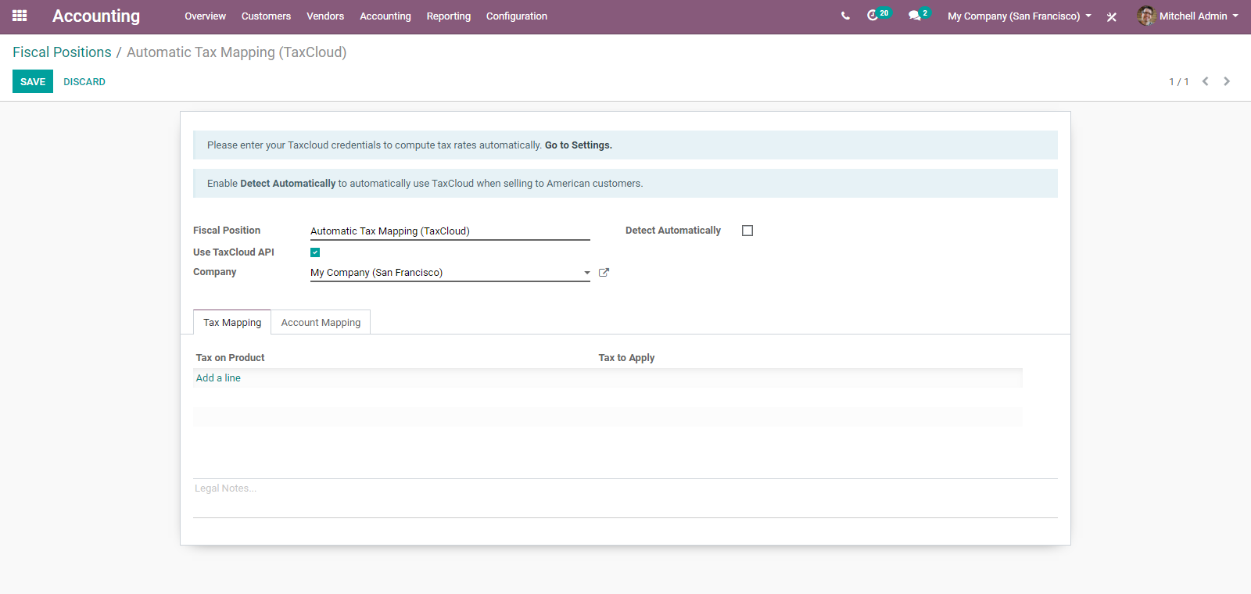
  - If you belong to multi-companies, the sales and purchase taxes will have different values according to the company. In that case, you can log in to two different companies and change the field for each company.

  - APPLYING TAXES CONDITIONING CUSTOMER STATUS OR LOCALIZATION
  - The sales tax is constantly connected to client status or localization. To outline diverse deals charges, BUSINESSBOXERP has brought the element Fiscal Positions.
  - The fiscal position goes about as a lot of principles that maps default charges (as characterized on item structure) into different tax assessments. The fundamental fiscal positions are automatically made agreeing the client confinement/localization. However, one may need to make fiscal positions for explicit use cases. To characterize fiscal positions, go to Invoicing/Accounting ‣ Configuration ‣ Fiscal Positions

  - 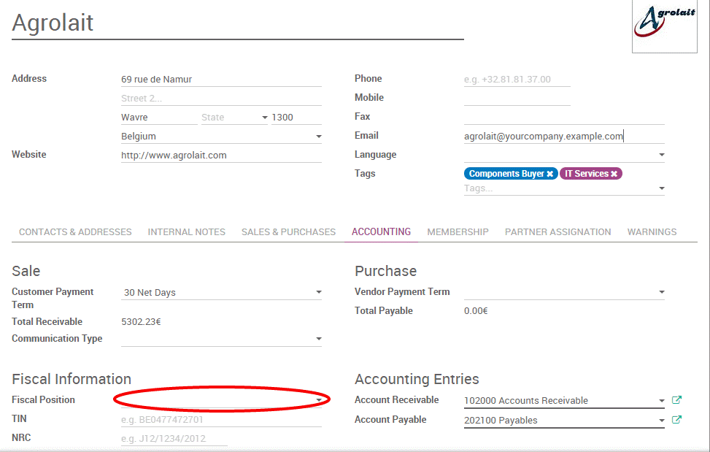

  - ADAPT TAXES TO YOUR CUSTOMER STATUS
  - If a client falls into a particular tax collection rule, you must apply a duty mapping. To do as such, create a fiscal position and allot it to your clients.
  - 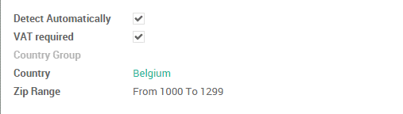

  - BUSINESSBOXERP will utilize the specific fiscal position for any order/invoice.

  - ADAPT TAXES TO YOUR CUSTOMER ADDRESS (DESTINATION-BASED)
  - Contingent upon your localization, sales taxes might be origin-based or destination-based. Most states or nations expect you to gather charges at the rate of the destination (for example your purchaser's location) while some others require you to gather them at the rate viable at the point of origin (for example your office or stockroom).
  - If you are under the destination-based rule, create one fiscal position per tax mapping to apply.
  - Check the case Detect Automatically
  - Select a country group, country, state or city to trigger the duty mapping.

  - 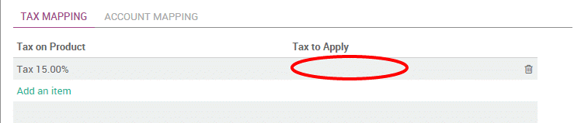
  - If no fiscal position is determined to the client, BUSINESSBOXERP will pick the fiscal position matching the transportation address on making a request.
  - Specific use cases
  - If, for some fiscal positions, you need to evacuate a tax, rather than supplanted by another, simply keep the Tax to Apply field empty/ unfilled.
  - If, for some fiscal positions, you want to replace a tax with two other taxes, just create two lines having the same Product Tax.

  - SALE AND PURCHASE IN DIFFERENT UNITS OF MEASURE
  - Now and again, dealing with products in the various unit of measure is vital. For instance, if you purchase items in a nation where the metric measuring standard is of utilization and sell them in a nation where the imperial framework is utilized, you should change over the units. BUSINESSBOXERP empowers to work with various units of measure for one item.

  - For that, go to Sales/Configuration / Settings and Activate Units of Measure under Product Catalog
  - 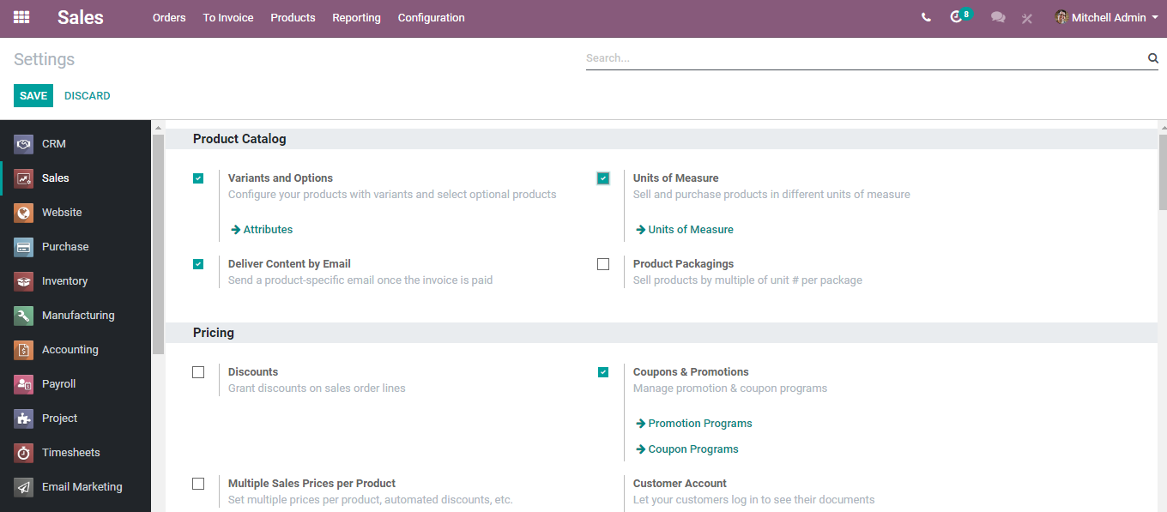
  - 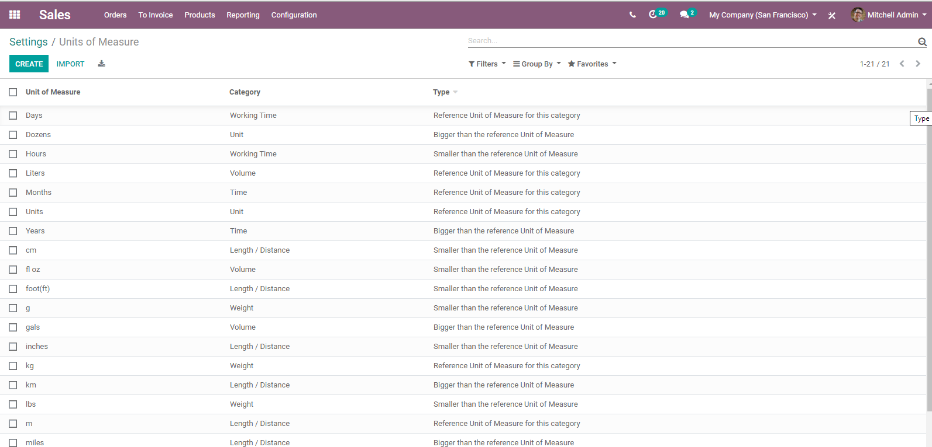
  - Upon clicking the create button, you can create new Units of Measure for your products.

  - 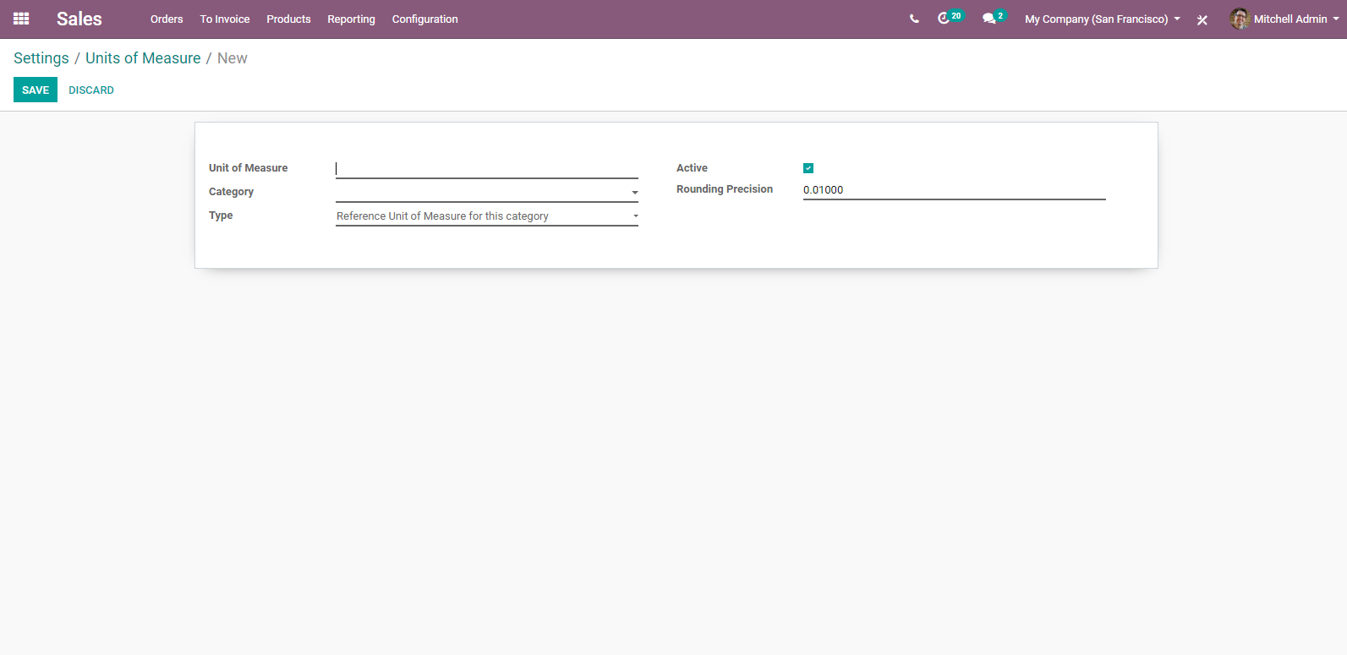
  - Here, you can name the unit of measure, define its category (conversion between two units of measure can happen only if they belong to the same category. The Conversion will be made based on the ratios.)
  - While doing inter-unit exchanges, the rounding adjustments are automatically done by BUSINESSBOXERP.

  - REPORTING
  - One needs to constantly monitor the team's performance to take accurate and relevant decisions for the business good. The Reporting section of BUSINESSBOXERP Sales represents a very important tool that helps in getting complete insight into the company's sales.
  - Go to Sales>Reporting Sales
  - 
   