**Sign**

With the BUSINESSBOXERP sign module, one can easily send, sign, and approve documents online. From uploading your PDF to drag & drop of fields, the module has its special wing of offerings. BUSINESSBOXERP Sign is a fast and convenient mode to get signed and approve the documents.

One can complete the signature requests in seconds and track the status of sent documents.

To start with, install the BUSINESSBOXERP sign app.

So right away entering the application you have a view of all our templates, that we have already uploaded.

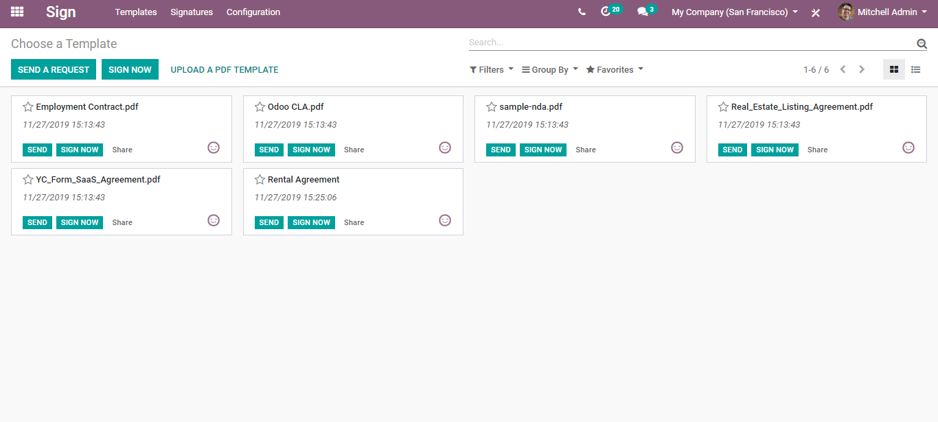

To upload a new template, click the button UPLOAD A PDF TEMPLATE.

To check out all the signatures that we already requested, go to Sign> Signatures.

Here currently we do not have any. However, to request the signature, you can click on the REQUEST A SIGNATURE button.

You will be navigated to a list of templates created. You can select your desired template and send a request via clicking the button SEND A REQUEST.

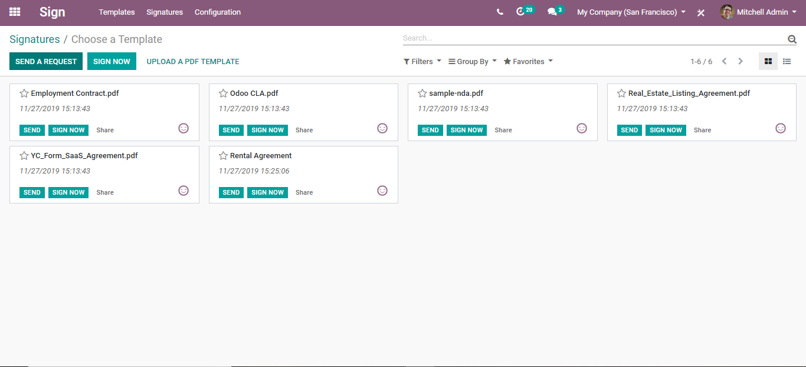

Right away you get a preview of that pdf document.

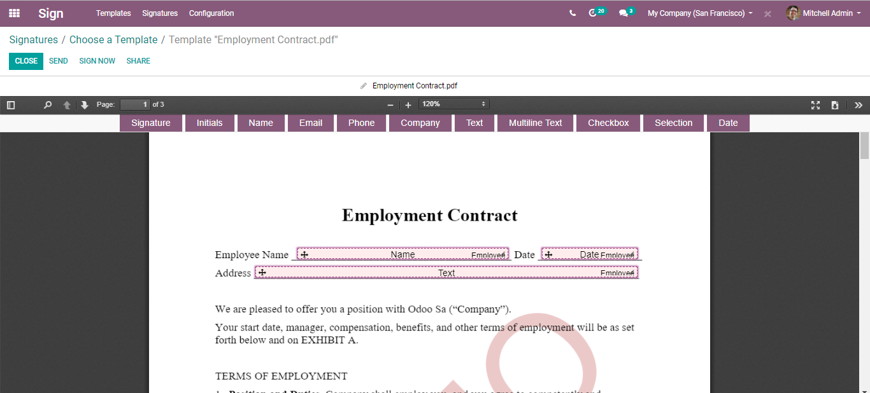

Here one can also add certain fields. For instance, if you want certain initials in this document, you can simply select the initials field and drag and drop them to the exact location where you need the initials.

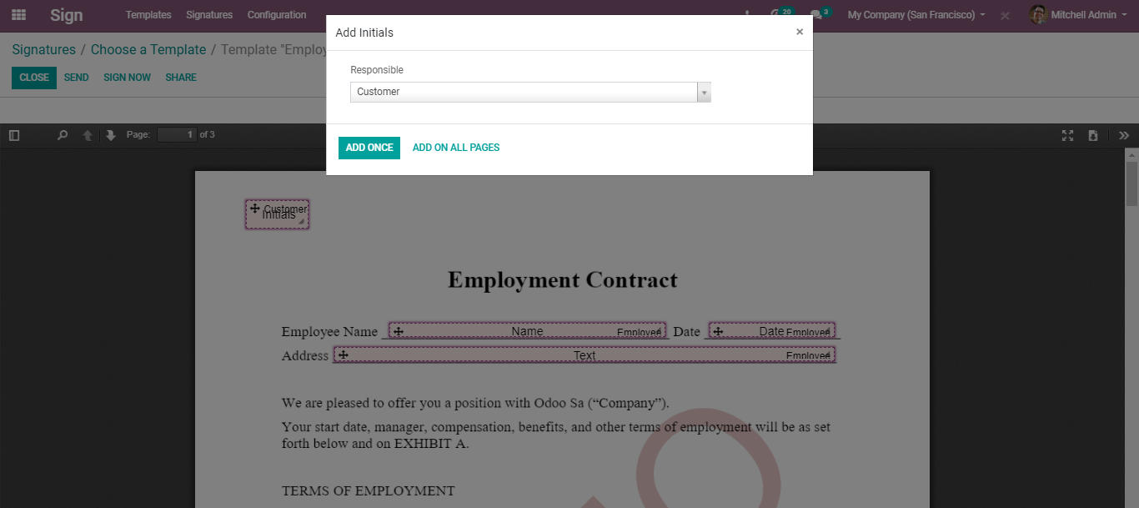

You can see here the response is the customer. One can either add the initials to this page alone via clicking the ADD ONCE option and initials to all pages via clicking the option ADD ON ALL PAGES.

If you are required of the signature for this document, you can select SIGNATURE from the top,

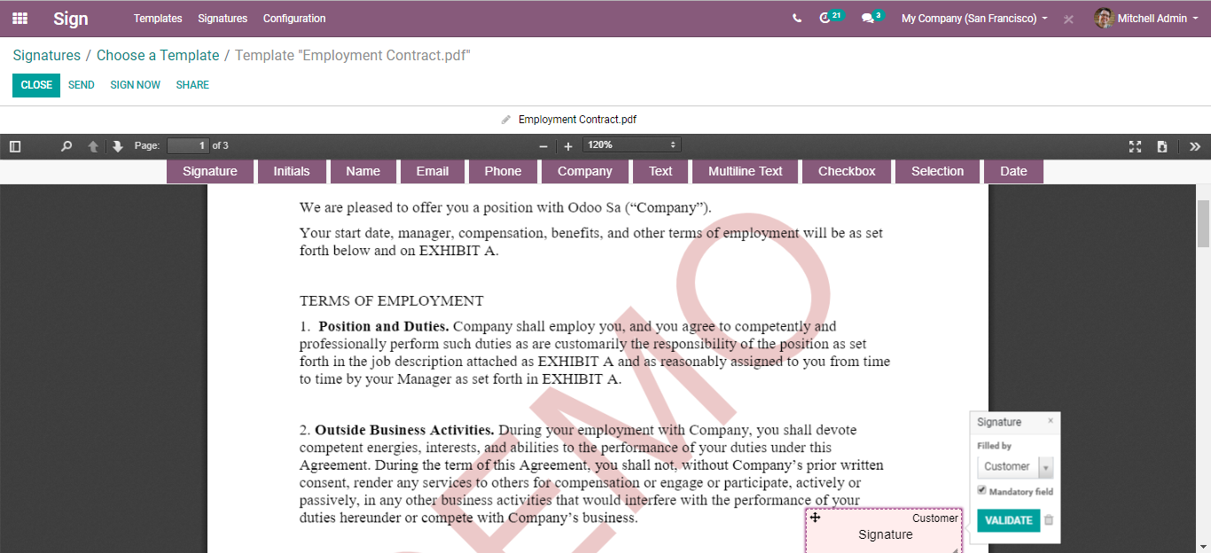

Drag and drop it to the exact location where you need the signature.



You can select here whether the field is mandatory or not.

And VALIDATE.

In the same way, we added initials and signatures, one can add many elements to the documents.

And once you are done with all the requirements, click the SEND button.

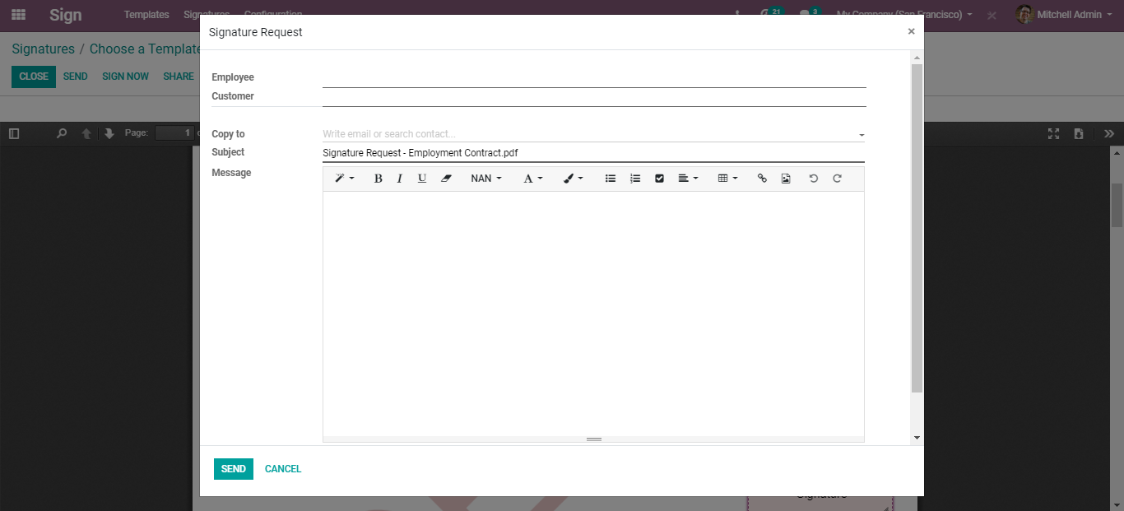

You can see a mail template requesting a signature. You can add here the employee and the customer whose signature is required and the messages.

Click SEND button to send the mail.

Once again you get to the preview of the document with signatures waiting from the employee and the customer. Via clicking the RESEND button, one can send the email to the person.

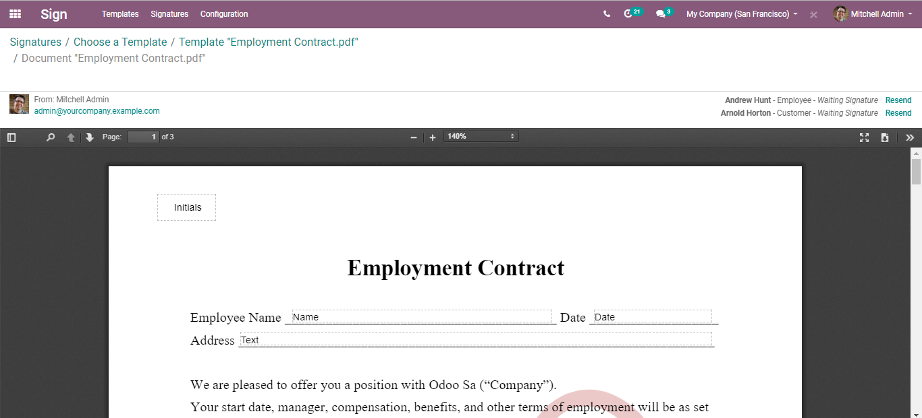

One can access the very same from the Kanban view of the Signature Dashboard.

Via simply clicking it you again get back to its preview.

Via clicking the three dots, you can access more info on it.

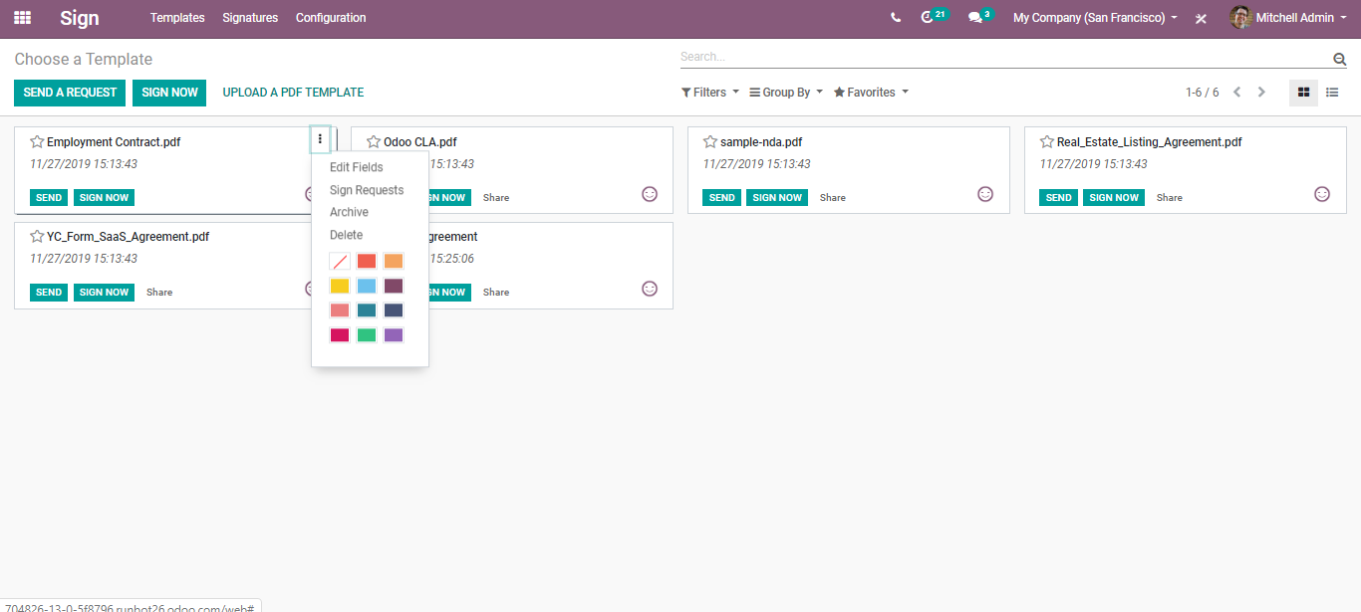

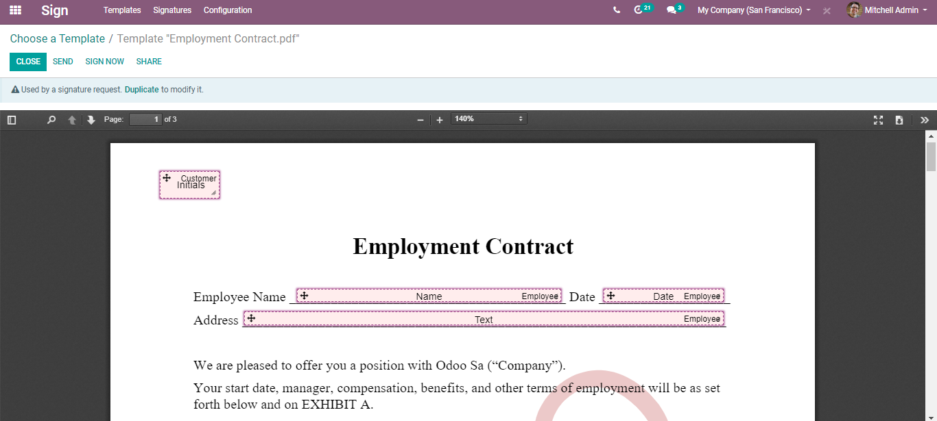

From the preview page itself, one can sign the document. For that click, the SIGN NOW button.

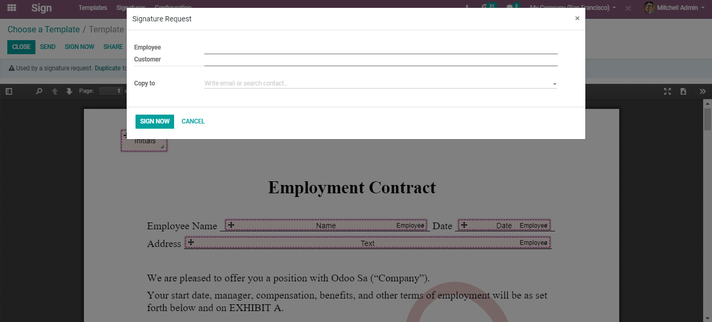

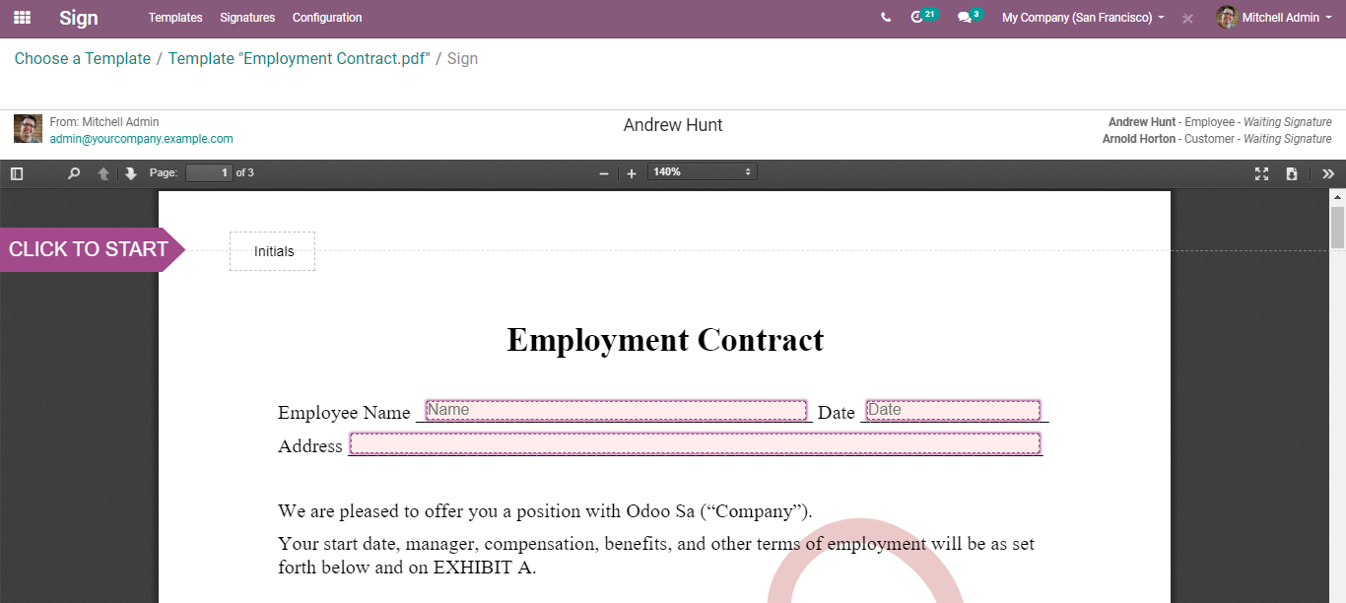

CLICK TO START.

And proceed.

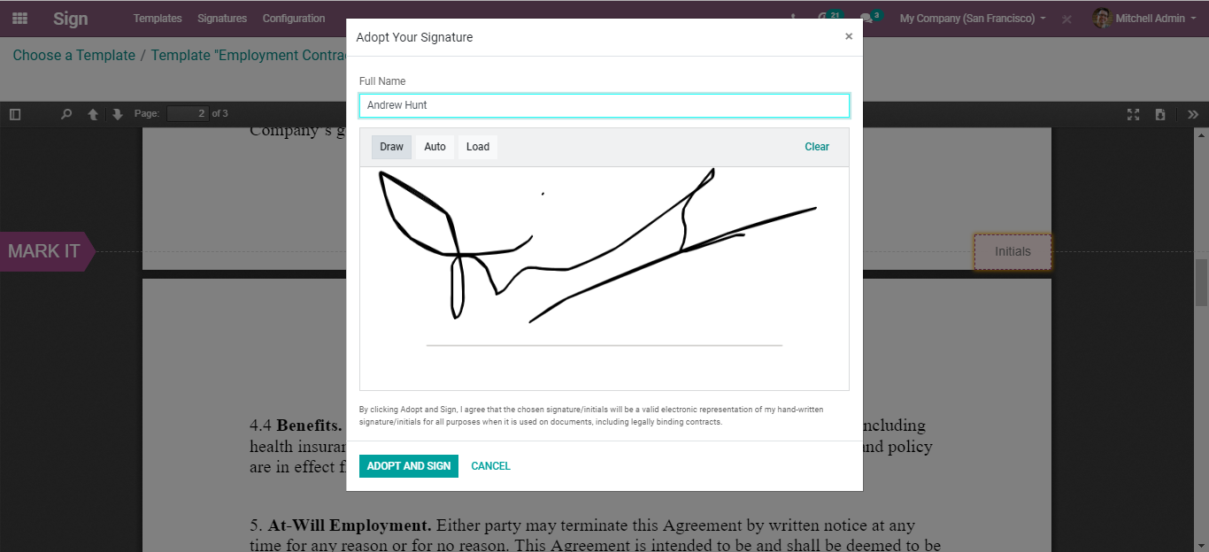

Click ADOPT AND SIGN.

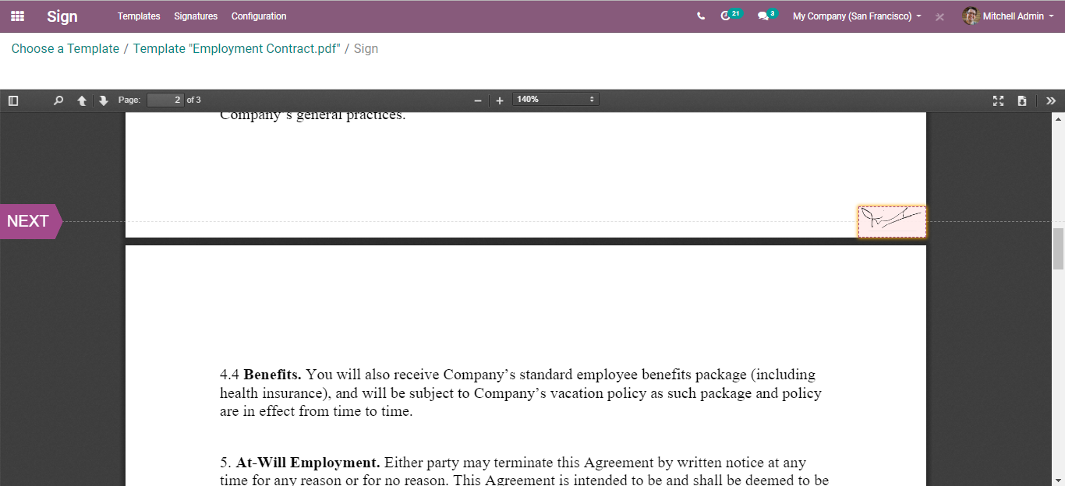

You can see the initials done in the document.

**Configuring Roles**

Before requesting a signature on your documents, it is very necessary to configure the roles i.e., whose signature you need in the document. For that go to Sign > Configuration> Roles.

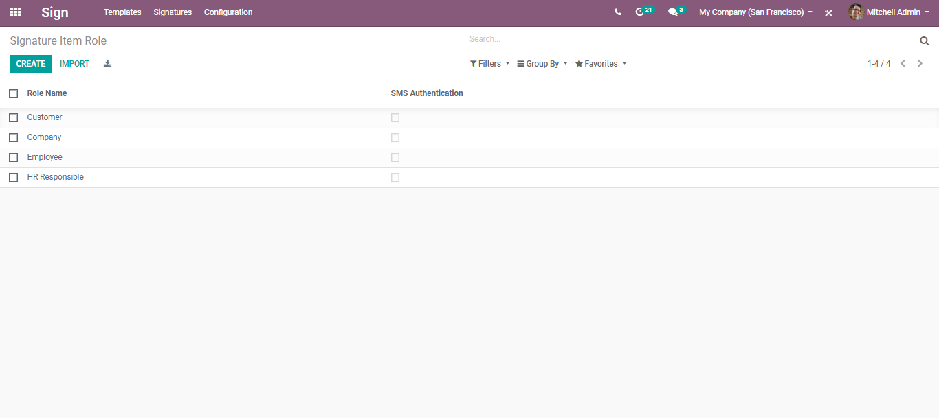

Upon clicking CREATE button you can create new roles in the company.

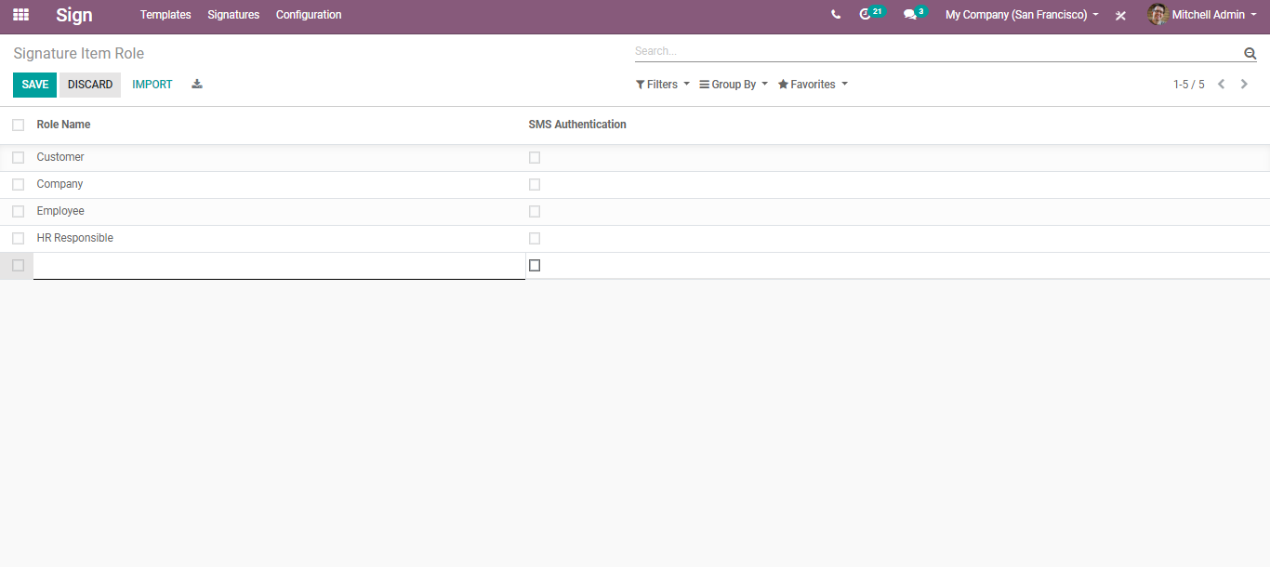

Isn’t it that simple? CLICK save to mark the changes.